Date :  26-02-2024

ai google keyword research version: 1.0.0

# **Overview**

Keyword Research helps to analyse keywords and related keywords competitions , search volume (google) and CPC. For private plans, custom plans, custom billing contact.

Note : Comprehensive Keyword Analysis": "Keyword Overview full analysis with SERP Analysis, Keyword Trending History, related Queries and keyword interest by region On Google Trends, Related Keywords data.

Keyword Research helps to analyse keywords and related keywords competitions, search volume, and CPC. Mostly useful for digital marketers and related platforms.

# **Getting Started**

## **Prerequisites**

* Volt Foundry
* [**Rapid API Account**](https://rapidapi.com/ramcharangoodboy-rd27go0ww30/api/ai-google-keyword-research)
* X-RapidAPI-Key, X-RapidAPI-Host.

## **Importing the adapter**

**To import the Data Adapter to Volt Foundry, do the following:**

1. Sign in to the  [HCL Foundry](https://manage.hclvoltmx.com/).
2. From the left navigation menu, select **API Management**.
3. In **API Management**, select **Custom Data Adapters**.  
   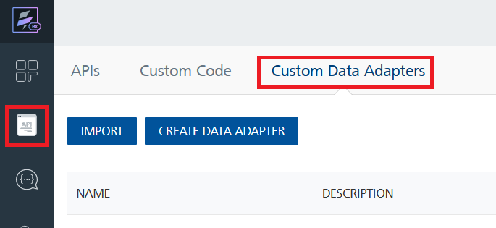
4. Click **IMPORT** to import a custom data adapter.  
   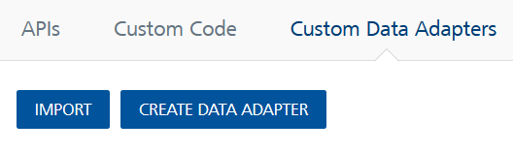
5. On the Import Data Adapter dialog box, click browser to import.  
   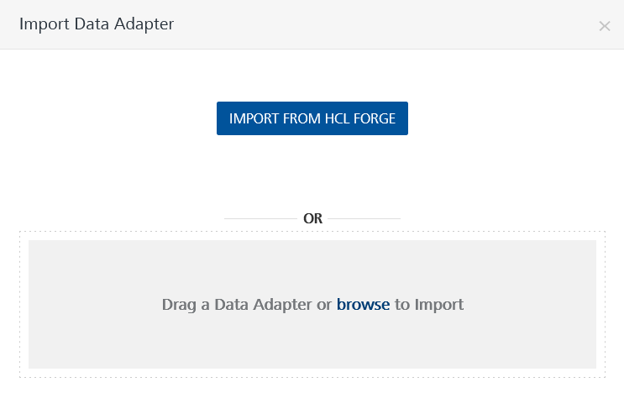
6. Select **AI Google Keyword Research zip** file and click **IMPORT**.

After you import the data adapter, Volt Foundry opens a window that shows the metadata of the data adapter.

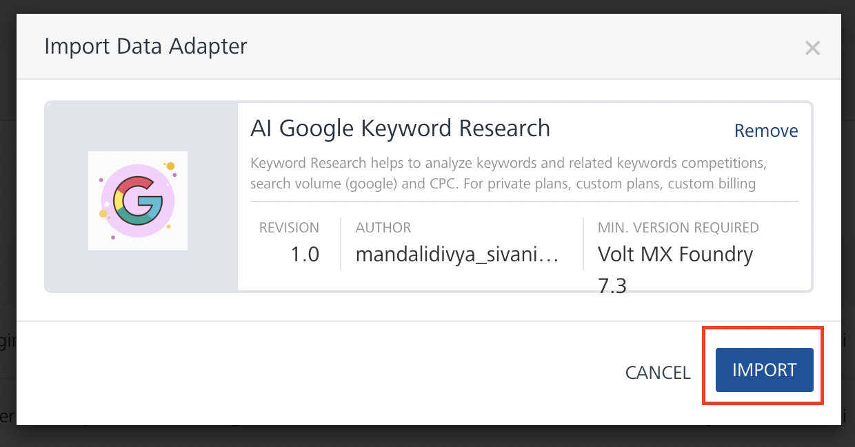

After you import the data adapter, you can view it on the Custom Data Adapters page and use it to create services on Volt Foundry.

## **Creating an Integration service**

After you import the data adapter into Volt Foundry, you can use it to create an Integration Service.

Follow the given steps to create an Integration service using the **AI Google Keyword Research** Adapter.

1. Sign in to the [HCL Foundry](https://manage.hclvoltmx.com/).
2. From the left navigation menu, select **API Management**.
3. In **API Management**, select **Integration**.

1. To create a new service, click the **+** button or the **CONFIGURE NEW** button.

1. On the Service Definition tab, select the service type as**AI Google Keyword Research,** and click **SAVE**.

Alternatively, you can also create a Foundry app and create an Integration service inside it.

## **Creating and Executing operations**

After you create an integration service, you can create and execute operations using the service.

#### **Creating an Operation**

* In **API Management/Foundry app you created**, in the **Integration** section, select the service that you created.
* After you select the service, navigate to the **Operation List** tab.  
  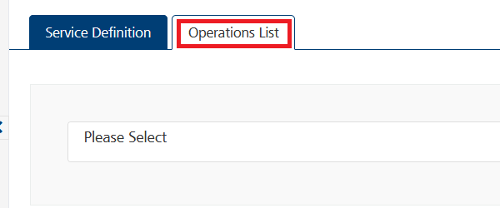
* From the drop-down list, select an operation that you want to execute, and click **ADD OPERATION**.

#### **Executing an Operation**

* From the **Operations List** tab, in the **Configured Operations** section, select the operation you want to execute.

**Note:**You can follow the same steps to create operations for other methods but ensure that you select the required API.

You can create multiple operations with required APIs and save them in the **Configured Operations** section. You can then execute the operations whenever required.

* On the Operation Page, in the **Request Input** tab, in the **Body** section, for the following parameters, specify the values in the respective boxes under the **Test Value** column.

**Mandatory Parameters**

* + **X-RapidAPI-Key, X-RapidAPI-Host [in header]:**  API Key associated with your RapidAPI account, required for authentication.

To get keys – Login in to [**Rapid API Account**](https://rapidapi.com/ramcharangoodboy-rd27go0ww30/api/ai-google-keyword-research)-> You can view your keys.

* + **keyword:** The keyword to perform research for.
  + **country:** The country code for which the research is conducted.

* Select a run-time environment and click **Save and Fetch Response** to get a response based on your inputs.

## **Publishing your application**

If you want to use the services in client applications, you need to publish an app to a run-time environment. You can create the service (as described above) in an application or import the service into an application and publish the application.

# **References**

## Endpoint Documentation

## **Requests Input Parameters for keyword-research**

|  |  |
| --- | --- |
| **Parameter** | **Description** |
| X-RapidAPI-Key(string) | **[Required]** **[Header]**API Key associated with your account. |
| X-RapidAPI-Host (string) | **[Required]** **[Header]** The host parameter specifies the domain name or IP address of the RapidAPI endpoint. In the context of the AI Google Keyword Research, the default host is set to 'ai-google-keyword-research.p.rapidapi.com'. This parameter is necessary for routing the request to the appropriate API endpoint. |
| keyword (string) | **[Required]** The keyword to perform research for. |
| country (string) | **[Required]** The country code for which the research is conducted. |

### **Response Output Parameters for keyword-research**

|  |  |
| --- | --- |
| **Object Property** | **Description** |
| High CPC (string) | The highest Cost Per Click (CPC) recorded for the keyword "email marketing". |
| Low CPC (string) | The lowest Cost Per Click (CPC) recorded for the keyword "email marketing". |
| avg_monthly_searches (integer) | The average monthly searches for the keyword "email marketing". |
| competition_index (integer) | The competition index representing the competitiveness level of the keyword. |
| competition_value (string) | The qualitative assessment of competition level (e.g., "MEDIUM") for the keyword. |
| Keyword (string) | The specific keyword being analyzed ("email marketing" in this case). |
| monthly_search_volumes (Array of Objects) | An array containing monthly search data for the keyword "email marketing" over different months. |
| monthly_search_volumes - month (string) | The month of the recorded search data. |
| monthly_search_volumes - searches (integer) | The number of searches for the keyword in the respective month. |
| monthly_search_volumes - year (integer) | The year for which the search data is recorded. |

**Reference Document:**  [[AI Google Keyword Research API Documentation (ramcharangoodboy-rd27go0ww30) | RapidAPI](https://rapidapi.com/ramcharangoodboy-rd27go0ww30/api/ai-google-keyword-research)](https://rapidapi.com/rahilkhan224/api/vehicle-rc-verification-india)

# **Revision History**

Adapter version 1.0.0:

## **Known Issues**

* No Known Issues

## **Limitations**

* No limitations