Date: 14 Oct 2025

AI IMAGE GENERATOR COMPONENT

VERSION: 1.0.0

OVERVIEW
The AI Image Generator Component takes in textual prompts and generates high-quality images using the image generation capabilities of leading AI models from Google and Microsoft.
It is powered by artificial intelligence that can create images based on text descriptions provided by the user. It's designed to help users generate visual content quickly and easily without needing advanced design skills. The component can offer diverse capabilities and high-quality outputs.
The AI Image Generator component uses Google Imagen 3, Microsoft DALL-E 3, and Gemini 2.0 Flash Preview provides a versatile, multi-model, and adaptive solution for image generation.

Use case:
- Creative Art Generation: Use DALL-E 3 for storybook illustrations.
- Photo-realistic Marketing: Use Imagen 3 for fashion product shots.
- Quick UI Mockups: Use Gemini Flash Preview for fast prototype sketches.

Percentage of re-use:

80%

Features
- User-Selectable Model Options: Users can manually choose between Google Imagen 3, Microsoft DALL-E 3, or Gemini 2.0 Flash Preview based on their specific needs
- Fast & Versatile Performance: Supports both high-fidelity rendering and low-latency image previews, allowing users to prioritize speed (Gemini Flash) or detail (Imagen 3/DALL-E 3).
- Text-to-Image Interface with Fine Control: Accepts detailed text prompts and parameters to guide image content, layout and style (when supported by the selected model).

GETTING STARTED

Prerequisites
Before you start using the AI Image Generator Component, ensure the following:
- HCL Foundry
- Volt MX Iris
- Microsoft account
  - Require endpoint, deployment-id and api-key to use the Dall-e 3 Azure OpenAI image generation model. Copy the details to add in the Foundry APP Setup.
Reference document: https://learn.microsoft.com/en-us/azure/ai-services/openai/how-to/dall-e?tabs=dalle3

- Get a Gemini API Key in Google AI Studio . Copy the key to add in the Foundry APP Setup.
Reference document: https://ai.google.dev/gemini-api/docs/quickstart?lang=rest
- Create a Google Cloud account create an account or sign up for a free trial
  - A dedicated service account is required to enable secure OAuth 2.0 server-to-server authentication for accessing the Vertex AI API. Unlike user credentials, a service account provides non-interactive authentication that allows backend systems and applications to programmatically interact with Vertex AI without manual user sign-in. The Vertex AI User permission should be specifically granted to ensure the service account can perform essential operations such as creating, managing, and invoking Vertex AI resources (e.g., models, endpoints, and pipelines).
  - Steps to create a service account is mentioned in this documentation https://developers.google.com/identity/protocols/oauth2/service-account#httprest
      - After Service account is created
      - Go to the Keys tab.
      - Click Add Key > Create new key.
      - Choose JSON and Download it.
      - Copy the type, private_key and Client email values from the JSON file. Go to HCL Foundry -> Environments -> App Services -> Settings -> Configurable Parameters -> Server Properties -> Add a new field with name GCP_SA_KEY and value as shown below
Note: Replace the YOUR_TYPE_VALUE, YOUR_PROJECT_ID, YOUR_PRIVATE_KEY_ID, YOUR_PRIVATE_KEY, YOUR_CLIENT_EMAIL and YOUR_CLIENT_ID with your copied values.
{ "type": "YOUR_TYPE_VALUE", "project_id": "YOUR_PROJECT_ID", "private_key_id" : "YOUR_PRIVATE_KEY_ID", "private_key": "YOUR_PRIVATE_KEY", "client_email": "YOUR_CLIENT_EMAIL", "client_id": "YOUR_CLIENT_ID" }
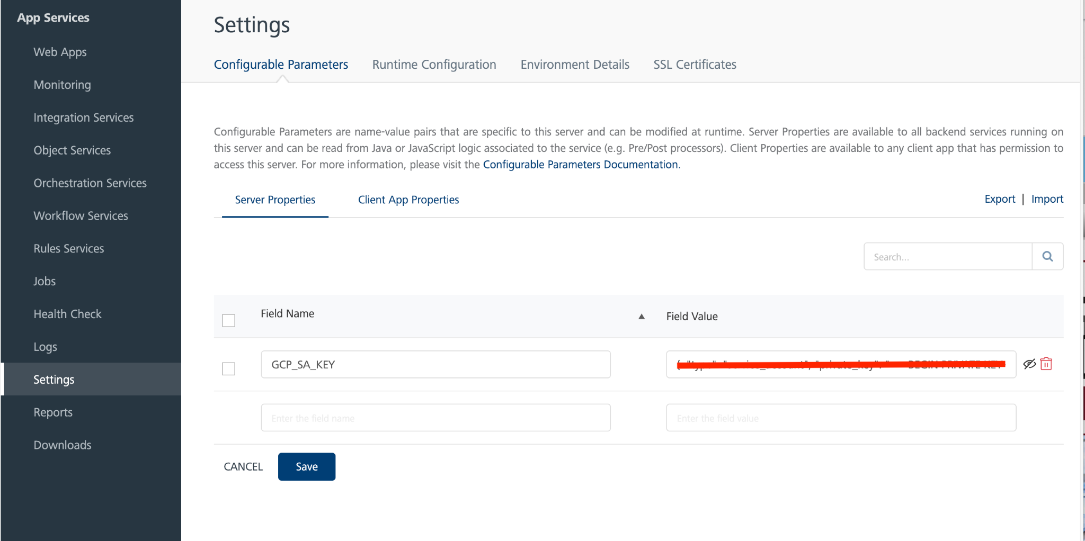
Reference documents:
https://developers.google.com/identity/protocols/oauth2/service-account#httprest,
https://cloud.google.com/vertex-ai/generative-ai/docs/image/generate-images#-drest

Platforms Supported

Mobile

iOS

Android

Importing the component

You can import the Forge components only into the apps that are of the Reference Architecture type.

To import the AI Image Generator Component, do the following:

Open your app project in Volt MX Iris.
  - In the Project Explorer, click the Templates tab.
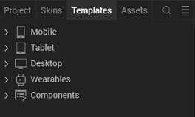

  - Right-click Components, and then select Import Component. The Import Component dialog box appears.
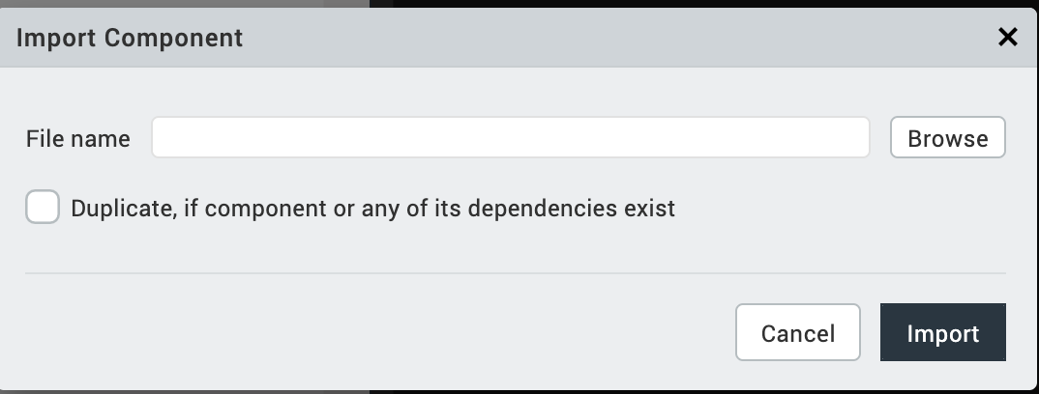
  - Click Browse to navigate to the location of the component, select the component, and then click Import. The component and its associated widgets and modules are added to your project.
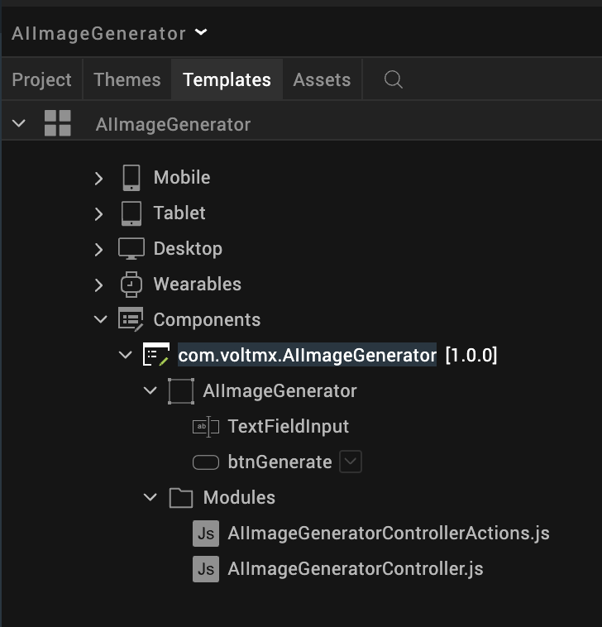

Once you have imported a component to your project, you can easily add the component to a form. For more information, refer Add a Component to a Form

Foundry APP Setup
When you import the component to your Volt MX Iris project, the HCL Volt MX Foundry services of the AI Image Generator are added to the HCL Volt MX Foundry app, which is associated with the Volt MX Iris project. While importing the AI Image Generator component to your Volt MX Iris project, if there is no HCL Volt MX Foundry app associated with the existing Volt MX Iris project, a new HCL Volt MX Foundry app is automatically added to your HCL Volt MX Foundry environment and is associated with your Volt MX Iris.
To set the Foundry app, follow these steps:
- Click the HCL Volt MX Foundry app associated with your Volt MX Iris project from the Project Explorer. Click DATA & SERVICES
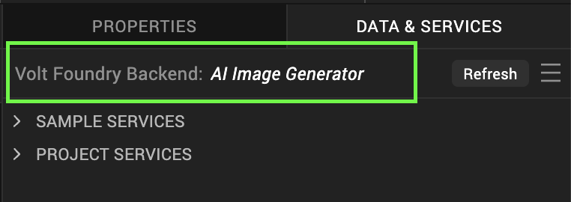
- Under the Configure Services tab, click Integration and can see the Google Gemini and Microsoft Integration services. Click on each Integration service to add the keys.
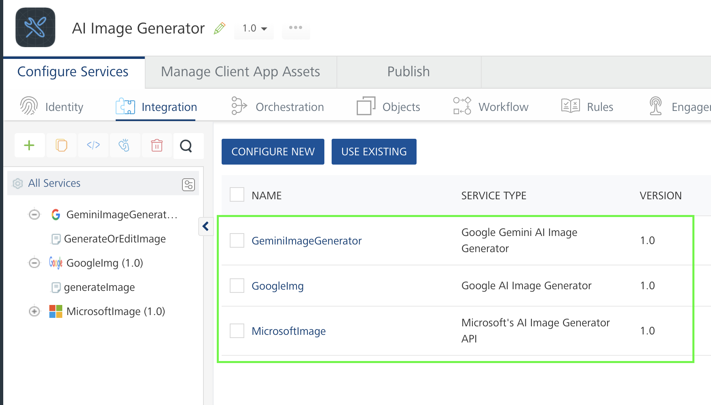
- i) Gemini Model Integration Service Configuration:
  - Click the GeminiImageGenerator Integration service. On the right pane, expand the GeminiImageGenerator service and then select the GenerateOrEditImage operation.
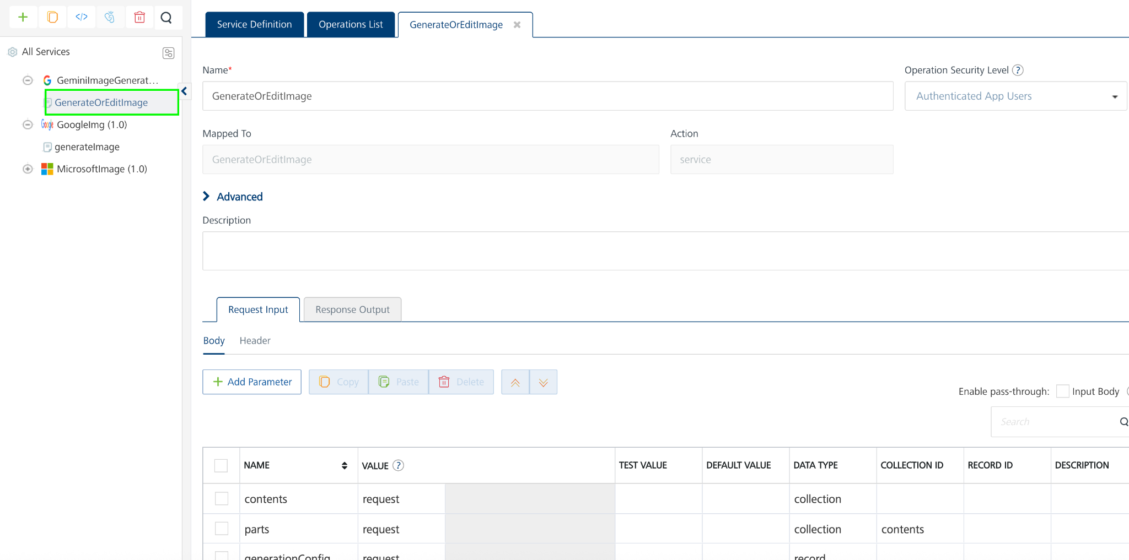
  - The GenerateOrEditImage tab opens with the Request Input sub-tab opened by default.
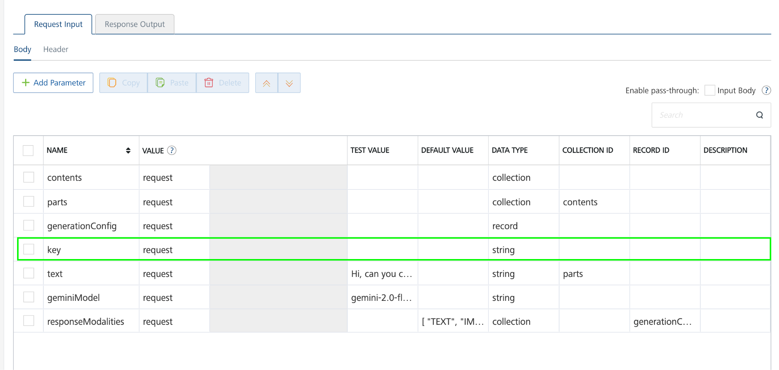
  - On the Request Input tab, in the Body section, for the following parameters, you can specify the values in the respective boxes under the Test Value columns.
NOTE: Add API Key generated from Get a Gemini API Key in Google AI Studio must be placed in the Default value column.
Mandatory Parameters
- Key [Required]: To use the Gemini API, you need an API key. You can create a key with a few clicks in Google AI Studio. Need to add in the Default value column.
- geminiModel [Required]: The name of the Model to use for generating the completion. The Gemini API offers different models that are optimized for specific use cases. Refer this https://ai.google.dev/gemini-api/docs/models/gemini#model-variations
Example model I have used here is: gemini-2.0-flash-preview-image-generation
- text [Required]: Represents the input prompt that the Gemini model will process to generate a response.
- generationConfig [Required]: Configuration options for model generation and outputs. Not all parameters are configurable for every model.
  - responseModalities[]enum (Modality): The requested modalities of the response. Represents the set of modalities that the model can return, and should be expected in the response. This is an exact match to the modalities of the response. A model may have multiple combinations of supported modalities. If the requested modalities do not match any of the supported combinations, an error will be returned. An empty list is equivalent to requesting only text.
For more information refer to this https://ai.google.dev/api/generate-content
Reference API Documentation: https://ai.google.dev/gemini-api/docs/image-generation#rest
  - Click SAVE OPERATION.
  - Click SAVE AND FETCH RESPONSE. The Output Result dialog appears with the response. Otherwise, the Output Result shows an error.
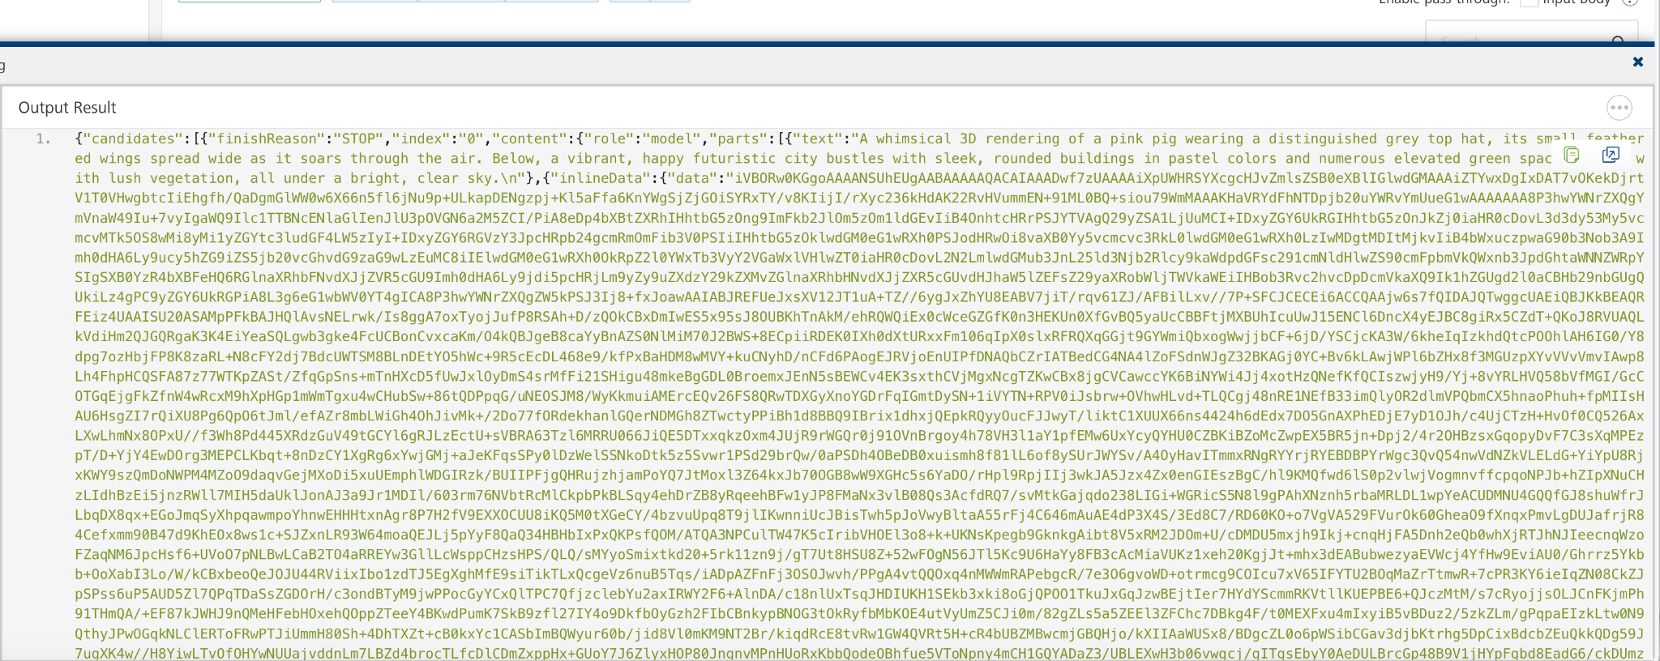
ii) Google Imagen 3 Model Integration Service Configuration:
- Click the GoogleTokenOrche Orchestration service. On the right pane, expand the GoogleTokenOrche service and then select the getToken operation.
- The getToken tab opens with the operation mapping opened by default. getAccToken service (Java connector service) is for getting Google OAuth 2.0 Access token and generateImage service is for generating images.
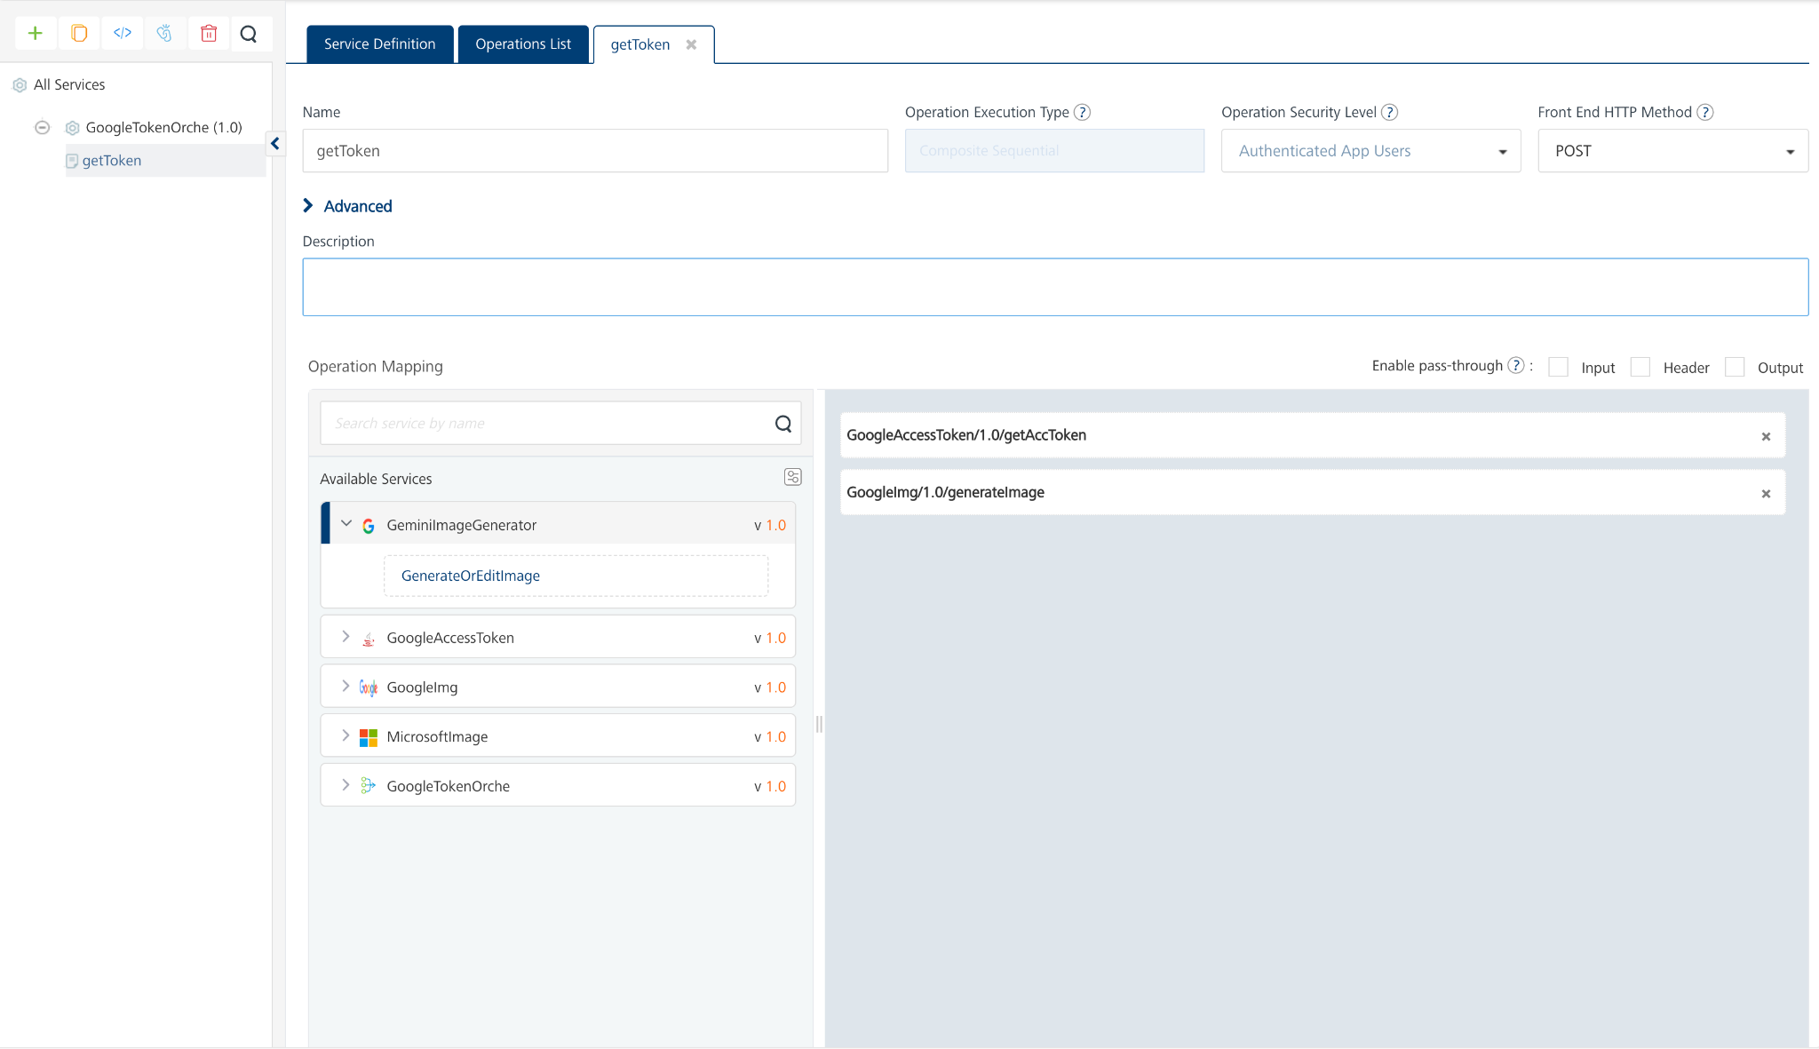
- Click on Save and fetch response.
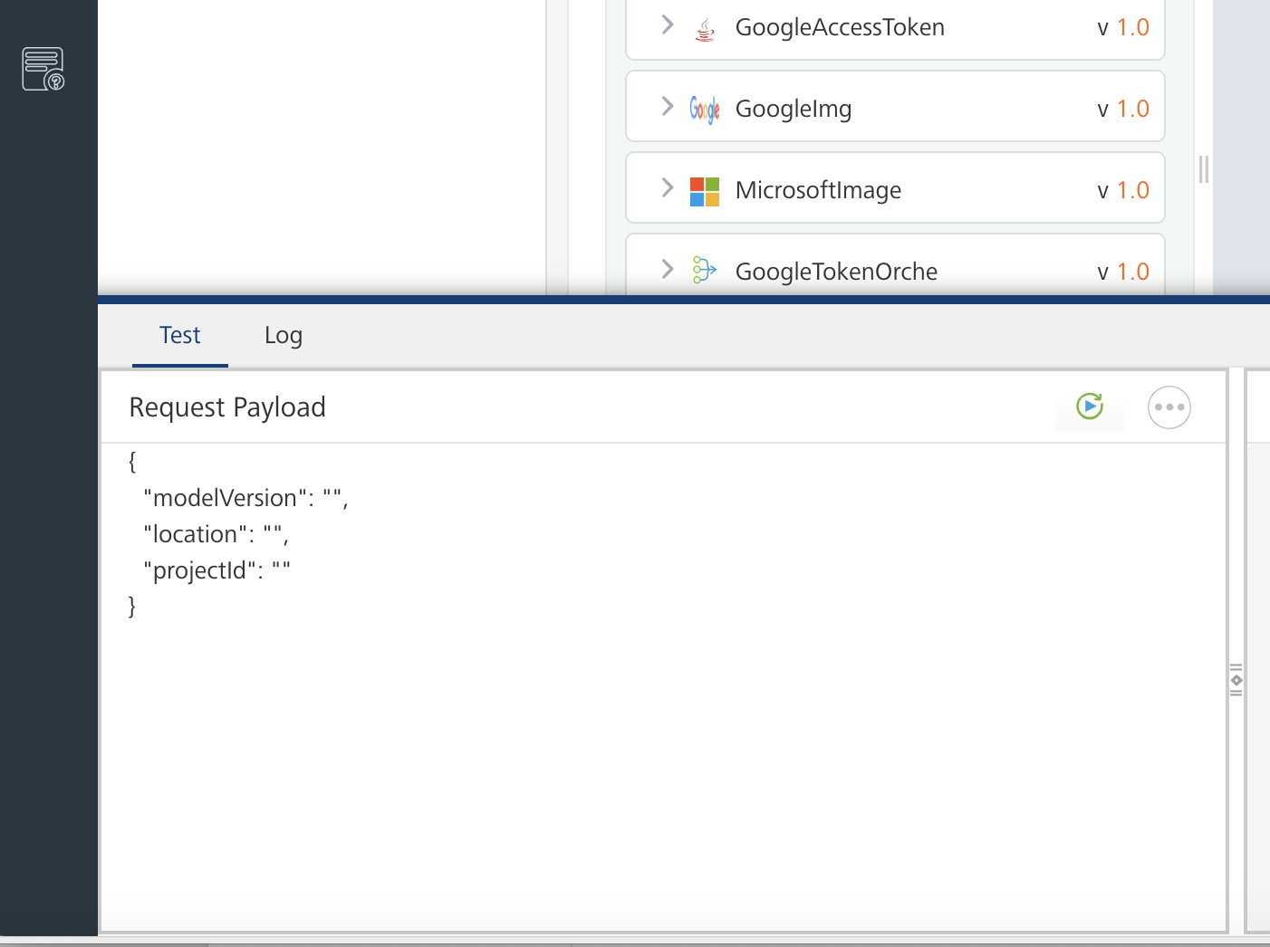
- A test tab will open by default. Enter the test data for example as shown below and click on the retest button.
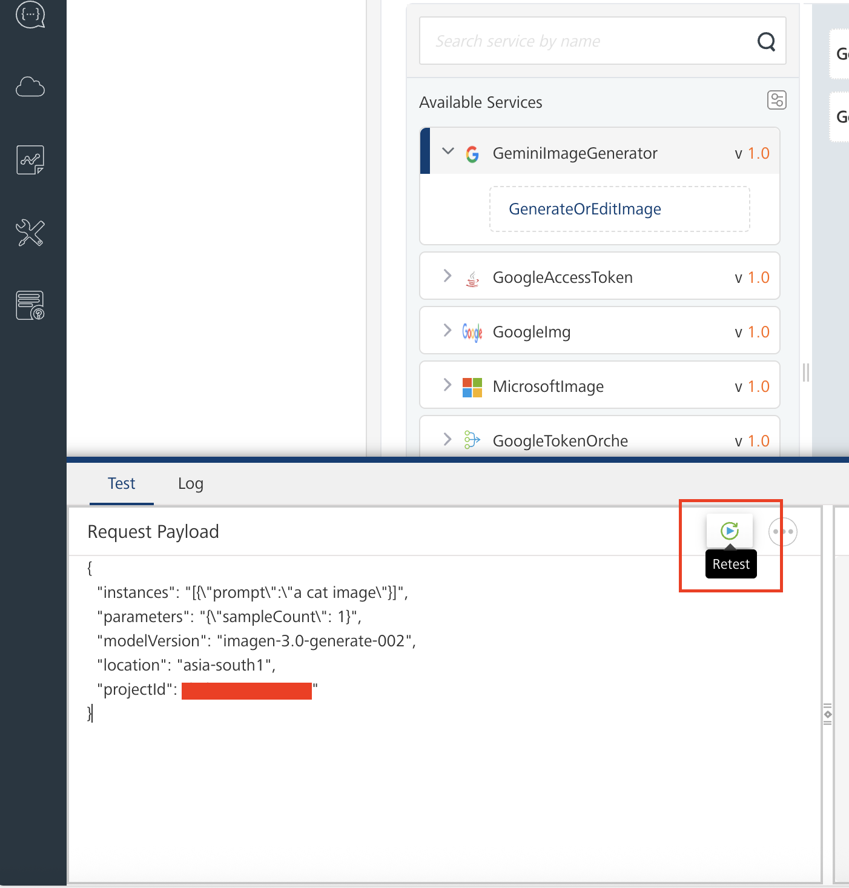
{
"instances": "[{\"prompt\":\"a cat image\"}]", //your text prompt
"parameters": "{\"sampleCount\": 1}", //given example 1
"modelVersion": "”, //Your Google Image model version",
"location": "", //Your location
"projectId": "" //Your location
}
- The Output Result dialog appears with the response. Otherwise, the Output Result shows an error.
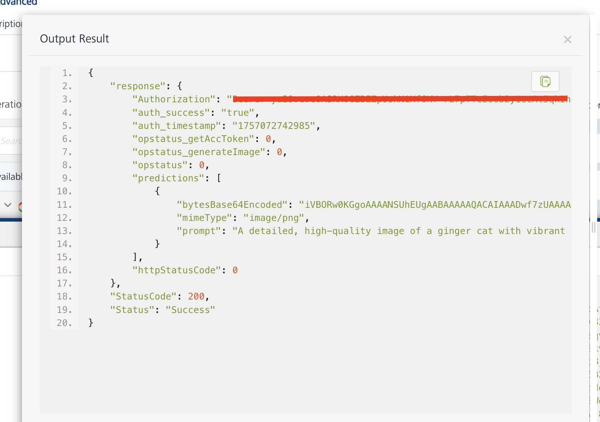
iii) Microsoft Dall-E 3 Model Integration Service Configuration:
- Click the MicrosoftImage Integration service. On the right pane, expand the generateImages service and then select the generateImages operation.
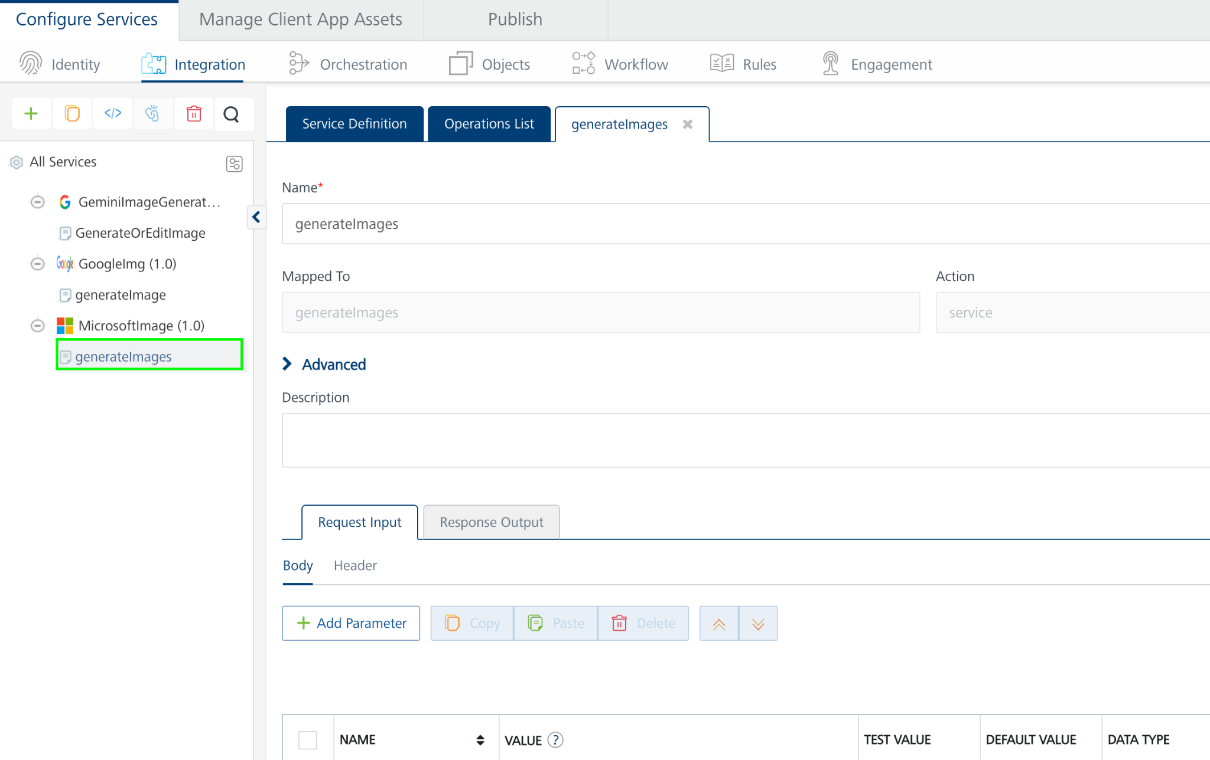
- The generateImages tab opens with the Request Input sub-tab opened by default.
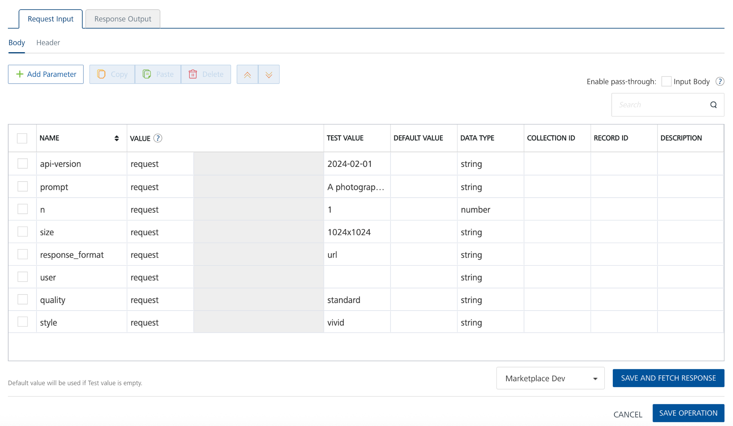
- On the Request Input tab, in the Body section, for the following parameters, specify the values in the respective boxes under the Test Value column.
Mandatory Parameters
- Prompt [Required]: A text description of the desired image(s). The maximum length is 4000 characters.
- Click Header sub-tab. The Header section opens.
- For api-key, In the box under the DEFAULT VALUE columns, type the API Key generated from Microsoft Azure OpenAI.
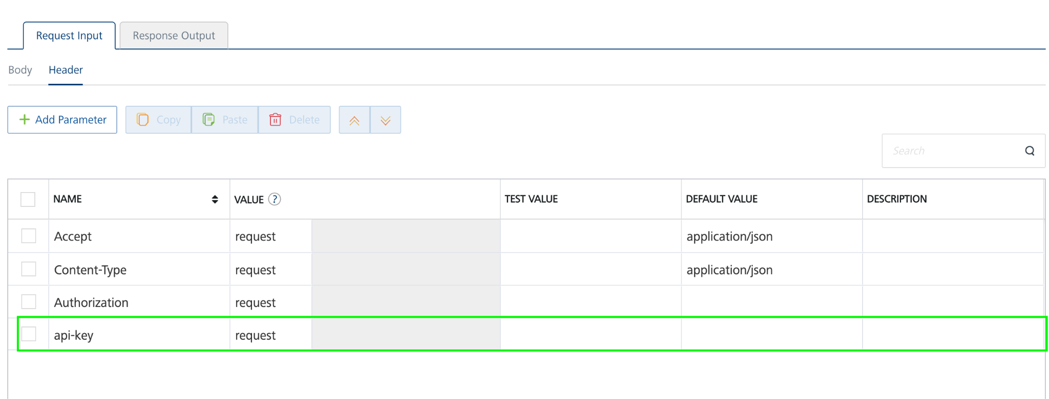
- Click SAVE OPERATION.
- Click SAVE AND FETCH RESPONSE. The Output Result dialog appears with the response. Otherwise, the Output Result shows an error.
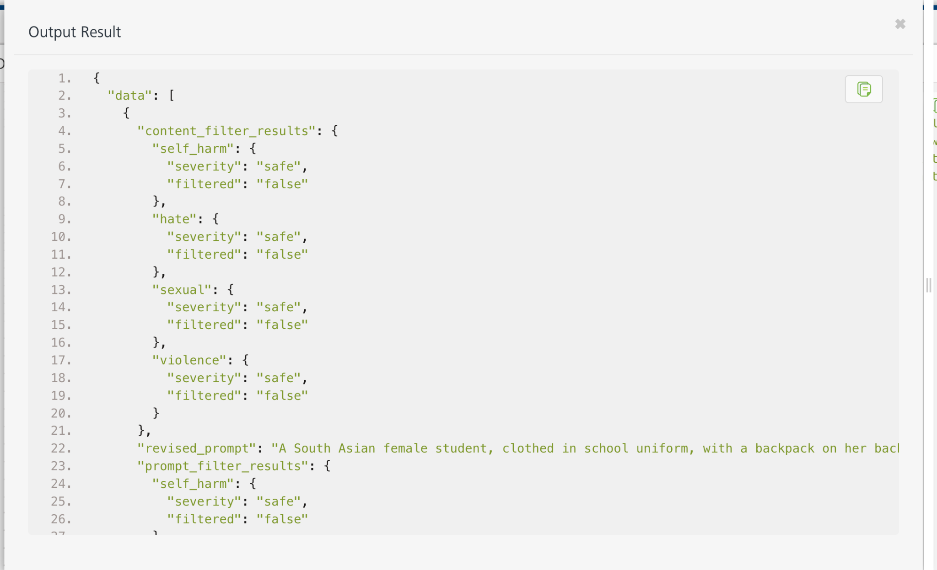
- Click the icon to go back to Volt MX Iris.

Publish the HCL Volt MX Foundry App
After you set the Operation Security Level, you must publish the HCL Volt MX Foundry app. To publish the HCL Volt MX Foundry, follow these steps:
In Volt MX Iris, click DATA & SERVICES, and then click Publish Project Services to Publish to your foundry app.
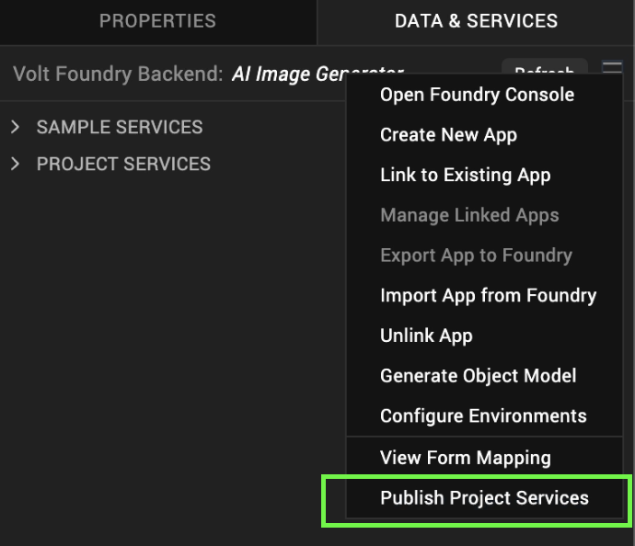

- Select the environment to which you want to publish your app, and then click Publish.
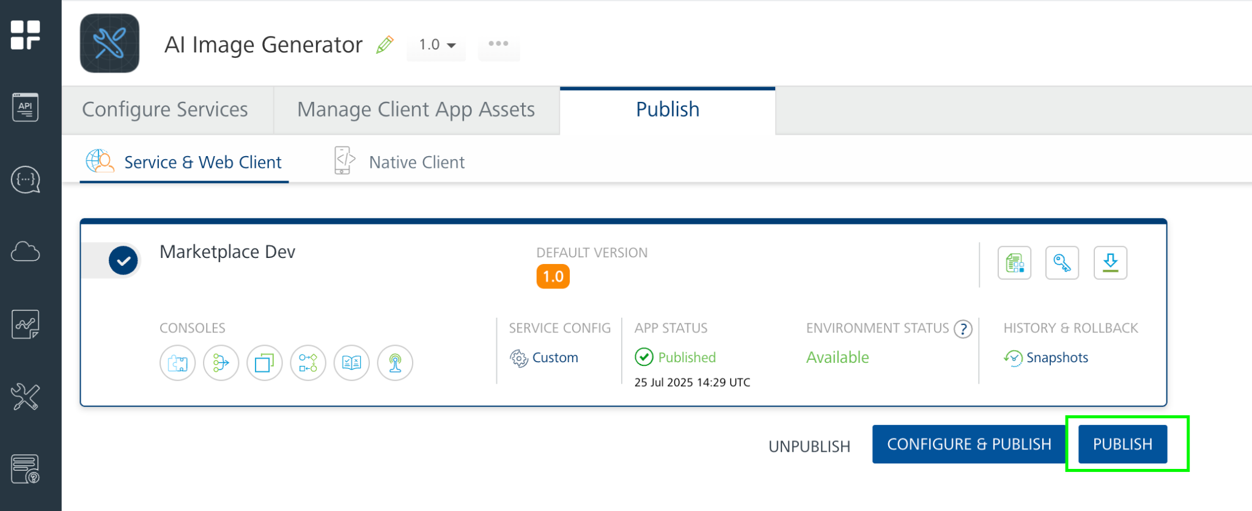
- After the app is published to your environment, the following window appears confirming the publish.
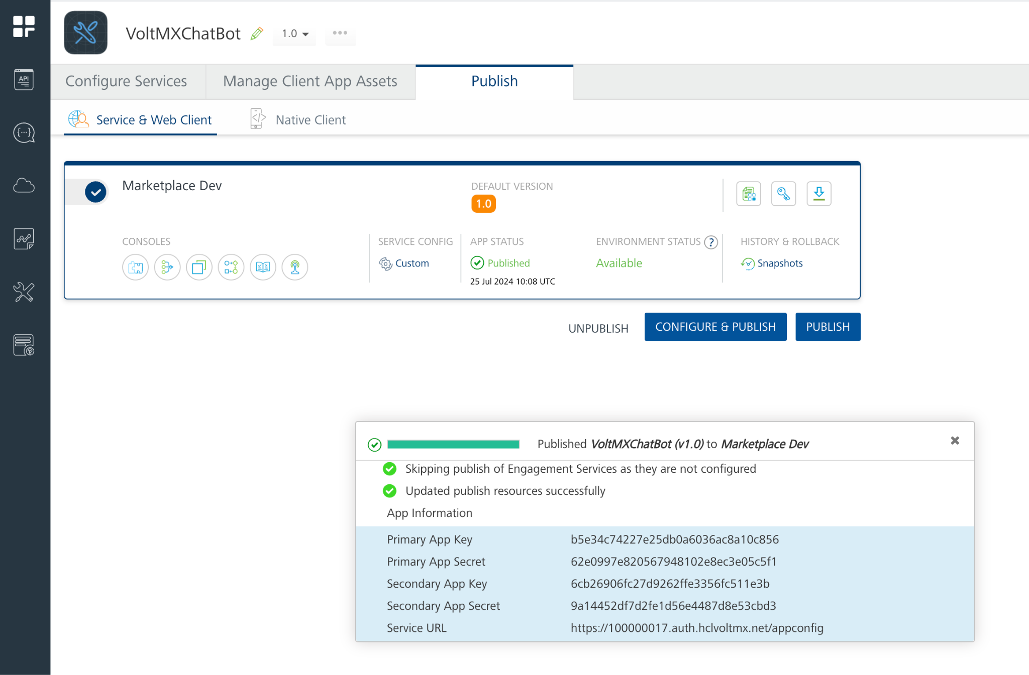

Building and previewing the app
After performing all the above steps, you can build your app and run it on your device. For more information, you can refer to the Building and Viewing an Application section of the Volt MX User Guide.
You can then run your app to see the Barcode/QR code Scanner work in real time.

REFERENCES

Dynamic Usage
You can also add an AI Image Generator Component component dynamically. To do so,

1. In the Project Explorer, on the Projects tab, click Controllers section to access the respective Form Controller. Create a method and implement the code snippet similar to the sample code mentioned below.

/* Creating AI Image Generator Component component instance */

createComponent: function()
{
/* Creating the component's object */
var imageGenerator = new com.voltmx.AIImageGenerator(
{
"clipBounds": true,
"height": "100%",
"id": "imageGenerator",
"isVisible": true,
"left": "0dp",
"top": "0dp",
"width": "100%",
"zIndex": 1
}, {}, {});
//General properties
imageGenerator.NumberOfImages = 1; //only applicable for Microsoft DALL-E 3 and Google Imagen 3
imageGenerator.AIService = "Microsoft DALL-E 3";
imageGenerator.TextInput = "The quick brown fox jumps over the lazy dog";
imageGenerator.TextPlaceholder = "Describe the image you want to create...";

//Google Imagen 3 Model property
imageGenerator.AspectRatio= "1:1";
imageGenerator.ProjectID = ""; //Provide Google ProjectID --> required
imageGenerator.Location = ""; //provide Location --> required

//Microsoft DALL-E 3 Model properties
imageGenerator.Style = "vivid";
imageGenerator.Size = "1024x1024";
imageGenerator.Quality = "standard";
this.view.add(imageGenerator);
}
In the code snippet, you can edit the properties of the component as per your requirement. For more information, see Setting Properties.
2. Save the file.

- Properties:

General Properties

- Text Input

Description: | Specifies a descriptive sentence or phrase that explains what image you want the AI to create.
Syntax: | TextInput
Type: | String
Read/Write: | Read + Write
Example: | this.view.imageGenerator.TextInput=”The quick brown fox jumps over the lazy dog”;
- Number Of Images

Description: | Specifies the number of images to generate.
Syntax: | NumberOfImages
Type: | Integer
Read/Write: | Read + Write
Example: | this.view.imageGenerator.NumberOfImages=1;
Remarks: | - Applicable to Microsoft Dall-e 3 and Google Imagen 3 models

- AI Service
Description: | Specifies the AI service to use.
Syntax: | AI Service
Type: | List Selector
Read/Write: | Read + Write
Example: | this.view.imageGenerator.AIService = "Microsoft DALL-E 3";
- PlaceHolder

Description: | Specifies the Text Input placeholder
Syntax: | TextPlaceHolder
Type: | String
Read/Write: | Read + Write
Example: | this.view.imageGenerator.TextPlaceholder = "Describe the image you want to create...";

Google Imagen 3 Model properties:

- Aspect Ratio
Description: | Specifies a generation mode parameter that controls aspect ratio
Syntax: | AspectRatio
Type: | List Selector
Read/Write: | Read + Write
Example: | this.view.imageGenerator.AspectRatio = "1:1";
- Google Project ID
Description: | Specifies our Google Cloud project ID. Required property.
Syntax: | ProjectID
Type: | String
Read/Write: | Read + Write
Example: | this.view.imageGenerator.ProjectID = "";

- Location
Description: | Specifies your project's region. For example, us-central1, europe-west2, or asia-northeast3. For a list of available regions, see Generative AI on Vertex AI locations. Required property.
Syntax: | Location
Type: | String
Read/Write: | Read + Write
Example: | this.view.imageGenerator.Location = "";

Microsoft Dall-E 3 Model properties:

- Style

Description: | Specifies a style of image. DALL-E 3 offers two style options: natural and vivid. The natural style is more similar to the default style of older models, while the vivid style generates more hyper-real and cinematic images.
Syntax: | Style
Type: | List Selector
Read/Write: | Read + Write
Example: | this.view.imageGenerator.Style = "vivid";

- Quality

Description: | Specifies a Quality of image. There are two options for image quality: hd and standard. The hd option creates images with finer details and greater consistency across the image. Standard images can be generated faster.
Syntax: | Quality
Type: | List Selector
Read/Write: | Read + Write
Example: | this.view.imageGenerator.Quality = "standard";

- Size

Description: | Specifies the size of the generated images. Must be one of 1024x1024, 1792x1024, or 1024x1792 for DALL-E 3 models. Square images are faster to generate.
Syntax: | Size
Type: | List Selector
Read/Write: | Read + Write
Example: | this.view.imageGenerator.Size = "1024x1024";

Skins:
- Generate Button Skin

Description: | Specifies the Generate Button Skin
Syntax: | GenerateButtonSkin
Type: | String
Read/Write: | Read + Write
Example: | this.view.imageGenerator.GenerateButtonSkin = "defBtnNormal0f294444ed36143";

- Generate Button Focus Skin

Description: | Specifies the Generate Button Focus Skin
Syntax: | GenerateButtonFocusSkin
Type: | String
Read/Write: | Read + Write
Example: | this.view.imageGenerator.GenerateButtonFocusSkin = "defBtnFocus0gd2d6bd670374e";

- Text Field Input Skin

Description: | Specifies the Text Field Input Skin
Syntax: | TextFieldInputSkin
Type: | String
Read/Write: | Read + Write
Example: | this.view.imageGenerator.TextFieldInputSkin = "defTextBoxNormal0";

- Text Field Input Focus Skin

Description: | Specifies the Text Field Input Focus Skin
Syntax: | TextFieldInputFocusSkin
Type: | String
Read/Write: | Read + Write
Example: | this.view.imageGenerator.TextFieldInputFocusSkin = "defTextBoxFocus0h";

APIs

– No APIs

Events

1. onSuccessImageGen

Description: | Invoked after the component generates the images. This onSuccessImageGen should be invoked in the onNavigate function.
Syntax: | onSuccessImageGen
Parameters: | results[JSON] : The generated images data
Remarks: | Need to invoke this event to get the generated images data
Example: | onNavigate: function() {  this.view.imageGenerator.onSuccessImageGen = function(results){  try{  if(results){  var nav = new voltmx.mvc.Navigation("frmResults");  nav.navigate(results);  }  else{  alert("No images generated");  }  }  catch(err){  alert("error= "+err);  }  };  }

Reference API documentations:
- Google Imagen 3 Model : https://cloud.google.com/vertex-ai/generative-ai/docs/image/generate-images#text-image-gen
- Microsoft Dall-E 3 Model: https://learn.microsoft.com/en-us/azure/ai-foundry/openai/how-to/dall-e?tabs=dalle-3
- Google Gemini 2.0 Flash Preview Image Generation Model: https://ai.google.dev/gemini-api/docs/image-generation#rest

REVISION HISTORY
Asset version 1.0.0:

Limitations
-N.A.-

B. Known Issue

-N.A.-

