Date : 20-Jan-25

AI/ML API

VERSION: 1.0.0

OVERVIEW
The AI/ML API provides a unified interface for accessing large language models and AI-powered capabilities such as text generation, conversational responses, content moderation, summarization, classification, and translation.
It enables applications to generate intelligent, context-aware outputs using simple REST-based requests.
The API supports flexible payload structures, configurable model selection, and fine-grained control over response behavior, making it suitable for enterprise-grade AI integrations. With support for chat-based interactions and task-oriented prompts, the AI/ML API helps build scalable, intelligent applications with minimal complexity.

Use case:
- Conversational AI & Virtual Assistants
Build intelligent chatbots capable of multi-turn conversations with contextual understanding.
- Content Generation & Writing Assistance
Generate articles, emails, documentation, product descriptions, and creative content efficiently.
- Content Moderation & Safety Filtering
Classify user input as safe or unsafe using guard models before processing or displaying content.
- Summarization & Information Extraction
Condense large documents, logs, or transcripts into concise, actionable insights.
- Translation & Multilingual Support
Translate text across multiple languages to support global applications.
- Enterprise Automation
Enable AI-driven workflows for internal tools, customer engagement, and productivity solutions.

Features:
- Unified AI Interface
Access multiple AI capabilities (chat, completion, moderation) through a single API structure.
- Dynamic Model Selection
Switch between text generation and safety models by changing the model parameter.
- Context-Aware Interactions
Supports multi-turn conversations using message-based inputs.
- Fine-Grained Response Control
Control creativity, randomness, and output length using parameters such as temperature, top_p, and max_tokens.
- Content Moderation Support
Built-in compatibility with guard models for real-time safety and policy enforcement.
- Structured JSON Responses
Consistent response format for easy parsing and UI rendering.
- Seamless Integration with Volt MX
Easily integrates through Volt MX Foundry adapters for secure, scalable enterprise applications.

GETTING STARTED

Prerequisites
Before you start using the AI/ML Adapter, ensure you have the following:

- HCL Foundry
- Volt MX Iris
- https://aimlapi.com/app/keys/
Reference document: AI/ML

B. Importing the AI/ML data adapter

You can import the AI/ML Data Adapter into HCL Foundry directly from the Volt MX Forge website or by importing the data adapter zip file.

To import Data Adapter to Volt Foundry, do the following:
- Sign in to the HCL Foundry.
- From the left navigation menu, select API Management.
- In API Management, select Custom Data Adapters.

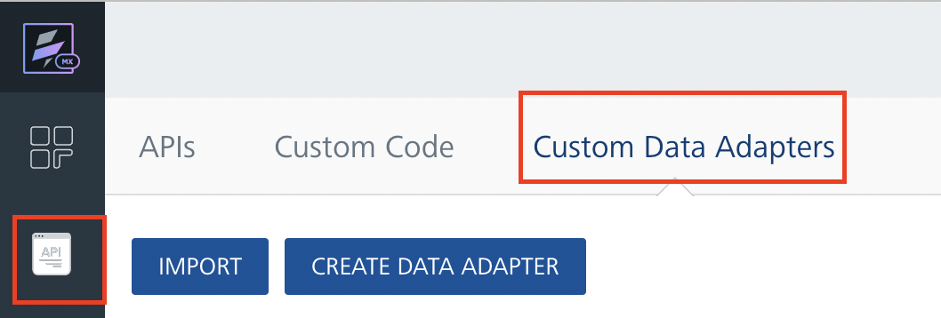
4. Click IMPORT to import a custom data adapter.
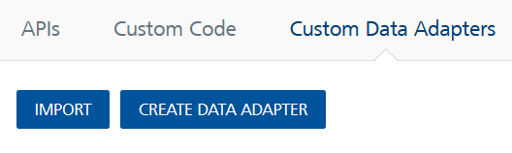
5. On the Import Data Adapter dialog box, click browser to import.

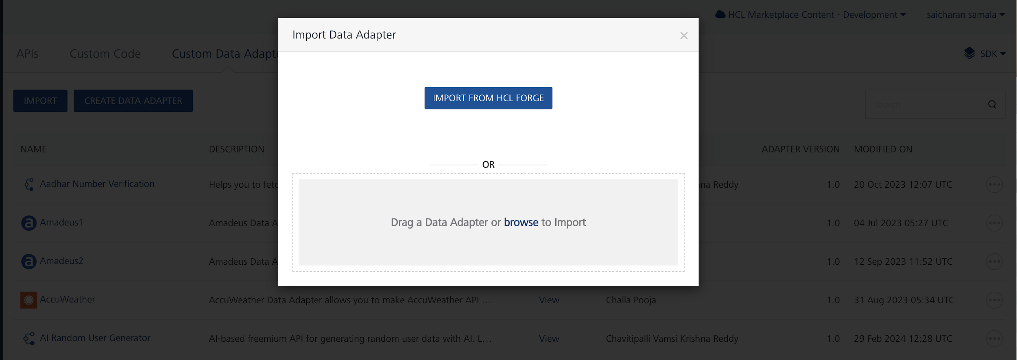

6. Click IMPORT FROM HCL FORGE. The Import Data Adapter from HCL Forge dialog appears with a list of available data adapters.
Click Import. AI/ML Data adapter is listed on the Custom Data Adapters page.
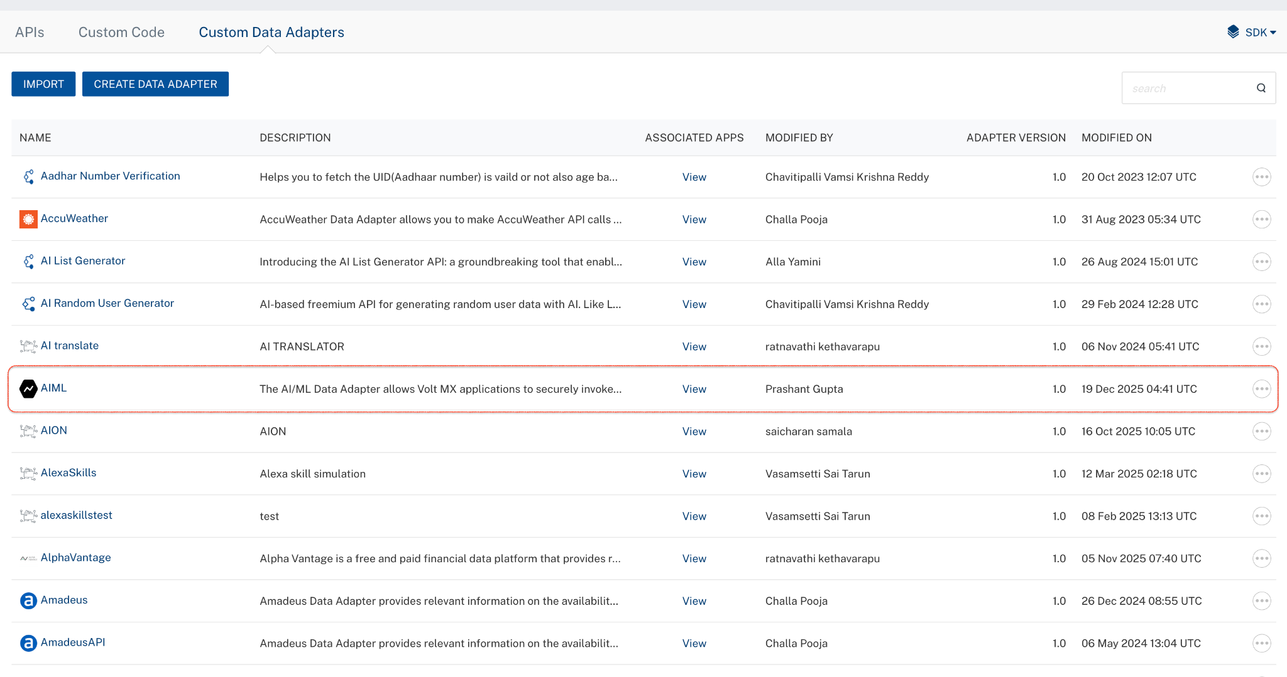
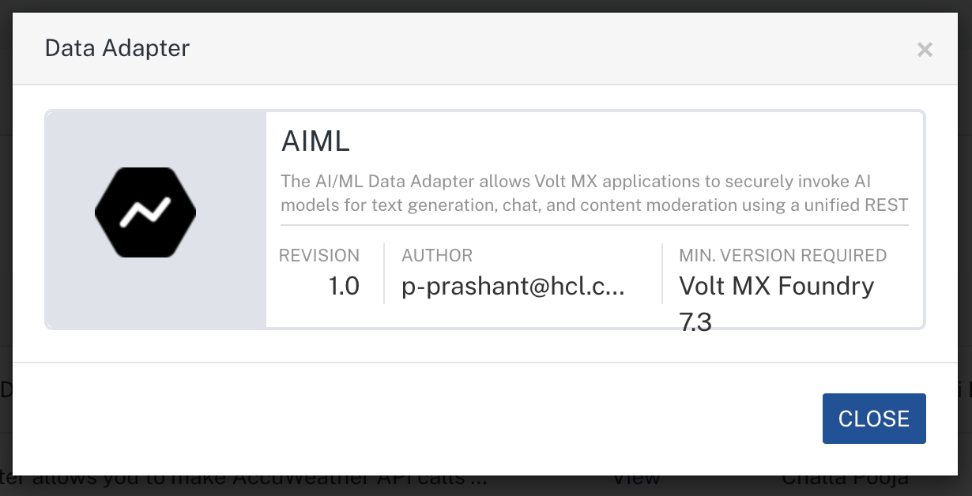
To import the data adapter zip file, do the following:
- Perform steps 1 to 4 in the above procedure
- Drag the data adapter zip file into the Drag a Data Adapter box.
Or
Click browse. The Open dialog appears.
Navigate to the location where you downloaded the data adapter (zip file) on your computer, select the data adapter, and click Open. The Import Data Adapter dialog shows the selected data adapter.
Note: Click Remove if the selected data adapter is not the one that you want to import.

C. Creating an Integration Service with AI/ML:
After you import AI/ML Data Adapter into Foundry, you must create an integration service with service type AI/ML.
To create an integration service with AI/ML, do the following:
- Log on to your HCL Foundry. The Dashboard page appears by default.
- In the left pane, click the API Management menu. The APIs tab opens by default.
- Click the Integration tab. The Integration tab opens with a list of existing integration services.
- Click CONFIGURE NEW. The Service Definition tab opens.
- In the Name box, type a unique name for your service.
- From the Service Type list,AI/ML.
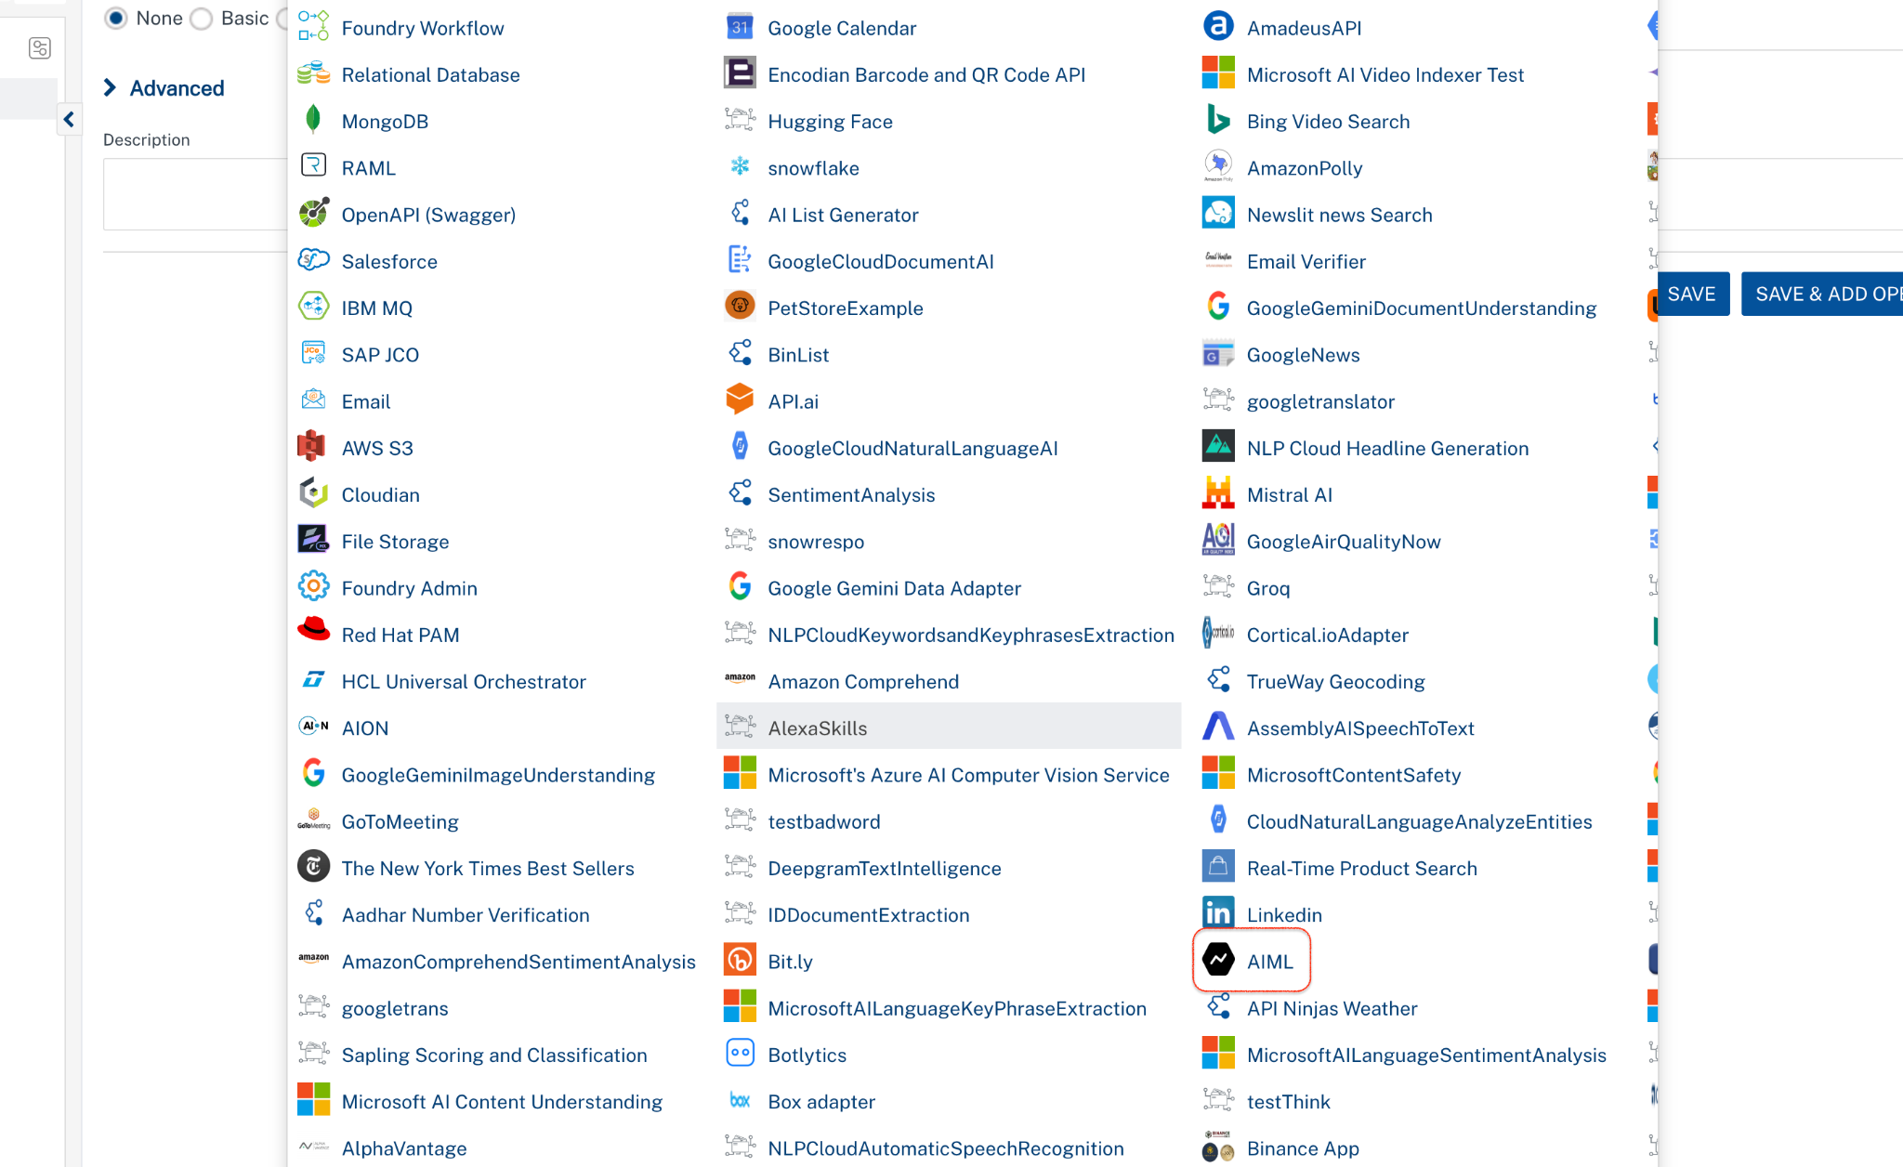
- Click Save

D. Creating an Operation
To make any API call in the HCL Foundry console, you must create an operation for the respective API and then execute the operation. Executing an operation involves making the API call and displaying the response.
This section provides steps to create an operation for the AI/ML.
Steps to create an operation for the AI/ML:
- Log on to your HCL Foundry. The Dashboard page appears by default.
- In the left pane, click the API Management menu. The APIs tab opens by default.
- Click the Integration tab. The Integration page appears with a list of existing integration services.
- From the list of integration services, select the integration service that you have created with service type as AI/ML. The Service Definition tab of the selected integration service opens by default.
- Click the Operations List tab. The Operations List tab opens.
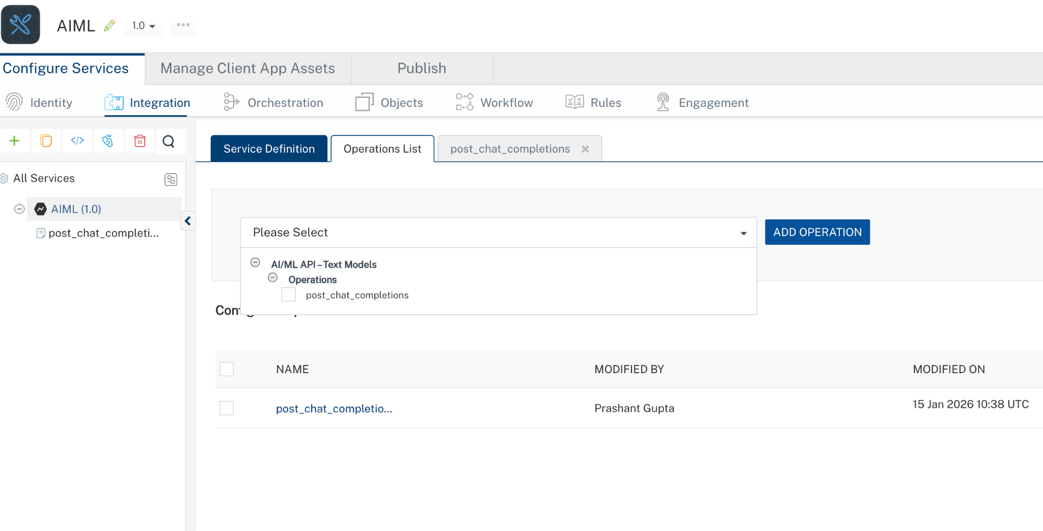
- Select post_chat_completions and Click Add Operations.
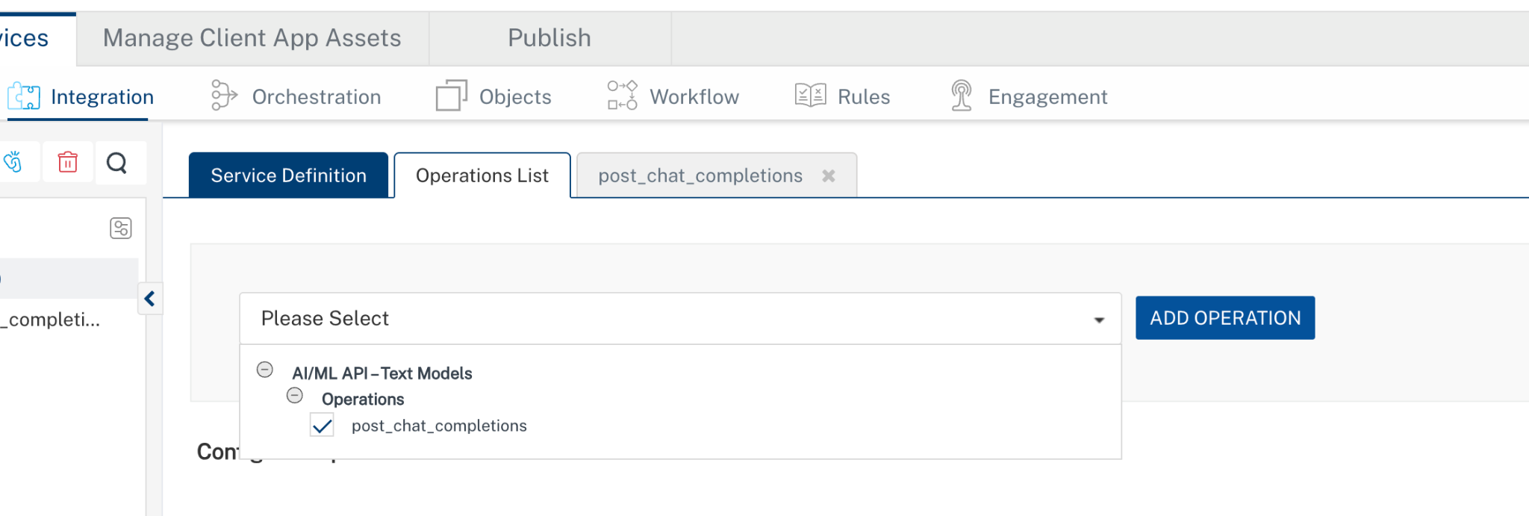

E. Executing Operation
Executing an operation involves making the API call by setting the necessary parameters and displaying the response. The procedure to execute any operation is the same, but the request parameters of the APIs vary. This section provides steps to execute the post_chat_completions(explained in Creating an Operation).
Steps to execute the post_chat_completions operation:
- Log on to your Hcl Foundry. The Dashboard page appears by default.
- In the left pane, click the API Management menu. The APIs tab opens by default.
- Click the Integration tab. The Integration tab opens with a list of existing integration services.
- From the list of integration services, select the integration service that you have created with service type AI/ML. The Service Definition tab of the selected integration service opens by default.
- Click the Operations List tab.
- In the Name box, the name of the operation is displayed by default. If you want, you can change the name.
- On the Request Input tab, in the Body section, for the following parameters, specify the values in the respective boxes under the Test Value column.
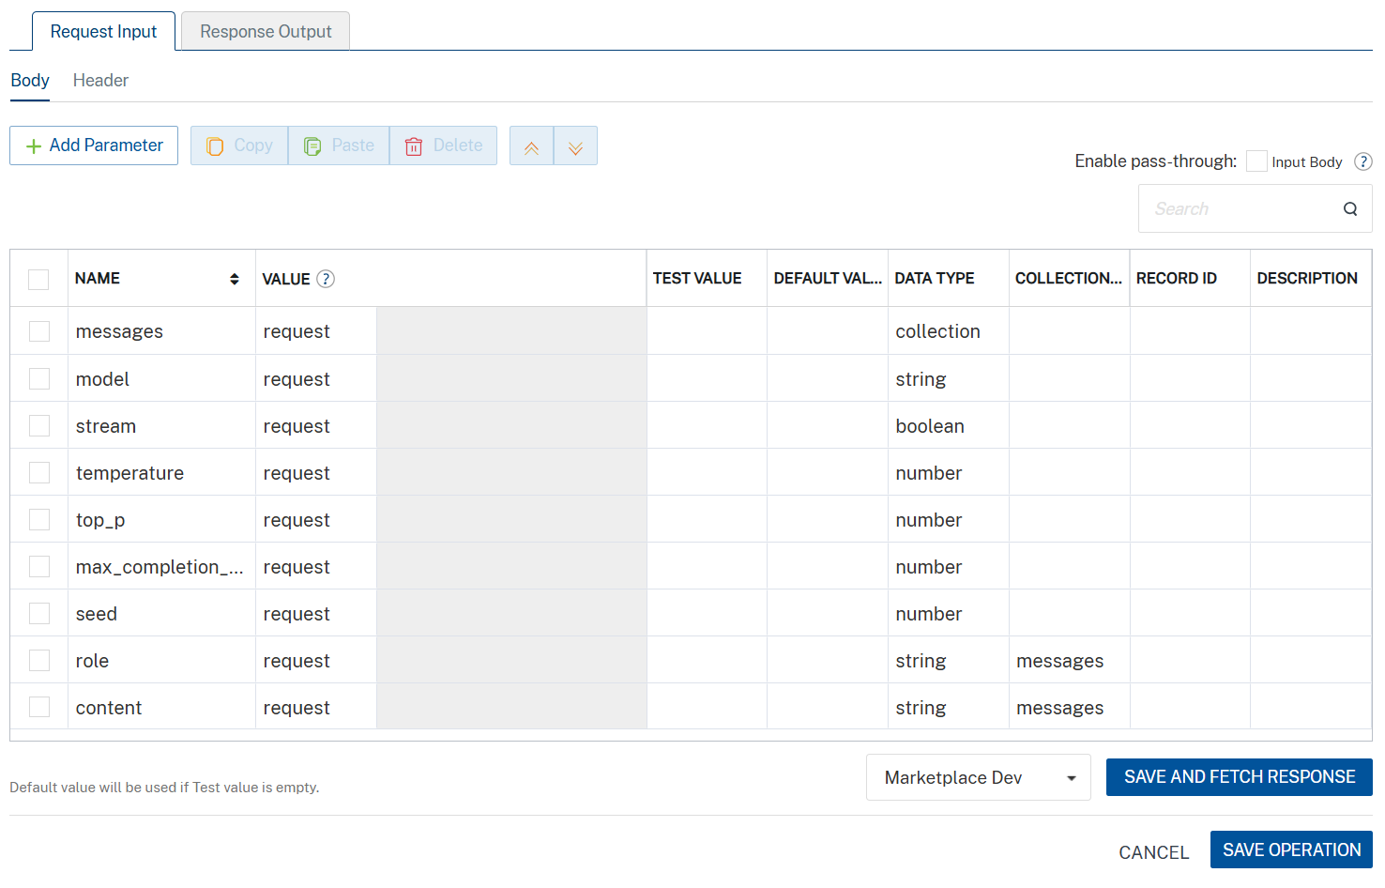
- Click SAVE AND FETCH RESPONSE. The Output Result dialog appears with the response. Otherwise, the Output Result shows an error.
. 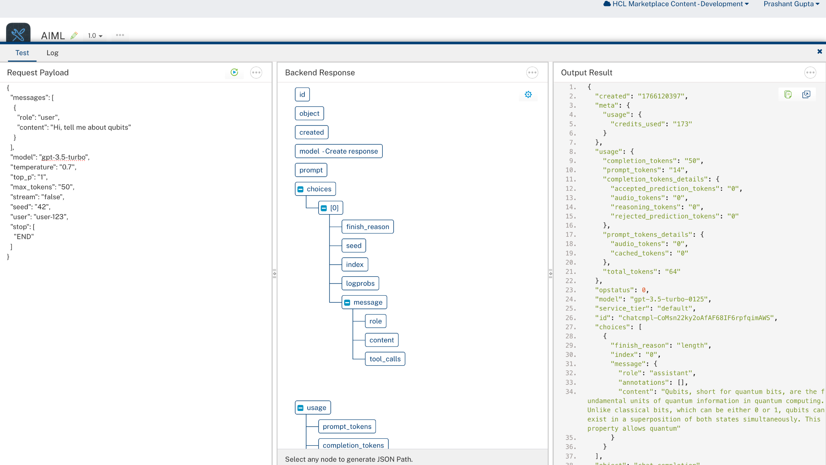

3. Publishing the App in VoltMX FOUNDRY:
After adding the AI/ML Data Adapter to your app and configuring the necessary configurations, you must publish the app to HCL Foundry. For more information, refer to Publish a foundry app.
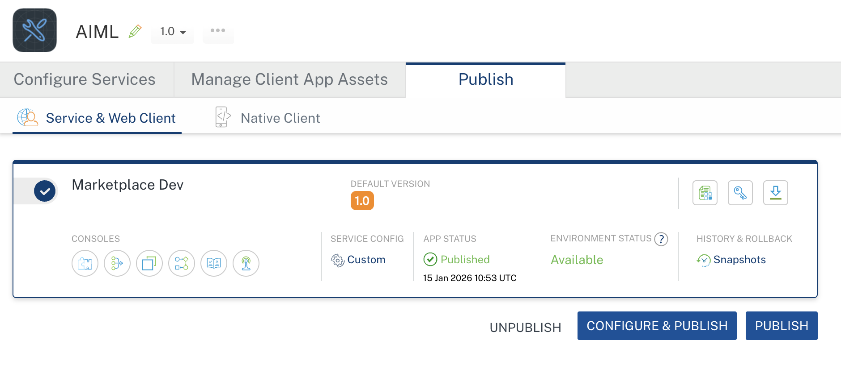

4. REFERENCES

Endpoint documentation
AI/ML

5. REVISION HISTORY
Adapter version 1.0.0:

Known Issues
None

Limitations
None

