Date : 21-Jan-25

AI/ML API APPLICATION

VERSION: 1.0.0

OVERVIEW
The AI/ML API provides a unified interface for accessing large language models and AI-powered capabilities such as text generation, conversational responses, content moderation, summarization, classification, and translation.
It enables applications to generate intelligent, context-aware outputs using simple REST-based requests.
The API supports flexible payload structures, configurable model selection, and fine-grained control over response behavior, making it suitable for enterprise-grade AI integrations. With support for chat-based interactions and task-oriented prompts, the AI/ML API helps build scalable, intelligent applications with minimal complexity.

Use case:
- Conversational AI & Virtual Assistants
Build intelligent chatbots capable of multi-turn conversations with contextual understanding.
- Content Generation & Writing Assistance
Generate articles, emails, documentation, product descriptions, and creative content efficiently.
- Content Moderation & Safety Filtering
Classify user input as safe or unsafe using guard models before processing or displaying content.
- Summarization & Information Extraction
Condense large documents, logs, or transcripts into concise, actionable insights.
- Translation & Multilingual Support
Translate text across multiple languages to support global applications.
- Enterprise Automation
Enable AI-driven workflows for internal tools, customer engagement, and productivity solutions.

Features:
- Unified AI Interface
Access multiple AI capabilities (chat, completion, moderation) through a single API structure.
- Dynamic Model Selection
Switch between text generation and safety models by changing the model parameter.
- Context-Aware Interactions
Supports multi-turn conversations using message-based inputs.
- Fine-Grained Response Control
Control creativity, randomness, and output length using parameters such as temperature, top_p, and max_tokens.
- Content Moderation Support
Built-in compatibility with guard models for real-time safety and policy enforcement.
- Structured JSON Responses
Consistent response format for easy parsing and UI rendering.

Percentage of re-use:
80%

GETTING STARTED

Prerequisites
Before you start using the AI/ML App, ensure you have the following:
- HCL Foundry
- Volt MX Iris
- https://aimlapi.com/app/keys/

Devices
- Mobile

Platforms
- Android
- IOS

Importing the App
To import the AI/ML App to Volt MX Iris, do the following:

To import the AI/ML App, do the following:
- Launch Volt MX Iris.
- Click project, and then select Import. The Import dialog box appears.
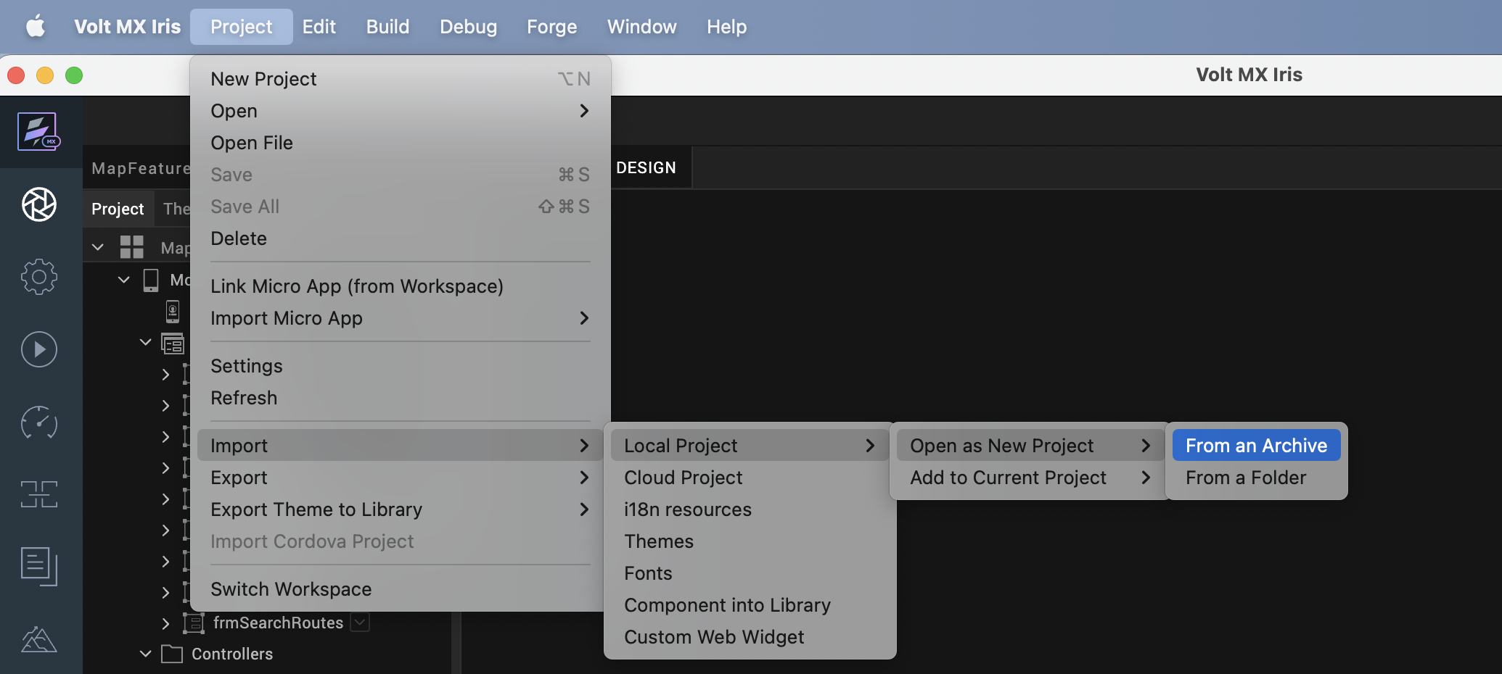

- Click From an Archive to navigate to the location of the project, select the files, and then click Import.
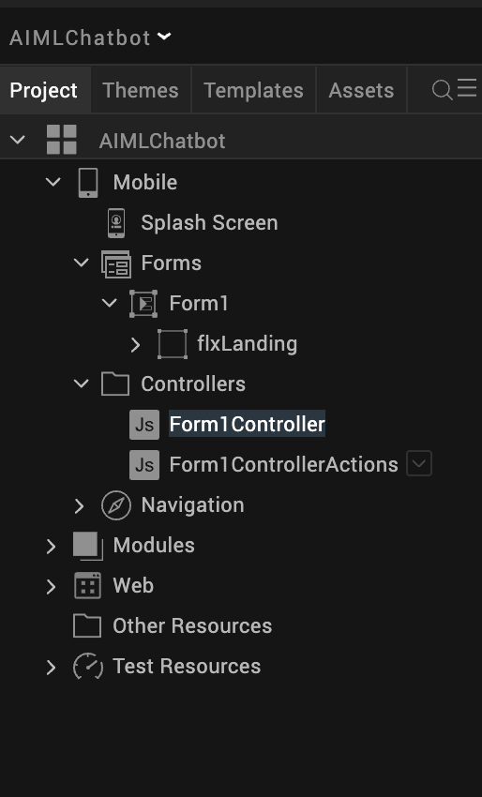
After you import the application, you can view the associated Foundry app connected at the in Data & Services section.
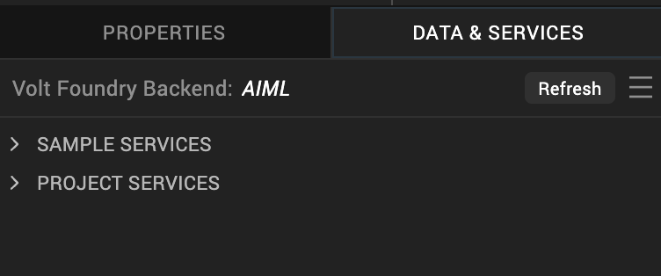

AI/ML Volt MX Foundry Services:
The AI/ML app contains an Integration Service:
AI/ML: The AI/ML API offers advanced text generation and completion capabilities, producing high-quality, contextually accurate text. It allows fine-grained control over style, tone, creativity, and structure using natural language instructions. AI/ML is optimized for interactive text generation—ideal for applications like content creation, chatbots, summarization, and educational materials.
Operations
Post_chat_completions
This operation invokes foundation models hosted on AI/ML Inference to generate AI responses for tasks such as text generation, summarization, and conversational AI.
Inputs include:
- prompt / messages – User input or conversation history
- model – Selected AI/ML-supported model
- temperature – Controls randomness of the output
- top_p – Controls nucleus sampling
- max_tokens – Maximum number of tokens to generate
- stop sequences (optional) – Tokens that stop generation
The operation processes the input using the selected AI/ML model and returns a generated response optimized for speed and scalability.

Building the app
From the menu bar, go to Build and then select Build Native Local.
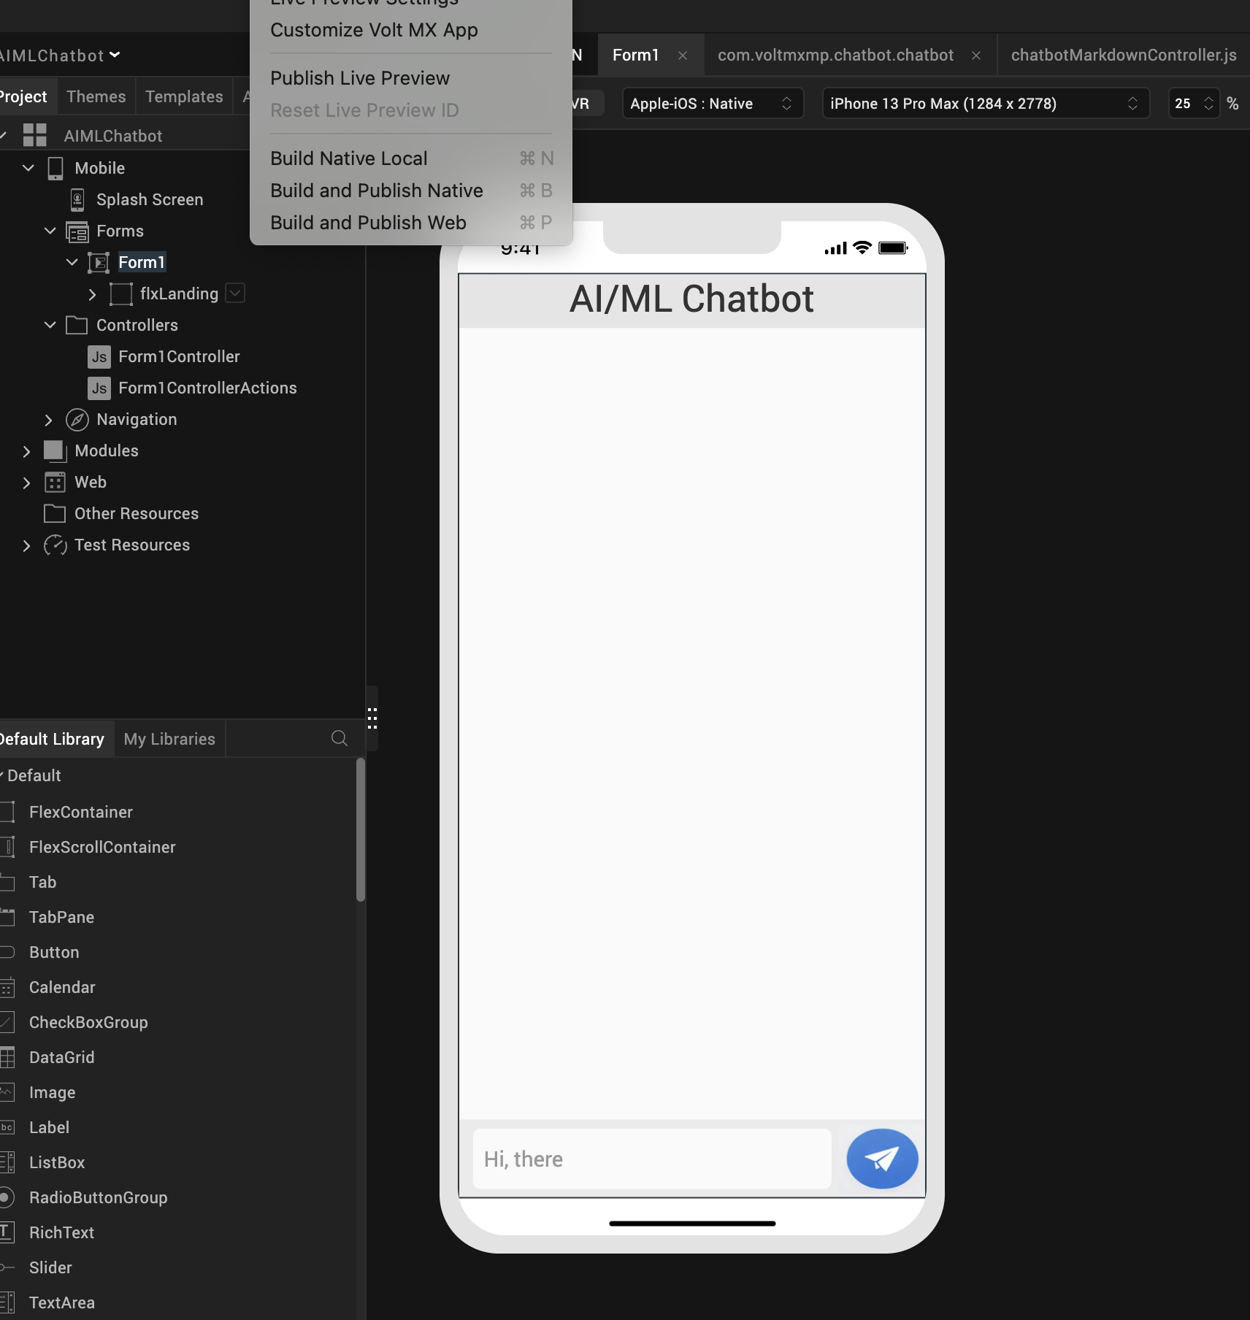

For Mobile, select Android and iOS. Click Build.
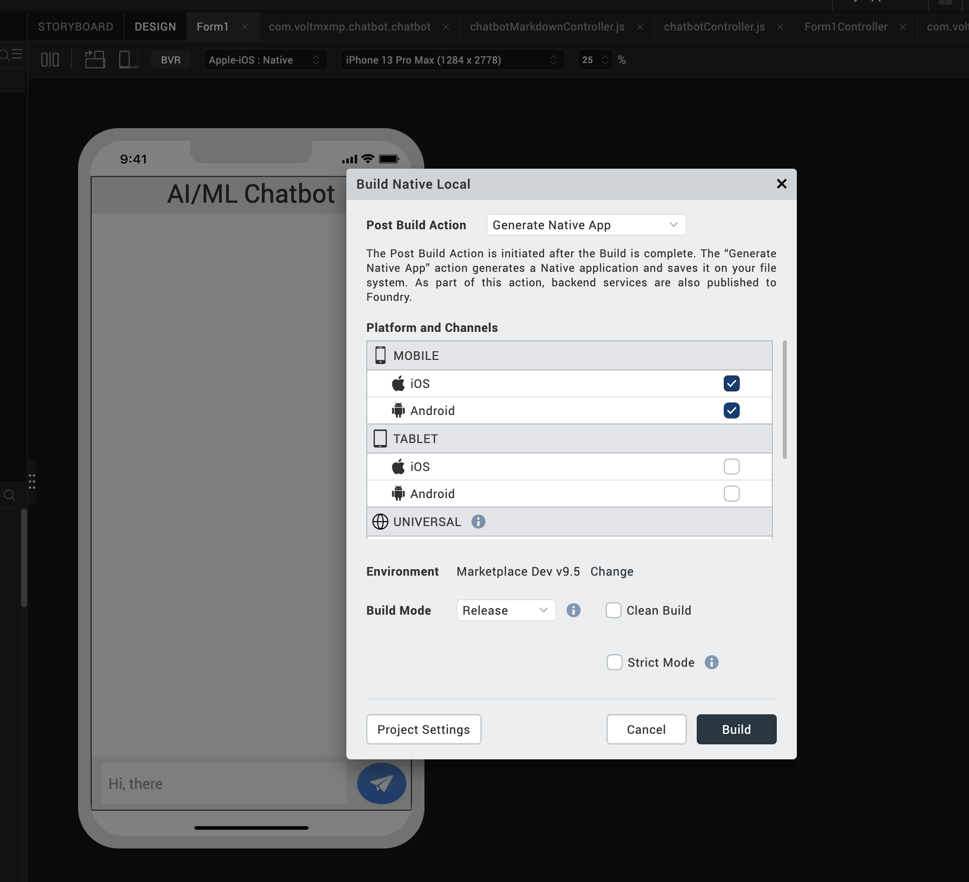

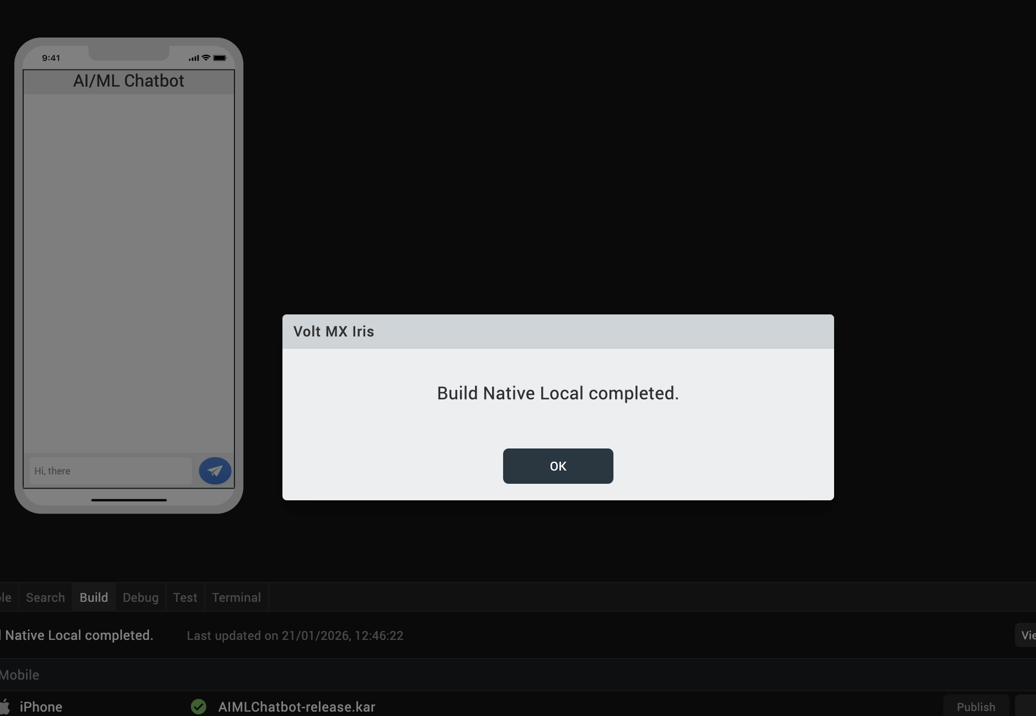

After the build is successful, run the app on your mobile device.

REVISION HISTORY
App version 1.0.0:

A. Limitations
1. Do not have support for Landscape mode.

B. Known Issue
- NA

