Date :  26-02-2024

ai & plagiarism checker version: 1.0.0

# **Overview**

Unlock the power of originality with our AI & Plagiarism Checker API. Seamlessly integrate our cutting-edge technology into your applications to scan and verify content for authenticity, ensuring academic integrity and content uniqueness with ease.

Introducing the cutting-edge AI & Plagiarism Checker API, a revolutionary tool that is set to redefine the way we approach content originality and integrity in the digital age. This powerful and versatile API is a game-changer for individuals, businesses, educators, and content creators, offering an unprecedented level of sophistication in detecting and preventing plagiarism.

In a world where information is readily accessible and content creation is at an all-time high, the need to maintain the authenticity and uniqueness of your work has never been more critical. The AI & Plagiarism Checker API emerges as the ultimate solution, empowering you with the ability to safeguard your intellectual property, maintain academic integrity, and ensure the credibility of your content.

**Use case:**

At its core, this API is a manifestation of advanced artificial intelligence and natural language processing technologies. Its ability to scan vast repositories of text and identify instances of copied or unoriginal content is nothing short of remarkable. With lightning-fast processing speeds and unparalleled accuracy, it provides a seamless and comprehensive solution for content creators to assess the originality of their work with unmatched precision.

The AI & Plagiarism Checker API operates on the forefront of AI, constantly evolving and improving to stay ahead of the ever-adaptive tactics employed by plagiarists. Its machine learning algorithms are trained on an extensive corpus of text, enabling it to detect even the subtlest forms of plagiarism, whether it be through paraphrasing, paraphrased quotations, or the use of synonyms to disguise stolen content.

But this API isn’t just about catching plagiarists; it’s also a tool for fostering a culture of originality and academic integrity. Educators can leverage its capabilities to efficiently evaluate student submissions, ensuring that learning institutions maintain a fair and honest environment for all. Moreover, businesses can use it to maintain the integrity of their brand by ensuring that their online content is both unique and authentic.

The API seamlessly integrates into your existing systems and applications, offering a hassle-free experience for developers and users alike. Its user-friendly interface and clear, detailed reporting make it accessible to individuals with varying levels of technical expertise, democratizing access to the power of plagiarism detection.

In a world where information is the currency of the digital age, the AI & Plagiarism Checker API is your trusted sentinel, guarding the gates of authenticity and originality. It represents a pioneering leap forward in the fight against plagiarism and an indispensable tool for those who value the integrity of their work, their brands, and their institutions. With this API, the future of content originality is at your fingertips, ushering in a new era where authenticity is paramount.

# **Getting Started**

## **Prerequisites**

* Volt Foundry
* [**Rapid API Account**](https://rapidapi.com/firdavscoder1/api/ai-plagiarism-checker)
* X-RapidAPI-Key, X-RapidAPI-Host.

## **Importing the adapter**

**To import the Data Adapter to Volt Foundry, do the following:**

1. Sign in to the  [HCL Foundry](https://manage.hclvoltmx.com/).
2. From the left navigation menu, select **API Management**.
3. In **API Management**, select **Custom Data Adapters**.  
   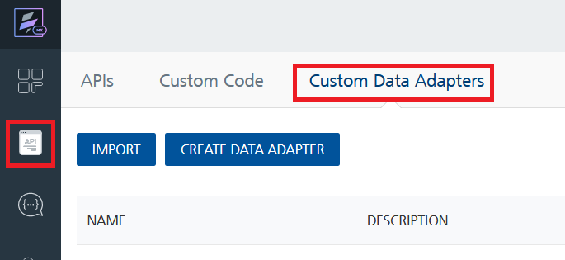
4. Click **IMPORT** to import a custom data adapter.  
   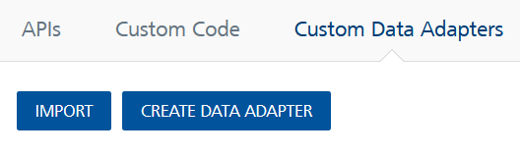
5. On the Import Data Adapter dialog box, click browser to import.  
   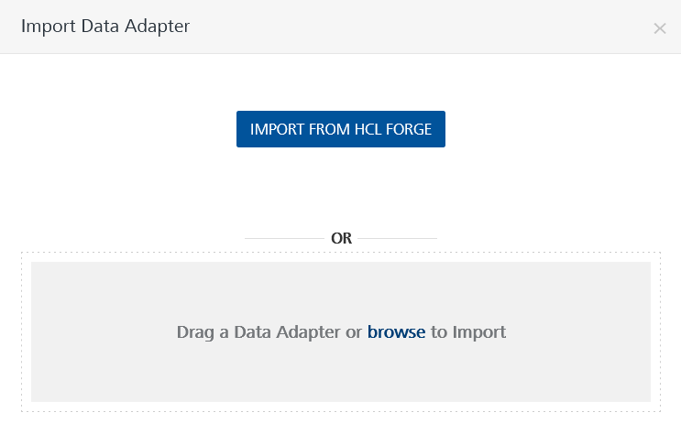
6. Select **AI & Plagiarism checker zip** file and click **IMPORT**.

After you import the data adapter, Volt Foundry opens a window that shows the metadata of the data adapter.

After you import the data adapter, you can view it on the Custom Data Adapters page and use it to create services on Volt Foundry.

## **Creating an Integration service**

After you import the data adapter into Volt Foundry, you can use it to create an Integration Service.

Follow the given steps to create an Integration service using the **AI & Plagiarism checker** Adapter.

1. Sign in to the [HCL Foundry](https://manage.hclvoltmx.com/).
2. From the left navigation menu, select **API Management**.
3. In **API Management**, select **Integration**.

1. To create a new service, click the **+** button or the **CONFIGURE NEW** button.

1. On the Service Definition tab, select the service type as**AI & Plagiarism checker,** and click **SAVE**.

Alternatively, you can also create a Foundry app and create an Integration service inside it.

## **Creating and Executing operations**

After you create an integration service, you can create and execute operations using the service.

#### **Creating an Operation**

* In **API Management/Foundry app you created**, in the **Integration** section, select the service that you created.
* After you select the service, navigate to the **Operation List** tab.  
  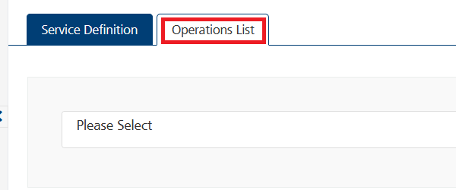
* From the drop-down list, select an operation that you want to execute, and click **ADD OPERATION**.

#### **Executing an Operation**

* From the **Operations List** tab, in the **Configured Operations** section, select the operation you want to execute.

* On the Operation Page, in the **Request Input** tab, in the **Body** section, for the following parameters, specify the values in the respective boxes under the **Test Value** column.

**Mandatory Parameters**

* + **X-RapidAPI-Key, X-RapidAPI-Host [in header]:**  API Key associated with your RapidAPI account, required for authentication.

To get keys – Login in to [**Rapid API Account**](https://rapidapi.com/firdavscoder1/api/ai-plagiarism-checker)-> You can view your keys.

* + **content:** The text content to be checked for plagiarism.

* Select a run-time environment and click **Save and Fetch Response** to get a response based on your inputs.

## **Publishing your application**

If you want to use the services in client applications, you need to publish an app to a run-time environment. You can create the service (as described above) in an application or import the service into an application and publish the application.

# **References**

## Endpoint Documentation

## **Requests Input Parameters**

|  |  |
| --- | --- |
| **Parameter** | **Description** |
| X-RapidAPI-Key(string) | **[Required]** **[Header]**API Key associated with your account. |
| X-RapidAPI-Host (string) | **[Required]** **[Header]** The host parameter specifies the domain name or IP address of the RapidAPI endpoint. In the context of the AI & Plagiarism Checker, the default host is set to 'ai-plagiarism-checker.p.rapidapi.com'. This parameter is necessary for routing the request to the appropriate API endpoint. |
| content (string) | **[Required]** The text content to be checked for plagiarism. |

### **Response Output Parameters**

|  |  |  |
| --- | --- | --- |
| **Object Property** | **Data Type** | **Description** |
| ai_percentage | Integer | The percentage indicating the likelihood that the content is generated by AI. |
| average_score | Float | The average score assigned to the content, representing its overall quality or relevance. |
| content_label | String | The label describing the content, indicating it is "Likely AI" or “Likely human” |
| gptzero_me_label | String | The label assigned to the content, suggesting it is related to AI ("ai" in this instance). |
| sentence_scores | Array | An array containing arrays representing each sentence along with its corresponding score. |
| sentence_scores - sentence | String | The actual sentence or content snippet. |
| sentence_scores - score | Float | The score assigned to the sentence, indicating its quality or relevance within the context of the content. |

**Reference Document:**  [[AI & Plagiarism Checker API Documentation (firdavscoder1) | RapidAPI](https://rapidapi.com/firdavscoder1/api/ai-plagiarism-checker)](https://rapidapi.com/rahilkhan224/api/vehicle-rc-verification-india)

# **Revision History**

Adapter version 1.0.0:

## **Known Issues**

* No Known Issues

## **Limitations**

* No limitations