Date :  01-03-2024

ai TEXtraction

version: 1.0.0

# **Overview**

A powerful AI-powered text parser that extracts custom user-defined entities from unstructured text.

It can extract exact values (examples: prices, dates, names, emails, phone numbers), semantic answers (examples: main topic, diagnosis, customer’s request), and it is pretty much limited by the imagination.

# **Getting Started**

## **Prerequisites**

* Volt Foundry
* [**Rapid API Account**](https://rapidapi.com/TextractionAI/api/ai-textraction/)
* X-RapidAPI-Key, X-RapidAPI-Host.

## **Importing the adapter**

**To import the Data Adapter to Volt Foundry, do the following:**

1. Sign in to the  [HCL Foundry](https://manage.hclvoltmx.com/).
2. From the left navigation menu, select **API Management**.
3. In **API Management**, select **Custom Data Adapters**.  
   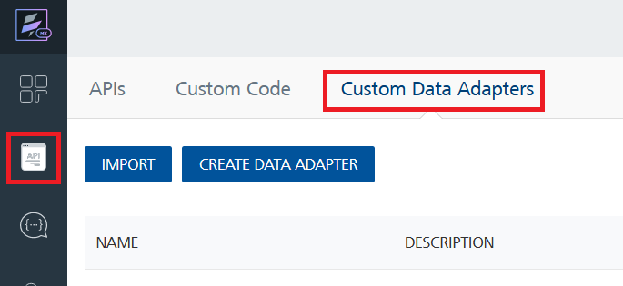
4. Click **IMPORT** to import a custom data adapter.  
   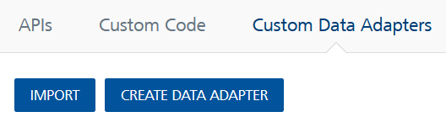
5. On the Import Data Adapter dialog box, click browser to import.  
   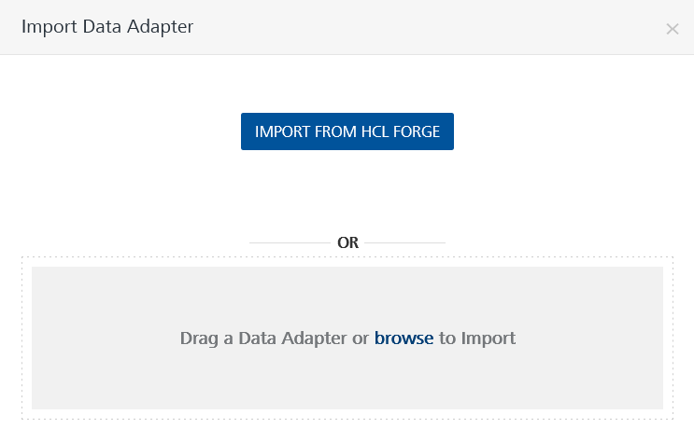
6. Select **AI Textraction zip** file and click **IMPORT**.

After you import the data adapter, Volt Foundry opens a window that shows the metadata of the data adapter.

After you import the data adapter, you can view it on the Custom Data Adapters page and use it to create services on Volt Foundry.

## **Creating an Integration service**

After you import the data adapter into Volt Foundry, you can use it to create an Integration Service.

Follow the given steps to create an Integration service using the **AI Textraction** Adapter.

1. Sign in to the [HCL Foundry](https://manage.hclvoltmx.com/).
2. From the left navigation menu, select **API Management**.
3. In **API Management**, select **Integration**.

1. To create a new service, click the **+** button or the **CONFIGURE NEW** button.

1. On the Service Definition tab, select the service type as**AI Textraction,** and click **SAVE**.

Alternatively, you can also create a Foundry app and create an Integration service inside it.

## **Creating and Executing operations**

After you create an integration service, you can create and execute operations using the service.

#### **Creating an Operation**

* In **API Management/Foundry app you created**, in the **Integration** section, select the service that you created.
* After you select the service, navigate to the **Operation List** tab.  
  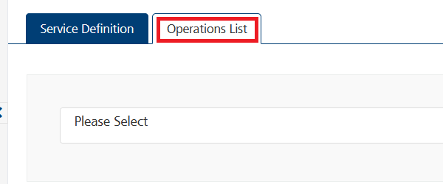
* From the drop-down list, select an operation that you want to execute, and click **ADD OPERATION**.

#### **Executing an Operation**

* From the **Operations List** tab, in the **Configured Operations** section, select the operation you want to execute.

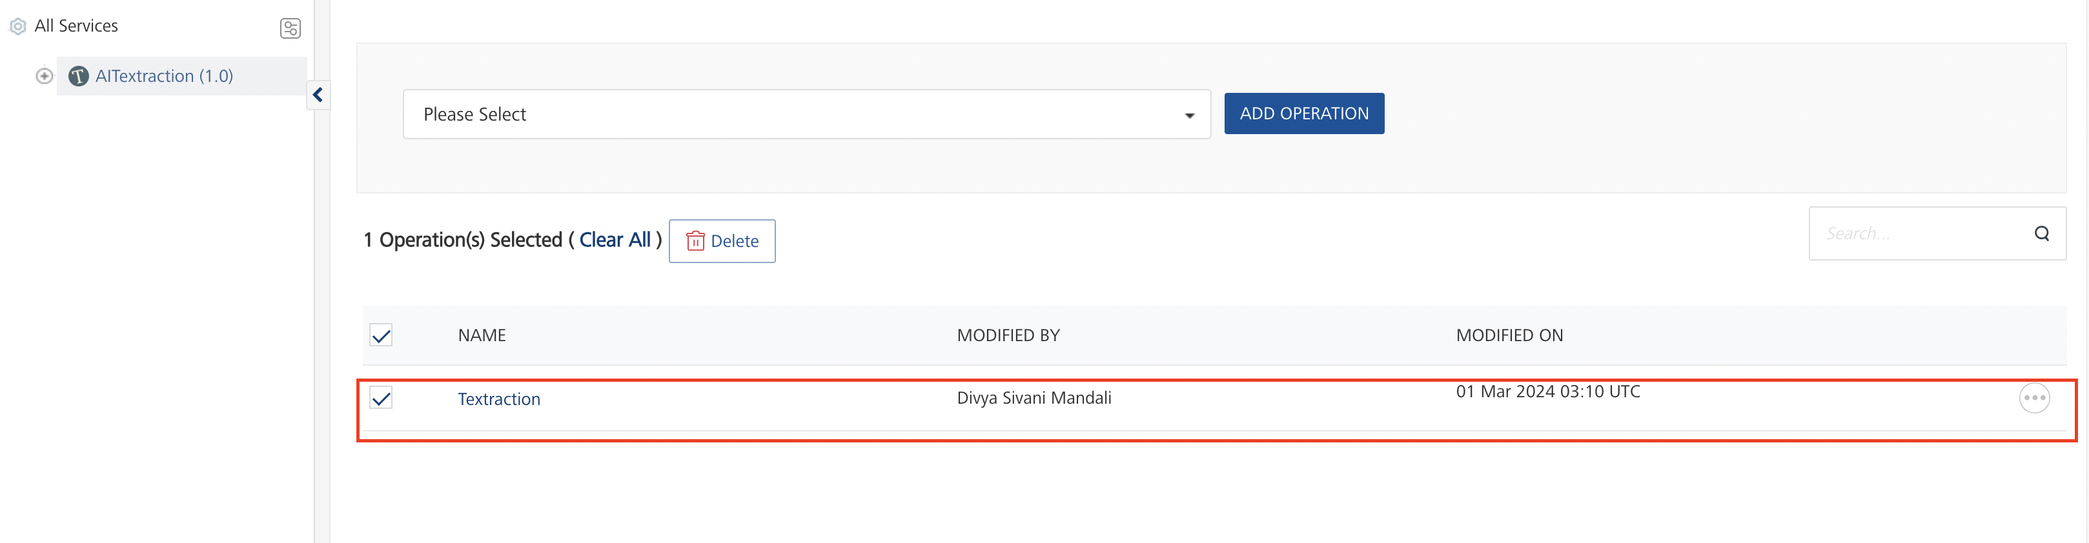

* On the Operation Page, in the **Request Input** tab, in the **Body** section, for the following parameters, specify the values in the respective boxes under the **Test Value** column.

**Mandatory Parameters**

* + **X-RapidAPI-Key, X-RapidAPI-Host [in header]:**  API Key associated with your RapidAPI account, required for authentication.

To get keys – Login in to [**Rapid API Account**](https://rapidapi.com/TextractionAI/api/ai-textraction/)-> You can view your keys.

* + **text:** Text from which entities will be extracted.
  + **entities:** Entities to extract based on required parameters.

* Select a run-time environment and click **Save and Fetch Response** to get a response based on your inputs.

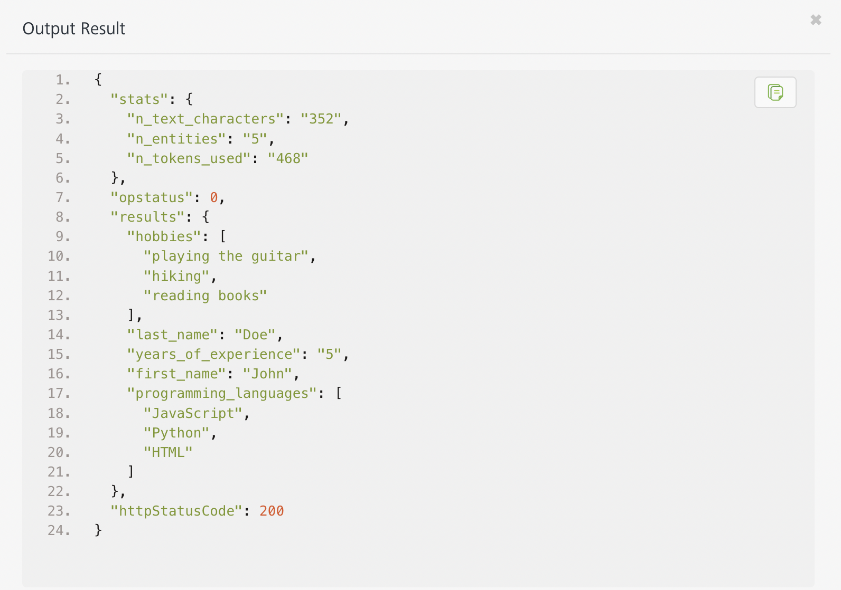

## **Publishing your application**

If you want to use the services in client applications, you need to publish an app to a run-time environment. You can create the service (as described above) in an application or import the service into an application and publish the application.

# **References**

## Endpoint Documentation

## **Requests Input Parameters**

|  |  |
| --- | --- |
| **Parameter** | **Description** |
| X-RapidAPI-Key(string) | **[Required]** **[Header]**API Key associated with your account. |
| X-RapidAPI-Host (string) | **[Required]** **[Header]** The host parameter specifies the domain name or IP address of the RapidAPI endpoint. In the context of the AI Textraction, the default host is set to 'ai-textraction.p.rapidapi.com'. This parameter is necessary for routing the request to the appropriate API endpoint. |
| text (string) | **[Required]** Text from which entities will be extracted. |
| entities (Array of Objects) | **[Required]** An array containing information about specific entities within the text. |
| entities - var_name (string) | The variable name of the entity. |
| entities - type (string) | The data type of the entity. |
| entities - description (string) | The description of the entity. |

### **Response Output Parameters**

## 

| **Object Property** | **Data Type** | **Description** |
| --- | --- | --- |
| results | Object | Contains information mentioned in text. |
| - first_name | String | The first name mentioned in text. |
| - last_name | String | The last name mentioned in text. |
| - years_of_experience | Integer | The number of years of experience of mentioned in text. |
| - programming_languages | Array of Strings | The list of programming languages mentioned in text. |
| - hobbies | Array of Strings | The list of hobbies given text enjoys. |
| stats | Object | Contains statistics about the text and entities. |
| - n_text_characters | Integer | The number of characters in the text. |
| - n_entities | Integer | The number of entities extracted from the text. |
| - n_tokens_used | Integer | The number of tokens used for extraction. |

**Reference Document:** [AI Textraction API Documentation (TextractionAI) | RapidAPI](https://rapidapi.com/TextractionAI/api/ai-textraction/)

# **Revision History**

Adapter version 1.0.0:

## **Known Issues**

* No Known Issues

## **Limitations**

* No limitations