24 -NOV-2025

ALPHA VANTAGE

VERSION: 1.0.0

OVERVIEW
Alpha Vantage is a financial market data platform that provides real-time and historical stock data through simple REST APIs. It enables developers to fetch quotes, price movements, company fundamentals, and technical indicators for building stock-related applications.
It offers multiple data endpoints including Global Quote, Symbol Search, Time Series Daily, Intraday, and Company Overview, making it suitable for trading apps, financial dashboards, research tools, and investment analysis platforms.
- Use case:
Alpha Vantage can be used to build stock-market analytics apps, price-tracking dashboards, investment recommendation tools, portfolio managers, and educational systems that visualize market trends.
It is also suitable for apps that show:
- Live stock quotes
- Historical price charts
- Company fundamentals
- Trend analysis
- Percentage of re-use:
80% (Data can be customizable and customers need to implement UI by themselves).

Features

Global Quote API
Provides the latest market price, price change, and percentage movement for a given stock symbol.

Symbol Search API
Returns best-match symbols when the user searches by company name or keyword.

Time Series Daily API
Provides historical daily open, high, low, close, and volume values.
Used to plot charts and compute trends.

Company Overview API
Returns company fundamentals such as description, sector, market capitalization, PE ratio, and more.

GETTING STARTED

Prerequisites
Before you start using the AlphaVantage Data Adapter, ensure you have the following:

- HCL Foundry
- Volt MX Iris
- AlphaVantage account
  - Sign up at the Alpha Vantage official website to create your account:
https://www.alphavantage.co/support/#api-key
  - Alpha Vantage provides a free tier with limited API calls per minute, which is suitable for development and testing.
- AlphaVantage API Key
Once logged in, go to the Get Your Free API Key section in the Alpha Vantage dashboard.
Generate your API key and store it securely.
This key is required for authenticating all API requests such as:
- Global Quote
- Time Series Daily
- Symbol Search
- Company Overview
- Technical Indicators
- API Access
Ensure that you understand the required API endpoints based on your use case:
- GLOBAL_QUOTE → Fetch latest price, change, and percentage
- SYMBOL_SEARCH → Search companies by name/keyword
- TIME_SERIES_DAILY → Fetch last 100 days of historical data
- OVERVIEW → Fetch company fundamentals (Description, Sector, Market Cap, etc.)
You can explore all available endpoints under the Alpha Vantage API Documentation.
- Project Setup
You can start with the free plan, which allows a limited number of API requests per minute.
For production systems or heavy usage, you can upgrade to a paid premium plan for:
- Higher rate limits
- Faster response times
- Priority access
- More advanced market data

- Reference document:
  - Alphavantage Overview
  - AlphaVanatge API Reference

Importing the data adapter

You can import Alpha Vantage Data Adapter into HCL Foundry directly from the voltmx Forge website or by importing the data adapter zip file.

To import the data adapter zip file, do the following:
- Log on to your HCL Foundry. The Dashboard page appears by default.
- In the left pane, click the API Management menu. The APIs tab opens by default.
- Click the Custom Data Adapters tab. The Custom Data Adapter page appears.
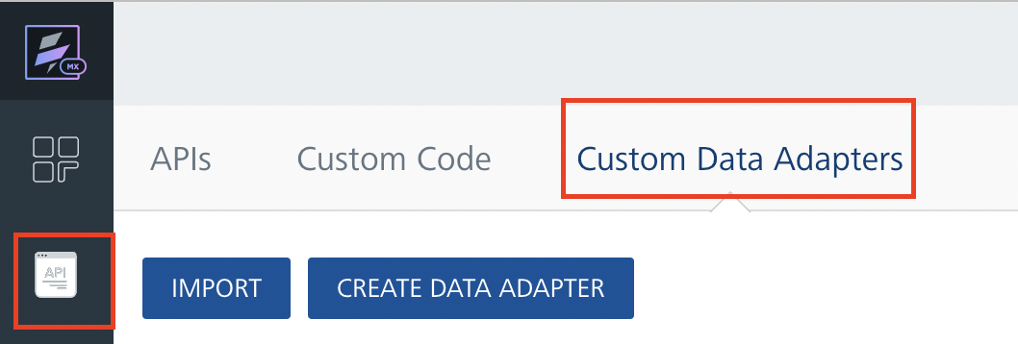
- Click Import. The Import Data Adapter dialog appears.

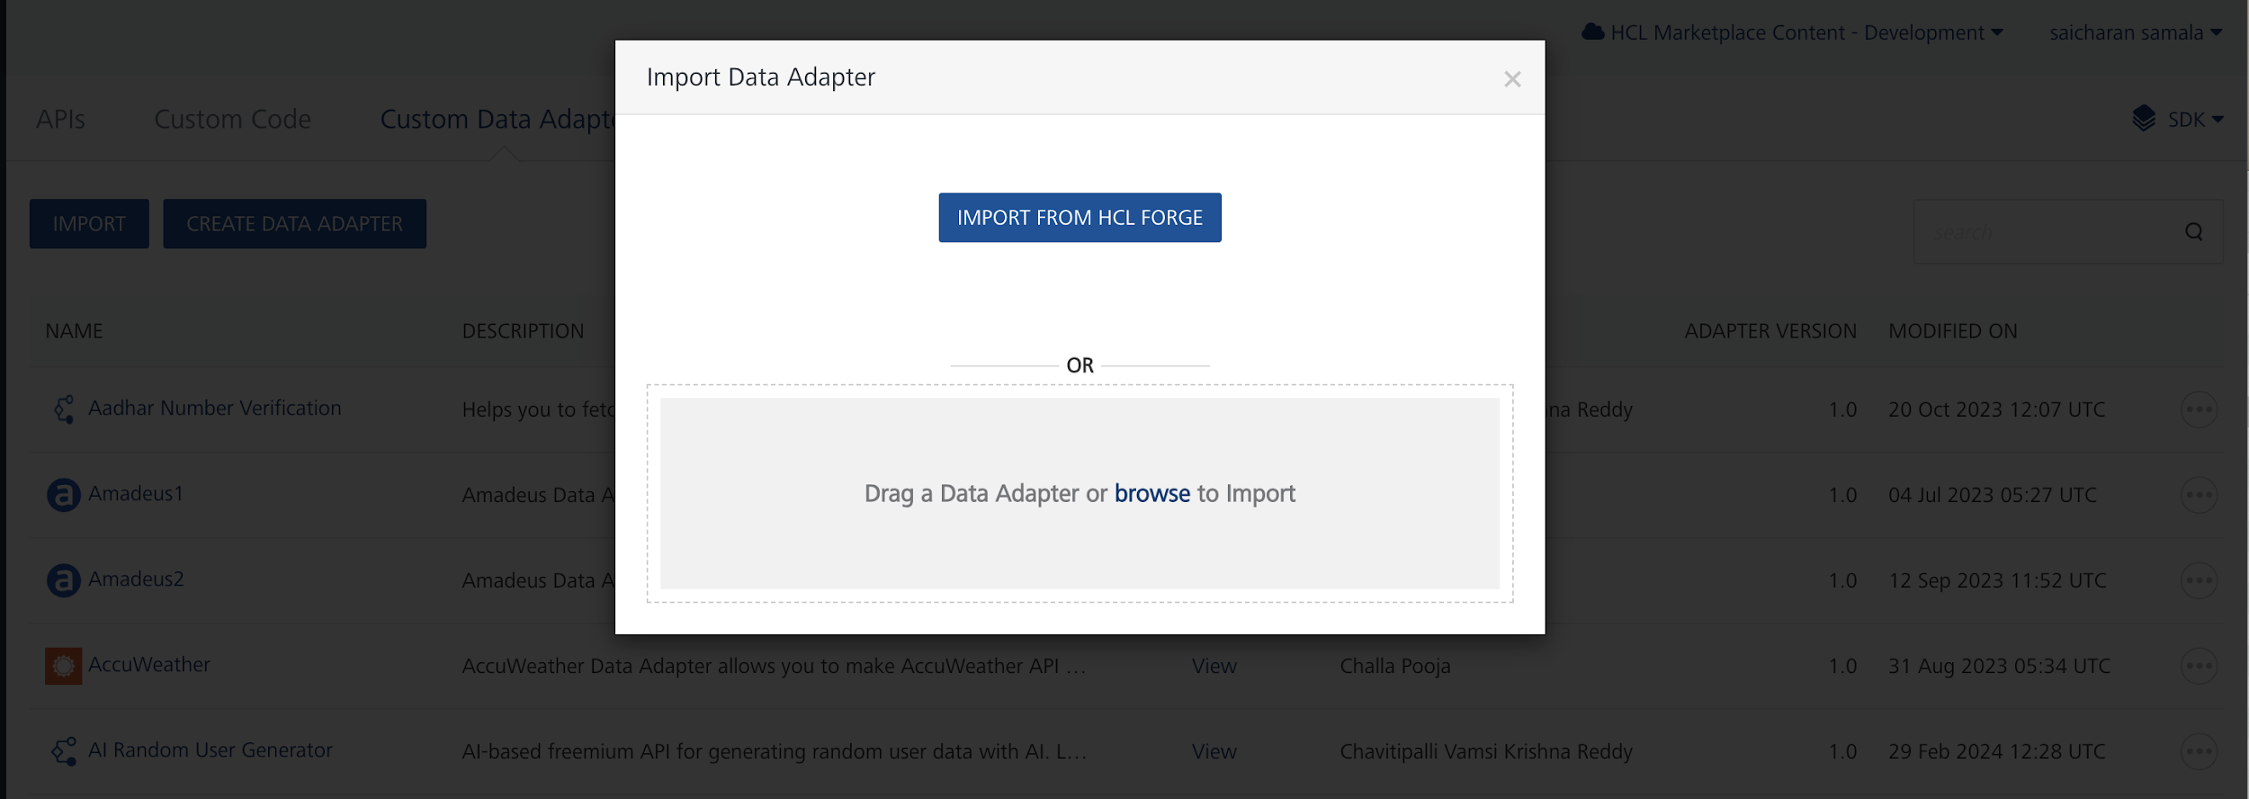

- Click IMPORT FROM HCL FORGE. The Import Data Adapter from HCL Forge dialog appears with a list of available data adapters.
- Click Import. Alpha Vantage data adapter is listed on the Custom Data Adapters page.
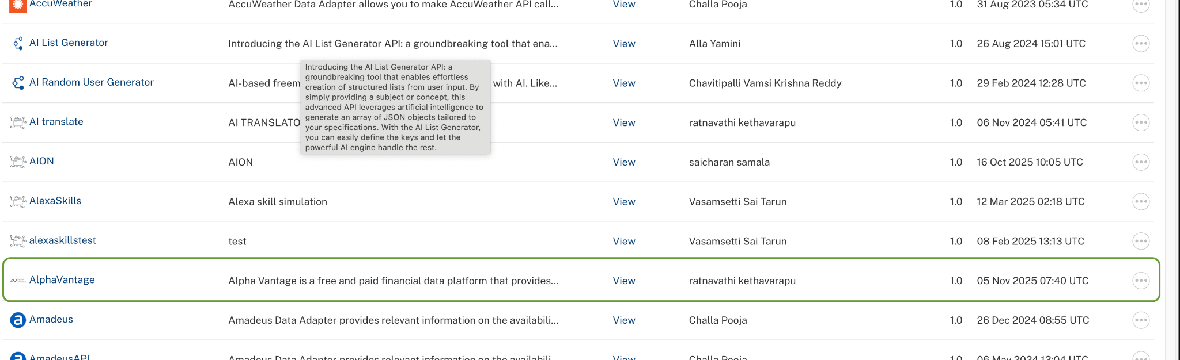

To import the data adapter zip file, do the following:
- Perform steps 1 to 4 in the above procedure
- Drag the data adapter zip file into the Drag a Data Adapter box.
Or
Click browse. The Open dialog appears.
Navigate to the location where you downloaded the data adapter (zip file) on your computer, select the data adapter, and click Open. The Import Data Adapter dialog shows the selected data adapter.

Creating an Integration Service with AlphaVantage :
After you import Alpha Vantage Data Adapter into Foundry, you must create an integration service with service type as Alpha Vantage .
To create an integration service with Alpha Vantage, do the following:
- Log on to your HCL Foundry. The Dashboard page appears by default.
- In the left pane, click the API Management menu. The APIs tab opens by default.
- Click the Integration tab. The Integration tab opens with a list of existing integration services.
- Click CONFIGURE NEW. The Service Definition tab opens.
- In the Name box, type a unique name for your service.
- From the Service Type list, select Alpha Vantage.
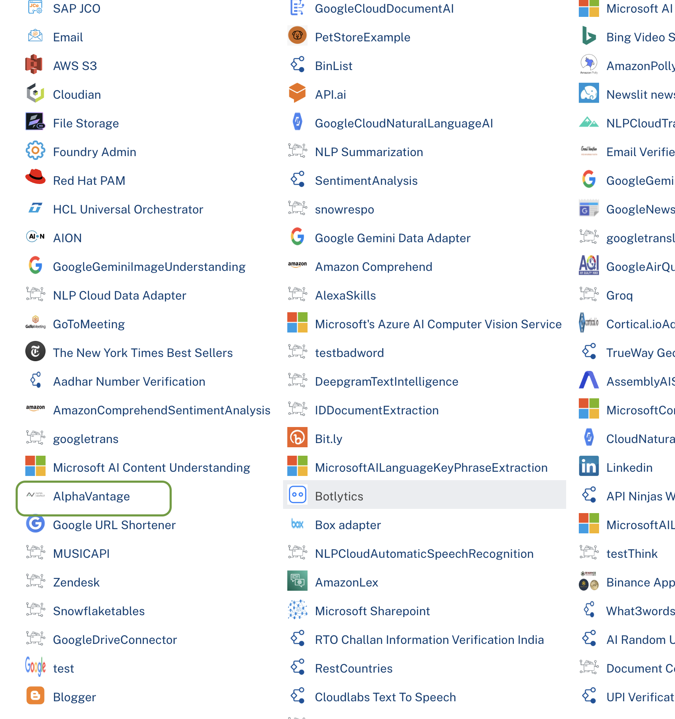
- Click Save

Creating an Operation
To make any API call in the HCL Foundry console, you must create an operation for the respective API and then execute the operation. Executing an operation involves making the API call and displaying the response.
This section provides steps to create an operation for the Alpha Vantage API.
Steps to create an operation for the Alpha Vantage API:
- Log on to your HCL Foundry. The Dashboard page appears by default.
- In the left pane, click the API Management menu. The APIs tab opens by default.
- Click the Integration tab. The Integration page appears with a list of existing integration services.
- From the list of integration services, select the integration service that you have created with service type as Alpha Vantage. The Service Definition tab of the selected integration service opens by default.
- Click the Operations List tab. The Operations List tab opens.
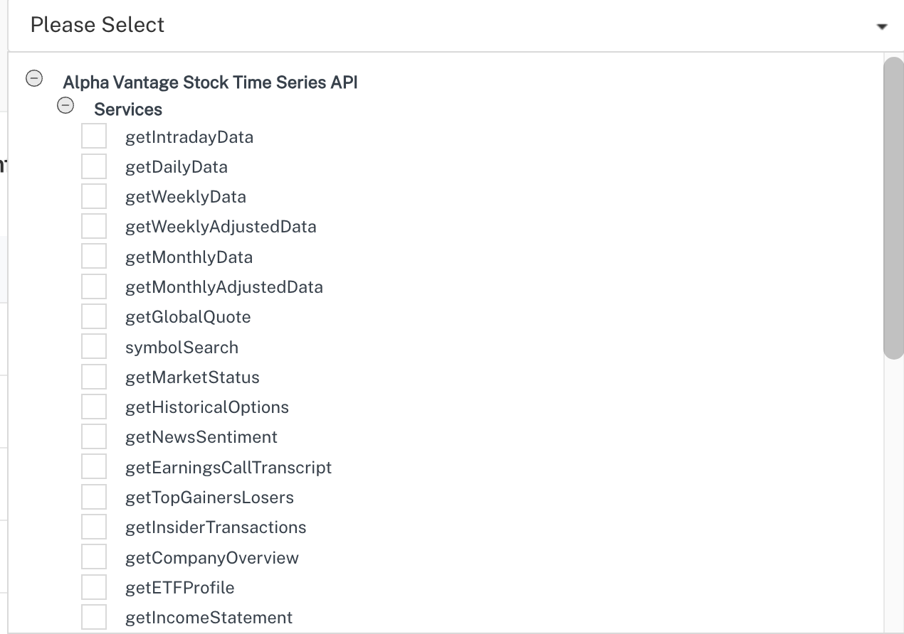
- Select getCompanyOverview and Click Add Operation.

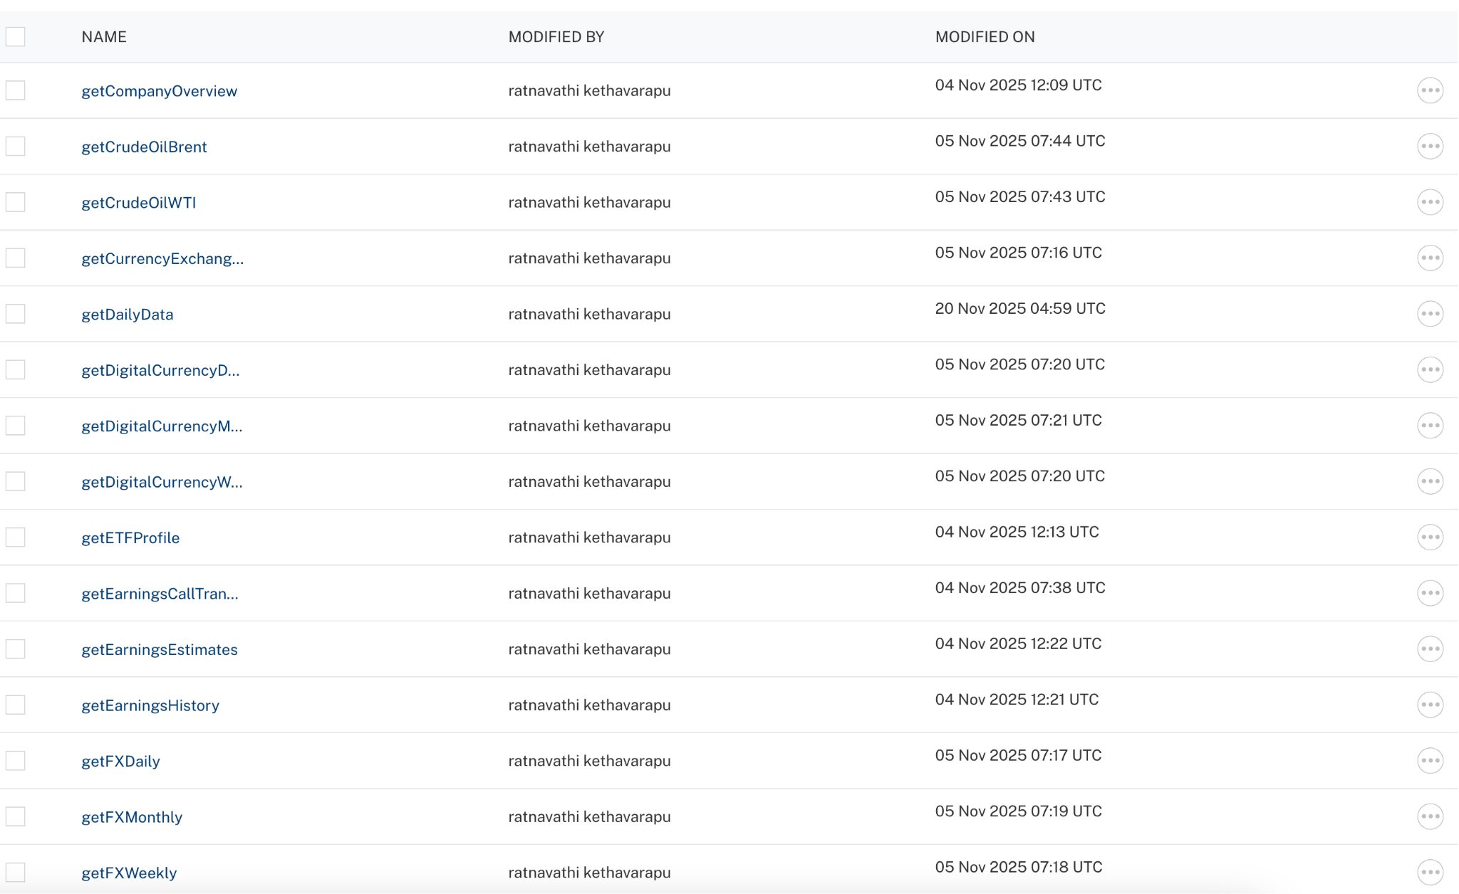

Executing Operation
Executing an operation involves making the API call by setting the necessary parameters and displaying the response. The procedure to execute any operation is the same, but the request parameters of the APIs vary. This section provides steps to execute the Alpha Vantage (explained in Creating an Operation).
Steps to execute the Alpha Vantage operation:
- Log on to your Hcl Foundry. The Dashboard page appears by default.
- In the left pane, click the API Management menu. The APIs tab opens by default.
- Click the Integration tab. The Integration tab opens with a list of existing integration services.
- From the list of integration services, select the integration service that you have created with service type as Alpha Vantage. The Service Definition tab of the selected integration service opens by default.
- Click the Operations List tab.
- In the Name box, the name of the operation is displayed by default. If you want, you can change the name.
- On the Request Input tab, in the Body section, for the following parameters, specify the values in the respective boxes under the Test Value column.
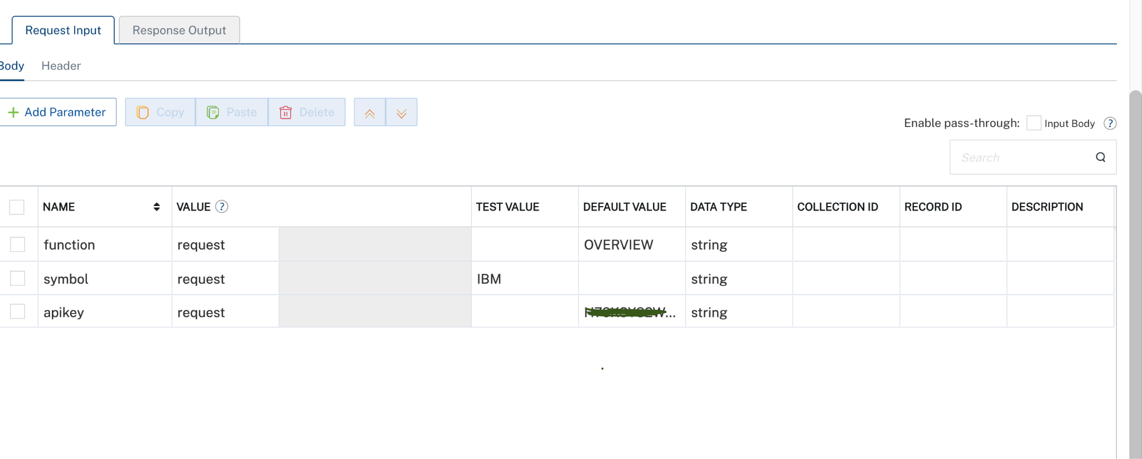

- Click SAVE AND FETCH RESPONSE. The Output Result dialog appears with the response. Otherwise, the Output Result shows an error.
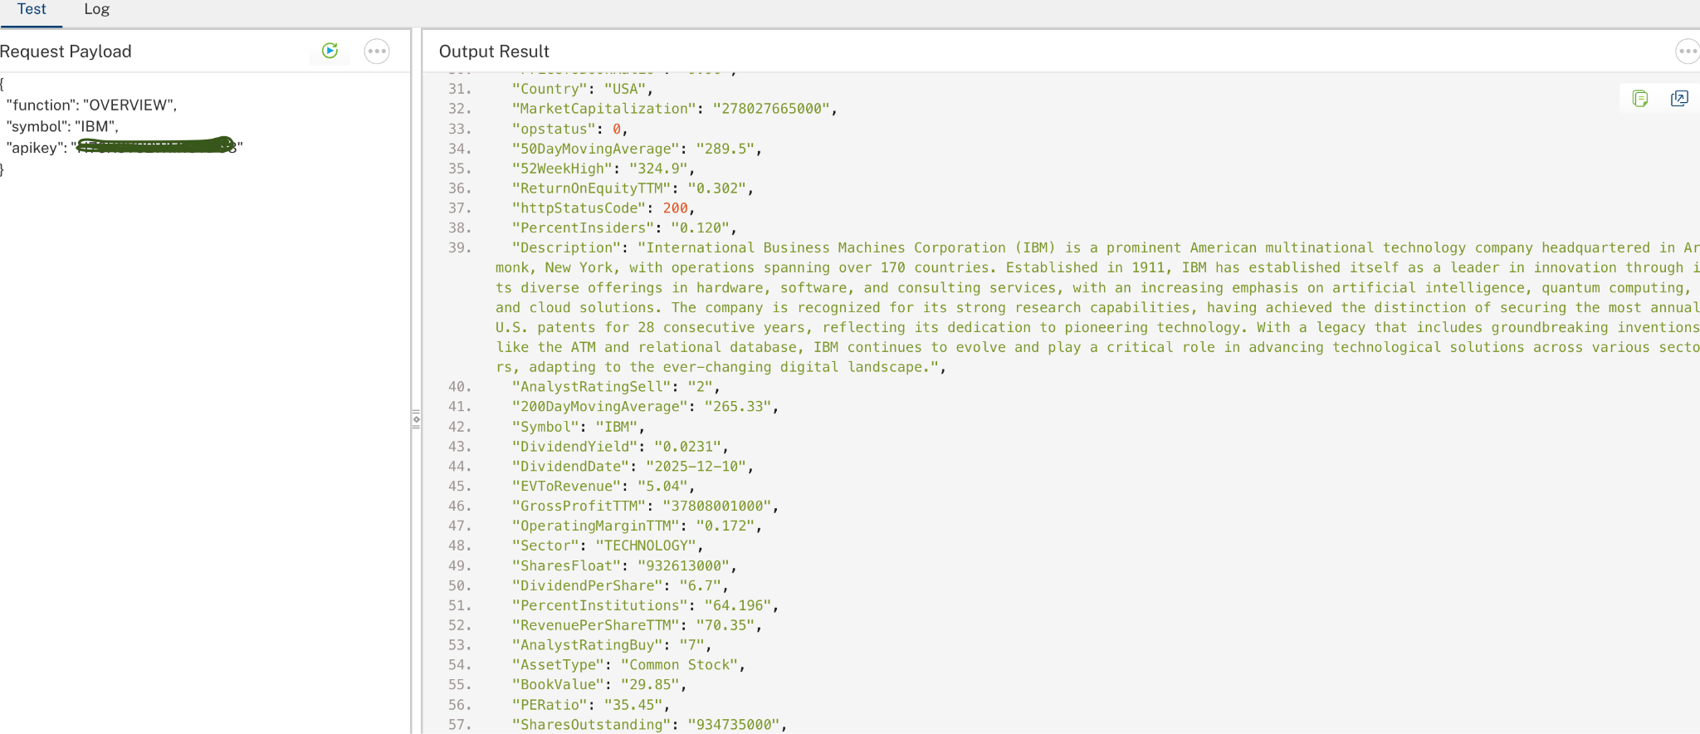
.

Publishing the App in VoltMX FOUNDRY:
After adding the Alpha Vantage Data Adapter to your app and configuring the necessary configurations, you must publish the app to HCL Foundry. For more information, refer to Publish a foundry app.
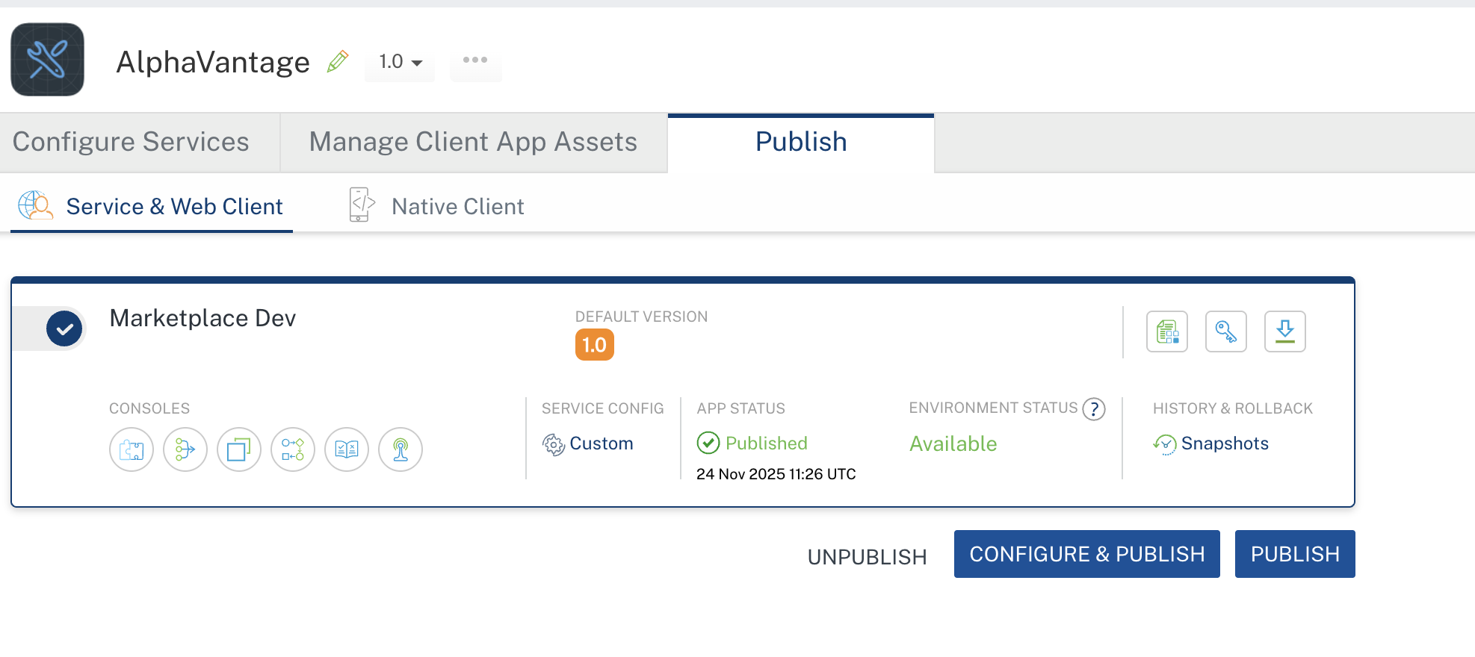

REFERENCES

Properties
- None of the properties are exposed.

Events
- None of the events are exposed.

API’s
- None of the APIs are exposed.

REVISION HISTORY
Adapter version 1.0.0:

Known Issues
None

Limitations
- Sometimes the Alpha Vantage API responds very slowly.
- At times, the API returns unusual or incomplete data — expected results may not always appear.
- Free API key is limited to 25 requests per day

