Date : 24-Nov-25

ALPHA VANTAGE APPLICATION

VERSION: 1.0.0

OVERVIEW
Alpha Vantage is a financial market data platform that provides real-time and historical stock data through simple REST APIs. It enables developers to fetch quotes, price movements, company fundamentals, and technical indicators for building stock-related applications.
It offers multiple data endpoints including Global Quote, Symbol Search, Time Series Daily, Intraday, and Company Overview, making it suitable for trading apps, financial dashboards, research tools, and investment analysis platforms.

Requirements:
Before you start using the Alpha Vantage Application, ensure you have the following:

- HCL Foundry
- Volt MX Iris
- AlphaVantage account
  - Sign up at the Alpha Vantage official website to create your account:
https://www.alphavantage.co/support/#api-key
  - Alpha Vantage provides a free tier with limited API calls per minute, which is suitable for development and testing.
- AlphaVantage API Key
Once logged in, go to the Get Your Free API Key section in the Alpha Vantage dashboard.
Generate your API key and store it securely.
This key is required for authenticating all API requests such as :
- Global Quote
- Time Series Daily
- Symbol Search
- Company Overview
- Technical Indicators
- API Access
Ensure that you understand the required API endpoints based on your use case:
- GLOBAL_QUOTE → Fetch latest price, change, and percentage
- SYMBOL_SEARCH → Search companies by name/keyword
- TIME_SERIES_DAILY → Fetch last 100 days of historical data
- OVERVIEW → Fetch company fundamentals (Description, Sector, Market Cap, etc.)
You can explore all available endpoints under the Alpha Vantage API Documentation.
- Project Setup
You can start with the free plan, which allows a limited number of API requests per minute.
For production systems or heavy usage, you can upgrade to a paid premium plan for:
- Higher rate limits
- Faster response times
- Priority access
- More advanced market data
- Reference document:
  - Alphavantage Overview
  - AlphaVanatge API Reference

Devices:
- Mobile

Platforms:
- Android
- IOS

Features

Global Quote API
  - Provides the latest market price, price change, and percentage movement for a given stock symbol.

Symbol Search API
  - Returns best-match symbols when the user searches by company name or keyword.

Time Series Daily API
  - Provides historical daily open, high, low, close, and volume values.
Used to plot charts and compute trends.

Company Overview API
  - Returns company fundamentals such as description, sector, market capitalization, PE ratio, and more.

App Functionality – Alpha Vantage Sample Application
When you build and run the Alpha Vantage Stock Market Sample Application, you can interact with real-time and historical stock market data powered by the Alpha Vantage APIs.
The app allows users to:
- Search for stock symbols
- View latest price, change, and trend
- Display company overview
- Render 5-day charts based on Time Series Daily API

Home Screen (frmSearch)
- The user types a company name or keyword into the search input field.
- On clicking Search, the app triggers a Foundry Integration Service call to the SYMBOL_SEARCH API.
- Matching stock symbols appear in a segment list.
- On selecting a symbol, navigation happens to the next form (frmSearchResults).

Stock Details Screen (frmSearchResults / Form 2)
- Displays the selected stock’s symbol, company name, last known price, and price change.
- The app calls the GLOBAL_QUOTE API to fetch the latest stock price.
- The screen updates dynamically depending on:
  - Whether the response contains price/change
  - Whether the API is slow
  - Whether Alpha Vantage returns partial or missing data
- If price/change isn't available, the app displays empty labels and shows a helpful alert.
The user can tap the row to view more detailed insights (frmDetails).

Insights Screen (frmDetails / Form 3)
- Shows company details and a 5-day mini-chart.
- The app calls:
  - TIME_SERIES_DAILY → for chart data
  - OVERVIEW → for company fundamentals
- If the daily data isn't available (common for some symbols), an alert is shown and the chart/textarea is cleared.
- If the overview description is missing, the app auto-generates a trend summary using recent values.

Authentication
- The app uses an Alpha Vantage API Key configured in Volt MX Foundry.
- The key is stored securely in the Foundry Integration Service.
- Every request to Alpha Vantage includes:
  - API key
  - Function name (GLOBAL_QUOTE, SYMBOL_SEARCH, etc.)
  - Symbol or keywords
- Foundry mediates the API request between the Volt MX app and Alpha Vantage.

Process Flow
- The user enters a company name or keyword.
- The request is sent to the Foundry Integration Service.
- Foundry calls the appropriate Alpha Vantage API.
- Alpha Vantage returns:
  - Stock symbol results
  - Latest price & change
  - Historical daily values
  - Company overview
- The Volt MX app receives this response and updates the UI accordingly.

Result Retrieval & Display
- Symbol search results appear in a scrollable list in frmSearch.
- Stock price and change appear in frmSearchResults.
- Insights page (frmDetails):
  - Renders a line chart for the last 5 days.
  - Displays company overview text or a fallback trend summary.
- Alerts appear whenever:
  - API returns partial or missing data
  - Price or change is not available
  - Time Series Daily is missing
Users can continue exploring stocks or navigate back to start a new search.

Importing the app
To import the Alpha Vantage Application into your workspace, follow these steps:
- Open Volt MX Iris
- On the main menu select Forge → Browse.
- Search for the Alpha Vantage Application, and then click Import to Workspace. The app is imported to your workspace. A dialog box appears, confirming that the app has been imported. Click OK.
- Switch to your project containing the Alpha Vantage Application. To switch to your project, click File → Open → Reference Architecture → <project name>

Building the app
After performing all the above steps, you can build your app and run it on your device. For more information, you can refer to the Building and Viewing an Application section of the Volt MX User Guide.
You can then run your app to see the Alpha Vantage work in real time.

Configure the UI and settings of the Alpha Vantage Application
The Alpha Vantage application is structured into three screens (forms), each responsible for a specific part of the stock-search experience.
Below is the clear & structured rewritten version for all 3 forms — frmSearch, frmSearchResults, and frmDetails.

Form 1: frmSearch (Home / Search Screen)

Purpose
This screen allows users to search for stock symbols using Alpha Vantage’s SYMBOL_SEARCH API.

UI Configuration
- Header Label
Displays the title: "Alpha Vantage – Stock Search"
- Search TextBox (txtSearch)
Placeholder: "Enter company name or symbol…"
- Search Button (btnSearch)
When clicked:
  - Reads the keyword
  - Calls Foundry → Integration Service → symbolSearch
- Segment Widget (segResults)
Displays a list of matching stocks returned from the search.
  - Aligned bubbles for API results
- Visibility Handling
  - Segment is hidden initially
  - Visible only after results are loaded

Flow / Logic
- User enters keyword
- Calls SYMBOL_SEARCH API
- Shows loader while request is processed
- On success:
  - Parse bestMatches
  - Populate segment
- User taps a result → navigate to frmSearchResults
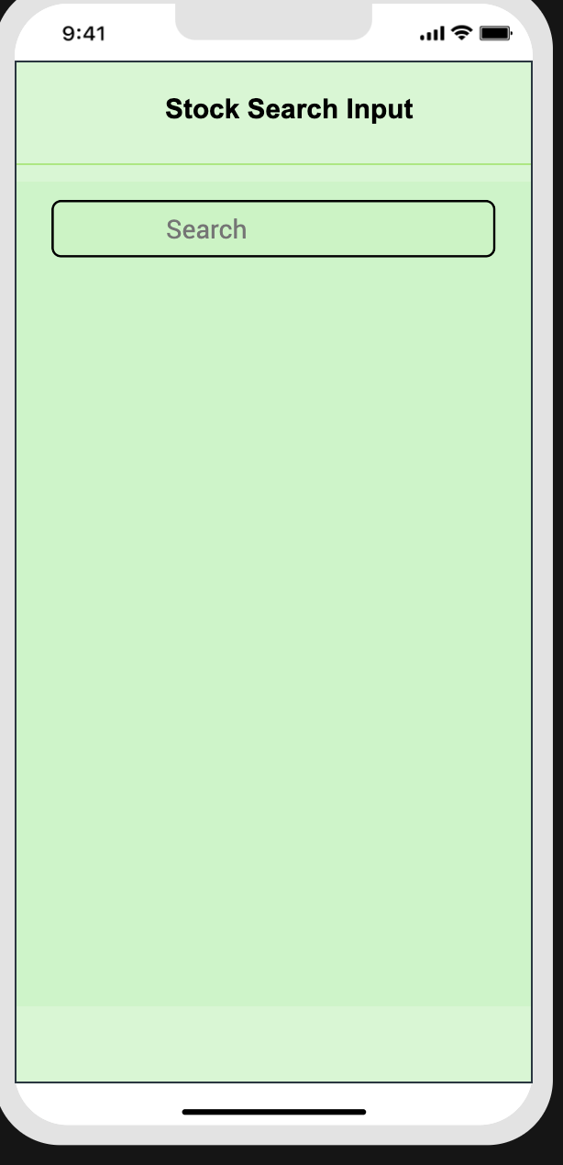

Form 2: frmSearchResults (Live Stock Quote Screen)

Purpose
Displays real-time stock price and percentage change using the Global Quote API.

UI Configuration
- Back Button
Returns to frmSearch (no clearing of previous results)
- Segment (segResults)
Shows:
  - Symbol
  - Name
  - Latest price
  - Change with arrow (up/down)
- Loader
Displayed while fetching LIVE data

Flow / Logic
- Receives selected symbol from frmSearch
- Shows placeholder row
- Calls Alpha Vantage GLOBAL_QUOTE API
- On success:
  - Loads price
  - Loads change
  - Applies arrow image based on positive/negative value
- User taps row → navigates to frmDetails

Special Cases
- If the API does not return price/change:
  - Hide arrow
  - Disable click navigation for segment
  - Inform user to choose another stock
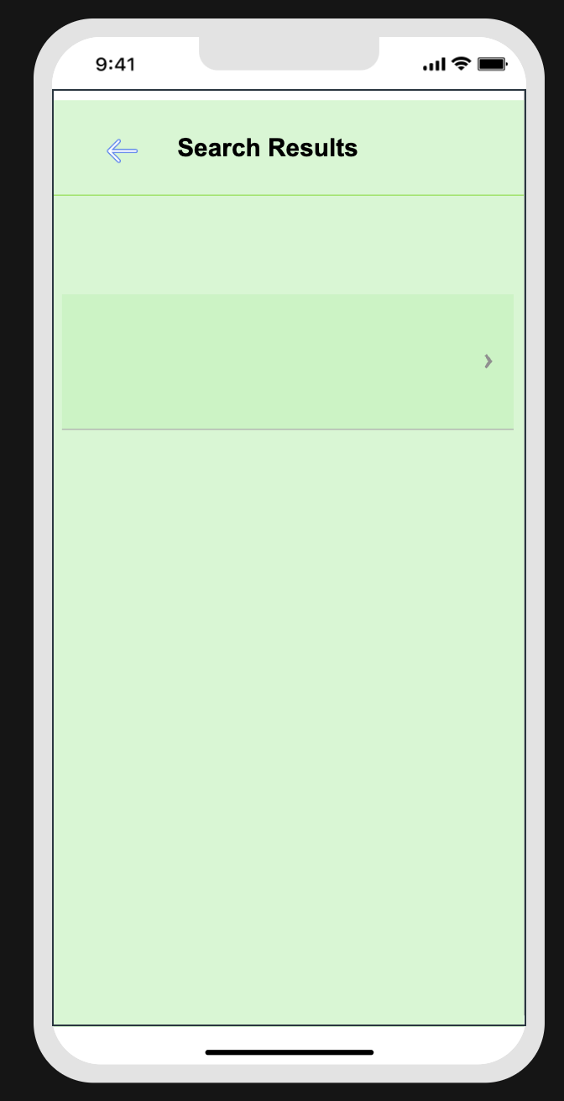

Form 3: frmDetails (Chart + Overview Screen)

Purpose
Displays in-depth stock information:
- Latest 5-day chart
- Company overview or AI-generated trend summary

UI Configuration
- Header Area
  - Stock name
  - Symbol
  - Price
  - Change
- Chart Container (flxChart)
Displays a Chart.js Line Chart for last 5 days
If no data → hide this section
- TextArea (TextAreaInput)
Shows company description or a generated trend summary
- Back Button
Navigates back to frmSearchResults with existing values

Flow / Logic

✔ Step 1 — Load TIME_SERIES_DAILY
- Requests the latest daily data
- Extracts the most recent 5 entries
- Renders a glowing neon Apple-style line chart

✔ Step 2 — Load OVERVIEW Data
- Fetches company information
- If description exists → display it
- If missing → generate trend summary using daily values

✔ Step 3 — Visibility Management
- If daily or overview data is missing:
  - Hide chart
  - Hide description box
  - Show alert to choose another stock
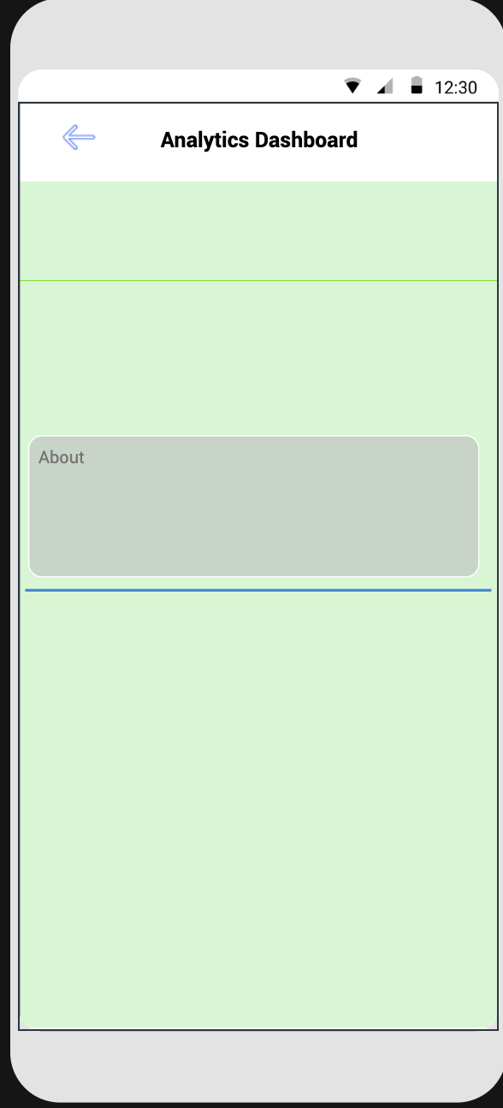

Final Summary – 3 Form App Flow
Form | Purpose | Key API | Navigation
frmSearch | Search stocks | SYMBOL_SEARCH | → frmSearchResults
frmSearchResults | Show live price | GLOBAL_QUOTE | → frmDetails
frmDetails | Show chart + overview | TIME_SERIES_DAILY, OVERVIEW | → back to frmSearchResults

Foundry APP Setup
When you import the application to your Volt MX Iris project, the HCL Volt MX Foundry services of the Alpha Vantage are added to the HCL Volt MX Foundry app, which is associated with the Volt MX Iris project. While importing the Alpha Vantage Application to your Volt MX Iris project, if there is no HCL Volt MX Foundry app associated with the existing Volt MX Iris project, a new HCL Volt MX Foundry app is automatically added to your HCL Volt MX Foundry environment and is associated with your Volt MX Iris.
To set the Foundry app, follow these steps:
- Click the HCL Volt MX Foundry app associated with your Volt MX Iris project from the Project Explorer. Click DATA & SERVICES.
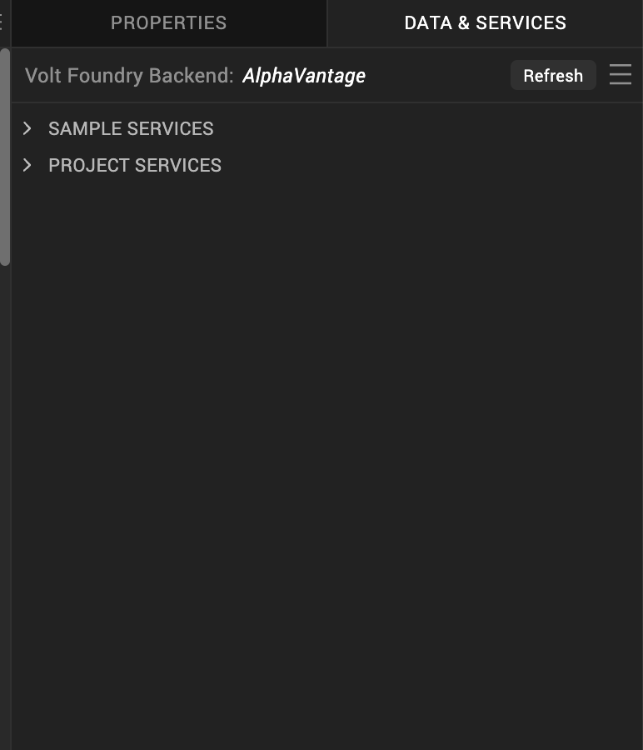

- Under the Configure Services tab, click Integration and can see the Alpha Vantage. Click on the Integration service to add the keys.
For the Host URL,replace the value of the endpoint URL mentioned in Alpha Vantage overview . Refer Alpha Vantage Documentation.
- 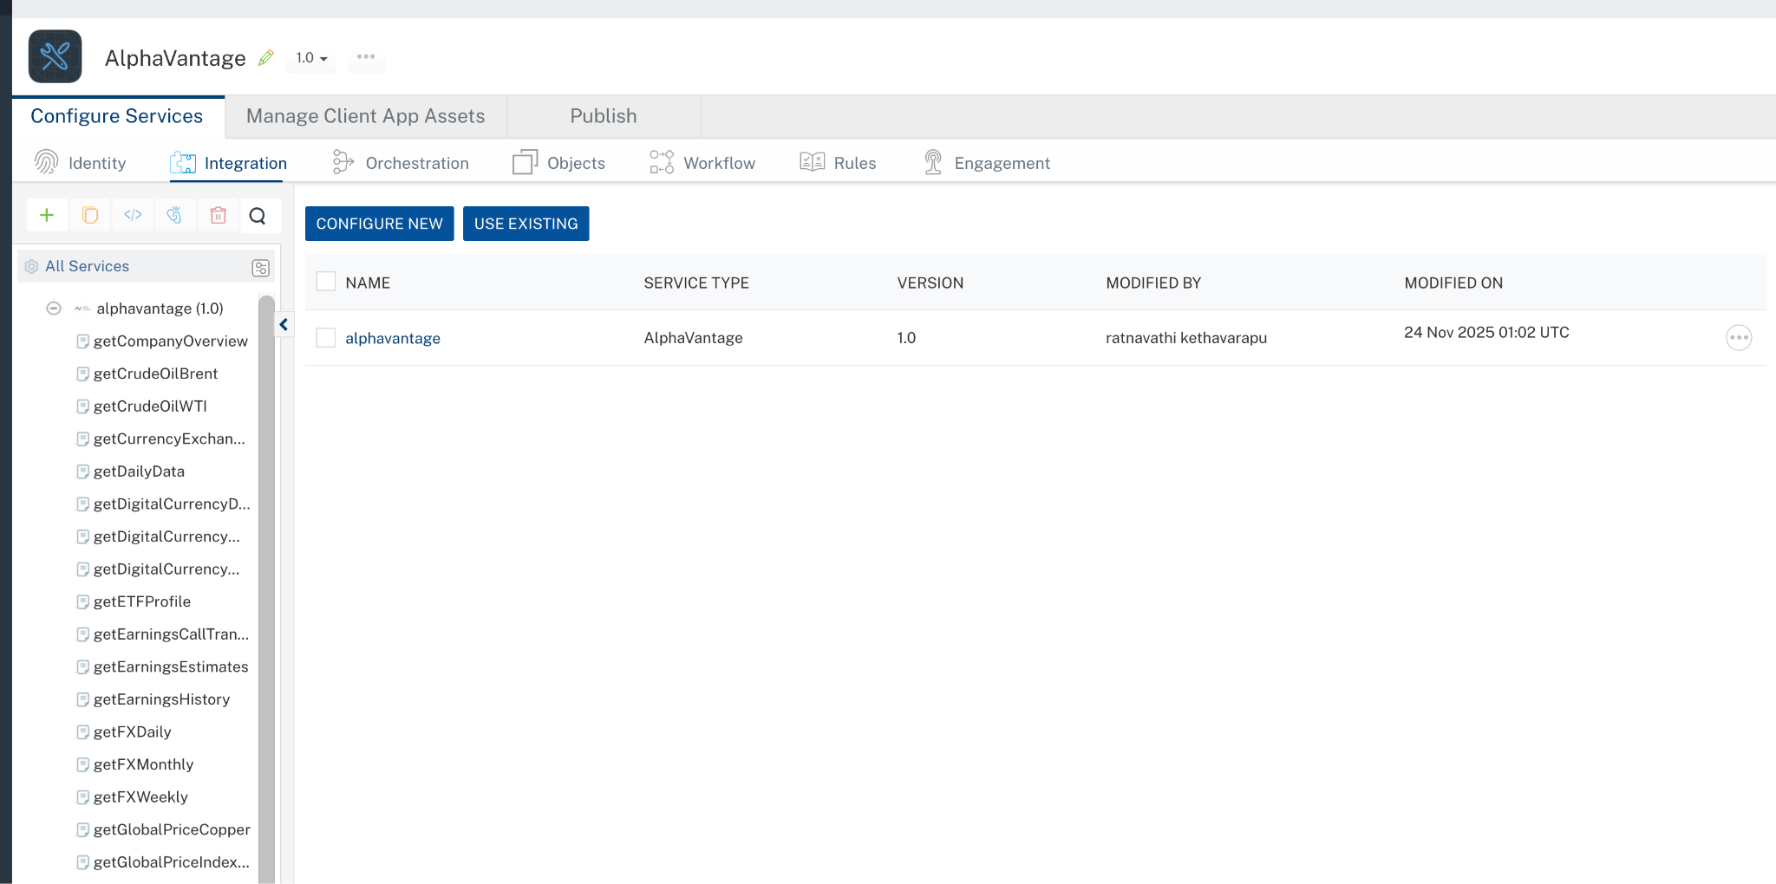
- Click on the Alpha Vantage integration service to expand the operations.
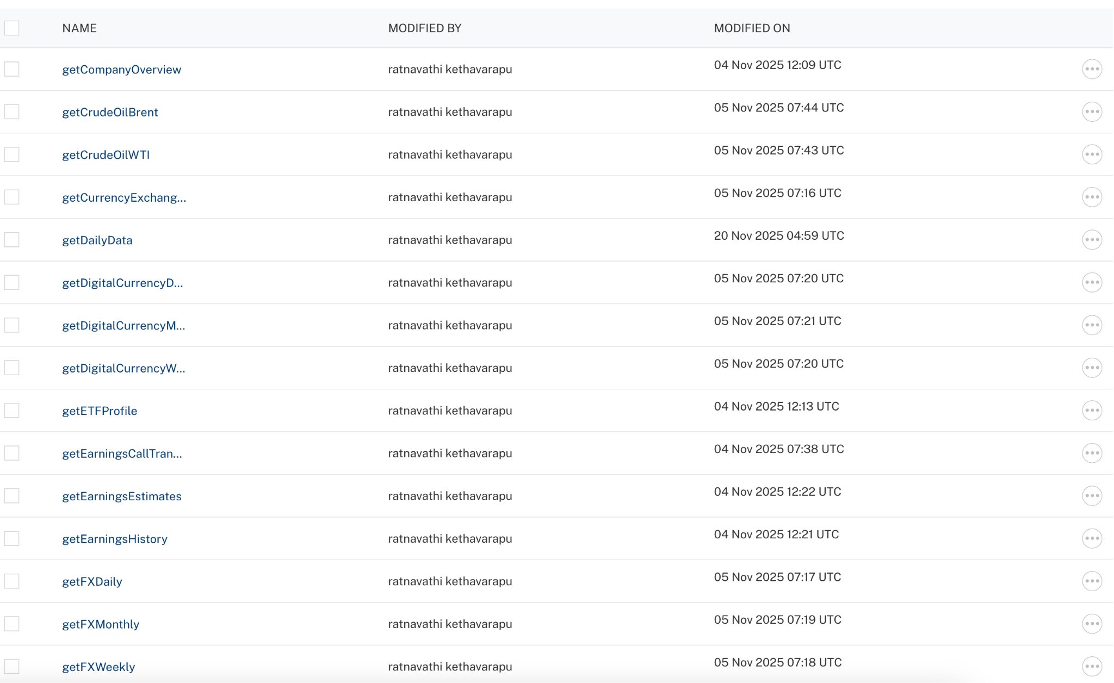
- Select each operation, On the Request Input tab, in the Body section, specify the values in the respective boxes under the Test Value column.
- For Key, In the box under the TEST VALUE and DEFAULT VALUE columns, type the API Key generated from Alpha Vantage Dashboard.
- Click SAVE OPERATION.
- Click SAVE AND FETCH RESPONSE. The Output Result dialog appears with the response. Otherwise, the Output Result shows an error.
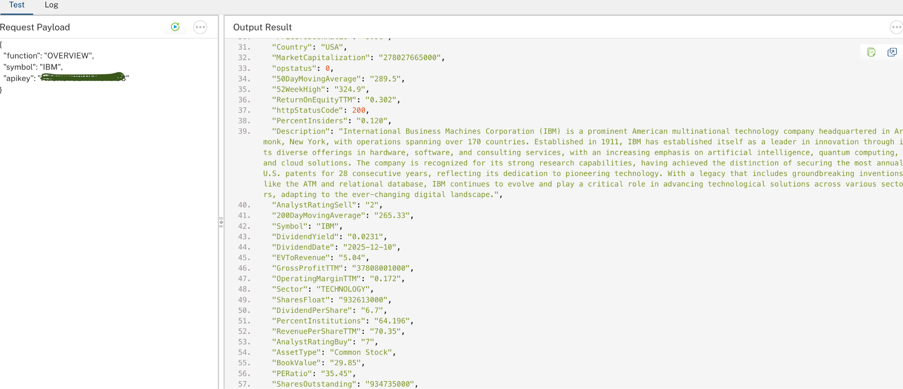

Publish the HCL Volt MX Foundry App
After you set the Operation Security Level, you must publish the HCL Volt MX Foundry app. To publish the HCL Volt MX Foundry, follow these steps:
In Volt MX Iris, click DATA & SERVICES, and then click Publish Project Services to Publish to your foundry app.
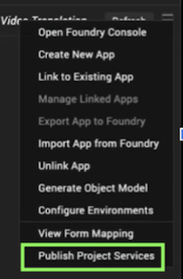
Select the environment to which you want to publish your app, and then click Publish.
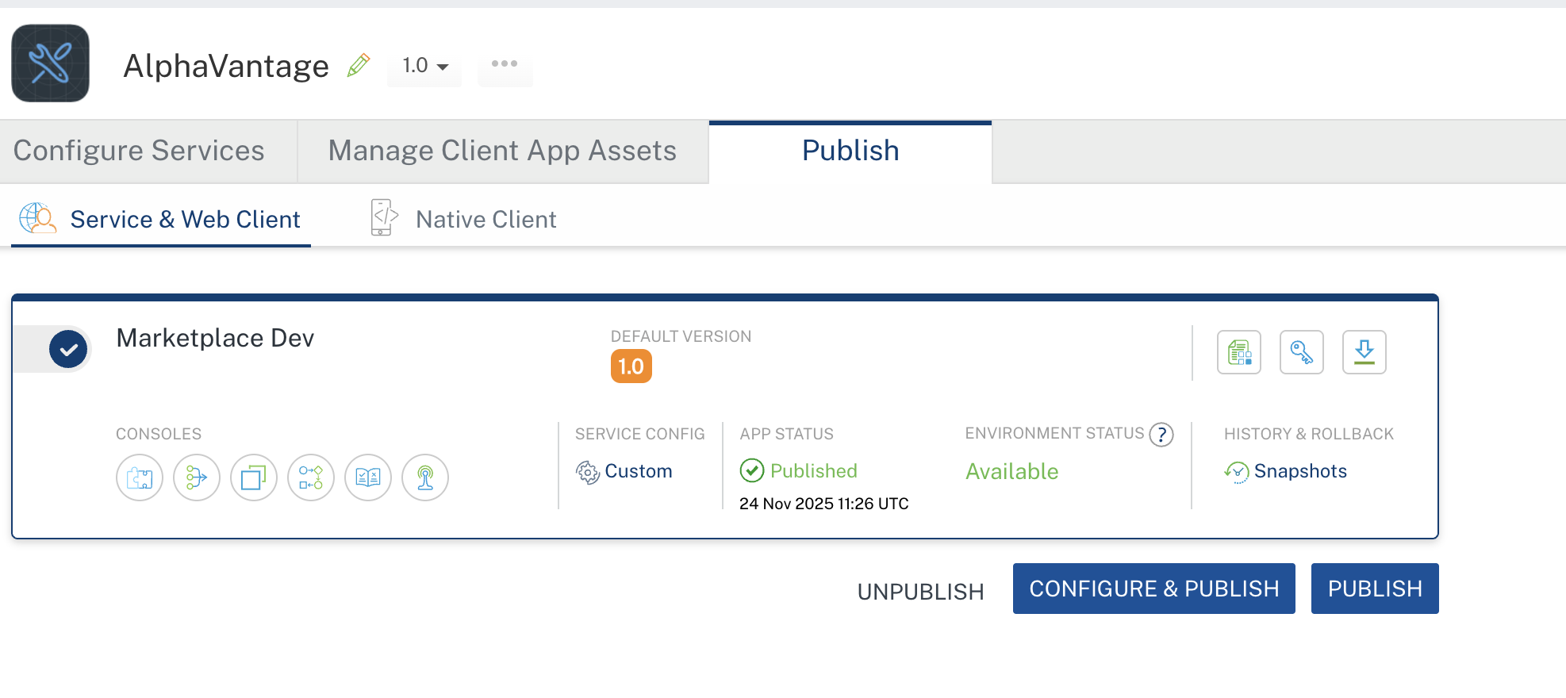

Building and previewing the app
After performing all the above steps, you can build your app and run it on your device. For more information, you can refer to the Building and Viewing an Application section of the Volt MX User Guide.
You can then run your app to see the Alpha Vantage work in real time.

Reference Documents:
- Alphavantage Overview
- AlphaVanatge API Reference

REVISION HISTORY
App version 1.0.0:

Known Issues
None

Limitations
- Sometimes the Alpha Vantage API responds very slowly.
- At times, the API returns unusual or incomplete data — expected results may not always appear.
- Free API key is limited to 25 requests per day

