8 May 2025

AMAZON COMPREHEND MEDICAL

VERSION: 1.0.0

Overview
Amazon Comprehend Medical is a natural language processing (NLP) service that uses machine learning to extract medically relevant information from unstructured clinical text. It can identify entities such as medical conditions, medications, dosages, tests, treatments, procedures, and more. Amazon Comprehend Medical helps healthcare providers, insurers, researchers, and pharmaceutical companies unlock insights from clinical documents while maintaining patient privacy and compliance.
Use Amazon Comprehend Medical to develop intelligent healthcare applications that understand the structure and content of clinical documentation. For example, you can analyze electronic health records (EHRs), doctor’s notes, and clinical trial reports to surface key medical information.

Use case:
- Enhance clinical workflows by extracting medical entities such as conditions, medications, and anatomy from EHRs and doctor’s notes.
- Improve patient care by analyzing clinical interactions and summarizing relevant medical data for physicians and care teams.
- Automate documentation by extracting standardized codes like ICD-10-CM and RxNorm to support billing, compliance, and interoperability.
- Protect sensitive information by detecting and redacting protected health information (PHI) from documents to support HIPAA compliance.
- Accelerate research by indexing and categorizing large volumes of medical literature and clinical trial data using medical entities and relationships.

Getting Started

Prerequisites
Before you start using the Amazon Comprehend Medical Data Adapter, ensure you have the following:
- An account with AWS
- Volt MX Iris
- HCL Foundry

Platforms Supported

Mobile

iOS

Android

Importing the app

You can import Amazon Comprehend Medical Data Adapter into HCL Foundry directly from the voltmx Forge website or by importing the data adapter zip file.

To import the data adapter zip file, do the following:
- Log on to your HCL Foundry. The Dashboard page appears by default.
- In the left pane, click the API Management menu. The APIs tab opens by default.

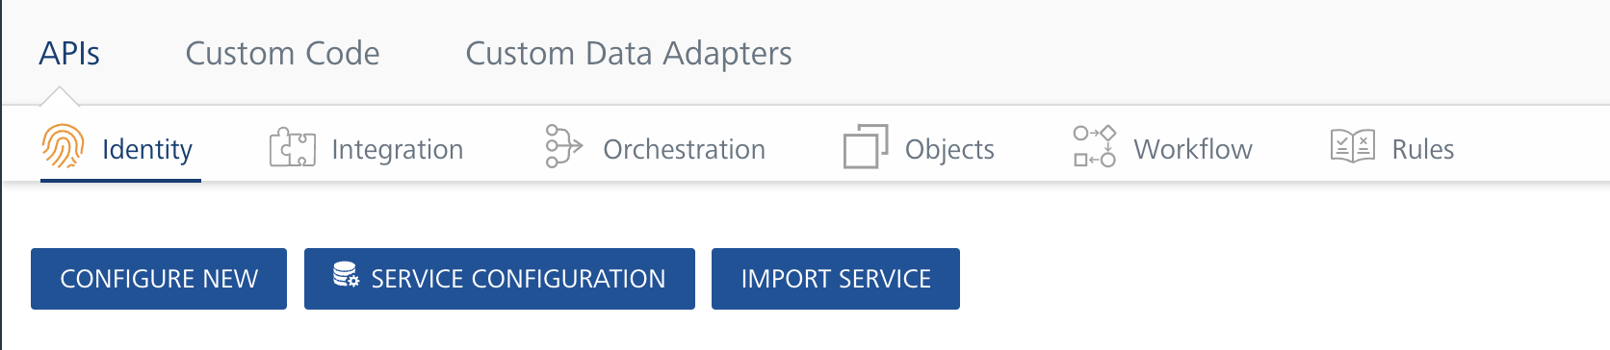

Click the Custom Data Adapters tab. The Custom Data Adapter page appears.

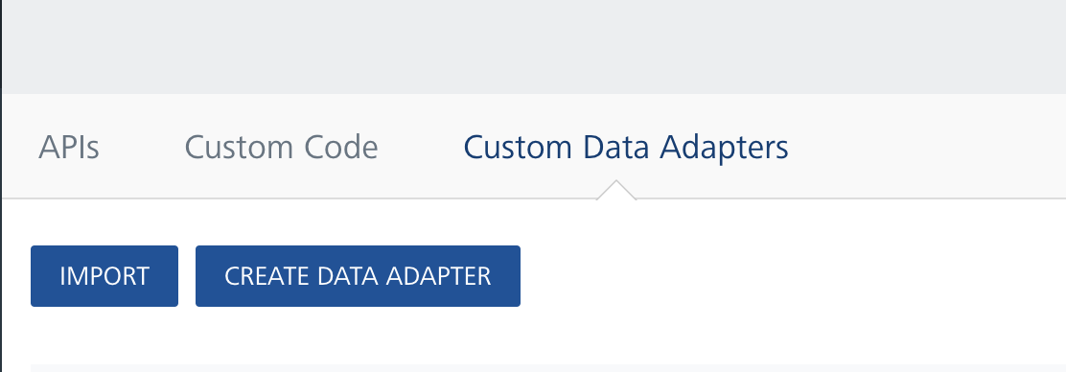

Click Import. The Import Data Adapter dialog appears.

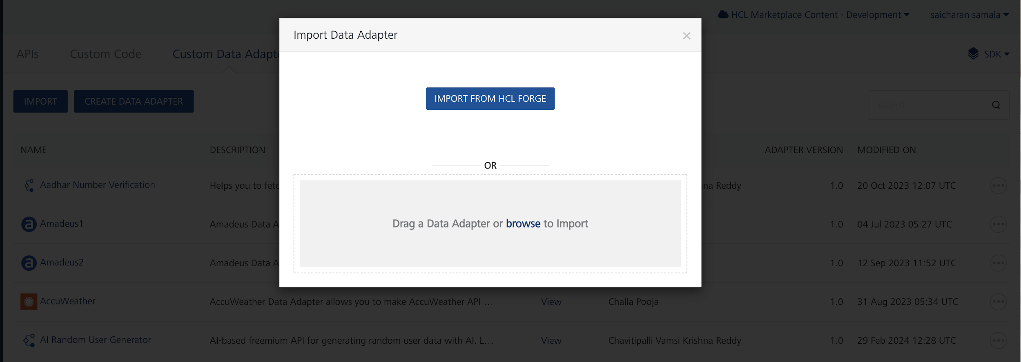

- Click IMPORT FROM HCL FORGE. The Import Data Adapter from HCL Forge dialog appears with a list of available data adapters.
- Click Import. Amazon Comprehend Medical data adapter is listed on the Custom Data Adapters page.
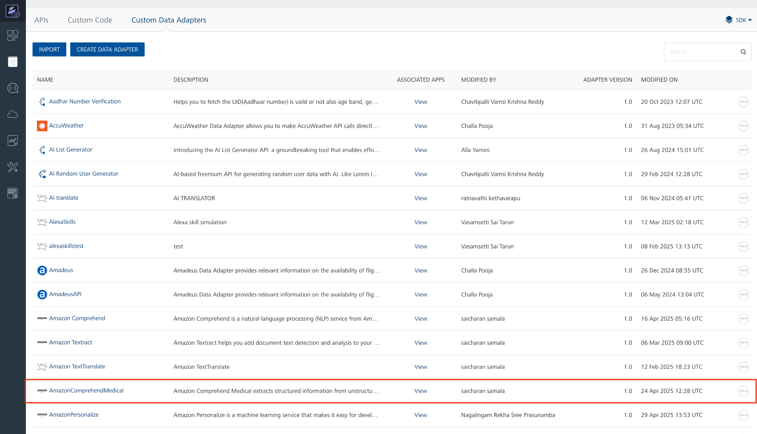

To import the data adapter zip file, do the following:
- Perform steps 1 to 4 in the above procedure
- Drag the data adapter zip file into the Drag a Data Adapter box.
Or
Click browse. The Open dialog appears.
Navigate to the location where you downloaded the data adapter (zip file) on your computer, select the data adapter, and click Open. The Import Data Adapter dialog shows the selected data adapter.
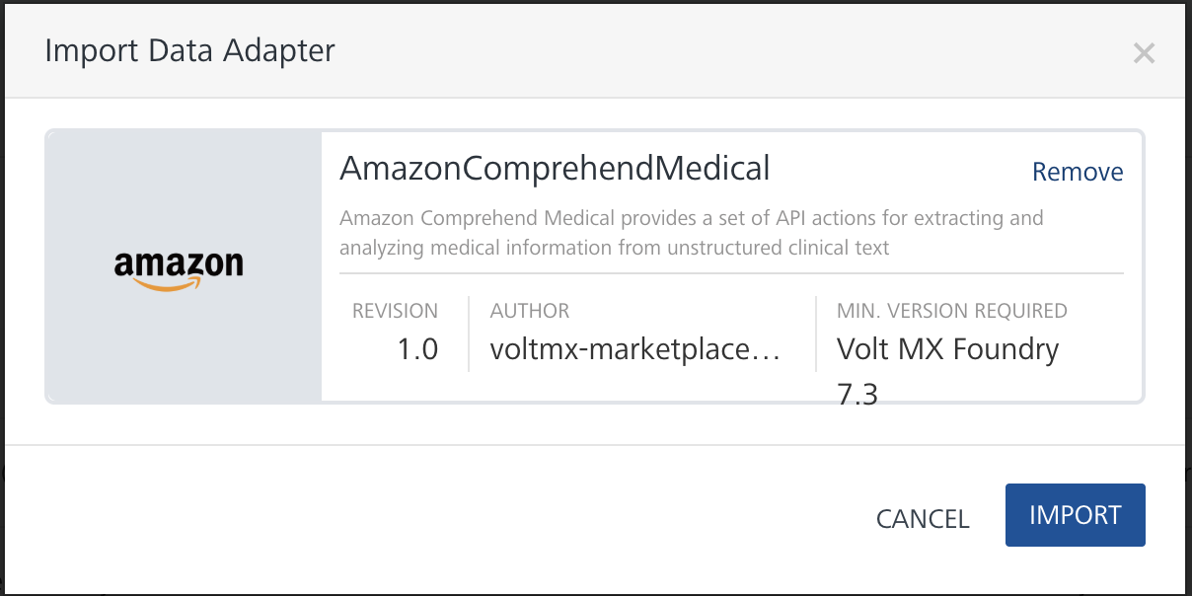

D. Creating an Integration Service with Amazon Comprehend Medical:

After you import Amazon Comprehend Medical Data Adapter into Foundry, you must create an integration service with service type as Amazon Comprehend Medical .
To create an integration service with Amazon Comprehend Medical, do the following:
- Log on to your HCL Foundry. The Dashboard page appears by default.
- In the left pane, click the API Management menu. The APIs tab opens by default.
- Click the Integration tab. The Integration tab opens with a list of existing integration services.
- Click CONFIGURE NEW. The Service Definition tab opens.
- In the Name box, type a unique name for your service.
- From the Service Type list, select Amazon Comprehend Medical.
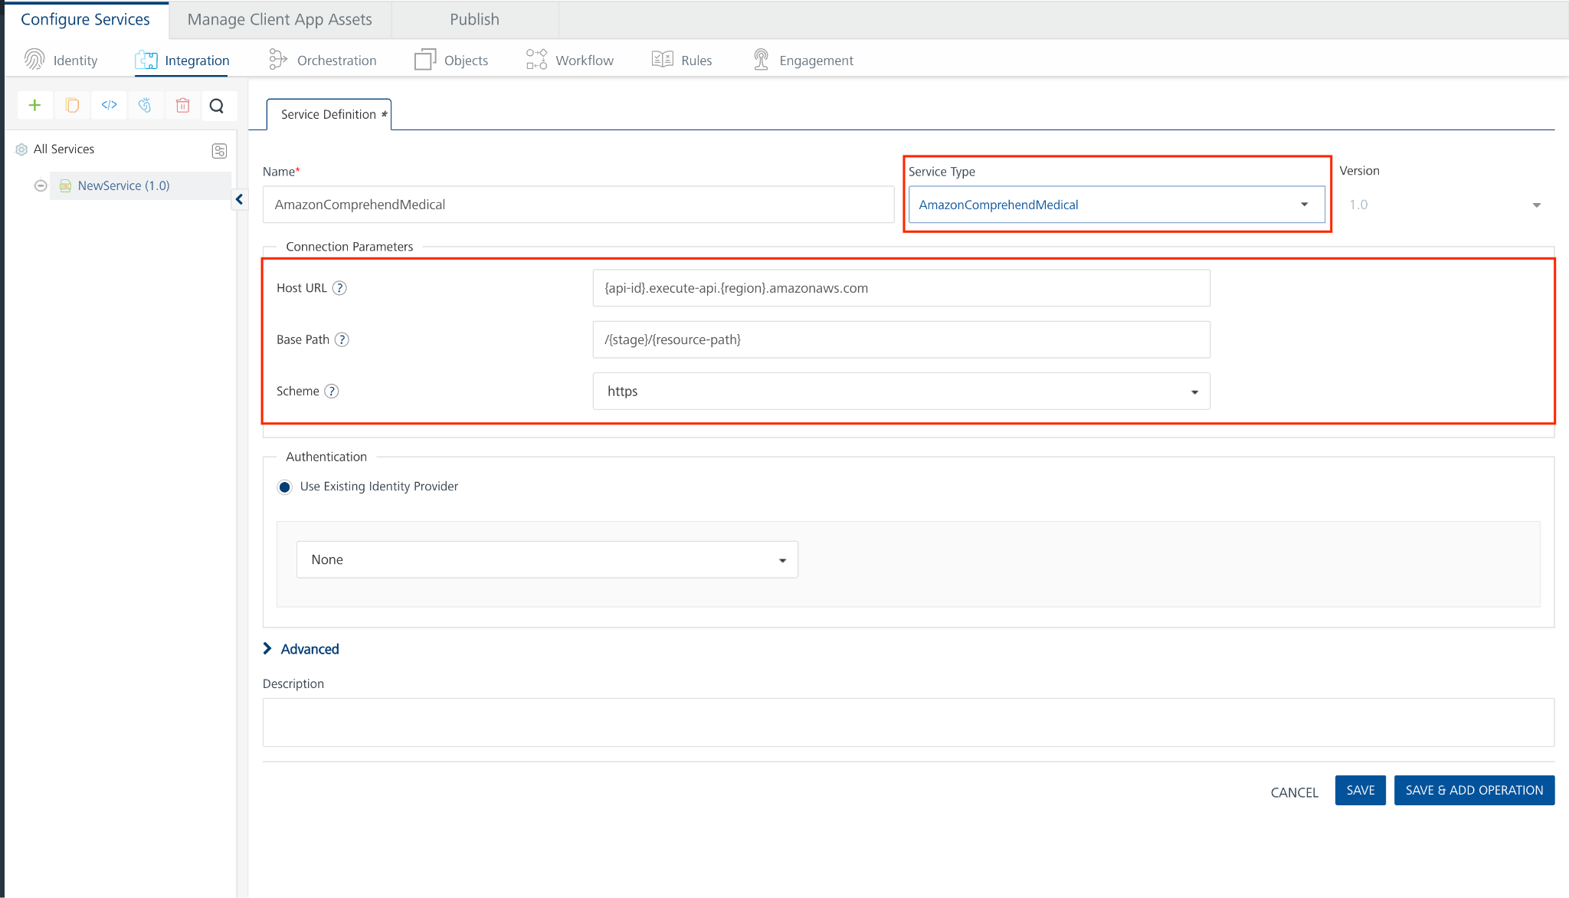
- Replace the Host URL and Base Path values, then click 'Save'.
E. Creating an Operation
To make any API call in the HCL Foundry console, you must create an operation for the respective API and then execute the operation. Executing an operation involves making the API call and displaying the response.
This section provides steps to create an operation for the Amazon Comprehend Medical API.
Steps to create an operation for the Amazon Comprehend Medical API:
- Log on to your HCL Foundry. The Dashboard page appears by default.
- In the left pane, click the API Management menu. The APIs tab opens by default.
- Click the Integration tab. The Integration page appears with a list of existing integration services.
- From the list of integration services, select the integration service that you have created with service type as Amazon Comprehend Medical. The Service Definition tab of the selected integration service opens by default.
- Click the Operations List tab. The Operations List tab opens.
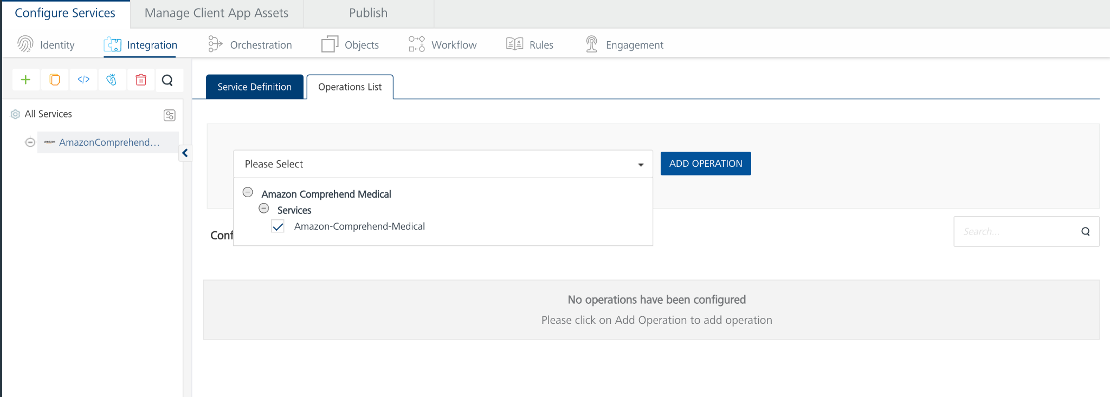
- Select Amazon-Comprehend-Medical and Click Add Operation.

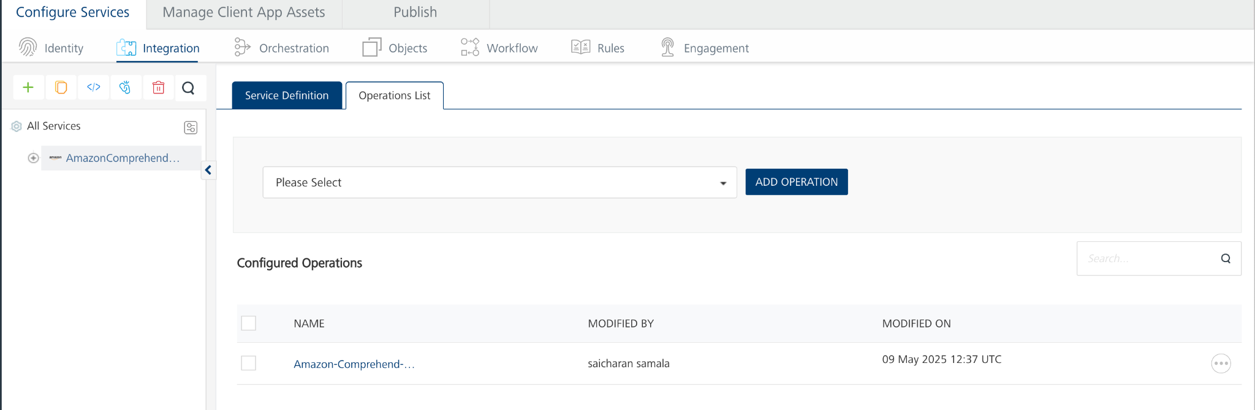

Executing Operation
Executing an operation involves making the API call by setting the necessary parameters and displaying the response. The procedure to execute any operation is same, but the request parameters of the APIs vary. For more information on request parameters of each API refer to link.
This section provides steps to execute the Amazon Comprehend Medical (explained in Creating an Operation).
Steps to execute the Amazon Comprehend Medical operation:
- Log on to your Hcl Foundry. The Dashboard page appears by default.
- In the left pane, click the API Management menu. The APIs tab opens by default.
- Click the Integration tab. The Integration tab opens with a list of existing integration services.
- From the list of integration services, select the integration service that you have created with service type as Amazon Comprehend Medical. The Service Definition tab of the selected integration service opens by default.
- Click the Operations List tab.
- In the Name box, the name of the operation is displayed by default. If you want, you can change the name.
- In the Request Input tab, under the Body section, provide the operation name (as used in the Lambda function code) along with its corresponding input parameters, and in the Headers section, paste the API key.
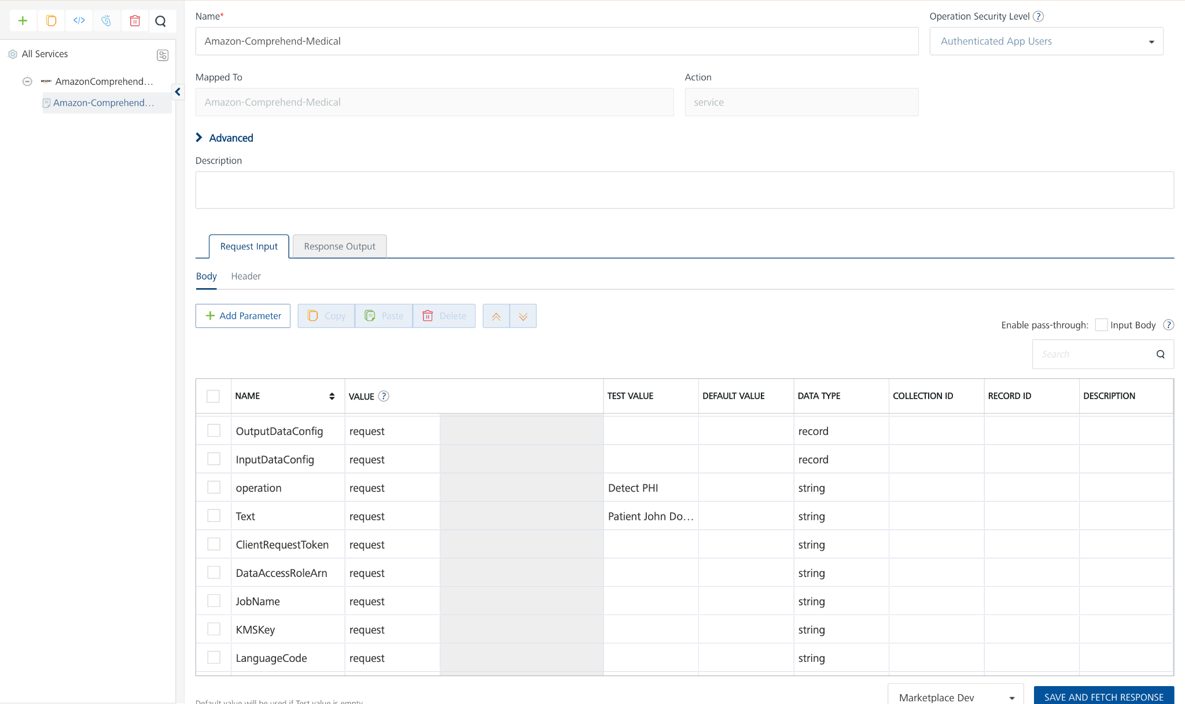
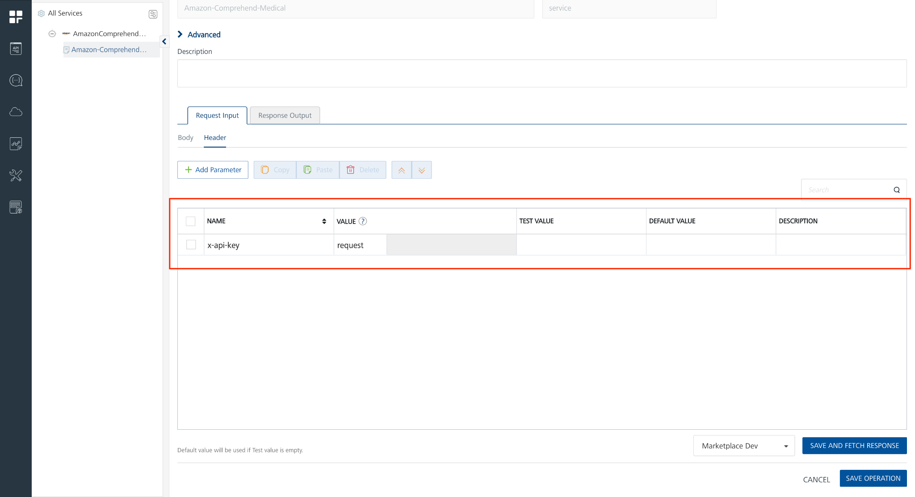
- Click SAVE AND FETCH RESPONSE. The Output Result dialog appears with the response. Otherwise, the Output Result shows an error.
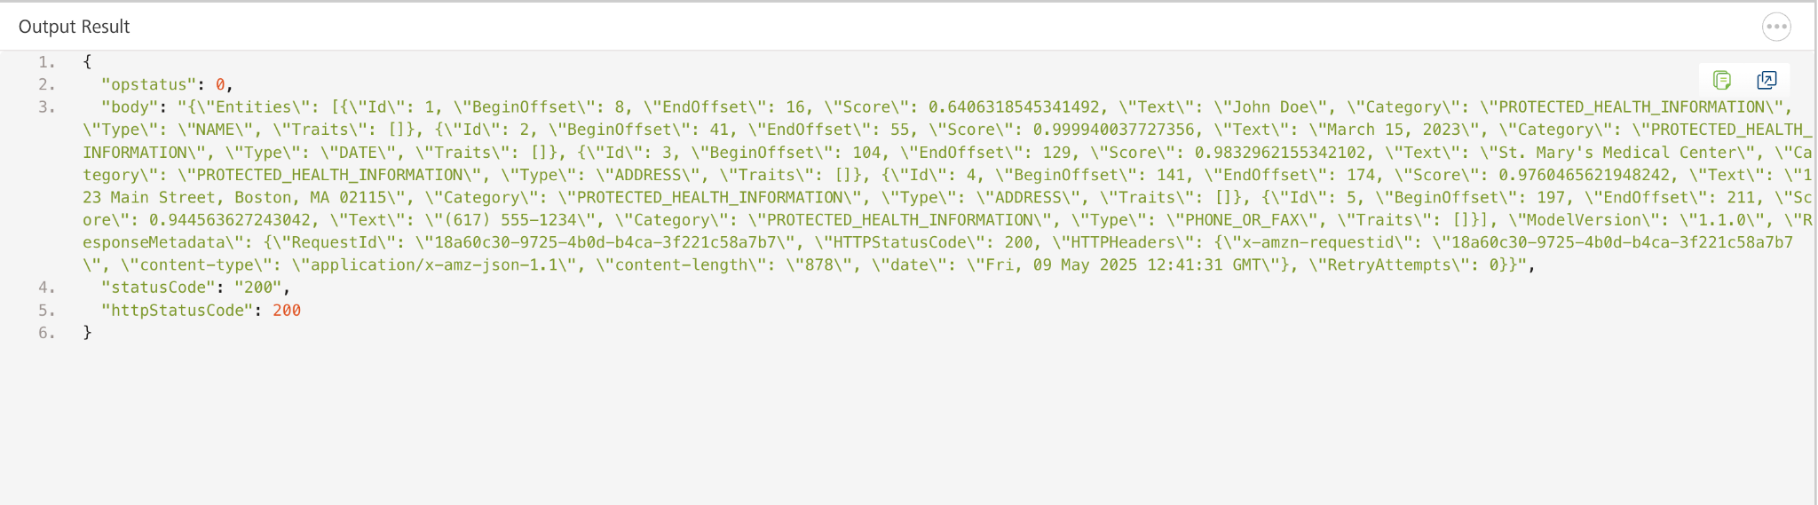

F. Create an IAM Role
- Navigate to IAM in AWS Console:
  - Go to the IAM service.
- Create a New Role:
  - Click Roles -> Create Role.
  - Choose AWS Service as the trusted entity type.
  - Select Lambda as the use case.
- Attach Policies:
  - Attach the following policies:
- AmazonComprehendMedicalFullAccess
- AmazonS3FullAccess
- AWSLambda_FullAccess
- Name and Create the Role:
  - Name the role and create it.

G. Create the Lambda Function
- Navigate to Lambda in AWS Console:
  - Open the Lambda service.
- Create a New Function:
  - Click Create function.
  - Choose Author from scratch.
  - Provide a function name.
  - Choose Python 3.13 as the runtime.
  - Under Change default execution role, select Use an existing role and choose the role created earlier.
- Add Amazon Comprehend Medical Logic:
  - Replace the default code with your Lambda function logic (available here) and click Deploy.

H. Set Up API Gateway
- Navigate to API Gateway in AWS Console:
  - Open the API Gateway service.
- Create a New API:
  - Select Rest API and click Build.
  - Give a Api name and click create Api.
- Create a Resource and Method:
- Click on Create Resource and give Resource Name.
- Select the created Resource and Click Create Method.
- Choose POST as the method type, select Lambda Function and choose your Lambda function.
- In Method Request Settings, enable API Key Required.
- Click Save and Deploy.
- Deployment Stage: Choose New Stage, give Stage Name
- Deploy the API.
- Deploy the API:
- Click Deploy API.
- Select New Stage and enter a Stage Name.
- Click Deploy.

- Create an API Key:
- In API Gateway, go to API Keys.
- Click Create API Key → Select Auto Generate.
- Give any name to the key.
- Click Save.
- Create a Usage Plan & Associate API Key:
- In API Gateway, go to Usage Plans.
- Click Create Usage Plan, give Name, Enable Throttling, Enable Quota.
- Select the usage plan created, under Associated stages select Add Stage. In stage details give API name and Stage created in step-4 and click Add to Usage plan.
- Select the usage plan created, under Associated API Keys select Add API Key. In API key details under Type select Add existing key and Under API Key give API Key Name.
- Deploy Api.
- Note the API Endpoint:
- Under Stages, find the Invoke URL.
- Replace the Host and Paths in your Amazon Comprehend Medical Adapter with this Invoke URL.

3. Publishing the App in HCL FOUNDRY:
After adding the Amazon Comprehend Medical Data Adapter to your app and configuring the necessary configurations, you must publish the app to HCL Foundry. For more information, refer to Publish a foundry app.

4. REFERENCES

Amazon Comprehend Medical Actions

5. REVISION HISTORY
Adapter version 1.0.0:
- Known Issues
None
- Limitations
None

