3 March 2025

AMAZON LEX

VERSION: 1.0.0

Overview

Amazon Lex is a fully managed AI service for building conversational interfaces using voice and text.It enables the creation of chatbots and virtual assistants powered by the same technology as Alexa.Lex uses deep learning for automatic speech recognition (ASR) and natural language understanding (NLU).It integrates easily with AWS Lambda, Amazon Connect, and other AWS services for scalable deployment.

Percentage of re-use:
Approximately 80% of reuse

Use case:
- Automate responses to common customer support queries and escalate complex issues to human agents.
- Power voice interfaces for mobile apps, smart devices, or IVR systems in call centers.
- Enable users to book, reschedule, or cancel appointments through conversational interfaces.
- Help customers place, track, or cancel orders in e-commerce or delivery platforms.
- Assist employees with HR or IT-related queries like onboarding, password resets, or troubleshooting.

Getting Started

Prerequisites
Before you start using the Amazon Lex Data Adapter, ensure you have the following:
- An account with AWS
- Volt MX Iris
- HCL Foundry

Importing the app

You can import Amazon Lex Data Adapter into HCL Foundry directly from the voltmx Forge website or by importing the data adapter zip file.

To import the data adapter zip file, do the following:
- Log on to your HCL Foundry. The Dashboard page appears by default.
- In the left pane, click the API Management menu. The APIs tab opens by default.

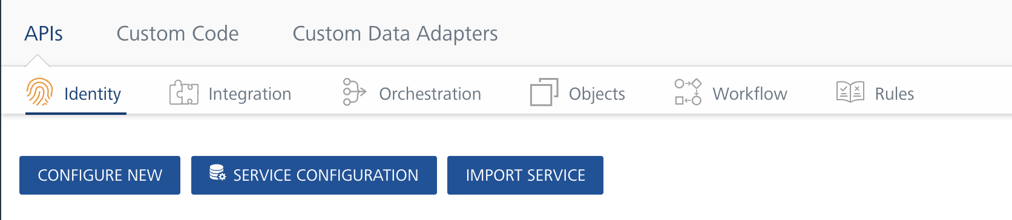

Click the Custom Data Adapters tab. The Custom Data Adapter page appears.

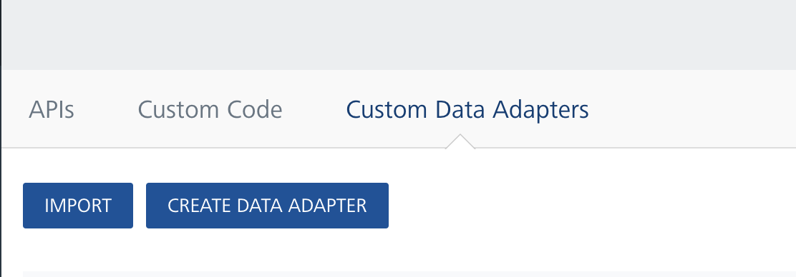

Click Import. The Import Data Adapter dialog appears.

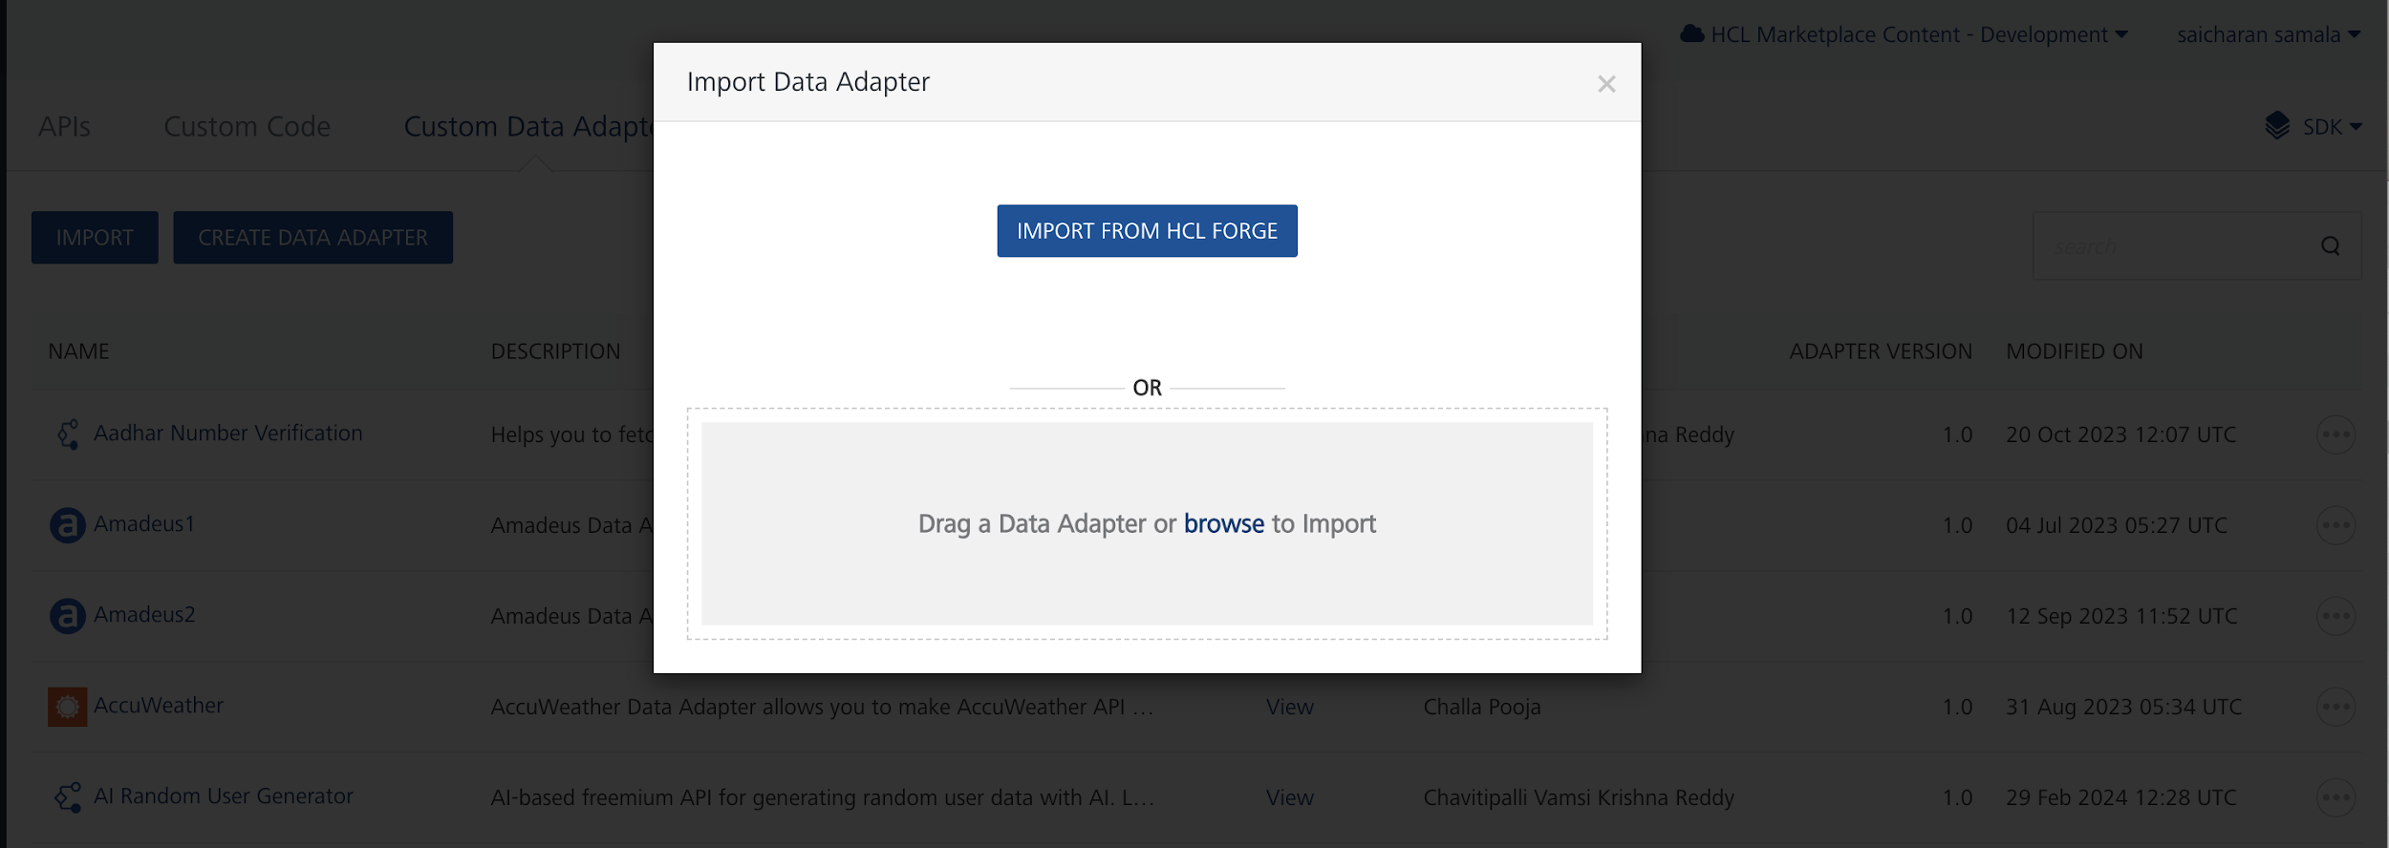

- Click IMPORT FROM HCL FORGE. The Import Data Adapter from HCL Forge dialog appears with a list of available data adapters.
- Click Import. Amazon Lex data adapter is listed on the Custom Data Adapters page.
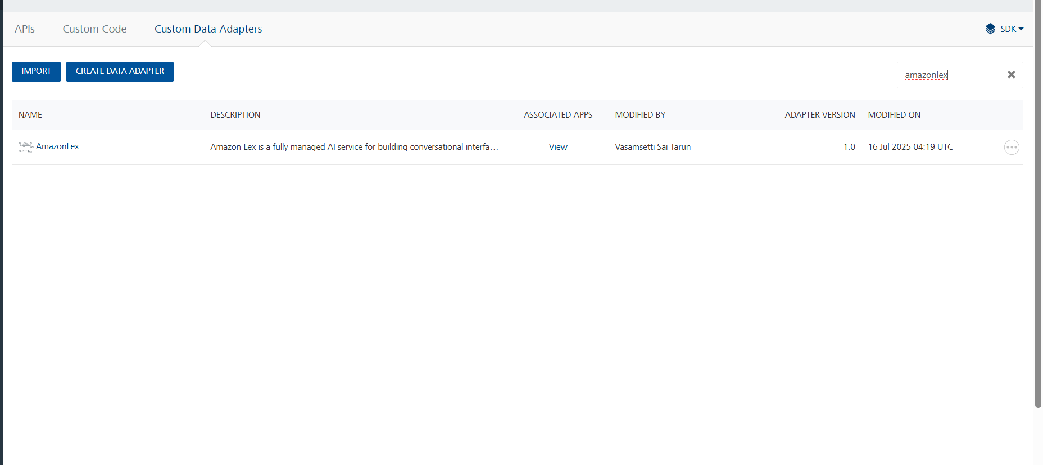

To import the data adapter zip file, do the following:
- Perform steps 1 to 4 in the above procedure
- Drag the data adapter zip file into the Drag Data Adapter box.
Or
Click browse. The Open dialog appears.
Navigate to the location where you downloaded the data adapter (zip file) on your computer, select the data adapter, and click Open. The Import Data Adapter dialog shows the selected data adapter.
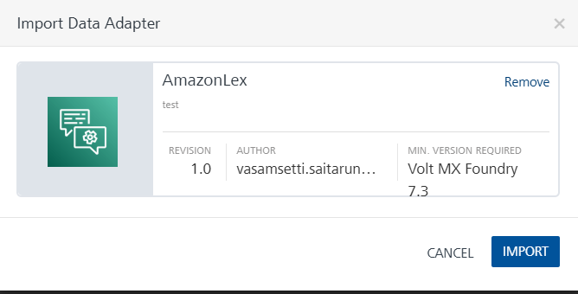

Creating an Integration Service with Amazon Lex:
After you import Amazon Lex Data Adapter into Foundry, you must create an integration service with service type as Amazon Lex .
To create an integration service with Amazon Lex, do the following:
- Log on to your HCL Foundry. The Dashboard page appears by default.
- In the left pane, click the API Management menu. The APIs tab opens by default.
- Click the Integration tab. The Integration tab opens with a list of existing integration services.
- Click CONFIGURE NEW. The Service Definition tab opens.
- In the Name box, type a unique name for your service.
- From the Service Type list, select Amazon Lex.
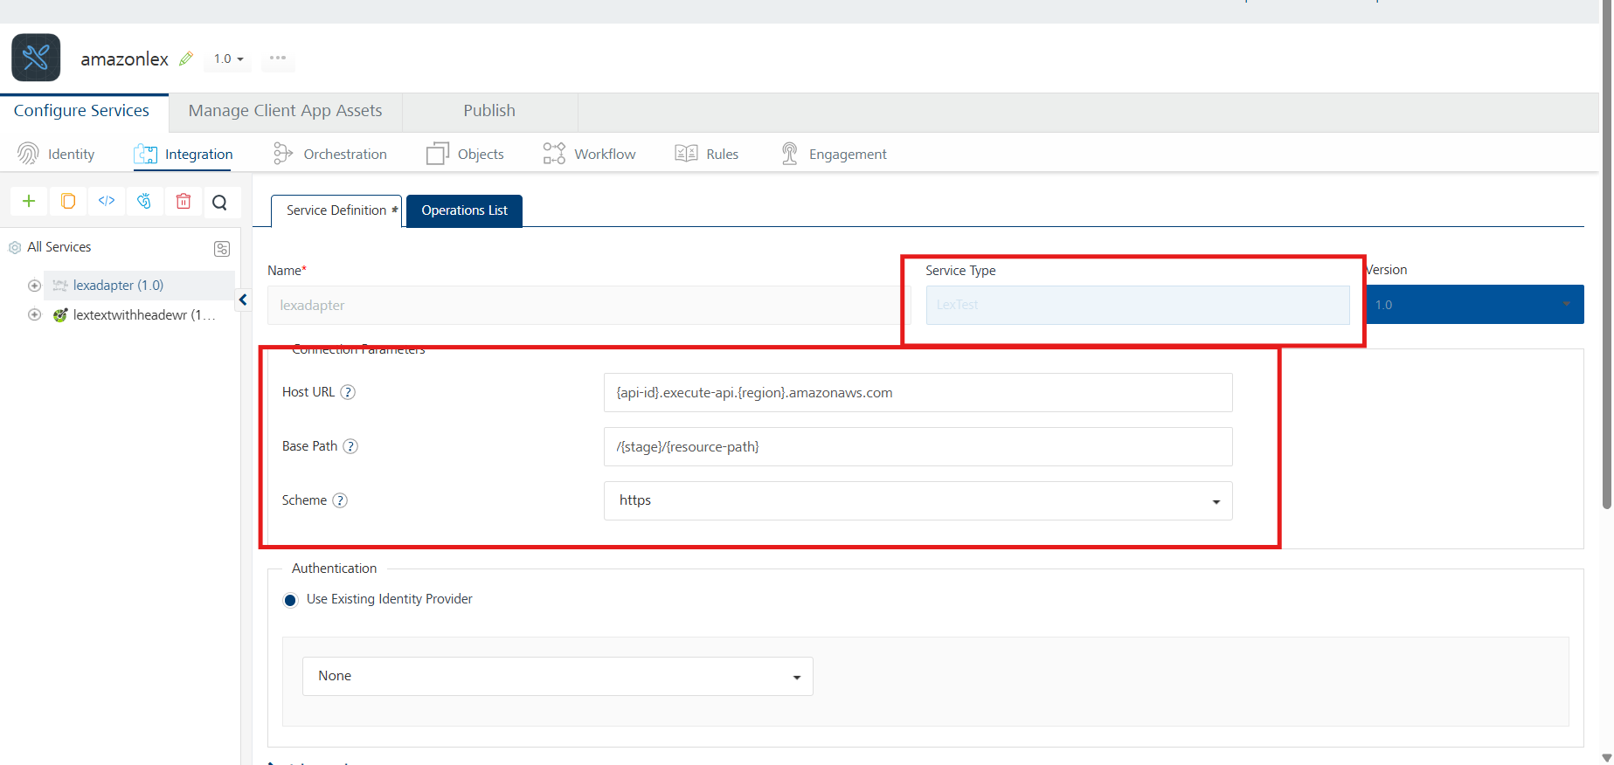
- Replace the Host URL and Base Path values, then click 'Save'.

Creating an Operation
To make any API call in the HCL Foundry console, you must create an operation for the respective API and then execute the operation. Executing an operation involves making the API call and displaying the response.
This section provides steps to create an operation for the Amazon Lex API.
Steps to create an operation for the Amazon Lex API:
- Log on to your HCL Foundry. The Dashboard page appears by default.
- In the left pane, click the API Management menu. The APIs tab opens by default.
- Click the Integration tab. The Integration page appears with a list of existing integration services.
- From the list of integration services, select the integration service that you have created with service type as Amazon Lex. The Service Definition tab of the selected integration service opens by default.
- Click the Operations List tab. The Operations List tab opens.
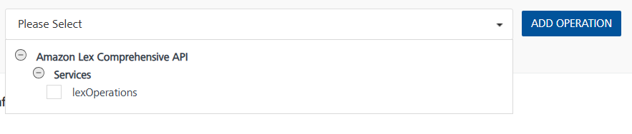
- Select Amazon-Lex and Click Add Operation.

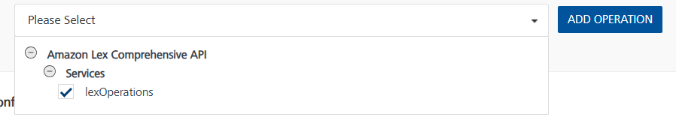

Executing Operation
Executing an operation involves making the API call by setting the necessary parameters and displaying the response. The procedure to execute any operation is the same, but the request parameters of the APIs vary. For more information on request parameters of each API refer to the link.
This section provides steps to execute the Amazon Lex (explained in Creating an Operation).
Steps to execute the Amazon Lex operation:
- Log on to your Hcl Foundry. The Dashboard page appears by default.
- In the left pane, click the API Management menu. The APIs tab opens by default.
- Click the Integration tab. The Integration tab opens with a list of existing integration services.
- From the list of integration services, select the integration service that you have created with service type as Amazon Lex. The Service Definition tab of the selected integration service opens by default.
- Click the Operations List tab.

- In the Name box, the name of the operation is displayed by default. If you want, you can change the name.

- In the Request Input tab, under the Body section, provide the operation name (as used in the Lambda function code) and its corresponding input parameters.
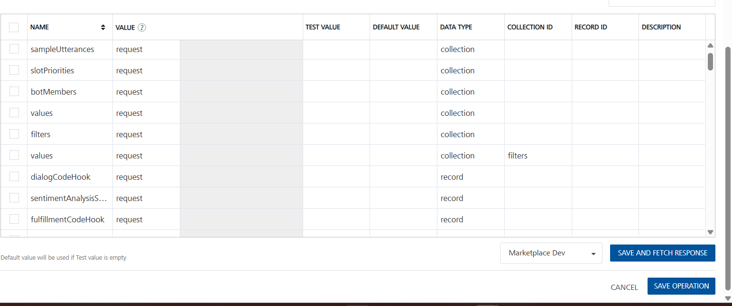

- Enter the X-api-key (API key)value that is created in the Set up API Gateway in default value.
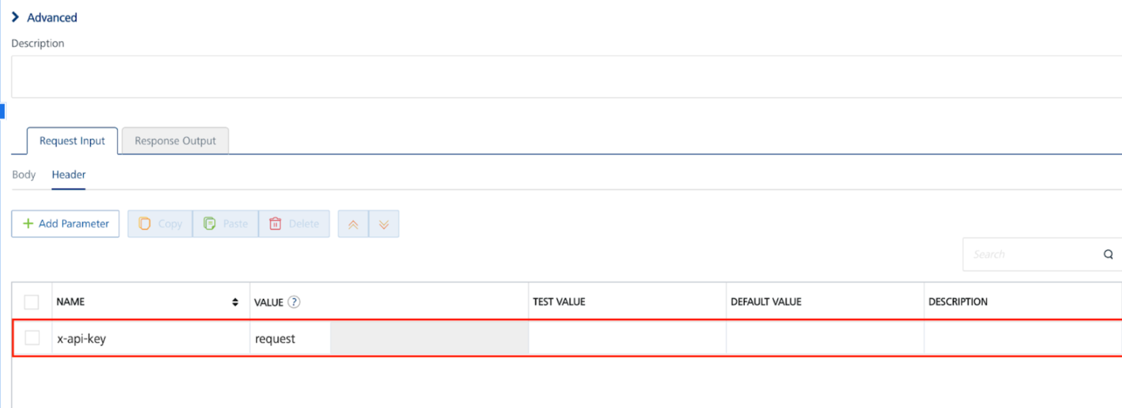
- Click SAVE AND FETCH RESPONSE. The Output Result dialog appears with the response. Otherwise, the Output Result shows an error.
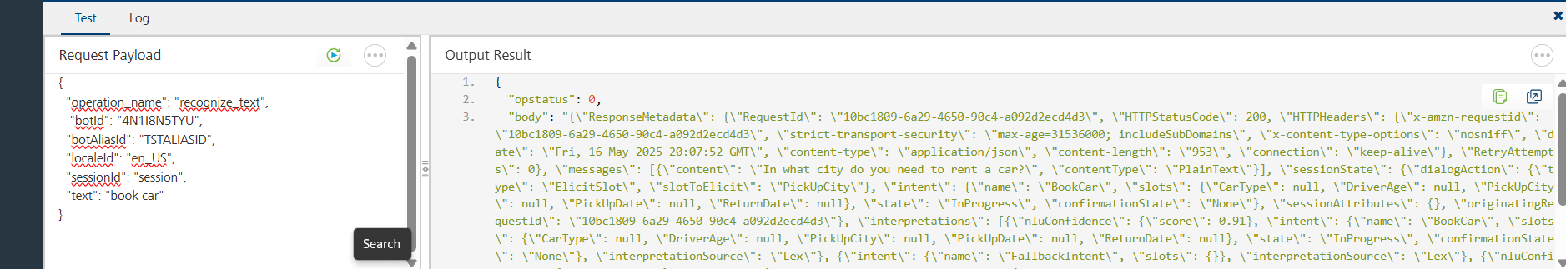

D. Create an IAM Role
- Navigate to IAM in AWS Console:
  - Go to the IAM service.
- Create a New Role:
  - Click Roles -> Create Role.
  - Choose AWS Service as the trusted entity type.
  - Select Lambda as the use case.
- Attach Policies:
  - Attach the following policies:
- AmazonLexFullAccess.
- AWSLambda_FullAccess
- Name and Create the Role:
  - Name the role and create it.

E. Create the Lambda Function
- Navigate to Lambda in AWS Console:
  - Open the Lambda service.
- Create a New Function:
  - Click Create function.
  - Choose Author from scratch.
  - Provide a function name.
  - Choose Python 3.13 as the runtime.
  - Under Change default execution role, select Use an existing role and choose the role created earlier.
- Add Amazon Lex Logic:
  - Replace the default code with your Lambda function logic(⦁ available here) and click Deploy.

F. Set Up API Gateway
- Navigate to API Gateway in AWS Console:
  - Open the API Gateway service.
- Create a New API:
  - Select Rest API and click Build.
  - Give an Api name and click create Api.
- Create a Resource and Method:
- Click on Create Resource and give Resource Name.
- Select the created Resource and Click Create Method.
- Choose POST as the method type, select Lambda Function and choose your Lambda function.
- In Method Request Settings, enable API Key Required.
- Click Save and Deploy.
- Deployment Stage: Choose New Stage, give Stage Name
- Deploy the API.
- Deploy the API:
- Click Deploy API.
- Select New Stage and enter a Stage Name.
- Click Deploy.

- Create an API Key:
- In API Gateway, go to API Keys.
- Click Create API Key → Select Auto Generate.
- Give any name to the key.
- Click Save.
- Create a Usage Plan & Associate API Key:
- In API Gateway, go to Usage Plans.
- Click Create Usage Plan, give Name, Enable Throttling, Enable Quota.
- Select the usage plan created, under Associated stages select Add Stage. In stage details give API name and Stage created in step-4 and click Add to Usage plan.
- Select the usage plan created, under Associated API Keys select Add API Key. In API key details under Type select Add existing key and Under API Key give API Key Name.
- Deploy Api.
- Note the API Endpoint:
- Under Stages, find the Invoke URL.
- Replace the Host and Paths in your Amazon Lex Adapter with this Invoke URL.

3. Publishing the App in HCL FOUNDRY:
After adding the Amazon Lex Data Adapter to your app and configuring the necessary configurations, you must publish the app to HCL Foundry. For more information, refer to Publish a foundry app.
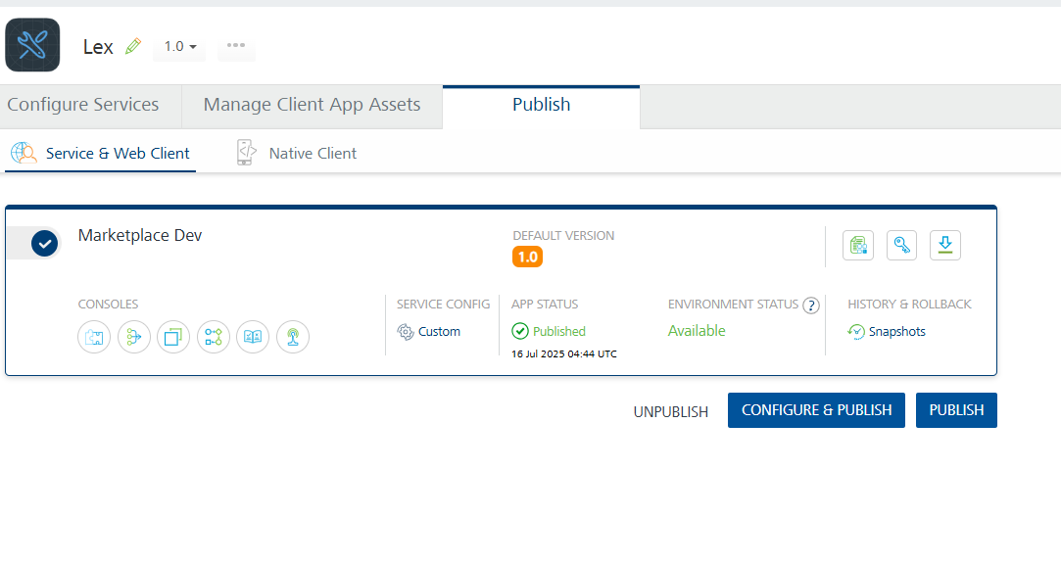

4. REFERENCES

Amazon Lex Actions

5. REVISION HISTORY
Adapter version 1.0.0:
- Known Issues
None
- Limitations
None

