Date : 23-Sep-25

AMAZON LOCATION SERVICE

VERSION: 1.0.0

OVERVIEW
Amazon Location Service is a fully managed cloud-based service from AWS that makes it easy to add location functionality to your applications. With built-in support for maps, places, geocoding, geofencing, routing, and tracking, it allows developers to integrate rich geospatial features without having to manage complex infrastructure, licensing, or scaling concerns.
Instead of building and maintaining your own mapping and routing solutions, Amazon Location Service provides secure, reliable, and scalable APIs that integrate seamlessly with other AWS services. Organizations can quickly enable geospatial use cases such as real-time tracking, delivery routing, location-aware apps, and geofencing alerts — all while retaining control of their data.
By leveraging location data from trusted providers (such as Esri and HERE), the service ensures high-quality mapping and routing information. Built-in AWS security, including encryption and fine-grained IAM controls, keeps your sensitive location data protected.

Use case:
Amazon Location Service can be applied across industries and scenarios:
- Transportation & Logistics: Optimize delivery routes, track fleet locations, and reduce costs with real-time routing and tracking.
- Retail & E-commerce: Provide store locators, delivery tracking, and personalized customer experiences based on location.
- Travel & Hospitality: Enhance booking apps with maps, POI (point-of-interest) search, and navigation features for tourists.
- Smart Cities & IoT: Power geofencing, asset monitoring, and connected devices with reliable location intelligence.
- Field Services & Workforce: Track employees in the field, optimize service visits, and improve scheduling.
- Emergency Services: Enable dispatchers to locate incidents quickly and provide optimal routes for emergency responders.

Features:
- Maps & Visualization – Add high-quality vector maps, styles, and overlays to your applications.
- Places (Geocoding & Search) – Convert between addresses and geographic coordinates, search for points of interest.
- Routing & Directions – Calculate routes, travel times, and optimized directions across multiple modes (car, truck, walking).
- Data Privacy & Security – Retain full ownership of location data, with AWS-managed security and encryption.
- Scalable & Reliable – Built on AWS infrastructure to support millions of requests per second.
- Pay-as-you-go Pricing – Cost-effective, no upfront licensing fees compared to traditional GIS solutions.

Percentage of re-use:
80% (Data can be customizable and customers need to implement UI by themselves).

GETTING STARTED

Prerequisites
Before you start using the Amazon Location Service data adapter, ensure you have the following:

- HCL Foundry
- Volt MX Iris
- An AWS account.If you do not have an AWS account, create one.
Reference document:
https://docs.aws.amazon.com/location/latest/developerguide/set-up.html

Importing the adapter
To import the Amazon Location Service Adapter to Volt MX Foundry, do the following:
- Sign in to the HCL Foundry
- In the left pane, click the API Management menu. The APIs tab opens by default.
- In API Management, select Custom Data Adapters.
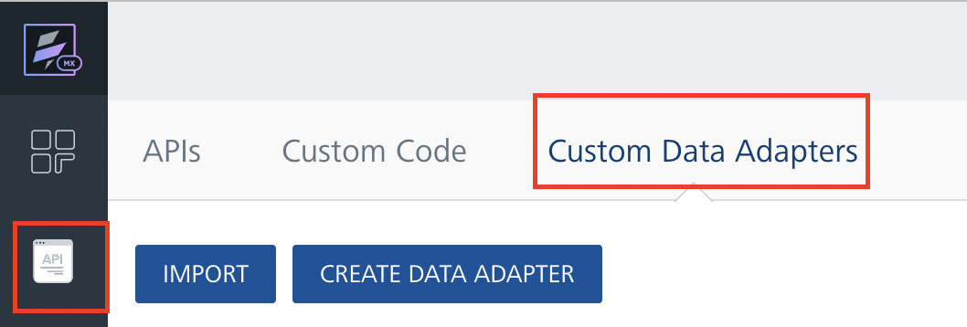
- Click IMPORT to import a custom data adapter.
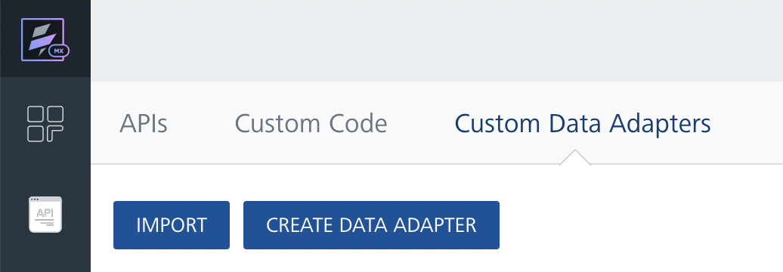
- On the Import Data Adapter dialog box, click browser to import.
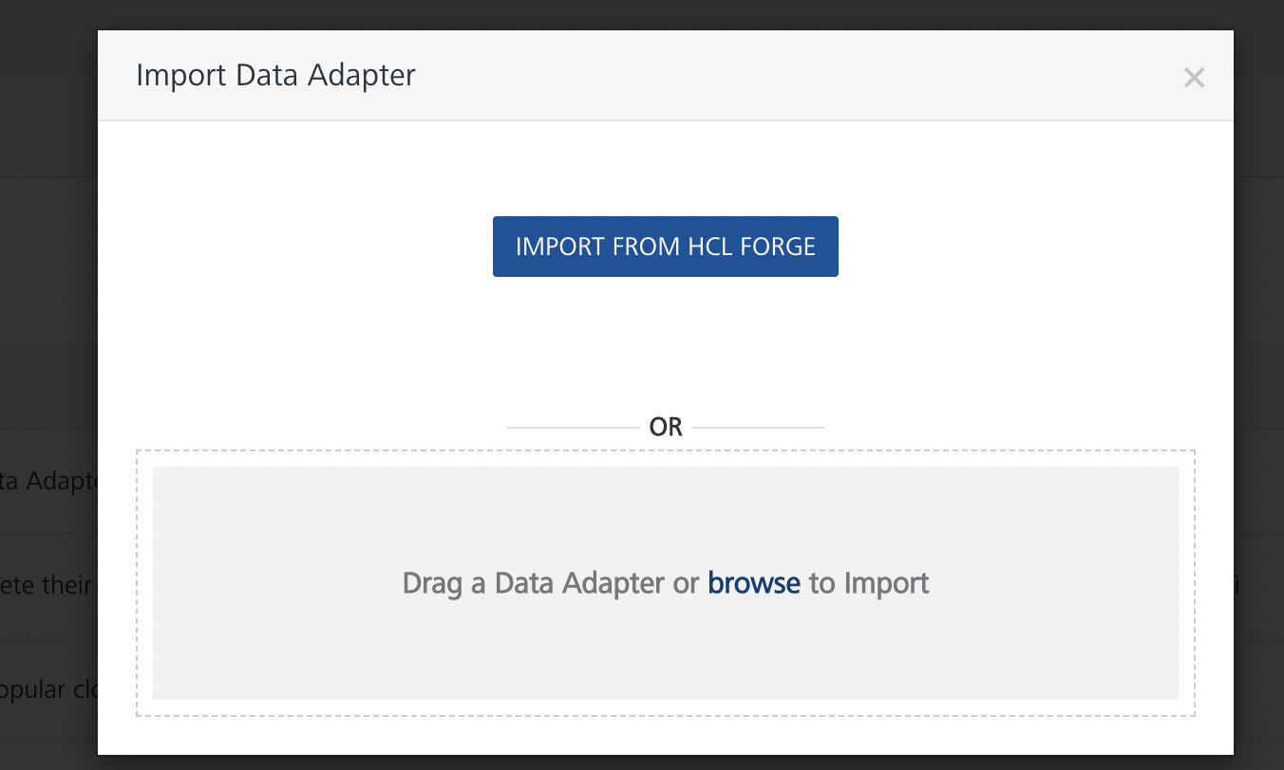
- Drag the data adapter zip file into the Drag Data Adapter box.
Or
Click browse. The Open dialog appears.
Navigate to the location where you downloaded the data adapter (zip file) on your computer, select the data adapter, and click Open. The Import Data Adapter dialog shows the selected data adapter.
Note: Click Remove if the selected data adapter is not the one that you want to import.
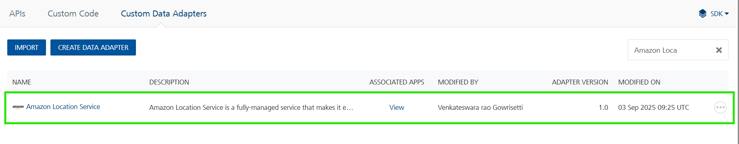
OR
To import the data adapter zip file, do the following:
- Perform steps 1 through 4 in the above procedure
- Click IMPORT FROM HCL FORGE. The Import Data Adapter from HCL Forge dialog appears with a list of available data adapters.
- Click Import.The Amazon Location Service data adapter is listed on the Custom Data Adapters page.
After you import the data adapter, you can view it on the Custom Data Adapters page and use it to create services on Volt MX Foundry.
After you add the data adapter to your Volt Foundry app, you need to get your endpoint and key from Amazon Location Console.

Creating an Integration Service with Amazon Location Service
After you import Amazon Location Service Data Adapter into Volt MX Foundry, you must create an integration service with service type as Amazon Location Service.
To create an integration service with Amazon Location Service, do the following:
- Log on to your HCL Foundry The Dashboard page appears by default.
- In the left pane, click the API Management menu. The APIs tab opens by default.
- Click the Integration tab. The Integration tab opens with a list of existing integration services.
- Click CONFIGURE NEW. The Service Definition tab opens.
- In the Name box, type a unique name for your service.
- From the Service Type list, select Amazon Location Service.
Note: The Amazon Location Service is listed only after you import the Amazon Location Service Data Adapter into Volt MX Foundry.
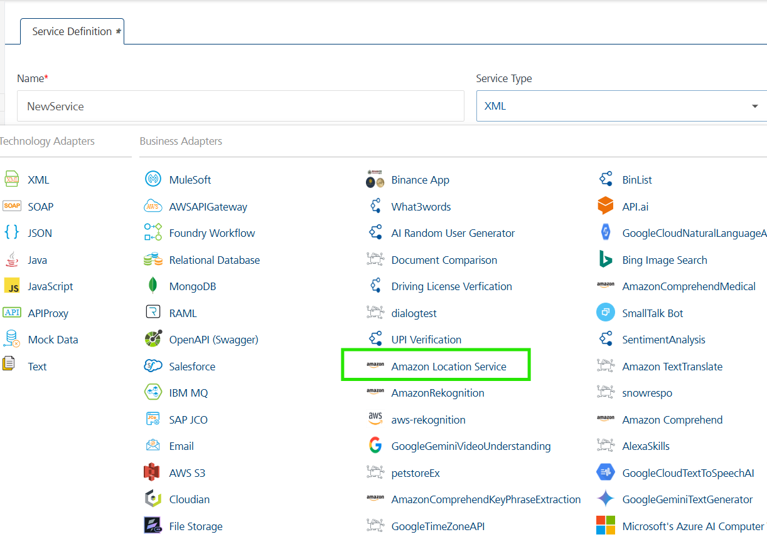
- Click Save.
If the details provided are valid, the Volt MX Foundry service connects to your Amazon Location Service developer site and allows you to make the API calls.
Refer to Integration Services for more information on creating and using integration services.

Creating an Operation
To make any API call in the Volt MX Foundry console, you must create an operation for the respective API and then execute the operation. Executing an operation involves making the API call and displaying the response. For more information, see Executing an Operation.
This section provides steps to create an operation for the Routes API.
Steps to create an operation for the Routes API:
- Log on to your HCL Foundry. The Dashboard page appears by default.
- In the left pane, click the API Management menu. The APIs tab opens by default.
- Click the Integration tab. The Integration page appears with a list of existing integration services.
- From the list of integration services, select the integration service that you have created with service type as Amazon Location Service. The Service Definition tab of the selected integration service opens by default.
- Click the Operations List tab. The Operations List tab opens.
- Click the context menu arrow to expand the Please Select list. The service is displayed.
- Click the plus icon to expand the list.
- Click the plus icon to expand the Services list and select Routes.
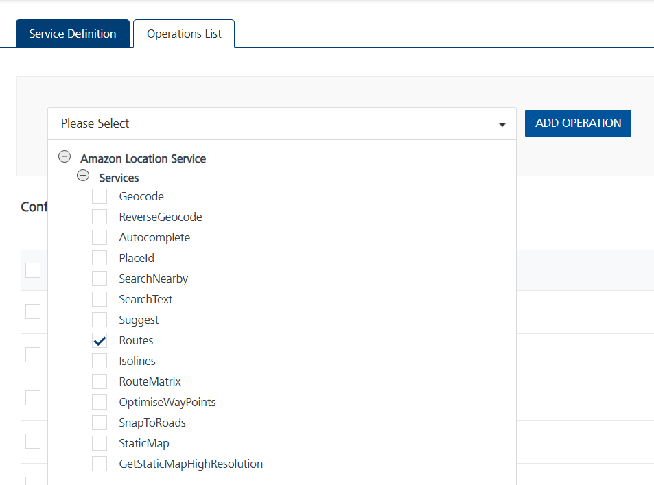
- Click ADD OPERATION. The Routes operation is listed in the Configured Operations section.
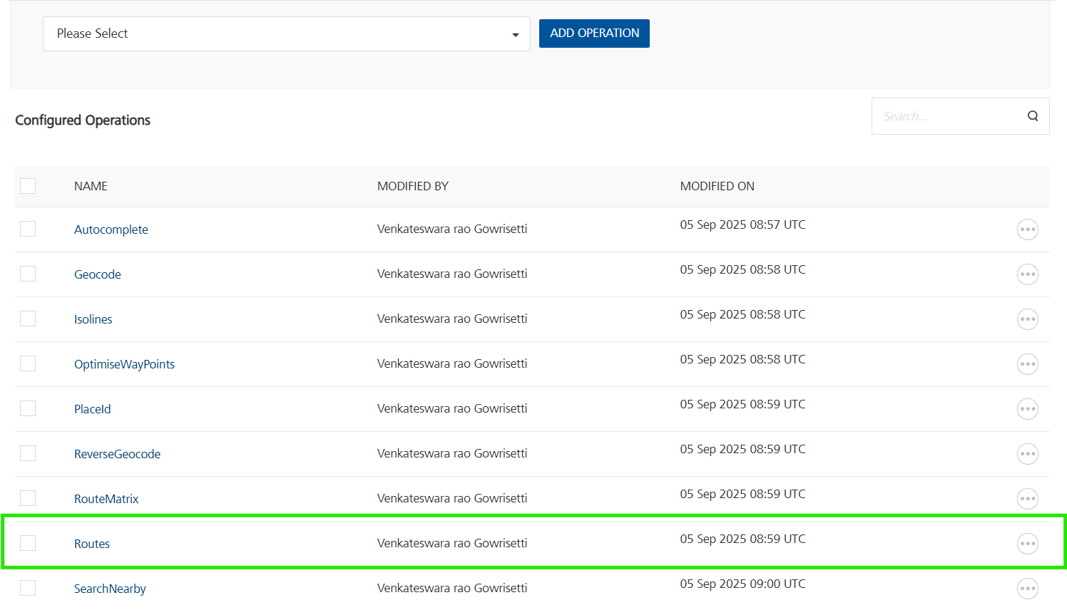
Note: You can follow the same steps to create operations for other methods, but ensure that you select the required API.
You can create multiple operations with required APIs and save them in the Configured Operations section. You can then execute the operations whenever required.
For the Host URL, replace the value of service and region with your Amazon Location Service API endpoint URL mentioned in Amazon Location Service API. Refer Amazon Location Service.
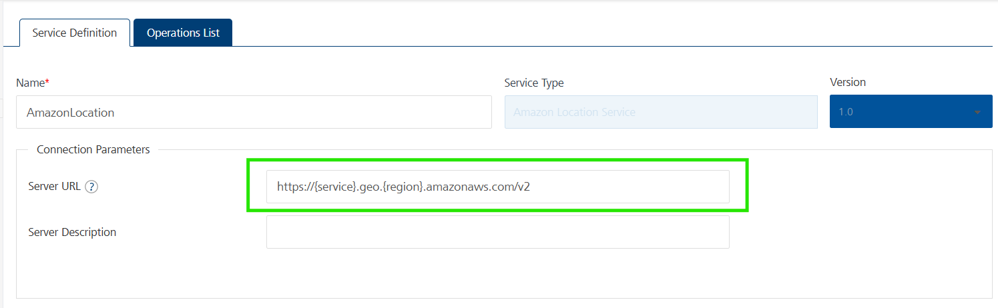

Executing an Operation
Executing an operation involves making the API call by setting the necessary parameters and displaying the response. The procedure to execute any operation is the same, but the request parameters of the APIs vary. For more information on request parameters of API, refer Amazon Location Service.
This section provides steps to execute the Routes operation (explained in Creating an Operation).
Steps to execute the Routes operation:
- Log on to your HCL Foundry. The Dashboard page appears by default.
- In the left pane, click the API Management menu. The APIs tab opens by default.
- Click the Integration tab. The Integration tab opens with a list of existing integration services.
- From the list of integration services, select the integration service that you have created with the service type as Amazon Location Service. The Service Definition tab of the selected integration service opens by default.
- Click the Operations List tab.
- Under the Configured Operations section, click the Routes operation. The Routes tab opens with the Request Input sub-tab opened by default.
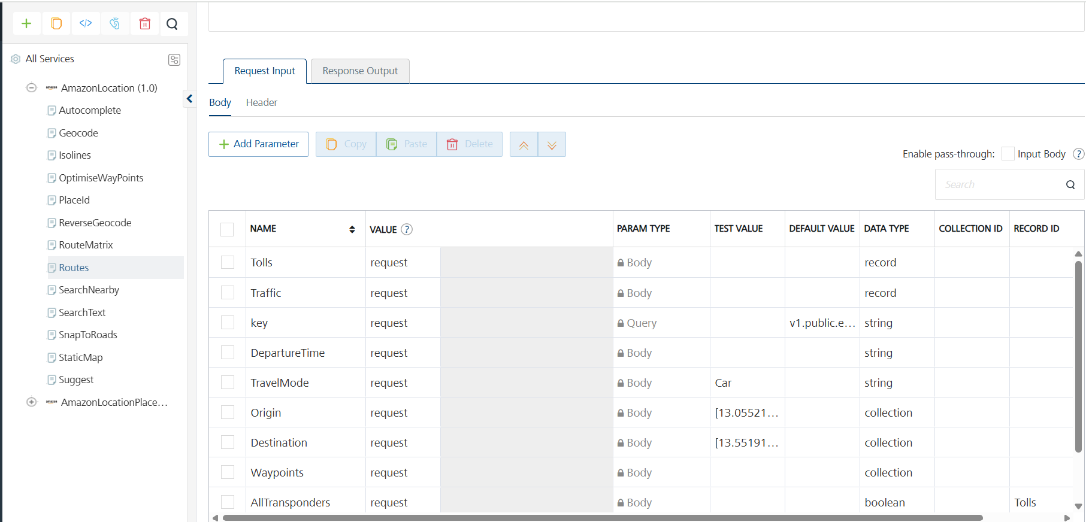

- In the Name box, the name of the operation is displayed by default. If you want, you can change the name.
- On the Request Input tab, in the Body section, for the following parameters, specify the values in the respective boxes under the Test Value column.
Mandatory Parameters
- Origin: The start position of the route in longitude and latitude.
- Destination:The end position of the route.
- TravelMode:Specifies the mode of transport when calculating a route. Used in estimating the speed of travel and road compatibility. You can choose Car, Truck, Walking, Bicycle or Motorcycle as options for the TravelMode.
- Key:API key to authorize the request.
- For Key, In the box under the TEST VALUE and DEFAULT VALUE columns, type the API Key generated from Amazon Location Console.
For more information refer to this Amazon Location Service Operations .
- Click SAVE OPERATION.
- Click SAVE AND FETCH RESPONSE. The Output Result dialog appears with the response. Otherwise, the Output Result shows an error.
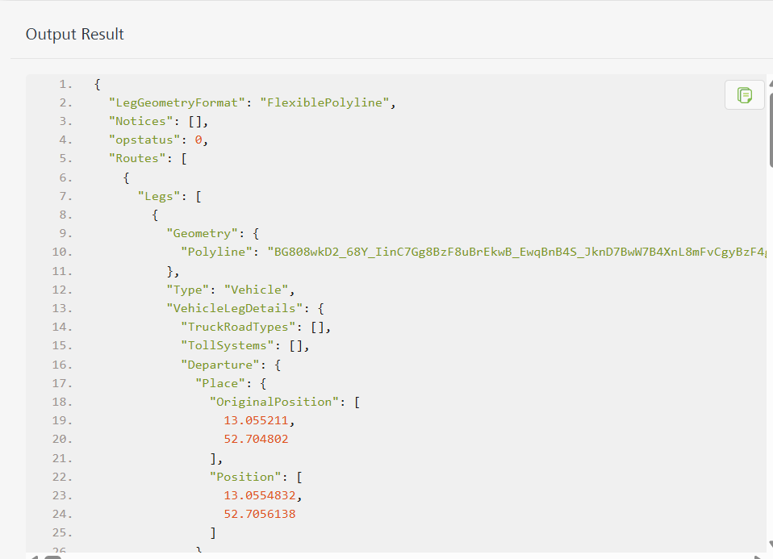

Publishing the App to Volt MX Foundry
After adding Amazon Location Service to your app and configuring the necessary configurations, you must publish the app to Volt MX Foundry. For more information, refer to Publish a Project to Volt MX Foundry.
If you want to use the services in client applications, you need to publish the app to a run-time environment.
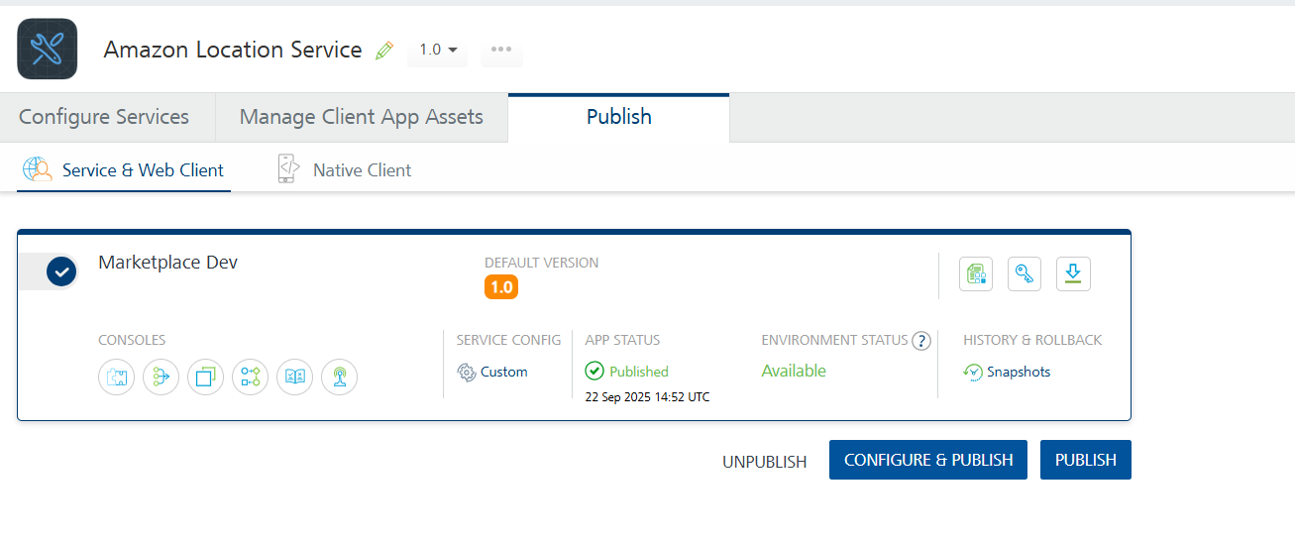
You can also link the Volt Foundry app to a client application.

Reference Documents:
- https://docs.aws.amazon.com/location/latest/developerguide/what-is.html
- https://docs.aws.amazon.com/location/previous/APIReference/API_Operations.html

REVISION HISTORY
App version 1.0.0:

Known Issues
None

Limitations
None

