Date : 23-Sep-25

AMAZON LOCATION SERVICE

VERSION: 1.0.0

OVERVIEW
Amazon Location Service is a fully managed cloud-based service from AWS that makes it easy to add location functionality to your applications. With built-in support for maps, places, geocoding, geofencing, routing, and tracking, it allows developers to integrate rich geospatial features without having to manage complex infrastructure, licensing, or scaling concerns.
Instead of building and maintaining your own mapping and routing solutions, Amazon Location Service provides secure, reliable, and scalable APIs that integrate seamlessly with other AWS services. Organizations can quickly enable geospatial use cases such as real-time tracking, delivery routing, location-aware apps, and geofencing alerts — all while retaining control of their data.
By leveraging location data from trusted providers (such as Esri and HERE), the service ensures high-quality mapping and routing information. Built-in AWS security, including encryption and fine-grained IAM controls, keeps your sensitive location data protected.

Requirements:

- HCL Foundry
- Volt MX Iris
- An AWS account.If you do not have an AWS account, create one.
Reference document:
https://docs.aws.amazon.com/location/latest/developerguide/set-up.html

Devices:
- Mobile

Platforms:
- Android
- IOS

Features
- Maps & Visualization – Add high-quality vector maps, styles, and overlays to your applications.
- Places (Geocoding & Search) – Convert between addresses and geographic coordinates, search for points of interest.
- Routing & Directions – Calculate routes, travel times, and optimized directions across multiple modes (car, truck, walking).

App Functionality
When you build and run the app, you can get route and distance between Origin and Destination places
- Home Screen (frmSearchRoutes)
  - User enters Origin and destination places.
  - “Get Route” button triggers places API to get origin and destination coordinates and Routes API to get distance between the places.
- Authentication
  - The app authenticates the user through API Key from foundry during requests.
- Process
  - Sends a place API search text request to Amazon, to get Origin and Destination coordinates .
  - Sends those coordinates to Routes API Find route request to get distance between the places..

- Result Retrieval & Display
  - Display the Map with origin and destination places.
  - Displays display between the places..
- Back Navigation
- Return to Home Screen to get route for another places.

Importing the app
To import the Amazon Location Application into your workspace, follow these steps:
- Open Volt MX Iris
- On the main menu select Forge → Browse.
- Search for the Amazon Location Application, and then click Import to Workspace. The app is imported to your workspace. A dialog box appears, confirming that the app has been imported. Click OK.
- Switch to your project containing the Amazon Location Application. To switch to your project, click File → Open → Reference Architecture → <project name>

Building the app
After performing all the above steps, you can build your app and run it on your device. For more information, you can refer to the Building and Viewing an Application section of the Volt MX User Guide.
You can then run your app to see the Amazon Location Service work in real time.

Configure the UI and settings of the Amazon Location Application

The Amazon Location Application consists of the following key components:
- Routing Component – Calculates distance between origin and destination estimated on the map.
UI Configuration
- Create the Home Screen
  - Add a TextBoxes for entering the Origin and Destination places .
  - Add a Button to get distance between the places .
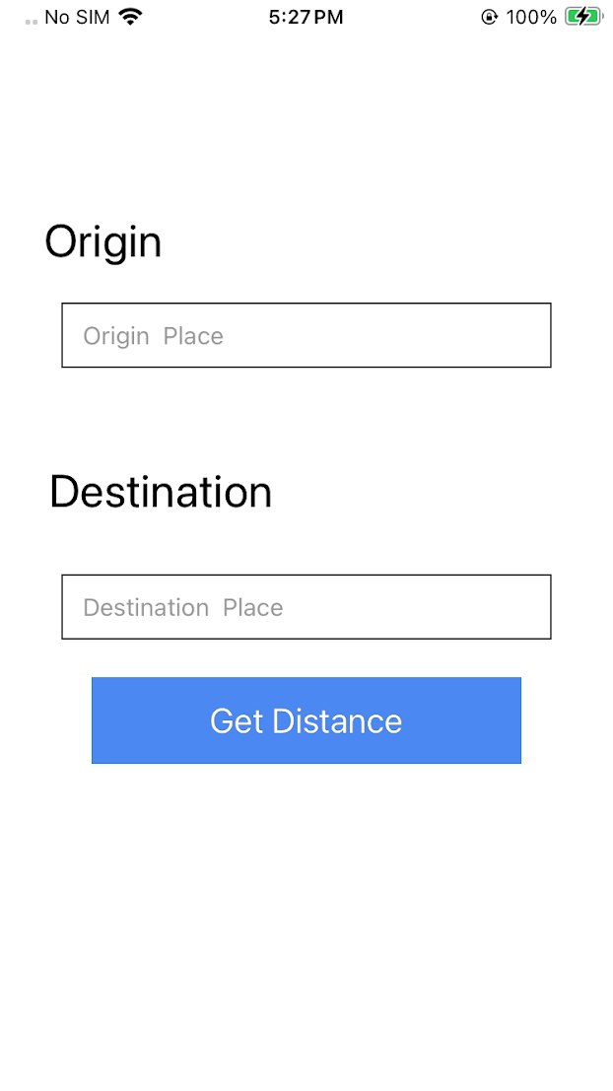
- Create the Distance Result Screen
  - Add a Browser widget inside a flex container to display the map.
  - Map loads the distance between origin and destination places..

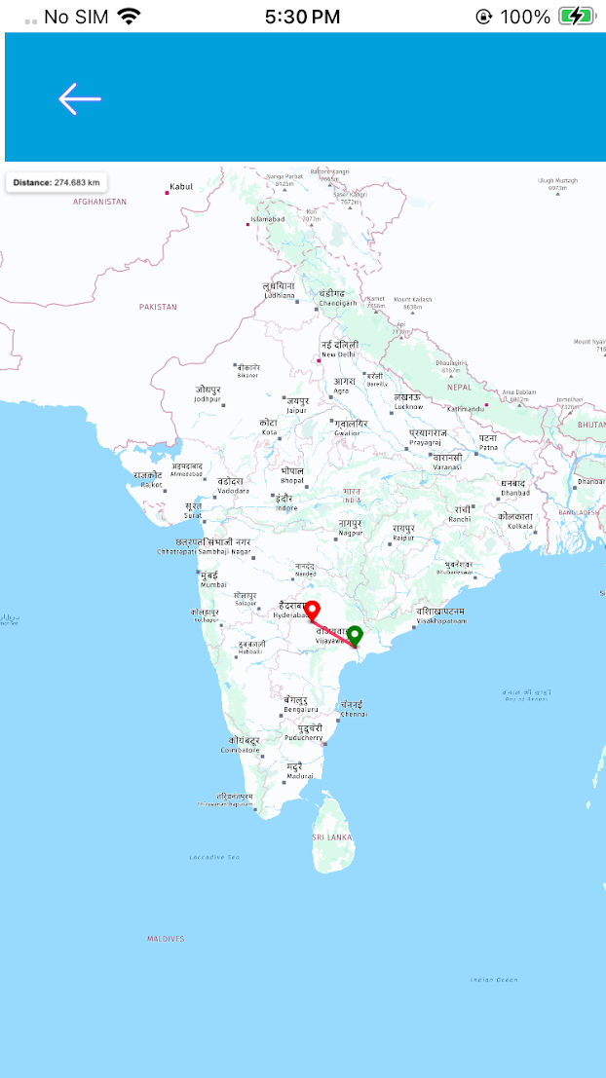

Foundry APP Setup
When you import the application to your Volt MX Iris project, the HCL Volt MX Foundry services of the Amazon Location Service are added to the HCL Volt MX Foundry app, which is associated with the Volt MX Iris project. While importing the Amazon Location Application to your Volt MX Iris project, if there is no HCL Volt MX Foundry app associated with the existing Volt MX Iris project, a new HCL Volt MX Foundry app is automatically added to your HCL Volt MX Foundry environment and is associated with your Volt MX Iris.
To set the Foundry app, follow these steps:
- Click the HCL Volt MX Foundry app associated with your Volt MX Iris project from the Project Explorer. Click DATA & SERVICES.
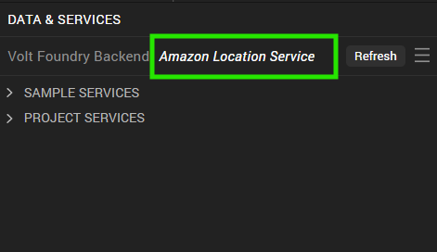

- Under the Configure Services tab, click Integration and can see the AmazonLocation. Click on the Integration service to add the keys.
For the Host URL,replace the value of service and region with your Amazon Location Service API endpoint URL mentioned in Amazon Location Service API. Refer Amazon Location Service.
- 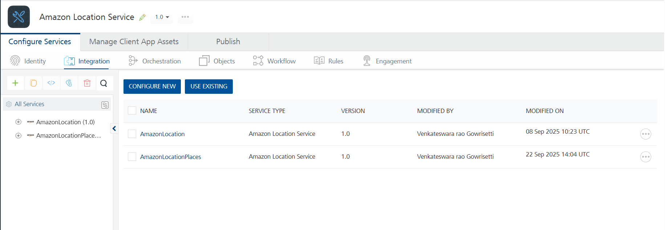
- Click on the AmazonLocation integration service to expand the operations.
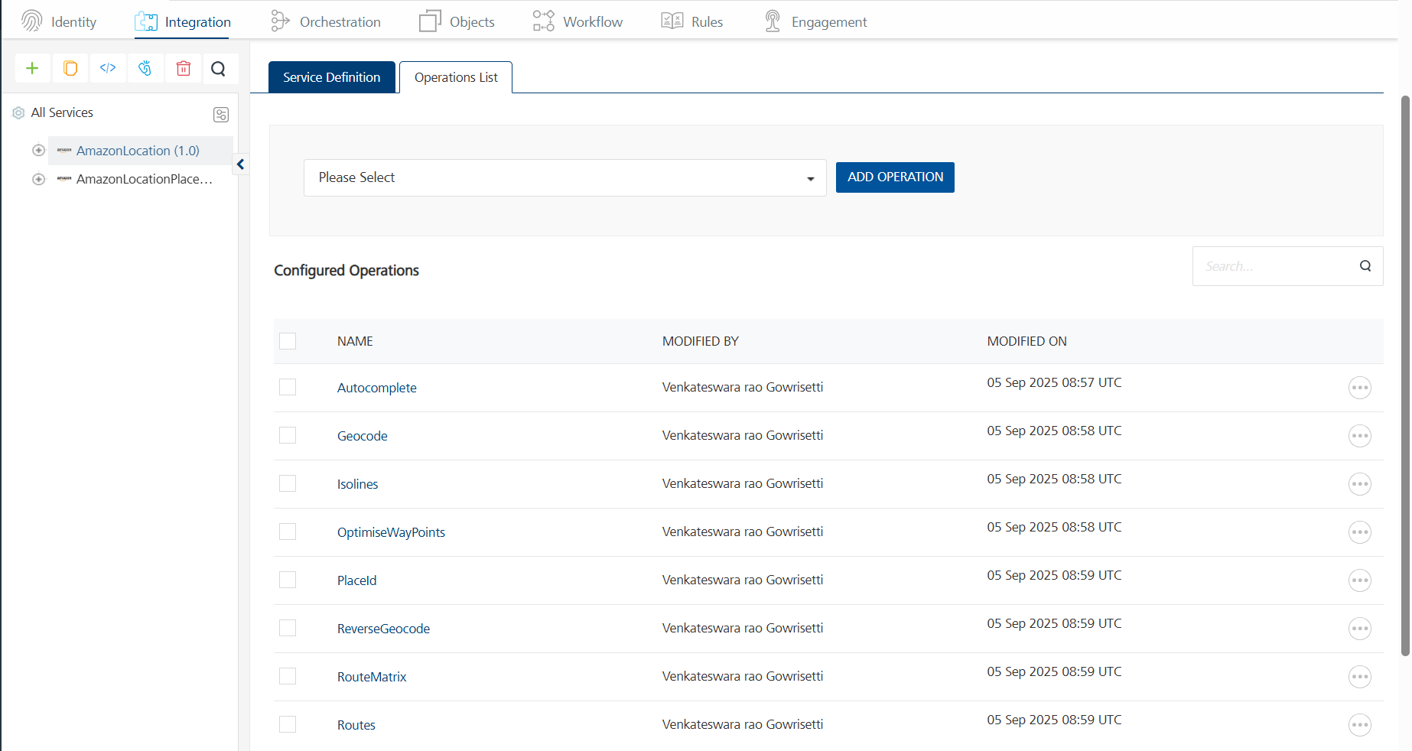
- Select each operation, On the Request Input tab, in the Body section, specify the values in the respective boxes under the Test Value column.
- For Key, In the box under the TEST VALUE and DEFAULT VALUE columns, type the API Key generated from Amazon Location Console.
- Click SAVE OPERATION.
- Click SAVE AND FETCH RESPONSE. The Output Result dialog appears with the response. Otherwise, the Output Result shows an error.
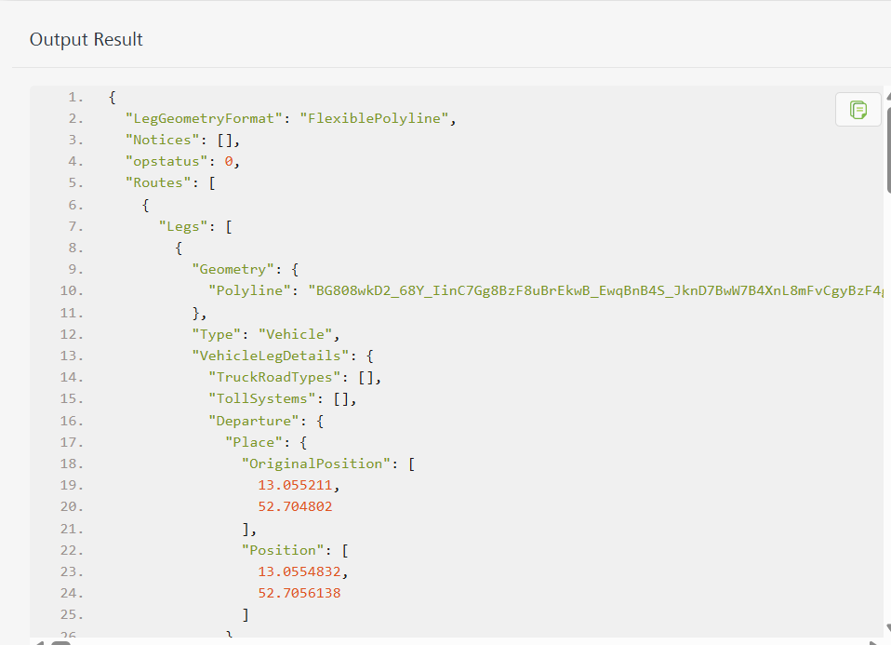

Publish the HCL Volt MX Foundry App
After you set the Operation Security Level, you must publish the HCL Volt MX Foundry app. To publish the HCL Volt MX Foundry, follow these steps:
In Volt MX Iris, click DATA & SERVICES, and then click Publish Project Services to Publish to your foundry app.
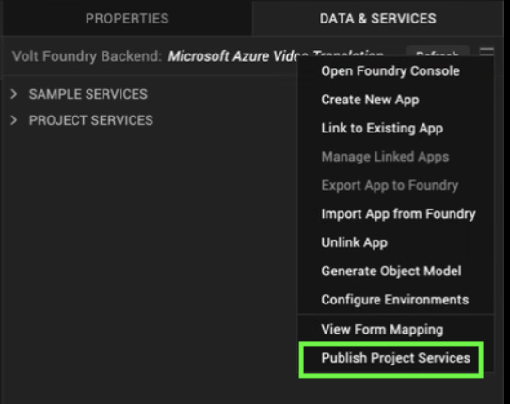
Select the environment to which you want to publish your app, and then click Publish.
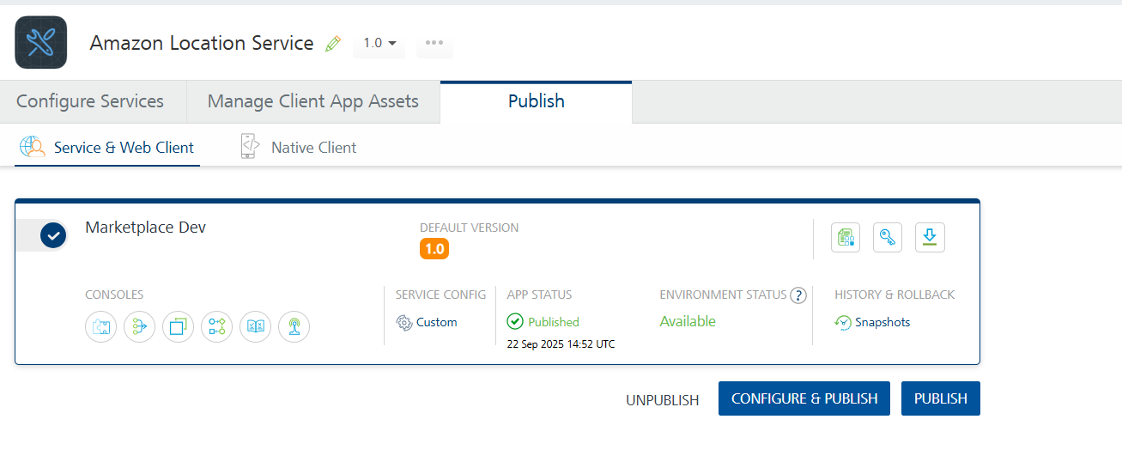
After the app is published to your environment, the following window appears confirming the publish.
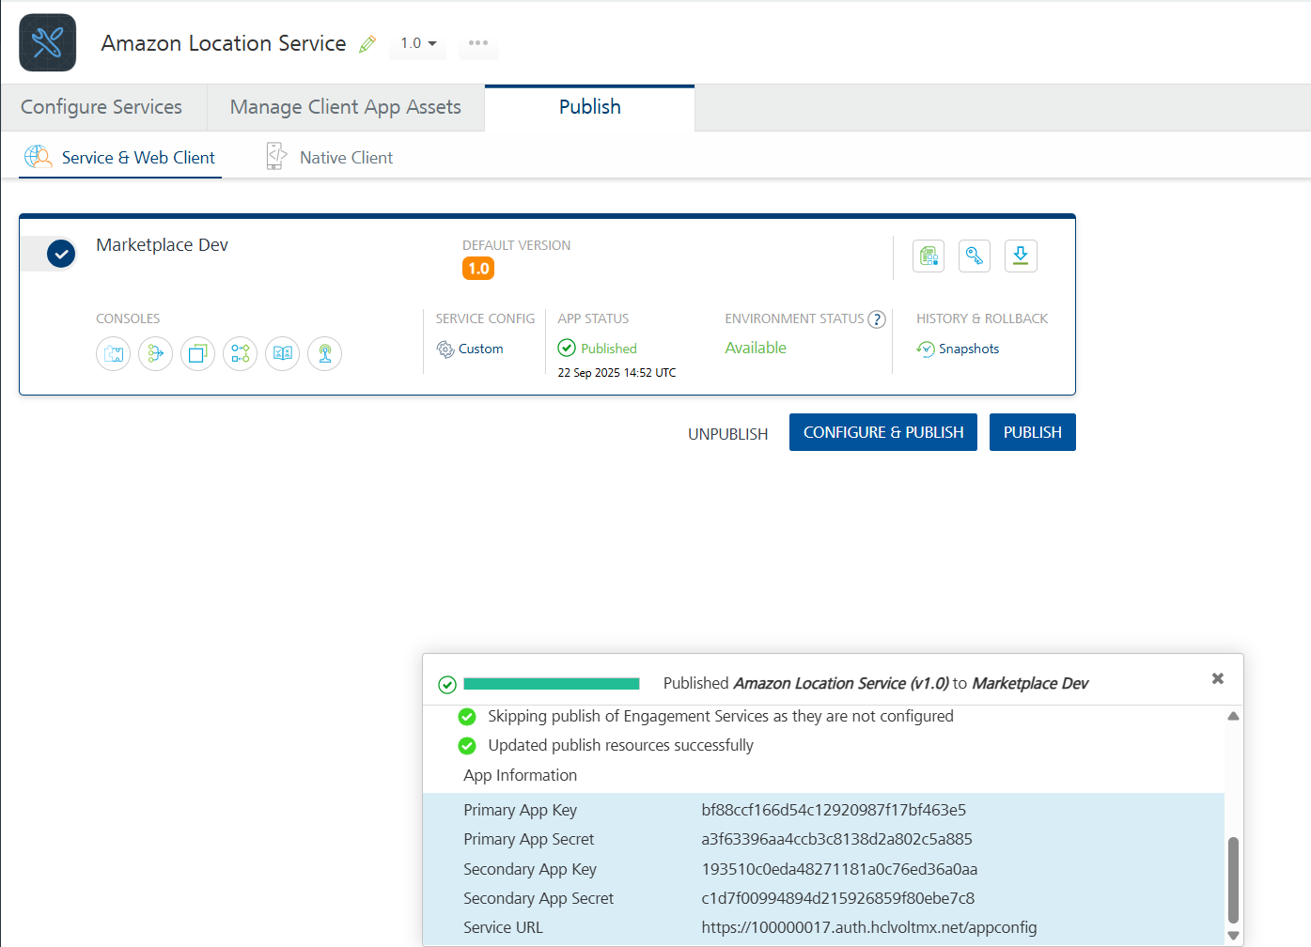

Building and previewing the app
After performing all the above steps, you can build your app and run it on your device. For more information, you can refer to the Building and Viewing an Application section of the Volt MX User Guide.
You can then run your app to see the Microsoft Azure Document Translation work in real time.

Reference Documents:
- https://docs.aws.amazon.com/location/latest/developerguide/what-is.htm
- https://docs.aws.amazon.com/location/previous/APIReference/API_Operations.html

REVISION HISTORY
App version 1.0.0:

Known Issues
None

Limitations
None

