21 Jul 2025

AMAZON POLLY

**VERSION: 1.0.0**

# **Overview**

Amazon Polly is a cloud service by AWS that converts **text into lifelike speech** using advanced deep learning technologies, specifically text-to-speech (TTS). It enables developers to add **speech capabilities** to their applications.

**A. Features:**

* **Text-to-Speech (TTS)** – Converts text into natural-sounding speech using deep learning models.
* **Neural TTS (NTTS)** – Delivers high-quality, human-like voices for more realistic interactions.
* **SSML Support** – Lets you control speech elements like pitch, rate, pauses, and emphasis via markup.
* **Multilingual & Multi-Voice Support** – Offers 30+ languages and dozens of male, female, and child voices.

**B. Percentage of re-use:**

Approximately 80% of reuse.

# **Getting Started**

## **Prerequisites**

Before you start using the Amazon Polly Data Adapter, ensure you have the following:

* An account with [AWS](https://aws.amazon.com/free/?gclid=CjwKCAiApsm7BhBZEiwAvIu2Xx9XbHAMeYbCeX8b6nQO-Z5uzxDYs6WCKud8CnDECDtDCK-mKS8qIhoCaVoQAvD_BwE&trk=2738afd4-9401-4d18-8e3e-1b1c194dea07&sc_channel=ps&ef_id=CjwKCAiApsm7BhBZEiwAvIu2Xx9XbHAMeYbCeX8b6nQO-Z5uzxDYs6WCKud8CnDECDtDCK-mKS8qIhoCaVoQAvD_BwE:G:s&s_kwcid=AL!4422!3!509606977839!p!!g!!aws!12618685604!120373368136&all-free-tier.sort-by=item.additionalFields.SortRank&all-free-tier.sort-order=asc&awsf.Free%20Tier%20Types=*all&awsf.Free%20Tier%20Categories=*all)
* Volt MX Iris
* [HCL Foundry](https://manage.hclvoltmx.com/)

## **Importing the app**

## You can import Amazon Polly Data Adapter into HCL Foundry directly from the voltmx Forge website or by importing the data adapter zip file.

## **To import the data adapter zip file, do the following:**

1. Log on to your HCL Foundry. The **Dashboard** page appears by default.
2. In the left pane, click the **API Management** menu. The **APIs** tab opens by default.

## Click the **Custom Data Adapters** tab. The **Custom Data Adapter** page appears.

## 

## Click **Import**. The **Import Data Adapter** dialog appears.

1. Click **IMPORT FROM HCL FORGE**. The **Import Data Adapter** from **HCL Forge** dialog appears with a list of available data adapters.
2. Click **Import**. **Amazon Polly** data adapter is listed on the **Custom Data Adapters** page.

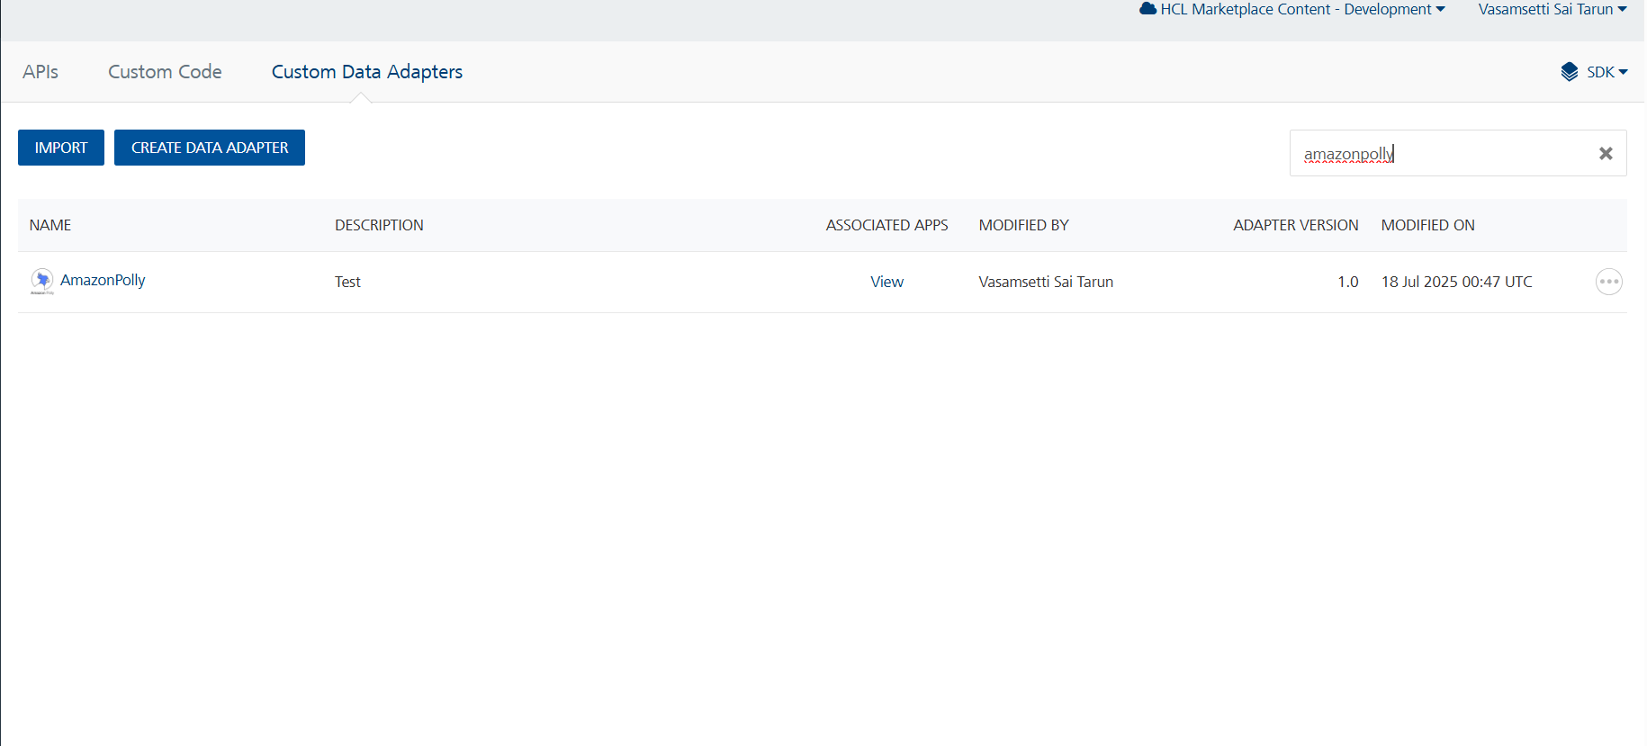

**To import the data adapter zip file, do the following:**

1. Perform steps 1 to 4 in the above procedure
2. Drag the data adapter zip file into the **Drag Data Adapter** box.

Or

Click **browse**. The **Open** dialog appears.

Navigate to the location where you downloaded the data adapter (zip file) on your computer, select the data adapter, and click **Open**. The **Import Data Adapter** dialog shows the selected data adapter.

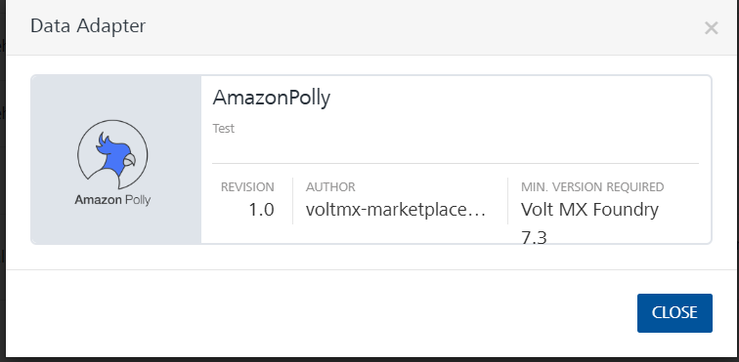

## **Creating an Integration Service with Amazon Polly:**

After you import Amazon PollyData Adapter into Foundry, you must create an integration service with service type as Amazon Polly .

**To create an integration service with Amazon Polly, do the following:**

1. Log on to your HCL Foundry. The **Dashboard** page appears by default.
2. In the left pane, click the **API Management** menu. The **APIs** tab opens by default.
3. Click the **Integration** tab. The **Integration** tab opens with a list of existing integration services.
4. Click **CONFIGURE NEW**. The **Service Definition** tab opens.
5. In the **Name** box, type a unique name for your service.
6. From the **Service Type** list, select **Amazon Polly.**

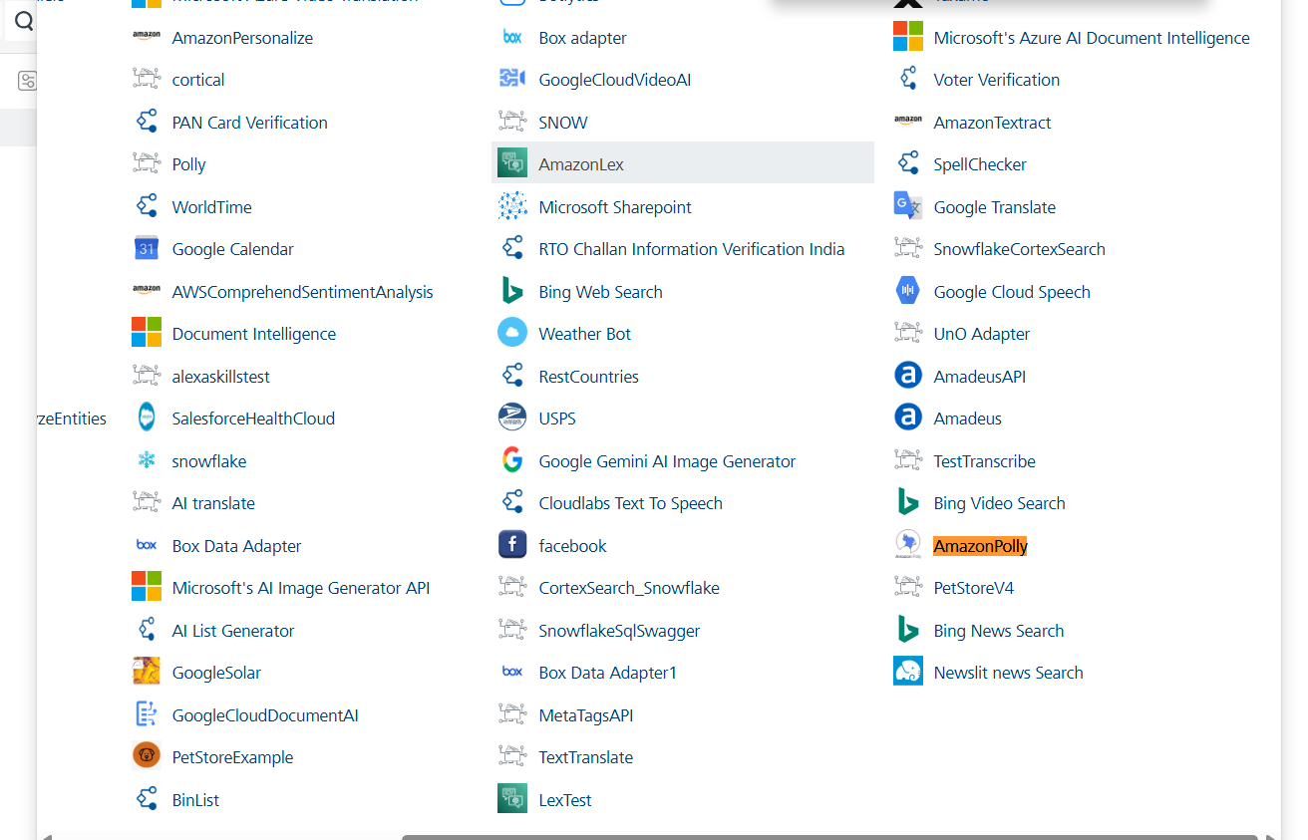

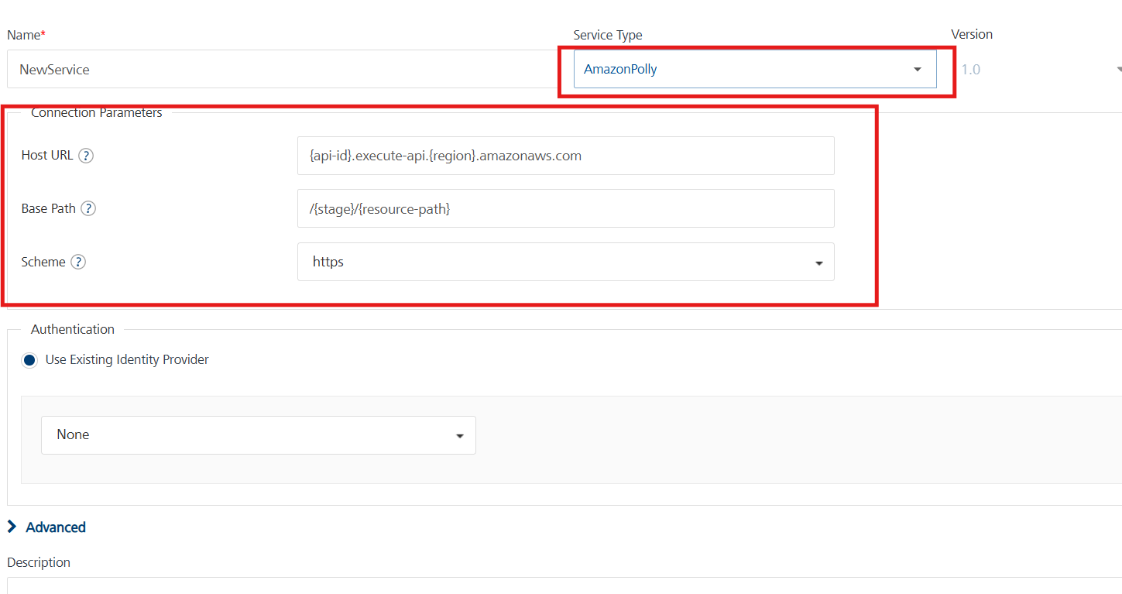

1. Replace the Host URL and Base Path values, then click 'Save'.

## **Creating an Operation**

To make any API call in the HCL Foundry console, you must create an operation for the respective API and then execute the operation. Executing an operation involves making the API call and displaying the response.

This section provides steps to create an operation for the **Amazon Polly** API.

Steps to create an operation for the **Amazon Polly** API:

1. Log on to your HCL Foundry. The **Dashboard** page appears by default.
2. In the left pane, click the **API Management** menu. The **APIs** tab opens by default.
3. Click the **Integration** tab. The **Integration** page appears with a list of existing integration services.
4. From the list of integration services, select the integration service that you have created with service type as **Amazon Polly**. The **Service Definition** tab of the selected integration service opens by default.
5. Click the **Operations List** tab. The **Operations List** tab opens.

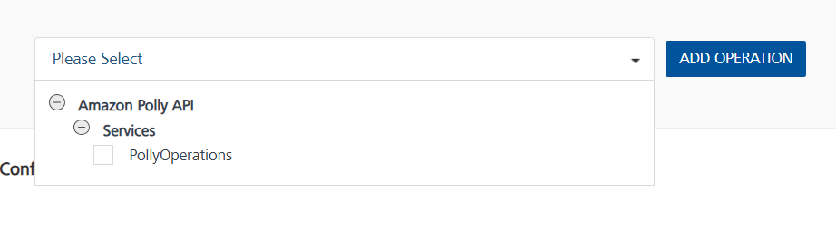

1. Select **Amazon-Polly** and Click Add Operation.

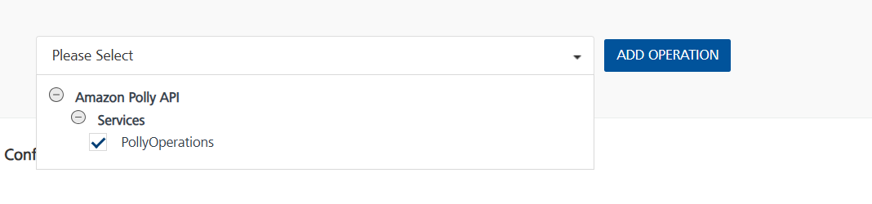

## **Executing Operation**

Executing an operation involves making the API call by setting the necessary parameters and displaying the response. The procedure to execute any operation is the same, but the request parameters of the APIs vary. For more information on request parameters of each API refer to the [link](https://docs.aws.amazon.com/polly/latest/dg/API_Reference.html).

This section provides steps to execute the **Amazon Polly** (explained in Creating an Operation).

**Steps to execute the Amazon Polly operation:**

1. Log on to your Hcl Foundry. The **Dashboard** page appears by default.
2. In the left pane, click the **API Management** menu. The **APIs** tab opens by default.
3. Click the **Integration** tab. The **Integration** tab opens with a list of existing integration services.
4. From the list of integration services, select the integration service that you have created with service type as **Amazon Polly**. The **Service Definition** tab of the selected integration service opens by default.
5. Click the **Operations List** tab.
6. In the **Name** box, the name of the operation is displayed by default. If you want, you can change the name.
7. In the Request Input tab, under the Body section, provide the operation name (as used in the Lambda function code) and its corresponding input parameters.

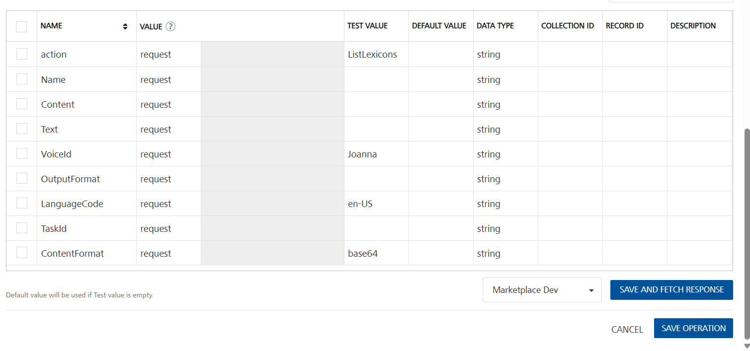

1. Enter the **X-api-key (API key)**value that is created in the Set up API Gateway in default value.

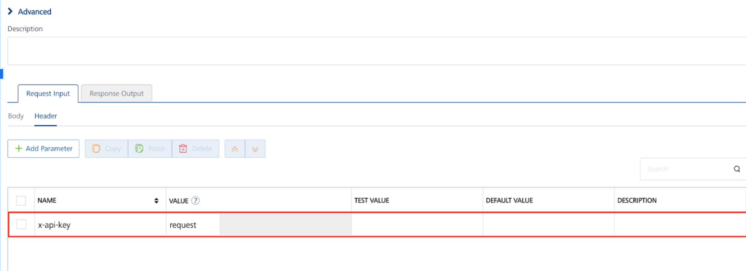

1. Click **SAVE AND FETCH RESPONSE**. The **Output Result** dialog appears with the response. Otherwise, the **Output Result** shows an error.

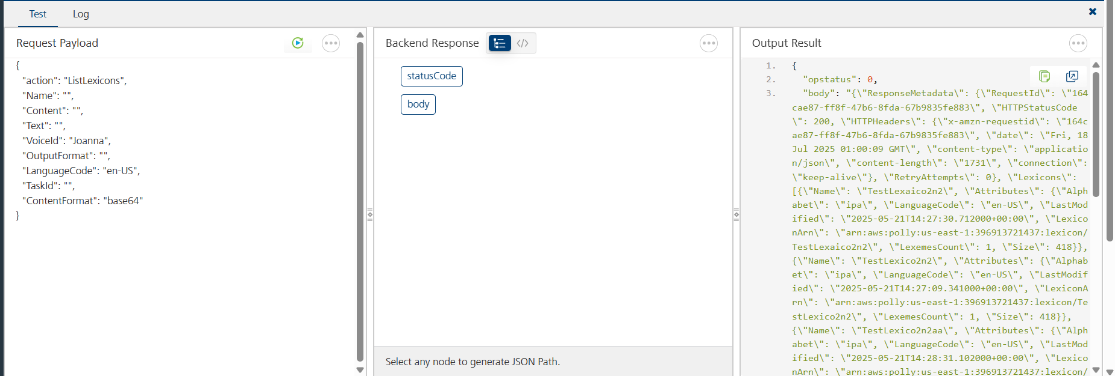

### **D. Create an IAM Role**

1. Navigate to IAM in [AWS Console](https://aws.amazon.com/console/):
   * Go to the IAM service.
2. Create a New Role:
   * Click Roles -> Create Role.
   * Choose **AWS Service** as the trusted entity type.
   * Select Lambda as the use case.
3. Attach Policies:
   * Attach the following policies:

* AmazonPollyFullAccess.
* [AWSLambda_FullAccess](https://us-east-1.console.aws.amazon.com/iam/home?region=us-east-1#/policies/details/arn%3Aaws%3Aiam%3A%3Aaws%3Apolicy%2FAWSLambda_FullAccess)

1. Name and Create the Role:
   * Name the role and create it.

### **E. Create the Lambda Function**

1. Navigate to Lambda in [AWS Console**:**](https://aws.amazon.com/console/)
   * Open the **Lambda** service.
2. Create a New Function**:**
   * Click **Create function**.
   * Choose an Author **from scratch**.
   * Provide a function name.
   * Choose **Python 3.13** as the runtime.
   * Under **Change default execution role**, select **Use an existing role** and choose the role created earlier.
3. Add Amazon Polly Logic**:**
   * Replace the default code with your **Lambda function logic (⦁** [**available here**](https://github.com/HCL-TECH-SOFTWARE/volt-mx-samples/tree/main/MP/AWSLambda/AmazonPolly)**)** and click Deploy.

### **F. Set Up API Gateway**

1. Navigate to API Gateway in [AWS Console](https://aws.amazon.com/console/):
   * Open the **API Gateway** service.
2. Create a New API:
   * Select Rest API and click Build.
   * Give an Api name and click create Api.
3. Create a Resource and Method:

* Click on Create Resource and give Resource Name.
* Select the created Resource and Click Create Method.
* Choose **POST** as the method type, select **Lambda Function** and choose your **Lambda function**.
* In **Method Request Settings**, enable **API Key Required**.
* Click **Save** and **Deploy**.
* **Deployment Stage**: Choose New Stage, give **Stage Name**
* Deploy the API.

1. Deploy the API:

* Click **Deploy API**.
* Select **New Stage** and enter a **Stage Name**.
* Click **Deploy**.

1. Create an API Key:

* In API Gateway, go to API Keys.
* Click Create API Key → Select Auto Generate.
* Give any name to the key.
* Click Save.

1. Create a Usage Plan & Associate API Key:

* In API Gateway, go to **Usage Plans.**
* Click **Create Usage Plan**, give Name, Enable Throttling, Enable Quota.
* Select the usage plan created, under Associated stages select Add Stage. In stage details give API name and Stage created in step-4 and click Add to Usage plan.
* Select the usage plan created, under Associated API Keys select Add API Key. In API key details under Type select Add existing key and Under API Key give API Key Name.
* Deploy Api.

1. Note the API Endpoint:

* Under **Stages**, find the **Invoke URL**.
* Replace the **Host and Paths** in your **Amazon Polly Adapter** with this **Invoke URL**.

## **3. Publishing the App in HCL FOUNDRY:**

After adding the Amazon Polly Data Adapter to your app and configuring the necessary configurations, you must publish the app to HCL Foundry. For more information, refer to [Publish a foundry app.](https://opensource.hcltechsw.com/volt-mx-docs/docs/documentation/Foundry/voltmx_appfactory_user_guide/Content/FoundryPublish.html)

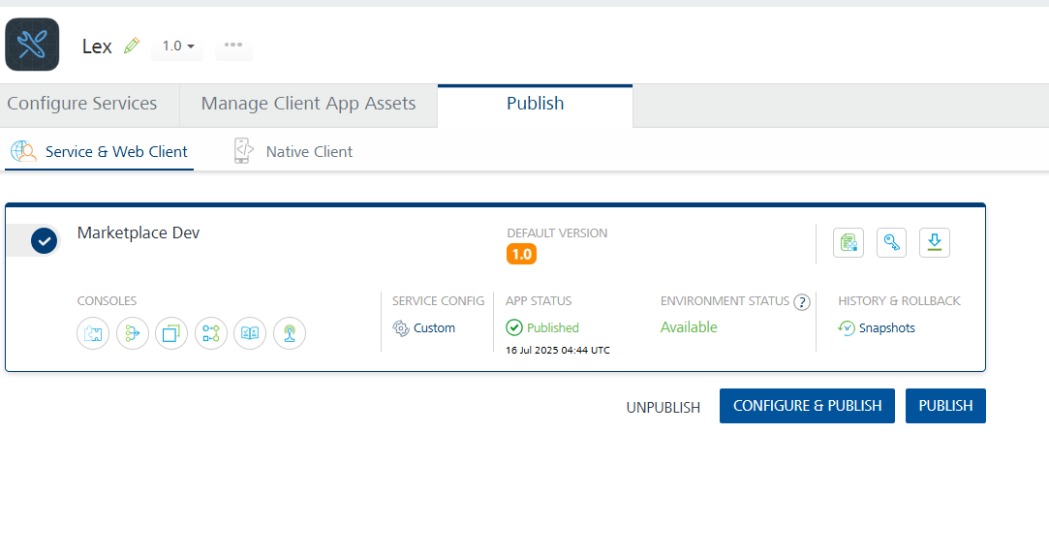

## **4. REFERENCES**

[Amazon Polly Actions](https://docs.aws.amazon.com/polly/latest/dg/API_Reference.html)

**5. REVISION HISTORY**

Adapter version 1.0.0:

1. **Known Issues**

None

1. **Limitations**

Amazon Polly character limit is 3000 characters