19 Jul 2025

AMAZON POLLY

VERSION: 1.0.0

OVERVIEW
The AmazonPolly component converts text input from a user to voice and reads the text aloud. Internally, the component uses the Amazon Polly text-to-speech service via the data adapter.
- Use Cases
  - Text-to-Audio Conversion - Transform written documents, articles, or messages into spoken audio files
  - Voice Announcements - Generate automated voice notifications for system alerts, public announcements, or status updates
  - Audio Content Creation - Synthesize voiceovers for videos, presentations, or educational materials without human narration
  - Dynamic Voice Responses - Create real-time spoken responses for chatbots, IVR systems, or interactive applications
  - Multilingual Speech Generation - Convert text to speech in multiple languages for international applications or translation services

Percentage of re-use:
Approximately 80% of reuse.

Getting Started

Prerequisites
Before you start using theAmazon Polly Component, ensure you have the following:
- HCL Foundry
- Volt MX Iris
- An account with AWS

Platforms Supported

Mobile

iOS

Android

  - Importing the Component to your project

You can import the components only into the apps that are of the Reference Architecture type.

To import the Amazon Polly Component, do the following:

- Open your app project in Volt MX Iris.

In the Project Explorer, click the Templates tab.

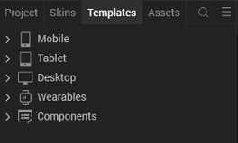

Right-click Components, and then select Import Component. The Import Component dialog box appears.
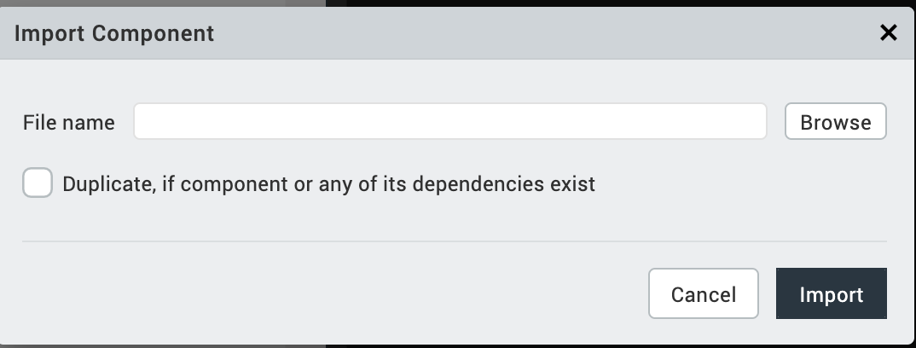

Click Browse to navigate to the location of the component, select the component and then click import. The component and its associated widgets and modules are added to your project.

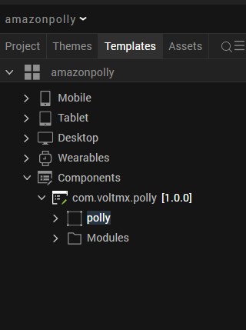
- Once you have imported a component to your project, you can easily add the component to a form. For more information, refer Add a Component to a Form

D. Building and previewing the app
After performing all the above steps, you can build your app and run it on your device. For more information, you can refer to the Building and Viewing an Application section of the Volt MX User Guide.
You can then run your app to see the Amazon Polly Component work in real time.

3. References

Dynamic Usage
You can also add Amazon Polly Component dynamically. To do so,
- In Project Explorer, on the Projects tab, click Controllers section to access the respective Form Controller. Create a method and implement the code snippet like the sample code mentioned below.

define({
// Type your controller code here
onNavigate: function() {
this.createComponent();
},
createComponent:function(){

var polly= new com.voltmx.polly({
"height": "100%",
"id": "polly",
"isVisible": true,
"left": "0dp",
"masterType": constants.MASTER_TYPE_USERWIDGET,
"skin": "CopyslFbox0b8ff21af8eb34d",
"top": "0dp",
"width": "12%",
"zIndex": 1,
}, {}, {});

polly.ServiceName = "pollyv2";
polly.OperatrionName = "PollyOperations";
this.view.add(polly);
}
});

In the code snippet, you can edit the properties of the component as per your requirement. For more information, see Setting Properties.
- Save the file

4. Properties:
The properties provided on the Component tab allow you to customize the UI elements in the Amazon Polly component. You can set the properties directly on the Component tab or by writing a JavaScript.

1. Speech On Icon
Category: | Pass Through
Description: | Specifies the source of the image that you want to display as the Speech On icon.
Syntax: | speechOnIcon
Type: | String
Read/Write: | Write
Example: | this.view.componentID.speechOnIcon = "speech_on.png";

2.Speech Off Icon
Category: | Pass Through
Description: | Specifies the source of the image that you want to display as the Speech Off icon.
Syntax: | speechOffIcon
Type: | String
Read/Write: | Write
Example: | this.view.componentID.speechOffIcon = "speech_off.png";

3. ServiceName
Category: | Custom
Description: | Specifies the service name in the adapter.
Syntax:
  ServiceName
Type: | String
Read/Write: | Write
Example: | this.view.componentID.ServiceName = "Service Name";

4. OperationName
Category: | Custom
Description: | Specifies the Operation name in the adapter.
Syntax:
  OperationName
Type: | String
Read/Write: | Write
Example: | this.view.componentID.OperationName = "Operation Name";

C. Events
1. speechOn
Category: | Custom
Description: | Invoked when the user clicks the component to start the speech.
Syntax: | speechOn
Example: | this.view.componentID.speechOn = function()  {  alert("Starting Speech.");  }.bind(this);
2. speechOff
Category: | Custom
Description: | Invoked when the user clicks the icon to stop the speech.
Syntax: | speechOff
Example: | this.view.componentID.speechOff = function()  {  alert("Stopping Speech.");  }.bind(this);

D. APIs
The following APIs pertain to the Amazon Polly component:
1. speakOut

Description: Converts and speaks the given text.
Syntax: startSpeak()
Parameters:
text [String]:
The text that you want to convert to speech.
VoiceId [String]:
Voice Ids provided by amazon polly
Return Value:
None
Sample Input Format:
var text = "Convert this text to speech.";
var VoiceId = “joanna”
this.view.componentID.startSpeak(text,VoiceId);

5. Setting up Foundry Application
Follow this documentation to set up your Polly foundry application.
After setting up use the property ServiceName to add your Service Name in the component.
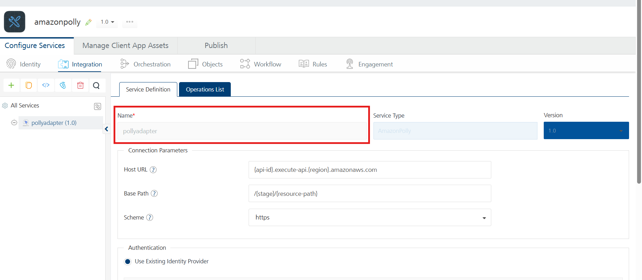
OperationName to add your operation name in the property.
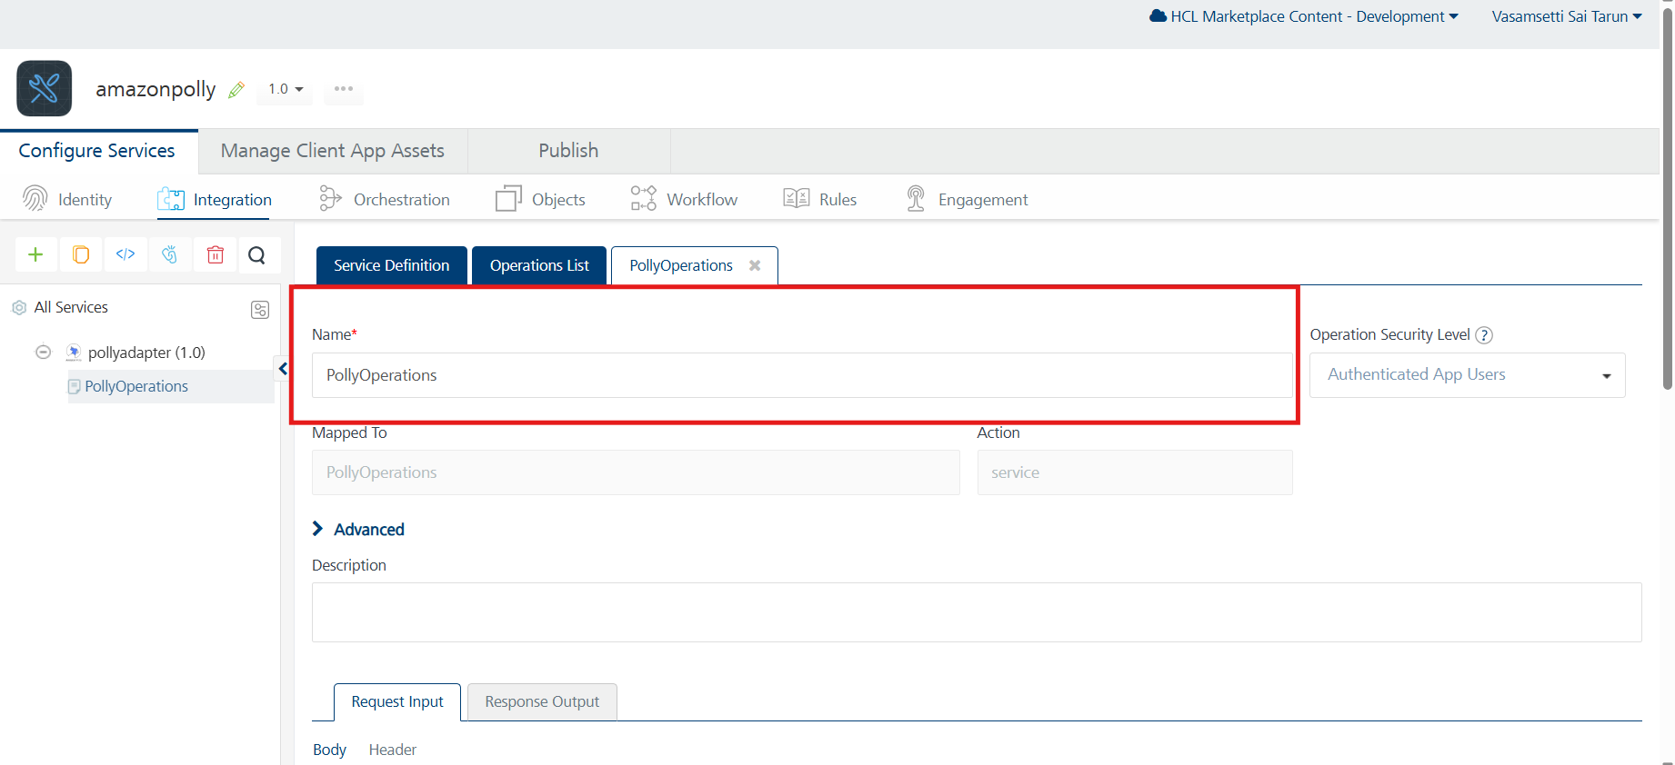

6. Revision History
App version 1.0.0:

Known Issues
- No Known Issues

Limitations
- Amazon Polly's character limit is 3000 characters.

