23-Feb-2026

AVIATIONSTACK

VERSION: 1.0.0

OVERVIEW
Aviationstack is a comprehensive aviation data platform that provides real-time and historical flight information through simple REST APIs. It enables developers to access live flight tracking, airline routes, airport data, aircraft details, and flight schedules for building aviation-related applications.
It offers multiple data endpoints including Flights, Airlines, Airports, Aircraft Types, Flight Schedules, Future Flights, and Timetables, making it suitable for flight tracking apps, travel platforms, airport dashboards, and aviation analytics tools.

- Use case:
Aviationstack can be used to build flight tracking applications with real-time status, airport dashboards showing live departures and arrivals, travel booking platforms with flight information, aviation analytics tools for trend analysis, flight notification systems for delays and gate changes, and educational platforms visualizing aviation data.
It is also suitable for apps that show:
• Live flight status (scheduled, active, landed, cancelled)
• Historical flight data (last 3 months)
• Airline and airport information
• Aircraft details and types
• Flight schedules and timetables
- Percentage of re-use:
80% (Data can be customizable and customers need to implement UI by themselves).

Features

Real-time Flights API
Provides live flight tracking with current status, delays, departure/arrival times, gates, terminals, and aircraft information for flights worldwide.
Airlines API
Returns comprehensive airline data including IATA/ICAO codes, fleet size, hub codes, country, status, and foundation dates.
Airports API
Provides detailed airport information including IATA/ICAO codes, location coordinates, timezone, country, and airport names.
Aircraft Types API
Returns aircraft model information with IATA codes, aircraft names, and plane type classifications.
Airplanes API
Provides specific aircraft registration details including model, engines, delivery dates, owner information, and operational status.
Cities API
Returns city data with IATA codes, geographical coordinates, timezone, and country information related to aviation.
Countries API
Provides country information including ISO codes, capitals, currencies, population, and phone prefixes.
Flight Timetable API
Returns scheduled flight departures and arrivals for specific airports with gate and terminal information.
Future Flights API
Provides upcoming flight schedules for dates beyond 7 days in the future.
Aviation Taxes API
Returns aviation tax information with IATA codes and tax names used in the industry.

GETTING STARTED

Prerequisites
Before you start using the Aviationstack Data Adapter, ensure you have the following:

- HCL Foundry
- Volt MX Iris
- Aviationstack Account

  - Sign up at the Aviationstack official website to create your account: https://aviationstack.com/signup
  - Aviationstack provides a free tier with limited API calls per month (100-500 requests), which is suitable for development and testing.
- Aviationstack API Key

Once logged in, go to the Dashboard section in the Aviationstack portal.
Generate your API key and store it securely. This key is required for authenticating all API requests such as:
• Real-time Flights
• Airlines Data
• Airports Information
• Aircraft Types
• Flight Schedules
• Historical Data
- API Access
Ensure that you understand the required API endpoints based on your use case:
• /flights → Fetch real-time flight status and details
• /airlines → Get airline information and fleet data
• /airports → Retrieve airport codes and locations
• /aircraft_types → Get aircraft model information
• /airplanes → Fetch specific aircraft registration details
• /cities → Get aviation-related city data
• /countries → Retrieve country information
• /timetable → Get flight schedules (Paid Plan)
• /flightsFuture → Get future flights (Paid Plan)
• /taxes → Get aviation tax information

You can explore all available endpoints under the Aviationstack API Documentation.
- Project Setup
You can start with the free plan, which allows 100-500 API requests per month. For production systems or heavy usage, you can upgrade to a paid premium plan for:
• Higher rate limits (10,000 - 1,000,000+ requests/month)
• Advanced filtering capabilities (by airport, airline, status, date)
• Faster response times
• Access to premium endpoints (timetable, future flights)
• Priority support
- Reference documents:
• Aviationstack Overview
• Aviationstack API Reference

Importing the data adapter

You can import Aviationstack Data Adapter into HCL Foundry directly from the voltmx Forge website or by importing the data adapter zip file.

To import the data adapter zip file, do the following:
- Log on to your HCL Foundry. The Dashboard page appears by default.
- In the left pane, click the API Management menu. The APIs tab opens by default.
- Click the Custom Data Adapters tab. The Custom Data Adapter page appears.
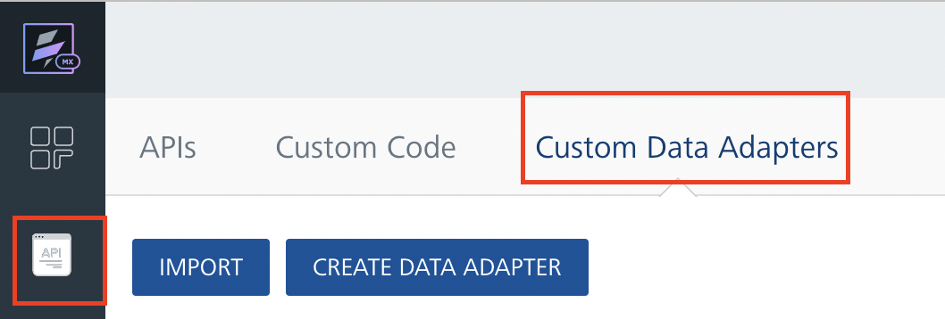
- Click Import. The Import Data Adapter dialog appears.

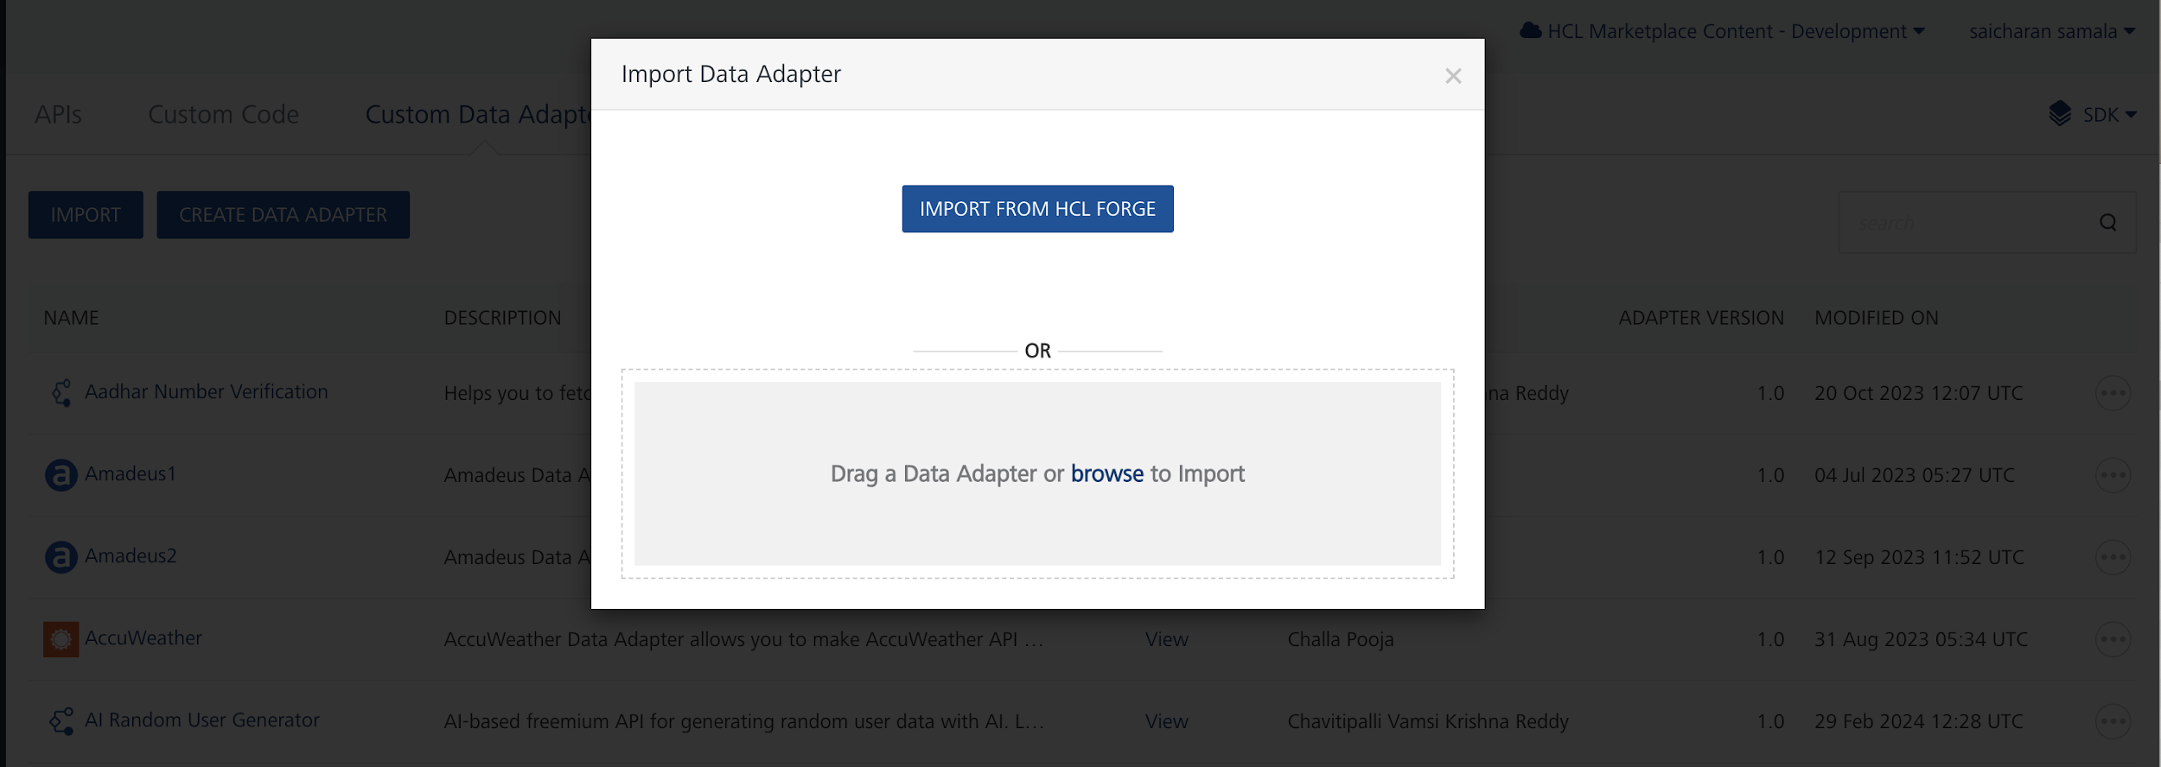

- Click IMPORT FROM HCL FORGE. The Import Data Adapter from HCL Forge dialog appears with a list of available data adapters.
- Click Import. Aviationstack data adapter is listed on the Custom Data Adapters page.

To import the data adapter zip file, do the following:
- Perform steps 1 to 4 in the above procedure
- Drag the data adapter zip file into the Drag a Data Adapter box.Or
Click browse. The Open dialog appears.
Navigate to the location where you downloaded the data adapter (zip file) on your computer, select the data adapter, and click Open. The Import Data Adapter dialog shows the selected data adapter.

Creating an Integration Service with Aviationstack :
After you import Aviationstack Data Adapter into Foundry, you must create an integration service with service type as Aviationstack .
To create an integration service with Aviationstack, do the following:
- Log on to your HCL Foundry. The Dashboard page appears by default.
- In the left pane, click the API Management menu. The APIs tab opens by default.
- Click the Integration tab. The Integration tab opens with a list of existing integration services.
- Click CONFIGURE NEW. The Service Definition tab opens.
- In the Name box, type a unique name for your service.
- From the Service Type list, select Aviationstack.
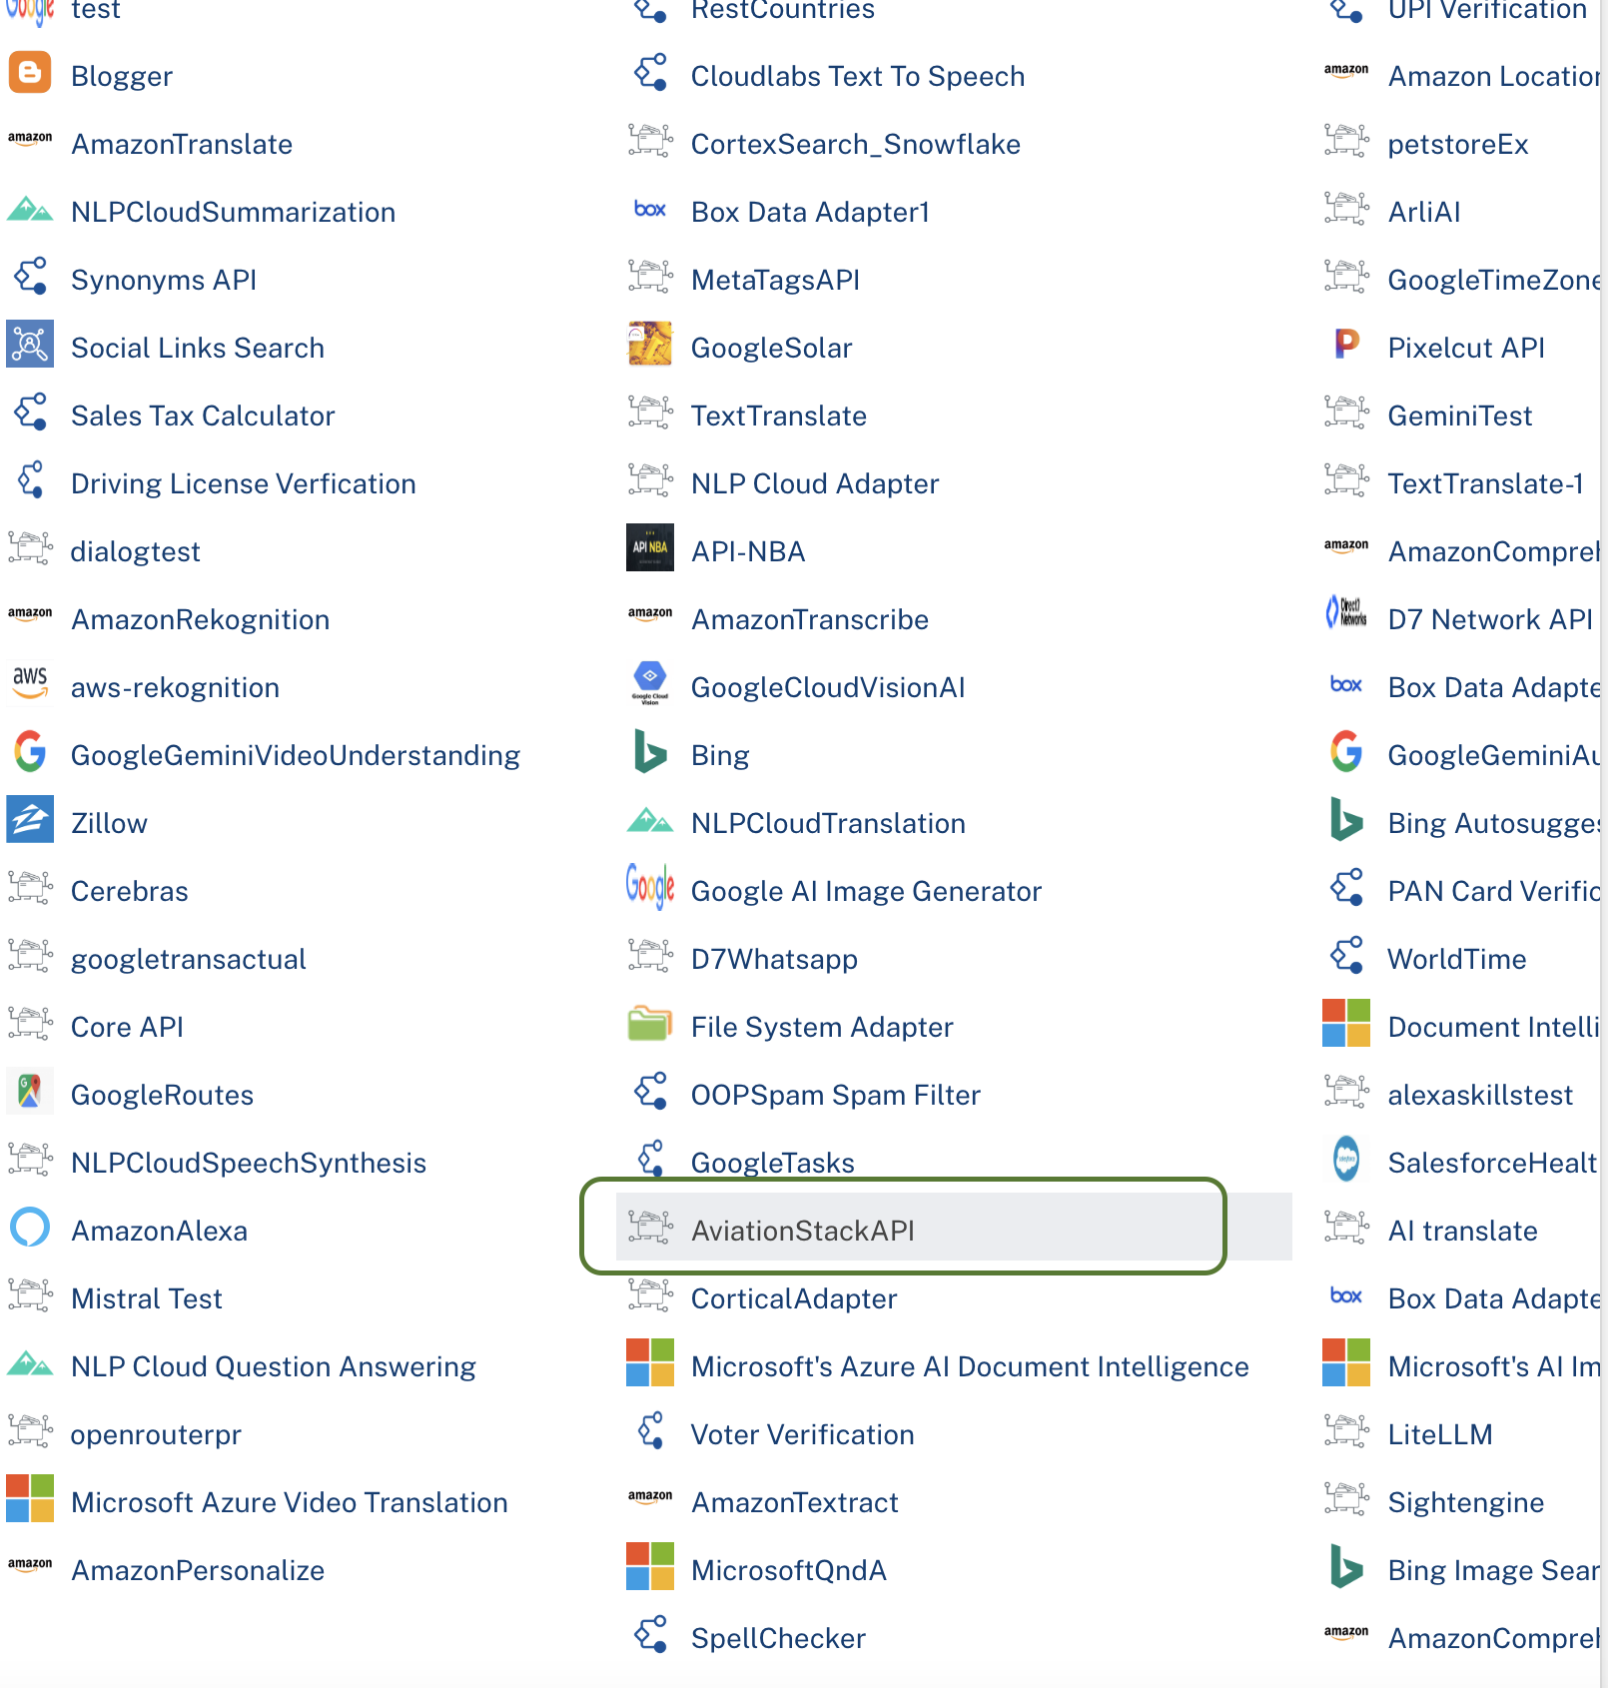
- Click Save

Creating an Operation
To make any API call in the HCL Foundry console, you must create an operation for the respective API and then execute the operation. Executing an operation involves making the API call and displaying the response.
This section provides steps to create an operation for the Aviationstack.
Steps to create an operation for the Aviationstack :
- Log on to your HCL Foundry. The Dashboard page appears by default.
- In the left pane, click the API Management menu. The APIs tab opens by default.
- Click the Integration tab. The Integration page appears with a list of existing integration services.
- From the list of integration services, select the integration service that you have created with service type as Aviationstack. The Service Definition tab of the selected integration service opens by default.
- Click the Operations List tab. The Operations List tab opens.
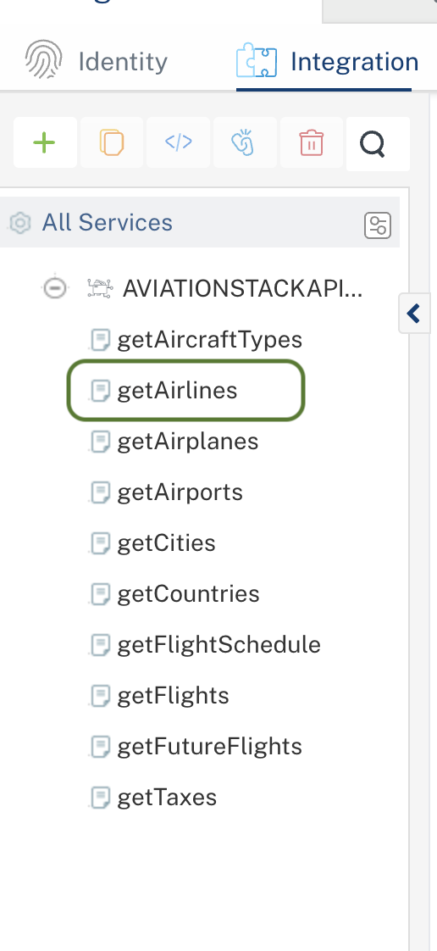

- Select getAirlines and Click Add Operation.

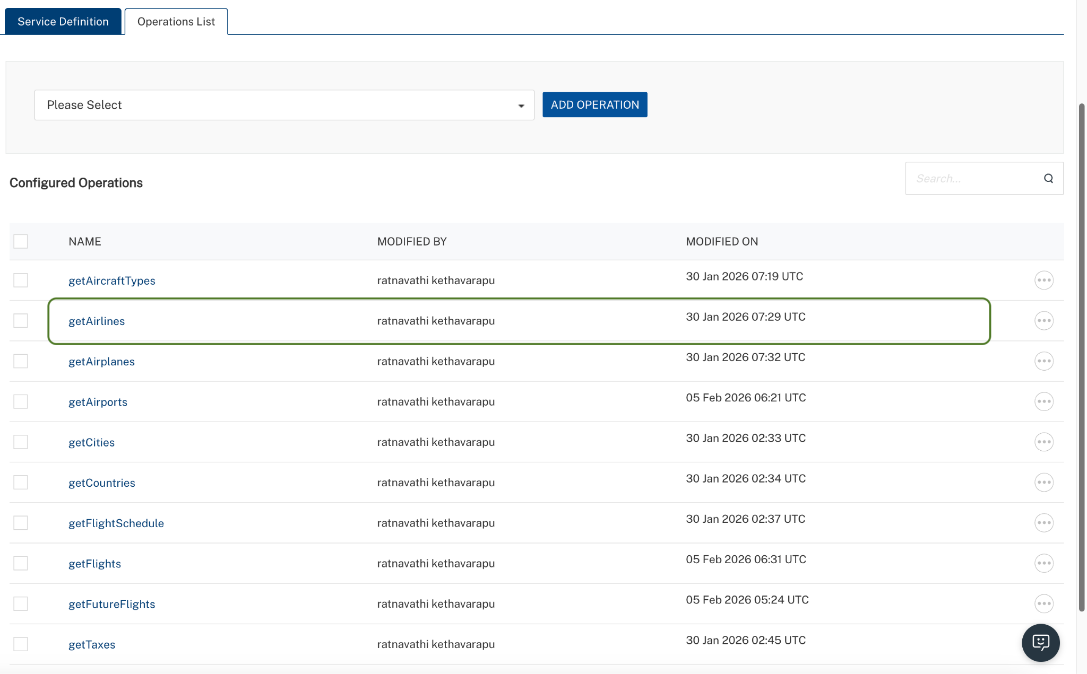

Executing Operation
Executing an operation involves making the API call by setting the necessary parameters and displaying the response. The procedure to execute any operation is the same, but the request parameters of the APIs vary. This section provides steps to execute the Aviationstack (explained in Creating an Operation).
Steps to execute the Aviationstack operation:
- Log on to your Hcl Foundry. The Dashboard page appears by default.
- In the left pane, click the API Management menu. The APIs tab opens by default.
- Click the Integration tab. The Integration tab opens with a list of existing integration services.
- From the list of integration services, select the integration service that you have created with service type as Aviationstack. The Service Definition tab of the selected integration service opens by default.
- Click the Operations List tab.
- In the Name box, the name of the operation is displayed by default. If you want, you can change the name.
- On the Request Input tab, in the Body section, for the following parameters, specify the values in the respective boxes under the Test Value column.
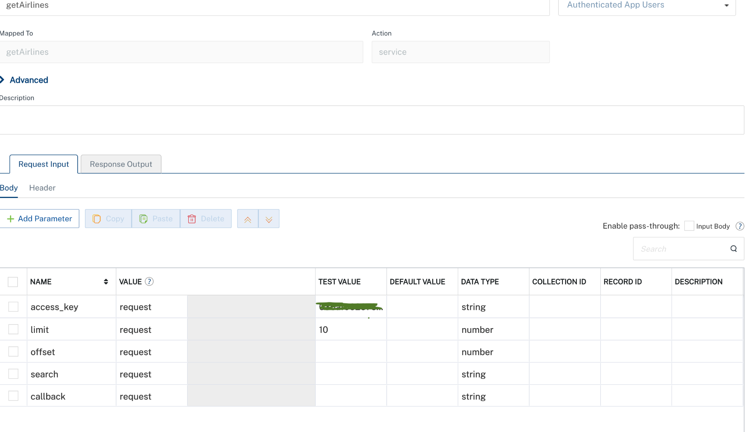

- Click SAVE AND FETCH RESPONSE. The Output Result dialog appears with the response. Otherwise, the Output Result shows an error.
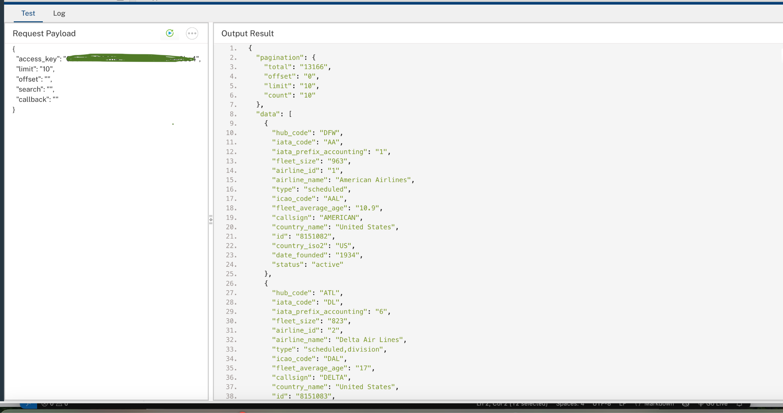
.

Publishing the App in VoltMX FOUNDRY:
After adding the Aviationstack Data Adapter to your app and configuring the necessary configurations, you must publish the app to HCL Foundry. For more information, refer to Publish a foundry app.
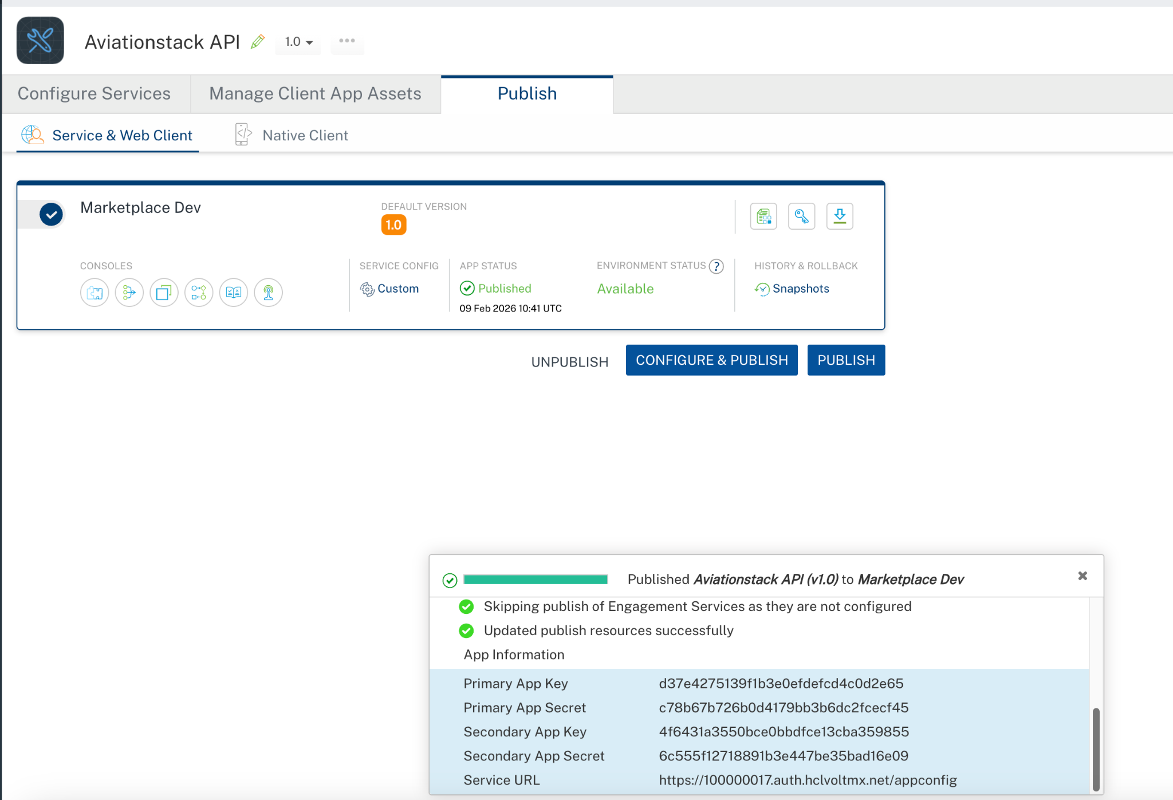

REFERENCES

Properties
- None of the properties are exposed.

Events
- None of the events are exposed.

API’s
- None of the APIs are exposed.

REVISION HISTORY
Adapter version 1.0.0:

Known Issues
None

Limitations

• At times, the API returns unusual or incomplete data — expected results may not always appear.
• The free API key is limited to 100-500 requests per month.
• Advanced filtering (by airport code, airline code, flight status, date) requires a paid subscription plan.
• Premium endpoints (/timetable, /flightsFuture) are not accessible on free plans and have strict rate limits (1 request per 60 seconds on free plan, 1 request per 10 seconds on paid plans).

