Date: 30-Apr-26
CLOUDFLARE WORKERS VISUAL TUTOR APPLICATION
VERSION: 1.0.0

A. Overview
Cloudflare Visual Tutor is an AI-powered visual learning application that leverages Cloudflare Workers AI to analyze images and provide intelligent explanations. The app allows users to capture or upload images (such as diagrams, handwritten notes, or real-world objects) and receive contextual, easy-to-understand explanations.
It uses multimodal AI capabilities to combine vision understanding with conversational AI, enabling users to interactively learn through follow-up questions. The application integrates vision models for image interpretation and large language models for generating detailed explanations, summaries, and guided learning responses.

Note:
⚠️ Educational Content Only
This application is designed solely for educational purposes. Please ensure all uploaded images and generated content are education-related. The system will prompt you to provide appropriate educational content if non-educational input is detected.

B. Requirements
- Cloudflare Account
Creating Account
1. Visit https://dash.cloudflare.com and click Sign Up.
2. Enter your email address and create a strong password.
3. Verify your email address through the confirmation link.
4. Complete your account setup by providing required information.
5. Access the Cloudflare dashboard to begin creating Workers applications.

C. Devices

- Mobile

D. Platforms
- Android
- iOS

E. Features
- Visual Content Analysis
  - Analyzes images using Cloudflare Workers AI vision models
  - Identifies objects, text, diagrams, and contextual meaning
  - Useful for educational content, notes, and real-world scenarios
- Interactive Learning Chat
- Enables multi-turn Q&A based on the uploaded image
- Provides explanations, summaries, and step-by-step guidance
- Maintains conversational context for better learning
- Concept Explanation Engine
- Breaks down complex topics into simple explanations
  - Supports educational use cases like science diagrams, charts, and notes
  - Can explain “what”, “why”, and “how” related to visual input
- Real-Time AI Feedback
- Displays loading indicator during processing
- Provides instant results after analysis
- Smooth and responsive user experience

F. Importing the Cloudflare Visual Tutor Application
- To import the Cloudflare Vision Application into your workspace:
- Open Volt MX Iris.
- On the main menu, select Forge → Browse.
- Search for CloudflareVision Application and click Import to Workspace.
- When prompted, confirm the import. A dialog box will appear confirming the app has been imported—click OK.
- Switch to your project containing the CloudflareVision Application:
- Go to File → Open → Reference Architecture → <project name>.

G. App Functionality

Cloudflare Vision App Overview
The Cloudflare Vision App is an AI-driven application that enables users to analyze images and receive instant, detailed insights using Cloudflare Workers and integrated AI models.

Features
- Scan Images via Gallery: Select an existing image from your device.
- AI-Powered Image Analysis: Instantly receive a description, classification, or other insights about the image.
- Interactive Q&A Chat: Ask follow-up questions about the analyzed image using a chat interface powered by AI.
- Simple, Intuitive UI: Clean results and chat screens for a seamless user experience.

UI Flow
1. frmClouflare (Main Interaction / Visual Tutor Form)

Purpose:
This is the central form where users interact with the app’s AI features. It acts as a hub for uploading images (homework, textbook pages) or generating visual aids, and chatting with the AI.

Key Features:
- Photo Modal: Lets users to select one from the gallery for analysis.
- Generate Visual Aid: Users can request the AI to generate educational diagrams or visuals.
- Chat Interface: Users can type questions or follow up on analyzed content.
- Cloudflare Worker Integration: All AI features (image analysis, chat,visual generation) are powered by Cloudflare Worker API endpoints.

Main Actions:
- onClickGallery, onClickUpload: Handle image input.
- onClickGenerateVisual: Navigates to the visual generation form.
- onClickSend: Determines the current mode and sends the appropriate request (image, chat, or visual generation).
- analyzeHomeworkImage, sendChatMessage, generateVisualAid: Make API calls to Cloudflare Workers and handle responses.
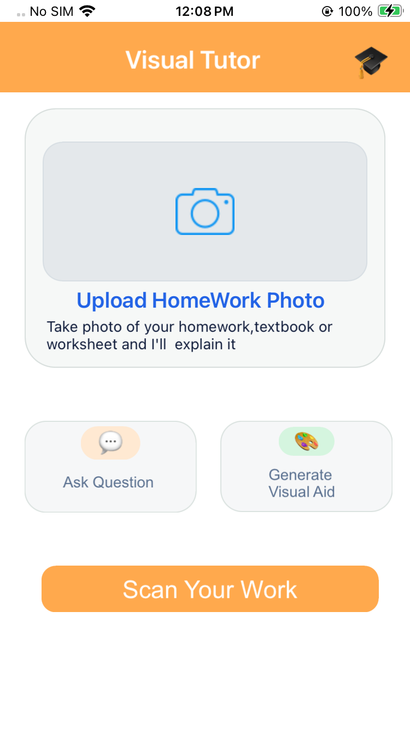

2. frmResult (Image Analysis Result Form)

Purpose:
Displays the results of an image analysis (e.g., description, validation as educational content) after a user uploads .

Key Features:
- Result Display: Shows the AI-generated description of the uploaded image.
- Validation: Checks if the image is educational (e.g., diagrams, charts) and prompts the user if not.
- Navigation: Allows users to proceed to the chat form for follow-up questions or return to the previous screen.

Main Actions:
- onNavigate: Receives image data from the previous form and triggers analysis.
- describeImage: Calls the backend to analyze the image.
- onDescribeSuccess, onDescribeFailure: Handle API responses and update the UI.
- onClickGoChart: Navigates to the chat form with the image description.
- onClickBack: Clears state and navigates back.
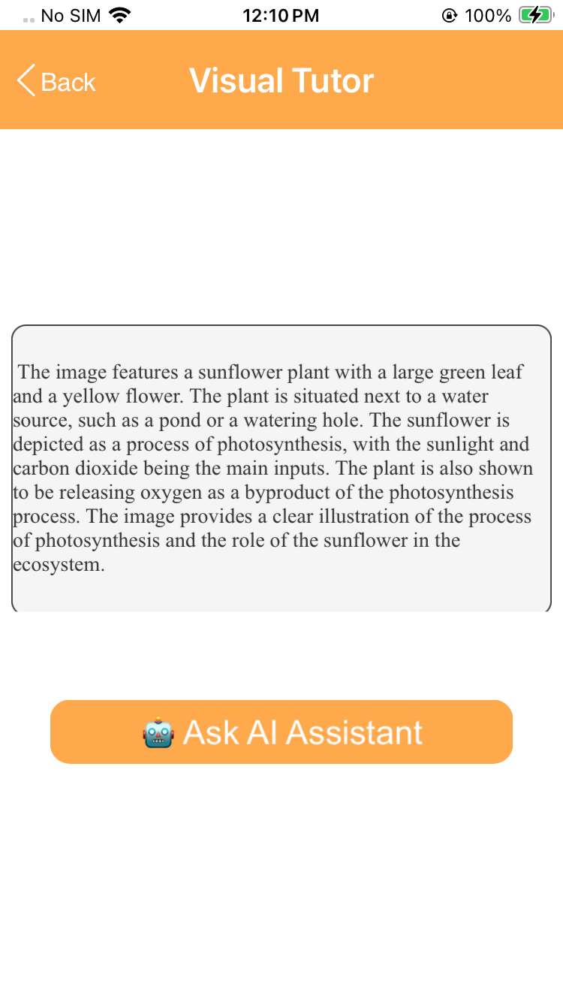

3. frmChat (Q&A Chat Form)

Purpose:
Provides a conversational interface for users to ask follow-up questions about the analyzed image, or generated visual. The chat is powered by an AI model via Cloudflare Workers.

Key Features:
- Chat Interface: Users can type questions and receive AI-generated answers.
- Contextual Q&A: The chat can use the context from the previous image/ visual generation.
- Message History: Maintains a conversation history for context continuity.

Main Actions:
- Receives context (e.g., image description) from frmResult or frmClouflare.
- Sends user questions to the Cloudflare Worker chat endpoint.
- Displays AI responses in the chat interface.
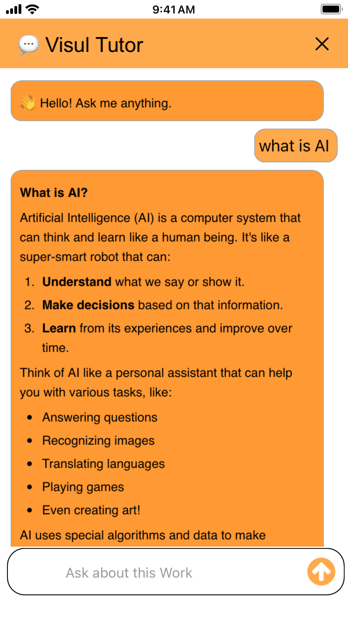
4.frmGenerateVisualAid (Visual Aid Generation Form)
Purpose:
This form allows users to request the generation of educational diagrams or visual aids based on a concept or topic they enter. It is dedicated to creating clear, labeled, textbook-style illustrations using AI.
Key Features:
- Concept Input: Users enter a description of the visual or diagram they need (e.g., “photosynthesis process diagram”).
- AI-Powered Generation: On submission, the app sends the prompt to a Cloudflare Worker endpoint, which generates a visual aid image.
- Result Display: The generated image is displayed on the form for the user to view or use in their studies.
- Navigation: Users can return to the main form or continue interacting with the AI.
Main Actions (Typical Implementation):
- Receives user input for the desired visual concept.
- Calls the /generate-image endpoint (as seen in frmClouflareController’s generateVisualAid method) with the user’s prompt.
- Handles the API response, displaying the generated image or showing an error if generation fails.
- Provides UI controls for submitting the request and navigating back.
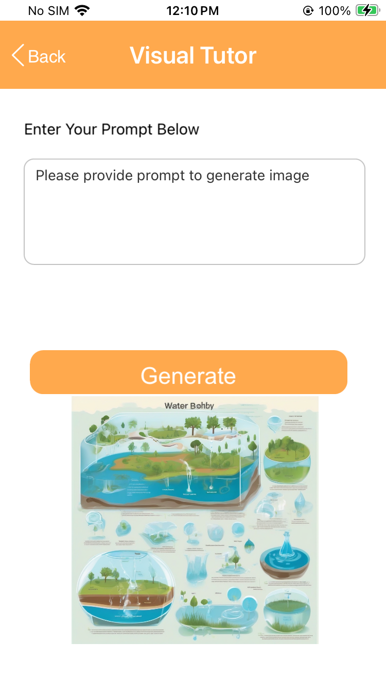

Summary Table
Form Name | Purpose | Main Features / Actions
frmClouflare | Main interaction & input hub | Image, visual generation, chat, API calls
frmResult | Display image analysis results | Shows description, validates educational content, nav
frmChat | Q&A chat about analyzed content | Conversational interface, context-aware Q&A
frmGenerateVisualAid | GenerateImage | The user enters a concept, AI generates and displays an educational diagram.

H. Foundry APP Setup
When you import the application to your Volt MX Iris project, the HCL Volt MX Foundry services of the CloudflareVisualTutor are added to the HCL Volt MX Foundry app, which is associated with the Volt MX Iris project. While importing the CloudflareVisualTutor Application to your Volt MX Iris project, if there is no HCL Volt MX Foundry app associated with the existing Volt MX Iris project, a new HCL Volt MX Foundry app is automatically added to your HCL Volt MX Foundry environment and is associated with your HCL Volt MX Iris.
To set the Foundry app, follow these steps:
- Click the HCL Volt MX Foundry app associated with your Volt MX Iris project from the Project Explorer. Click DATA & SERVICES.
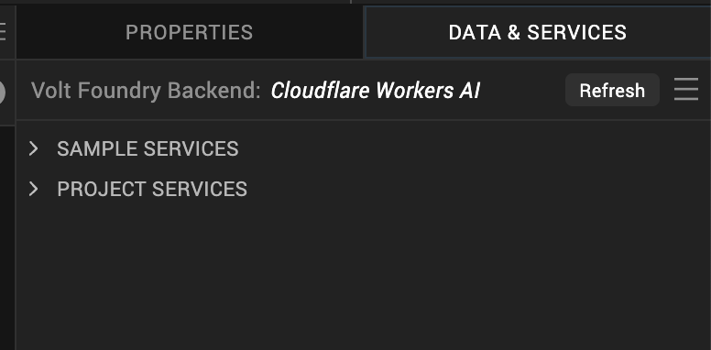

- Under the Configure Services tab, click Integration and you will see the Cloudflare Workers AI integration service. Click on the Integration service to add the keys.
- Click on the Cloudflare Workers AI integration service to expand the operations.
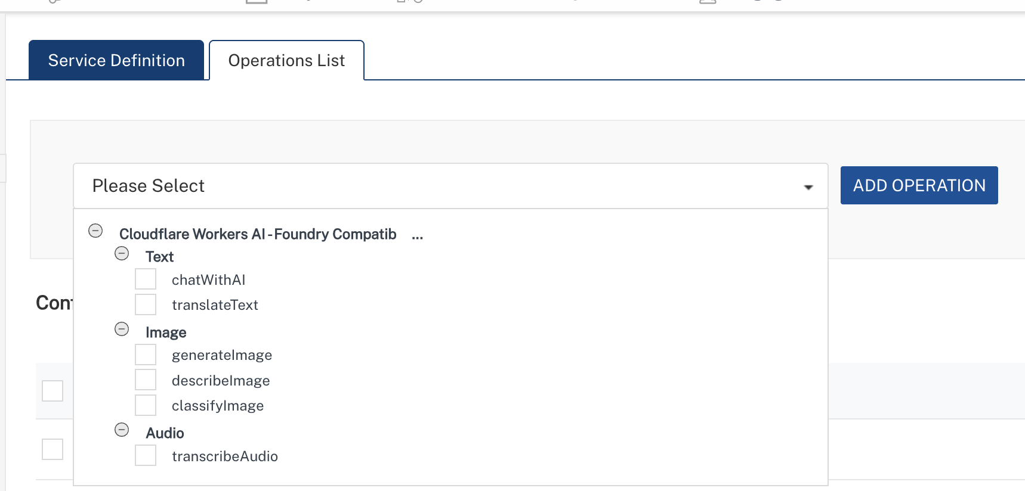
- Select ChatWithAI operation, On the Request Input tab, in the Body section, specify the values in the respective boxes under the Test Value column.
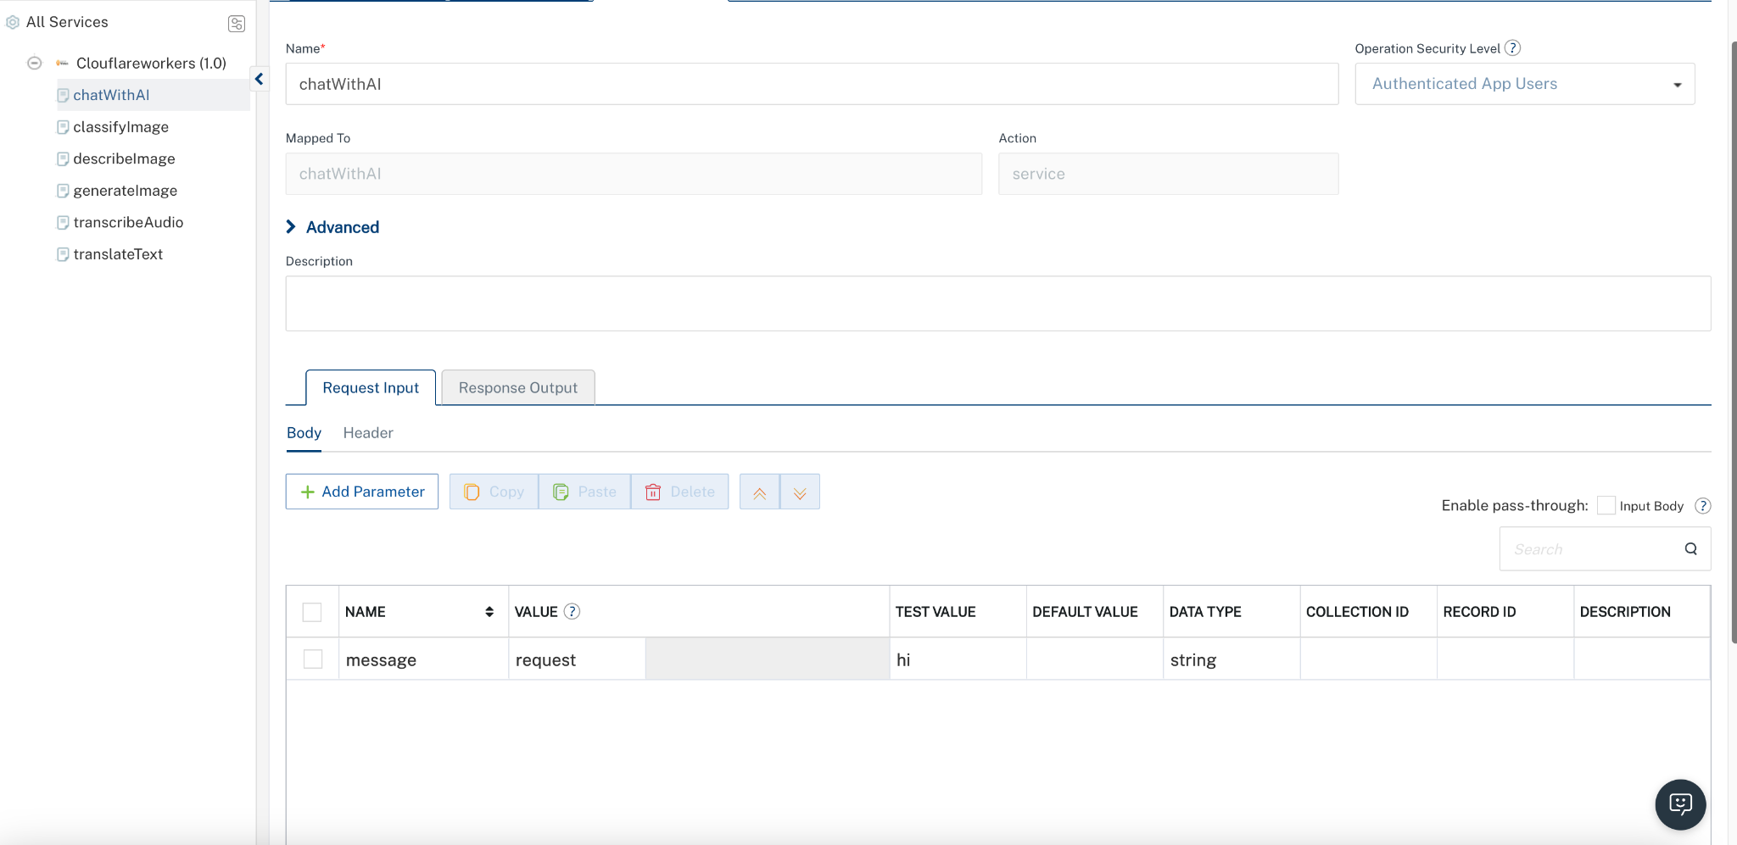

Parameter | Description | Syntax Example
message | message must include a role (system, user, or assistant) and content. | "message": [{"role": "hi"}]

- Click SAVE AND FETCH RESPONSE. The Output Result dialog appears with the response. Otherwise, the Output Result shows an error.
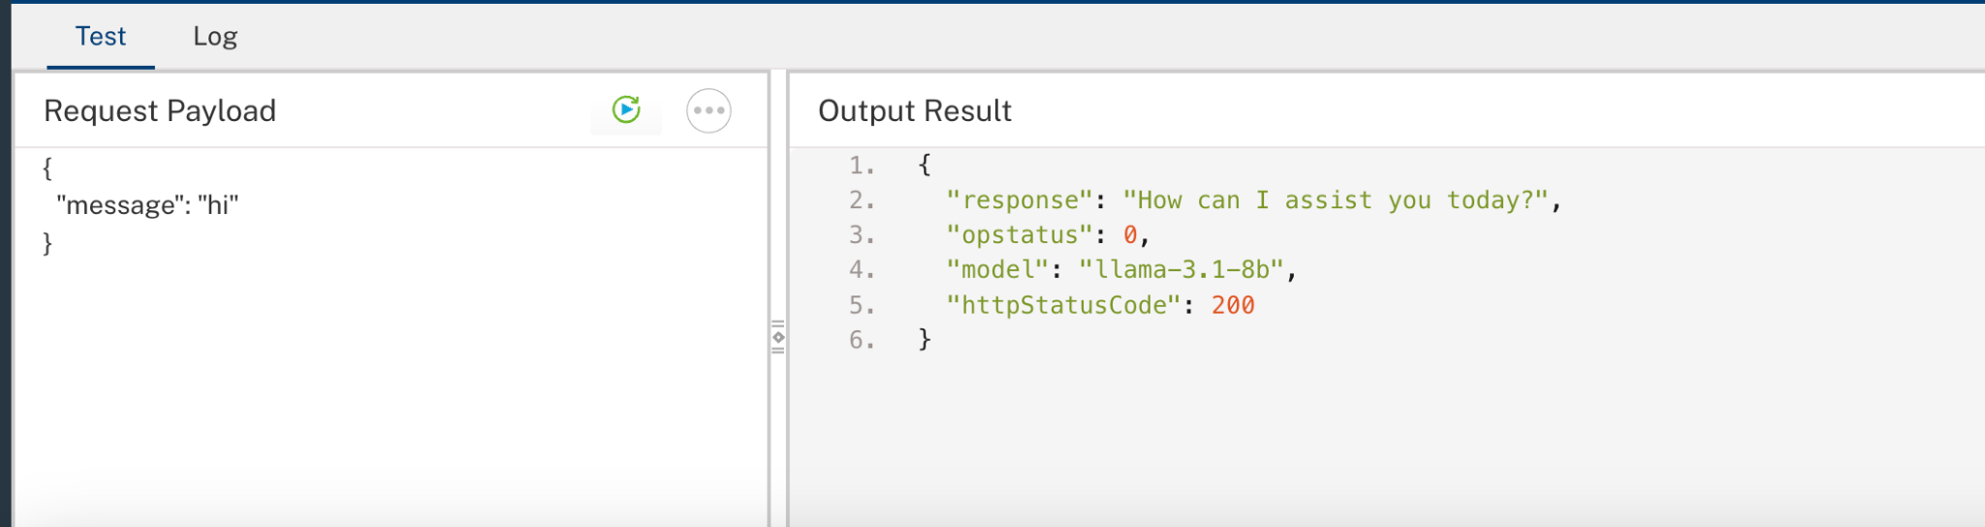

<uses-permission android:name="android.permission.READ_MEDIA_IMAGES" />
<uses-permission android:name="android.permission.READ_EXTERNAL_STORAGE" />
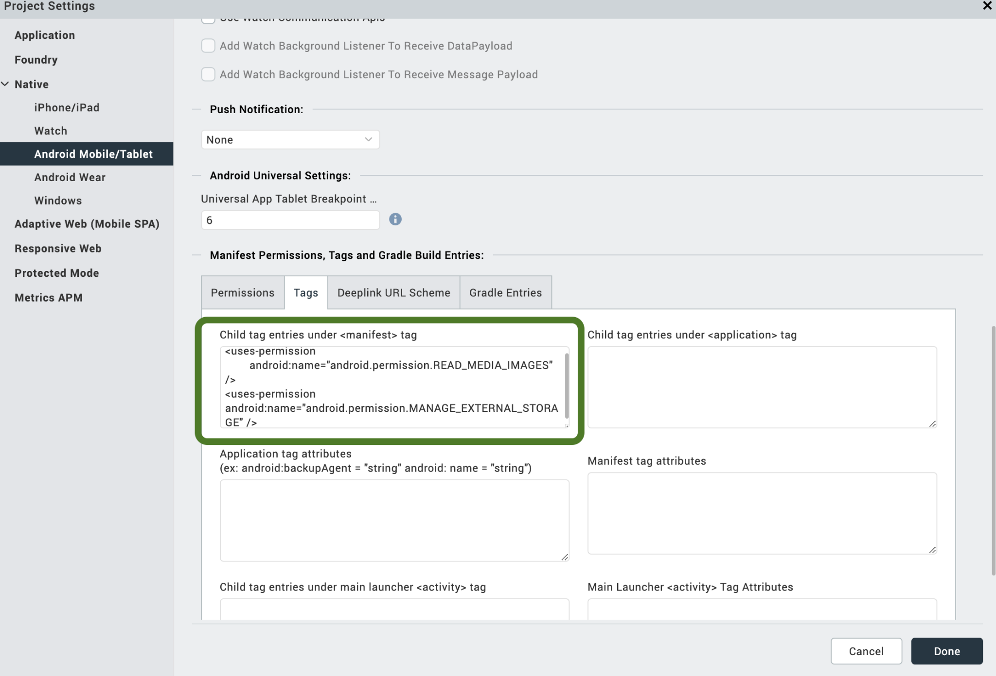
Add appropriate storage permissions before building—use READ_MEDIA_IMAGES for Android 13+ and READ_EXTERNAL_STORAGE for older versions; avoid MANAGE_EXTERNAL_STORAGE unless absolutely necessary.

I. Building and previewing the app
After performing all the above steps, you can build your app and run it on your device. For more information, you can refer to the Building and Viewing an Application section of the Volt MX User Guide.

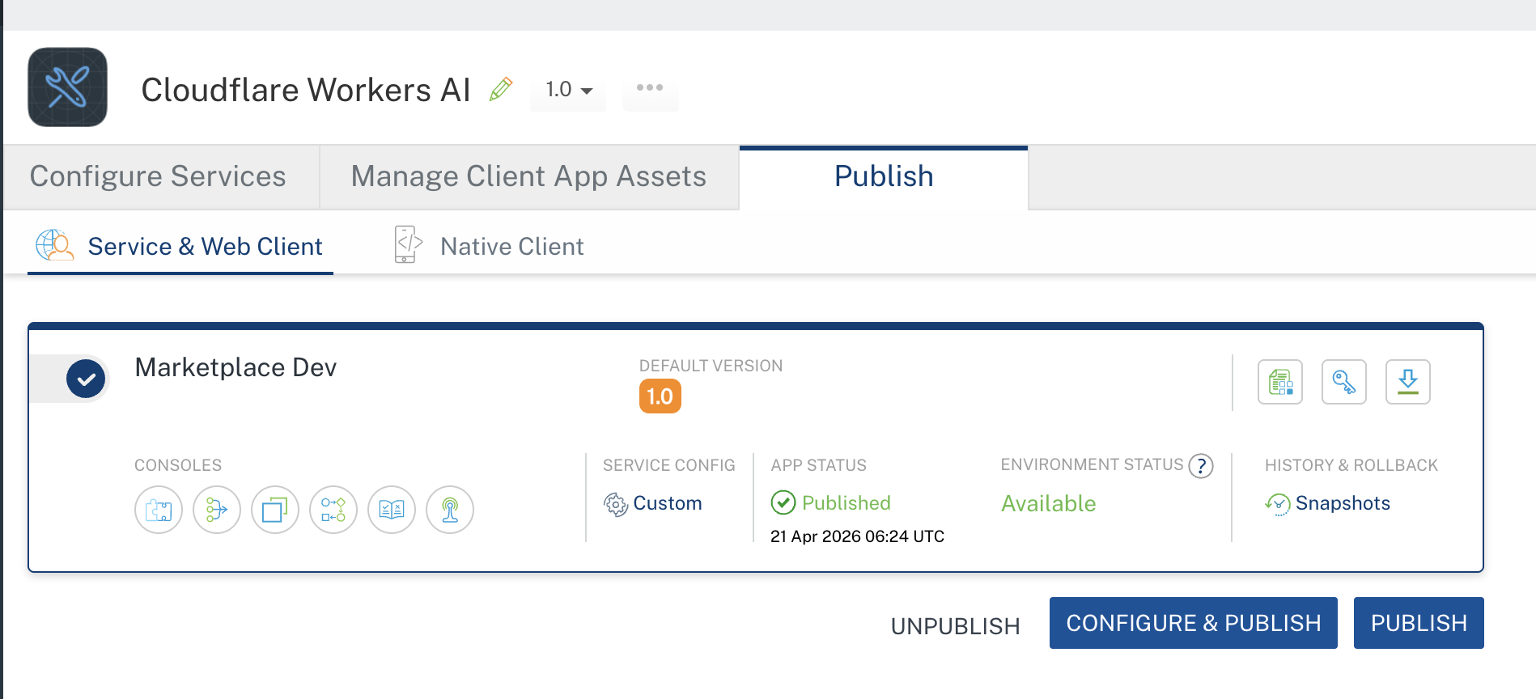

J. Reference API Documentation
https://developers.cloudflare.com/workers/
https://developers.cloudflare.com/workers/get-started/dashboard/
https://developers.cloudflare.com/workers/examples/
https://developers.cloudflare.com/workers/tutorials/
https://developers.cloudflare.com/api/

H. REVISION HISTORY
App version 1.0.0:
Known Issues
- Workers have CPU time limits that may affect long-running computations.
- Cold start latency may occur for infrequently accessed Workers.
- Some Node.js APIs are not available in the Workers runtime.
Limitations
- Maximum script size of 1 MB after compression.
- CPU time limited to 10ms on free tier, 50ms on paid plans.
- Memory usage is capped at 128 MB.
- Maximum 50 subrequests per Worker invocation.
- Environment variables have a 5 KB total size limit.
1. AudioTranscribe endpoint -
Processing Limitations (Platform Constraints)
- Android Limitation: browseFiles API is not available in the current runtime.
- iOS Limitation: openMediaGallery does not support audio selection (invalid query context / media not available).
- Impact: Audio-based features such as transcription and translation cannot be fully implemented or tested within the current platform.
- Status: Blocked due to platform/API limitations; further progress is not feasible at this time.

2. Translate Endpoint -

Unicode Encoding Issue (UTF-8 Not Preserved)
- Issue: Unicode characters (e.g., Hindi text) are rendered as ????? when passed through Volt MX Foundry Integration Services.
- Example Input:
{
"text": "test हिंदी test",
"from": "hindi",
"to": "spanish"
}
- Actual Result:
{
"original": "test ????? test",
"translated": "¿Cuál es el test?"
}
- Expected Result:
{
"original": "test हिंदी test",
"translated": "¿Cuál es el test?"
}
- Backend Verification:
  - Direct API calls (curl/Postman) handle UTF-8 correctly.
  - Issue occurs only within Foundry.
- Root Cause:
  - Foundry reconstructs the request body from individual parameters.
  - This leads to incorrect encoding (non-UTF-8) and loss of Unicode characters.
- Impact:
  - Multilingual and non-English inputs are not reliably supported.
  - Affects translation, NLP, and text-processing use cases.

