06 -NOV-2025

COHERE

VERSION: 1.0.0

OVERVIEW
Cohere Platform is a comprehensive suite of large language model (LLM) services designed to help developers and enterprises build intelligent text-based and retrieval-augmented applications. It provides APIs and infrastructure for text generation, semantic search, retrieval-augmented generation (RAG), reranking, and embeddings.
- Use case:
Cohere can be used to build conversational AI, enterprise search systems, document summarization, knowledge-based Q&A, and custom domain-specific assistants.

Percentage of re-use:
80% (Data can be customizable and customers need to implement UI by themselves).

Features
- Command Models – Large language models for text generation, summarization, and conversational agents.
- Embed Models – Convert text or documents into high-dimensional vector embeddings for semantic search and retrieval.
- Rerank Models – Improve the relevance of search results by ranking documents based on contextual similarity.
- RAG Support – Built-in support for retrieval-augmented generation workflows with citation grounding.

GETTING STARTED

Prerequisites
Before you start using the Cohere Data Adapter, ensure you have the following:

- HCL Foundry
- Volt MX Iris
- Cohere account
  - Sign up at https://dashboard.cohere.com to create your Cohere account.
- Cohere API Key
  - Once logged in, navigate to the API Keys section in the Cohere dashboard to generate an API key.
  - This key is required to authenticate your application when calling the Cohere APIs (for generation, embedding, or reranking).
- Model Access
  - Ensure your account has access to the required model families such as Command, Embed, or Rerank, depending on your use case.
  - You can explore available models and capabilities under the Models documentation.
- Project Setup
  - You can start with the free tier for testing and experimentation, then upgrade to a paid plan for production usage if needed.
- Reference document:
Cohere Platform Overview
Cohere API Reference

Importing the data adapter

You can import Cohere Data Adapter into HCL Foundry directly from the voltmx Forge website or by importing the data adapter zip file.

To import the data adapter zip file, do the following:
- Log on to your HCL Foundry. The Dashboard page appears by default.
- In the left pane, click the API Management menu. The APIs tab opens by default.
- Click the Custom Data Adapters tab. The Custom Data Adapter page appears.
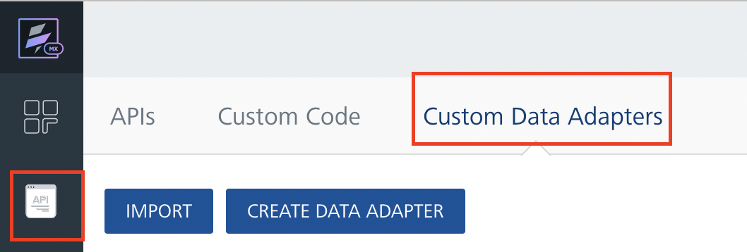
- Click Import. The Import Data Adapter dialog appears.

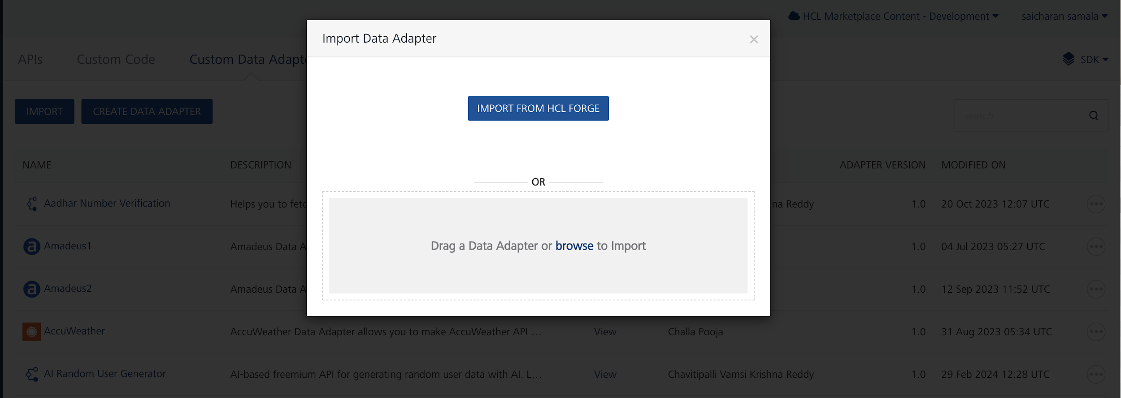

- Click IMPORT FROM HCL FORGE. The Import Data Adapter from HCL Forge dialog appears with a list of available data adapters.
- Click Import. Cohere data adapter is listed on the Custom Data Adapters page.
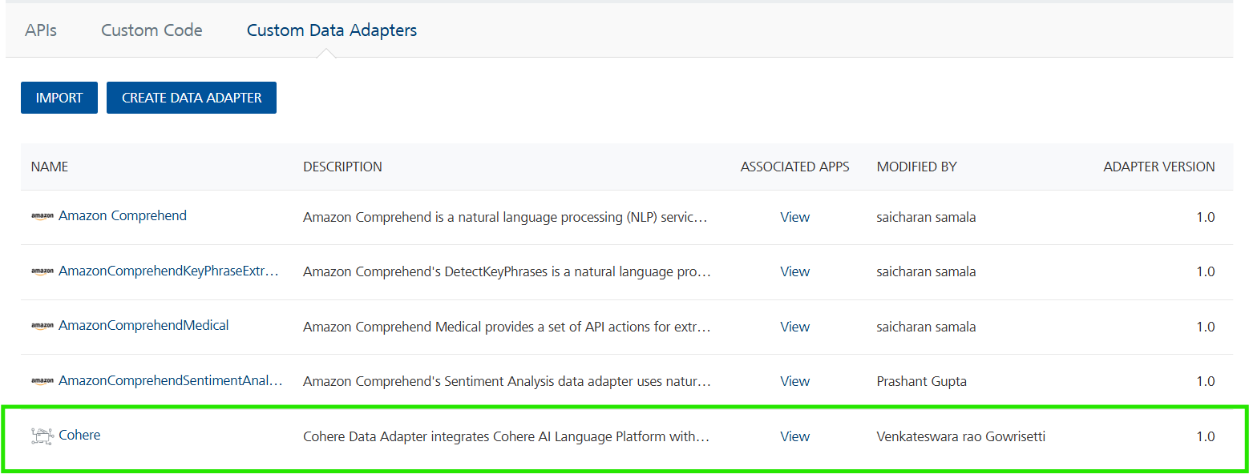

To import the data adapter zip file, do the following:
- Perform steps 1 to 4 in the above procedure
- Drag the data adapter zip file into the Drag a Data Adapter box.
Or
Click browse. The Open dialog appears.
Navigate to the location where you downloaded the data adapter (zip file) on your computer, select the data adapter, and click Open. The Import Data Adapter dialog shows the selected data adapter.

Creating an Integration Service with Cohere :
After you import Cohere Data Adapter into Foundry, you must create an integration service with service type as Cohere .
To create an integration service with Cohere, do the following:
- Log on to your HCL Foundry. The Dashboard page appears by default.
- In the left pane, click the API Management menu. The APIs tab opens by default.
- Click the Integration tab. The Integration tab opens with a list of existing integration services.
- Click CONFIGURE NEW. The Service Definition tab opens.
- In the Name box, type a unique name for your service.
- From the Service Type list, select Cohere.
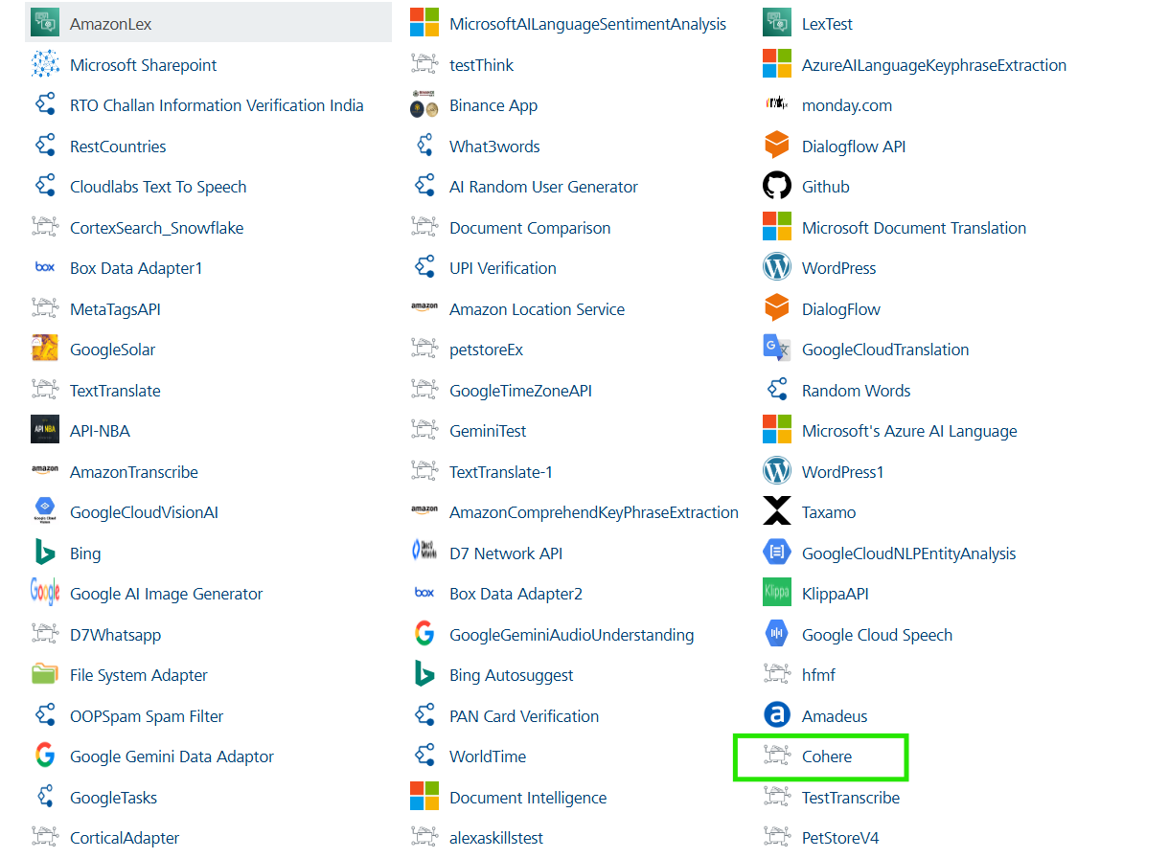
- Click Save

Creating an Operation
To make any API call in the HCL Foundry console, you must create an operation for the respective API and then execute the operation. Executing an operation involves making the API call and displaying the response.
This section provides steps to create an operation for the Cohere API.
Steps to create an operation for the Cohere API:
- Log on to your HCL Foundry. The Dashboard page appears by default.
- In the left pane, click the API Management menu. The APIs tab opens by default.
- Click the Integration tab. The Integration page appears with a list of existing integration services.
- From the list of integration services, select the integration service that you have created with service type as Cohere. The Service Definition tab of the selected integration service opens by default.
- Click the Operations List tab. The Operations List tab opens.
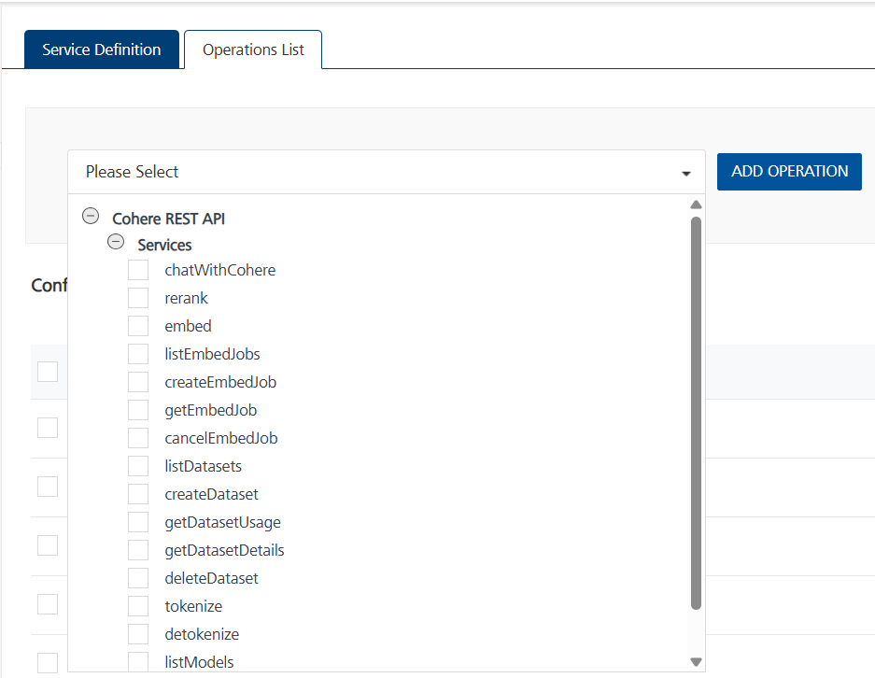
- Select chatWithCohere and Click Add Operation.

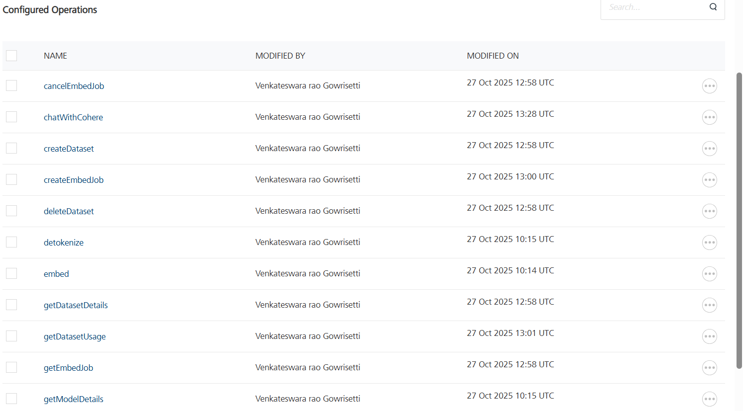

Executing Operation
Executing an operation involves making the API call by setting the necessary parameters and displaying the response. The procedure to execute any operation is same, but the request parameters of the APIs vary. This section provides steps to execute the Cohere (explained in Creating an Operation).
Steps to execute the Cohere operation:
- Log on to your Hcl Foundry. The Dashboard page appears by default.
- In the left pane, click the API Management menu. The APIs tab opens by default.
- Click the Integration tab. The Integration tab opens with a list of existing integration services.
- From the list of integration services, select the integration service that you have created with service type as Cohere. The Service Definition tab of the selected integration service opens by default.
- Click the Operations List tab.
- In the Name box, the name of the operation is displayed by default. If you want, you can change the name.
- On the Request Input tab, in the Body section, for the following parameters, specify the values in the respective boxes under the Test Value column.
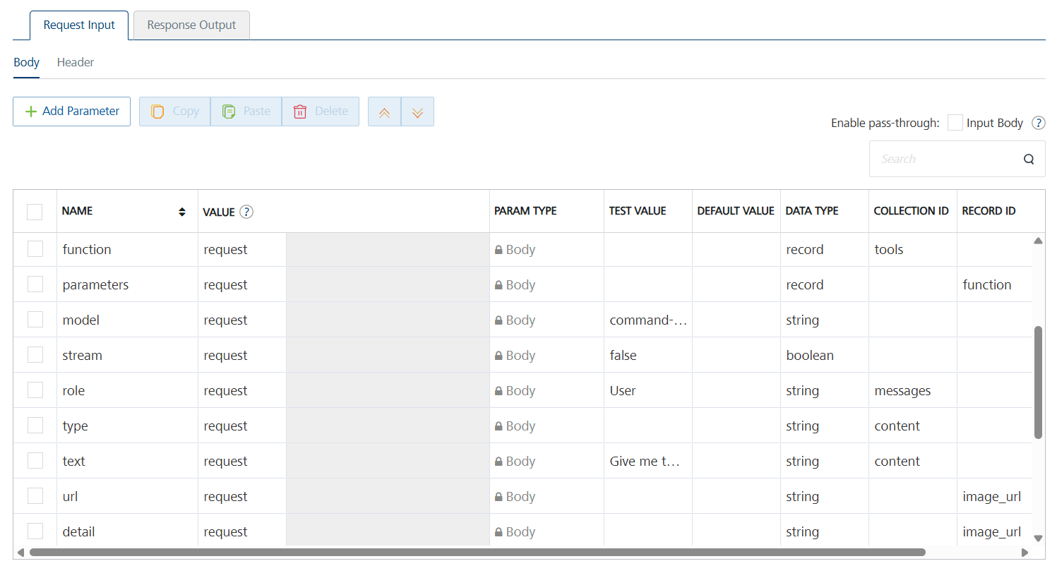

- Enter the value of Authorization in the header part as default value
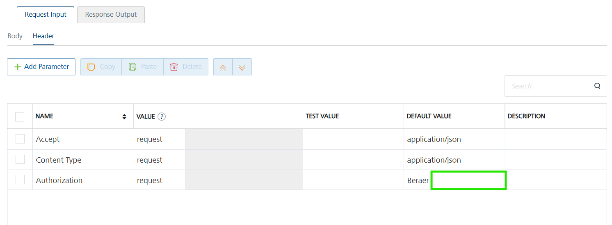
- Click SAVE AND FETCH RESPONSE. The Output Result dialog appears with the response. Otherwise, the Output Result shows an error.
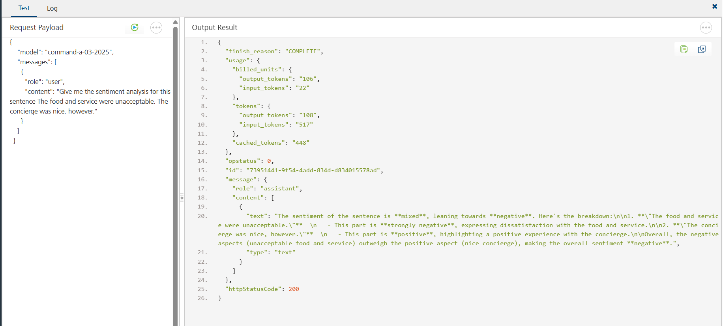
.

Publishing the App in VoltMX FOUNDRY:
After adding the Cohere Data Adapter to your app and configuring the necessary configurations, you must publish the app to HCL Foundry. For more information, refer to Publish a foundry app.
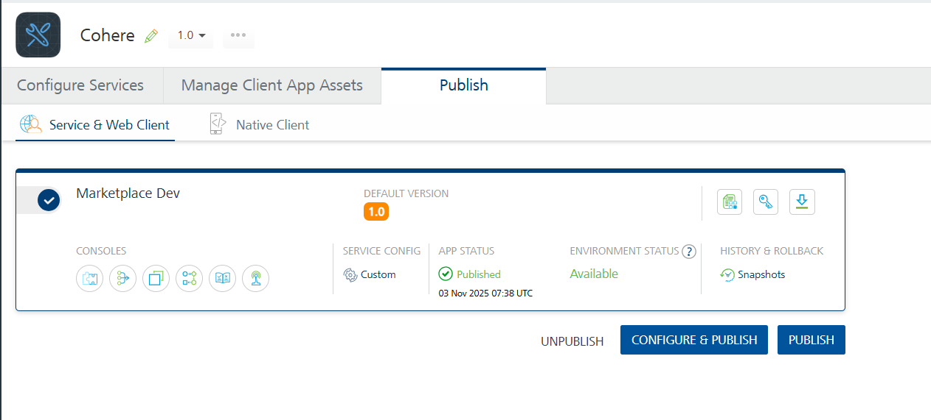

REFERENCES

Properties
- None of the properties are exposed.

Events
- None of the events are exposed.

API’s
- None of the APIs are exposed.

REVISION HISTORY
Adapter version 1.0.0:

Known Issues
None

Limitations
None

