Date : 28-Oct-21

Confirmation Popup (1.0.5)
- Overview
Confirmation popup is used when you need user's explicit confirmation to proceed with an action eg. while deleting a record.

Use case

when deleting a record or while cancelling an order placed etc.

Features
- Easily configurable- set display text and other properties directly from Volt MX Iris
- Fully customizable skins allow you to change look and feel of the component

Percentage of re-use:
90%

Getting Started

Prerequisites
Before you start using the Confirmation Pop-up component, ensure the following:
- HCL Foundry
- Volt MX Iris

Platforms Supported

Mobile

iOS

Android

Tablets

PWA

Importing the Component

You can import the Forge components only into the apps that are of the Reference Architecture type.

To import the Confirmation Popup component, do the following:

Open your app project in Volt MX Iris.
- In the Project Explorer, click the Templates tab.

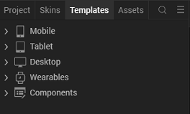

3.Right-click Components, and then select Import Component. The Import Component dialog box appears.
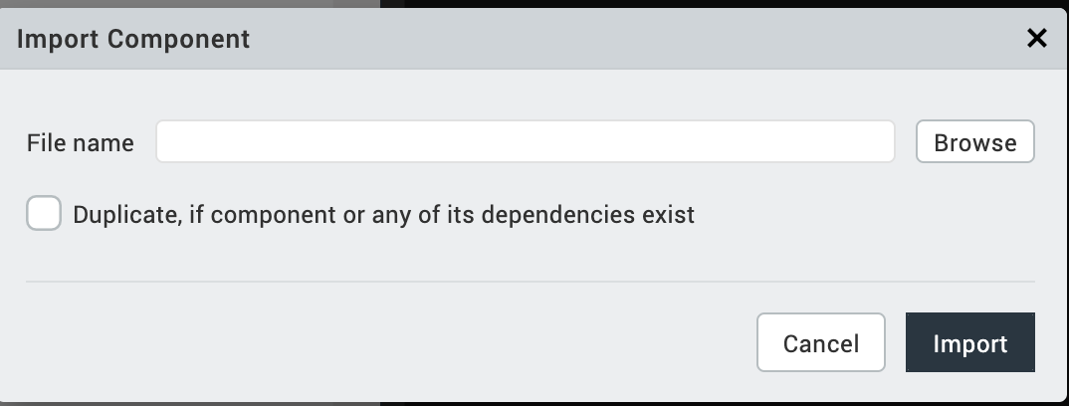
4.Click Browse to navigate to the location of the component, select the component, and then click Import. The component and its associated widgets and modules are added to your project.
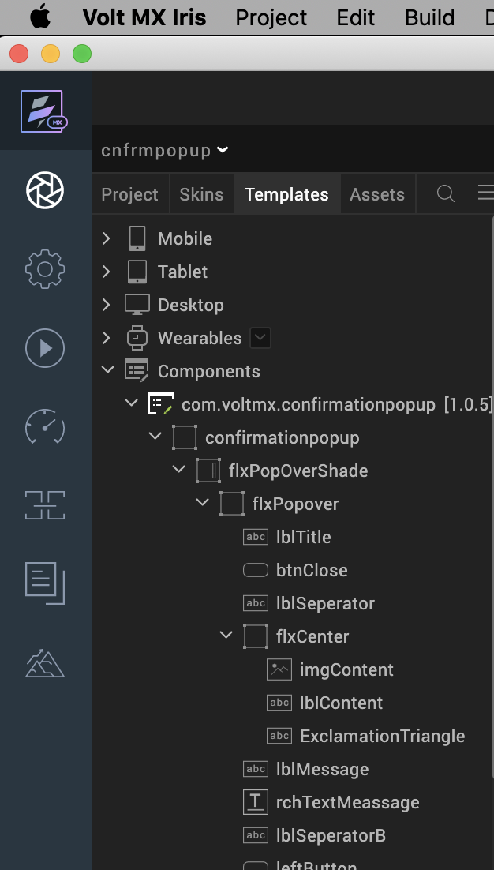

Once you have imported a component to your project, you can easily add the component to a form. For more information, refer Add a Component to a Form.

Building and previewing the app
After performing all the above steps, you can build your app and run it on your device. For more information, you can refer to the Building and Viewing an Application section of the VoltMX Iris User Guide.
You can then run your app to see the Confirmation Popup work in real time.

References

Dynamic Usage
You can also add a Confirmation popup component dynamically. To do so,
- In the Project Explorer, on the Projects tab, click Controllers section to access the respective Form Controller. Create a method and implement the code snippet similar to the sample code mentioned below.
var confirmationpopup = new com.voltmx.confirmationpopup(
{
"clipBounds": true,
"height": "100%",
"id": "confirmationpopup",
"isVisible": true,
"layoutType": voltmx.flex.FREE_FORM,
"left": "0dp",
"masterType": constants.MASTER_TYPE_USERWIDGET,
"skin": "slFbox",
"top": "0dp",
"width": "100%",
"centerX" :"50%",
"centerY" :"50%"

}, {}, {});

/*Setting the component's properties*/

confirmationpopup.leftButtonText = "No";
confirmationpopup.rightButtonText = "Yes";
confirmationpopup.titleText="Confirmation";
confirmationpopup.textMessage="Do you want to proceed with this <b> operation </b>";
confirmationpopup.textContent="Lorem ipsum dolor sit et amet.";

/*Adding the confirmationpopup component to a Form*/

this.view.add(confirmationpopup);
In the code snippet, you can edit the properties of the component as per your requirement. For more information, see Setting Properties.
- Save the file.

.

Properties
The properties provided on the Component tab allow you to customize the UI elements in the Confirmation Popup component. You can set the properties directly on the Component tab or by writing a JavaScript.
General Properties
1. LeftBtnText(leftBtnText)
Description: | Specifies the text for left button.
Syntax: | leftBtnText
Type: | String
Read/Write: | Read + Write
Example: | this.view.confirmationpopup.leftBtnText= "No";
Remarks: | The default value for the property is No.
2. RightBtnText(rightBtnText)
Description: | Specifies the text for right button.
Syntax: | rightBtnText
Type: | String
Read/Write: | Read + Write
Example: | this.view.confirmationpopup.rightBtnText = "Yes";
Remarks: | The default value for the property is "Yes".
3. Text Message(textMessage)
Description: | Specifies the text for Display Message.
Syntax: | textMessage
Type: | String
Read/Write: | Read + Write
Example: | this.view.confirmationpopup.textMessage = " Do you want to proceed with this operation ?";
Remarks: | The default value for the property is " Do you want to proceed with this operation ?"
4. Title Text(titleText)
Description: | Specifies the text for Display Title.
Syntax: | titleText
Type: | String
Read/Write: | Read + Write
Example: | this.view.confirmationpopup.titleText= "Confirmation";
Remarks: | The default value for the property is "Confirmation "

5. Text Content(textContent)

Description: | Specifies the text for Display Text Content.
Syntax: | textContent
Type: | Constant
Read/Write: | Read + Write
Example: | this.view.componentID.textContent=”Lorem ipsum dolor sit et amet. ”;
Remarks: | The default value for the property is "Lorem ipsum dolor sit et amet. ”

Skin Section
6.Left Button Skin(leftButtonSkin)
Description: | This property enables the consumer to change the left button skin of the Confirmation Pop Up component.
Syntax: | leftButtonSkin
Widget Type: | Button
Read/Write: | Read + Write
Example: | this.view.confirmationpopup.leftButtonSkin= "leftButtonSkin";
Remarks: | Skin assigned to the property is accepted only by same widget type.
7. Right Button Skin(rightButtonSkin)
Description: | This property enables the consumer to change the right button skin of the Confirmation Pop Up component.
Syntax: | rightButtonSkin
Widget Type: | Button
Read/Write: | Read + Write
Example: | this.view.confirmationpopup.rightButtonSkin= "rightButtonSkin ";
Remarks: | Skin assigned to the property is accepted only by same widget type.

8. Flex PopOver Shade Skin (flexPopOverShadeSkin)
Description: | This property enables the consumer to change the Flex PopOver Shade Skin of the Confirmation Pop Up component.
Syntax: | flexPopOverShadeSkin
Widget Type: | Flex Container
Read/Write: | Read + Write
Example: | this.view.confirmationpopup.flexPopOverShadeSkin= " flxPopOverShadeSkin";
Remarks: | Skin assigned to the property is accepted only by same widget type.

9. Flex PopOver Skin (flexPopOverSkin)
Description: | This property enables the consumer to change the Flex PopOver Skin of the Confirmation Pop Up component.
Syntax: | flexPopOverSkin
Widget Type: | Flex Container
Read/Write: | Read + Write
Example: | this.view.confirmationpopup.flexPopOverSkin = “flxPopOverSkin”;
Remarks: | Skin assigned to the property is accepted only by same widget type.

10. Flex Center Skin (rightButtonSkin)
Description: | This property enables the consumer to change the Flex Center Skin of the Confirmation Pop Up component.
Syntax: | flexCenterSkin
Widget Type: | Flex Container
Read/Write: | Read + Write
Example: | this.view.confirmationpopup.flexCenterSkin = " flxCenterSkin";
Remarks: | Skin assigned to the property is accepted only by same widget type.

Events
1. btnLeftOnClick
Description: | This event is invoked when the user-touch is released from the left button on the Confirmation Pop Up.
Syntax: | btnLeftOnClick
Type: | String
Read/Write: | Read + Write
Example: | this.view.confirmationpopup.btnLeftOnClick= function(){ alert(“Left Button Clicked”); }
2. btnRightOnClick
Description: | This event is invoked when the user-touch is released from the right button on the Confirmation Pop Up.
Syntax: | btnRightOnClick
Type: | String
Read/Write: | Read + Write
Example: | this.view.confirmationpopup.btnRightOnClick= function(){ alert(“Right Button Click”); }

3. btnCloseOnClick
Description: | This event is invoked when the user-touch is released from the close button on the Confirmation Pop Up.
Syntax: | btnCloseOnClick
Type: | String
Read/Write: | Read + Write
Example: | this.view.confirmationpopup.btnCloseOnClick= function(){ alert(“Close Button Click”); }

APIs

--No APIs are exposed.

Revision History
App version 1.0.5

Limitations
1.landscape mode is not supported in all channels.

