Date : 01-03-2024

cryptocurrency news

version: 1.0.0

Overview
Get the latest crypto news direct from your preferred sources (fast & reliable).
Use case:
- Stay Informed: Access the latest cryptocurrency news from reputable sources like CoinDesk, Cointelegraph, and others to stay updated on market trends, regulatory developments, and technological advancements in the blockchain industry, helping investors make informed decisions.
- Market Analysis: Analyse market sentiment and assess potential impacts on cryptocurrency prices by aggregating news from multiple sources such as Bitcoinist, Decrypt, and BSC News, enabling traders and analysts to anticipate market movements and adjust their strategies accordingly.
- Educational Resource: Utilize cryptocurrency news from trusted sources like The Guardian to educate newcomers and enthusiasts about blockchain technology, digital assets, and the evolving landscape of decentralized finance (DeFi), fostering greater understanding and adoption of cryptocurrencies.

Getting Started

Prerequisites
- Volt Foundry
- Rapid API Account
- X-RapidAPI-Key, X-RapidAPI-Host.

Importing the adapter
To import the Data Adapter to Volt Foundry, do the following:
- Sign in to the HCL Foundry.
- From the left navigation menu, select API Management.
- In API Management, select Custom Data Adapters.
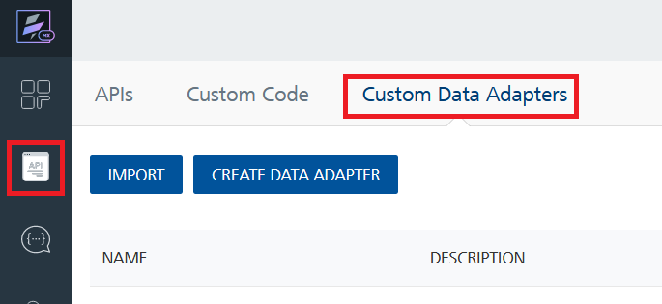
- Click IMPORT to import a custom data adapter.
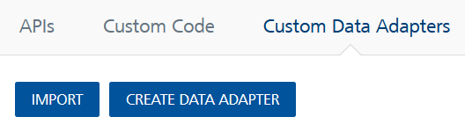
- On the Import Data Adapter dialog box, click browser to import.
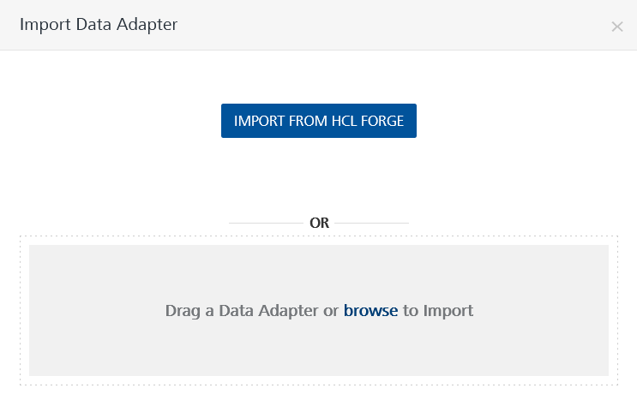
- Select Cryptocurrency News zip file and click IMPORT.
After you import the data adapter, Volt Foundry opens a window that shows the metadata of the data adapter.
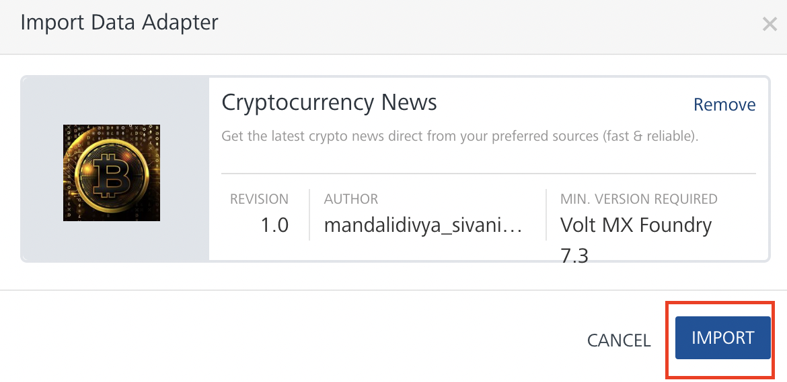
After you import the data adapter, you can view it on the Custom Data Adapters page and use it to create services on Volt Foundry.
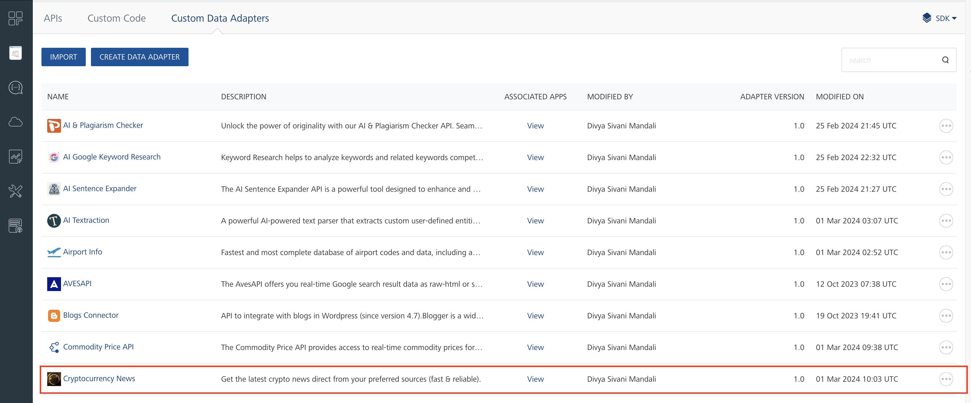

Creating an Integration service
After you import the data adapter into Volt Foundry, you can use it to create an Integration Service.
Follow the given steps to create an Integration service using the Cryptocurrency News Adapter.
- Sign in to the HCL Foundry.
- From the left navigation menu, select API Management.
- In API Management, select Integration.
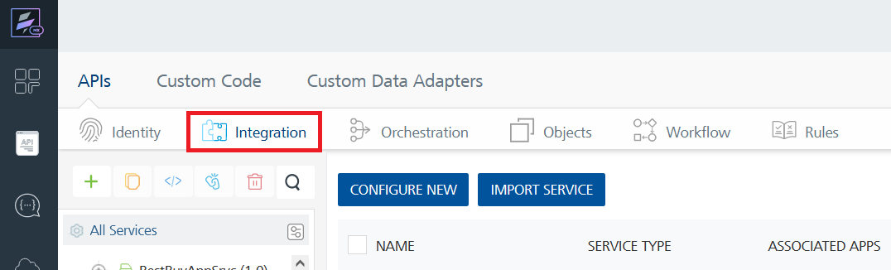

- To create a new service, click the + button or the CONFIGURE NEW button.
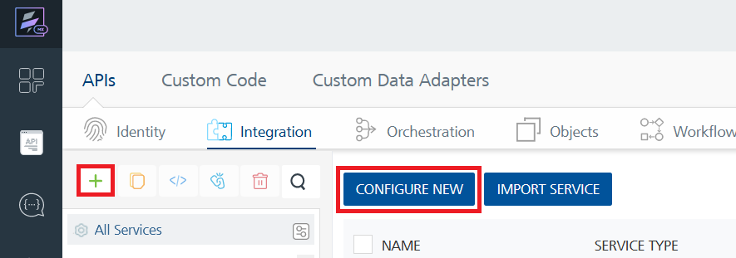
- On the Service Definition tab, select the service type as Cryptocurrency News, and click SAVE.
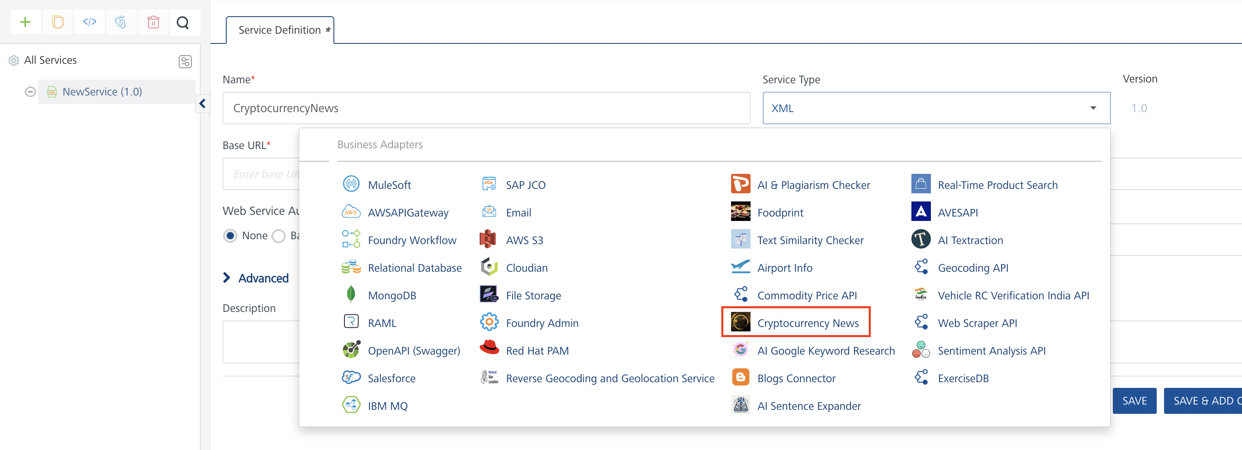
Alternatively, you can also create a Foundry app and create an Integration service inside it.

Creating and Executing operations
After you create an integration service, you can create and execute operations using the service.

Creating an Operation
- In API Management/Foundry app you created, in the Integration section, select the service that you created.
- After you select the service, navigate to the Operation List tab.
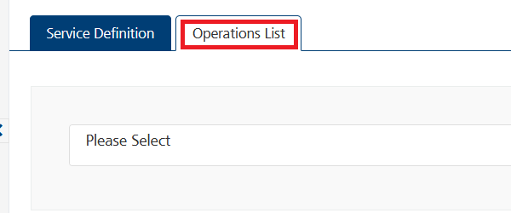
- From the drop-down list, select an operation that you want to execute, and click ADD OPERATION.
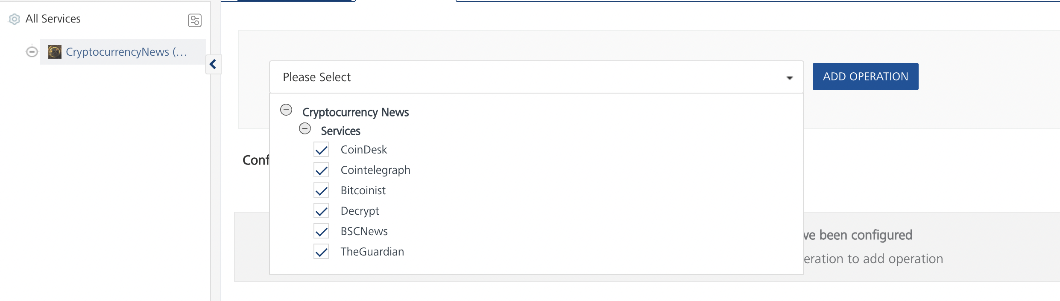

Executing an Operation
- From the Operations List tab, in the Configured Operations section, select the operation you want to execute.
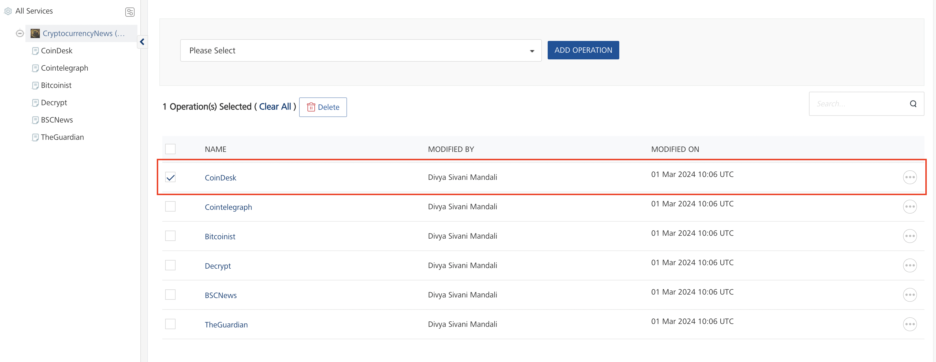
Note: You can follow the same steps to create operations for other methods but ensure that you select the required API.
You can create multiple operations with required APIs and save them in the Configured Operations section. You can then execute the operations whenever required.
- On the Operation Page, in the Request Input tab, in the Body section, for the following parameters, specify the values in the respective boxes under the Test Value column.
Mandatory Parameters
  - X-RapidAPI-Key, X-RapidAPI-Host [in header]: API Key associated with your RapidAPI account, required for authentication.
To get keys – Login in to Rapid API Account -> You can view your keys.
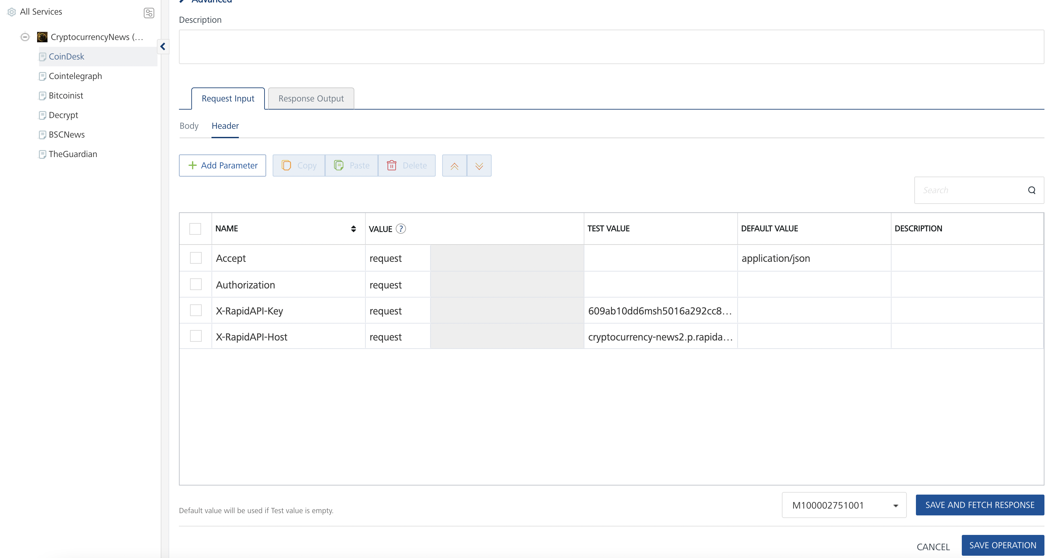

- Select a run-time environment and click Save and Fetch Response to get a response based on your inputs.
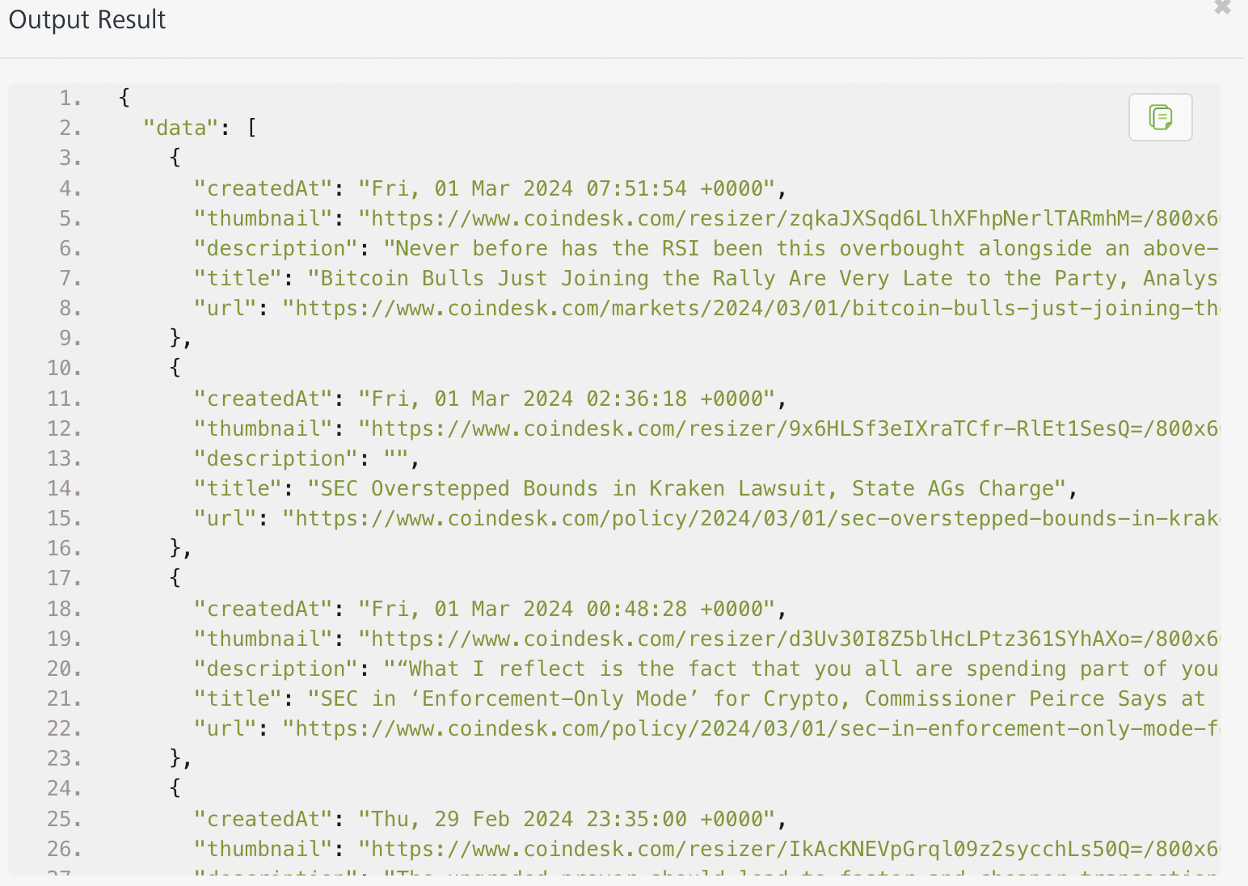

Publishing your application
If you want to use the services in client applications, you need to publish an app to a run-time environment. You can create the service (as described above) in an application or import the service into an application and publish the application.

References

Endpoint Documentation

Requests Input Parameters for CoinDesk
Parameter | Description
X-RapidAPI-Key(string) | [Required] [Header]API Key associated with your account.
X-RapidAPI-Host (string) | [Required] [Header] The host parameter specifies the domain name or IP address of the RapidAPI endpoint. In the context of the Cryptocurrency News, the default host is set to 'cryptocurrency-news2.p.rapidapi.com'. This parameter is necessary for routing the request to the appropriate API endpoint.

Response Output Parameters for CoinDesk

Object Property | Data Type | Description
data | Array | An array containing objects representing news articles. Each object contains the following properties:
createdAt | String | The date and time when the article were created.
thumbnail | String | The URL of the thumbnail image associated with the article.
description | String | The description or summary of the article.
title | String | The title of the article.
url | String | The URL of the full article.

Reference Document: Cryptocurrency News API Documentation (topapi-topapi-default) | RapidAPI

Revision History
Adapter version 1.0.0:

Known Issues
- No Known Issues

Limitations
- No limitations

