18 Nov 2021

D3 Collection library (1.0.1)
- Overview
D3.js is a JavaScript library for manipulating documents based on data. D3 helps you bring data to life using HTML, SVG, and CSS.

Use case

The D3.js Collection Libraries contains components that integrate the visualization features with Iris. You can use these components in scenarios such as: an Analytics app, in which you want to visually represent statistical data to the user.

The following charts are bundled in the collection library -
- Population Pyramid
- Sequence Sunburst
- Collapsible Indented Tree
- Live Update Chart

Percentage of re-use:
Approximate 85% of reuse.

Getting Started

Prerequisites
This is a getting started section for the D3.js collection library. It contains information about setting up and running components from the library in an application.
Before you start using the D3.js collection library, make sure that you meet all the prerequisites.
• HCL Foundry
• Volt MX Iris

Platforms Supported

PWA/Responsive Web

After you make sure that you meet all the prerequisites, you can expand any of the following drop-down sections for details about every step of getting started with the collection library

Importing the collection library to your project

You can import the Forge components only into the apps that are of the Reference Architecture type.

Make sure that you are signed into Volt MX Iris.

You can download the collection library onto your system as a zip file from Volt MX Forge.

You can then import the zip file by selecting the Import Library option from My Libraries as shown in below.

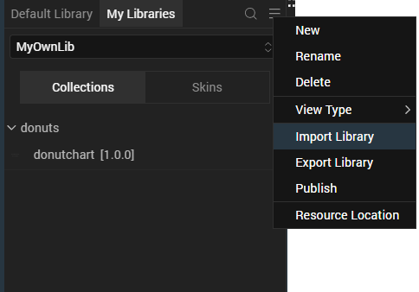

After Iris downloads the collection library, it adds the library to your workspace. You can access the library from the My Libraries tab on the lower-left panel on Iris.
After you import the collection library, you can add components from the library to your app.
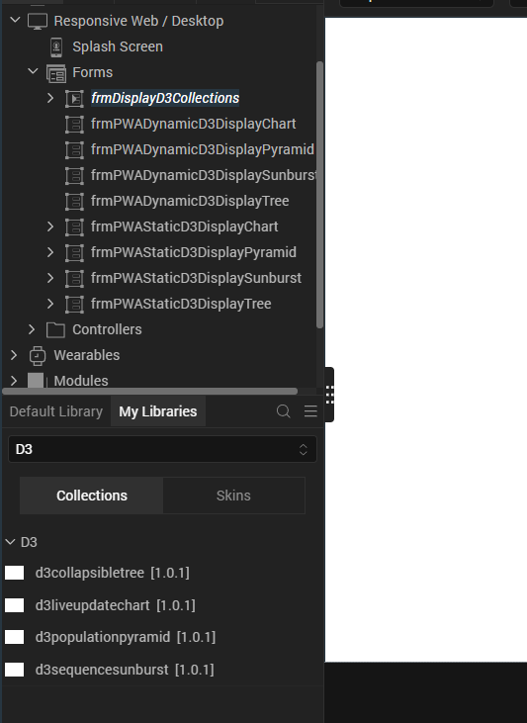

After you add the components to your form, you can Preview or Build your app.

Adding components to your app

From the lower-left panel of Iris, switch to the My Libraries tab

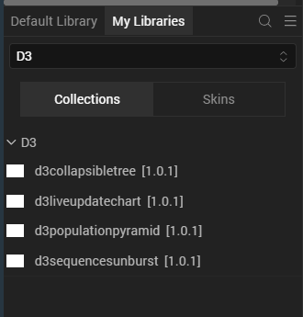

From the drop-down list, select the D3.js library that you imported from Forge.

From Collections, drag and drop a component onto your form.

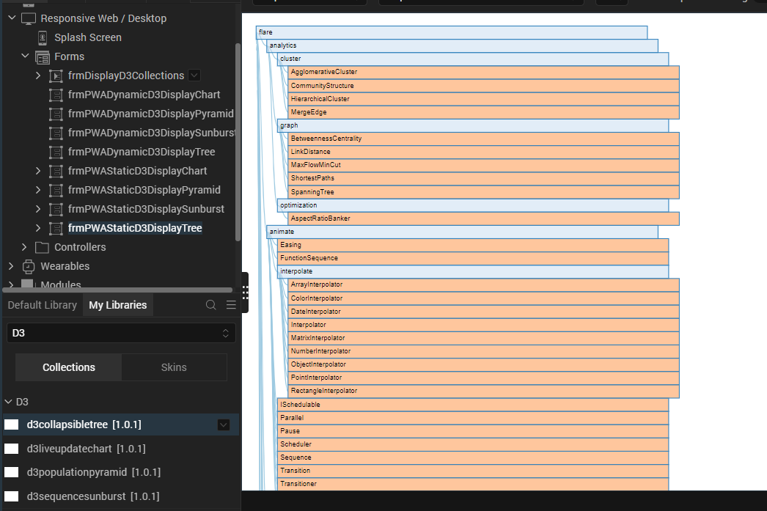

After you add a component to a form, you can Preview or Build your app.
For more information on the components in the library, you can refer to the following sections of the document.

Collapsible Tree Component
Live Update Chart Component
Population Pyramid Component
Sequence Sunburst Component
Modifying the UI of a component
You can modify the UI of a component by editing the CSS files that are associated with the component.
To access the CSS files that are associated with a component, follow these steps:
- From the Project explorer, go to Web → Localfiles.
- Open the folder that has the same name as the component you want to modify.
For example: Open d3populationpyramid.
- From the styles folder, select a CSS file that you want to edit.
- Edit the CSS based on your preference.

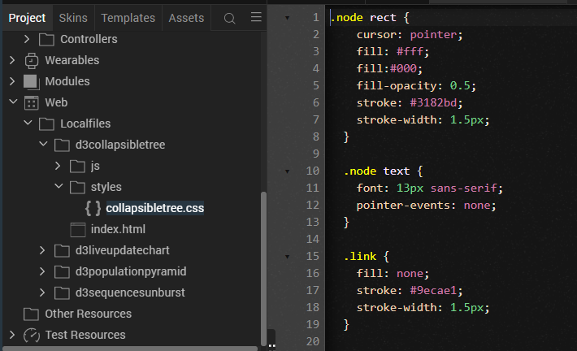

After you edit the CSS, you can Build and Preview your app to view the modifications to the UI.
For more information on the components in the library, you can refer to the following sections of the document.

- Collapsible Tree Component
- Live Update Chart Component
- Population Pyramid Component
- Sequence Sunburst Component

Building and previewing your app
After performing all the above steps, you can perform either of the following tasks.
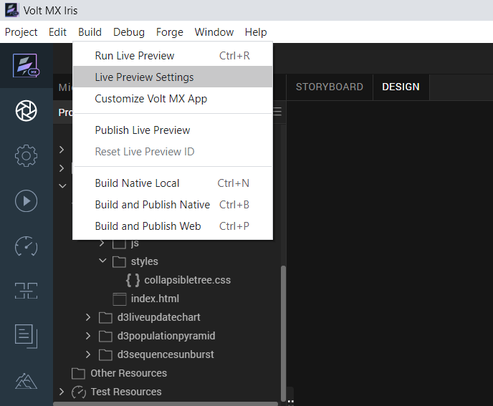
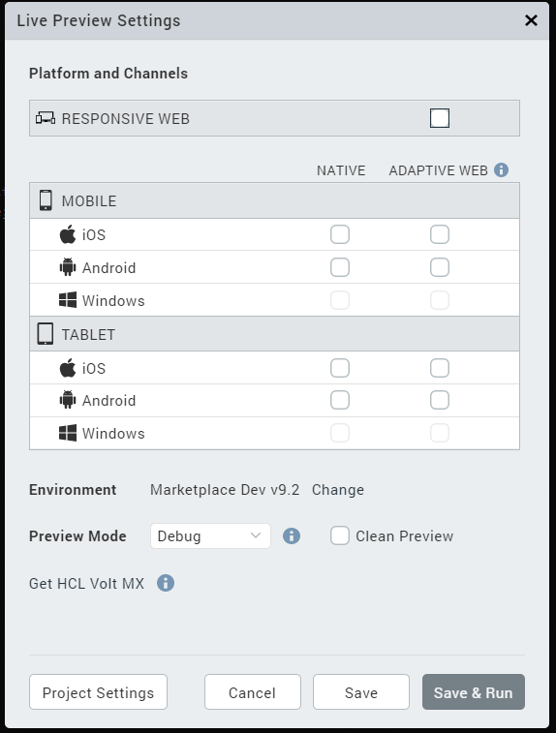

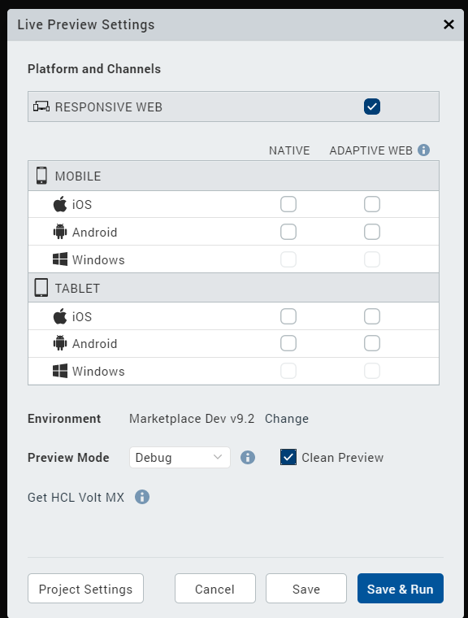

For more information, you can refer to the Building and Viewing an Application section of the Volt MX User Guide.

D3.js: Collapsible Tree Component
The Collapsible Tree component in the D3.js displays data in a tree structure. A user can expand or collapse different parts of the data tree by clicking the header nodes.
Note:
>> To render the tree with data, call the setData API by using Actions.
>> If you copy the code from any example, make sure that you replace componentID with the name of your component.

Dynamic Usage

If you want to use a component dynamically, you need to add the component to your project Templates. Follow the given steps to do so.
From the Project explorer, expand Responsive Web/Desktop.
Right-click forms and select New Form
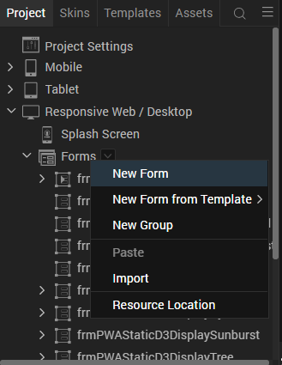
From the My Libraries tab, drag and drop the component onto the form.
Right-click the form that you created and select Delete.
From the Project explorer, go to the Templates tab.
The component that you want to add should be available in the Components section.
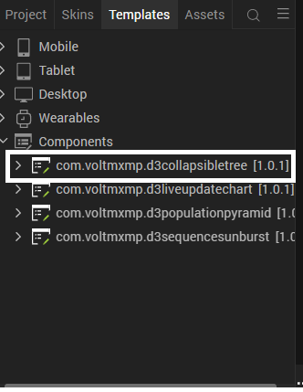
After you add the component into your project templates, follow the given steps to add the component to your app dynamically.
Access the FormController of the form you want to add the component into.
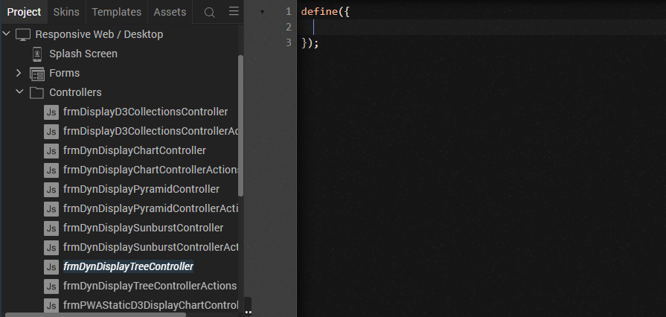
Create a function called createComponent(); and type a code inside the function to create and configure the component.
You can refer to the given sample code for more information.

/* Creating the component's object */
var collapsibleTreeObj = new com.voltmxmp.d3collapsibletree(
{
"clipBounds": true,
"height": "100%",
"id": "CollapsibleTree",
"isVisible": true,
"left": "0dp",
"top": "0dp",
"width": "100%",
"zIndex": 1
}, {}, {});

/* Setting the component's properties */
collapsibleTreeObj.sampleData = false;
collapsibleTreeObj.headerColor = "#fff";
collapsibleTreeObj.itemColor = "#dcdcdc";
/* Adding the component to the form */
this.view.add(collapsibleTreeObj);
/* Calling the component's API to render the tree */
this.view.CollapsibleTree.setData("https://gist.githubusercontent.com/mbostock/1093025/raw/b40b9fc5b53b40836ead8aa4b4a17d948b491126/flare.json");

To execute the code, you need to call this function using Actions. For more information, refer to the Add Actions section of the Iris User Guide.

Properties
You can use a component's Properties to customize and configure the elements. These elements can be UI widgets, service parameters, and other elements. For more information about properties, you can refer to the Components Overview section of the Iris User Guide.
You can set the properties from the Properties panel on the right side of Iris. You can also configure these properties using a JavaScript code.

General
Show Sample Data
Description: | Toggles the visibility of the sample data of the component.
Syntax: | sampleData
Type: | Boolean
Read/Write: | Write
Default Value: | True
Example: | this.view.componentID.sampleData = false;

Data URL
Description: | Specifies the URL that the component uses to fetch the data.
Syntax: | userData
Type: | String
Read/Write: | Write
Remarks: | The URL must contain data in a JSON format
Example: | this.view.componentID.userData = “https://gist.githubusercontent.com  /mbostock/1093025/raw/  b40b9fc5b53b40836ead8aa4b4a17d948b491126/flare.json

Header Color
Description: | Specifies the color of the headers of the tree.
Syntax: | headerColor
Type: | String
Read/Write: | Write
Remarks: | - Make sure that you enter the hex code with the pound (#) symbol.
Example: | this.view.componentID.headerColor = "#fff";
Item Color
Description: | Specifies the color of the items of the tree.
Syntax: | itemColor
Type: | String
Read/Write: | Write
Remarks: | - Make sure that you enter the hex code with the pound (#) symbol.
Example: | this.view.componentID.itemColor = "#dcdcdc";

Events
The component invokes events when its corresponding action is performed. You can configure any logic you want the component to perform whenever an event occurs. You can configure the events directly on the Actions tab or by writing a JavaScript, For more information, refer to Add Actions in the Iris User Guide.
onItemClick
Description: | Invoked when the user selects an item from the tree.
Syntax: | onItemClick
Parameters: | itemName [String] :  Name of the selected item.
Example: | this.view.componentID.onItemClick = function(itemName)  {  alert("Selected Item: "+itemName);  }.bind(this);
onErrorCallback
Description: | Invoked when an error occurs within the component.
Syntax: | onErrorCallback
Parameters: | errObj [JSON] :  Information about the error such as the error code, and the error message.
Example: | this.view.componentID.onErrorCallback = function(errObj)  {  alert("Error Occured: "+JSON.stringify(errObj));  }.bind(this);

APIs
The following APIs pertain to the D3.js: Collapsible Tree component.
setData
Description: | Renders a collapsible tree based on the specified data.
Syntax: | setData(json)
Parameters: | json [String] :  A URL that contains the data (in JSON format) that you want to display on the tree.
Return Value: | None
Example: | var json =  "https://gist.githubusercontent.com/  mbostock/1093025/raw/  b40b9fc5b53b40836ead8aa4b4a17d948b491126/flare.json";  this.view.componentID.setData(json);

D3.js: Live Update Chart Component
The Live Update Chart component in the D3.js displays data as a horizontal chart that updates the displayed data after a specified time interval.

Note:
To render the chart with data, call the setChartData API by using Actions.
If you copy the code from any example, make sure that you replace componentID with the name of your component.
If the JSON that is specified in the Data URL property or the setChartData API is updated, the component updates the data after the specified Time Interval.

Dynamic Usage

If you want to use a component dynamically, you need to add the component to your project Templates. Follow the given steps to do so.
From the Project explorer, expand Responsive Web/Desktop.
Right-click forms and select New Form
From the My Libraries tab, drag and drop the component onto the form.
Right-click the form that you created and select Delete.
From the Project explorer, go to the Templates tab.
The component that you want to add should be available in the Components section.
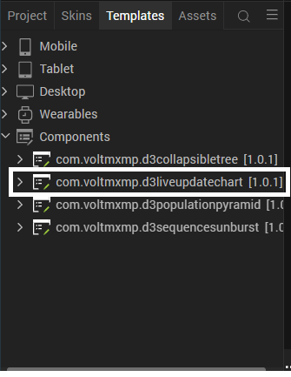
After you add the component into your project templates, follow the given steps to add the component to your app dynamically.
Access the FormController of the form you want to add the component into.
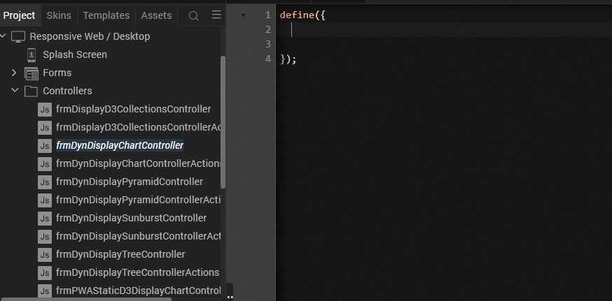
Create a function called createComponent(); and type a code inside the function to create and configure the component.
You can refer to the given sample code for more information.

/* Creating the component's object */
var liveUpdateChartObj = new com.voltmxmp.d3liveupdatechart(
{
"clipBounds": true,
"height": "100%",
"id": "LiveUpdateChart",
"isVisible": true,
"left": "0dp",
"top": "0dp",
"width": "100%",
"zIndex": 1
}, {}, {});
/* Setting the component's properties */
liveUpdateChartObj.timeInterval = 3;
liveUpdateChartObj.isSampleData = false;
/* Adding the component to the form */
this.view.add(liveUpdateChartObj);
/* Calling the component's API to render the chart */
this.view.LiveUpdateChart.setChartData("https://gist.githubusercontent.com/charlesdguthrie/11356441/raw/cc4659e14869f01c88cf461b817f84cd0e1353d0/fakeData.json");

To execute the code, you need to call this function using Actions. For more information, refer to the Add Actions section of the Iris User Guide.

Properties
You can use a component's Properties to customize and configure the elements. These elements can be UI widgets, service parameters, and other elements. For more information about properties, you can refer to the Components Overview section of the Iris User Guide.
You can set the properties from the Properties panel on the right side of Iris. You can also configure these properties using a JavaScript code.

General
Time Interval
Description: | Specifies the time (in seconds) after which the component updates the data.
Syntax: | timeInterval
Type: | Integer
Read/Write: | Write
Example: | this.view.componentID.timeInterval = 3;
Sample Data
Description: | Toggles the visibility of the sample data of the component.
Syntax: | isSampleData
Type: | Boolean
Read/Write: | Write
Default Value: | True
Example: | this.view.componentID.isSampleData = false;
Data URL
Description: | Specifies the URL that the component uses to fetch the data.
Syntax: | userData
Type: | String
Read/Write: | Write
Remarks: | - The URL must contain data in a JSON format.
Example: | this.view.componentID.userData =  "https://gist.githubusercontent.com/  charlesdguthrie/11356441/raw/  cc4659e14869f01c88cf461b817f84cd0e1353d0  /fakeData.json";

Events
The component invokes events when its corresponding action is performed. You can configure any logic you want the component to perform whenever an event occurs. You can configure the events directly on the Actions tab or by writing a JavaScript, For more information, refer to Add Actions in the Iris User Guide.
onTimeIntervalExpiry
Description: | Invoked after the specified Time Interval ends.
Syntax: | onTimeIntervalExpiry
Parameters: | chartData [JSON] :  The data on the chart at the end of the time interval.
Remarks: | To update the chart after the time interval ends, use the setChartData API in the actions of the onTimeIntervalExpiry event.
Example: | this.view.componentID.onTimeIntervalExpiry = function(chartData)  {  alert("Chart Data: "+JSON.stringify(chartData));  }.bind(this);
onErrorCallback
Description: | Invoked when an error occurs within the component.
Syntax: | onErrorCallback
Parameters: | errObj [JSON] :  Information about the error such as the error code, and the error message.
Example: | this.view.componentID.onErrorCallback = function(errObj)  {  alert("Error Occured: "+JSON.stringify(errObj));  }.bind(this);

APIs
The following APIs pertain to the D3.js: Live Update Chart component.
setChartData
Description: | Renders a chart based on the specified data.
Syntax: | setChartData(chartData)
Parameters: | chartData [String] :  A URL that contains the data (in JSON format) that you want to display on the chart.
Return Value: | None
Example: | var chartData =  "https://gist.githubusercontent.com/  charlesdguthrie/11356441/raw/  cc4659e14869f01c88cf461b817f84cd0e1353d0/  fakeData.json";  this.view.componentID.setChartData(chartData);

D3.js: Population Pyramid Component
The Population Pyramid component in the D3.js displays data as a bar-graph and also displays the selected year on the upper-left corner. A user can change the year and move the graph by using the left and right arrow keys.
Note:
To render the graph with data, call the setData API by using Actions.
If you copy the code from any example, make sure that you replace componentID with the name of your component.

Dynamic Usage
If you want to use a component dynamically, you need to add the component to your project Templates. Follow the given steps to do so.
From the Project explorer, expand Responsive Web/Desktop.
Right-click forms and select New Form
From the My Libraries tab, drag and drop the component onto the form.
Right-click the form that you created and select Delete.
From the Project explorer, go to the Templates tab.
The component that you want to add should be available in the Components section.
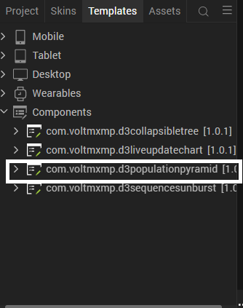

After you add the component into your project templates, follow the given steps to add the component to your app dynamically.
Access the FormController of the form you want to add the component into.
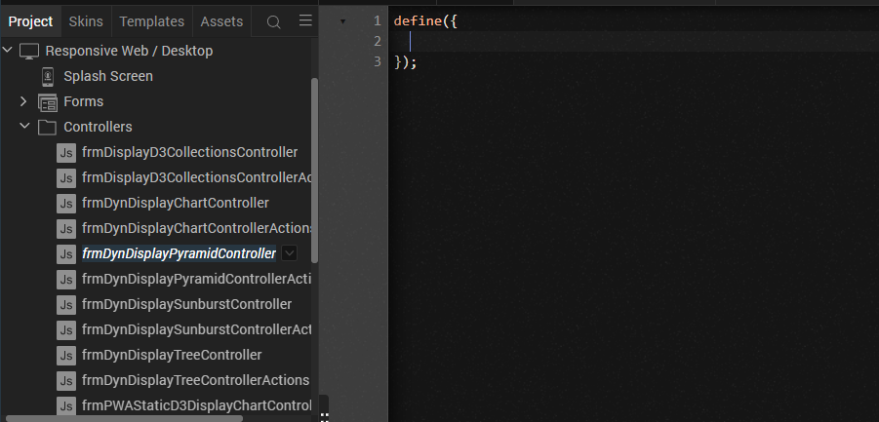
Create a function called createComponent(); and type a code inside the function to create and configure the component. You can refer to the given sample code for more information.
/* Creating the component's object */
var populationPyramidObj = new com.voltmxmp.d3populationpyramid( {
"clipBounds": true,
"height": "100%",
"id": "PopulationPyramid",
"isVisible": true,
"left": "0dp",
"top": "0dp",
"width": "100%",
"zIndex": 1
}, {}, {});
/* Setting the component's properties */ populationPyramidObj.sampleData = false;
/* Adding the component to the form */ this.view.add(populationPyramidObj);
/* Calling the component's API to render the graph */ this.view.PopulationPyramid.setData("https://gist.githubusercontent.com/mbostock/4062085/raw/dbd4a66dcadd54fa189f84c106795c644401e753/population.csv");

To execute the code, you need to call this function using Actions. For more information, refer to the Add Actions section of the Iris User Guide.

Properties
You can use a component's Properties to customize and configure the elements. These elements can be UI widgets, service parameters, and other elements. For more information about properties, you can refer to the Components Overview section of the Iris User Guide.
You can set the properties from the Properties panel on the right side of Iris. You can also configure these properties using a JavaScript code.

General

Sample Data
Description: | Toggles the visibility of the sample data of the component.
Syntax: | sampleData
Type: | Boolean
Read/Write: | Write
Default Value: | True
Example: | this.view.componentID.sampleData = false;
Data URL
Description: | Specifies the URL that the component uses to fetch the data.
Syntax: | userData
Type: | String
Read/Write: | Write
Remarks: | - The URL must contain data in a CSV format.
Example: | this.view.componentID.userData =  "https:// gist.githubusercontent.com/  mbostock/4062085/raw/  dbd4a66dcadd54fa189f84c106795c644401e753  / population.csv";

Events
The component invokes events when its corresponding action is performed. You can configure any logic you want the component to perform whenever an event occurs. You can configure the events directly on the Actions tab or by writing a JavaScript, For more information, refer to Add Actions in the Iris User Guide.
onKeyClick
Description: | Invoked when the user presses a key on the keyboard.
Syntax: | onKeyClick
Parameters: | keyValue [String] :  Value of the key that was pressed on the keyboard.
Example: | this.view.componentID.onKeyClick = function(keyValue)  {  alert "Key Pressed: "+keyValue);  }.bind(this);
onErrorCallback
Description: | Invoked when an error occurs within the component.
Syntax: | onErrorCallback
Parameters: | errObj [JSON] :  Information about the error such as the error code, and the error message.
Example: | this.view.componentID.onErrorCallback = function(errObj)  {  alert("Error Occured: "+JSON.stringify(errObj));  }.bind(this);

APIs
The following APIs pertain to the D3.js: Population Pyramid component.
setData
Description: | Renders a graph based on the specified data.
Syntax: | setData(csvUrl)
Parameters: | csvUrl [String] :  A URL that contains the data (in CSV format) that you want to display on the graph.
Return Value: | None
Example: | var csvUrl =  "https://gist.githubusercontent.com/  mbostock/4062085  /raw/ dbd4a66dcadd54fa189f84c106795c644401e753/  population.csv";  this.view.componentID.setData(csvUrl);

D3.js: Sequence Sunburst Component
The Sequence Sunburst component in the D3.js displays data as concentric circular charts and also contains a legend for the data that is displayed on the chart. A user can hover over an element on the chart to view the sequence and percentage data of the element.
Note:
To render the graph with data, call the setData API by using Actions.

Dynamic Usage
If you want to use a component dynamically, you need to add the component to your project Templates. Follow the given steps to do so.
From the Project explorer, expand Responsive Web/Desktop.
Right-click forms and select New Form
From the My Libraries tab, drag and drop the component onto the form.
Right-click the form that you created and select Delete.
From the Project explorer, go to the Templates tab.
The component that you want to add should be available in the Components section.
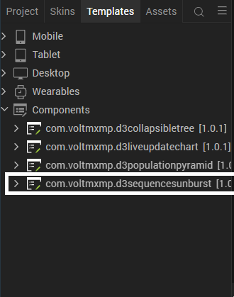

After you add the component into your project templates, follow the given steps to add the component to your app dynamically.
Access the FormController of the form you want to add the component into.
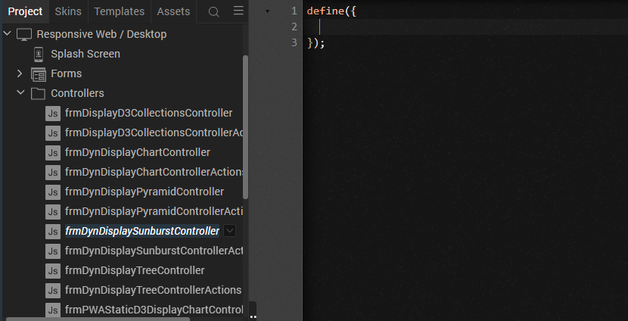
Create a function called createComponent(); and type a code inside the function to create and configure the component.
You can refer to the given sample code for more information.
/* Creating the component's object */
var sequenceSunburstObj= new com.voltmxmp.d3sequencesunburst(
{
"clipBounds": true,
"height": "100%",
"id": "SequenceSunburst",
"isVisible": true,
"left": "0dp",
"top": "0dp",
"width": "100%",
"zIndex": 1
}, {}, {});

/* Setting the component's properties */
sequenceSunburstObj.sampleData = false;
sequenceSunburstObj.userData = "https://gist.githubusercontent.com/kerryrodden/766f8f6d31f645c39f488a0befa1e3c8/raw/9fc86efac379f228749b2de3537acd629c0867c8/visit-sequences.csv";
sequenceSunburstObj.chartText = "Visited";
sequenceSunburstObj.legendMasterData =
{
"data":
[
{
"name" : "home",
"color" : "#5687d1"
},
{
"name" : "product",
"color" : "#7b615c"
},
{
"name" : "search",
"color" : "#de783b"
},
{
"name" : "account",
"color" : "#6ab975"
},
{
"name" : "other",
"color" : "#a173d1"
},
{
"name" : "end",
"color" : "#bbbbbb"
}
]
};
/* Adding the component to the form */
this.view.add(sequenceSunburstObj);

To execute the code, you need to call this function using Actions. For more information, refer to the Add Actions section of the Iris User Guide.

Properties
You can use a component's Properties to customize and configure the elements. These elements can be UI widgets, service parameters, and other elements. For more information about properties, you can refer to the Components Overview section of the Iris User Guide.
You can set the properties from the Properties panel on the right side of Iris. You can also configure these properties using a JavaScript code.

General
Show Sample Data
Description: | Toggles the visibility of the sample data of the component.
Syntax: | sampleData
Type: | Boolean
Read/Write: | Write
Default Value: | True
Example: | this.view.componentID.sampleData = false;
Data URL
Description: | Specifies the URL that the component uses to fetch the data.
Syntax: | userData
Type: | String
Read/Write: | Write
Remarks: | The URL must contain data in a CSV format
Example: | this.view.componentID.userData = “https://gist.githubusercontent.com  /kerryrodden/766f8f6d31f645c39f488a0befa1e3c8  /raw/9fc86efac379f228749b2de3537acd629c0867c8  /visit-sequences.csv

Chart Text
Description: | Specifies the text that you want to display as the suffix to the element data.
Syntax: | chartText
Type: | String
Read/Write: | Write
Example: | this.view.componentID.chartText = "Visited";

Legends data
Description: | Specifies the data that you want to display in the chart legend.
Syntax: | legendMasterData
Type: | Data Grid  JSON
Read/Write: | Write
Remarks: | Every row in the Data Grid contains the following keys:  - name [String] :  The name of the element in the legend  - color [String] :  The hex code of the background color of the element in the legend
Example: | this.view.componentID.legendMasterData =  {  "data":  [  {  "name" : "home",  "color" : "#5687d1"  },  {  "name" : "product",  "color" : "#7b615c"  },  {  "name" : "search",  "color" : "#de783b"  },  {  "name" : "account",  "color" : "#6ab975"  },  {  "name" : "other",  "color" : "#a173d1"  },  {  "name" : "end",  "color" : "#bbbbbb"  }  ]  }

Events
The component invokes events when its corresponding action is performed. You can configure any logic you want the component to perform whenever an event occurs. You can configure the events directly on the Actions tab or by writing a JavaScript, For more information, refer to Add Actions in the Iris User Guide.
onChartHover
Description: | Invoked when the user hovers over an element on the chart.
Syntax: | onChartHover
Parameters: | paam [JSON] :  The data of the element that the user hovers on.
Example: | this.view.componentID.onChartHover = function(param)  {  alert("Hovered Over: "+JSON.stringify(param));  }.bind(this);
onErrorCallback
Description: | Invoked when an error occurs within the component.
Syntax: | onErrorCallback
Parameters: | errObj [JSON] :  Information about the error such as the error code, and the error message.
Example: | this.view.componentID.onErrorCallback = function(errObj)  {  alert("Error Occured: "+JSON.stringify(errObj));  }.bind(this);

APIs
The following APIs pertain to the D3.js: Sequence Sunburst component.
setData
Description: | Renders a sequence sunburst chart based on the specified data.
Syntax: | setChartData(csvUrl, legendObj, suffix)
Parameters: | - csvUrl [String] :  A URL that contains the data (in CSV format) that you want to display on the chart.  - legendObj [JSON] :  Contains the data that you want to display in the legend of the chart.  - suffix [String] :  The text that you want to display as the suffix to the element data
Return Value: | None
Example: | var csvUrl =  "https://gist.githubusercontent.com/  kerryrodden/766f8f6d31f645c39f488a0befa1e3c8/  raw/9fc86efac379f228749b2de3537acd629c0867c8  /visit-sequences.csv";  var legendObj =  {  "home": "#5687d1",  "product": "#7b615c",  "search": "#de783b",  "account": "#6ab975",  "other": "#a173d1",  "end": "#bbbbbb"  };  var suffix = "Visited";  this.view.setData.setChartData(csvUrl, legendObj, suffix);

Revision History
App version 1.0.1:

Known Issues

-

Limitations
D3 Collections library is a web component. So, it doesn’t support for Android and IOS devices.

