Date: 23-Jun-26

Expense Tracker

VERSION: 1.0.0

Overview:
Expense Tracker is a modern Flutter application designed to help users record, organize, and analyze daily expenses in a simple and visually engaging way. With category-based tracking, calendar insights, transaction history, and spending analytics, users can stay in control of their finances and make informed decisions.

Built with a clean UI and smooth navigation, the app provides an efficient way to manage personal spending across different categories and time periods.

Requirements:
- Android Studio
- Visual Studio Code
- Install Flutter from here
- HCL Foundry

Platforms:
- Android
- iOS
- Web

Features:
- Dashboard & Expense Overview
- View monthly expense summaries at a glance
- Interactive charts and visual spending breakdowns
- Percentage-based category insights
- Quick month and year navigation

- Transaction Management
- Add expenses with:
  - Expense name
  - Category and subcategory
  - Date selection
  - Amount entry
- View complete transaction history
- Filter expenses by category
- Access and review previous records easily

- Category-Based Expense Tracking
- Organize spending into categories such as:
  - Food & Dining
  - Shopping
  - Entertainment
  - Transport
  - Bills & Utilities
- Analyze category-wise totals and trends

- Calendar Expense View
- Visual monthly calendar with daily expense highlights
- Tap any date to view detailed spending records
- Monitor day-wise financial activity

- Analytics & Insights
- Monthly expense distribution
- Spending trend visualization
- Total expense calculations
- Better understanding of financial habits

User Experience:
- Clean and intuitive interface
- Fast and responsive performance
- Simple navigation across screens
- Designed for an efficient personal finance experience

Technology Stack:
- Flutter
- Dart
- Scalable architecture with clean UI components.

Ideal For:
- Personal expense tracking
- Budget monitoring
- Daily spending management
- Monthly financial analysis
Manage expenses smarter and gain better visibility into your spending with Expense Tracker.

IMPORTING THE BACK-END SERVICE
- Download the ExpenseTracker backend app zip file from this link .
- Sign in to the HCL Foundry Console.
- On the Foundry Apps page, click IMPORT.
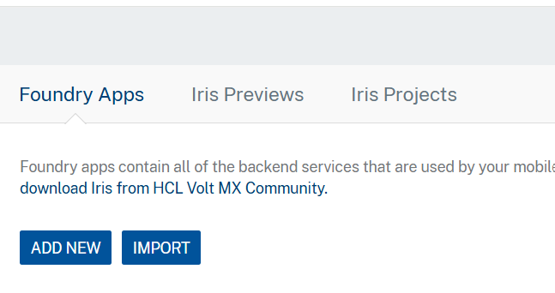
- On the Import App dialog box, drag and drop the zip file that you downloaded earlier. Alternatively, you can browse for the zip file on your system. 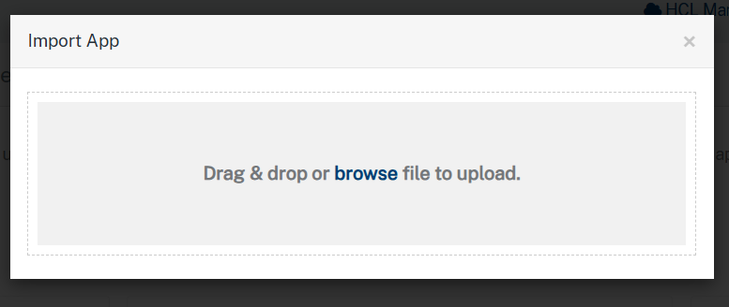
- After the zip file is uploaded, the console displays the default App Name and Version.
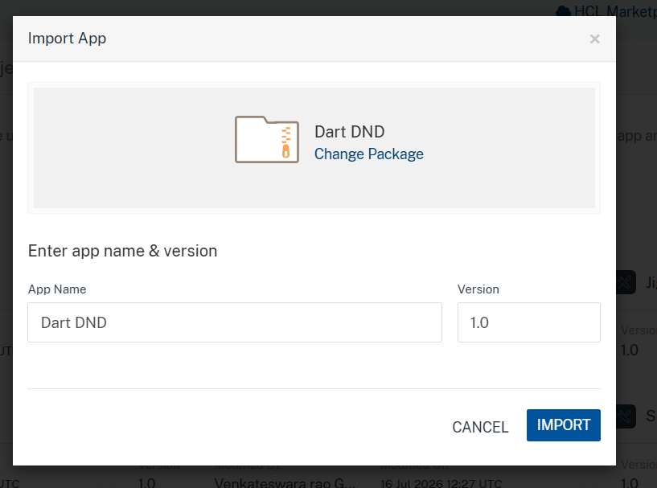
- Click IMPORT.

Publishing the App to Volt MX Foundry
After adding the ExpenseTrackerFoundry back-end service to your app and configuring the necessary configurations, you must publish the app to Volt MX Foundry. For more information, refer to Publish a Project to Volt MX Foundry.
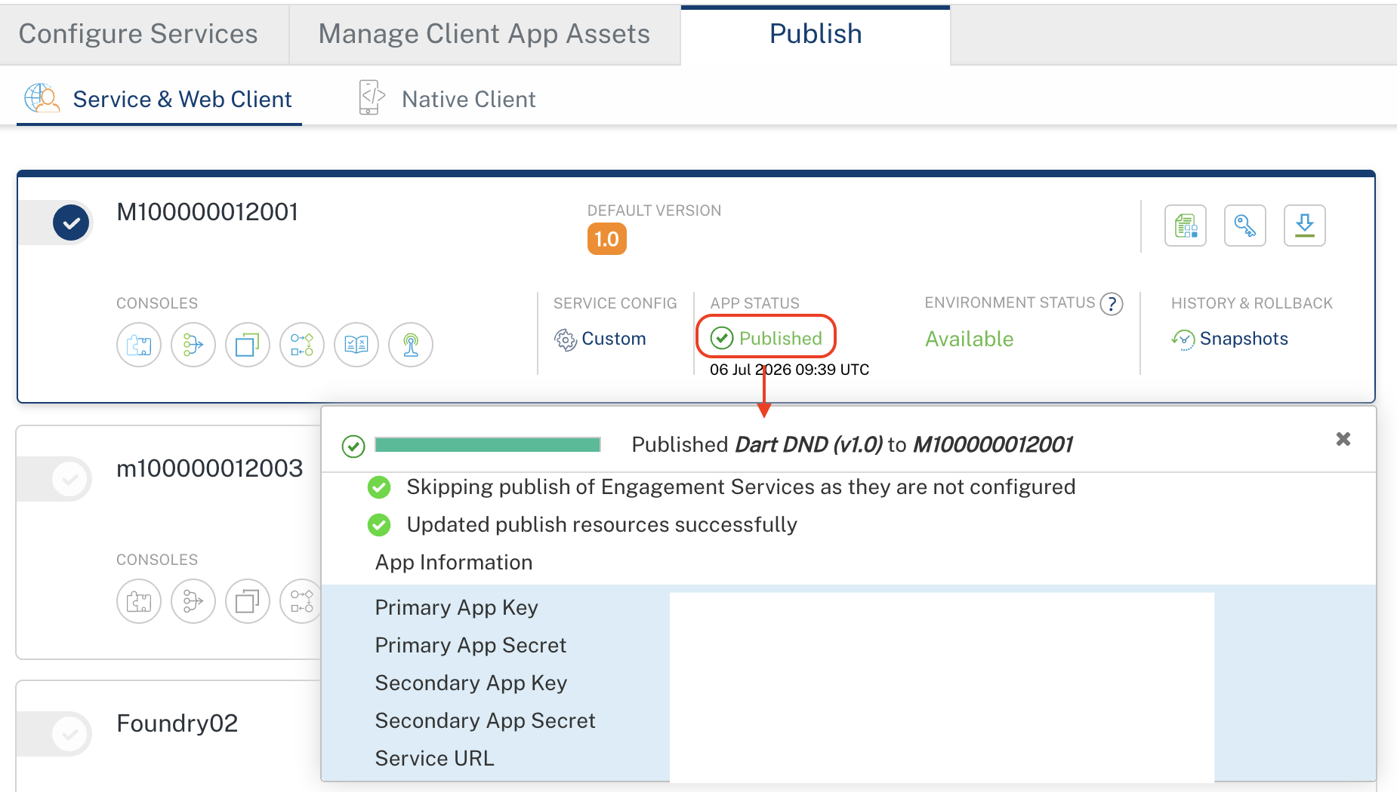
After opening the project, go to the lib folder, then open app_constants.dart file.
Replace your Primary App Key, Primary App Secret, and Service URL in the place below.
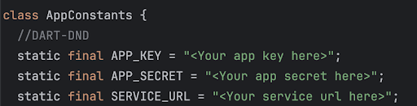

Importing the app:
To import the Expense Tracker into your workspace, follow these steps:
- Open Android Studio.
- On the main menu, select open→ Browse to the location where the app folder is present.
- A dialog box appears, confirming that the app has been imported. Click OK.

Configuration and build:
If the "Dart SDK is not configured" message appears after importing a Flutter project, configure the Dart SDK by following these steps:
- Open Android Studio.
- Navigate to File → Settings → Languages & Frameworks → Dart.
- Enable Dart support for the project (if it is not already enabled).
- In the Dart SDK path field, specify the Dart SDK bundled with your Flutter installation:
<Flutter_Installation_Directory>\bin\cache\dart-sdk
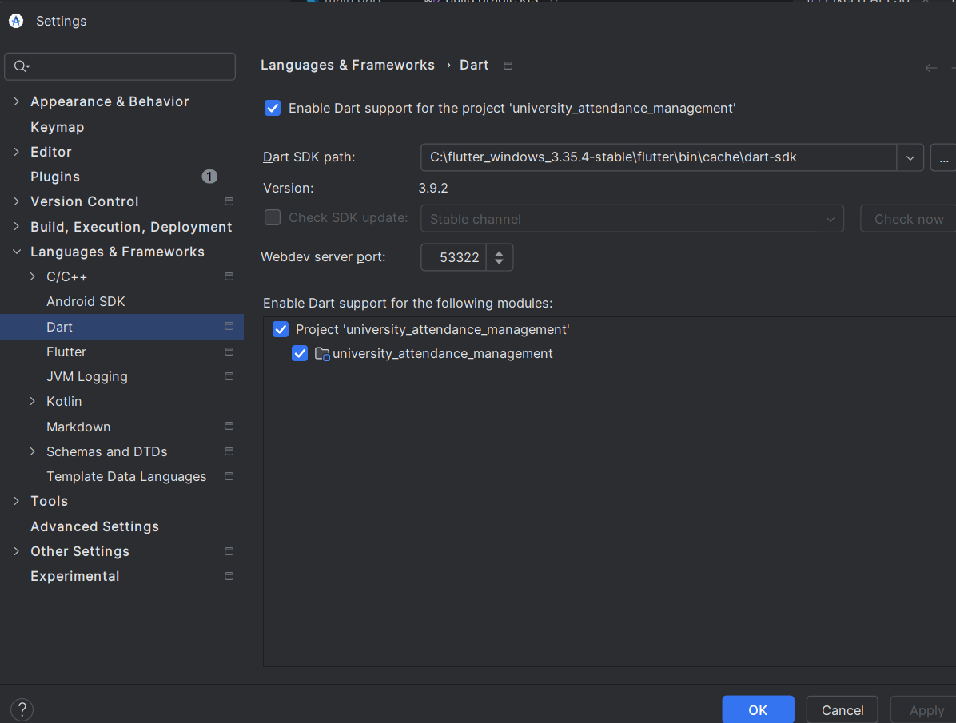
- Make sure that under the Plugins section, Dart and Flutter were installed.
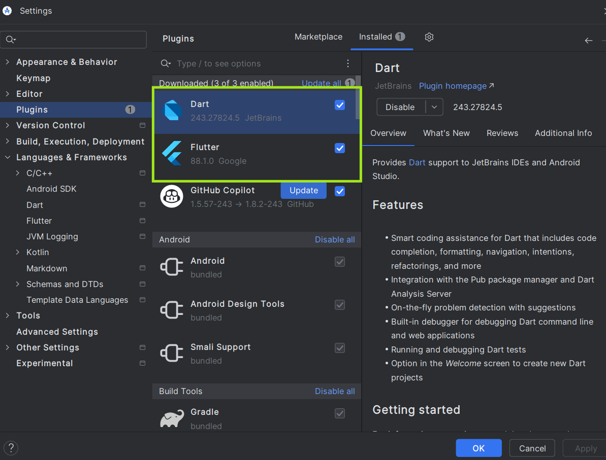
Note: Ensure that the Flutter SDK is installed and correctly configured before configuring the Dart SDK. The Dart SDK is included with the Flutter SDK, so a separate Dart installation is not required.
- Click Apply, then OK.
- Restart application
After importing the project into Android Studio. Go to the app's root folder, then execute the following commands.
1. flutter clean
2. flutter pub get
If you are targeting the iOS platform, navigate to the ios directory by running the following command:
cd ios
Once you are in the ios directory, install the required CocoaPods dependencies by executing:
pod install

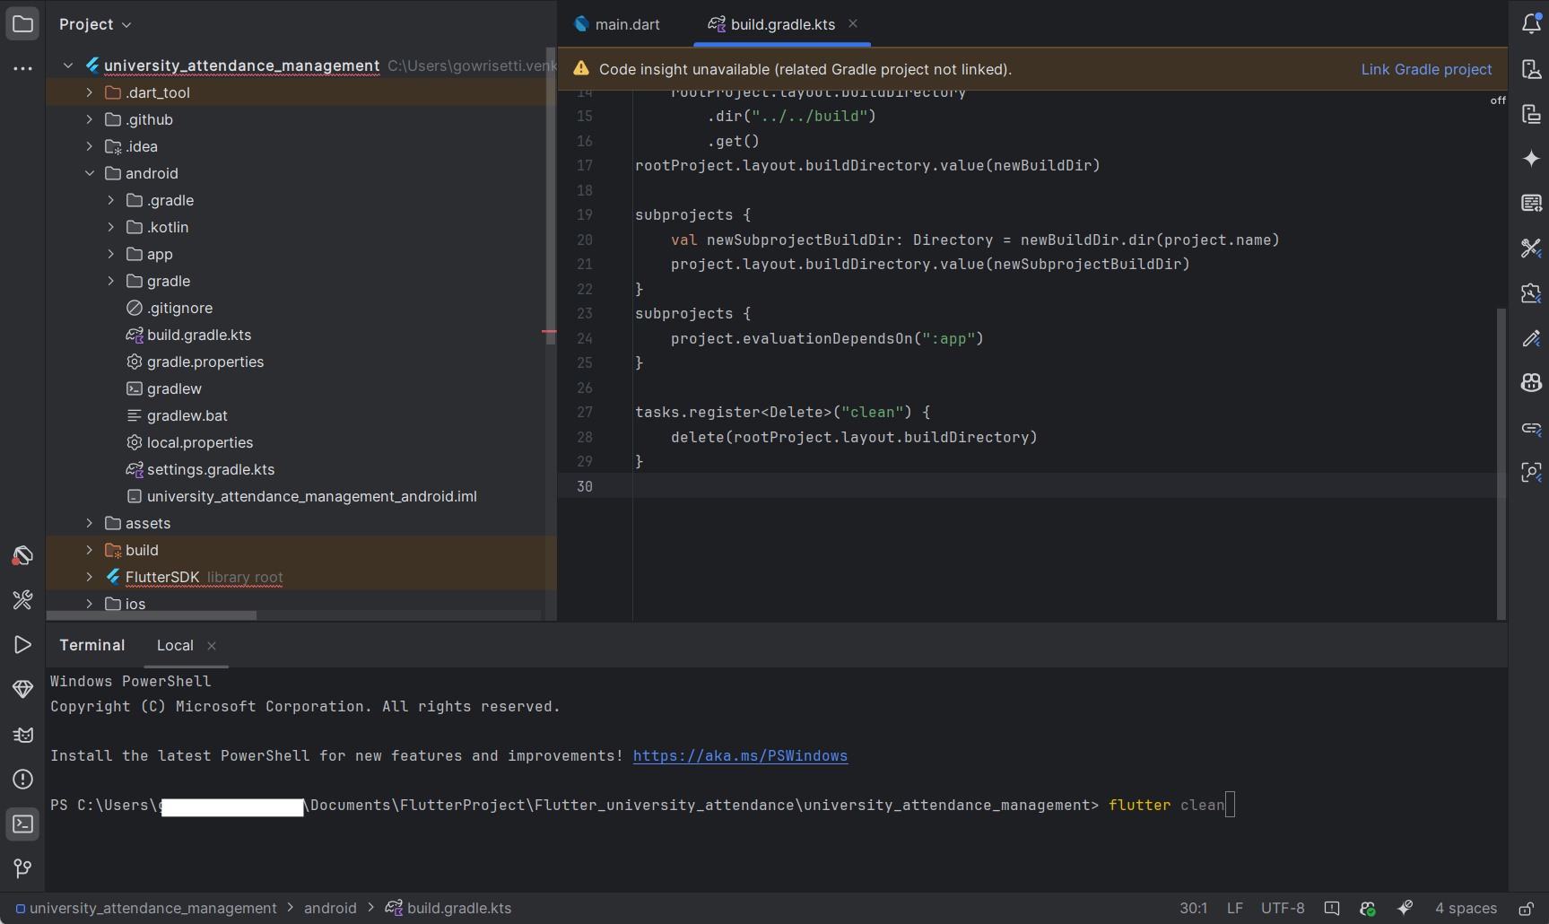
After installing all the dependencies, run the app for any platforms like Android, iOS and Web.
Select the devices dropdown and choose either mobile (iOS or Android) or Web
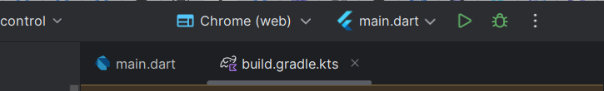
VSCode:
If you want to run the app in VSCode, then open Terminal in VSCode and check the list of
available devices using the command below.
flutter devices
To run in iOS:
flutter run -d iphone
To run in Android:
flutter run -d emulator-5554
To run in Chrome:
flutter run -d chrome

Permission Required:
1. ACCESS_NETWORK_STATE
Used to check whether the device is connected to the internet.
Helps the app detect online/offline status before loading data.
2. ACCESS_WIFI_STATE
Used to check the device’s Wi-Fi connection status.
Helps improve app performance when using internet-based features.
Application flow:
1. Home Screen: Users land on the dashboard to view monthly expenses with a visual breakdown by category and quick month switching.
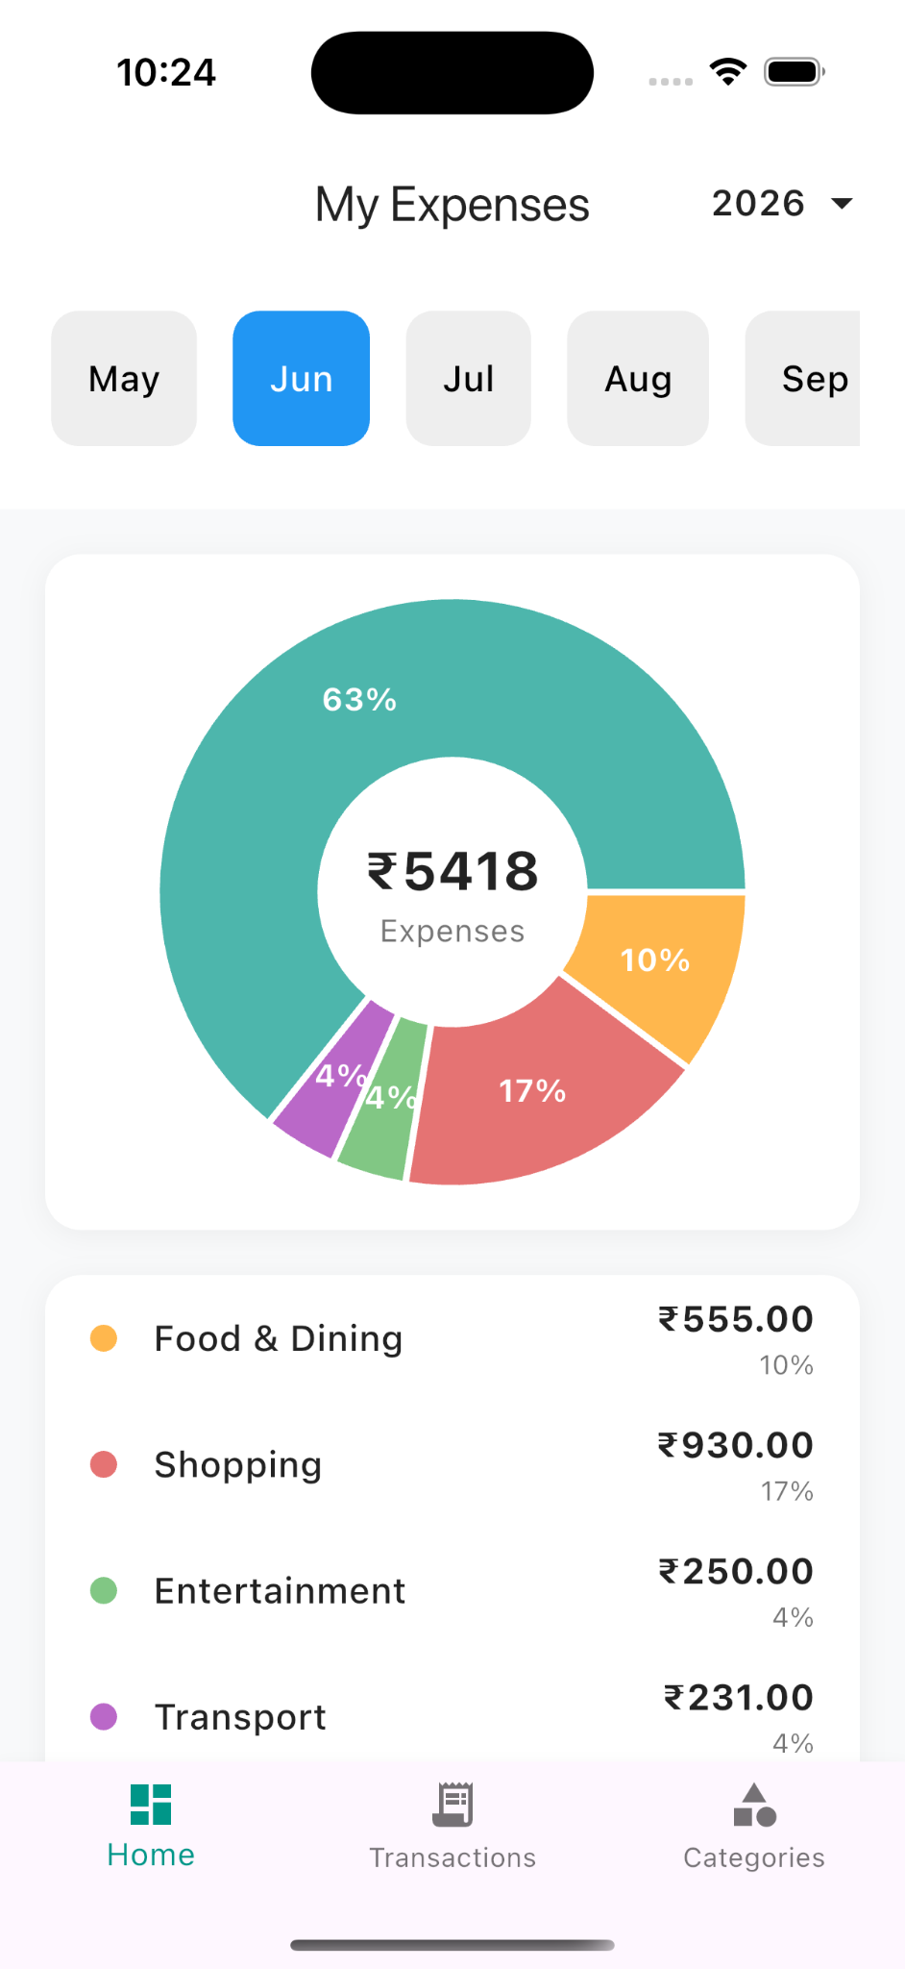
2. Transactions Screen: Users can browse all recorded expenses, filter by category, and review transaction details for a selected month.
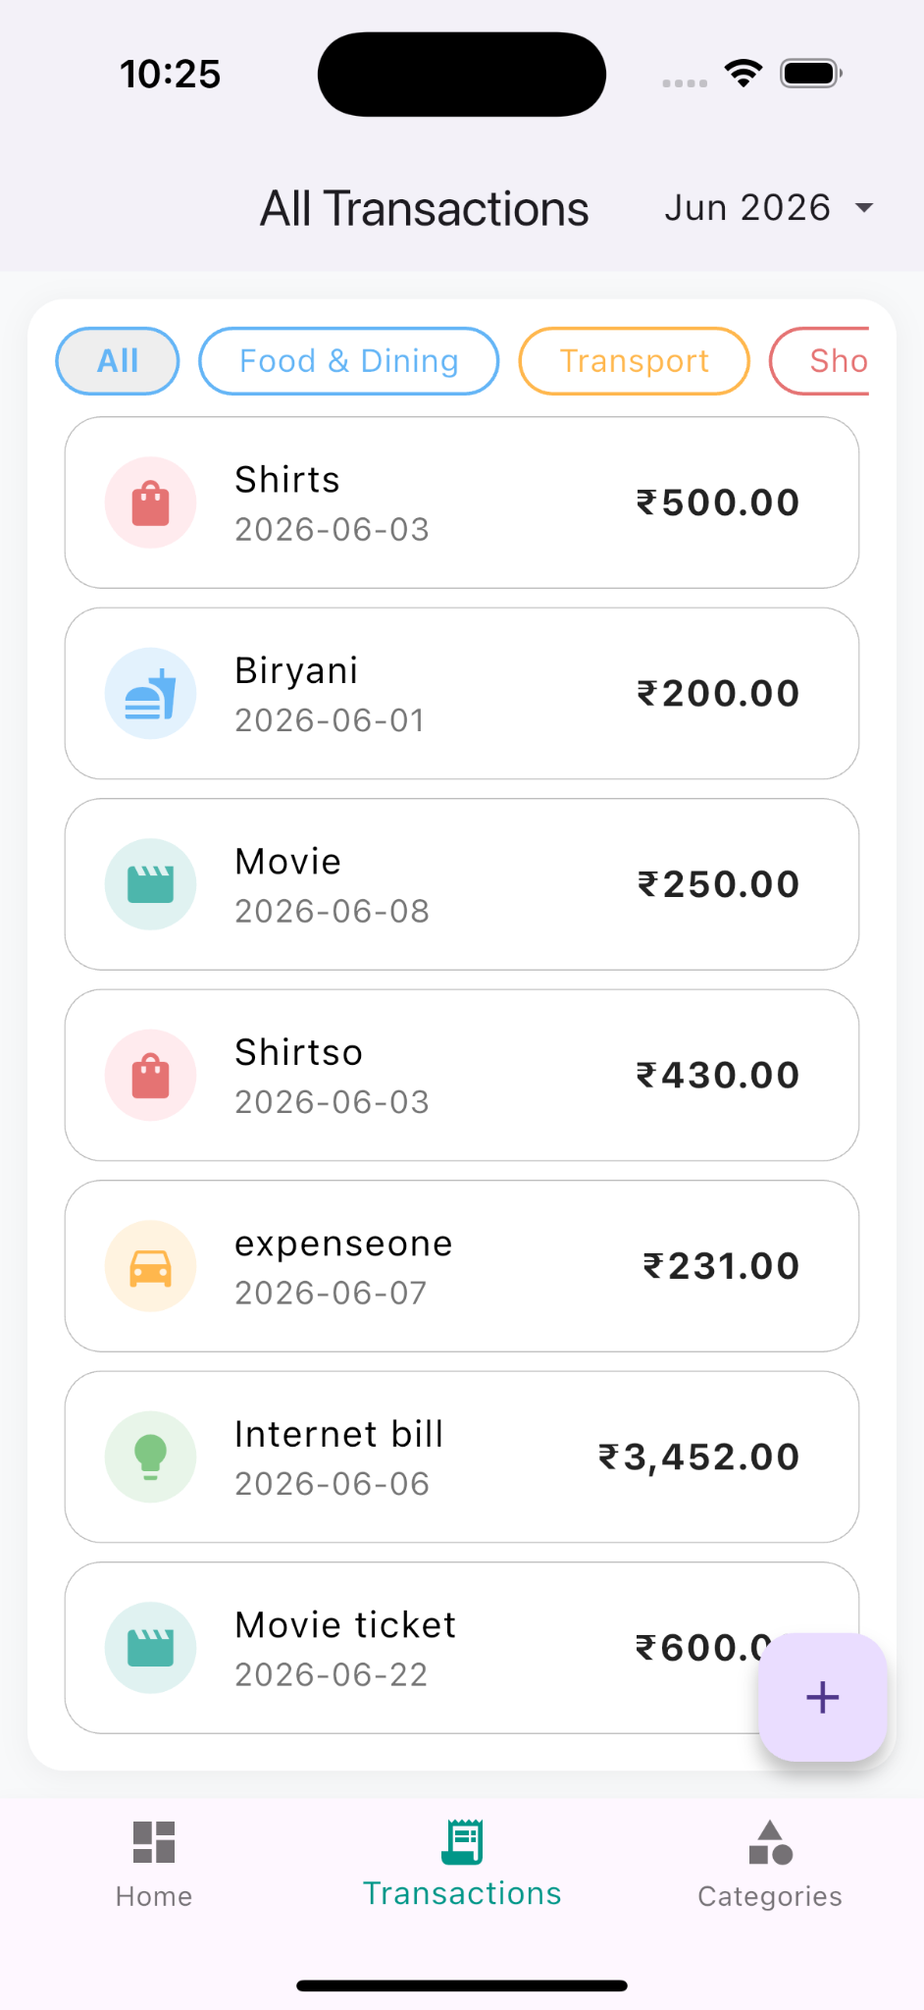

3. Add Expense Screen: Users enter expense details including name, category, subcategory, date, and amount, then save the record instantly.
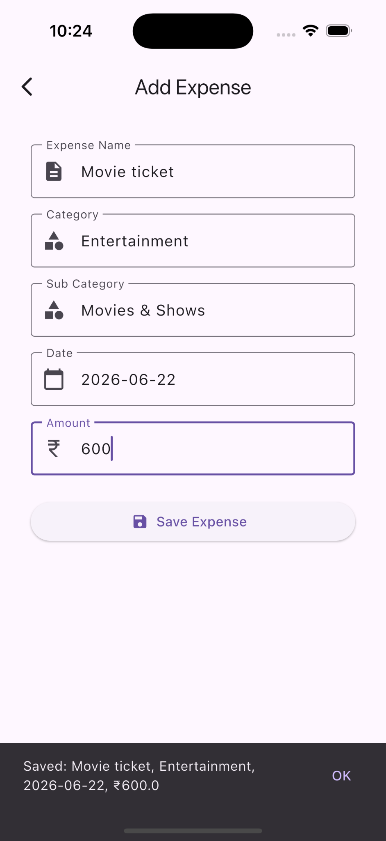

4. Categories Screen: Users analyze how expenses are distributed across different spending categories over the selected month.
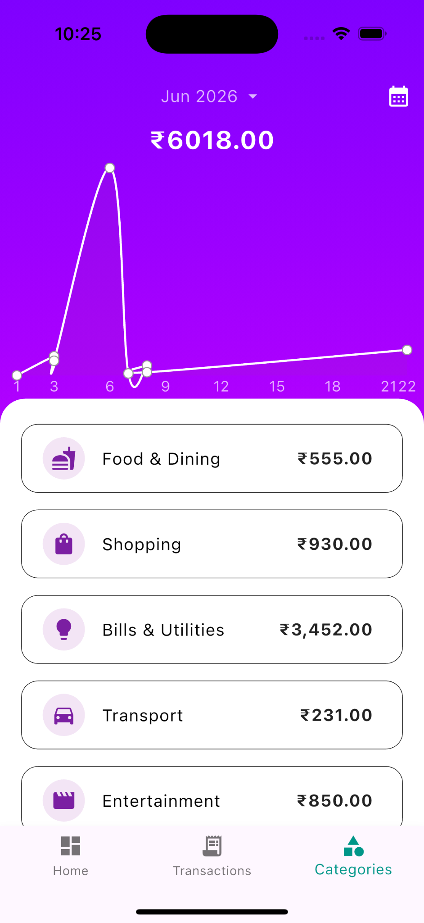

5. Categories -> Calendar View Screen: Users navigate expenses day-by-day through a calendar to understand spending patterns across the month.
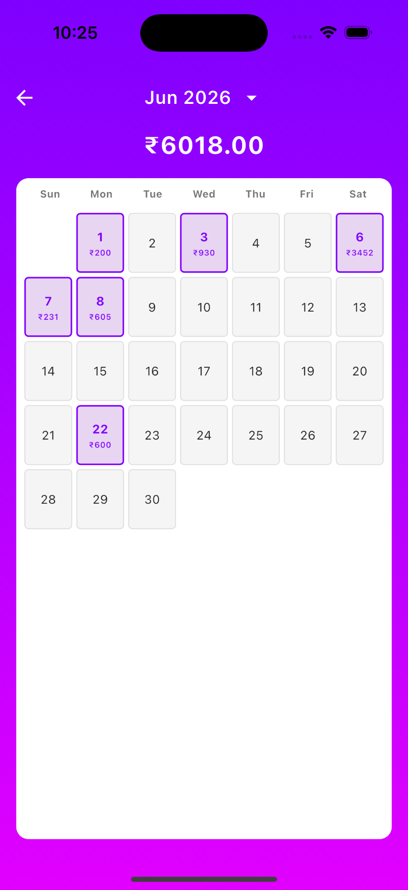

6. Categories -> Expense Detail Popup View: Selecting a date opens a detailed summary of expenses recorded for that specific day.
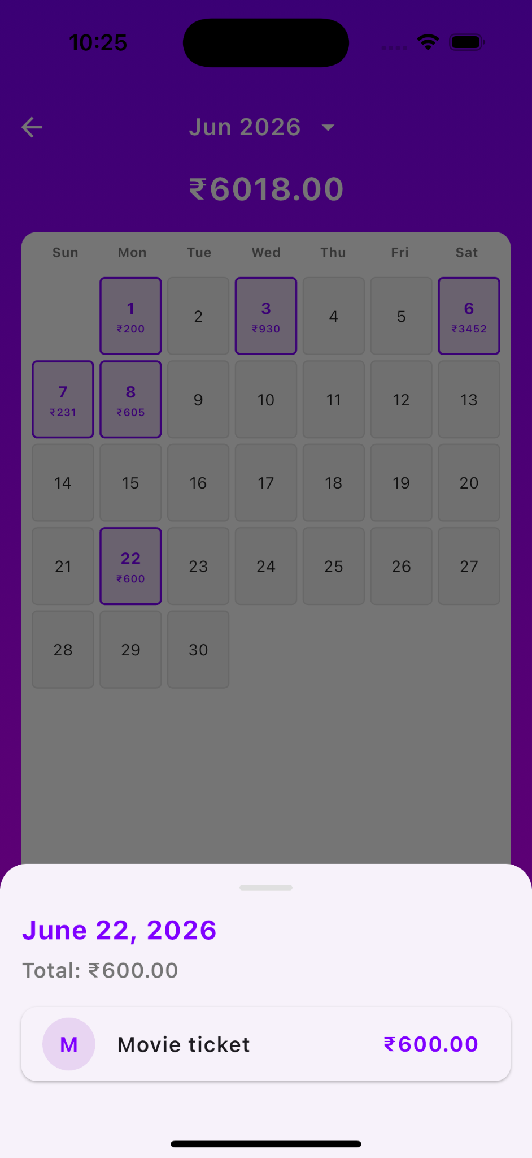
Overall Workflow:
The user opens the app and views monthly expense summaries and spending insights.
Users can add new expenses by entering details such as category, date, and amount.
All recorded expenses are automatically organized and displayed in transaction history.
Users can track expenses using calendar and category-based visual reports.
The app provides analytics and summaries to help users monitor and manage spending effectively.

