Date : 04-March-26

Fireworks API

VERSION: 1.0.0

OVERVIEW
The Fireworks AI API provides a unified interface for accessing high-performance large language models and generative AI capabilities such as chat completions, text generation, reasoning, embeddings, and multimodal processing.
It enables applications to generate intelligent, context-aware responses through simple REST-based API requests. Fireworks AI supports low-latency inference and scalable deployments, making it suitable for real-time conversational applications and enterprise-grade AI solutions.
The API offers flexible request payload structures, dynamic model selection, streaming support, and fine-grained control over parameters such as temperature, max tokens, and top-p sampling. With support for chat-based interactions and task-driven prompts, Fireworks AI empowers developers to build scalable, efficient, and production-ready AI applications with minimal integration complexity.

Use case:

Conversational AI & Virtual Assistants : Build intelligent chatbots using Fireworks AI chat completion models capable of multi-turn conversations with contextual awareness and low-latency responses.

Content Generation & Writing Assistance : Generate high-quality articles, emails, technical documentation, product descriptions, and creative content using advanced instruct-tuned models.

Reasoning & Code Assistance : Leverage large-scale foundation models for complex reasoning tasks, structured outputs, and code generation for development workflows.

Summarization & Information Extraction : Summarize large documents, transcripts, logs, or datasets into concise insights and extract structured information from unstructured text.

Embeddings & Semantic Search : Generate vector embeddings for semantic search, document retrieval, clustering, and recommendation systems.

Multilingual & Global Applications : Support multilingual conversations and translation use cases across global applications using capable language models.

Enterprise AI Applications : Power scalable AI-driven workflows for internal tools, automation systems, analytics platforms, and customer engagement solutions.

Features:

Unified Inference API : Access multiple generative AI capabilities such as chat completions, text generation, reasoning, and embeddings through a consistent REST-based API structure.

Dynamic Model Selection : Easily switch between different foundation models (e.g., Llama, DeepSeek, Qwen, etc.) by modifying the model parameter in the request payload.

Context-Aware Chat Support : Enable multi-turn conversational experiences using structured message-based inputs for maintaining conversation history.

Streaming Response Support : Receive real-time, token-by-token responses for low-latency conversational applications.

Fine-Grained Response Control : Control creativity, randomness, and output length using configurable parameters such as temperature, top_p, max_tokens, and other sampling controls.

High-Performance & Scalable Inference : Optimized for low latency and high throughput, making it suitable for real-time enterprise applications.

Structured JSON Responses : Consistent and predictable response format for simplified parsing, logging, and UI rendering.

Seamless Integration with Volt MX : Easily integrates with Volt MX Iris via Foundry services, enabling secure API communication and scalable enterprise deployments.

GETTING STARTED

Prerequisites
Before you start using the Fireworks Adapter, ensure you have the following:

- HCL Foundry
- Volt MX Iris
- https://app.fireworks.ai/settings/users/api-keys
Reference document: Fireworks

B. Importing the Fireworks data adapter

You can import the Fireworks Data Adapter into HCL Foundry directly from the Volt MX Forge website or by importing the data adapter zip file.

To import Data Adapter to Volt Foundry, do the following:
- Sign in to the HCL Foundry.
- From the left navigation menu, select API Management.
- In API Management, select Custom Data Adapters.

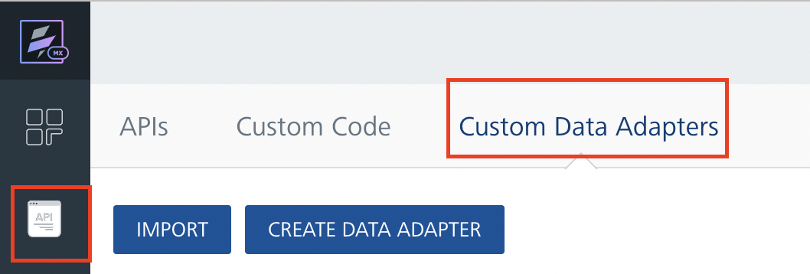
4. Click IMPORT to import a custom data adapter.
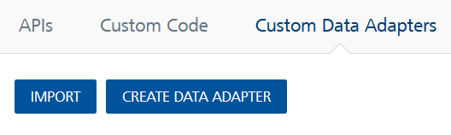
5. On the Import Data Adapter dialog box, click browser to import.

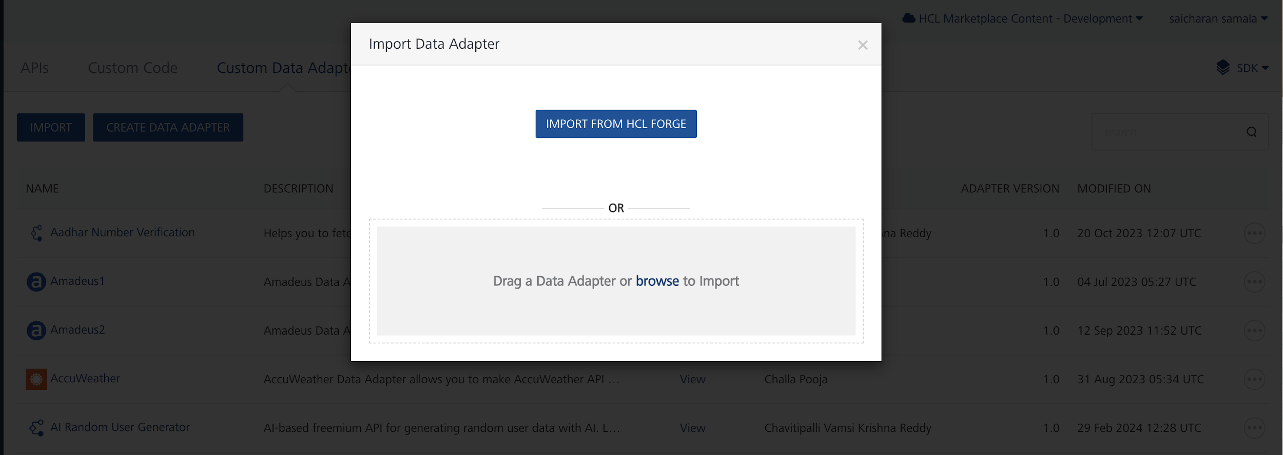

6. Click IMPORT FROM HCL FORGE. The Import Data Adapter from HCL Forge dialog appears with a list of available data adapters.
Click Import. Fireworks Data adapter is listed on the Custom Data Adapters page.
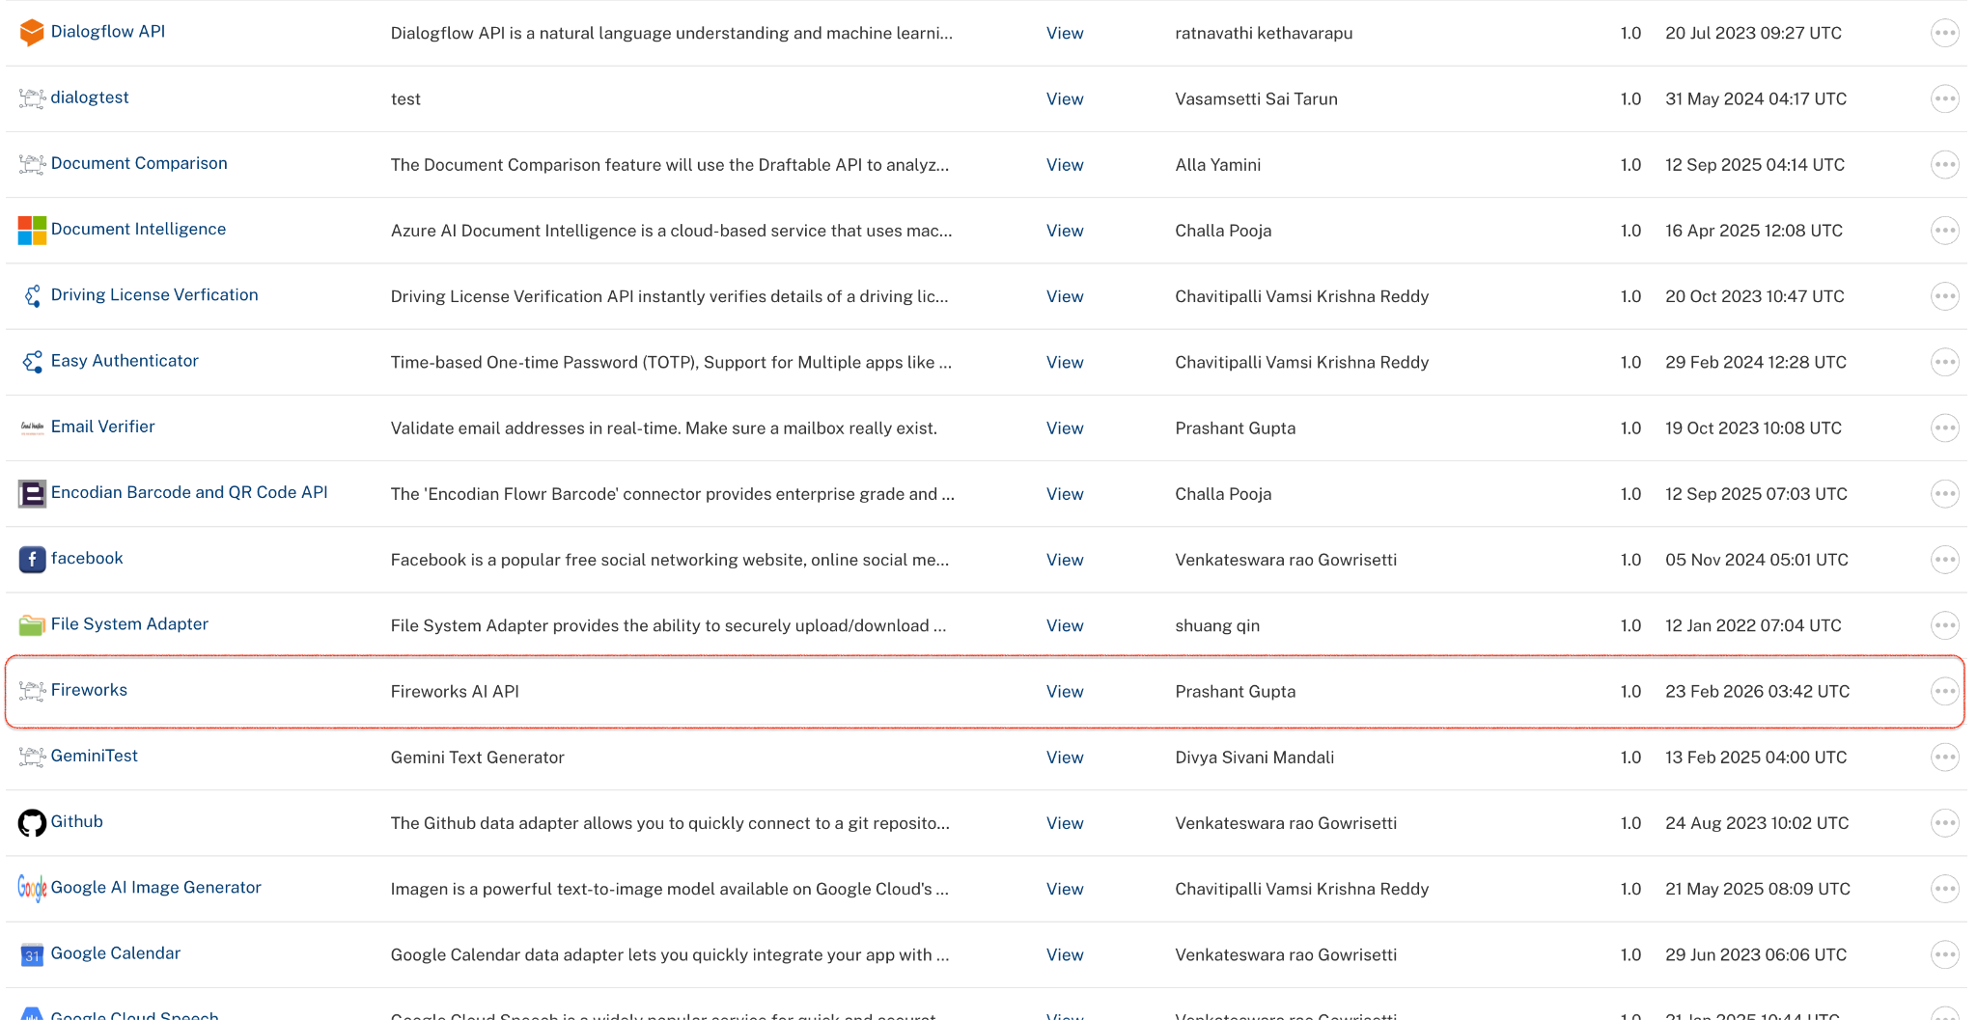
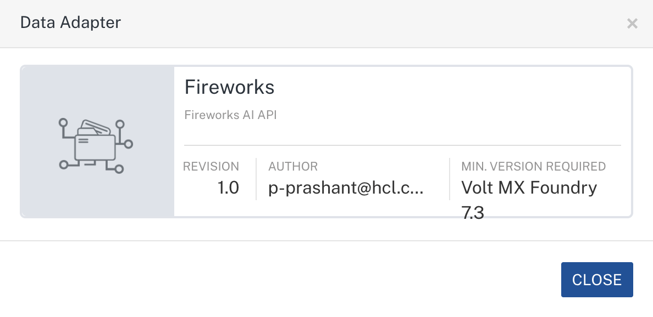
To import the data adapter zip file, do the following:
- Perform steps 1 to 4 in the above procedure
- Drag the data adapter zip file into the Drag a Data Adapter box.
Or
Click browse. The Open dialog appears.
Navigate to the location where you downloaded the data adapter (zip file) on your computer, select the data adapter, and click Open. The Import Data Adapter dialog shows the selected data adapter.
Note: Click Remove if the selected data adapter is not the one that you want to import.

C. Creating an Integration Service with Fireworks:
After you import Fireworks Data Adapter into Foundry, you must create an integration service with service type Fireworks.
To create an integration service with Fireworks, do the following:
- Log on to your HCL Foundry. The Dashboard page appears by default.
- In the left pane, click the API Management menu. The APIs tab opens by default.
- Click the Integration tab. The Integration tab opens with a list of existing integration services.
- Click CONFIGURE NEW. The Service Definition tab opens.
- In the Name box, type a unique name for your service.
- From the Service Type list,Fireworks.
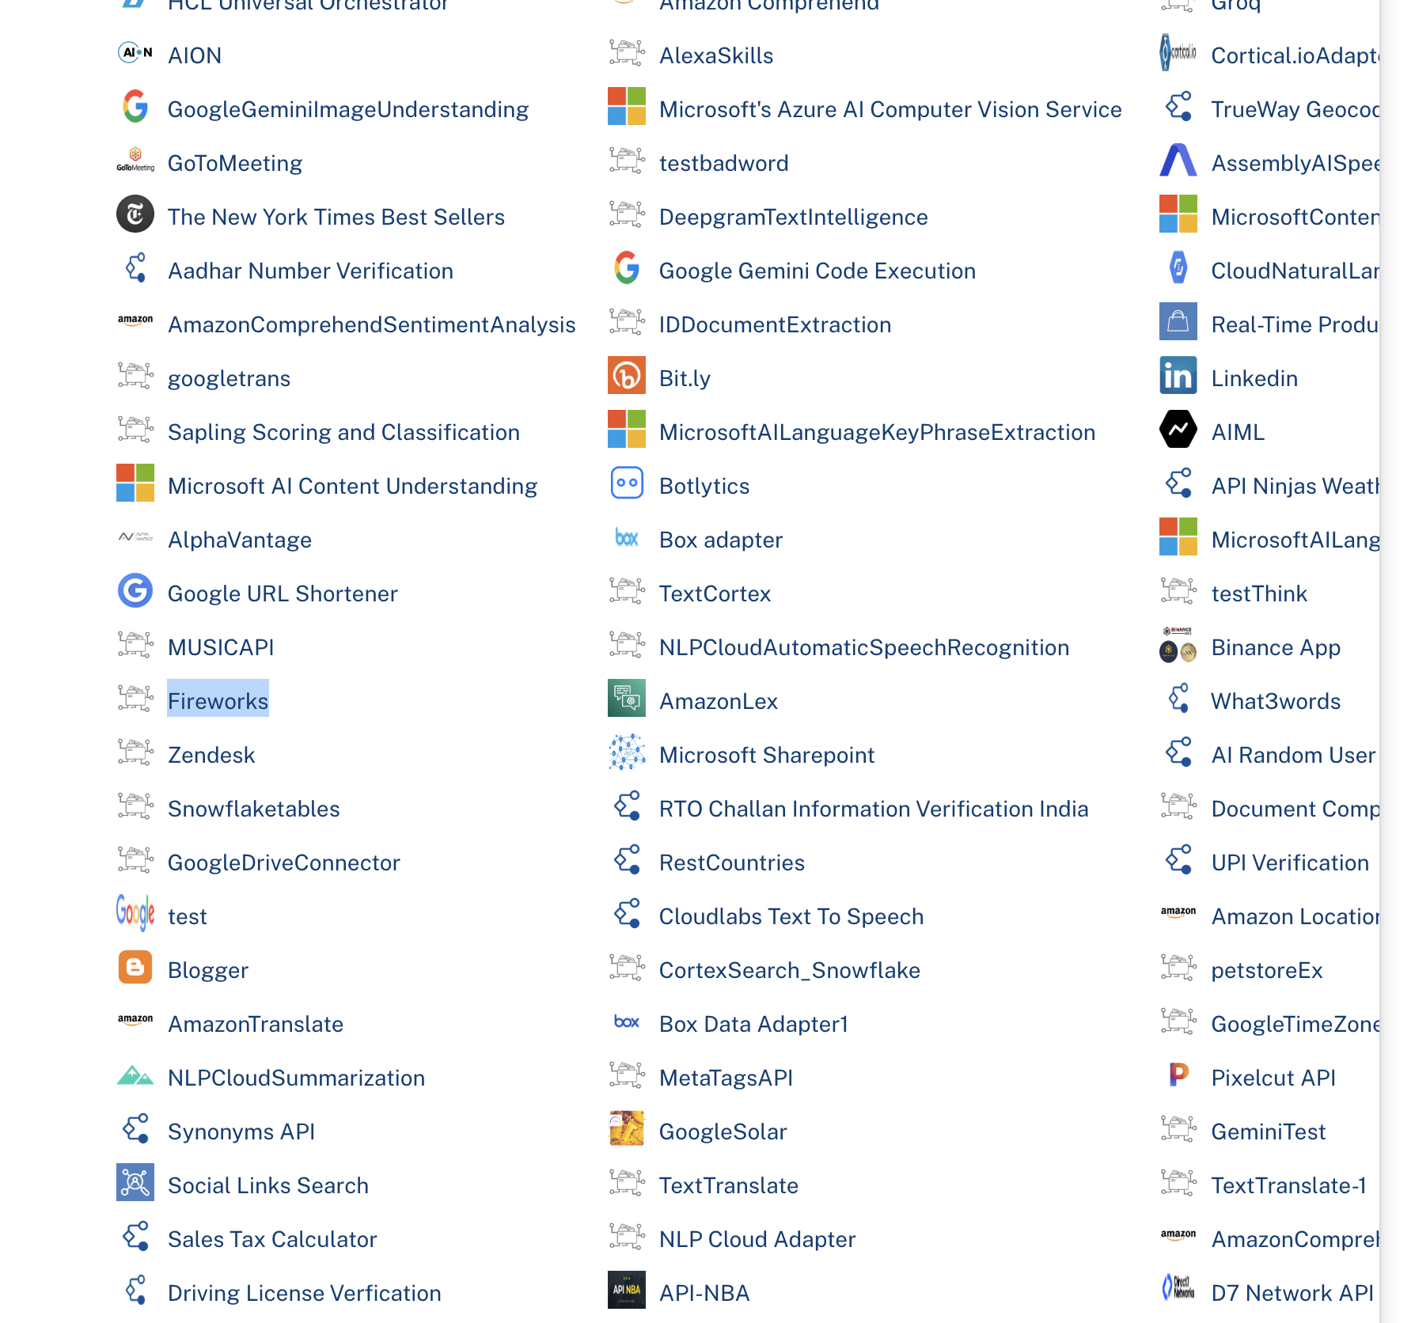
- Click Save

D. Creating an Operation
To make any API call in the HCL Foundry console, you must create an operation for the respective API and then execute the operation. Executing an operation involves making the API call and displaying the response.
This section provides steps to create an operation for the Fireworks.
Steps to create an operation for the Fireworks:
- Log on to your HCL Foundry. The Dashboard page appears by default.
- In the left pane, click the API Management menu. The APIs tab opens by default.
- Click the Integration tab. The Integration page appears with a list of existing integration services.
- From the list of integration services, select the integration service that you have created with service type as Fireworks. The Service Definition tab of the selected integration service opens by default.
- Click the Operations List tab. The Operations List tab opens.
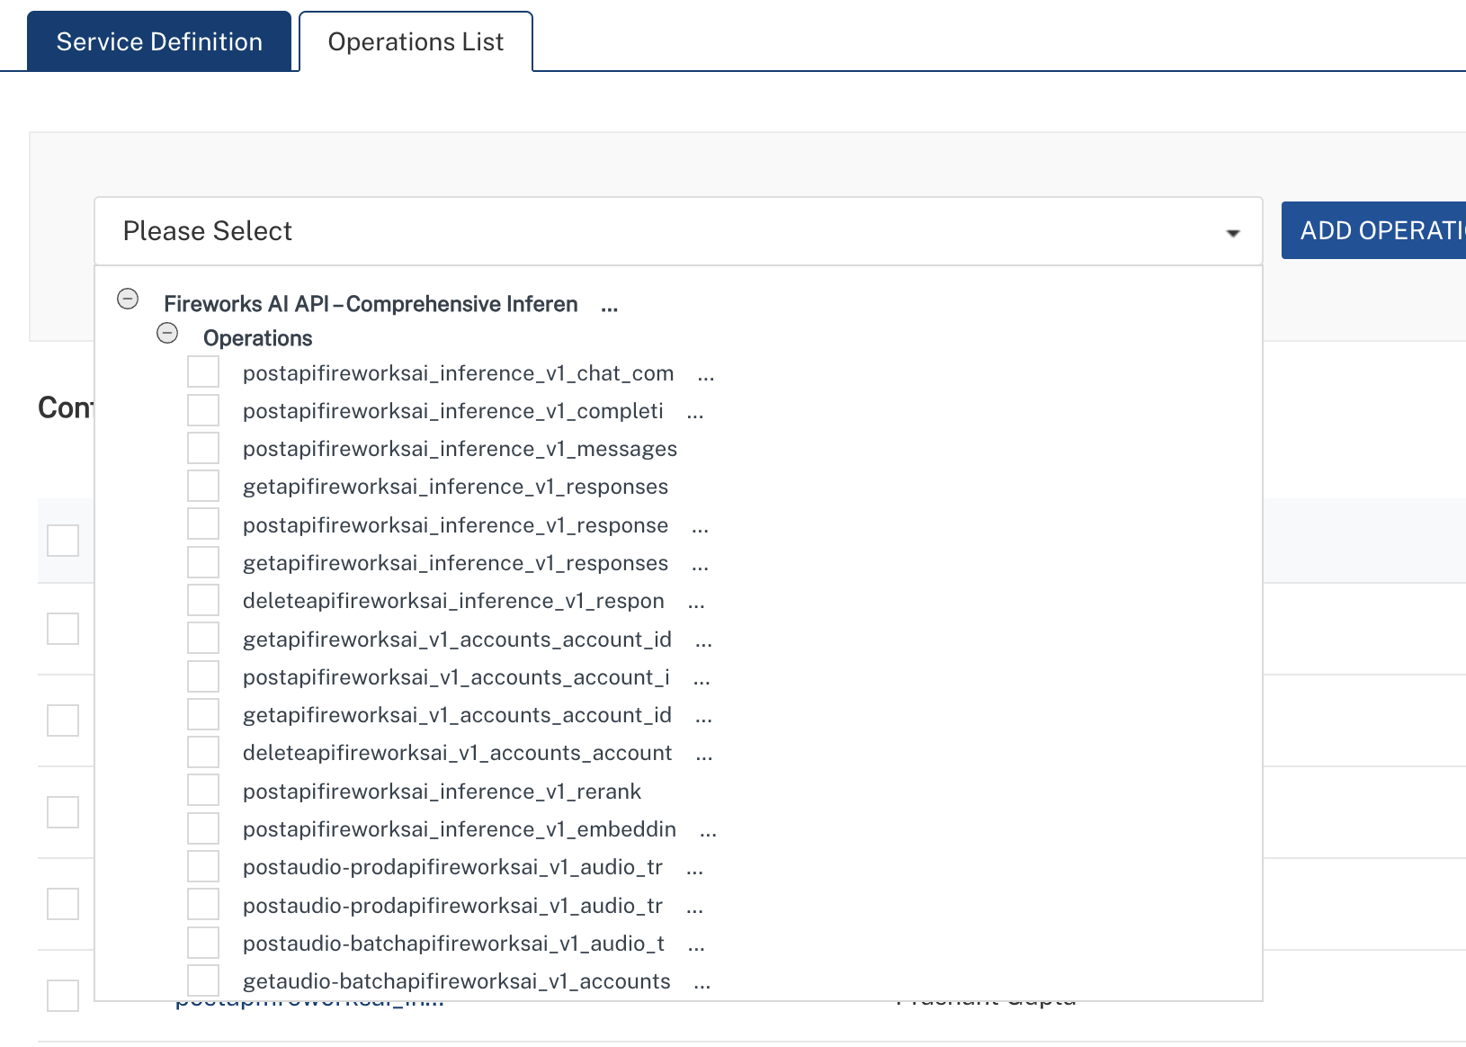
- Select post_chat_completions and Click Add Operations.
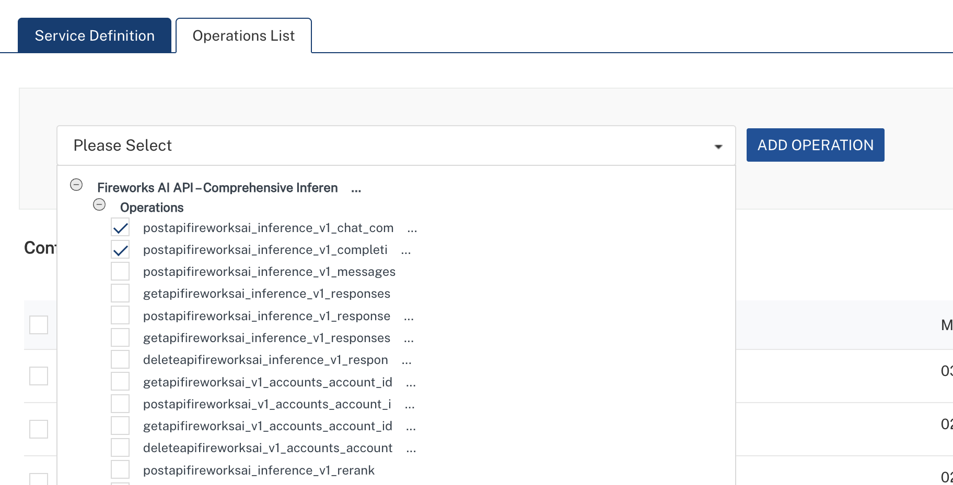

E. Executing Operation
Executing an operation involves making the API call by setting the necessary parameters and displaying the response. The procedure to execute any operation is the same, but the request parameters of the APIs vary. This section provides steps to execute the post_chat_completions(explained in Creating an Operation).
Steps to execute the post_chat_completions operation:
- Log on to your Hcl Foundry. The Dashboard page appears by default.
- In the left pane, click the API Management menu. The APIs tab opens by default.
- Click the Integration tab. The Integration tab opens with a list of existing integration services.
- From the list of integration services, select the integration service that you have created with service type Fireworks. The Service Definition tab of the selected integration service opens by default.
- Click the Operations List tab.
- In the Name box, the name of the operation is displayed by default. If you want, you can change the name.
- On the Request Input tab, in the Body section, for the following parameters, specify the values in the respective boxes under the Test Value column.
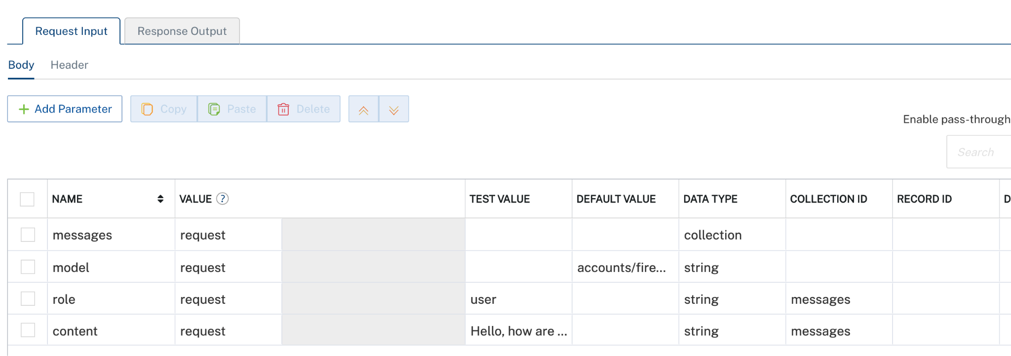
- Click SAVE AND FETCH RESPONSE. The Output Result dialog appears with the response. Otherwise, the Output Result shows an error.
. 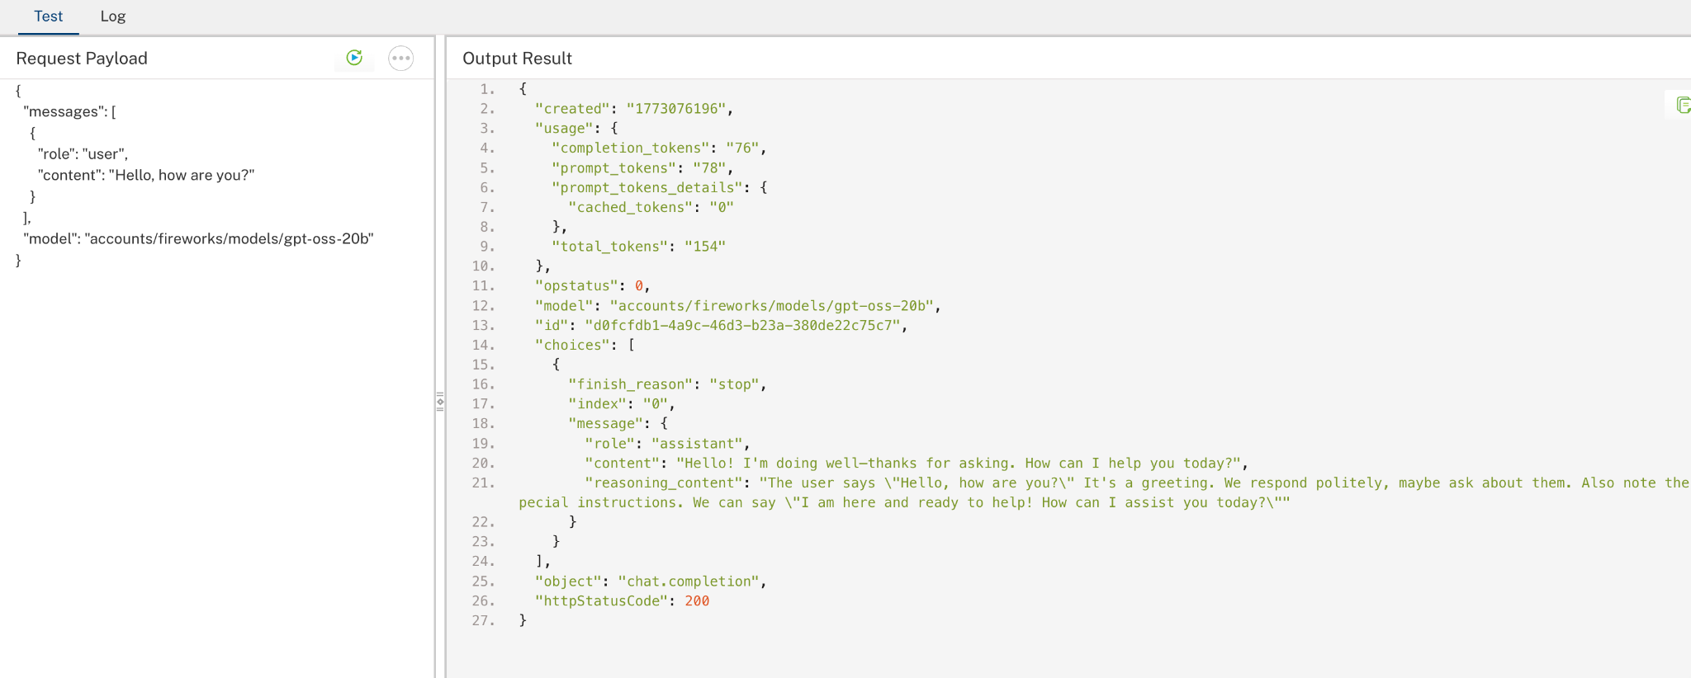

3. Publishing the App in VoltMX FOUNDRY:
After adding the Fireworks Data Adapter to your app and configuring the necessary configurations, you must publish the app to HCL Foundry. For more information, refer to Publish a foundry app.
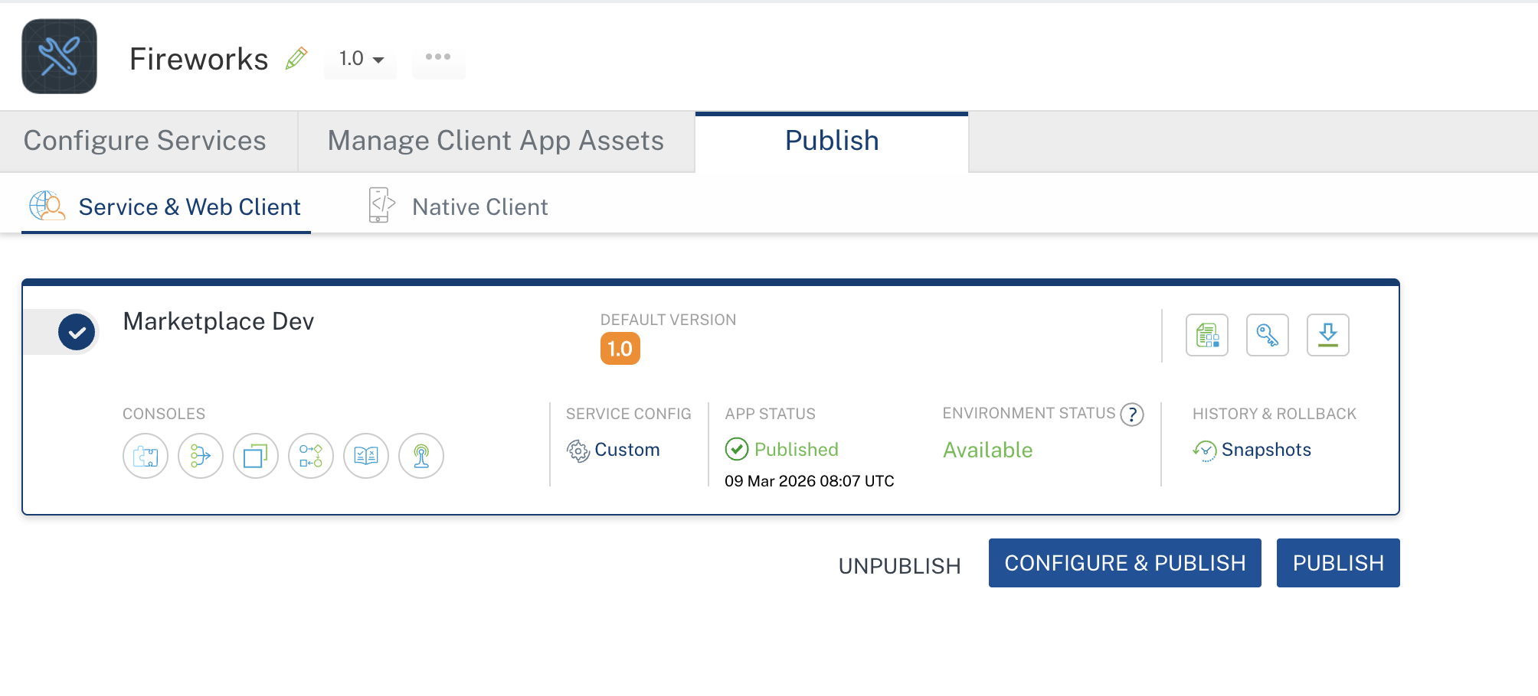

4. REFERENCES

Endpoint documentation
Fireworks

5. REVISION HISTORY
Adapter version 1.0.0:

Known Issues
None

Limitations
None

