Date : 04-Mar-25

FIREWORKS AI APPLICATION

VERSION: 1.0.0

OVERVIEW
The Fireworks AI API provides a unified interface for accessing high-performance large language models and generative AI capabilities such as chat completions, text generation, reasoning, embeddings, and multimodal processing.
It enables applications to generate intelligent, context-aware responses using simple REST-based API requests. Developers can integrate advanced AI functionality into their applications without managing complex infrastructure.
The API supports flexible request payloads, configurable model selection, and fine-grained control over generation parameters such as temperature, top_p, and max_tokens. Fireworks AI also supports streaming responses for real-time conversational experiences.
With support for chat-based interactions and task-driven prompts, the Fireworks AI API helps developers build scalable, low-latency AI-powered applications suitable for enterprise and production environments.

Use case:
- Conversational AI & Virtual Assistants – Build chatbots capable of multi-turn, context-aware conversations.
- Content Generation – Generate articles, emails, documentation, and creative content.
- Code Assistance – Generate code snippets, debugging help, and technical explanations.
- Summarization – Convert large documents or logs into concise summaries.
- Semantic Search & Embeddings – Enable document search, retrieval, and recommendation systems.
- Multilingual Support – Support translation and multilingual interactions.
- Enterprise Automation – Power AI-driven workflows for customer support and internal tools.

Features:
- Unified Inference API – Access AI capabilities such as chat completions, text generation, and embeddings through a single API structure.
- Dynamic Model Selection – Easily switch between different models by modifying the model parameter in the request.
- Context-Aware Conversations – Supports multi-turn interactions using message-based inputs.
- Response Control – Configure parameters like temperature, top_p, and max_tokens to control output behavior.
- Structured JSON Responses – Consistent response format for easy parsing and UI integration.

Percentage of re-use:
80%

GETTING STARTED

Prerequisites
Before you start using the Fireworks App, ensure you have the following:
- HCL Foundry
- Volt MX Iris
- https://app.fireworks.ai/settings/users/api-keys

Devices
- Mobile

Platforms
- Android
- IOS

Importing the App
To import the Fireworks App to Volt MX Iris, do the following:

To import the Fireworks App, do the following:
- Launch Volt MX Iris.
- Click project, and then select Import. The Import dialog box appears.
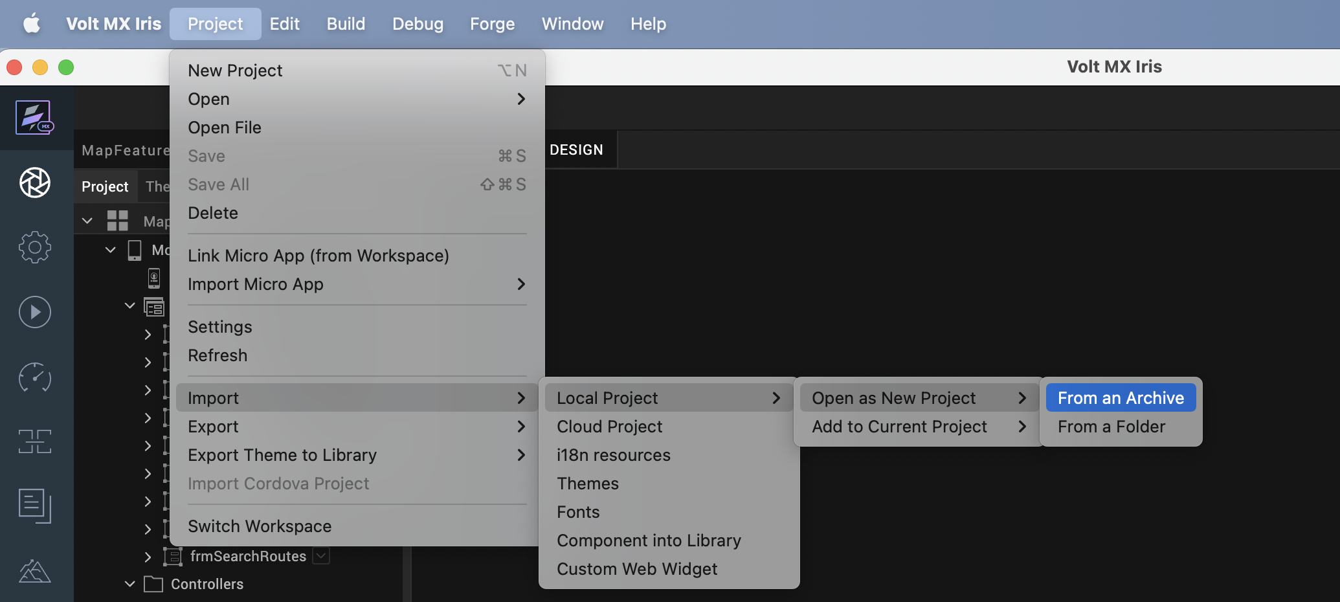

- Click From an Archive to navigate to the location of the project, select the files, and then click Import.
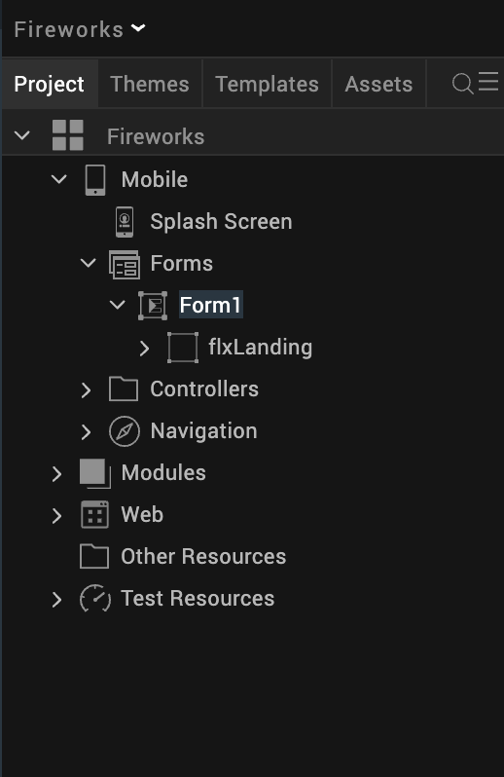
After you import the application, you can view the associated Foundry app connected at the in Data & Services section.
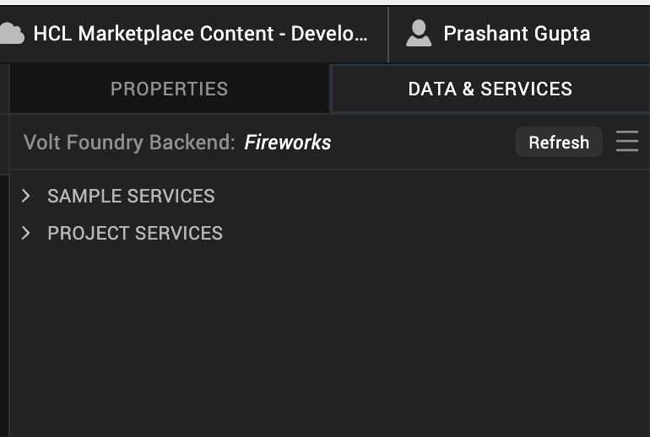

Fireworks Volt MX Foundry Services:
The Fireworks app contains an Integration Service:
Fireworks: The Fireworks API offers advanced text generation and completion capabilities, producing high-quality, contextually accurate text. It allows fine-grained control over style, tone, creativity, and structure using natural language instructions. Fireworks is optimized for interactive text generation—ideal for applications like content creation, chatbots, summarization, and educational materials.
Operations
Post_chat_completions
This operation invokes foundation models hosted on Fireworks Inference to generate AI responses for tasks such as text generation, Embeddings.
Inputs include:
- prompt / messages – User input or conversation history
- model – Selected Fireworks-supported model
- temperature – Controls randomness of the output
- top_p – Controls nucleus sampling
- max_tokens – Maximum number of tokens to generate
- stop sequences (optional) – Tokens that stop generation
The operation processes the input using the selected Fireworks model and returns a generated response optimized for speed and scalability.

Building the app
From the menu bar, go to Build and then select Build Native Local.
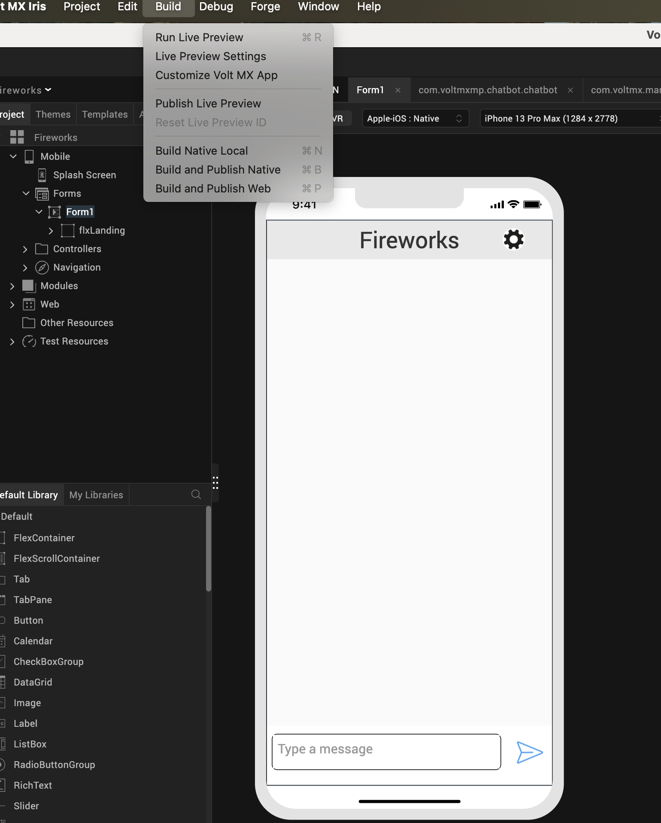

For Mobile, select Android and iOS. Click Build.
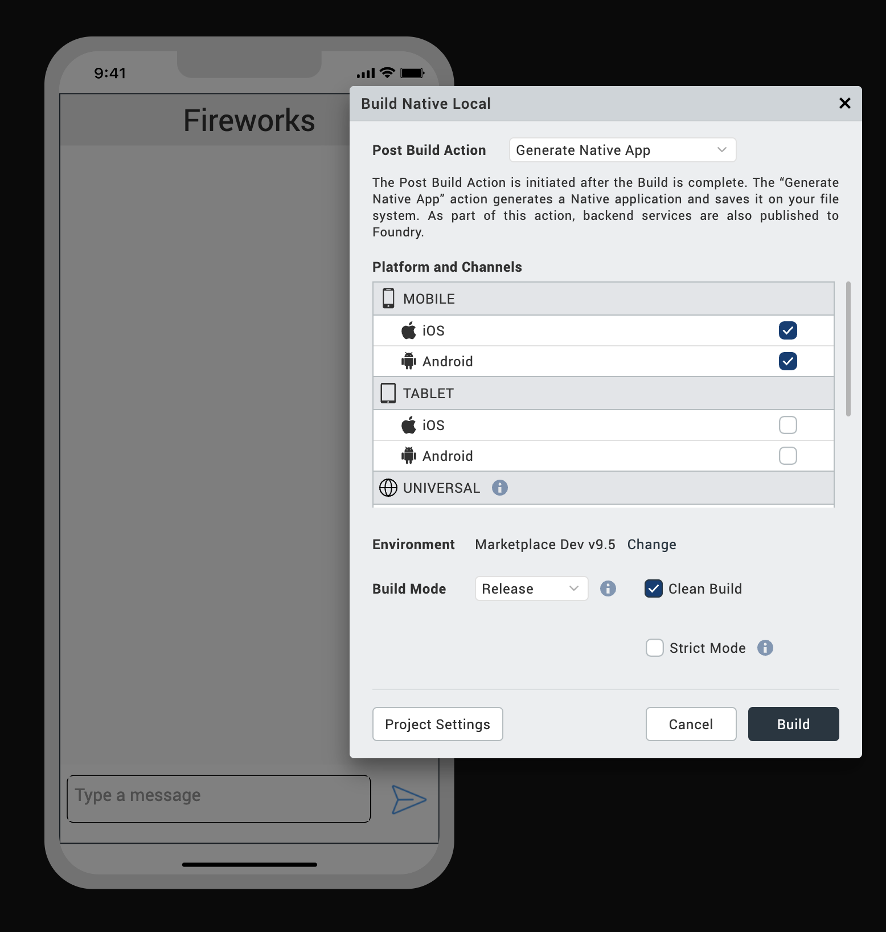

After the build is successful, run the app on your mobile device.

G. Application Flow
1. Landing Page of the application
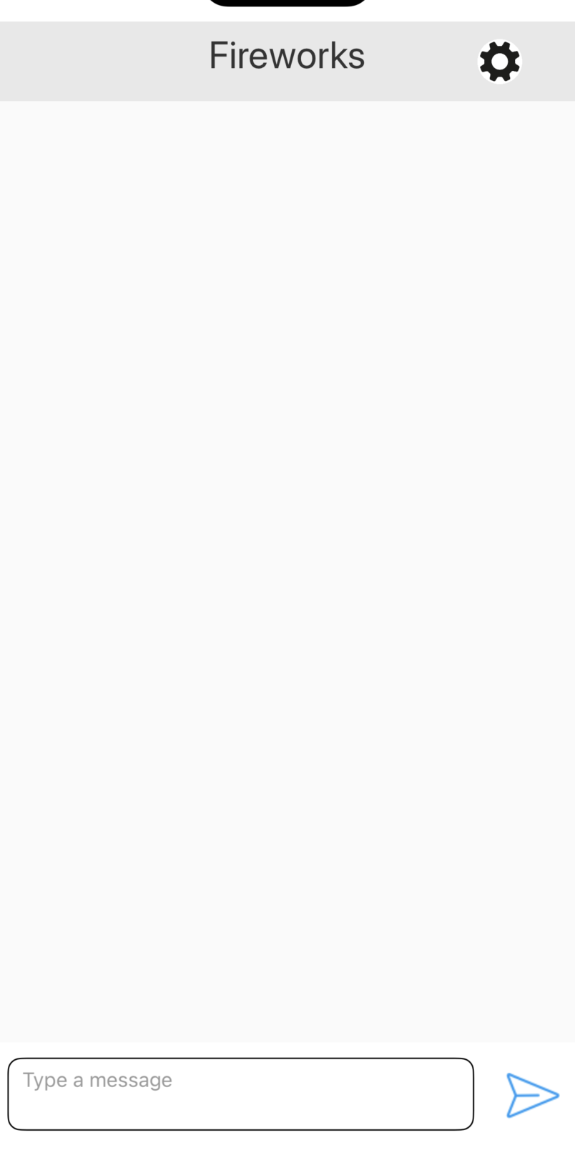

2. Select the model from settings

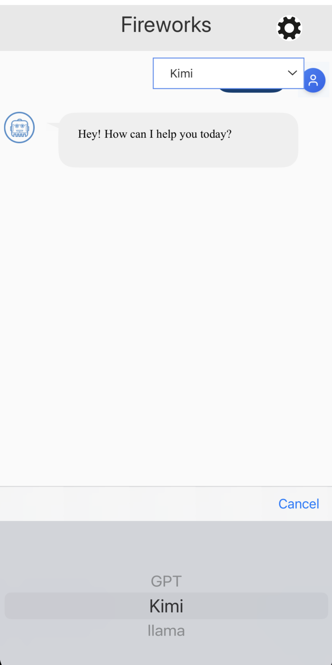

3. Ask/chat with the bot

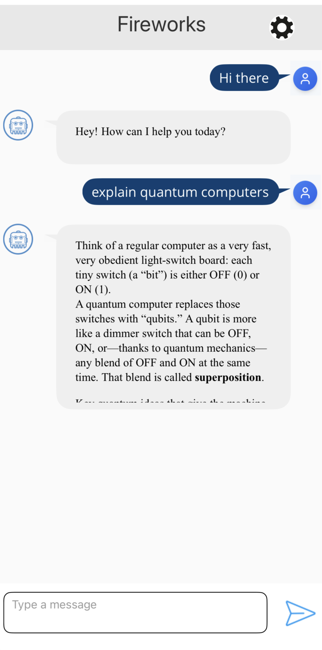

REVISION HISTORY
App version 1.0.0:

A. Limitations
1. Do not have support for Landscape mode.

B. Known Issue
- NA

