Date :29 Oct 2021

GET DIRECTIONS USING GOOGLE MAPS - APPLE MAPS

VERSION: 1.1.1

1. OVERVIEW
The Get Directions using Google Maps-Apple Maps component launches Google Maps or Apple Maps to provide navigation directions to the user. Under the hood, it utilizes URL schemes provided by Google Maps and Apple Maps. To get Place IDs we can configure from the documentation Places API

Use case:

Provide navigation directions to your app users using Google Maps/ Apple Maps

Features

Configure origin, destination, travel modes etc. properties directly from Iris property panel.

Customize look and feel of the component as per your company's branding guidelines.

The component uses URL schemes provided by Google Maps/ Apple Maps.

Percentage of re-use:
90%

Getting Started

Prerequisites
Before you start using the Get Direction component, ensure the following:
- HCL Foundry
- Volt MX Iris

Platforms Supported

Mobile

iOS

Android

Tablets

Importing the Component

You can import the Forge components only into the apps that are of the Reference Architecture type.

To import the Get Direction component, do the following:

1. Open your app project in Volt MX Iris.
2. In the Project Explorer, click the Templates tab.
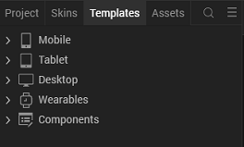

3. Right-click Components, and then select Import Component. The Import Component dialog box appears.
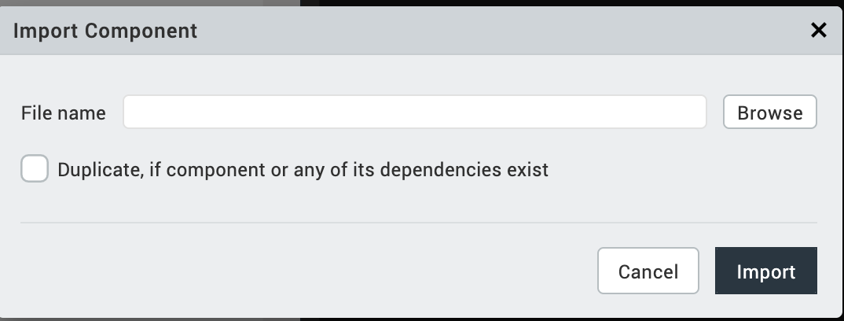
4. Click Browse to navigate to the location of the component, select the component, and then click Import. The component and its associated widgets and modules are added to your project.

Once you have imported a component to your project, you can easily add the component to a form. For more information, refer Add a Component to a Form.

Building and previewing the app
After performing all the above steps, you can build your app and run it on your device. For more information, you can refer to the Building and Viewing an Application section of the VoltMx Iris User Guide.
You can then run your app to see the Get Direction Component work in real time.

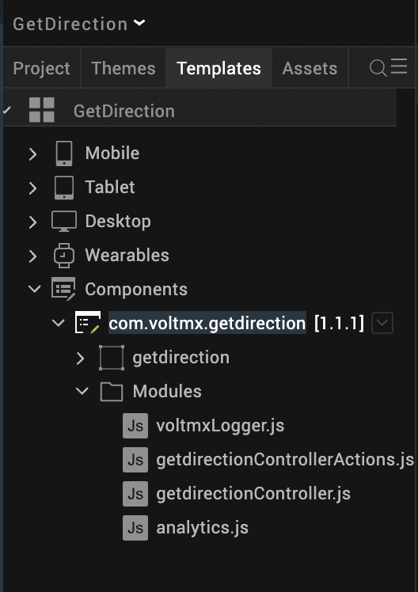

References

Dynamic Usage
You can also add a Get Direction component dynamically. To do so,
- In the Project Explorer, on the Projects tab, click Controllers section to access the respective Form Controller. Create a method and implement the code snippet like the sample code mentioned below.
define({
onNavigate: function(){
/* Creating component s object */
var getdirection = new com.voltmx.getdirection(
{
"autogrowMode": voltmx.flex.AUTOGROW_NONE,
"clipBounds": true,
"height": "80dp",
"id": "getdirection",
"isVisible": true,
"layoutType": voltmx.flex.FREE_FORM,
"left": "30%",
"masterType": constants.MASTER_TYPE_USERWIDGET,
"skin": "slFbox",
"top": "20%",
"width": "80dp"
}, {}, {});
/* Setting the component's Properties */
getdirection.icon = getdirection.png ;
getdirection.iconScaleMode = constants.IMAGE_SCALE_MODE_MAINTAIN_ASPECT_RATIO;
getdirection.headerMainText = "Get Directions";
getdirection.iOSMapOptions = "Both Maps";
getdirection.travelModesForAppleMaps = "driving";
getdirection.travelModesForGoogleMaps = "driving";
/* For iOS Devices*/
getdirection.originPlace = "paris";
getdirection.destinationPlace = "frankfurt";
/* For Android Devices*/
getdirection.destinationPlaceId = "ChIJxZZwR28JvUcRAMawKVBDIgQ";
getdirection.originPlaceId = "ChIJD7fiBh9u5kcRYJSMaMOCCwQ";
getdirection.wayPoints = "berlin|amsterdam";
getdirection.waypointPlaceIds="ChIJAVkDPzdOqEcRcDteW0YgIQQ|ChIJVXealLU_xkcRja_At0z9AGY";
getdirection.turnByTurnNavigation = false;
/*adding component to a form*/
this.view.add(getdirection);
}
});

In the code snippet, you can edit the properties of the component as per your requirement. For more information, see Setting Properties.
- Save the file.

.

Properties
The properties provided on the Component tab allow you to customize the UI elements in the Get Direction component. You can set the properties directly on the Component tab or by writing a JavaScript.
General Properties
1. icon Source(getDirectionIconSrc)
Description: | Specifies the source of the component's icon.
Syntax: | getDirectionIconSrc
Type: | String
Remarks: | Make sure that the source file is present in the project resources.
Example: | this.view.componentID.getDirectionIconSrc = directionImg.png;
2. icon Scale Mode(iconScaleMode)
Description: | Specifies the scale mode of the component's icon.
Syntax: iconScaleMode
Type : Constant
Read/Write: Read+write
Values: constants.IMAGE_SCALE_MODE_CROP
constants.IMAGE_SCALE_MODE_FIT_TO_DIMENSIONS
constants.IMAGE_SCALE_MODE_MAINTAIN_ASPECT_RATIO
Example: this.view.componentID.iconScaleMode = constants.IMAGE_SCALE_MODE_MAINTAIN_ASPECT_RATIO;

3. Origin(originPlace)
Description: | Specifies the starting point for the directions.
Syntax: | originPlace
Type: | String
Read/Write: | Read + Write
Example: | this.view.componentID.originPlace = paris ;
Remarks: | The saddr parameter in Apple Maps URL scheme.  The Origin Parameter in Google Maps Directions URL scheme.
 | For more information, you can refer to the Google Maps documentation and Apple Maps reference.
4. Destination(destinationPlace)
Description: | Specifies the endpoint of the directions.
Syntax: | destinationPlace
Type: | String
Read/Write: | Read + Write
Example: | this.view.componentID.destinationPlace = Frankfurt;
Remarks: | 1. For more information, you can refer to the Google Maps  Documentation and Apple Maps reference.  2.An exception stating “Please provide a valid destination” is thrown if there is no destination provided.

iOS

1. Map options(iOSMapoptions)
Description: |  | This property is used to ask the users which map they want to use. This property invokes an Action Sheet pop-up that presents the choice of map to the user - Google Maps, or Apple Maps.  This property has the following options:  - Apple Maps  - Google Maps  - Both Maps
Syntax: iOSMapOptions

Type: String

Read/Write: Read + Write

Default Value: ”Both Maps”

Remarks: The component throws an exception if the given value is not a valid string.
The Action Sheet will not pop up if you enable only one map.

2.Action Sheet Main Text
Description: | Specifies the text to be displayed as the main header of the Action Sheet. You can refer to the Map Options property for more information regarding Action Sheet.
Syntax: | headerMainText
Type: | String
Read/Write: | Read + Write
Remarks: | The Action Sheet will not display the Header if you do not provide any text.
Example: | this.view.componentID.headerMainText = "Launch Map";

3.Action Sheet Sub Text
Description: | Specifies the text to be displayed as the sub header of the Action Sheet. You can refer to the Map Options property for more information regarding Action Sheet.
Syntax: | headerSubText
Type: | String
Read/Write: | Read + Write
Remarks: | The Action Sheet will not display the Sub Header if you do not provide any text.
Example: | this.view.componentID.headerSubText = "Which map would you like to use?";
Action Sheet Skin Properties
An Action Sheet is a pop-up in iOS that presents the choice of map to the user - Google Maps, or Apple Maps.
You can change the exposed skins of the Action Sheet component in the Skins tab under the Properties panel on the right side of VoltMx Iris
1. Sheet Background Skin

Description: | Specifies the skin that is applied to the background container of Header and Options of the Action Sheet.
Syntax: | sheetBackgroundSkin
Type: | String
Read/Write: | Read + Write
Example: | this.view.componentID.sheetBackgroundSkin = "sheetBGSkin";

2. Header Main Text Skin
Description: | Specifies the skin that is applied to the header's main text in the Action Sheet.
Syntax: | headerMainTextSkin
Type: | String
Read/Write: | Read + Write
Example: | this.view.componentID.headerMainTextSkin = "headerTextSkin";

3. Header Sub Text Skin
Description: | Specifies the skin that is applied to the header's sub text in the Action Sheet.
Syntax: | headerSubTextSkin
Type: | String
Read/Write: | Read + Write
Example: | this.view.componentID.headerSubTextSkin = "headerTextSkin2";

4. Separator Skin
Description: | Specifies the skin that is applied to the separator lines in the Action Sheet.
Syntax: | separatorSkin
Type: | String
Read/Write: | Read + Write
Example: | this.view.componentID.separatorSkin = "separatorSkin";

5. Options Skin
Description: | Specifies the skin to be applied to the options in the Action Sheet.
Syntax: | optionsSkin
Type: | String
Read/Write: | Read + Write
Example: | this.view.componentID.optionsSkin = "optSkin";

6. Options Focus Skin
Description: | Specifies the skin to be applied to the options in the Action Sheet when it is focused.
Syntax: | optionsFocusSkin
Type: | String
Read/Write: | Read + Write
Example: | this.view.componentID.optionsFocusSkin = "optFocusSkin";

7. Footer Background Skin
Description: | Specifies the skin to be applied to the background container of the Footer in the Action Sheet.
Syntax: | footerBackgroundSkin
Type: | String
Read/Write: | Read + Write
Example: | this.view.componentID.footerBackgroundSkin = "footBGSkin";

8. Footer Button Skin
Description: | Specifies the skin to be applied to the Footer button in the Action Sheet.
Syntax: | footerButtonSkin
Type: | String
Read/Write: | Read + Write
Example: | this.view.componentID.footerButtonSkin = "footBtnSkin";

9. Footer Button Focus Skin
Description: | Specifies the skin to be applied to the Footer button in the Action Sheet when it is focused.
Syntax: | footerButtonFocusSkin
Type: | String
Read/Write: | Read + Write
Example: | this.view.componentID.footerButtonFocusSkin = "footBtnFocusSkin";

Google Maps Properties
1. Travel Mode
Description: | Defines the method of travel. The Options for the Travel Mode are:  - Driving - It routes through major roads and streets.  - Walking - It prefers available pedestrian paths and sidewalks.  - Bicycling - It routes through available bike paths and preferred streets.  - Transit - It routes through available Bus or Train transits.
Syntax: | travelModesForGoogleMaps
Type: | List Selector
Read/Write: | Read + Write
Default Value: | None
Remarks: | - This property can be set to none if the user does not want to give any travel mode. If the mode is set to none, Google Maps will show the most relevant modes for the specified route or the user preferred mode.  - It refers to the travelmode parameter of the Google Maps Directions URL scheme. For more details you can refer to Google Maps Documentation.  - If you give an empty string or an invalid value, the component throws an exception stating "Please provide a valid travel mode for Google Maps".
Example: | this.view.componentID.travelModesForGoogleMaps = "Driving";

2. Origin Place ID
Description: | Specifies Google Maps Place ID of the Origin. A Place ID is a unique identifier for a place in the Google Places database and Google Maps.
Syntax: | originPlaceId
Type: | String
Read/Write: | Read + Write
Remarks: | - This property refers to the origin_place_id parameter of Google Maps Directions URL scheme. For more details you can refer to Google Maps Documentation.  - Make sure this property is used only if the Origin is provided.
Example: | this.view.componentID.originPlaceId = "frankfurt";

3 . Destination Place ID
Description: | Specifies Google Maps Place ID of the Destination. A Place ID is a unique identifier for a place in the Google Places database and Google Maps.
Syntax: | destinationPlaceId
Type: | String
Read/Write: | Read + Write
Remarks: | - This property refers to the destination_place_id parameter of Google Maps Directions URL scheme. For more details you can refer to Google Maps Documentation.  - Make sure this property is used only if the Destination is provided.
Example: | this.view.componentID.destinationPlaceId = "paris";

4 . Waypoints
Description: | Specifies one or more intermediary places between the origin and destination to route the directions through.  - Multiple waypoints can be specified by using the pipe character ( | ) to separate places (for example, Berlin,Germany|Paris,France).  - Each waypoint can be either a place name, address or comma-separated latitude/longitude coordinates.
Syntax: | wayPoints
Type: | String
Read/Write: | Read + Write
Remarks: | - The number of waypoints allowed varies by the platform where the link opens, with up to three waypoints supported on mobile browsers, and a maximum of nine waypoints supported otherwise.  - Waypoints are displayed on the map in the same order that they are listed in the URL.
Example: | this.view.componentID.wayPoints = "berlin|amsterdam";
5. waypoints Place IDs
Description: | Specifies a list of Google Maps Place IDs to match the list of waypoints. A Place ID is a unique identifier for a place in the Google Places database and Google Maps.  - Each waypoint Place ID should be separated using the pipe character ( | )
Syntax: | waypointPlaceIds
Type: | String
Read/Write: | Read + Write
Remarks: | - This property refers to the waypoints_place_ids parameter of Google Maps Directions URL scheme. For more details you can refer to Google Maps Documentation.  - Make sure it is used only if waypoints are provided.
Example: | this.view.componentID.waypointPlaceIds = "ChIJAVkDPzdOqEcRcDteW0YgIQQ|ChIJVXealLU_xkcRja_At0z9AGY";

6. Turn By Turn Navigation
Description: | Launches either turn-by-turn navigation or route preview to the specified destination, based on whether the origin is available.  The map launches a route preview if:  - The origin is not close to the user's current location.  - The user's current location is not available.  The map launches a turn-by-turn navigation if:  - The user does not specify an origin - The origin defaults to the user's current location.  - The Origin is close to the user's current location.
Syntax: | turnByTurnNavigation
Type: | Boolean
Read/Write: | Read + Write
Remarks: | This property refers to the dir_action = navigate parameter of Google Maps Directions URL scheme. For more details you can refer to Google Maps Documentation.
Example: | this.view.componentID.turnByTurnNavigation = true;

Apple Maps properties
1. Travel Modes
Description: | Specifies the transport type for Apple Maps. The Options for the Travel Mode are:  - driving - It refers to d (by car).  - walking - It refers to w (by foot).  - transit - It refers to r (by public transit).
Syntax: | travelModesForAppleMaps
Type: | List Selector
Default Value: | None
Read/Write: | Read + Write
Remarks: | - It refers to the dirflg parameter of the Apple Maps URL scheme. For more details you can refer to Apple Maps URL Scheme reference.  - If you give an empty string or an invalid value, the component throws an exception stating "Please provide a valid travel mode for Apple Maps".
Example: | this.view.componentID.travelModesForGoogleMaps = "driving";

Events
---No Events are Used

APIs

--No APIs are exposed.

Revision History
App version 1.1.1

Limitations:

1 . For iOS we will get the Both “Apple Map” & “Google Map” options.
2 . For Android we will get only “Google Map” option.

