Date : 28-Feb-24

GNEWS (1.0.0)

Overview
- GNews API is a simple REST API with which you can search for current and historic news articles published by over 60,000 sources. With this news API, you can also collect the current top headlines articles based on the Google News ranking.

Getting Started

Prerequisites
Before you start using the GNEWSdata adapter, ensure you have the following:

- HCL Foundry
- Volt MX Iris
- An account with GNews and API key

Platforms Supported

Mobile

iOS

Android

Tablets

PWA

Importing the adapter
To import the Data Adapter to Volt Foundry, do the following:
- Sign in to the HCL Foundry.
- From the left navigation menu, select API Management.
- In API Management, select Custom Data Adapters.
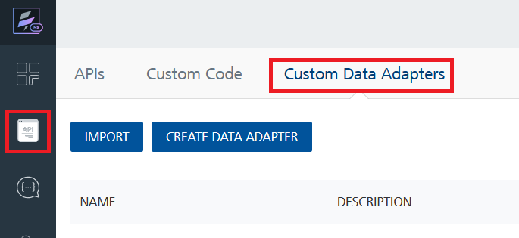
- Click IMPORT to import a custom data adapter.
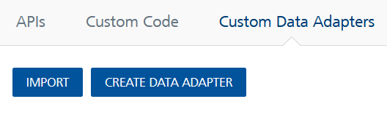
- On the Import Data Adapter dialog box, click browse to import.
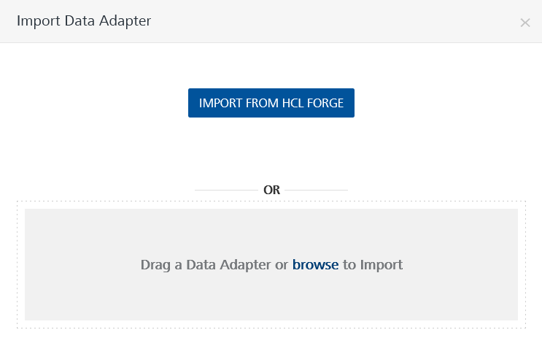
- Select data adapter zip file and click IMPORT.
After importing the GNEWSdata adapter, Volt Foundry opens a window that shows the metadata of the data adapter.

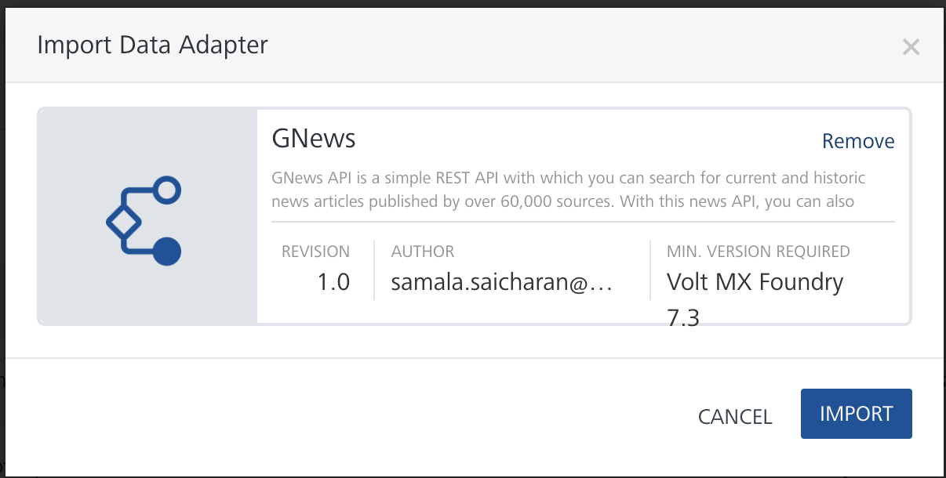
After you import the data adapter, you can view it on the Custom Data Adapters page and use it to create services on VoltMX Foundry.

Creating an Integration service
Follow the given steps to create an Integration service using the GNEWS Data Adapter.
- Sign in to the HCL Foundry.
- From the left navigation menu, select API Management.
- In API Management, select Integration.
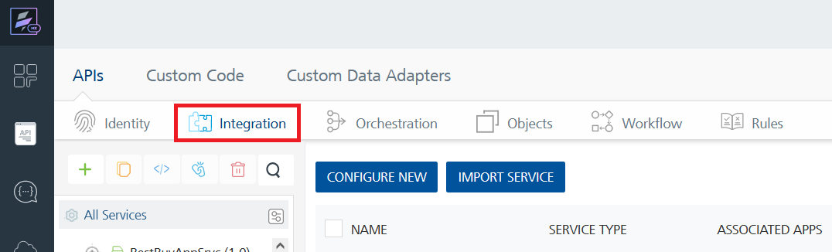
- To create a new service, click the + button or the CONFIGURE NEW button.
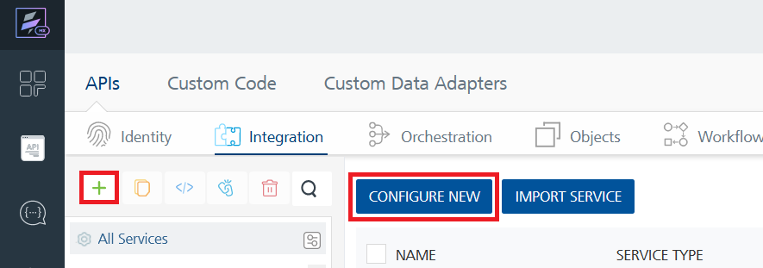
- On the Service Definition tab, select the service type as GNews, and click SAVE.
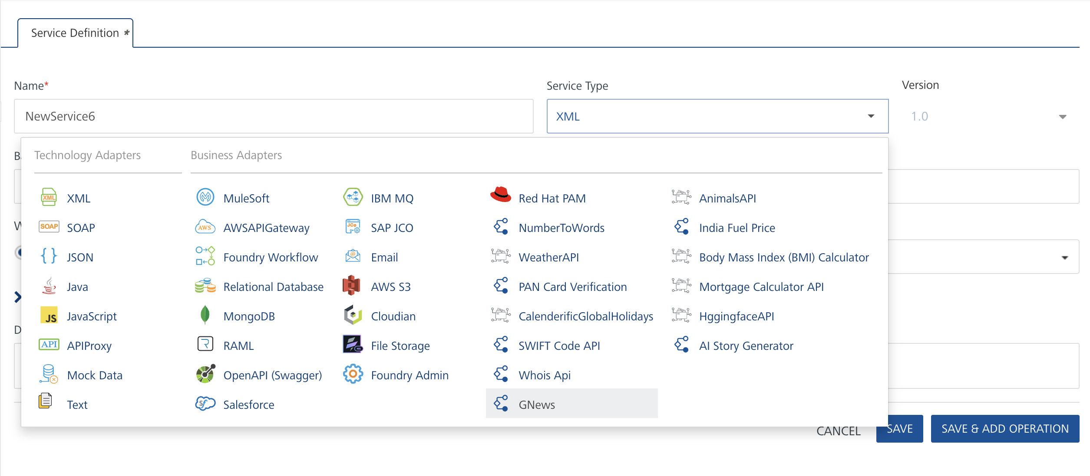

Creating and Executing operations
After you create an integration service, you can create and execute operations using the service.

Creating an operation
- In the API Management/Foundry app you created, in the Integration section, select the service that you created.
- After you select the service, navigate to the Operation List tab.
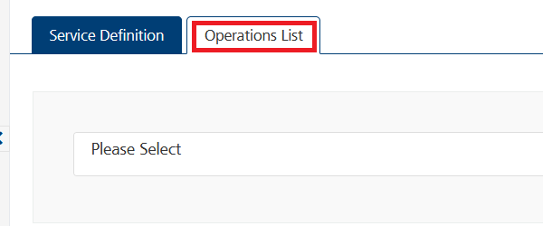
- From the drop-down list, select an operation that you want to execute, and click ADD OPERATION.
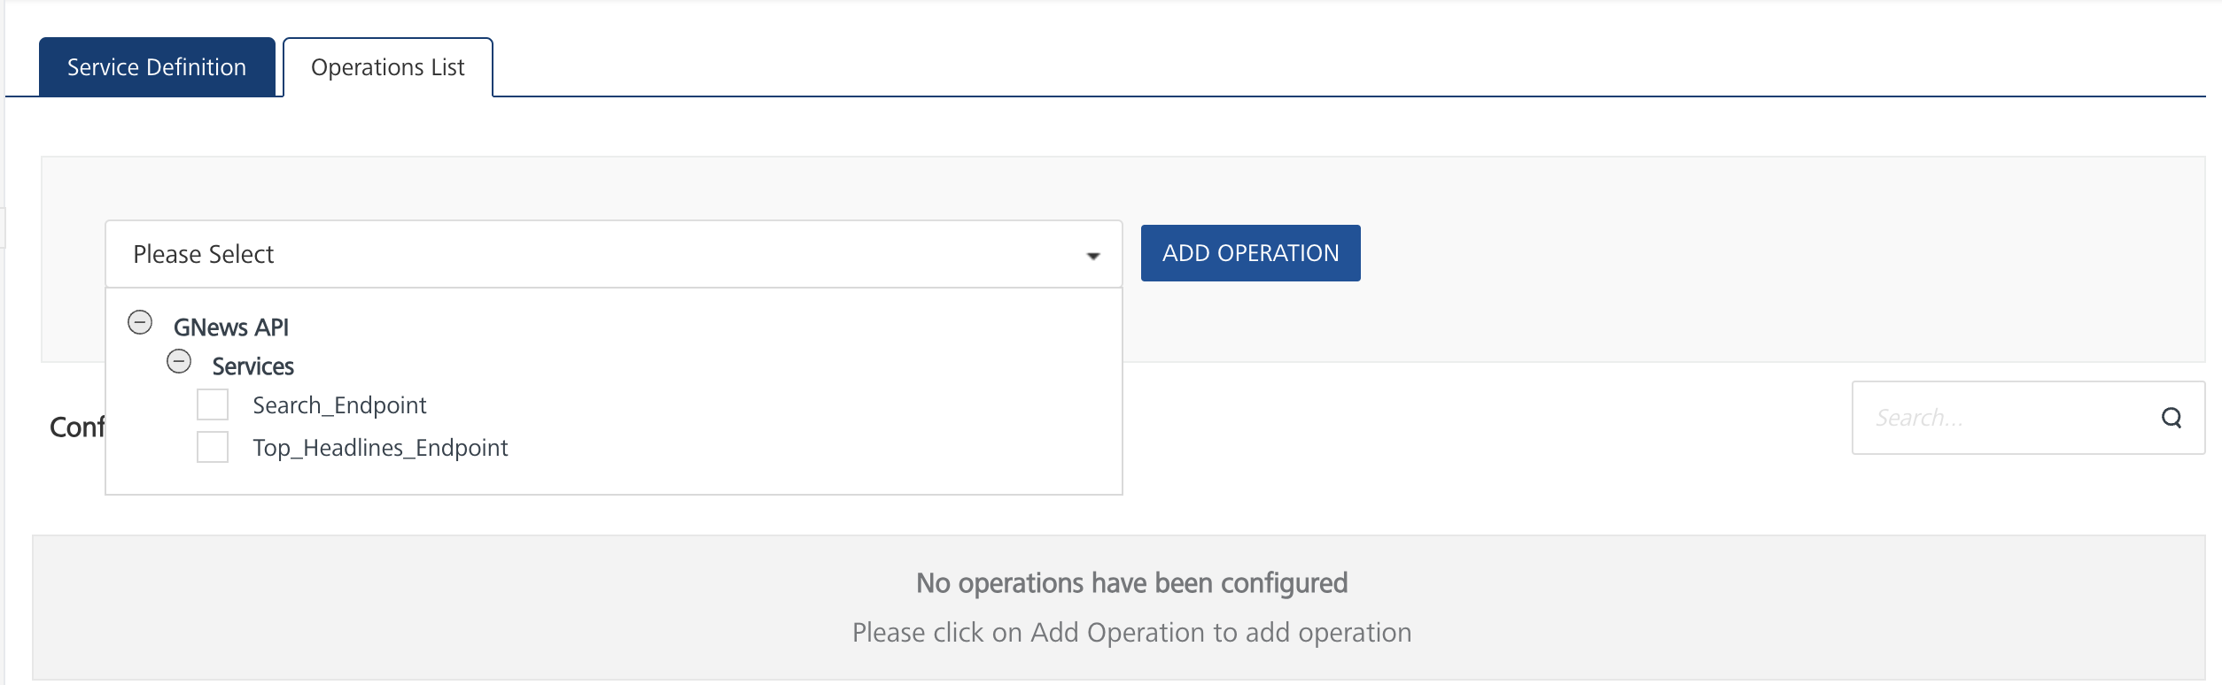

Executing an Operation
- From the Operations List tab, in the Configured Operations section, select the operation you want to execute and click on ADD OPERATION button.
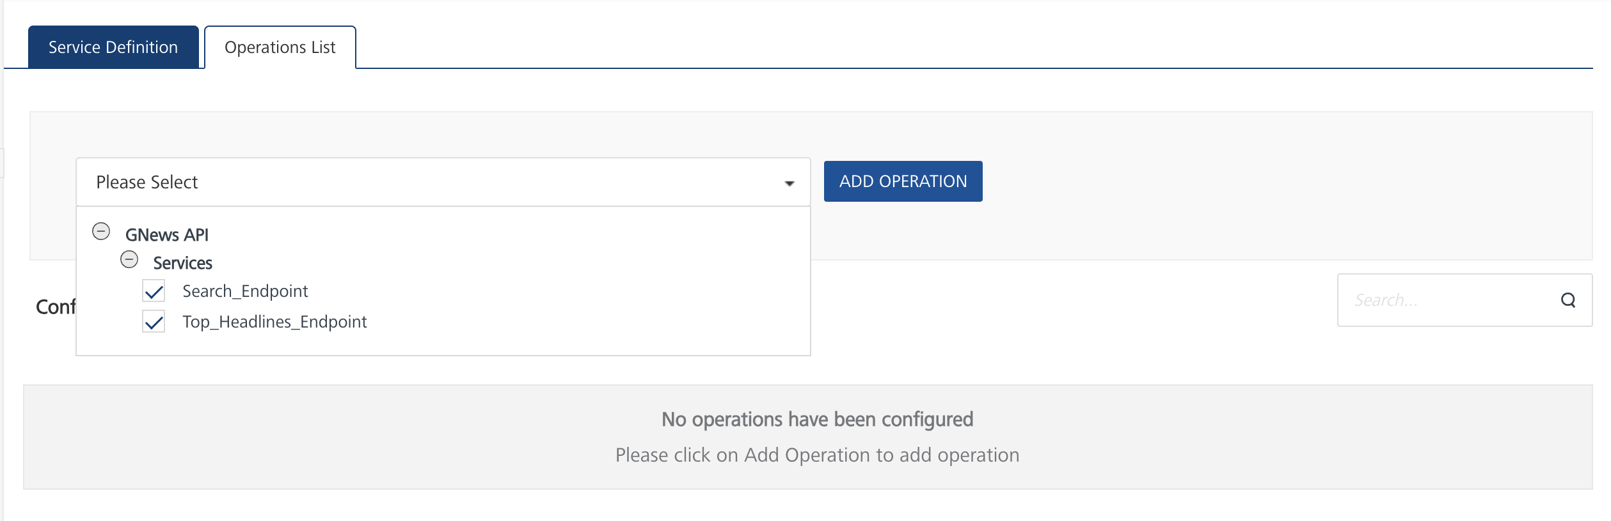
- On the Operation Page, in the Request Input tab, enter a TEST VALUE for all the fields.
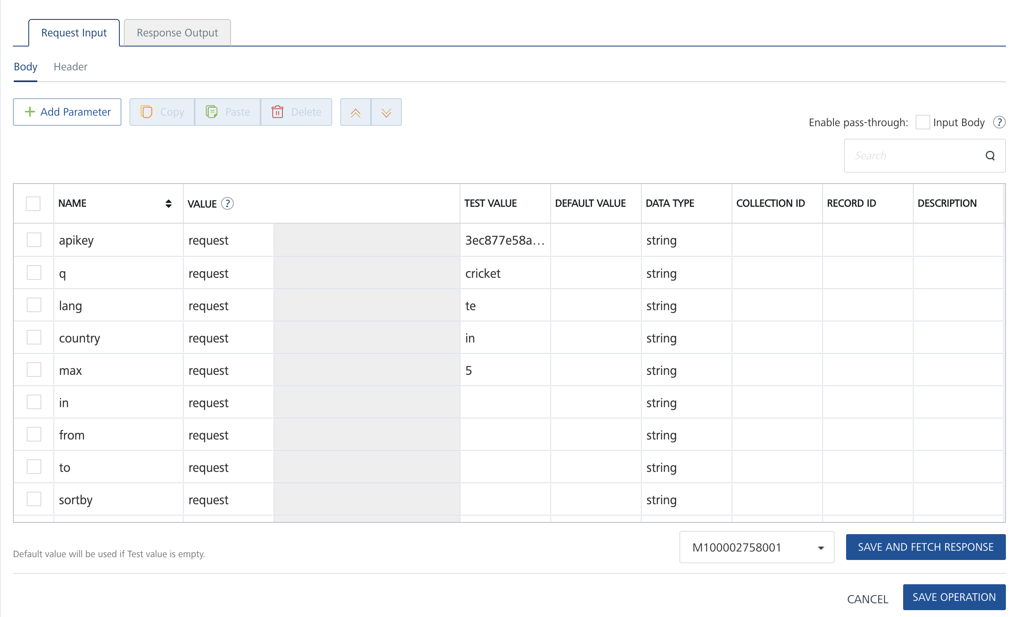

- Select a run-time environment and click Save and Fetch Response to get a response based on your inputs.
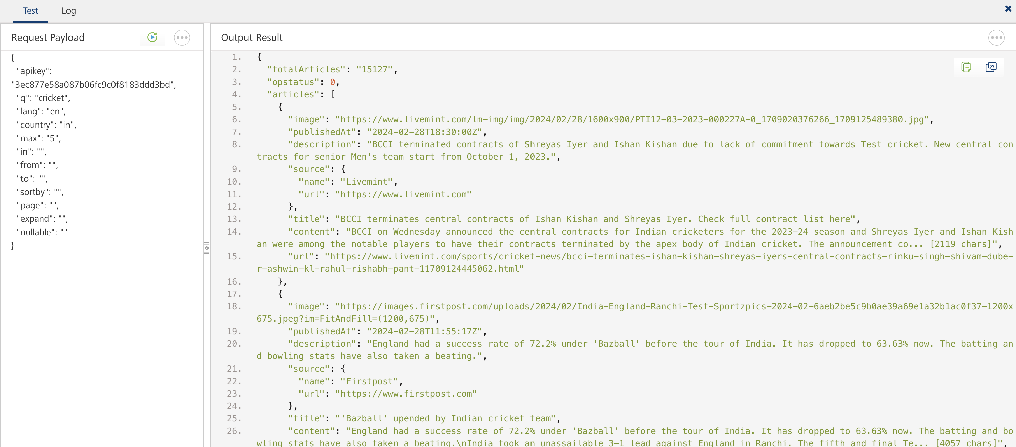

Publishing your application
If you want to use the services in client applications, you need to publish an app to a run-time environment. You can create the service (as described above) in an application or import the service into an application and publish the application.

References
Base url : https://gnews.io/api/v4

Endpoint Documentation
Endpoints | Input params-Type | Description
/search | BODY PARAMETERS:  - apikey(required)  - q(required)  - lang  - country  - max  - in  - from  - to  - sortby  - pages  - expand  - nullable | This endpoint allows you to search for news articles through a combination of keywords.
/top-headlines | BODY PARAMETERS:  - apikey(required)  - category  - lang  - country  - max  - in  - from  - to  - sortby  - pages  - expand  - nullable | This endpoint allows you to search for current trending articles, the articles that are selected to be returned by this endpoint are based on the Google News ranking. There are 9 categories available, the default category is "general".

Refer the link for more information about API endpoints .

Revision History
Adapter version 1.0.0

