Date : 23-02-2024

Google API
Version: 1.0.0

Overview
This is all-in-one solution for seamless translation and comprehensive searches. Unlock the power of translation across languages, harness the potential of video, web, and image searches within a single interface. The API empowers developers to effortlessly integrate versatile search functionalities into their applications, offering users an enriched and connected search experience. With a unified approach to language translation and diverse media exploration, The API opens doors to new possibilities in information discovery and communication. Elevate your applications with a dynamic, integrated search solution that transcends boundaries and enhances user engagement.

Getting Started

Prerequisites
- Volt Foundry
- Rapid API Account
- X-RapidAPI-Key, X-RapidAPI-Host

Importing the adapter
To import the Data Adapter to Volt Foundry, do the following:
- Sign in to the HCL Foundry.
- From the left navigation menu, select API Management.
- In API Management, select Custom Data Adapters.
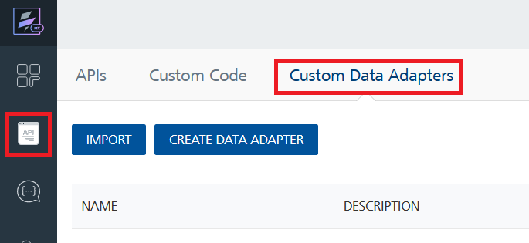
- Click IMPORT to import a custom data adapter.
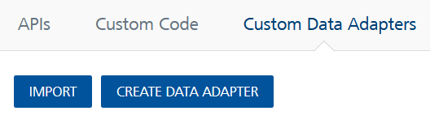
- On the Import Data Adapter dialog box, click browser to import.
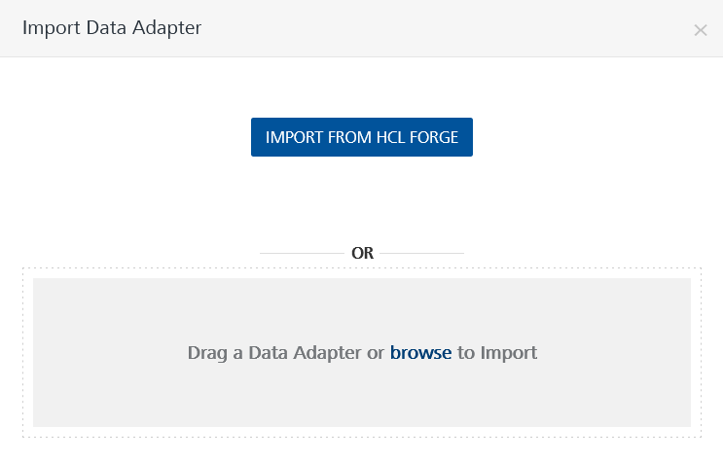
- Select Google API zip file and click IMPORT.
After you import the data adapter, Volt Foundry opens a window that shows the metadata of the data adapter.

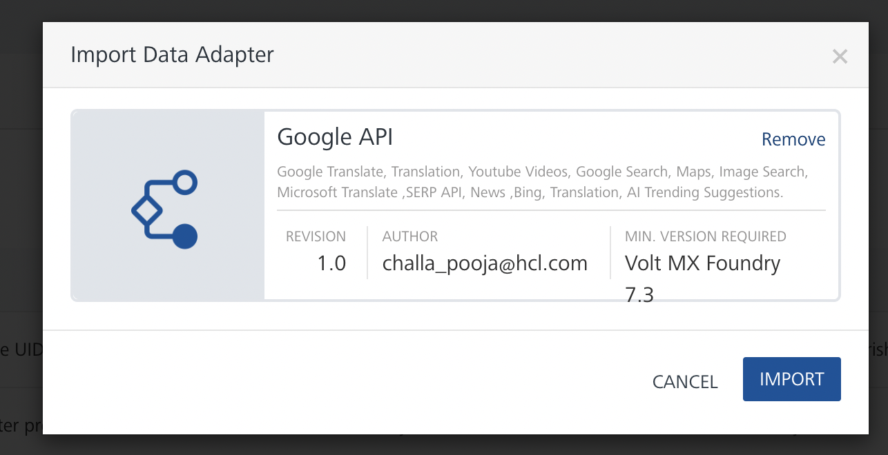
After you import the data adapter, you can view it on the Custom Data Adapters page and use it to create services on Volt Foundry.
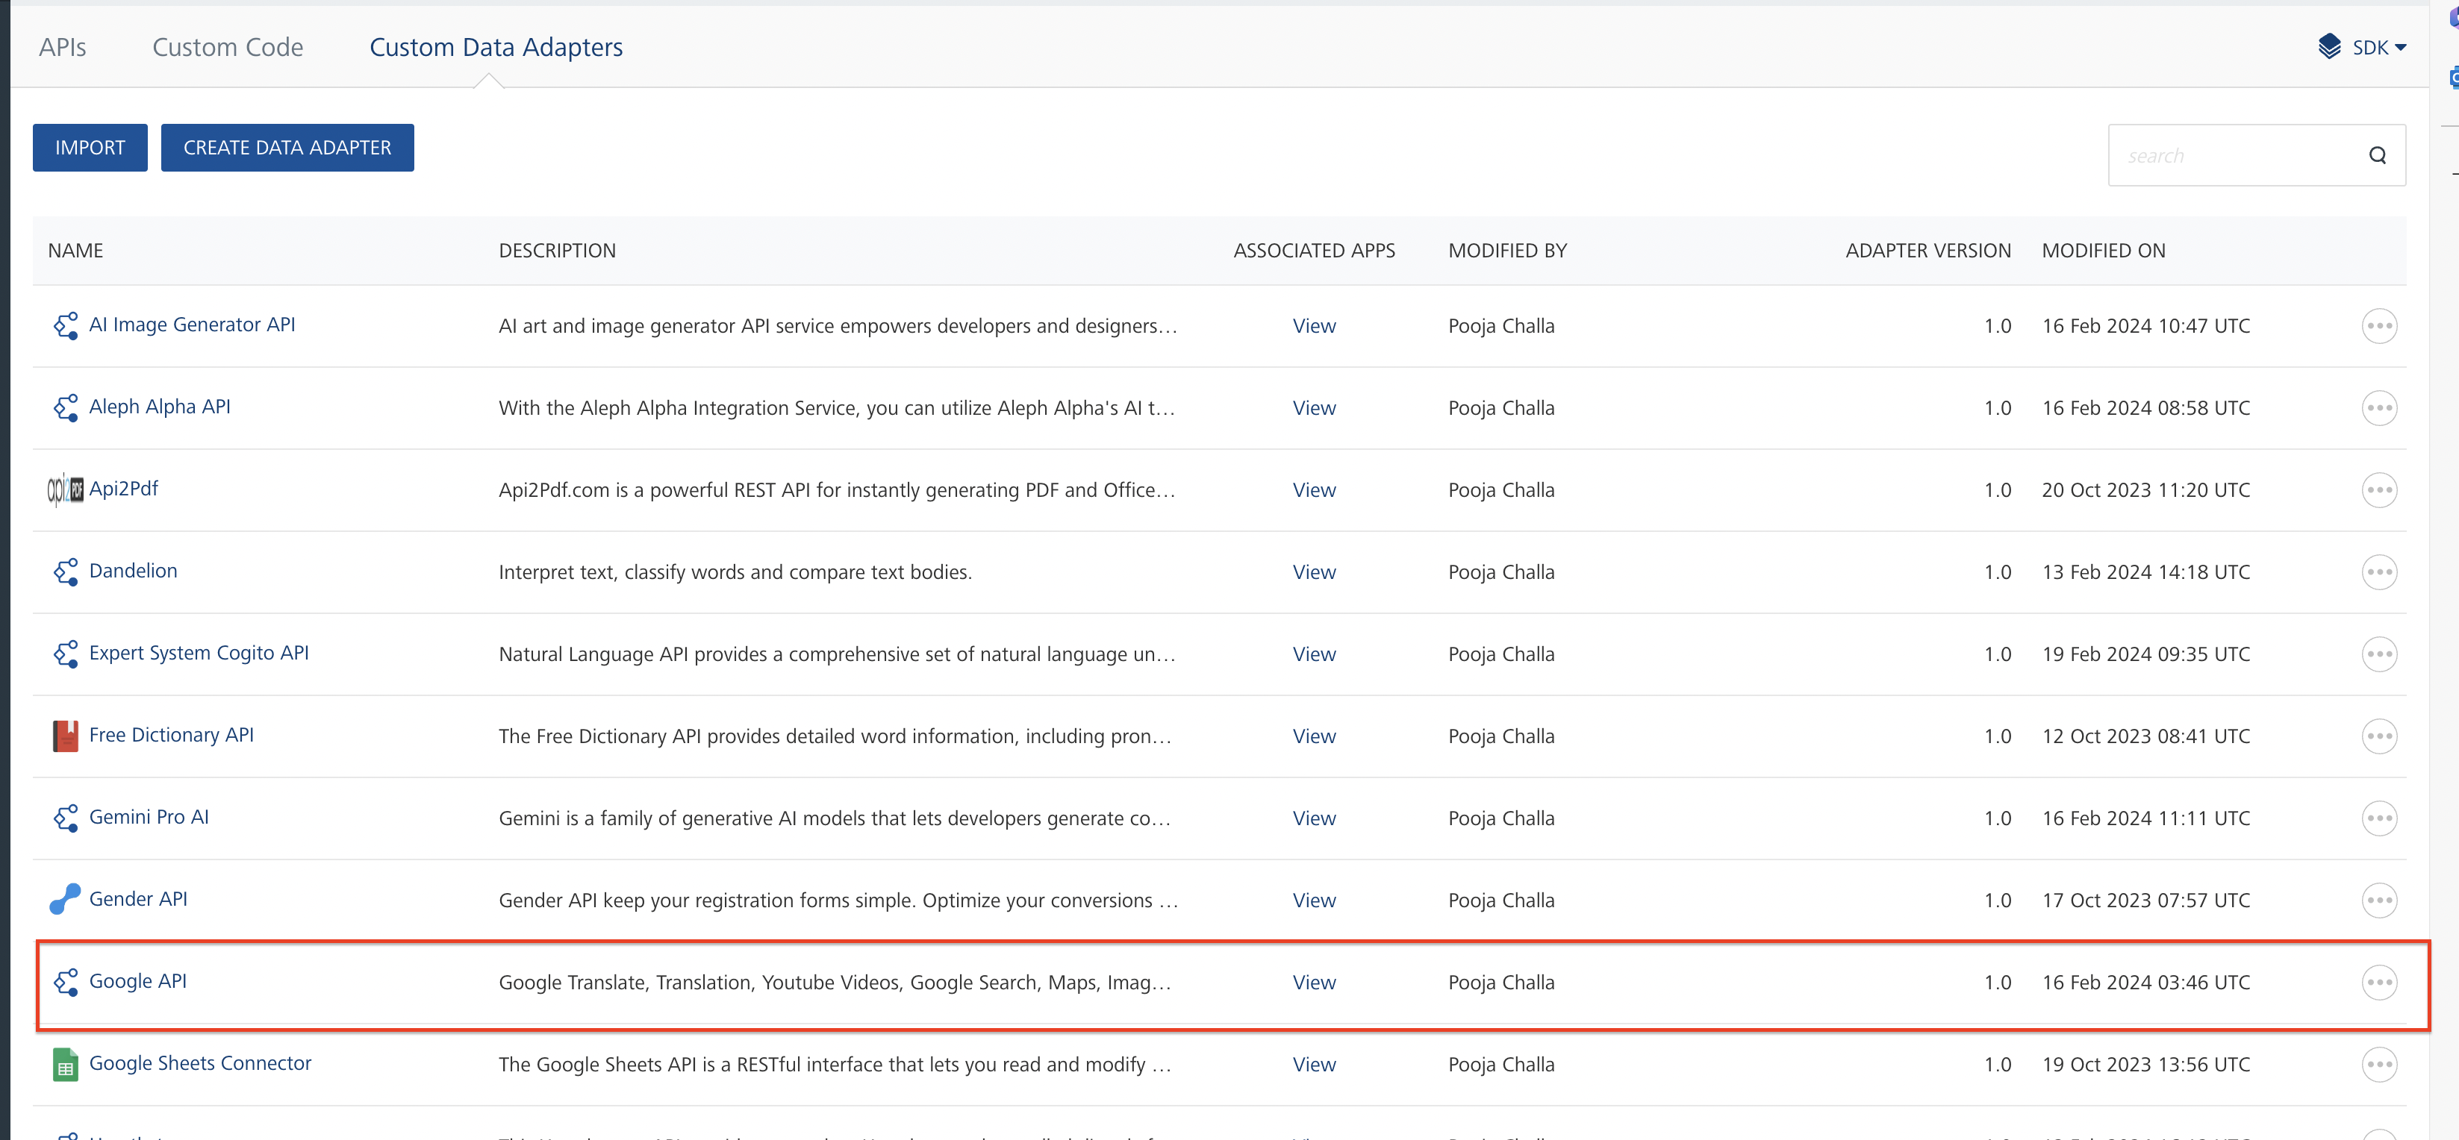

Creating an Integration service
After you import the data adapter into Volt Foundry, you can use it to create an Integration Service.
Follow the given steps to create an Integration service using the Google API Adapter.
- Sign in to the HCL Foundry.
- From the left navigation menu, select API Management.
- In API Management, select Integration.
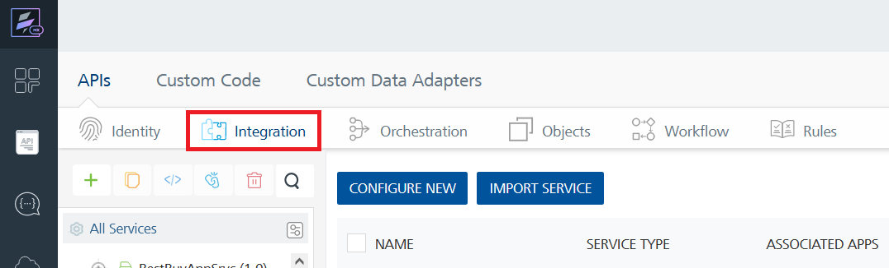
- To create a new service, click the + button or the CONFIGURE NEW button.
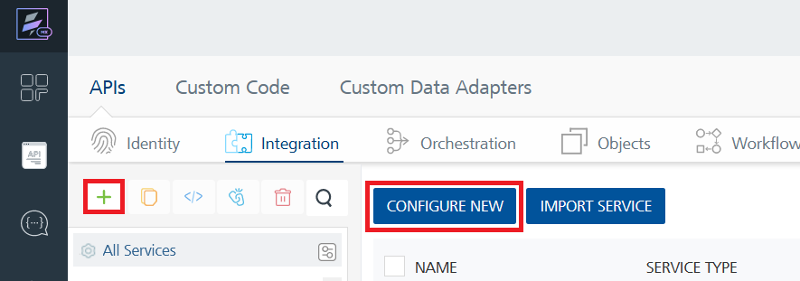
- On the Service Definition tab, select the service type as Google API and click SAVE.

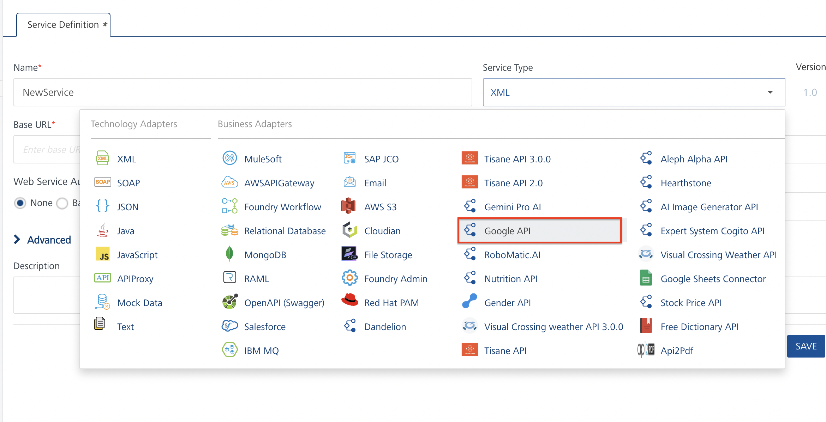
Alternatively, you can also create a Foundry app and create an Integration service inside it.
- Creating and Executing operations
After you create an integration service, you can create and execute operations using the service.

Creating an Operation
- In API Management/Foundry app you created, in the Integration section, select the service that you created.
- After you select the service, navigate to the Operation List tab.
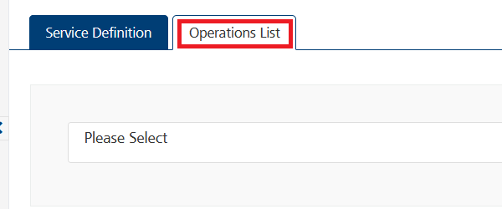
- From the drop down list, select an operation that you want to execute, and click ADD OPERATION.
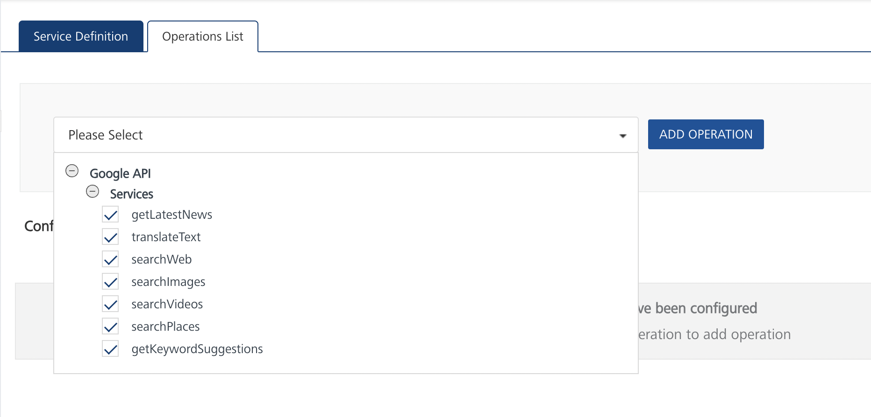

Executing an operation
- From the Operations List tab, in the Configured Operations section, select the operation you want to execute.
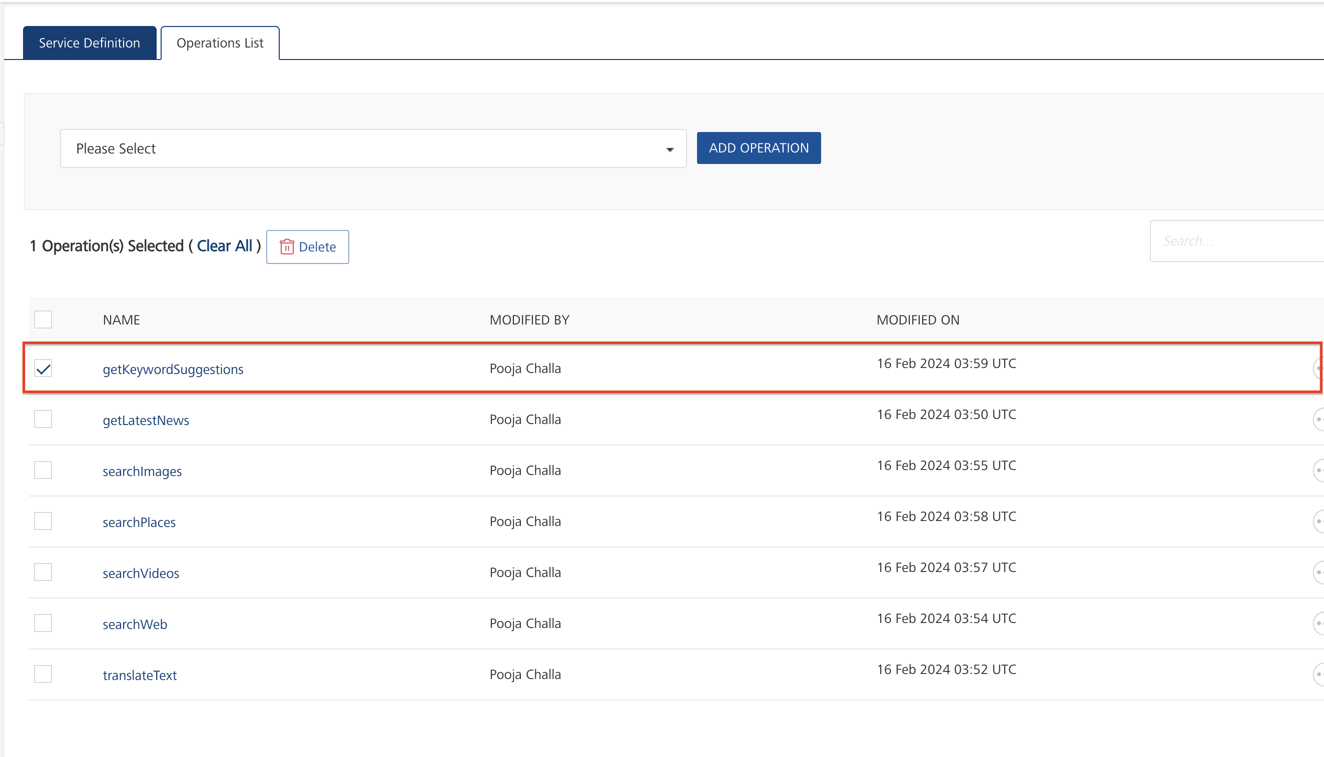
- On the Operation Page, in the Request Input tab, enter a TEST VALUE for all the fields.
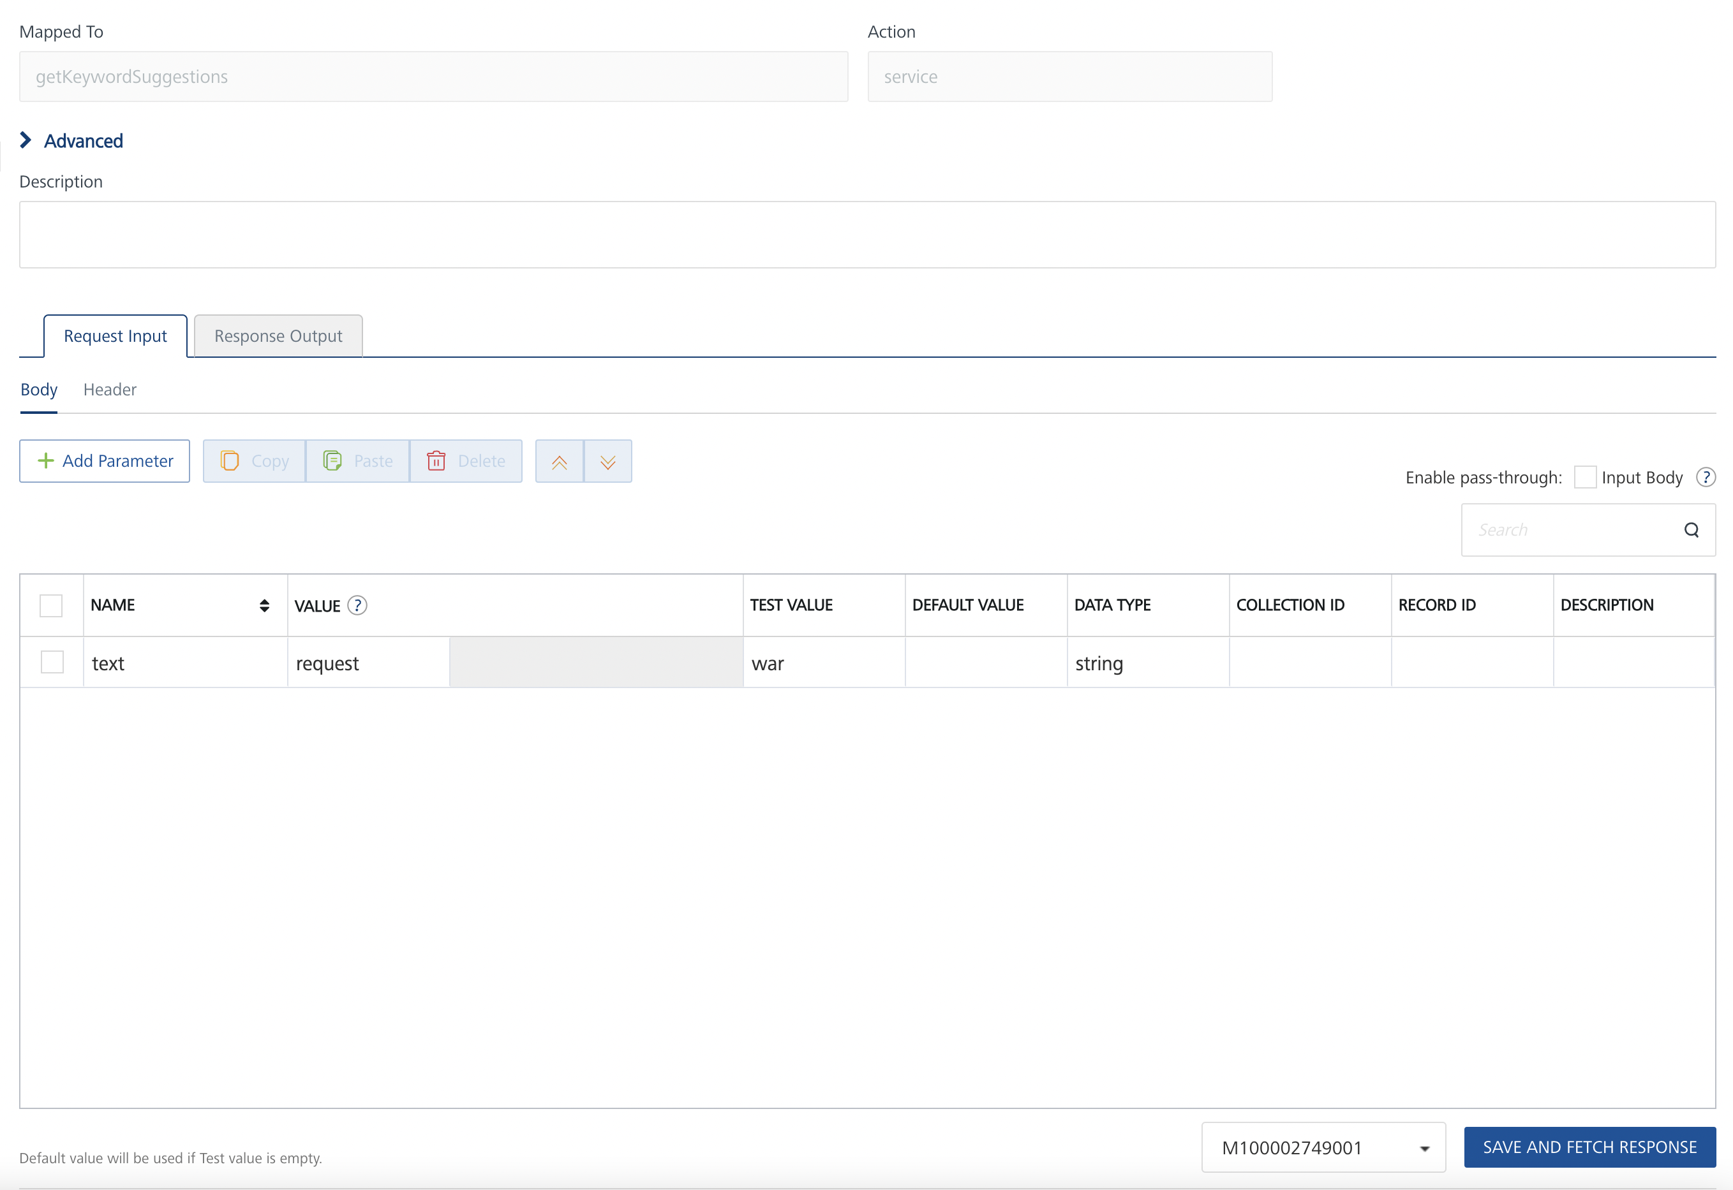
Request Header:
Authorization: X-RapidAPI-Key, X-RapidAPI-Host [in header]: API Key associated with your RapidAPI account, required for authentication. To get keys – Login in to Rapid API Account -> You can view your keys.
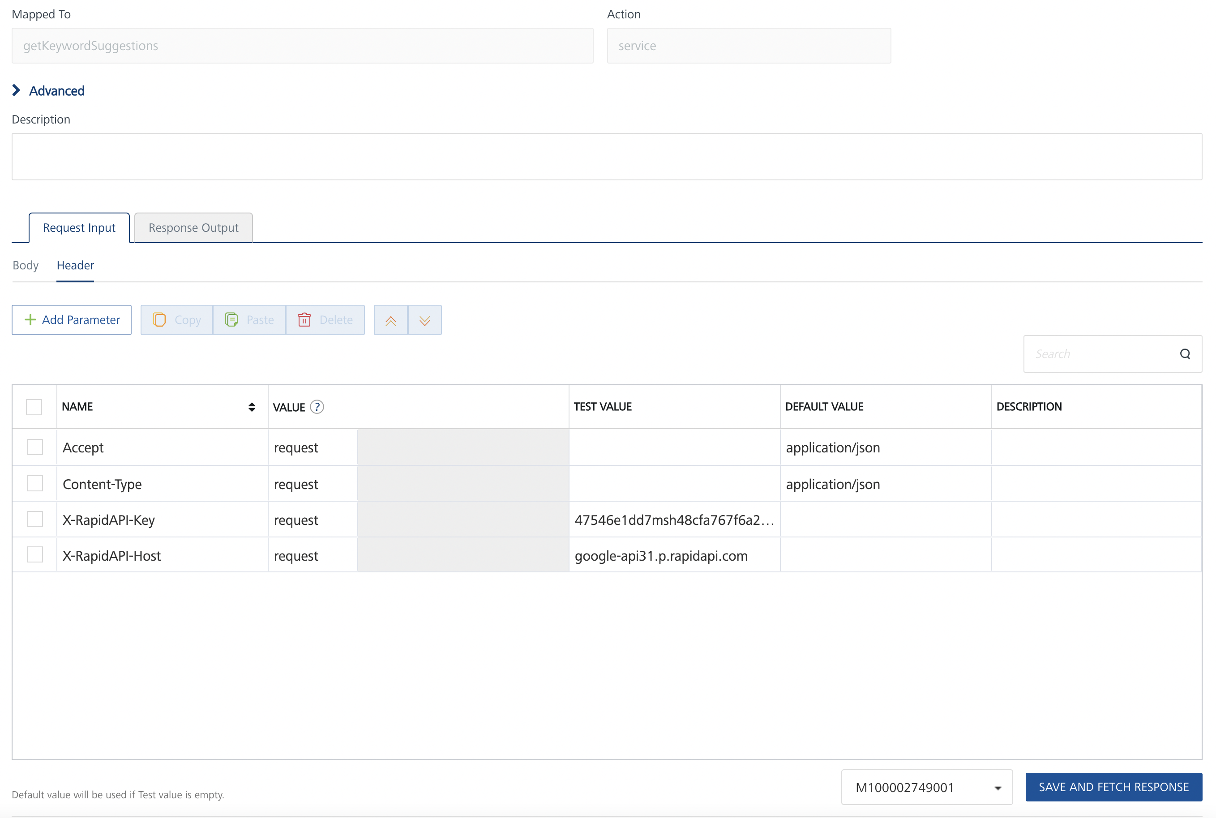
- Select a run-time environment and click Save and Fetch Response to get a response based on your inputs.
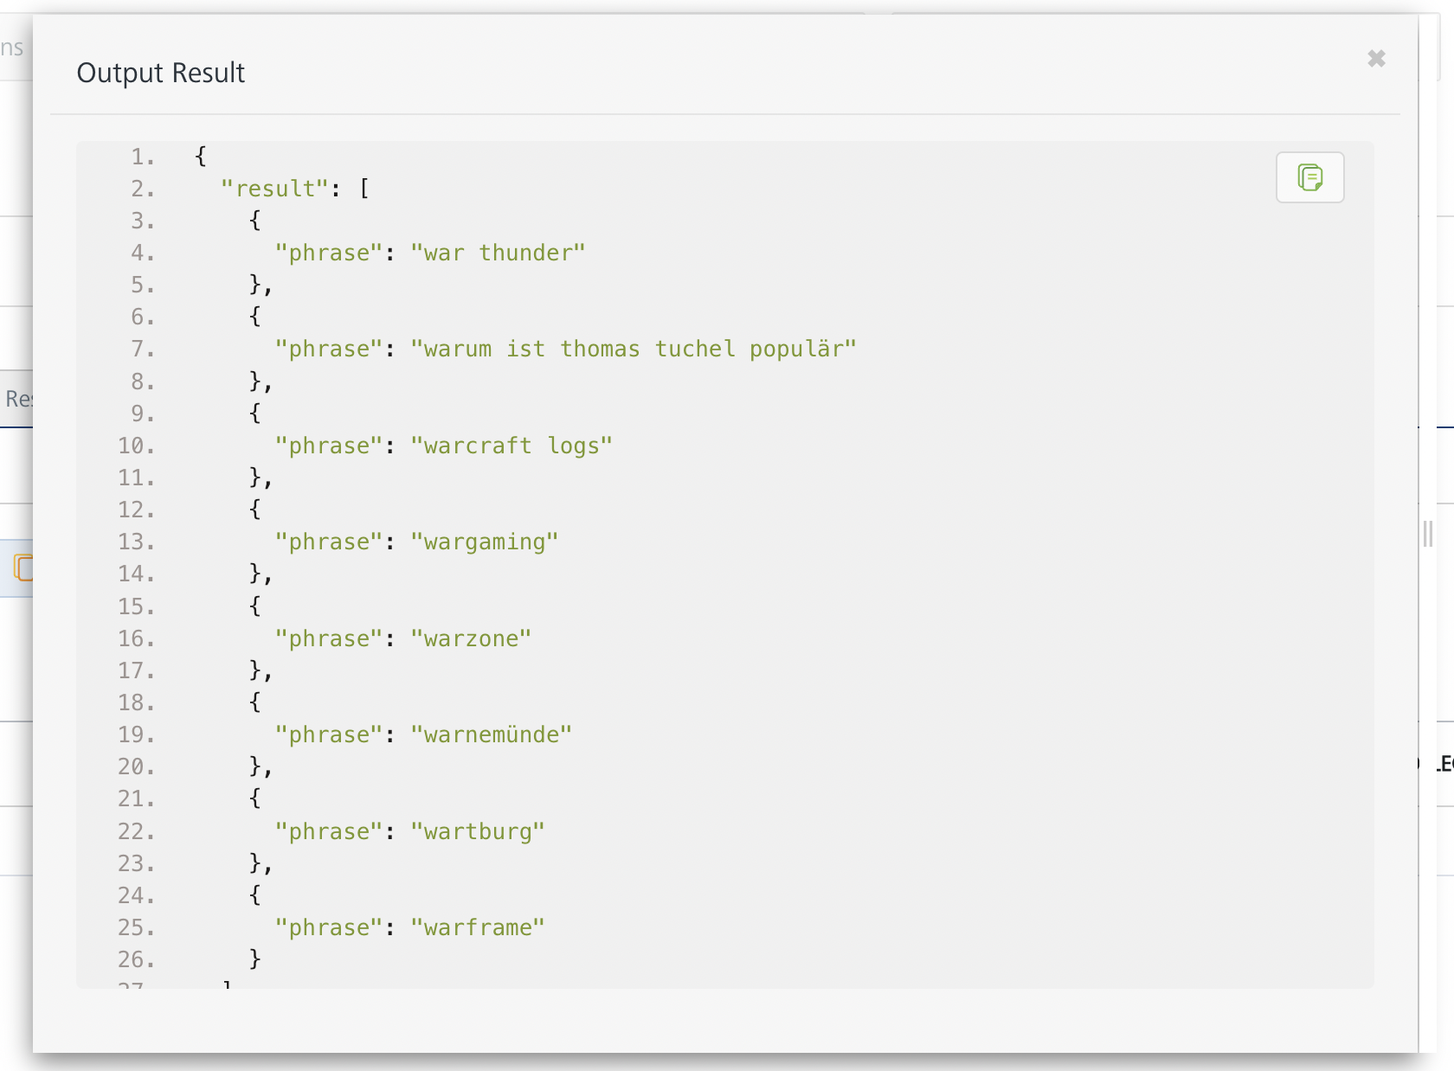

Publishing your application
If you want to use the services in client applications, you need to publish an app to a run-time environment. You can create the service (as described above) in an application or import the service into an application and publish the application.

References

Endpoint Documentation

Requests Input Parameters for getKeywordSuggestions operation
Parameter | Description
X-RapidAPI- Key(string) | [Required] [Header]API Key associated with your account.
X-RapidAPI-Host (string) | [Required] [Header]The host parameter specifies the domain name or IP address of the RapidAPI endpoint. In the context of the Google API, the default host is set to 'google-api31.p.rapidapi.com'. This parameter is necessary for routing the request to the appropriate API endpoint.
text (string) | [Required] keywords for query.

Response Output Parameters for getKeywordSuggestions operation
Field | Description | Type
result | An array containing phrases extracted from the input data. | array
result.phrase | The extracted phrase. | string

Reference Document: Refer this document https://rapidapi.com/rphrp1985/api/google-api31 to know the request input, request header and response output parameters for the other operations.

Revision History
Adapter version 1.0.0:

Known Issues
- No Known Issues

Limitations
- No Limitations

