Date : 28-07-2026

GOOGLE CLOUD VISION AI-EXTRACT INSIGHTS FROM IMAGE
version: 1.0.1

OVERVIEW
Google Cloud’s Vision AI suite of tools combines computer vision with other technologies to understand and analyse image and easily integrate vision detection features within applications, including image labelling, face and landmark detection, optical character recognition (OCR), and tagging of explicit content.

Features:
- Document text detection
- Detect Landmarks
- Detect Logos
- Detect Multiple Objects
- Detect Web entities and pages
- Detect text in images
- Detect faces
- Detect image properties
- Detect Labels
- Detect explicit content (SafeSearch)

Percentage of re-use:
Approximately (80-90)% of reuse.

GETTING STARTED

Prerequisites
Before you start using the Cloud Vision AI App, ensure the following:
- HCL Foundry
- Volt MX Iris
- Download the Google Cloud SDK installer from this link https://dl.google.com/dl/cloudsdk/channels/rapid/GoogleCloudSDKInstaller.exe
- After the installation is complete, restart your terminal or run the following command to initialize the SDK:
gcloud init
- To check if gcloud is installed correctly, run:
gcloud --version
- Authenticate with Google Cloud
gcloud auth login
- To get Print Access token
gcloud auth print-access-token

Importing the Data Adapter

You can import Google Cloud Vision AI Data Adapter into HCL Foundry directly from the VoltMX website or by importing the data adapter zip file.

To import the Data Adapter to Volt Foundry, do the following:
- Sign in to the HCL Foundry.
- From the left navigation menu, select API Management.
- In API Management, select Custom Data Adapters.
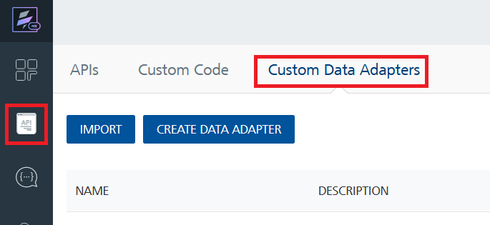
- Click IMPORT to import a custom data adapter.
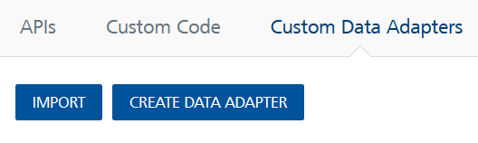
- On the Import Data Adapter dialog box, click browser to import.
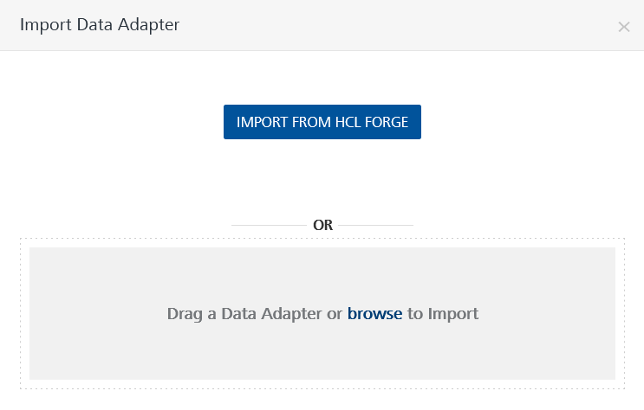
- Select Google Cloud Vision AI zip file and click IMPORT.
After you import the data adapter, VoltMX Foundry opens a window that shows the metadata of the data adapter.
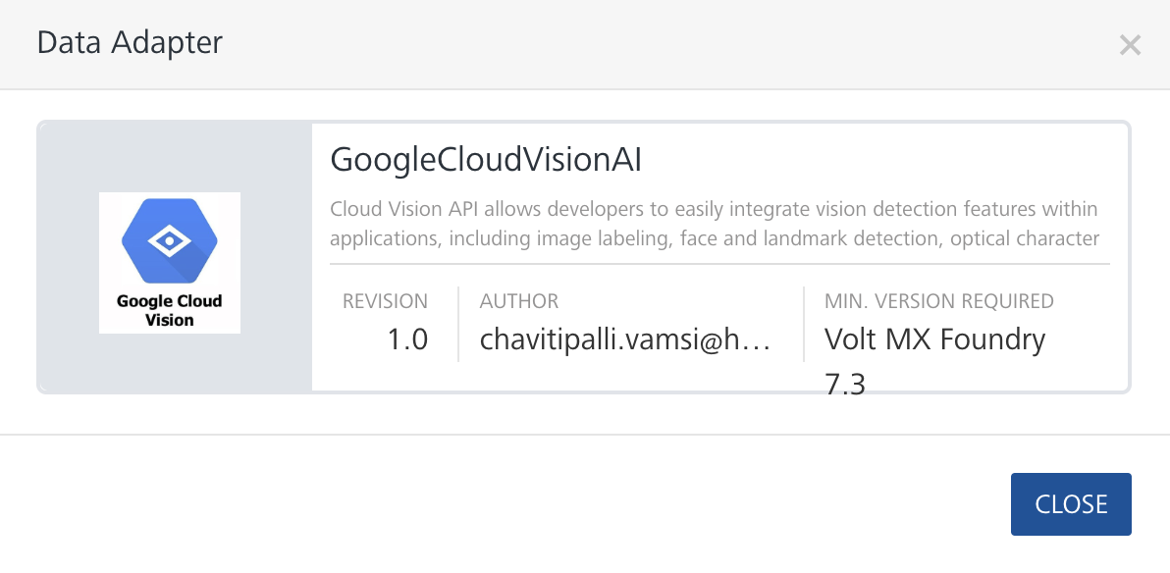
To import the data adapter zip file, do the following:
- Perform steps 1 through 4 in the above procedure
- Drag the data adapter zip file into the Drag a Data Adapter box.
Or
Click browse. The Open dialog appears.
Navigate to the location where you downloaded the data adapter (zip file) on your computer, select the data adapter, and click Open. The Import Data Adapter dialog shows the selected data adapter.

Note: Click Remove if the selected data adapter is not the one that you want to import.
Request Header:
Authorization: Print Access Token : follow the steps from the Prerequisites and get print access token
x-goog-user-project: The project ID can be obtained from the Google Cloud project that was created.
Link: https://console.cloud.google.com/home/dashboard
Select a project:
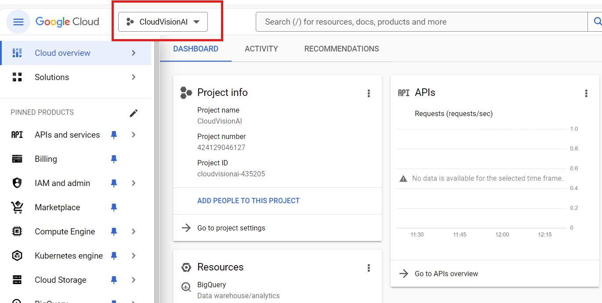

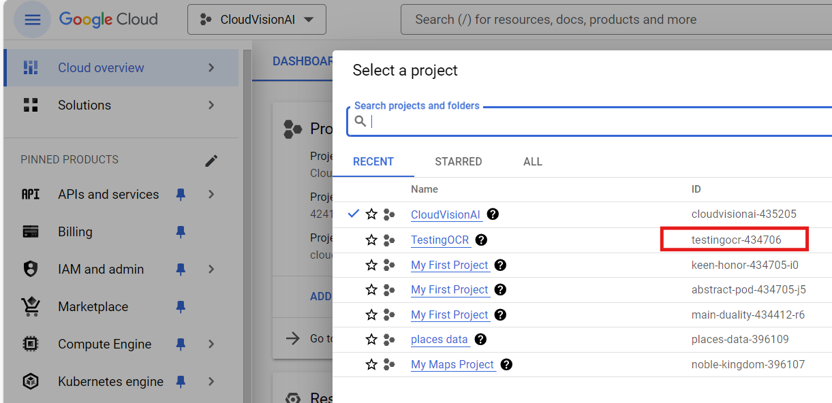

Creating an Integration Service with Google Cloud Vision AI
After you import Google Cloud Vision AI Data Adapter into Foundry, you must create an integration service with service type as Google Cloud Vision AI to connect with your Google Cloud Vision AI developer site.
To create an integration service with Google Cloud Vision AI, do the following:
- Log on to your Foundry. The Dashboard page appears by default.
- In the left panel, click the API Management menu. The APIs tab opens by default.
- Click the Integration tab. The Integration tab opens with a list of existing integration services.
- Click CONFIGURE NEW. The Service Definition tab opens.
- In the Name box, type a unique name for your service.
- From the Service Type list, select Google Cloud Vision AI.
Note: The Google Cloud Vision AI is listed only after you import the Google Cloud Vision AI Data Adapter into Foundry.
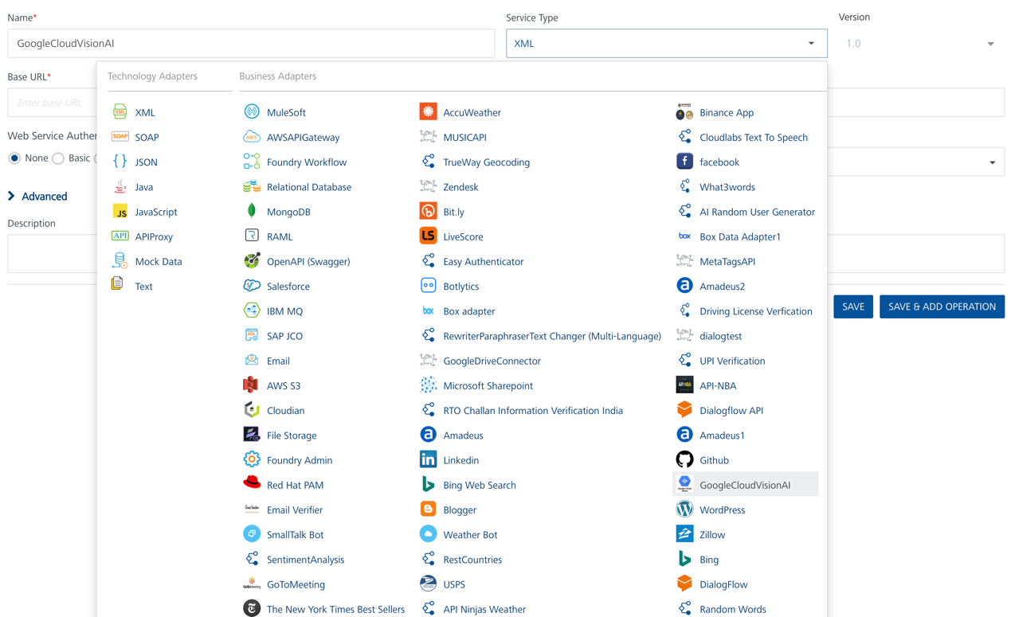
- Click Save.
If the details provided are valid, the Foundry service connects to your Google Cloud Vision AI developer site and allows you to make the API calls.
Refer to Integration Services for more information on creating and using integration services.
- Creating an Operation
To make any API call in the Foundry console, you must create an operation for the respective API and then execute the operation. Executing an operation involves making the API call and displaying the response. For more information, see Executing an Operation.
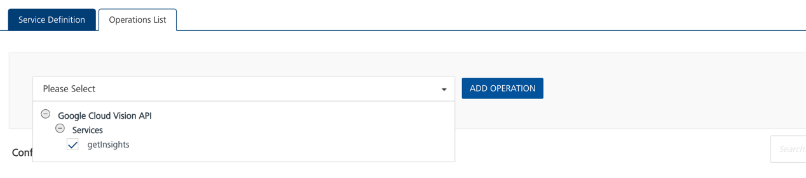

- Executing an Operation

Under the Configured Operations section, click the operation. The Request Input sub-tab opened by default. Provide Body and Headers.
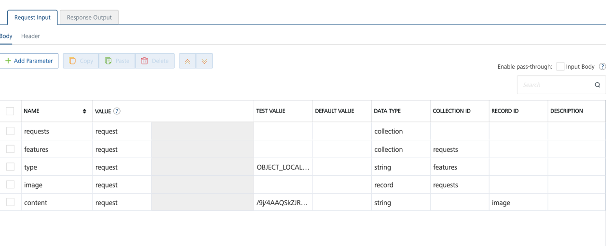
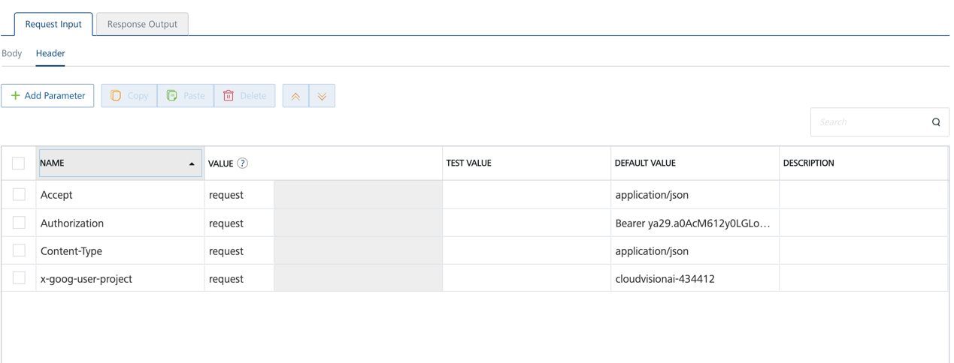

Click SAVE AND FETCH RESPONSE. The Output Result dialog appears with the response. Otherwise, the Output Result shows an error.
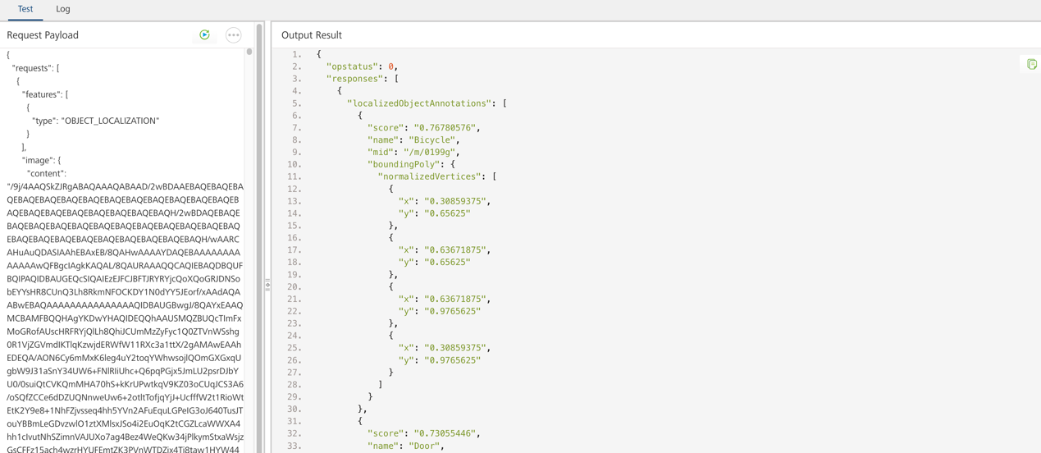

Publishing your application
If you want to use the services in client applications, you need to publish an app to a run-time environment. You can create the service (as described above) in an application or import the service into an application and publish the application.
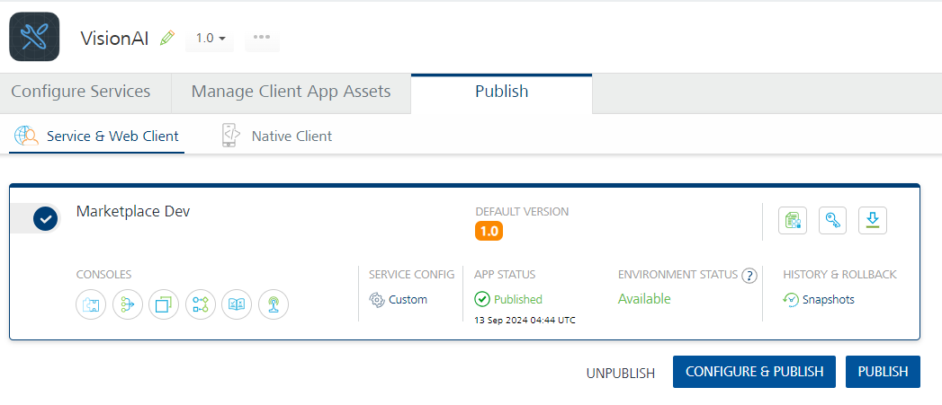

Sample App requirements

Note:
1. While building the app for Android in Debug and Release mode, in order to open the camera and gallery. You need to add CAMERA and WRITE_EXTERNAL_STORAGE permissions in project settings.
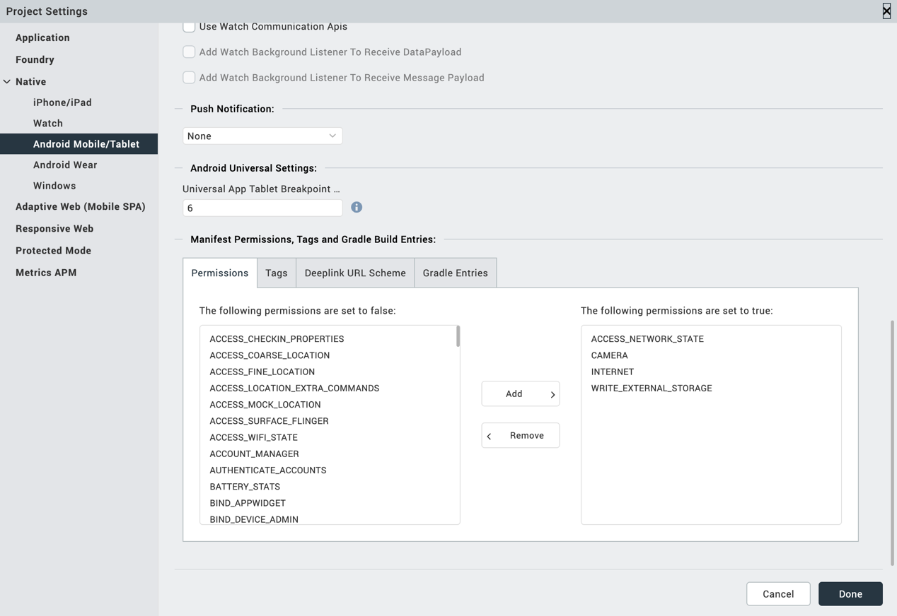

2. Enter the given snippet in Child tag entries under <manifest > tag
For Android below permissions are required in IRIS project setting > Native> Android Mobile/Tablet -> Tags (Child tag entries under tag) depending on the target version.
If target version is 33 and above below media permission must be added.
- <uses-permission android:name="android.permission.READ_MEDIA_IMAGES"/>
If target version is 34 and above below permission must be added along with other media permissions.
- <uses-permission android:name="android.permission.READ_MEDIA_VISUAL_USER_SELECTED"/>

Configuring Native Settings (iOS)
Follow the given steps to enable the permissions.
1. From the Project explorer, navigate to the Assets tab.
2. Right click Media and select Resource Location to open the project resources folder.
3. In the browser window that opens, navigate to the common folder.
4. Open the infoplist_configuration.json file with a text or code editor.
5. Add the given code at the end of the file. You can replace the values with your own descriptions.
{
"NSCameraUsageDescription" : " This app uses Camera ",

"NSPhotoLibraryUsageDescription" : "This app uses photo library"
}

6. Save the file.

References
A. Endpoint Documentation
https://cloud.google.com/vision/docs

Revision History
App version 1.0.1:

Known Issues
- No Known Issues

Limitations
- No Limitations

