Date : 01-July-25

GOOGLE GEMINI AI IMAGE GENERATOR

VERSION: 1.0.0

OVERVIEW
Google Gemini AI Image Generator is a powerful tool that creates high-quality, realistic images from text prompts. It uses advanced multimodal AI models to understand and blend visual and linguistic inputs. Gemini supports diverse styles, creativity, and detailed scene generation. It’s designed to be easy to use - just describe your idea in words and it turns it into a visual image.

Use case:
- Content Creation: Generate high-quality visual assets for presentations, marketing materials, and creative projects for professional use.
- Business Applications: Create custom visuals for websites, social media, advertisements, and promotional materials without needing professional photography or design skills.
- Educational and Personal Use: Generate illustrations for presentations, personal projects, or learning materials.
- Interactive Storytelling: The technology supports "interactive stories, or brainstorming visual ideas in conversation".

Features:
- Text to Image: Just type what you want and it creates the picture
- Multiple Styles: Can create realistic photos, paintings, cartoons, or artistic images
- Easy to Use: Understands everyday language - no special commands needed
- Fast Generation: Creates images in seconds

Percentage of re-use:
90% (Data can be customizable and customers need to implement UI by themselves).

GETTING STARTED

Prerequisites
Before you start using the Google Gemini AI Image Generator data adapter, ensure you have the following:

- HCL Foundry
- Volt MX Iris
- Get a Gemini API Key in Google AI Studio
Reference document: https://ai.google.dev/gemini-api/docs/quickstart?lang=rest

Importing the adapter
To import the Google Gemini AI Image Generator Adapter to Volt MX Foundry, do the following:
- Sign in to the HCL Foundry
- In the left pane, click the API Management menu. The APIs tab opens by default.
- In API Management, select Custom Data Adapters.
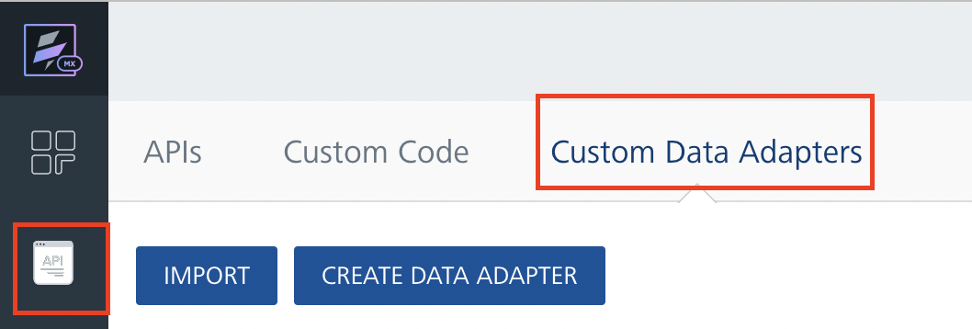
- Click IMPORT to import a custom data adapter.
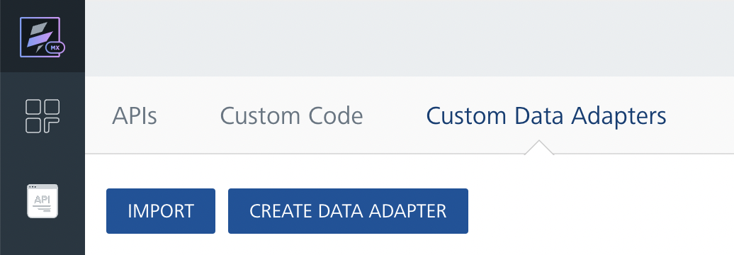
- On the Import Data Adapter dialog box, click browser to import.
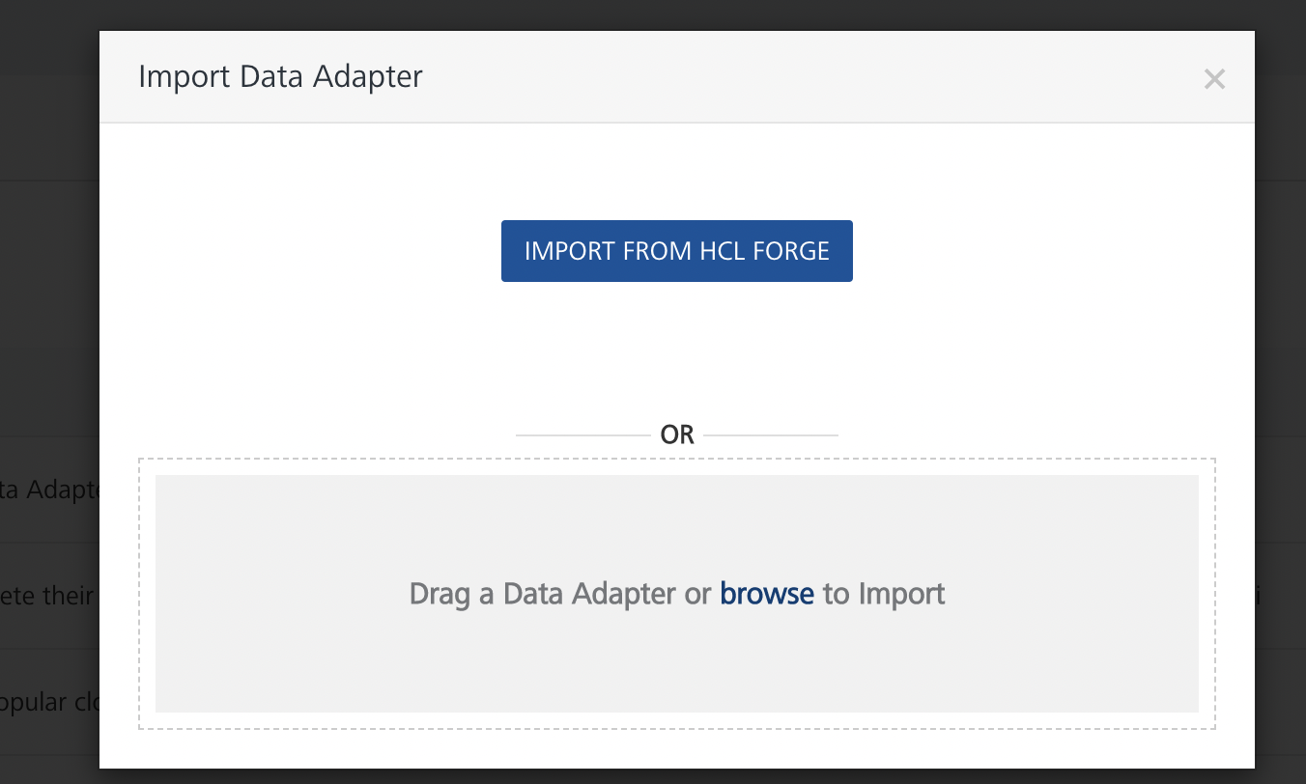
- Drag the data adapter zip file into the Drag a Data Adapter box.
Or
Click browse. The Open dialog appears.
Navigate to the location where you downloaded the data adapter (zip file) on your computer, select the data adapter, and click Open. The Import Data Adapter dialog shows the selected data adapter.
Note: Click Remove if the selected data adapter is not the one that you want to import.
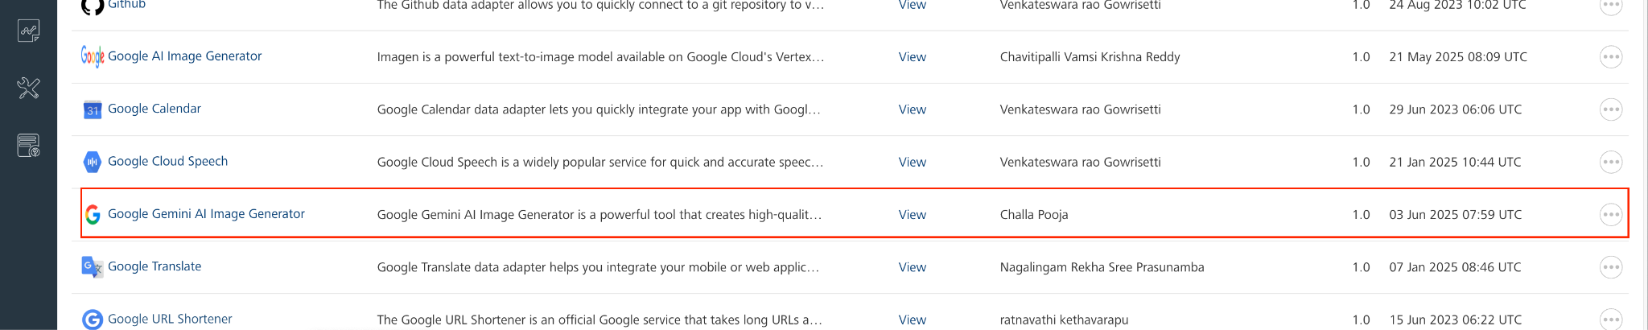
OR
To import the data adapter zip file, do the following:
- Perform steps 1 through 4 in the above procedure
- Click IMPORT FROM HCL FORGE. The Import Data Adapter from HCL Forge dialog appears with a list of available data adapters.
- Click Import. The Google Gemini AI Image Generator data adapter is listed on the Custom Data Adapters page.
After you import the data adapter, you can view it on the Custom Data Adapters page and use it to create services on Volt MX Foundry.
After you add the data adapter to your Volt Foundry app, you need to get your api key from Google AI Studio. You can refer to Google AI Studio.

Creating an Integration Service with Google Gemini AI Image Generator
After you import Google Gemini AI Image Generator API Data Adapter into Volt MX Foundry, you must create an integration service with service type as Google Gemini AI Image Generator.
To create an integration service with Google Gemini AI Image Generator, do the following:
- Log on to your HCL Foundry The Dashboard page appears by default.
- In the left pane, click the API Management menu. The APIs tab opens by default.
- Click the Integration tab. The Integration tab opens with a list of existing integration services.
- Click CONFIGURE NEW. The Service Definition tab opens.
- In the Name box, type a unique name for your service.
- From the Service Type list, select Google Gemini AI Image Generator.
Note: The Google Gemini AI Image Generator API is listed only after you import the Google Gemini AI Image Generator Data Adapter into Volt MX Foundry.
- Under Authentication select Use Existing Identity provider. From the drop-down list select Google Gemini AI Image Generator API.
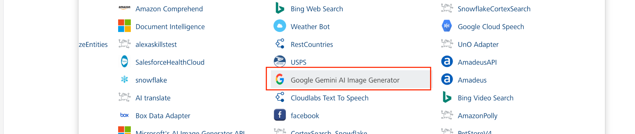
- Click Save.
If the details provided are valid, the Volt MX Foundry service connects to your Google Gemini AI Image Generator API developer site and allows you to make the API calls.
Refer to Integration Services for more information on creating and using integration services.

Creating an Operation
To make any API call in the Volt MX Foundry console, you must create an operation for the respective API and then execute the operation. Executing an operation involves making the API call and displaying the response. For more information, see Executing an Operation.
This section provides steps to create an operation for the GenerateOrEditImage API.
Steps to create an operation for the GenerateOrEditImage API:
- Log on to your HCL Foundry. The Dashboard page appears by default.
- In the left pane, click the API Management menu. The APIs tab opens by default.
- Click the Integration tab. The Integration page appears with a list of existing integration services.
- From the list of integration services, select the integration service that you have created with service type as GenerateOrEditImage. The Service Definition tab of the selected integration service opens by default.
- Click the Operations List tab. The Operations List tab opens.
- Click the context menu arrow to expand the Please Select list. The service is displayed.
- Click the plus icon to expand the list.
- Click the plus icon to expand the Services list and select GenerateOrEditImage.
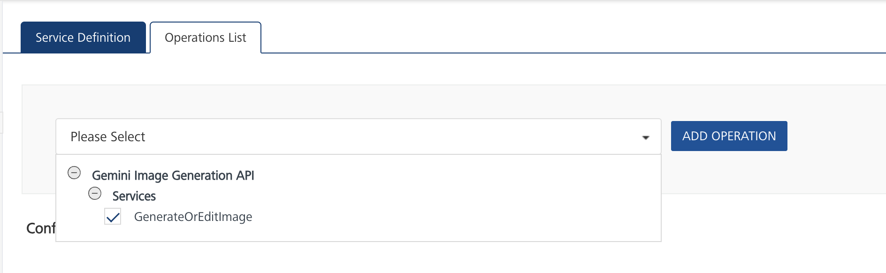
- Click ADD OPERATION. The GenerateOrEditImage operation is listed in the Configured Operations section.
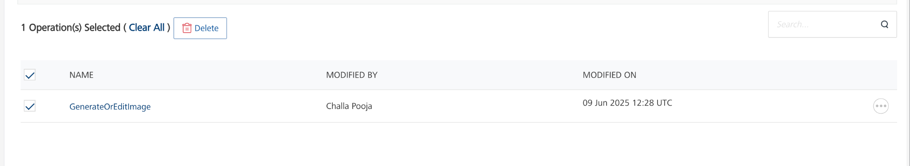
Note: You can follow the same steps to create operations for other methods, but ensure that you select the required API.
You can create multiple operations with required APIs and save them in the Configured Operations section. You can then execute the operations whenever required.

Executing an Operation
Executing an operation involves making the API call by setting the necessary parameters and displaying the response. The procedure to execute any operation is the same, but the request parameters of the APIs vary. For more information on request parameters of API, refer Gemini Image Generation.
This section provides steps to execute the GenerateOrEditImage operation (explained in Creating an Operation).
Steps to execute the GenerateOrEditImage operation:
- Log on to your HCL Foundry. The Dashboard page appears by default.
- In the left pane, click the API Management menu. The APIs tab opens by default.
- Click the Integration tab. The Integration tab opens with a list of existing integration services.
- From the list of integration services, select the integration service that you have created with the service type as GenerateOrEditImage. The Service Definition tab of the selected integration service opens by default.
- Click the Operations List tab.
- Under the Configured Operations section, click the GenerateOrEditImage operation. The GenerateOrEditImage tab opens with the Request Input sub-tab opened by default.
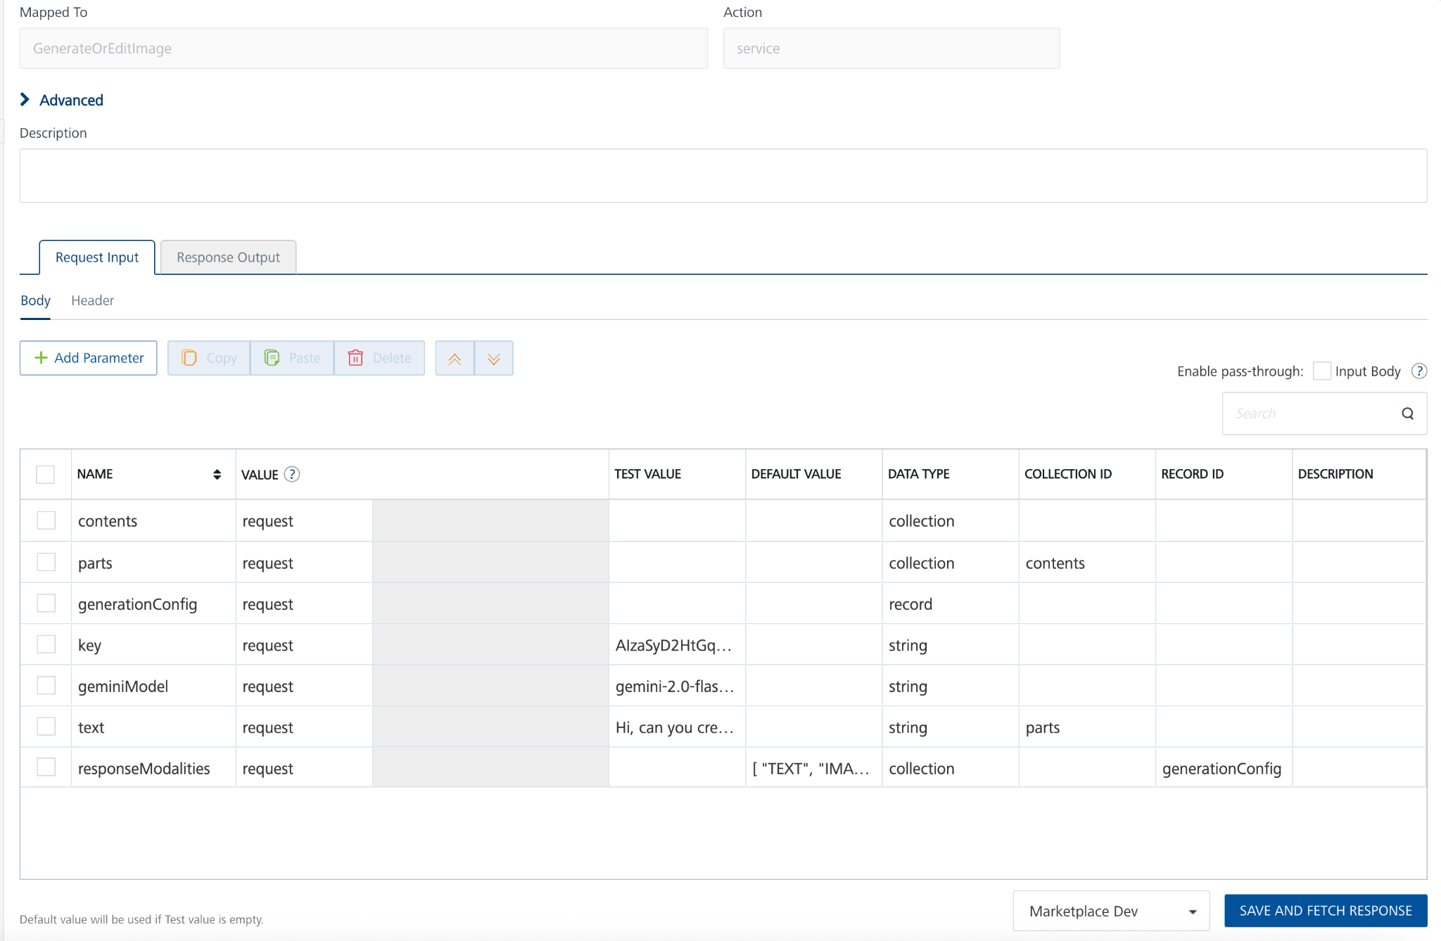
- In the Name box, the name of the operation is displayed by default. If you want, you can change the name.
- On the Request Input tab, in the Body section, for the following parameters, specify the values in the respective boxes under the Test Value column.
Parameters
- Key: To use the Gemini API, you need an API key. You can create a key with a few clicks in Google AI Studio.
- geminiModel: The name of the Model to use for generating the completion. The Gemini API offers different models that are optimized for specific use cases. Refer this https://ai.google.dev/gemini-api/docs/models/gemini#model-variations
Example model I have used here is gemini-2.0-flash-preview-image-generation
- text: Represents the input prompt that the Gemini model will process to generate a response.
- generationConfig: Configuration options for model generation and outputs. Not all parameters are configurable for every model.
  - responseModalities[]enum (Modality): Optional. The requested modalities of the response. Represents the set of modalities that the model can return, and should be expected in the response. This is an exact match to the modalities of the response. A model may have multiple combinations of supported modalities. If the requested modalities do not match any of the supported combinations, an error will be returned. An empty list is equivalent to requesting only text.
For more information refer to this https://ai.google.dev/api/generate-content
- Click SAVE OPERATION.
- Click SAVE AND FETCH RESPONSE. The Output Result dialog appears with the response. Otherwise, the Output Result shows an error.
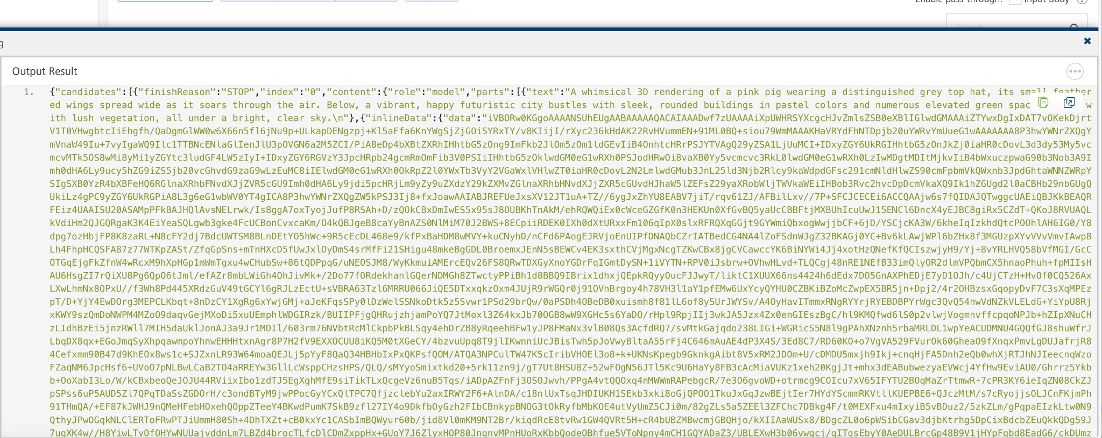

Publishing the App to Volt MX Foundry
After adding Google Gemini AI Image Generator to your app and configuring the necessary configurations, you must publish the app to Volt MX Foundry. For more information, refer to Publish a Project to Volt MX Foundry.
If you want to use the services in client applications, you need to publish the app to a run-time environment.
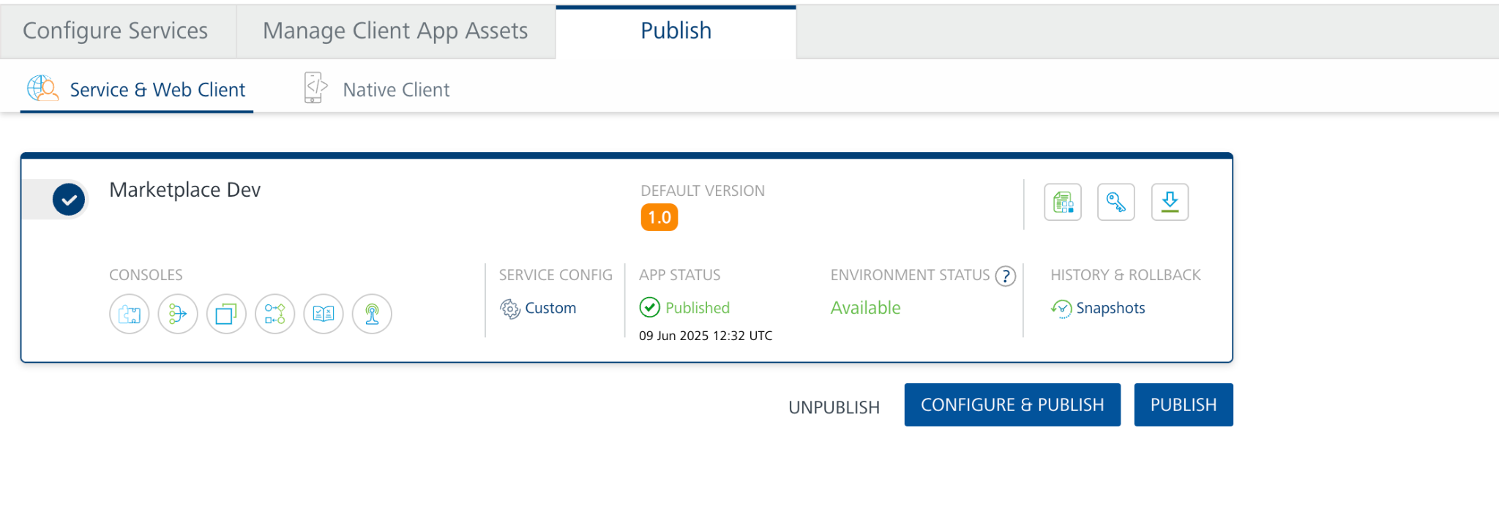
You can also link the Volt Foundry app to a client application.

Reference Document: https://ai.google.dev/gemini-api/docs/image-generation#rest

REVISION HISTORY
App version 1.0.0:

Known Issues
None

Limitations
None

