Date : 04-September-25

GOOGLE GEMINI AI THINKING

VERSION: 1.0.0

OVERVIEW
Google Gemini AI Thinking Backend Service is part of the Gemini family of advanced multimodal AI models that excel at reasoning, multi-step planning, and complex problem solving. It enables sophisticated cognitive workflows by simulating an internal "thinking process," allowing users to perform advanced tasks such as coding, mathematical problem solving, data analysis, and decision-making support.
This system enhances productivity by breaking down complex tasks into logical steps, reasoning about intermediate results, and providing detailed explanations or solutions.

Use case:
- Complex Coding Assistance: Generate structured code with advanced logic, handle debugging tasks, and suggest optimized algorithms.
- Advanced Mathematics: Solve multi-step math problems, algebra, calculus, and statistical analysis with detailed reasoning steps.
- Data Analysis & Interpretation: Analyze datasets, generate insights, and provide data-driven recommendations with clear step-by-step explanations.
- Strategic Planning & Decision Support: Help in decision-making by evaluating scenarios, calculating outcomes, and offering reasoned suggestions.
- Interactive Question Answering: Answer complex questions with multi-step reasoning rather than simple factual retrieval.

Features:
- Internal Thinking Process: Simulates structured reasoning by decomposing problems into smaller steps and analyzing intermediate results.
- Multi-step Planning: Capable of planning sequences of actions or reasoning steps required to solve advanced tasks.
- Flexible Output Formats: Produces structured JSON outputs, natural language explanations, or formatted code, depending on the need.
- Context Awareness: Understands context from prior interactions and applies it intelligently in reasoning.
- Error Detection & Self-correction: Identifies inconsistencies in logic or calculations and proposes corrections in real-time.
- Multimodal Fusion (optional): Can combine text and image inputs to reason about tasks that involve visual data alongside text-based logic.

GETTING STARTED

Prerequisites
Before you start using the Google Gemini AI Thinking Backend App, ensure you have the following:

- HCL Foundry
- Volt MX Iris
- Get a Gemini API Key from Google AI studio.
Reference document: https://ai.google.dev/gemini-api/docs/thinking
  - Importing the Google Gemini AI Thinking Backend App
- Log on to your HCL Foundry The Dashboard page appears by default.
- In the left pane, click Apps menu. The Custom Apps page appears.
- Click IMPORT. The Import App dialog appears.
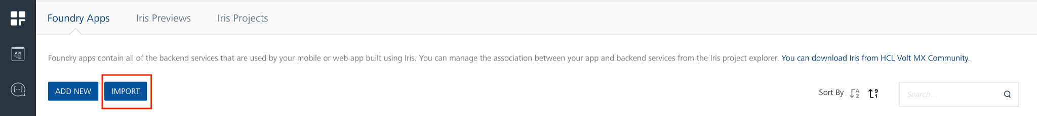
- Click Browse.
- Select the GoogleGeminiAIThinking zip file located in your system and click Open.
- In the Import App dialog, click IMPORT.

- Imported App will be shown in Foundry Apps.
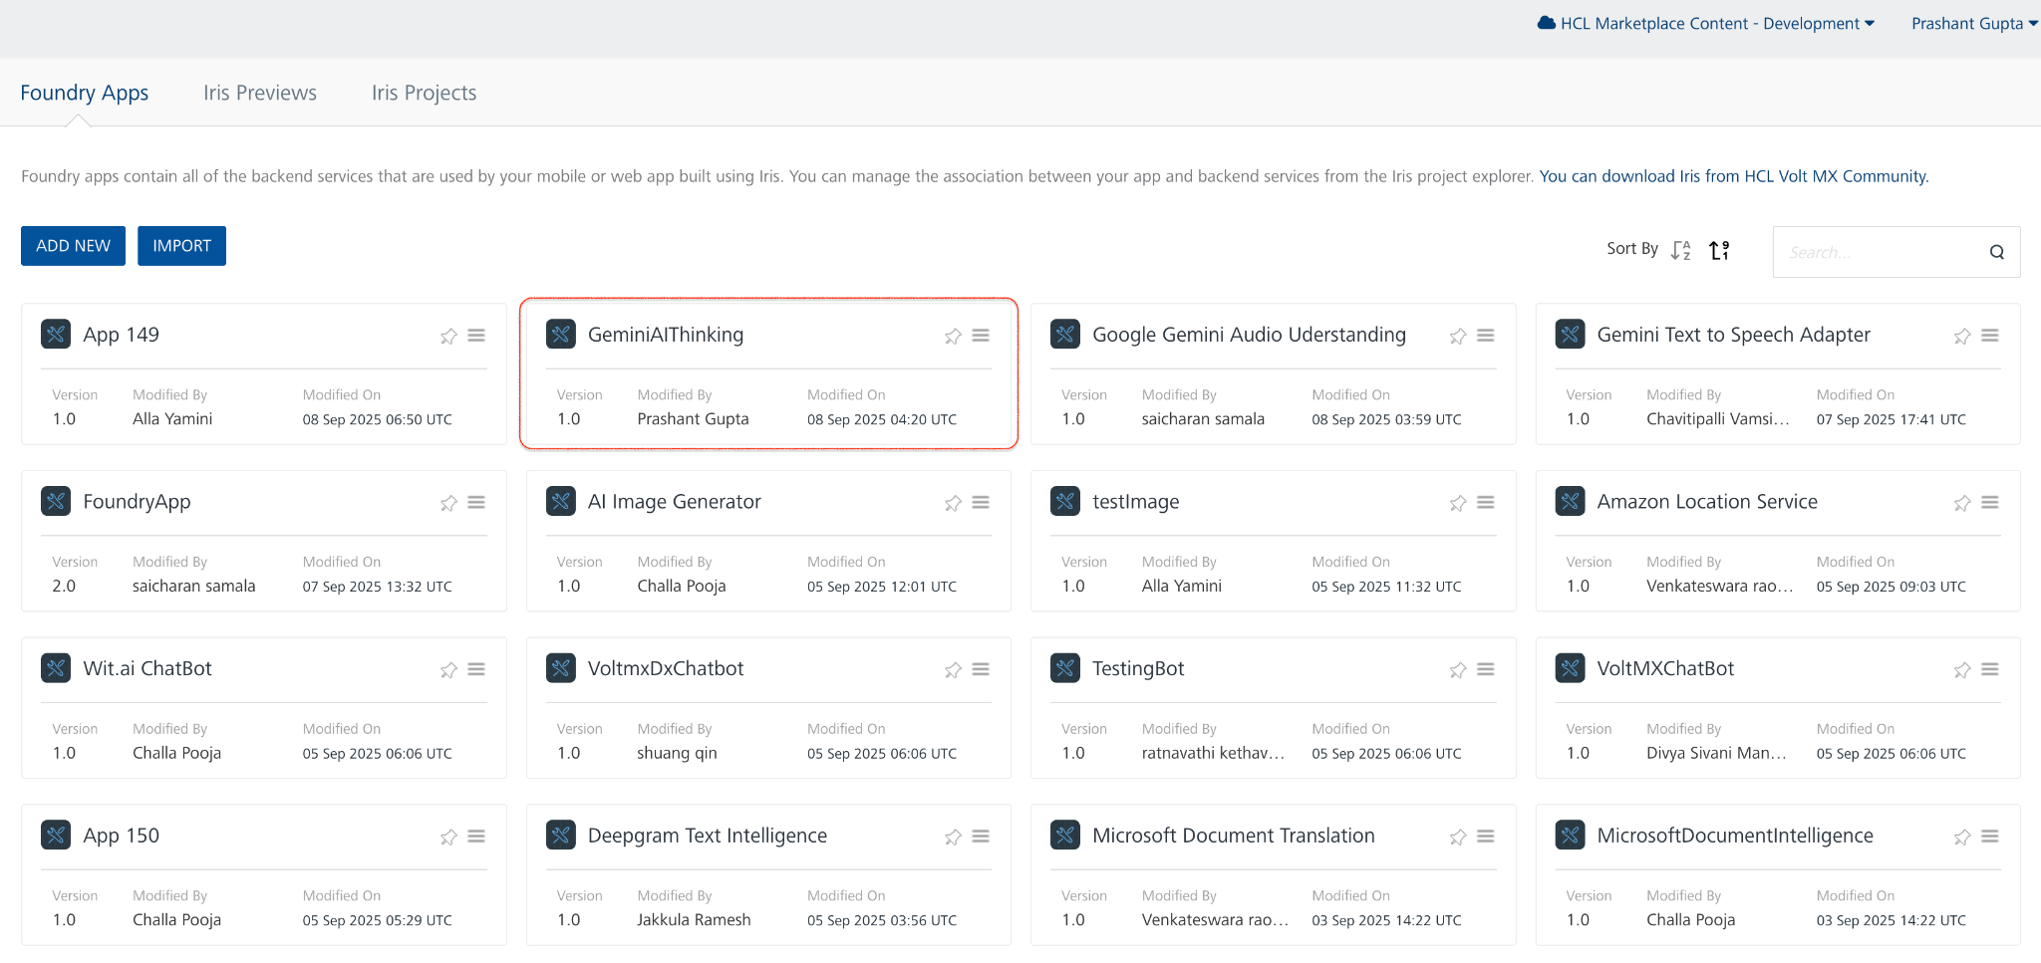

To associate your app with the GeminiAIThinking App, do the following:
- In Voltmx iris, go to Data & services.
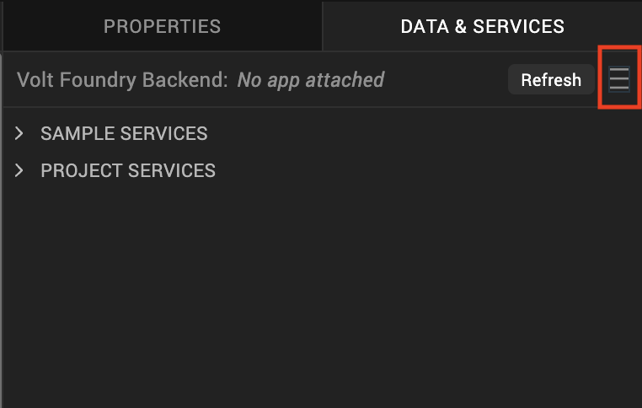
- Click the hamburger menu and select Link To Existing App.
- The Volt Foundry Applications dialog appears with a list of existing apps.
- Find the app, and click the Associate button against the app.

Integration Services
The Google Gemini AI Thinking Volt MX Foundry app includes a default integration service that connects your app to the Google Gemini AI Thinking APIs.
To view the Google Gemini AI Thinking integration services, do the following:
- Log on to your HCL Foundry. The Dashboard page appears by default.
- In the left pane, click the Apps menu. The Custom Apps page appears.
- Find and click the Google Gemini AI Thinking app. The Google Gemini AI Thinking page appears along with the Configure Services tab and the Identity sub-tab opened by default.
- Click the Integration sub-tab. The Integration tab displays a list of integration services.
- Click on the required integration service. The Service Definition tab of the selected integration service opens by default.

Executing an Operation
Executing an operation involves making the API call by setting the necessary parameters and displaying the response. The procedure to execute any operation is the same, but the request parameters of the APIs vary.
Steps to execute the GeminiAIThinking operation:
6. Click the Operations List tab and select GeminiAIThinking Operation.
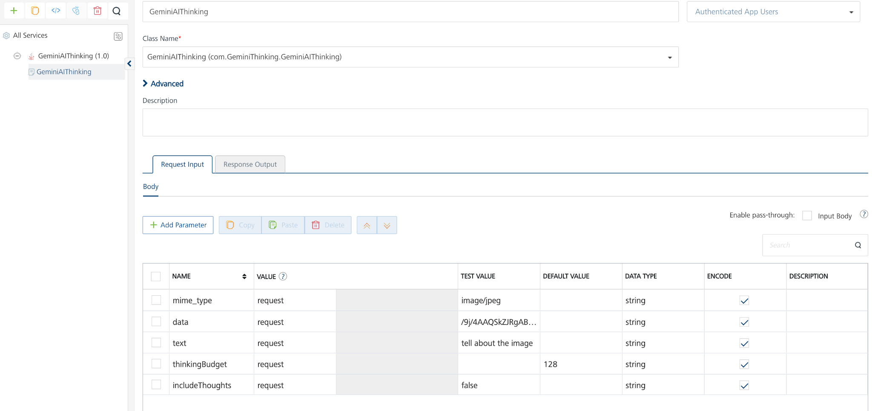

7. On the Request Input tab, in the Body section, for the following parameters, specify the values in the respective boxes under the Test Value column.
Mandatory Parameters
- apikey - apikey generated from google gemini studio.
- thinkingbudget - range 128 - 32768 or turn on dynamic thinking by value -1.
- text - The prompt or question you want to ask (e.g., Caption this image).
8. Select Advanced, then click Custom Code Invocation in the Preprocessor select
JavaScript.
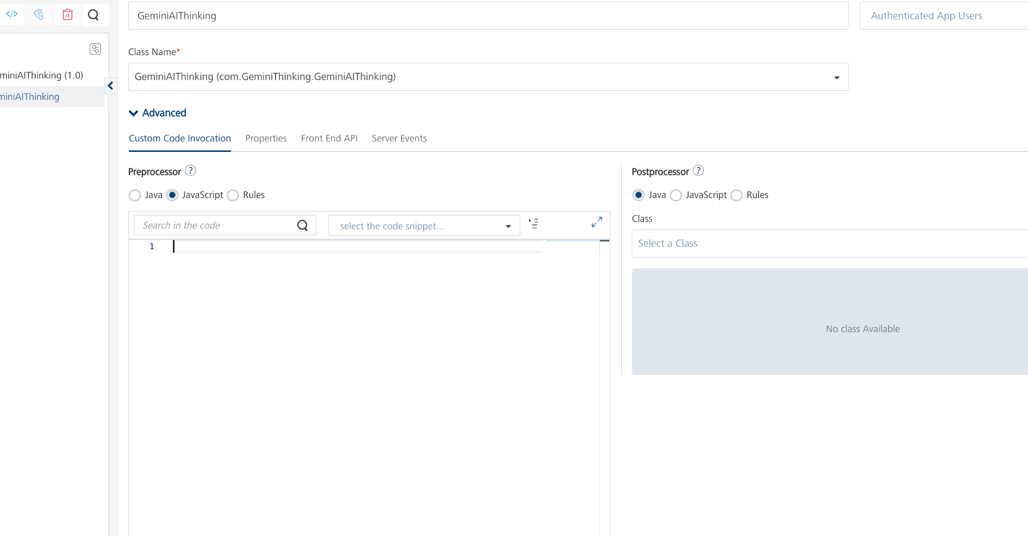

9. Select the code snippet drop-down and choose Add Request Parameter. Replace eventId with apikey and replace QueMessage with your API key value, i.e.:
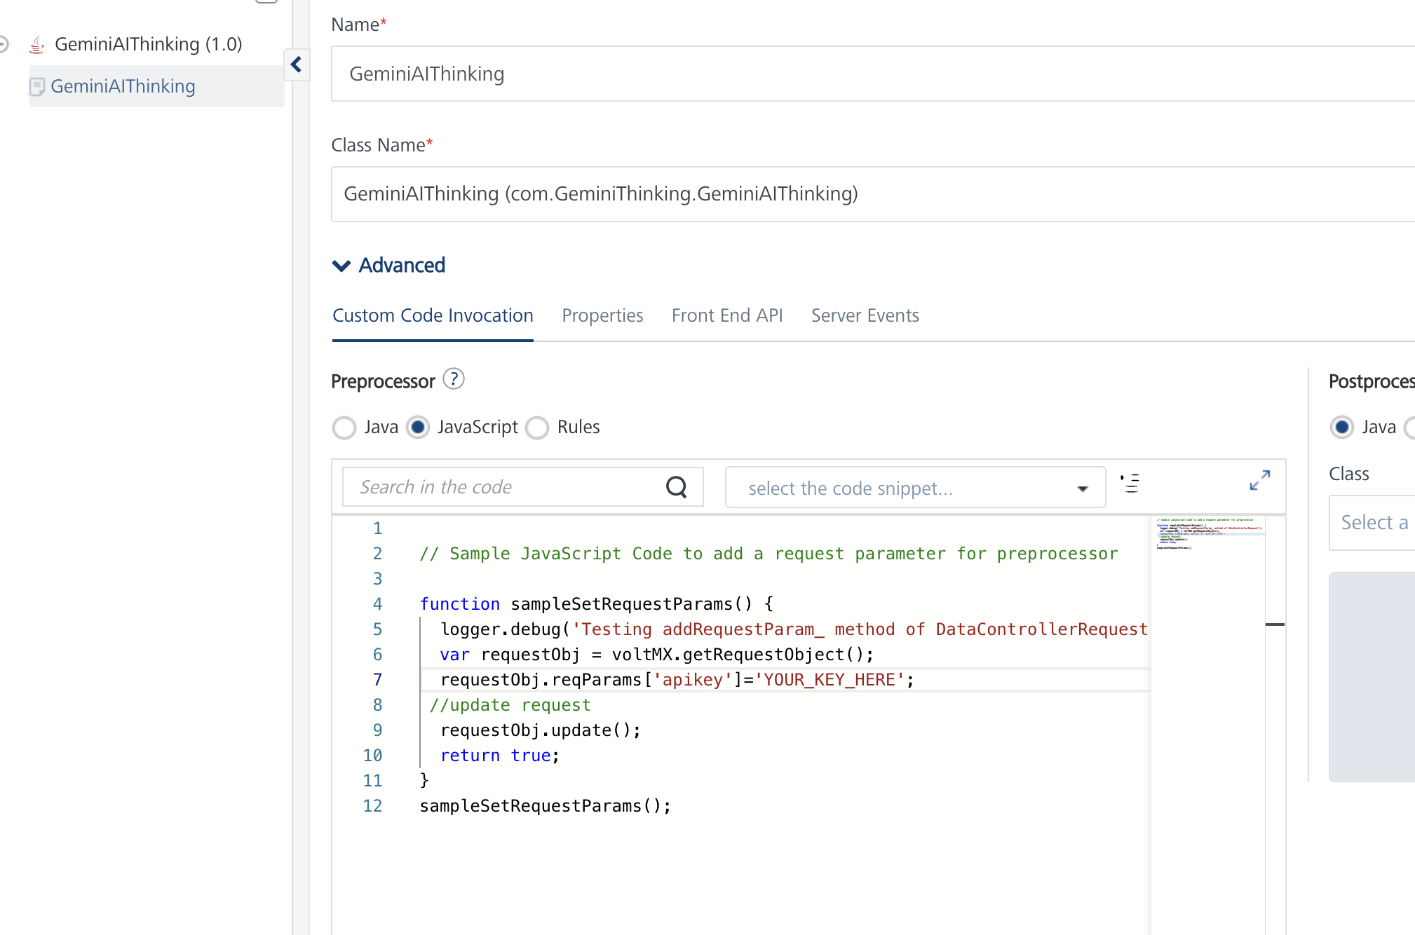
10. Click SAVE OPERATION.
Click SAVE AND FETCH RESPONSE. The Output Result dialog appears with the response. Otherwise, the Output Result shows an error.
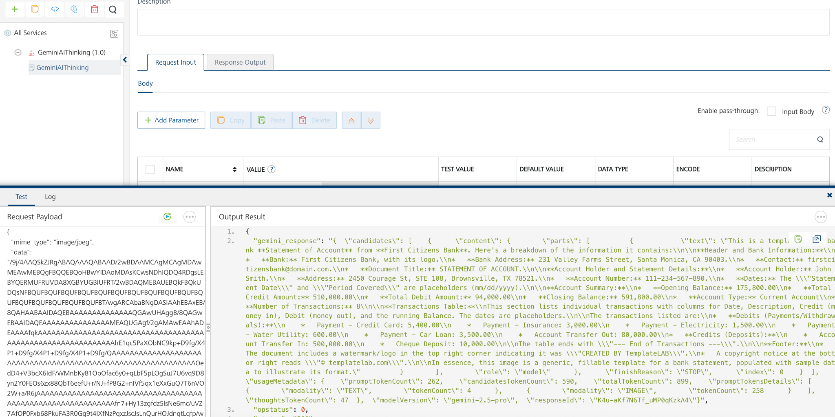

Publishing the App to Volt MX Foundry
After adding Google Gemini AI Thinking to your app and configuring the necessary configurations, you must publish the app to Volt MX Foundry. For more information, refer to Publish a Project to Volt MX Foundry.
If you want to use the services in client applications, you need to publish the app to a run-time environment. 
Reference Document:
https://ai.google.dev/gemini-api/docs/thinking

REVISION HISTORY
App version 1.0.0:

Known Issues
None

Limitations
None

