Date: 29-Oct-2025

GOOGLE GEMINI IMAGE UNDERSTANDING COMPONENT

VERSION: 1.0.0

OVERVIEW

Google Gemini Image Understanding Component enables seamless interaction with Google’s Gemini multimodal AI models for intelligent image analysis. This component allows you to upload image files (JPG, PNG, etc.) along with a text prompt, and receive AI-generated responses derived from both the visual and textual elements present in the image.
Google Gemini Image Understanding is a capability of Google’s Gemini multimodal AI models that allows them to see, interpret, and analyze images in their entirety — not just detecting objects or text, but understanding layout, composition, visual context, and relationships between elements to derive deeper meaning and insights.

Use case:
- Education + Learning
Schools and e-learning platforms can transform images from textbooks, lecture slides, and infographics into interactive study materials. Gemini can interpret diagrams, charts, and labeled images to generate explanations, quizzes, or summaries that enhance visual learning.
- Business Intelligence + Reporting
Organizations can analyze dashboards, charts, and infographics from business reports or presentations. Gemini can extract key metrics, detect performance trends, and summarize insights from visual data representations like graphs or KPI widgets.
- Research + Analysis
Researchers can upload scientific figures, experiment images, or charts to get detailed interpretations, summaries, and comparisons. Gemini understands captions, plots, and annotations, helping accelerate literature and data review.
- Healthcare + Medical Imaging
Medical professionals can analyze diagnostic images, lab charts, and medical diagrams to extract relevant information or summaries. Gemini can identify patterns, interpret labeled medical visuals, and assist in creating structured reports.
- Legal + Compliance
Law firms can process scanned legal documents, annotated contracts, or image-based forms. Gemini can read embedded text, detect signatures, stamps, or clauses from image files, ensuring both visual and textual comprehension for compliance review.

Percentage of re-use:
Approximate 85% of reuse.

Features

- Full-Context Visual Analysis
Understands entire images holistically — including layout, composition, and spatial relationships — to derive context-aware insights beyond basic object or text detection.
- Multi-Modal Intelligence
Processes both visual and textual elements such as charts, diagrams, graphs, infographics, and handwritten content, enabling deeper semantic interpretation.
- Structured Output Generation
Delivers results in JSON, plain text, or tabular formats, suitable for integration into analytics, automation, or reporting systems.
- Flexible Input Methods
Supports image uploads (JPG, PNG) or Base64-encoded image data for inline or API-based processing, ensuring compatibility across web and mobile applications.
- Technical Capabilities
- Maximum file size: up to 20 MB per image
- Supported formats: JPG, JPEG, PNG

GETTING STARTED

Prerequisites
Before you start using the Google Gemini Image Understanding component, ensure the following
- Volt MX Iris
- HCL VoltMX Foundry
- To use the Gemini API, you need an API key. You can create a key with a few clicks in Google AI Studio.Get a Gemini API key in Google AI Studio
- Image Requirements
- Supported formats: JPG, JPEG, PNG
- Maximum file size: 20 MB per image (for inline Base64 uploads)
- Image quality: Use clear, high-resolution images — avoid blurry, cropped, or low-contrast visuals.
- Orientation: Ensure images are upright for accurate interpretation.
- Content: Images may include charts, diagrams, handwritten notes, or scanned pages for best multimodal analysis.

Reference document:
​​https://ai.google.dev/gemini-api/docs/image-understanding

Platforms Supported
- Mobile
- iOS
- Android

Importing the component
You can import the Forge components only into the apps that are of the Reference Architecture type.

To import the Google Gemini Image Understanding component, do the following:
- Open your app project in Volt MX Iris.
- In the Project Explorer, click the Templates tab.
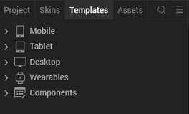
- Right-click Components, and then select Import Component. The Import Component dialog box appears.
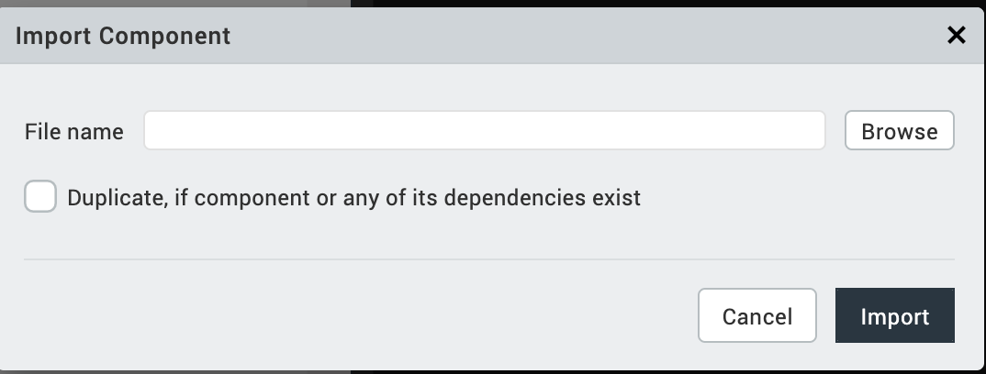
- Click Browse to navigate to the location of the component, select the component, and then click Import. The component and its associated widgets and modules are added to your project.

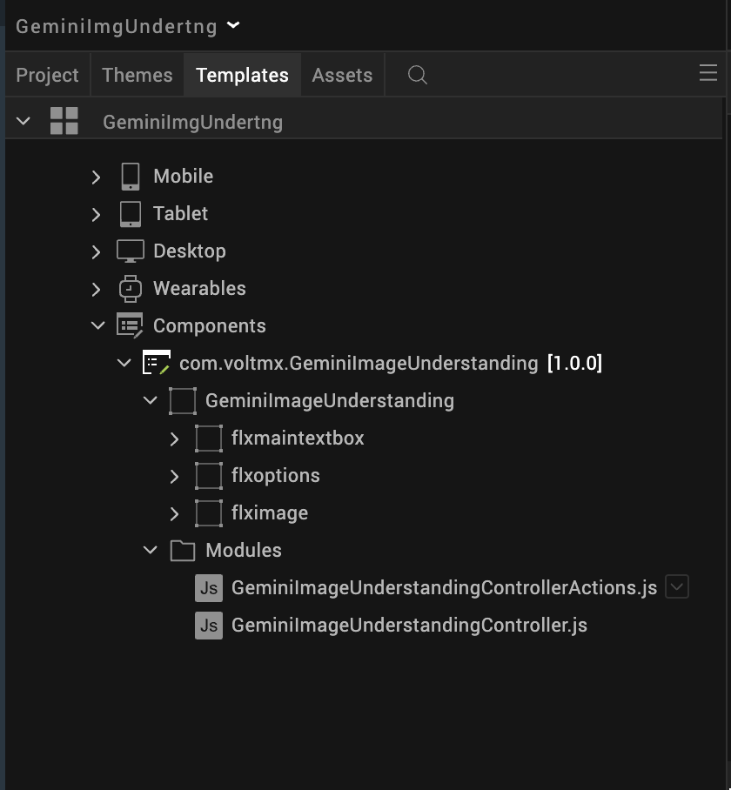

Once you have imported a component to your project, you can easily add the component to a form. For more information, refer Add a Component to a Form

- Foundry APP Setup
When you import the component to your Volt MX Iris project, the HCL Volt MX Foundry services of the GoogleGeminiImageUnderstanding are added to the HCL Volt MX Foundry app, which is associated with the Volt MX Iris project. While importing the Google Gemini Image Understanding Component to your Volt MX Iris project, if there is no HCL Volt MX Foundry app associated with the existing Volt MX Iris project, a new HCL Volt MX Foundry app is automatically added to your HCL Volt MX Foundry environment and is associated with your Volt MX Iris.
To set the Foundry app, follow these steps:
- Click the HCL Volt MX Foundry app associated with your Volt MX Iris project from the Project Explorer. Click DATA & SERVICES.
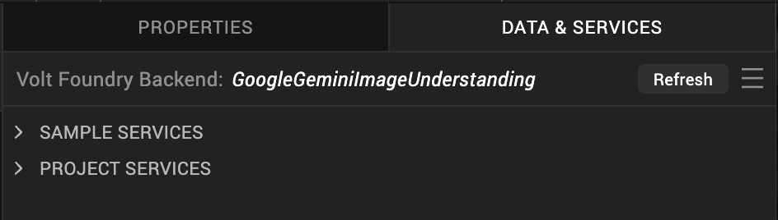
- Under the Configure Services tab, click Integration and can see the GeminiImageUnderstanding Integration service. Click on that Integration service to add the keys.
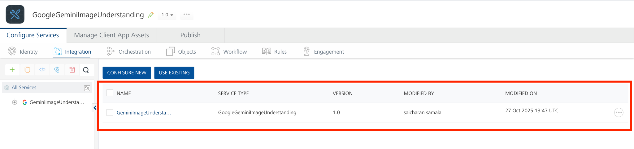
- Click the Operations List tab. The Operations List tab opens with the list of operations available.
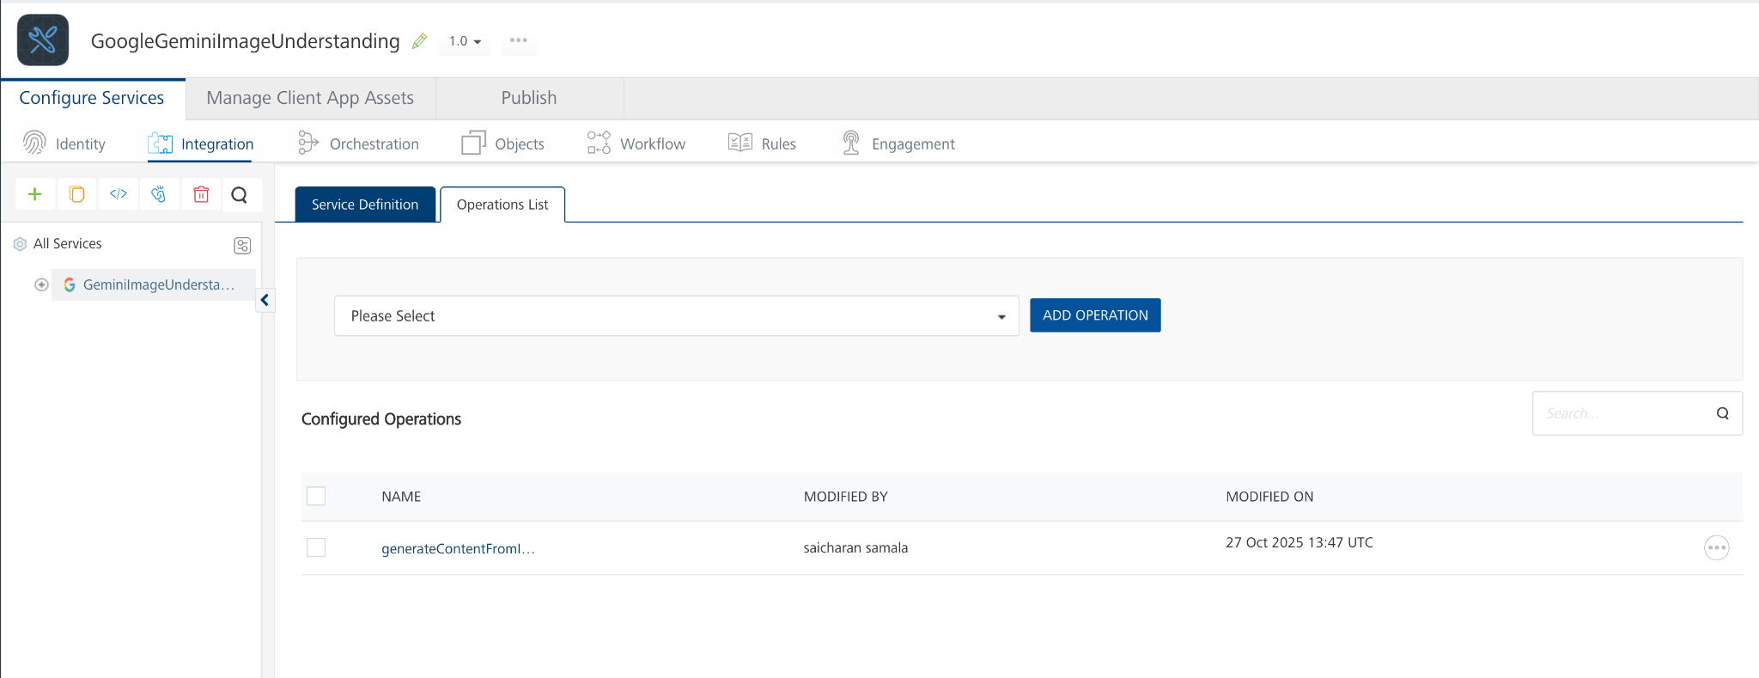
- Executing an Operation
Executing an operation involves making the API call by setting the necessary parameters and displaying the response. The procedure to execute any operation is the same, but the request parameters of the APIs vary. For more information on request parameters of API, refer Passing Inline Image Data (Base64).
This section provides steps to execute the generateContentFromImage operation.
A) Under the Configured Operations section, click the generateContentFromImage operation. The generateContentFromImage tab opens with the Request Input sub-tab opened by default.
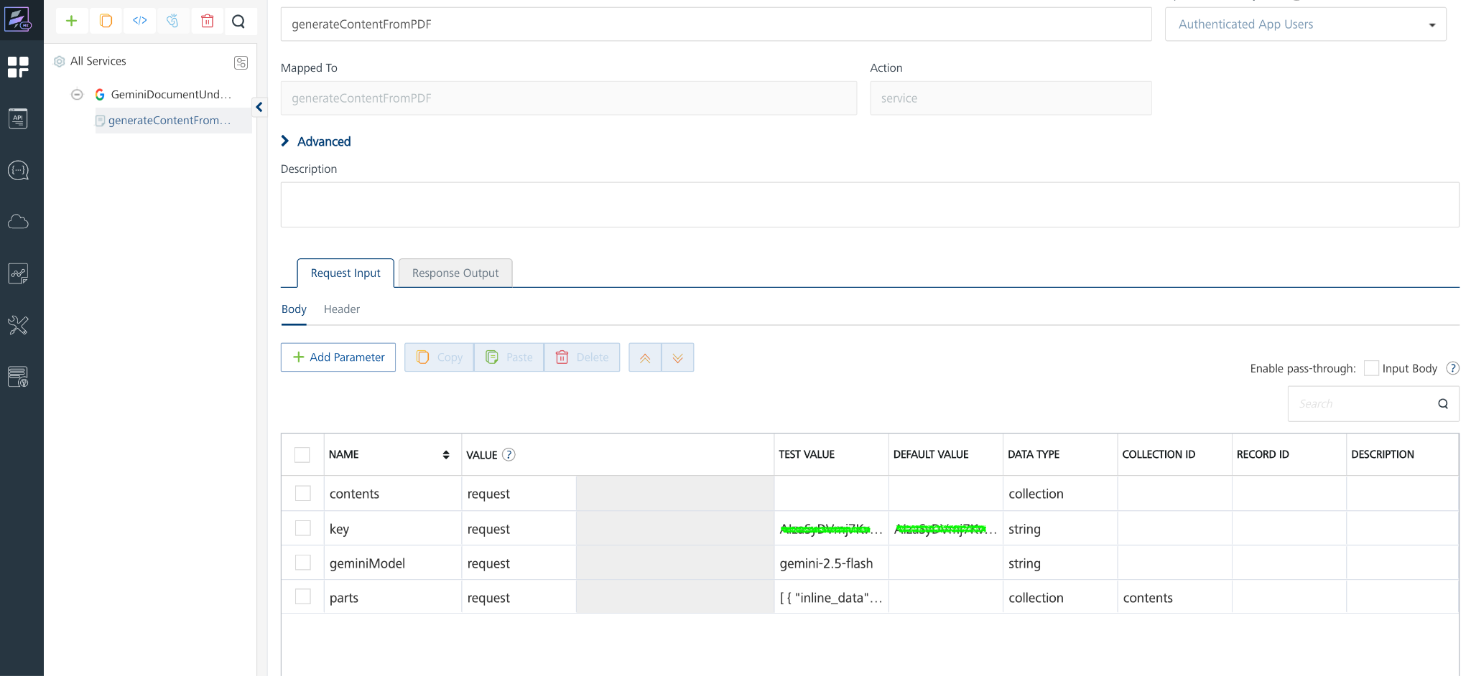

B) On the Request Input tab, in the Body section, for the following parameters, specify the values in the respective boxes under the Test Value column.
Mandatory Parameters
- key: To use the Gemini API, you need an API key. You can create a key with a few clicks in Google AI Studio. In the box under the TEST VALUE and DEFAULT VALUE columns, type the API Key generated
- geminiModel: The name of the Model to use for generating the completion. The Gemini API offers different models that are optimized for specific use cases. For Example : gemini-2.5-flash
- parts: The parts parameter specifies the input data passed to the Gemini API for processing. Each part represents either image content (inline data) or prompt/questions (text prompt).
- inline_data – Used to send the actual Image for Gemini to process. Image File Size should be less than 20MB
  - mime_type: The image type (e.g.,image/jpeg).
  - data: The Base64-encoded Image content.
- text – Used to provide questions, or prompts related to the Image.
We need to pass the parts value in request body like this

[
{
"inline_data": {
"mime_type": "image/jpeg",
"data": "base64 encoded image "
}
},
{
"text": "Caption this image."
}
]

C) Click SAVE OPERATION.
D) Click SAVE AND FETCH RESPONSE. The Output Result dialog appears with the response. Otherwise, the Output Result shows an error.
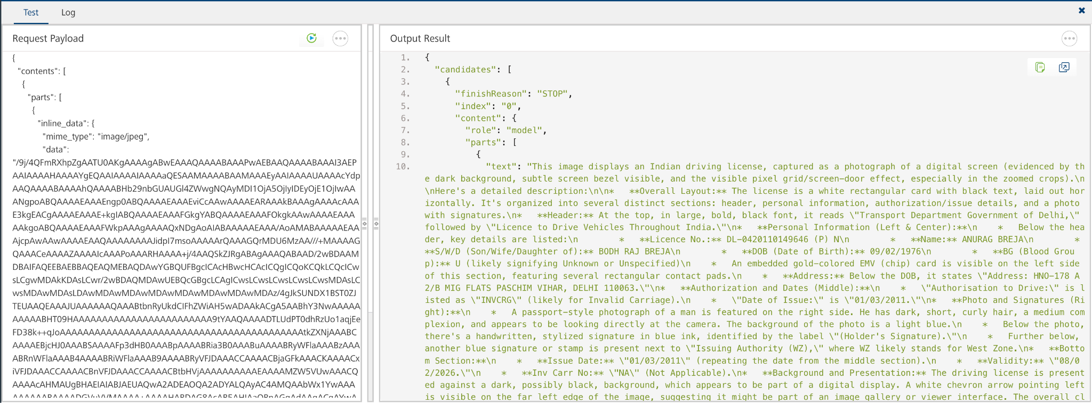
- Publishing the APP to VoltMX Foundry
After adding Google Gemini Image Understanding to your app and configuring the necessary configurations, you must publish the app to Volt MX Foundry. For more information, refer to Publish a Project to Volt MX Foundry.
If you want to use the services in client applications, you need to publish the app to a run-time environment.
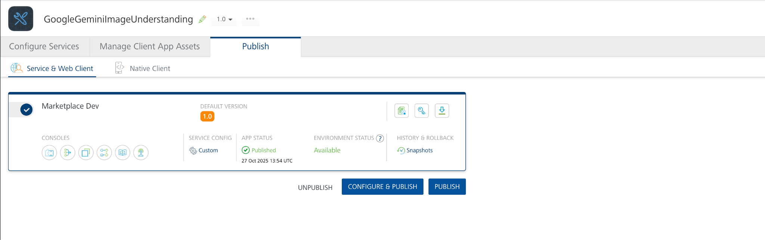

Building and previewing the app
After performing all the above steps, you can build your app and run it on your device. For more information, you can refer to the Building and Viewing an Application section of the Volt MX User Guide.
You can then run your app to see Google Gemini Image Understanding work in real time.

REFERENCES

Dynamic Usage
You can also add a Google Gemini Image Understanding Component dynamically. To do so,
1. In the Project Explorer, on the Projects tab, click Controllers section to access the respective Form Controller. Create a method and implement the code snippet similar to the sample code mentioned below.

createComponent: function() {
var GeminiImageUnderstanding = new com.voltmx.GeminiImageUnderstanding({
"height": "20%",
"id": "GeminiImageUnderstanding",
"isVisible": true,
"left": "0%",
"masterType": constants.MASTER_TYPE_USERWIDGET,
"isModalContainer": false,
"skin": "slFbox0eadb17da372c44",
"top": "80%",
"width": "100%",
"zIndex": 1
}, {}, {});

this.view.add(GeminiImageUnderstanding);
}
In the code snippet, you can edit the properties of the component as per your requirement. For more information, see Setting Properties.
2. Save the file

Configuring Native Settings (Android)

To configure the native settings for Android, follow these steps:
1. From the left navigation menu, click Project Settings.
2. In the Project Settings window, go to Native → Android Mobile/Tablet.
3. We need to give the below permissions for Android Mobile.
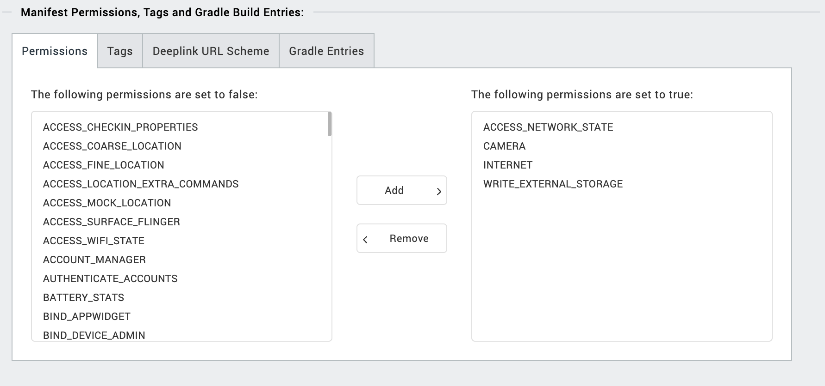
4. Enter the given snippet in Child tag entries under <manifest > tag

<uses-permission android:name="android.permission.READ_MEDIA_VISUAL_USER_SELECTED"/>
<uses-permission android:name="android.permission.READ_MEDIA_IMAGES" />

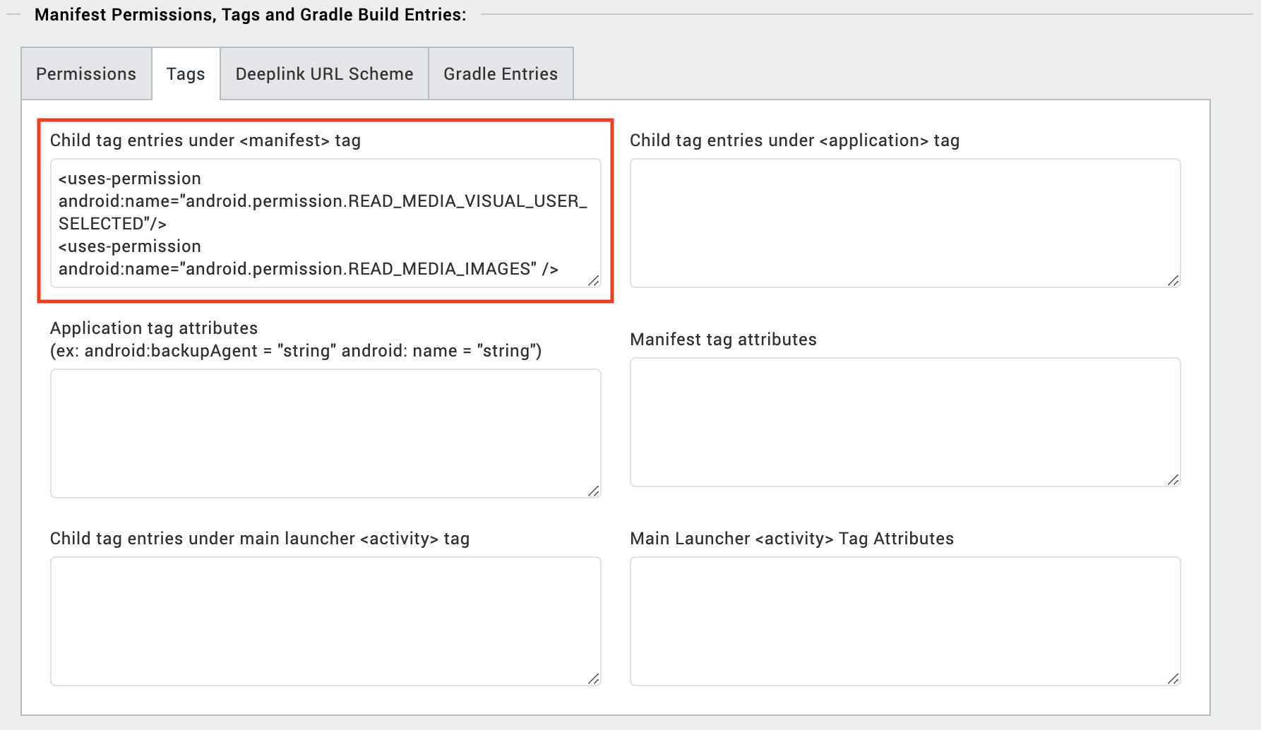

IOS:
Follow the steps given to enable the permissions.
1. From the Project explorer, navigate to the Assets tab.
2. Right click Media and select Resource Location to open the project resources folder.
3. In the browser window that opens, navigate to the common folder.
4. Open the infoplist_configuration.json file with a text or code editor.
5. Add the given code at the end of the file. You can replace the values with your own descriptions.
{
"NSCameraUsageDescription" : " This app uses Camera ",
"NSPhotoLibraryUsageDescription" : "This app uses photo library"
}

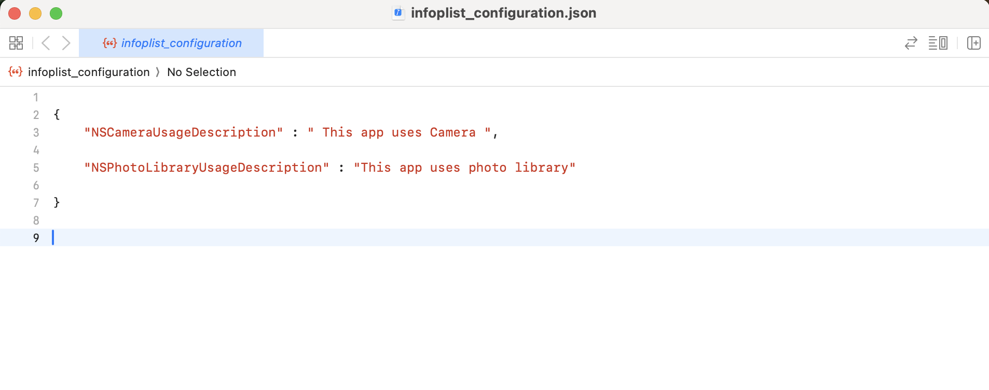

Events
The component invokes events when its corresponding action is performed. You can configure any logic you want the component to perform whenever an event occurs. You can configure the events directly on the Actions tab or by writing a JavaScript, For more information, refer to Add Actions in the Volt MX Iris User Guide.

getrawbytes

Description: | Receives the Base64-encoded content of the uploaded image file. This can be used to display or process the image within the app.
Syntax: | getrawbytes
Parameters: | imageRawBytes  The Base64 representation of the Image file.
Example: | this.view.componentID.getrawbytes = function(imageRawBytes){  alert("Received image in Base64);  }.bind(this);

getquerytext

Description: | Receives the input text prompt provided by the user along with the Image. This allows you to display or log the user’s query.
Syntax: | getquerytext
Parameters: | querytext  The input text prompt entered by the user.
Example: | this.view.componentID.getquerytext = function(querytext){  alert("User entered text prompt”);  }.bind(this);

onImageAnalysisSuccess

Description: | Receives the AI-generated content/response based on the Image and input text. This is the processed output from Gemini Image Understanding.
Syntax: | onImageAnalysisSuccess
Parameters: | result  The AI-generated text result.
Example: | this.view.componentID.onImageAnalysisSuccess= function(result){  alert("AI Response”);  }.bind(this);

onImageAnalysisFailure

Description: | Receives the AI-generated content/response based on the Image and input text. This is the processed output from Gemini Image Understanding.
Syntax: | onImageAnalysisFailure
Parameters: | result  The AI-generated text result.
Example: | this.view.componentID.onImageAnalysisFailure= function(error){  alert("Image Analysis Failed”);  }.bind(this);

REVISION HISTORY

App version 1.0.0:

A. Limitations
- Use Image less than 20 MB. Refer this https://ai.google.dev/gemini-api/docs/image-understanding

B. Known Issue

- NA

