Date : 18-Aug-25

GOOGLE GEMINI TEXT TO SPEECH

VERSION: 1.0.0

OVERVIEW
The Gemini API offers advanced text-to-speech (TTS) capabilities that convert text into high-quality single or multi-speaker audio. It allows fine-grained control over tone, accent, pace, and style using natural language instructions. Unlike the Live API, which supports real-time, interactive audio generation, Gemini TTS is optimized for precise text narration—ideal for applications like podcasts, audiobooks, and voiceovers.

Use case:
- Audiobook and Podcast Generation: Create natural, expressive narrations with custom tone and style.
- Virtual Assistants & Chatbots: Provide lifelike voice responses with controlled accent and pacing.
- E-learning & Accessibility: Generate clear, engaging audio for educational materials or screen readers.
- Marketing & Media Production: Produce voiceovers for ads, videos, or announcements with consistent quality.

Features:
- Controllable Speech Generation: Adjust style, tone, pace, and accent using natural language prompts.
- Multi-Speaker Support: Generate dialogues or multi-character audio content.
- High-Quality, Natural Voices: Delivers realistic, human-like speech output.
- Fine-Grained Audio Control: Ideal for structured, non-interactive scenarios like storytelling or training modules.
- Seamless API Integration: Easily integrates with applications for automated audio generation.

GETTING STARTED

Prerequisites
Before you start using the Google Gemini Text to Speech Backend App, ensure you have the following:

- HCL Foundry
- Volt MX Iris
- Get a Gemini API Key from Google AI studio.
Reference document: https://ai.google.dev/gemini-api/docs/speech-generation
  - Importing the Gemini Text to Speech Backend App
- Log on to your HCL Foundry The Dashboard page appears by default.
- In the left pane, click Apps menu. The Custom Apps page appears.
- Click IMPORT. The Import App dialog appears.
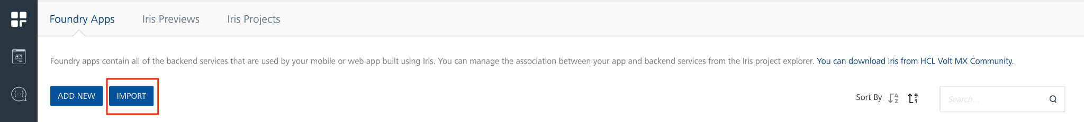
- Click Browse.
- Select the Gemini Text to Speech zip file located in your system and click Open.
- In the Import App dialog, click IMPORT.
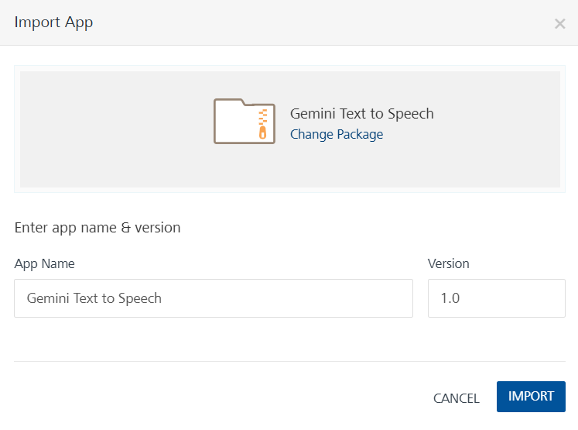
- Imported App will be shown in Foundry Apps.
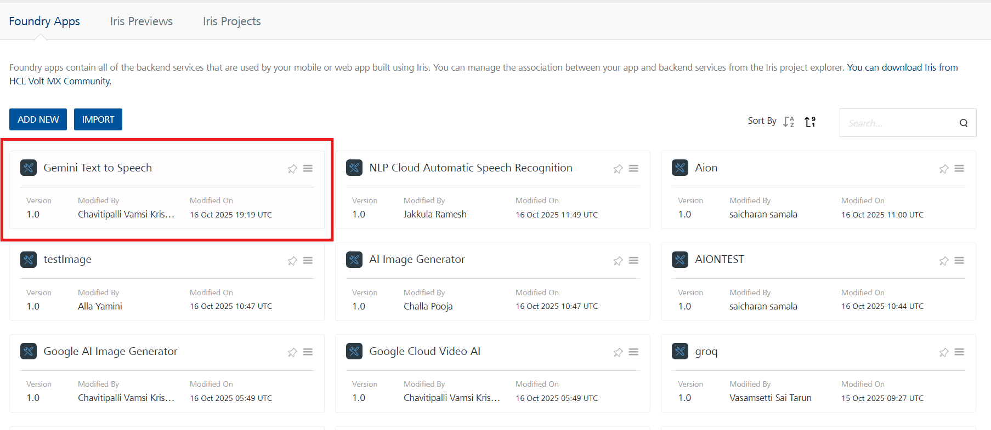
C.Creating an Integration Service
After you import Gemini Text to Speech into Foundry, you must create an integration service with service type as Java to connect with your developer Gemini Text to Speech site.
To create an integration service with Gemini Text to Speech, do the following:
- Log on to your Foundry. The Dashboard page appears by default.
- In the left panel, click the API Management menu. The APIs tab opens by default.
- Click the Integration tab. The Integration tab opens with a list of existing integration services.
- Click CONFIGURE NEW. The Service Definition tab opens.
- In the Name box, type a unique name for your service.
- From the Service Type list, select Java
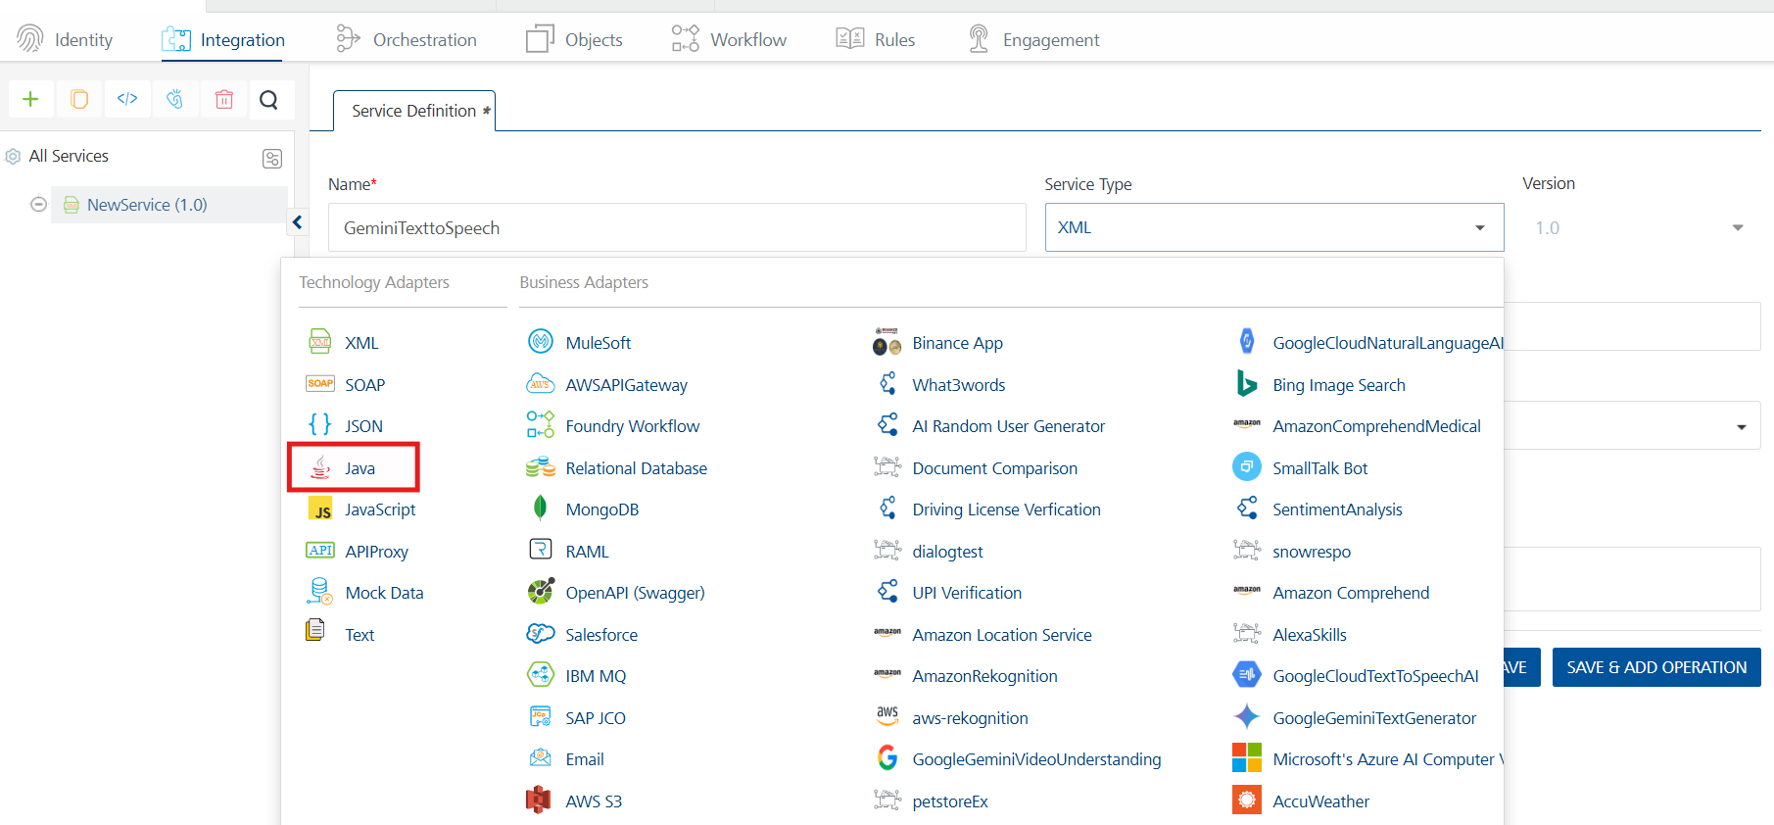
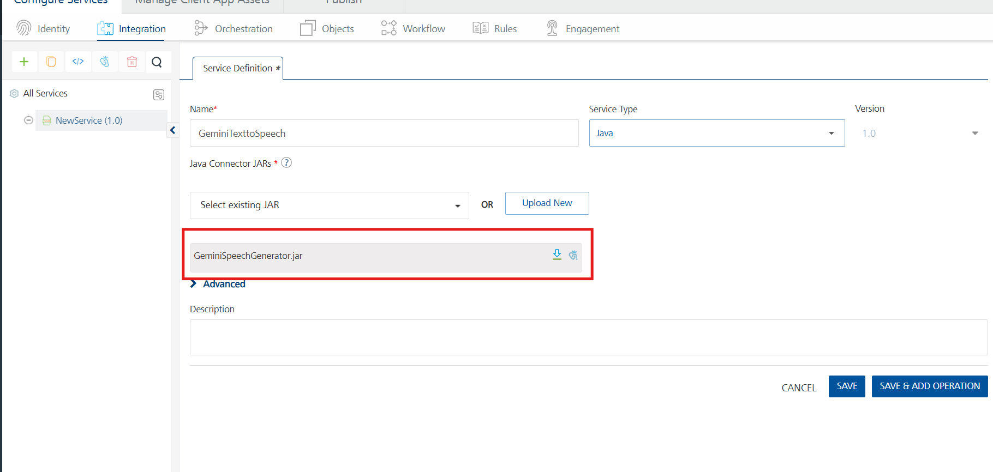
- Click Save.
If the details provided are valid, the Foundry service connects to your Gemini Text to Speech developer site and allows you to make the API calls.
Refer to Integration Services for more information on creating and using integration services.
8. Creating an Operation
To make any API call in the Foundry console, you must create an operation for the respective API and then execute the operation. Executing an operation involves making the API call and displaying the response.
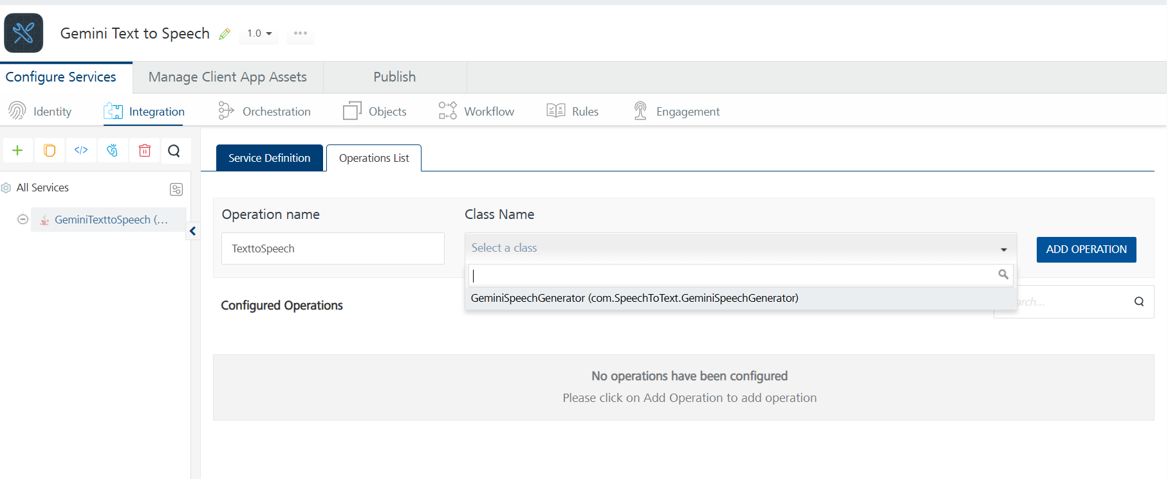

- Executing an Operation

D.Executing an Operation
Executing an operation involves making the API call by setting the necessary parameters and displaying the response. The procedure to execute any operation is the same, but the request parameters of the APIs vary.
Steps to execute the TexttoSpeech operation:
1. Click the Operations List tab and select TexttoSpeech Operation.
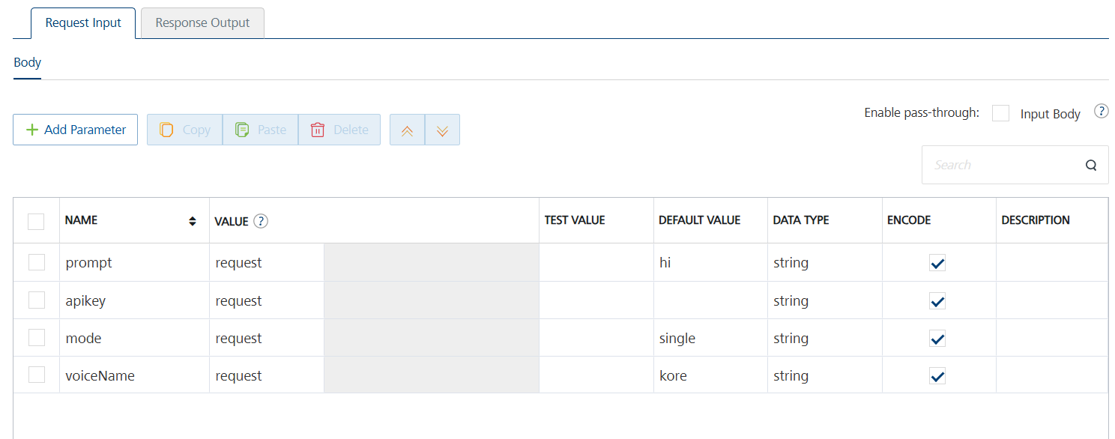

2. On the Request Input tab, in the Body section, for the following parameters, specify the values in the respective boxes under the Test Value column.
Mandatory Parameters
- voiceName : TTS models support the following 30 voice options
- apikey : get the apikey from https://aistudio.google.com/prompts/new_chat
- mode: Use clear values like "single" or "multi" to specify single-speaker or multi-speaker mode
- prompt: This field contains the text input that you want the model to convert into speech.
3. Click SAVE OPERATION.
Click SAVE AND FETCH RESPONSE. The Output Result dialog appears with the response. Otherwise, the Output Result shows an error.
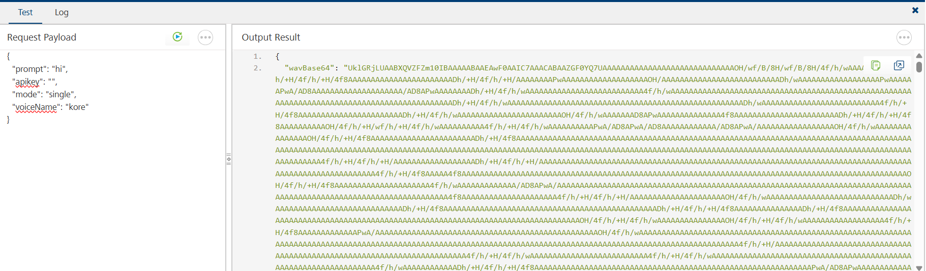

Publishing the App to Volt MX Foundry
After adding Gemini Text to Speech to your app and configuring the necessary configurations, you must publish the app to Volt MX Foundry. For more information, refer to Publish a Project to Volt MX Foundry.
If you want to use the services in client applications, you need to publish the app to a run-time environment.
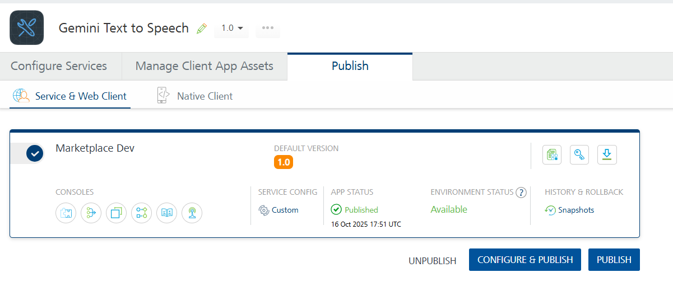
Reference Document:
https://ai.google.dev/gemini-api/docs/speech-generation

3. REVISION HISTORY
App version 1.0.0:

Known Issues
None

Limitations
None

