28 Oct 2021

Vue Hamburger Menu Component (1.0.1)

Overview

Hamburger menu allows you to hide the navigation beyond the edge of the

screen and reveal it only after a user’s action.

Use case

Screen space is a precious commodity on mobile and the slide menu is one of the most popular mobile navigation patterns that helps you save it.

The drawer panel allows you to hide the navigation beyond the edge of the screen and reveal it only after a user’s action.

This pattern can be particularly useful if you want your user to focus on the main content.

This component provides a ready to use Sliding menu for VoltMX Apps. This component is based on the Vue.js framework.

Percentage of re-use:
Approximate 85% of reuse.

Features
- Enriches your app with popular navigation pattern, Hamburger Menu
- Flexible to display and hide the menu
- Saves the screen space
- Menu slides with animation onto the screen
- Provides controls to customize the UI and to set events

Getting Started

Prerequisites
Before you start using the Hamburger menu component, ensure the following:
• HCL Foundry
• Volt MX Iris

Platforms Supported

Responsive Web & PWA

Importing the app

You can import the Forge components only into the apps that are of the Reference Architecture type.

To import the Hamburger menu component, do the following:

Open your app project in Volt MX Iris.

In the Project Explorer, click the Templates Tab
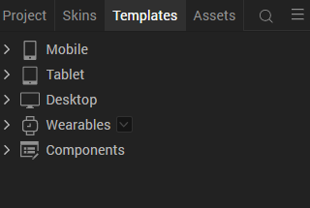
- Right-click Components, and then select Import Component. The Import Component dialog box appears.
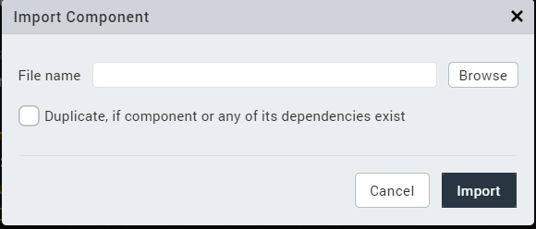
- Click Browse to navigate to the location of the component, select the component, and then click Import. The component and its associated widgets and modules are added to your project.

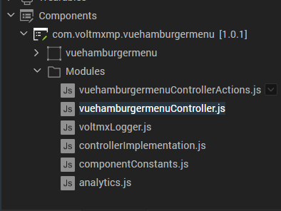
Once you have imported a component to your project, you can easily add the component to a form.

D. Building and previewing the app
After performing all the above steps, you can build your app and run it on your device.
You can then run your app to see the Hamburger menu work in real time.

3.References

Dynamic Usage
You can also add Hamburger Menu component dynamically. To do so,

In the Project Explorer, on the Projects tab, click Controllers section to access the respective Form Controller. Create a method and implement the code snippet similar to the sample code mentioned below.
/*Creating Hamburger Menu component instance*/
define({

//Type your controller code here
onNavigate : function(){
this.view.preShow=this.preShow();
},
preShow : function(){
this.createComponent();
},
createComponent: function()
{
/* Creating the component's object */
var vueHamburgerMenu = new com.voltmxmp.vuehamburgermenu(
{
"clipBounds": true,
"height": "100%",
"id": "vueHamburgerMenu",
"isVisible": true,
"left": "0dp",
"top": "0dp",
"width": "300px",
"zIndex": 1
}, {}, {});

/* Setting the component's properties */
vueHamburgerMenu.menuItems =
{
"data":
[
{
"icon": "resources/home.png",
"id": "01",
"title": "HOME"
},
{
"icon": "resources/pro.png",
"id": "02",
"title": "PRODUCT"
}
]
};
vueHamburgerMenu.defaultWidth = 300;
vueHamburgerMenu.defaultVisibility = false;
vueHamburgerMenu.defaultMenuItem = "01";
vueHamburgerMenu.logoVisibility = true;
vueHamburgerMenu.logoURL = "./resources/voltmx_logo.png";
vueHamburgerMenu.menuIconURL = "./resources/menu.png";
vueHamburgerMenu.closeIconURL = "./resources/close.png";
vueHamburgerMenu.onMenuItemClick = function(id) {}.bind(this);
vueHamburgerMenu.onErrorCallback = function(errObj){}.bind(this);
vueHamburgerMenu.onShowHamburgerMenu = function(){}.bind(this);
vueHamburgerMenu.onHideHamburgerMenu = function(){}.bind(this);
/* Adding the component to a form */
this.view.add(vueHamburgerMenu);
}
});
In the code snippet, you can edit the properties of the component as per your requirement. For more information, see Setting Properties. And Save the file

Properties
The properties provided on the Component tab allow you to customize the UI elements in the Hamburger Menu component. You can set the properties directly on the Component tab or by writing a JavaScript. This section provides information on how to set the properties by writing a JavaScript.

General properties
Menu Items
Description: | Specifies the data that you want to show as the items on the menu.
Syntax: | menuItems
Type: | - Data Grid  - JSON
Read/Write: | Write
Default Value: | {  "data":  [  {  "icon": "resources/home.png",  "id": "01",  "title": "HOME"  },  {  "icon": "resources/pro.png",  "id": "02",  "title": "PRODUCT"  }  ]  }
Example: | this.view.componentID.menuItems =  {  "data":  [  {  "icon": "resources/home.png",  "id": "01",  "title": "HOME"  },  {  "icon": "resources/pro.png",  "id": "02",  "title": "PRODUCT"  }  ]  };
Default Width in PX
Description: | Specifies the width of the menu (in pixels) in the expanded state.
Syntax: | defaultWidth
Type: | Integer
Read/Write: | Write
Default Value: | 300
Example: | this.view.componentID.defaultWidth = 300;
Default Visibility
Description: | Specifies whether the menu should expand by default.
Syntax: | defaultVisibility
Type: | Boolean
Read/Write: | Write
Default Value: | true
Example: | this.view.componentID.defaultVisibility = false;
Default Menu ID
Description: | Specifies the ID of the menu item that should be highlighted by default.
Syntax: | defaultMenuItem
Type: | String
Read/Write: | Write
Default Value: | 01
Example: | this.view.componentID.defaultMenuItem = "01";
Logo Visibility
Description: | Toggles the visibility of the logo.
Syntax: | logoVisibility
Type: | Boolean
Read/Write: | Write
Default Value: | true
Example: | this.view.componentID.logoVisibility = true;
Logo URL
Description: | Specifies the URL of the image that you want to set as the logo.
Syntax: | logoURL
Type: | String
Read/Write: | Write
Default Value: | ./resources/quantum.png
Example: | this.view.componentID.logoURL = "./resources/quantum.png";
Burger Menu Icon URL
Description: | Specifies the URL of the image that you want to set as the burger menu icon.
Syntax: | menuIconURL
Type: | String
Read/Write: | Write
Default Value: | ./resources/menu.png
Example: | this.view.componentID.menuIconURL = "./resources/menu.png";
Close Icon URL
Description: | Specifies the URL of the image that you want to set as the close icon.
Syntax: | closeIconURL
Type: | String
Read/Write: | Write
Default Value: | ./resources/close.png
Example: | this.view.componentID.closeIconURL = "./resources/close.png";

C. Events
You can define events to be executed when an action is performed. You can configure the events directly on the Actions tab or by writing a JavaScript. To configure the events on the Action tab, click Edit against each event.
onMenuItemClick
Description: | Invoked when the user selects an item from the menu.
Syntax: | onMenuItemClick
Parameters: | id [String] :  The ID of the item that the user selected from the menu.
Example: | this.view.componentID.onMenuItemClick = function(id)  {  alert("Menu Item Selected: "+id);  }.bind(this);
onErrorCallback
Description: | Invoked when an error occurs in the component.
Syntax: | onErrorCallback
Parameters: | errObj [JSON] :  Contains information about the error, such as the error code and the error message.
Example: | this.view.componentID.onErrorCallback = function(errObj)  {  alert("Error: "+JSON.stringify(errObj));  }.bind(this);
onShowHamburgerMenu
Description: | Invoked when the user clicks the burger menu icon and expands the menu.
Syntax: | onShowHamburgerMenu
Parameters: | None
Example: | this.view.componentID.onShowHamburgerMenu = function()  {  alert("Menu Opened.");  }.bind(this);
onHideHamburgerMenu
Description: | Invoked when the user clicks the close icon or a menu item and hides the menu.
Syntax: | onHideHamburgerMenu
Parameters: | None
Example: | this.view.componentID.onHideHamburgerMenu = function()  {  alert("Menu hidden.");  }.bind(this);

D. APIs
The following APIs pertain to the Hamburger Menu - vue.js component:
setMenuItems
Description: | Sets the items on the menu based on the specified data..
Syntax: | setMenuItems(data)
Parameters: | data [Array of JSON] :  Contains the ID, the Title, and the Icon URL for the items that you want to display on the menu.
Return Value: | None
Example: | var data =  [  {  "icon": "resources/home.png",  "id": "01",  "title": "HOME"  },  {  "icon": "resources/pro.png",  "id": "02",  "title": "PRODUCT"  }  ];  this.view.componentID.setMenuItems(data);
selectMenuItem
Description: | Selects the specified item from the menu.
Syntax: | selectMenuItem(id)
Parameters: | id [String] :  The ID of the item that you want to select from the menu.
Return Value: | None
Remarks: | Selecting an item by using the selectMenuItem API does not close the menu.
Example: | var id = "02";  this.view.componentID.selectMenuItem(id);

REVISION HISTORY
App version: 1.0.1

Limitations

Vue Hamburger menu is a web component. So, it doesn’t support for Android and IOS devices.

