Date : 23-Apr-26

HELICONE APPLICATION

VERSION: 1.0.0

OVERVIEW
Helicone is an observability and monitoring platform designed for applications using large language models (LLMs). It provides developers with tools to log, track, and analyze API requests and responses across different AI providers such as OpenAI, Anthropic, and Mistral AI. By integrating Helicone as a proxy or middleware, developers can capture detailed insights including request latency, token usage, cost tracking, and error rates.
The platform enables iterative debugging and optimization by allowing developers to inspect prompts, compare responses, and monitor performance over time. It also supports features like caching, retries, rate limiting, and analytics dashboards for better control and reliability of AI-powered systems. This makes Helicone especially useful for building and scaling applications such as chatbots, AI assistants, content generation tools, and other LLM-driven solutions while maintaining visibility, cost efficiency, and performance monitoring.

Use case:
- Multi-Model Chatbots & Virtual Assistants – Build conversational AI by routing requests to models like Llama, Mistral, or providers such as OpenAI and Anthropic through a single API.
- Unified Text Generation & Summarization – Generate content such as emails, blogs, and summaries using different models via one OpenAI-compatible interface.
- Smart Model Routing & Optimization – Dynamically route requests to the best-performing or lowest-cost model based on latency, pricing, or use case requirements.
- AI Request Logging & Monitoring – Track all API requests and responses with detailed logs, enabling debugging, auditing, and performance analysis.
- Cost Tracking & Usage Analytics – Monitor token usage and costs across multiple providers to optimize spending and improve efficiency.
- Caching & Performance Optimization – Reduce latency and cost by caching repeated AI responses and reusing them when applicable.
- Failover & Reliability Handling – Automatically retry or switch providers if a request fails, ensuring high availability for AI applications.
- Prompt Testing & Experimentation – Iteratively test prompts across different models and compare outputs to improve quality and accuracy.
- Multimodal AI Applications – Build applications that support text and image inputs by integrating multiple providers through a single gateway.
- AI Observability & Debugging Tools – Gain insights into request performance, latency, and errors with dashboards and analytics.
- Scalable AI Integrations – Easily integrate AI into web and mobile applications using REST APIs without managing multiple provider SDKs.

Features:
- Multiple Model Access:
Access a wide range of AI models from providers like OpenAI, Anthropic, Google, and open models such as Llama and Mistral through a single unified API gateway.
- Unified Text Generation & Chat:
Generate high-quality text, perform chat completions, summarization, and conversational AI interactions using an OpenAI-compatible API format.
- Smart Model Routing:
Dynamically route requests to different models or providers based on cost, latency, or performance requirements for optimized results.
- AI Request Logging & Observability:
Track and monitor all API requests and responses with detailed logs, enabling debugging, auditing, and performance analysis.
- Cost Tracking & Usage Analytics:
Monitor token usage, request counts, and overall costs across multiple providers to optimize budget and usage.
- Caching & Performance Optimization:
Improve response time and reduce costs by caching repeated requests and reusing responses when applicable.
- Failover & Reliability Handling:
Ensure high availability with automatic retries and fallback to alternative providers if a request fails.
- OpenAI-Compatible REST API:
Easily integrate with existing applications using standard HTTP requests and JSON responses without major code changes.
- Prompt Testing & Experimentation:
Test and compare prompts across multiple models to evaluate output quality and refine AI responses.
- Scalable & Developer-Friendly:
Provides a flexible and scalable infrastructure for building AI-powered applications without managing multiple APIs separately.

Percentage of re-use:
80%

GETTING STARTED

Prerequisites
Before you start using the Helicone Adapter, ensure you have the following:
- HCL Foundry
- Helicone API Key Account - Get a Helicone API key

Step 1: Create a Helicone Account
- Navigate to the Helicone website.
- Sign up using your email, Google, or GitHub account.
- Log in to access the Helicone Dashboard.
Step 2: Generate a Helicone API Key
- Go to the Dashboard.
- Navigate to Settings → API Keys.
- Click on Create API Key.
- Copy and securely store the generated API key.
Step 3: Choose API Usage Method
Helicone supports two methods for using APIs:
Option A: Bring Your Own Key (BYOK) – Recommended
- Obtain an API key from your preferred provider:
  - OpenAI
  - Anthropic
  - Google
- Use Helicone as a gateway by setting the base URL:
https://ai-gateway.helicone.ai/v1
- Include the following headers in your request:
  - Helicone-Auth: Bearer <HELICONE_API_KEY>
Option B: Helicone Managed API Key (Pass-through Billing)
- Add billing details in the Helicone Dashboard.
- Use the generated Helicone API key directly.
- Include the following header in your request:
  - Authorization: Bearer <HELICONE_API_KEY>

Devices
- Mobile

Platforms
- Android
- IOS

Importing the App
To import the Helicone App to Volt MX Iris, do the following:

To import the Helicone App, do the following:
- Launch Volt MX Iris.
- Click project, and then select Import. The Import dialog box appears.
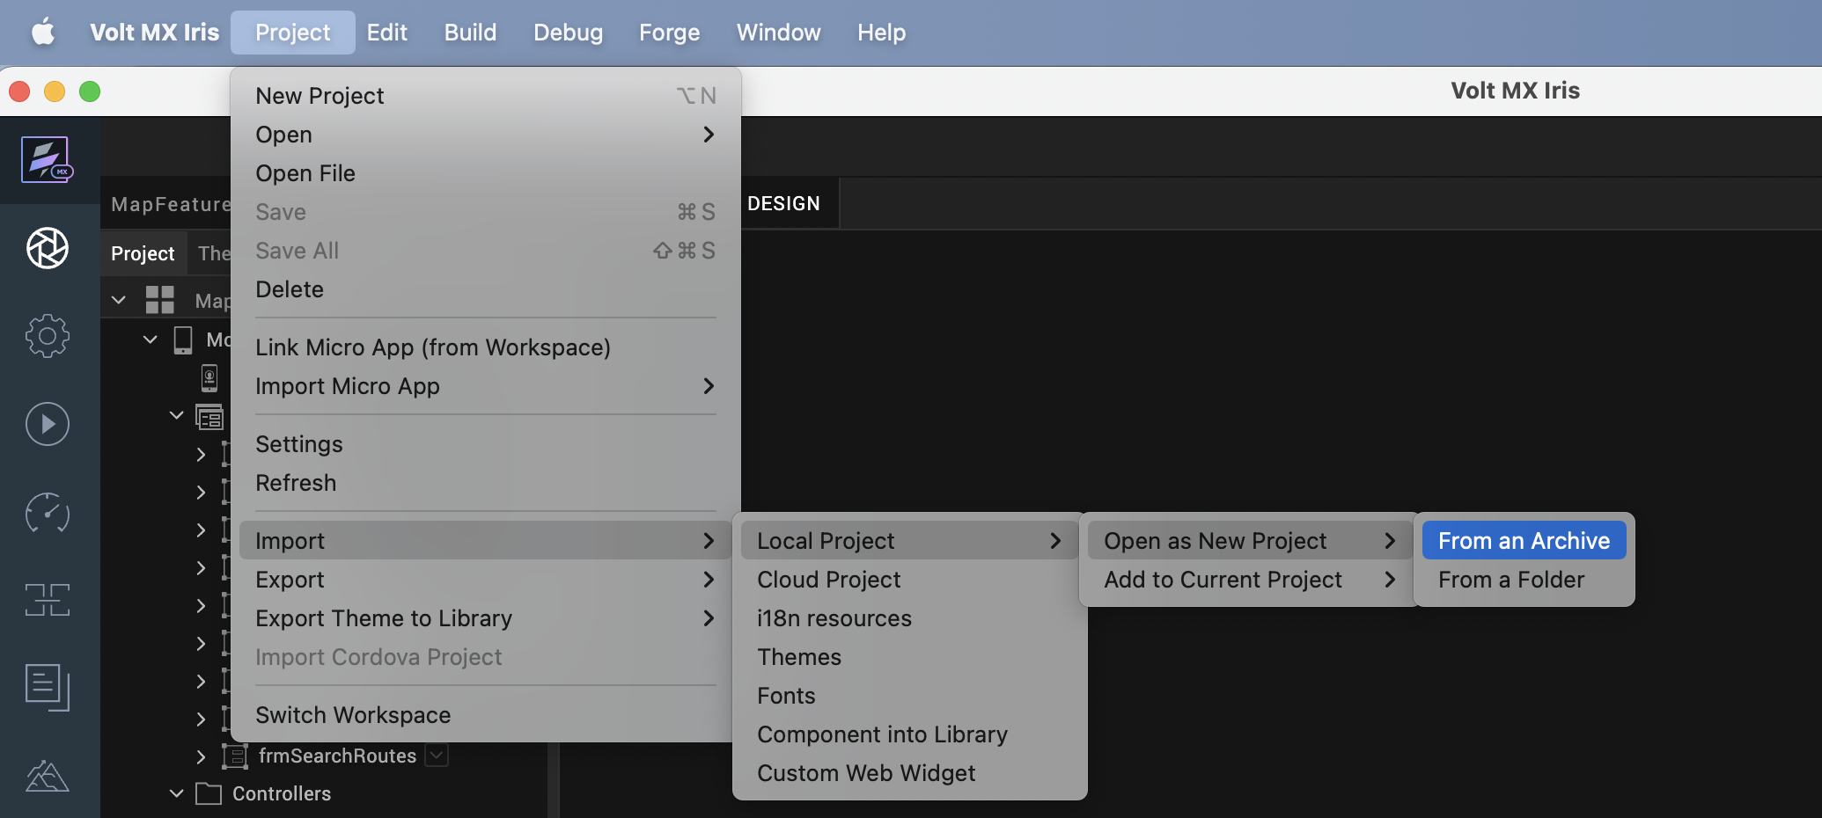

- Click From an Archive to navigate to the location of the project, select the files, and then click Import.
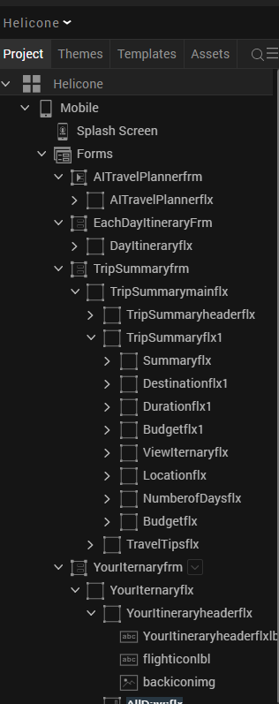
After you import the application, you can view the associated Foundry app connected at the in Data & Services section.
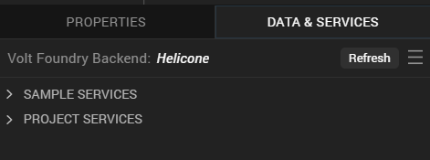

Helicone Volt MX Foundry Services:
When you import the application to your Volt MX Iris project, the HCL Volt MX Foundry services of the Helicone are added to the HCL Volt MX Foundry app, which is associated with the Volt MX Iris project. While importing the Helicone App to your Volt MX Iris project, if there is no HCL Volt MX Foundry app associated with the existing Volt MX Iris project, a new HCL Volt MX Foundry app is automatically added to your HCL Volt MX Foundry environment and is associated with your Volt MX Iris.
To set up the Foundry app, follow these steps:

1. Click the HCL Volt MX Foundry app associated with your Volt MX Iris project from the Project Explorer. Click on DATA & SERVICES.

2. Under the Configure Services tab, click Integration and can see the Helicone Integration service. Click on that Integration service to add the keys.

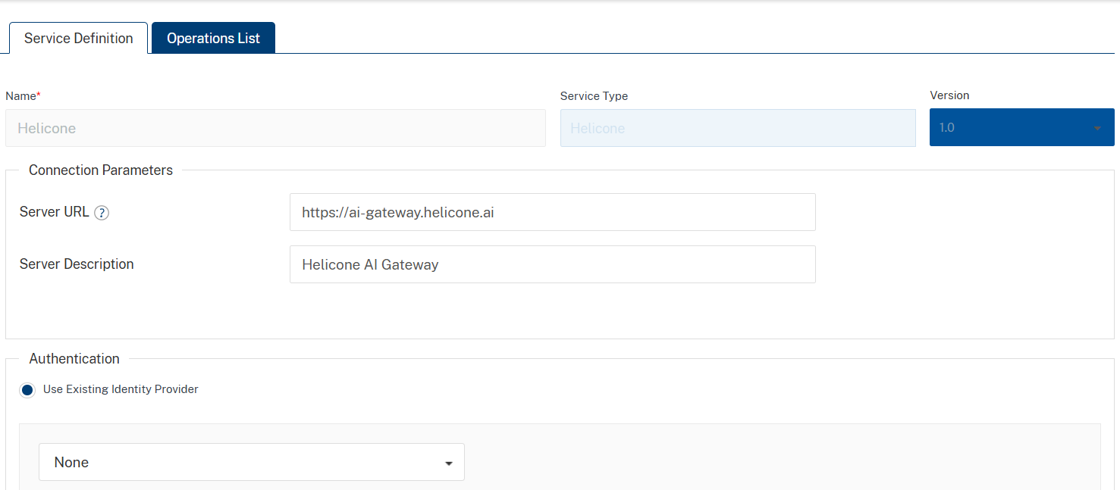

3. Click the Operations List tab. The Operations List tab opens with the list of operations available.
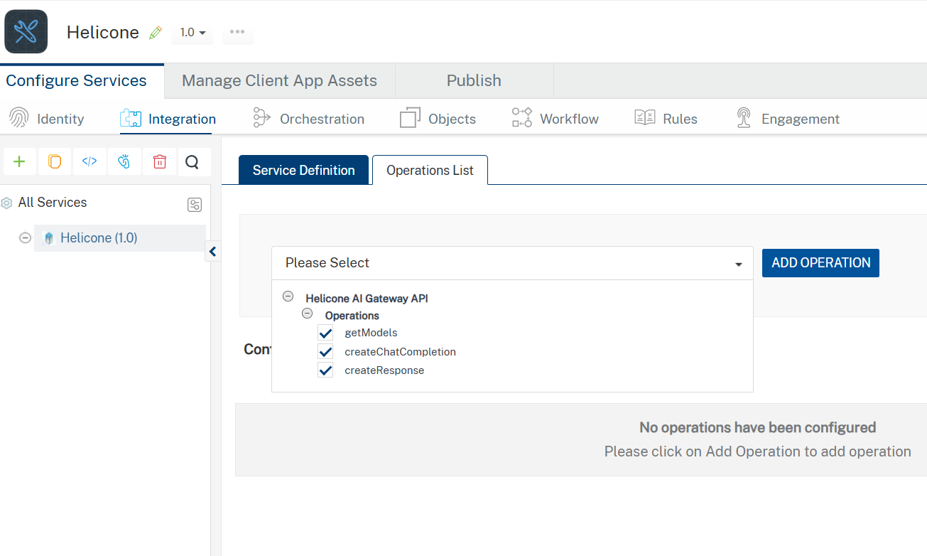

4. Executing an operation
A) Under the Configured Operations section, click the operation. The Request Input sub-tab opened by default. Provide Body and Headers.
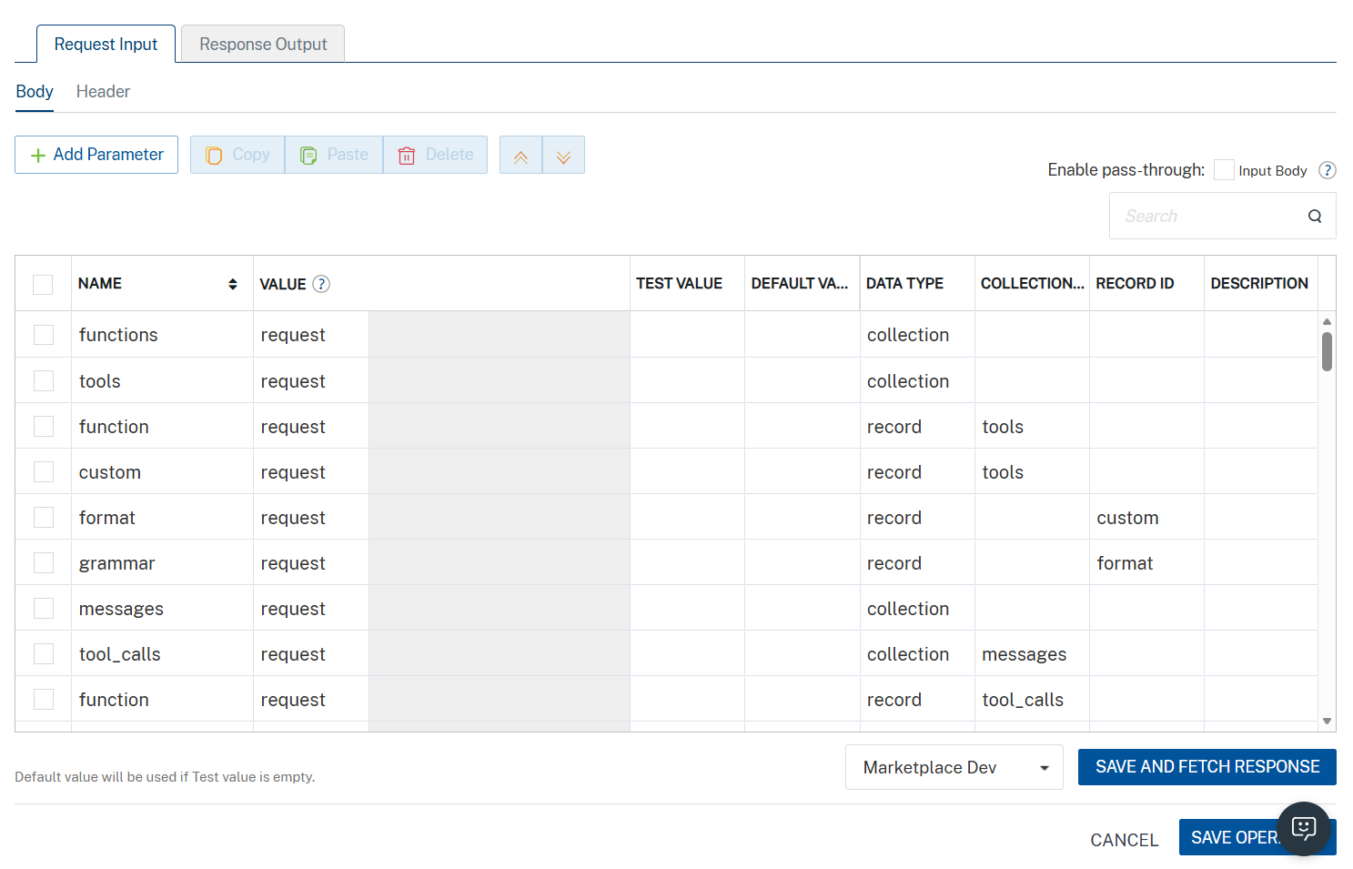
Parameter | Description | Syntax Example
model (Required) | Specifies which AI model to use for the request. Available models depend on your Scaleway configuration. | "model": "gemini-2.5-flash"
messages (Required) | Array of conversation messages. Each message must include a role (system, user, or assistant) and content. | "messages": [  { "role": "system", "content": "You are a helpful assistant." },  { "role": "user", "content": "Say hello in one sentence." }  ]
temperature (Optional) | Controls randomness of output. Lower values produce deterministic responses; higher values increase creativity. | "temperature": 0.7
max_completion_tokens  (Optional) | Maximum number of tokens the model can generate in the response. | -9007199254740991 <= x <= 9007199254740991
top_p (Optional) | Nucleus sampling parameter that controls diversity by limiting token selection to a probability mass. | "top_p": 1
stream (Optional) | Enables real-time streaming response when set to true. | "stream": true
stop (Optional) | Specifies sequences where the API will stop generating further tokens. | "stop": ["\n", "###"]
presence_penalty (Optional) | Penalizes new tokens based on whether they appear in the text so far, encouraging new topics. | "presence_penalty": 0.6
frequency_penalty (Optional) | Penalizes repeated tokens based on their frequency in the text so far. | "frequency_penalty": 0.5
Additionally, the messages parameter (array of objects) must be passed completely within the messages value as a properly structured JSON array.
Set the API key value to the default key generated in the Prerequisites section.

Helicone accepts the API key in the format: Bearer YOUR_API_KEY in the Headers
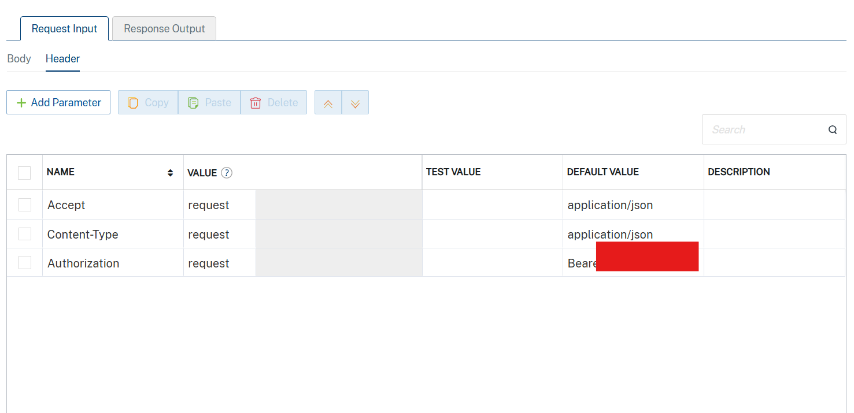

B) Click SAVE AND FETCH RESPONSE. The Output Result dialog appears with the response. Otherwise, the Output Result shows an error.
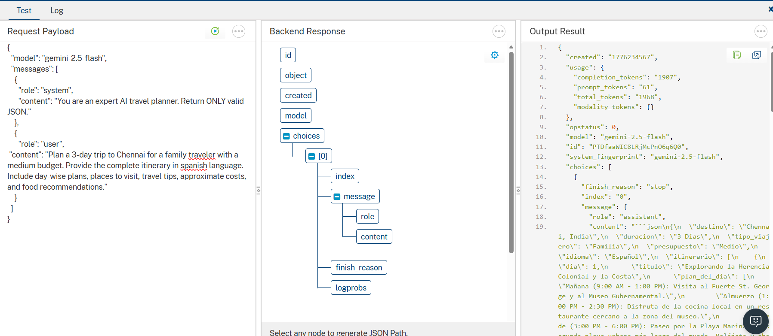

5.Publishing your application
After you set the Operation Security Level, you must publish the HCL Volt MX Foundry app. To publish the HCL Volt MX Foundry, follow these steps:

In Volt MX Iris, click DATA & SERVICES, and then click Publish Project Services to Publish to your foundry app.

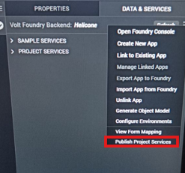

Select the environment to which you want to publish your app, and then click Publish. After the app is published to your environment, the following window appears confirming the publish.

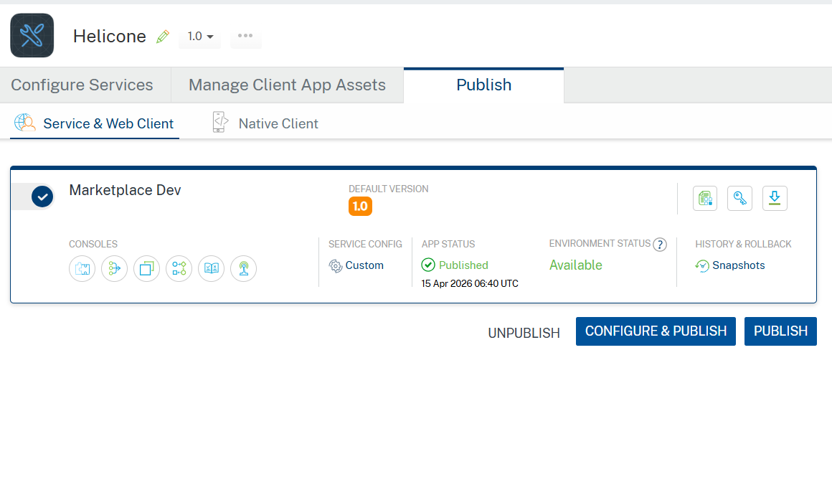

Building the app
From the menu bar, go to Build and then select Build Native Local.

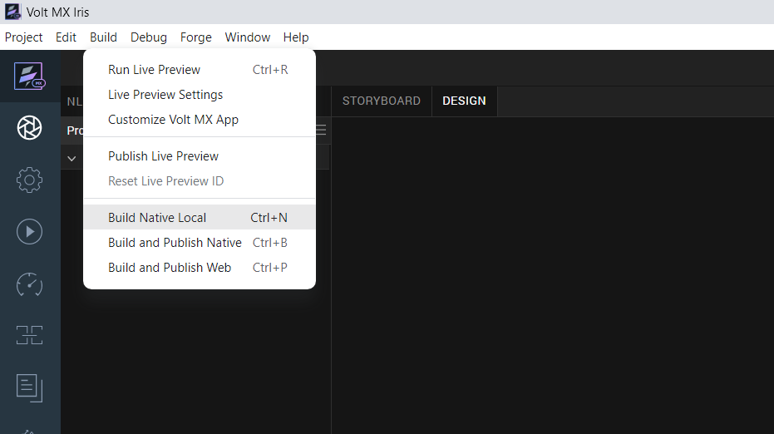

For Mobile, select Android and iOS. Click Build.
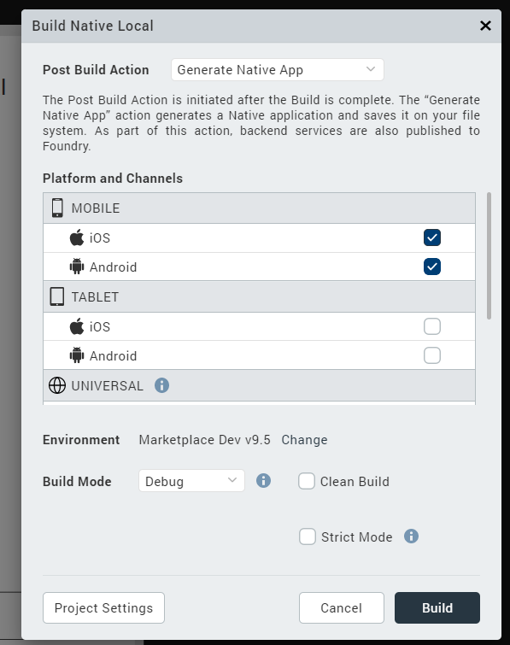

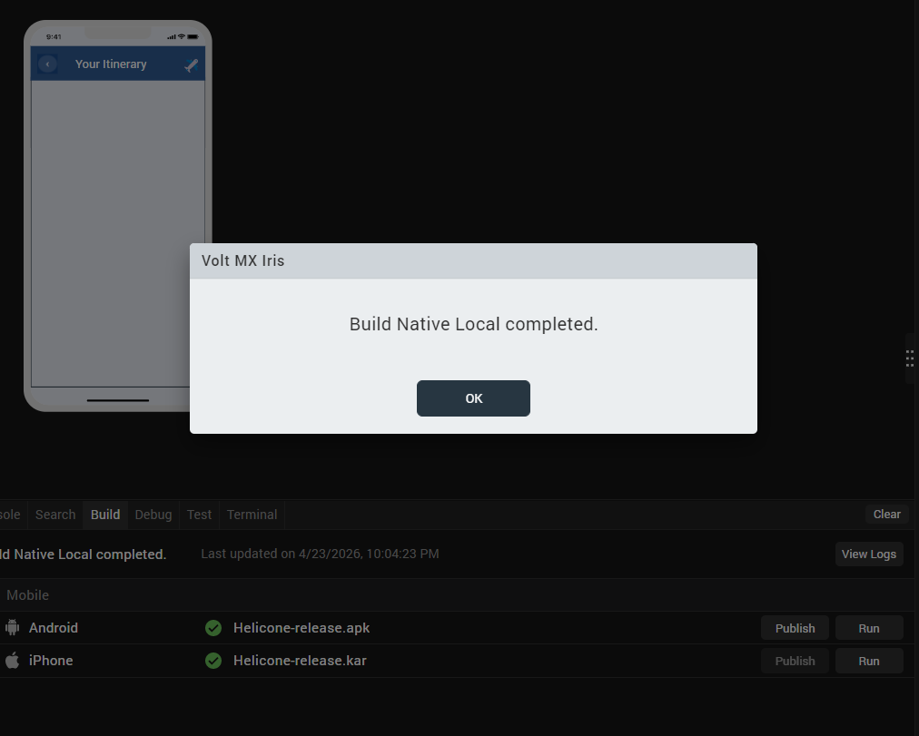
After the build is successful, run the app on your mobile device.

H. Application Flow
The landing page for the app is as follows:


Enter destination, select budget, travel type, and duration, and click "Generate Plan".

Once on the trip summary screen, you can view details such as the destination, duration, budget, and travel tips.

Selecting "View Itinerary" will navigate you to the itinerary screen, where detailed information for each day is displayed. The view updates to show specific details for Day 1, Day 2, and so on, based on the selected day.

You can view the complete details for a specific day by selecting any day (e.g., 1, 2, or 3).
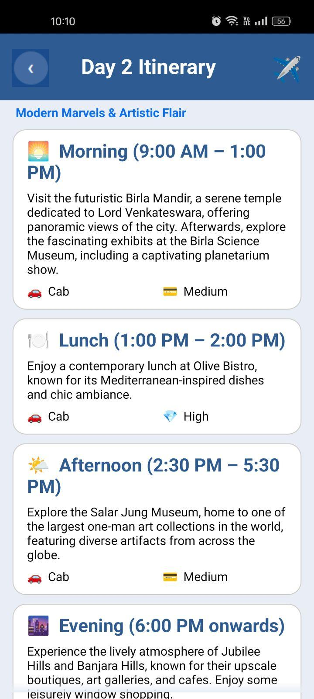

Note: Helcione Adapter is present in the Marketplace page.
Marketplace link:

4.REFERENCES

Endpoint Documentation
Helicone Account

5.REVISION HISTORY
App version 1.0.0:
  - Known Issues
None
  - Limitations
None

