Date : 30-Oct-25

HUGGING FACE APPLICATION

VERSION: 1.0.0

1.OVERVIEW
The Hugging Face AI Platform is a comprehensive ecosystem that enables seamless interaction with thousands of open-source machine learning models across text, images, audio, video, and multimodal tasks. It provides developers, researchers, and enterprises with the tools to build, deploy, and scale AI applications using community-driven models and industry-grade inference APIs.
Hugging Face allows you to upload datasets, test models, run inference, fine-tune models, and integrate AI capabilities directly into applications. It supports all major ML frameworks, including PyTorch, TensorFlow, JAX, and ONNX — making it one of the most flexible and open ecosystems for AI development.
Hugging Face is not just a model hub; it is an end-to-end platform that powers model sharing, training, hosting, evaluation, and production-level deployment.

Use case:

1. Multimodal Image Understanding
Analyze images with prompts — object details, context reasoning, captioning, comparisons, and visual Q&A.

2. Document Intelligence (OCR + Extraction)
Parse scanned documents, forms, receipts, tables, handwriting, and convert them into structured text.

3. Text Intelligence (NLP)
Perform summarization, translation, sentiment analysis, embeddings, classification, and chatbot functions.

4. Image + Audio + Text Embeddings & Search
Create embeddings for similarity search across images, text, or audio — ideal for recommendations and vector databases.

5. Model & Dataset Hosting (Hugging Face Hub)
Store, version, share, and collaborate on models/datasets with community features and Spaces for demos.

6. Inference API for Production AI
Run any model (vision, text, audio, diffusion) via a single API endpoint without deploying servers.

7. Training & Fine-Tuning with Transformers
Fine-tune open-source models (LLMs, vision models, audio models) using Trainer, PEFT, LoRA, TRL, and integrate into apps seamlessly.

Percentage of re-use:
Approximate 85% of reuse.

Features

1. Model Hub
A massive repository of open-source AI models (LLMs, vision, audio, multimodal) with versioning, documentation, and community contributions.

2. Inference API
Run any model instantly via a single API endpoint—no servers, GPUs, or setup required. Supports text, image, audio, and diffusion models.

3. Dataset Hub
Host, version, explore, and load datasets easily with built-in tools, streaming, and community sharing.

4. Spaces (App Hosting)
Deploy ML apps using Gradio/Streamlit with one click. Ideal for demos, prototypes, and production-ready UI integration.

5. Transformers Library
A unified Python/JS library for training, fine-tuning, and using state-of-the-art NLP, vision.

2.Requirements

- HCL Foundry
- Volt MX Iris
- To use the Hugging Face API, you need an API key. You can create a key with a few clicks in.Get a Hugging Face API key.

Devices:
- Mobile

Platforms:
- Android
- IOS

App Functionality
When you build and run the app, you can enter a text prompt, select an AI operation, and retrieve AI-generated responses based purely on textual input using Hugging Face models.
Home Screen (frmHome)
- The user selects an AI operation from the dropdown (for example, Text Generation or Sentiment Analysis).
- The user enters a text prompt or input, such as a question, paragraph, or feedback statement.
- On submission, the entered prompt and the AI-generated result are displayed in the UI for reference.
- The Hugging Face API processes the text input and generates a context-aware response based on the selected operation.
Text Processing
- The application captures the user-entered text prompt.
- The text input is sent to the Hugging Face API Component along with the selected task type.
- The Hugging Face model analyzes the text to understand intent, structure, meaning, or sentiment depending on the chosen operation.
Response Handling
- Displays the AI-generated output in the response section.
- The response may include generated text, structured explanations, summaries, or sentiment labels.
- The user’s original input remains visible to maintain clarity and context.
Error Handling
If text processing fails due to an API error, invalid input, or network issue, the app displays a failure alert.
The response area is cleared automatically, allowing the user to retry by updating the text input or re-submitting the request.

Importing the app
To import the Hugging Face API Application into your workspace, follow these steps:
- Open Volt MX Iris
- On the main menu select Forge → Browse.
- Search for the Hugging Face API Application, and then click Import to Workspace. The app is imported to your workspace. A dialog box appears, confirming that the app has been imported. Click OK.
- Switch to your project containing the Hugging Face API Application. To switch to your project, click File → Open → Reference Architecture → <project name>

Building the app
After performing all the above steps, you can build your app and run it on your device. For more information, you can refer to the Building and Viewing an Application section of the Volt MX User Guide.
You can then run your app to see the Hugging Face API Application work in real time.

Configure the UI and settings of the Hugging Face API Application

The Hugging Face API Application consists of the following key components:
- Hugging Face API Component – Used to read, interpret, and analyze Image files (≤20MB) with text prompts, and generate AI-powered responses based on both textual.
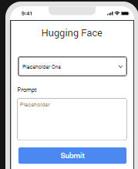

- Foundry APP Setup
When you import the component to your Volt MX Iris project, the HCL Volt MX Foundry services of the Hugging Face API are added to the HCL Volt MX Foundry app, which is associated with the Volt MX Iris project. While importing the Hugging Face API Component to your Volt MX Iris project, if there is no HCL Volt MX Foundry app associated with the existing Volt MX Iris project, a new HCL Volt MX Foundry app is automatically added to your HCL Volt MX Foundry environment and is associated with your Volt MX Iris.
To set the Foundry app, follow these steps:
- Click the HCL Volt MX Foundry app associated with your Volt MX Iris project from the Project Explorer. Click DATA & SERVICES.

- Under the Configure Services tab, click Integration and can see the GeminiImageUnderstanding Integration service. Click on that Integration service to add the keys.
- Click the Operations List tab. The Operations List tab opens with the list of operations available.
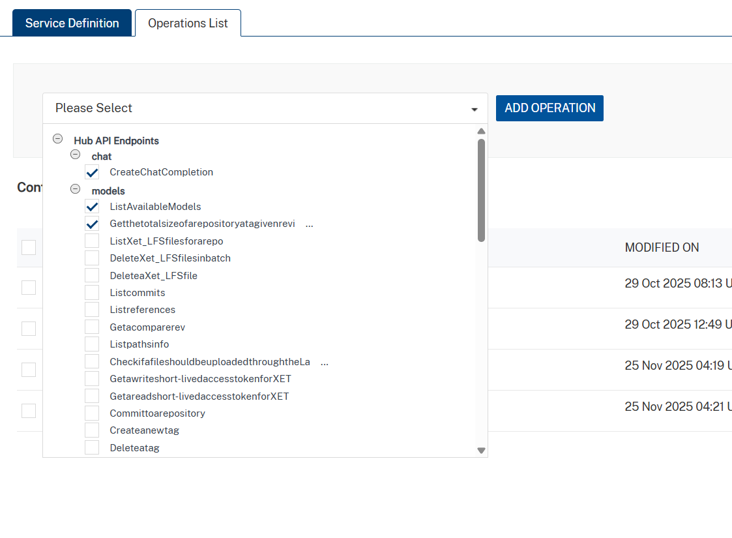
- Executing an Operation
Executing an operation involves making the API call by setting the necessary parameters and displaying the response. The procedure to execute any operation is the same, but the request parameters of the APIs vary.
This section provides steps to execute the generateContentFromImage operation.
A) Under the Configured Operations section, click the generateContentFromImage operation. The generateContentFromImage tab opens with the Request Input sub-tab opened by default.
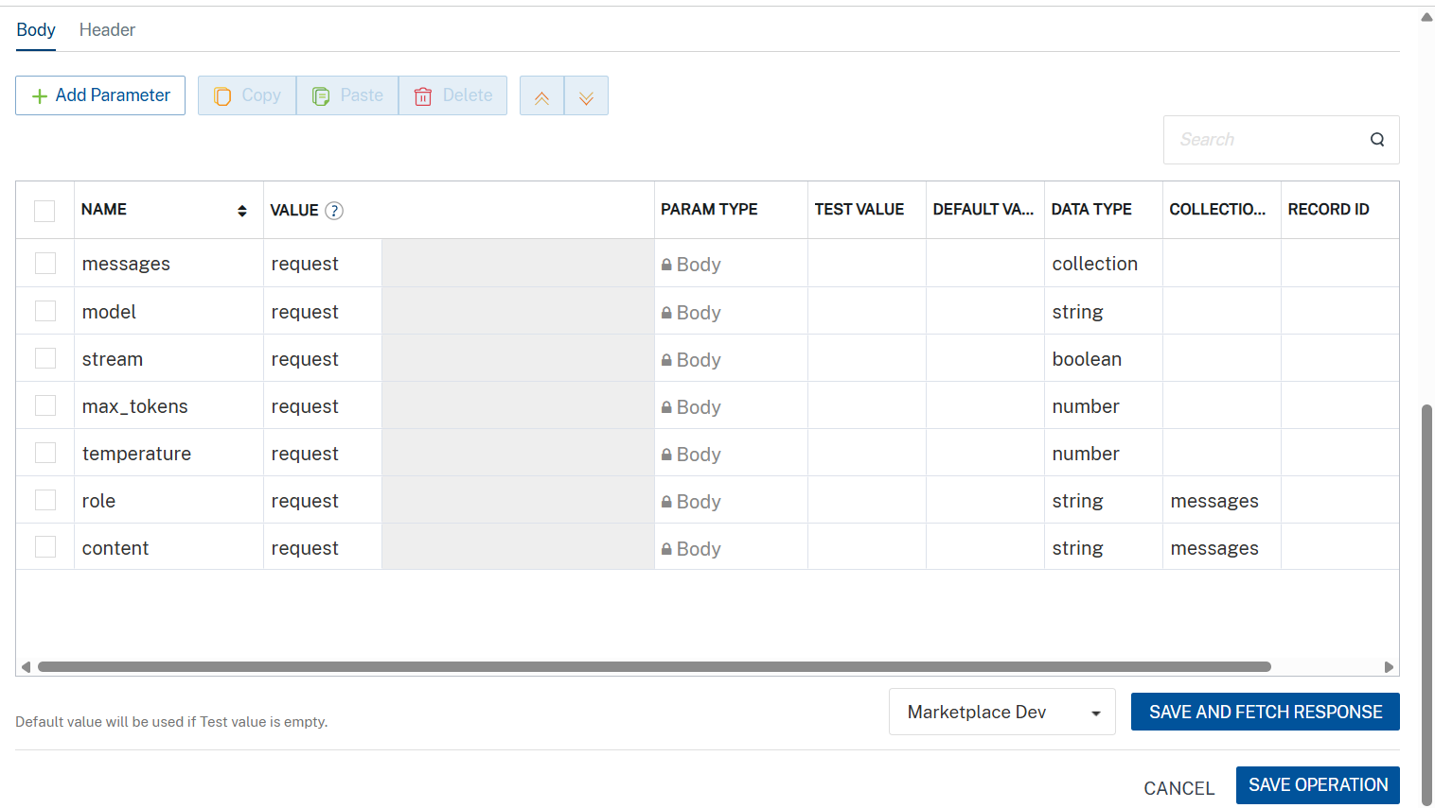
B) On the Request Input tab, in the Body section, for the following parameters, specify the values in the respective boxes under the Test Value column.
C) Click SAVE OPERATION.
D) Click SAVE AND FETCH RESPONSE. The Output Result dialog appears with the response. Otherwise, the Output Result shows an error.
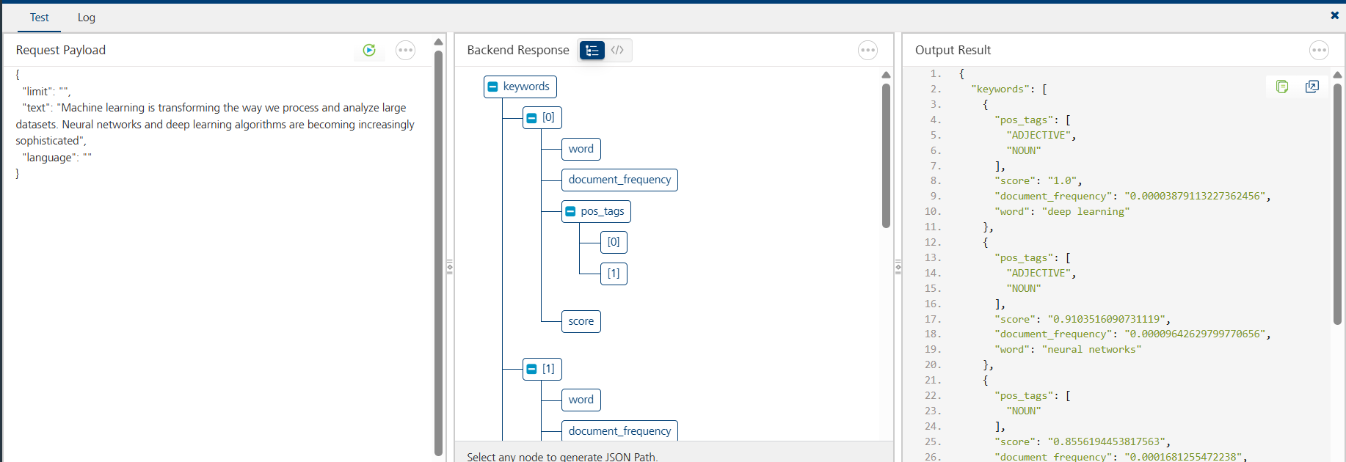

Publish the HCL Volt MX Foundry App
After you set the Operation Security Level, you must publish the HCL Volt MX Foundry app. To publish the HCL Volt MX Foundry, follow these steps:
In Volt MX Iris, click DATA & SERVICES, and then click Publish Project Services to Publish to your foundry app.
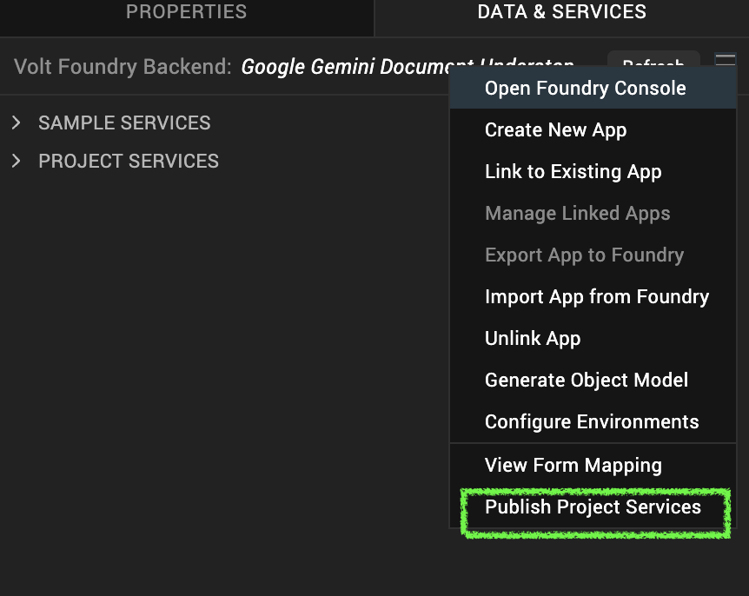
Select the environment to which you want to publish your app, and then click Publish.
After the app is published to your environment, the following window appears confirming the publish.
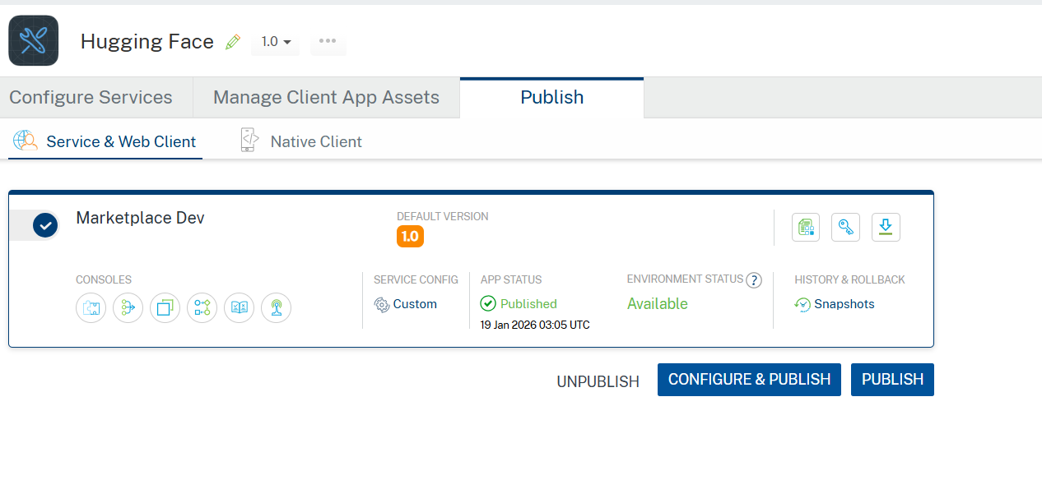

Building and previewing the app
After performing all the above steps, you can build your app and run it on your device. For more information, you can refer to the Building and Viewing an Application section of the Volt MX User Guide.
You can then run your app to see the Hugging Face API work in real time.

3.REVISION HISTORY
App version 1.0.0:

Known Issues
None

Limitations
None

