Date: 29-Oct-2025

HUGGING FACE API COMPONENT

VERSION: 1.0.0

OVERVIEW
The Hugging Face AI Platform is a comprehensive ecosystem that enables seamless interaction with thousands of open-source machine learning models across text, images, audio, video, and multimodal tasks. It provides developers, researchers, and enterprises with the tools to build, deploy, and scale AI applications using community-driven models and industry-grade inference APIs.
Hugging Face allows you to upload datasets, test models, run inference, fine-tune models, and integrate AI capabilities directly into applications. It supports all major ML frameworks, including PyTorch, TensorFlow, JAX, and ONNX — making it one of the most flexible and open ecosystems for AI development.
Hugging Face is not just a model hub; it is an end-to-end platform that powers model sharing, training, hosting, evaluation, and production-level deployment.

Use case:

1. Multimodal Image Understanding
Analyze images with prompts — object details, context reasoning, captioning, comparisons, and visual Q&A.

2. Document Intelligence (OCR + Extraction)
Parse scanned documents, forms, receipts, tables, handwriting, and convert them into structured text.

3. Text Intelligence (NLP)
Perform summarization, translation, sentiment analysis, embeddings, classification, and chatbot functions.

4. Image + Audio + Text Embeddings & Search
Create embeddings for similarity search across images, text, or audio — ideal for recommendations and vector databases.

5. Model & Dataset Hosting (Hugging Face Hub)
Store, version, share, and collaborate on models/datasets with community features and Spaces for demos.

6. Inference API for Production AI
Run any model (vision, text, audio, diffusion) via a single API endpoint without deploying servers.

7. Training & Fine-Tuning with Transformers
Fine-tune open-source models (LLMs, vision models, audio models) using Trainer, PEFT, LoRA, TRL, and integrate into apps seamlessly.

Percentage of re-use:
Approximate 85% of reuse.

Features

1. Model Hub
A massive repository of open-source AI models (LLMs, vision, audio, multimodal) with versioning, documentation, and community contributions.

2. Inference API
Run any model instantly via a single API endpoint—no servers, GPUs, or setup required. Supports text, image, audio, and diffusion models.

3. Dataset Hub
Host, version, explore, and load datasets easily with built-in tools, streaming, and community sharing.

4. Spaces (App Hosting)
Deploy ML apps using Gradio/Streamlit with one click. Ideal for demos, prototypes, and production-ready UI integration.

5. Transformers Library
A unified Python/JS library for training, fine-tuning, and using state-of-the-art NLP, vision, audio, and multimodal models.

GETTING STARTED

Prerequisites
Before you start using the Hugging Face API component, ensure the following
- Volt MX Iris
- HCL VoltMX Foundry
- To use the Hugging Face API, you need an API key. You can create a key with a few clicks in.Get a Hugging Face API key.

Reference document:
https://huggingface.co/docs

Platforms Supported
- Mobile
- iOS
- Android

Importing the component
You can import the Forge components only into the apps that are of the Reference Architecture type.

To import the Hugging Face API component, do the following:
- Open your app project in Volt MX Iris.
- In the Project Explorer, click the Templates tab.
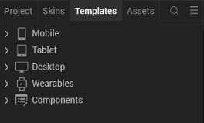
- Right-click Components, and then select Import Component. The Import Component dialog box appears.
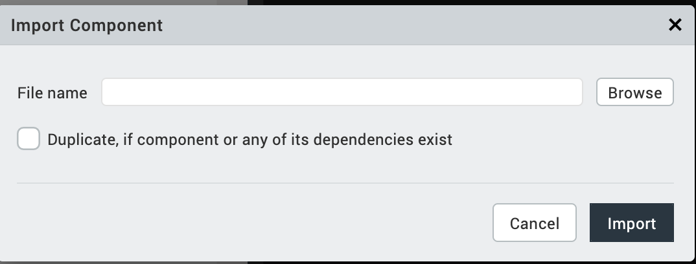
- Click Browse to navigate to the location of the component, select the component, and then click Import. The component and its associated widgets and modules are added to your project.

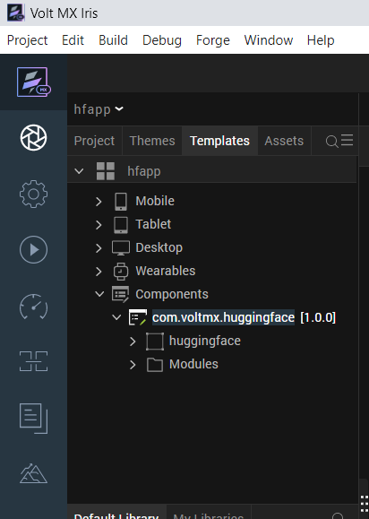

Once you have imported a component to your project, you can easily add the component to a form. For more information, refer Add a Component to a Form

- Foundry APP Setup
When you import the component to your Volt MX Iris project, the HCL Volt MX Foundry services of the Hugging Face are added to the HCL Volt MX Foundry app, which is associated with the Volt MX Iris project. While importing the Hugging Face API Component to your Volt MX Iris project, if there is no HCL Volt MX Foundry app associated with the existing Volt MX Iris project, a new HCL Volt MX Foundry app is automatically added to your HCL Volt MX Foundry environment and is associated with your Volt MX Iris.
To set the Foundry app, follow these steps:
- Click the HCL Volt MX Foundry app associated with your Volt MX Iris project from the Project Explorer. Click DATA & SERVICES.
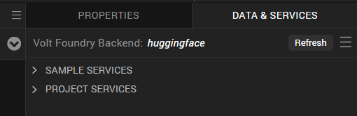
- Under the Configure Services tab, click Integration and can see the Huggingface Integration service. Click on that Integration service to add the keys.
- Click the Operations List tab. The Operations List tab opens with the list of operations available.
- Executing an Operation
Executing an operation involves making the API call by setting the necessary parameters and displaying the response. The procedure to execute any operation is the same, but the request parameters of the APIs vary. Click SAVE OPERATION.
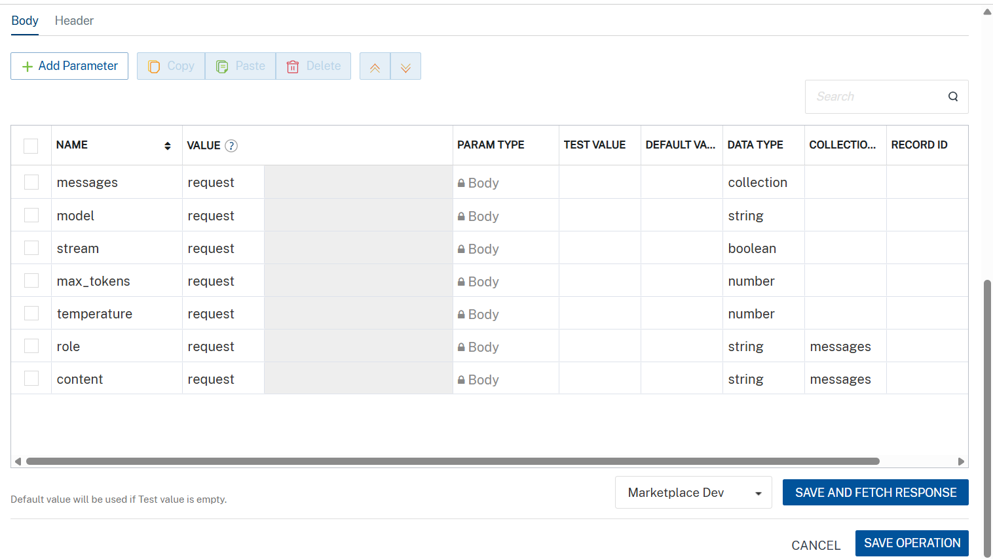
Click SAVE AND FETCH RESPONSE. The Output Result dialog appears with the response. Otherwise, the Output Result shows an error.
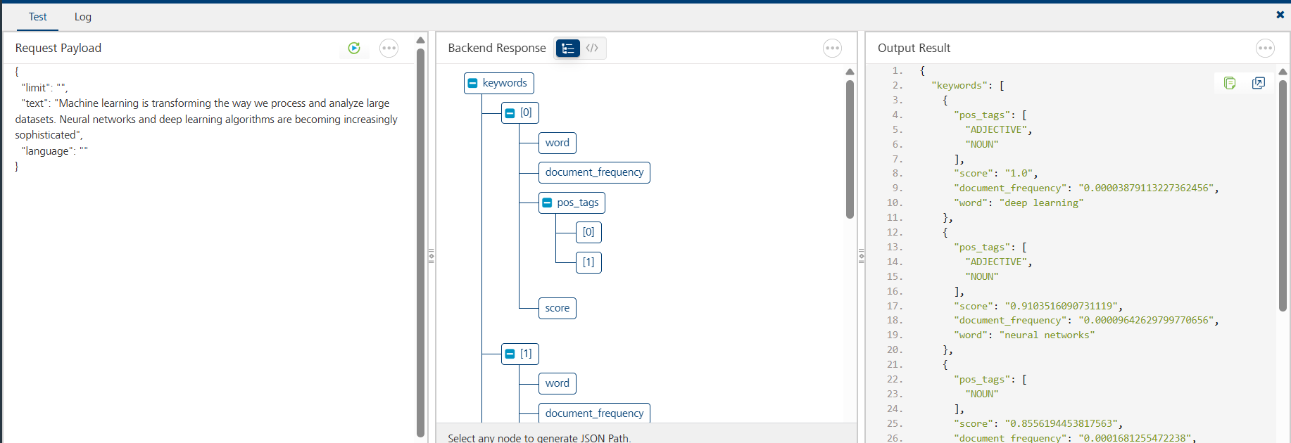
- Publishing the APP to VoltMX Foundry
After adding Hugging Face API to your app and configuring the necessary configurations, you must publish the app to Volt MX Foundry. For more information, refer to Publish a Project to Volt MX Foundry.
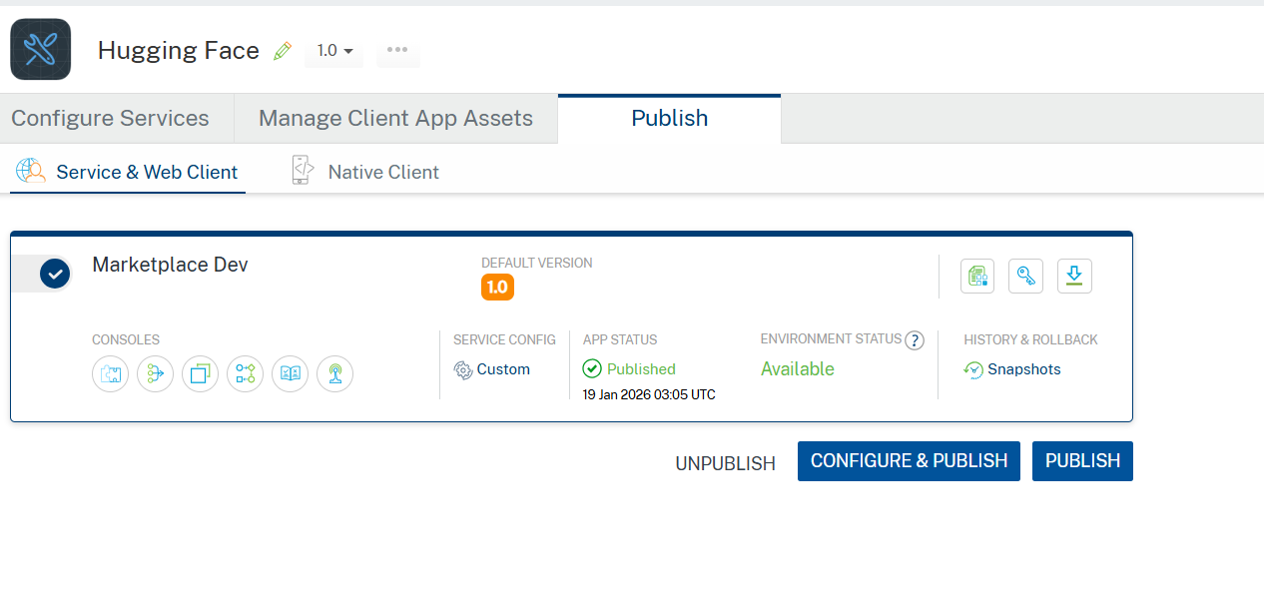
If you want to use the services in client applications, you need to publish the app to a run-time environment.

Building and previewing the app
After performing all the above steps, you can build your app and run it on your device. For more information, you can refer to the Building and Viewing an Application section of the Volt MX User Guide.
You can then run your app to see Hugging Face API work in real time.

REFERENCES

Dynamic Usage
You can also add a Hugging Face API Component dynamically. To do so,
1. In the Project Explorer, on the Projects tab, click Controllers section to access the respective Form Controller. Create a method and implement the code snippet similar to the sample code mentioned below.

createComponent: function() {
var HuggingFace= new com.voltmx.HuggingFace({
"height": "20%",
"id": "HuggingFace",
"isVisible": true,
"left": "0%",
"masterType": constants.MASTER_TYPE_USERWIDGET,
"isModalContainer": false,
"skin": "CopyslFbox0eadb17da372c44",
"top": "80%",
"width": "100%",
"zIndex": 1
}, {}, {});

this.view.add(HuggingFace);
}
In the code snippet, you can edit the properties of the component as per your requirement. For more information, see Setting Properties.
2. Save the file

Events
The component invokes events when its corresponding action is performed. You can configure any logic you want the component to perform whenever an event occurs. You can configure the events directly on the Actions tab or by writing a JavaScript, For more information, refer to Add Actions in the Volt MX Iris User Guide.

SelectModel

Description: | Selects a model.
Syntax: | selectmodel
Parameters: | modelid
Example: | this.view.componentID.selectmodel

parseddata

Description: | Parses data from different hugging face services.
Syntax: | parseddata
Parameters: | data
Example: | this.view.componentID.parseddata

APIs

- callHFService

Description: | Call Huggingface service.
Syntax: | callHFService
Parameters: | user text
Example: | this.view.huggingface.callHFService(user text)

REVISION HISTORY

App version 1.0.0:

A. Limitations
NA

B. Known Issue

- NA

