Date : 26-March-26

HYPERBOLIC

VERSION: 1.0.0

OVERVIEW
The Hyperbolic AI API provides a serverless inference platform for accessing high-performance AI models across multiple modalities, including chat completions, text generation, image generation, vision-language processing, and audio generation.
It enables applications to integrate advanced AI capabilities through simple REST-based API requests, eliminating the need to manage underlying GPU infrastructure. Hyperbolic AI supports scalable and low-latency inference, making it suitable for real-time applications, conversational interfaces, and enterprise-grade AI solutions.
The API follows an OpenAI-compatible request/response structure, allowing seamless integration with existing workflows. It supports dynamic model selection, structured payloads, and configurable parameters such as temperature, max tokens, steps, and other model-specific controls.
With support for multi-turn conversations, multimodal inputs (text, image, audio), and flexible inference workflows, Hyperbolic AI enables developers to build scalable, efficient, and production-ready AI applications with minimal integration effort.

Use case:

Conversational AI : Build chatbots with multi-turn, context-aware responses.

Content Generation : Generate text like emails, docs, and creative content.

Image Generation : Create images from text prompts for design and media.

Vision AI : Analyse images and perform visual Q&A using text + image inputs.

Text-to-Speech : Convert text into audio for voice-based applications.

Multimodal Apps : Combine text, image, and audio in a single workflow.

Enterprise Automation : Enable scalable AI-driven workflows and applications.

Features:

Unified Inference API : Access multiple AI capabilities such as chat, image generation, vision-language, and audio through a consistent REST-based API.

Dynamic Model Selection : Easily switch between different models by updating the model parameter in the request.

Context-Aware Chat Support : Supports multi-turn conversations using message-based inputs for maintaining context.

Multimodal Support : Enables processing of text, images, and audio within a single platform.

Fine-Grained Control : Configure output using parameters like temperature, max_tokens, steps, cfg_scale, etc.

Serverless GPU Inference : No infrastructure management required; scalable and efficient backend execution.

High Performance & Low Latency : Optimized for real-time AI applications with fast response times.

Structured JSON Responses : Consistent response format for easy parsing and integration.

Seamless Integration with Volt MX : Easily integrates with Volt MX Iris via Foundry services for enterprise applications.

GETTING STARTED

Prerequisites
Before you start using the Hyperbolic Adapter, ensure you have the following:

- HCL Foundry
- Volt MX Iris
- https://app.hyperbolic.ai/settings/api-keys
Reference document: Hyperbolic

B. Importing the Hyperbolic data adapter

You can import the Hyperbolic Data Adapter into HCL Foundry directly from the Volt MX Forge website or by importing the data adapter zip file.

To import Data Adapter to Volt Foundry, do the following:
- Sign in to the HCL Foundry.
- From the left navigation menu, select API Management.
- In API Management, select Custom Data Adapters.

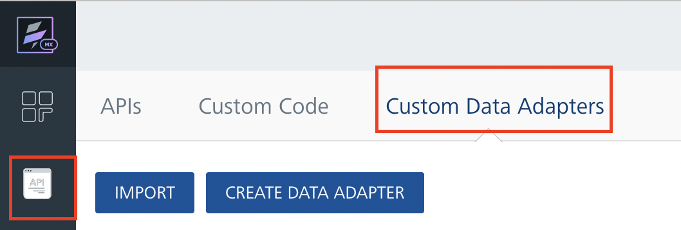
4. Click IMPORT to import a custom data adapter.
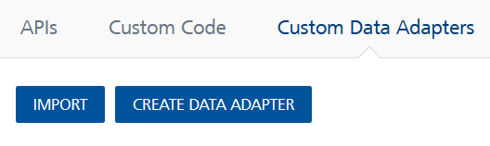
5. On the Import Data Adapter dialog box, click browser to import.

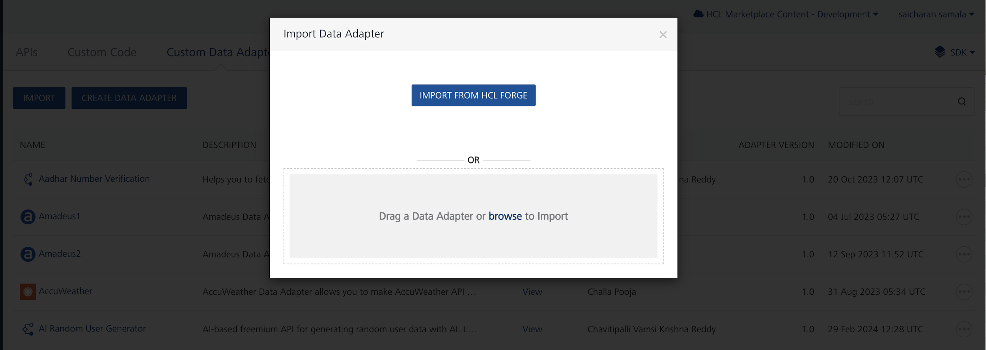

6. Click IMPORT FROM HCL FORGE. The Import Data Adapter from HCL Forge dialog appears with a list of available data adapters.
Click Import. Hyperbolic Data adapter is listed on the Custom Data Adapters page.
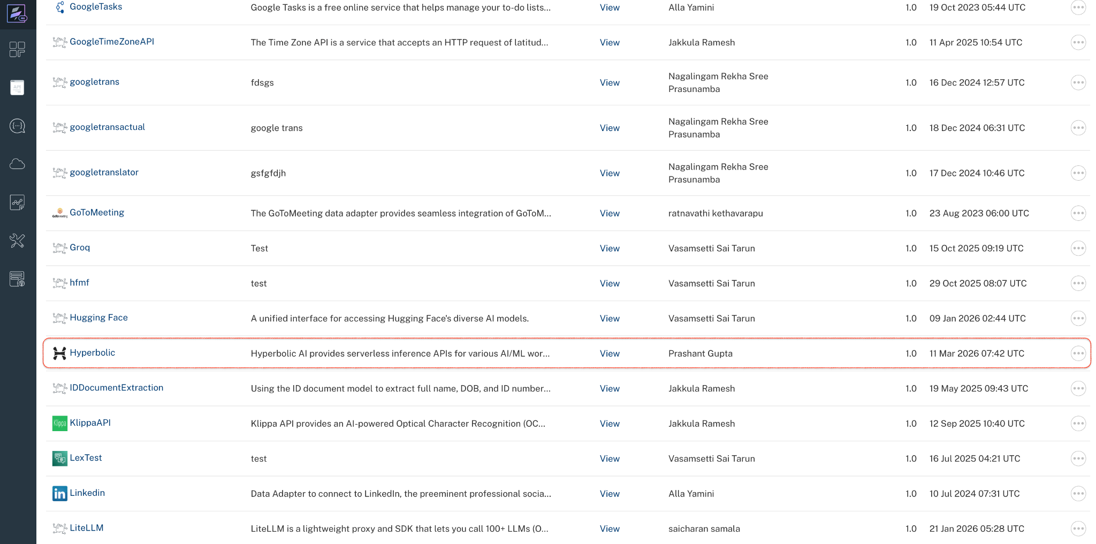
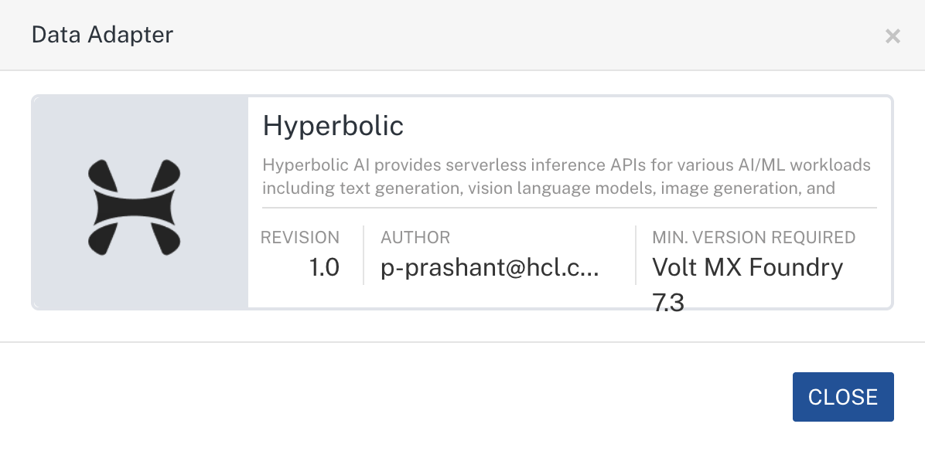
To import the data adapter zip file, do the following:
- Perform steps 1 to 4 in the above procedure
- Drag the data adapter zip file into the Drag a Data Adapter box.
Or
Click browse. The Open dialog appears.
Navigate to the location where you downloaded the data adapter (zip file) on your computer, select the data adapter, and click Open. The Import Data Adapter dialog shows the selected data adapter.
Note: Click Remove if the selected data adapter is not the one that you want to import.

C. Creating an Integration Service with Hyperbolic:
After you import Hyperbolic Data Adapter into Foundry, you must create an integration service with service type Hyperbolic.
To create an integration service with Hyperbolic, do the following:
- Log on to your HCL Foundry. The Dashboard page appears by default.
- In the left pane, click the API Management menu. The APIs tab opens by default.
- Click the Integration tab. The Integration tab opens with a list of existing integration services.
- Click CONFIGURE NEW. The Service Definition tab opens.
- In the Name box, type a unique name for your service.
- From the Service Type list,Hyperbolic.
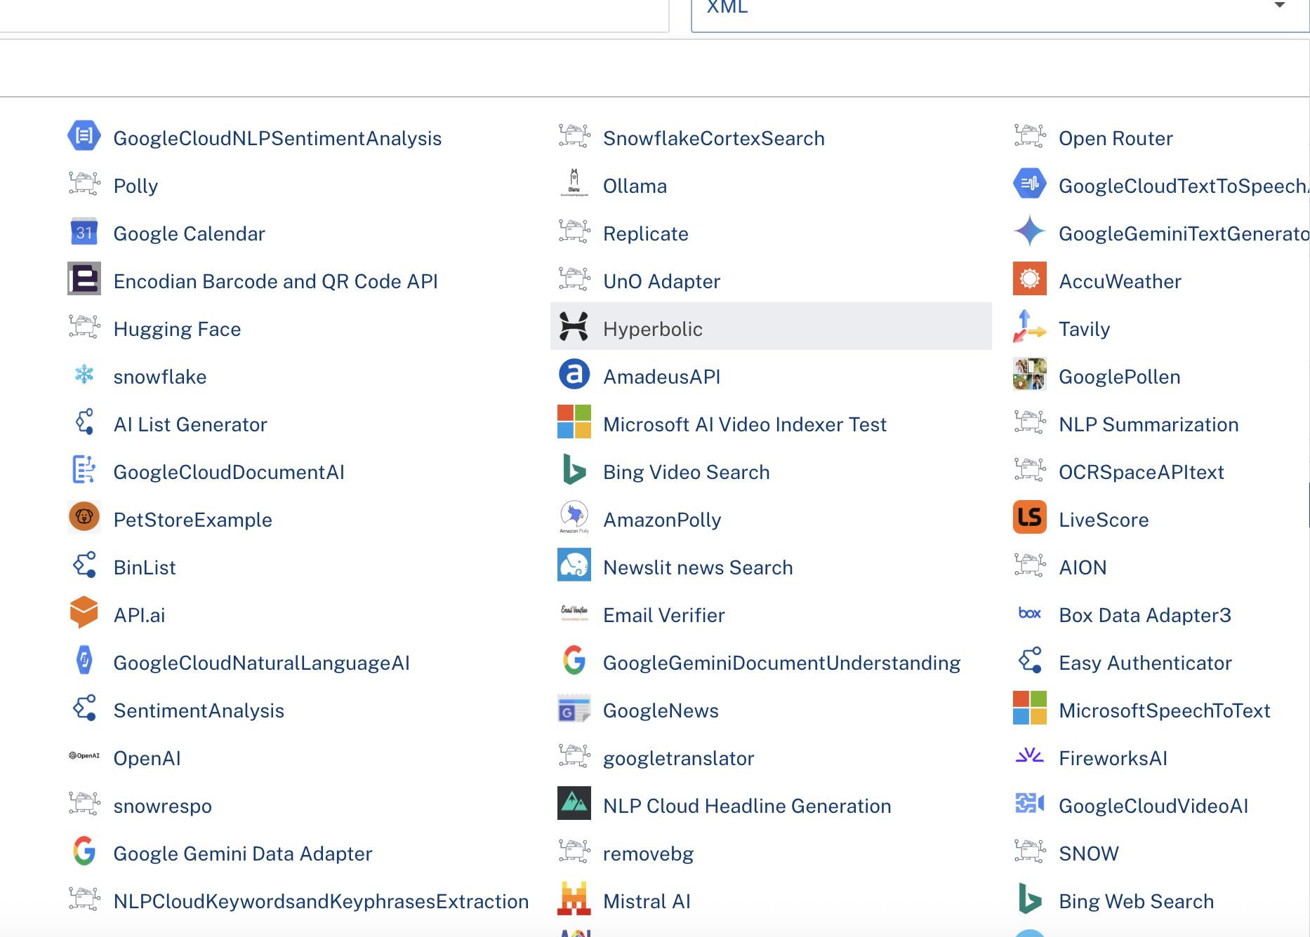
- Click Save

D. Creating an Operation
To make any API call in the HCL Foundry console, you must create an operation for the respective API and then execute the operation. Executing an operation involves making the API call and displaying the response.
This section provides steps to create an operation for the Hyperbolic.
Steps to create an operation for the Hyperbolic:
- Log on to your HCL Foundry. The Dashboard page appears by default.
- In the left pane, click the API Management menu. The APIs tab opens by default.
- Click the Integration tab. The Integration page appears with a list of existing integration services.
- From the list of integration services, select the integration service that you have created with service type as Hyperbolic. The Service Definition tab of the selected integration service opens by default.
- Click the Operations List tab. The Operations List tab opens.
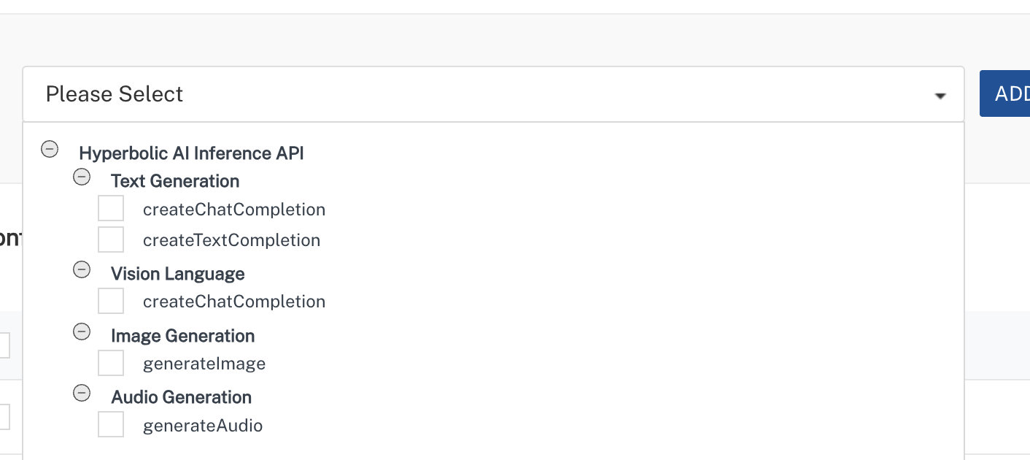
- Select post_chat_completions and Click Add Operations.
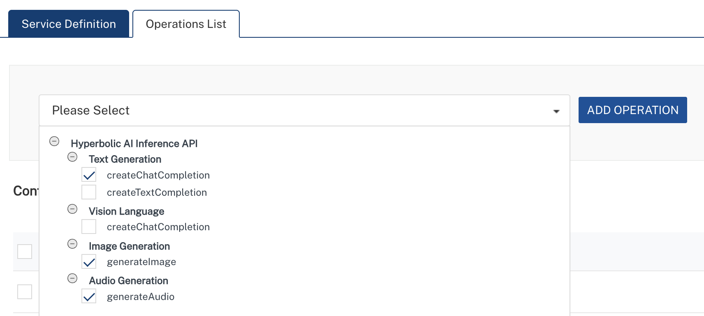

E. Executing Operation
Executing an operation involves making the API call by setting the necessary parameters and displaying the response. The procedure to execute any operation is the same, but the request parameters of the APIs vary. This section provides steps to execute the post_chat_completions(explained in Creating an Operation).
Steps to execute the post_chat_completions operation:
- Log on to your Hcl Foundry. The Dashboard page appears by default.
- In the left pane, click the API Management menu. The APIs tab opens by default.
- Click the Integration tab. The Integration tab opens with a list of existing integration services.
- From the list of integration services, select the integration service that you have created with service type Hyperbolic. The Service Definition tab of the selected integration service opens by default.
- Click the Operations List tab.
- In the Name box, the name of the operation is displayed by default. If you want, you can change the name.
- On the Request Input tab, in the Body section, for the following parameters, specify the values in the respective boxes under the Test Value column.
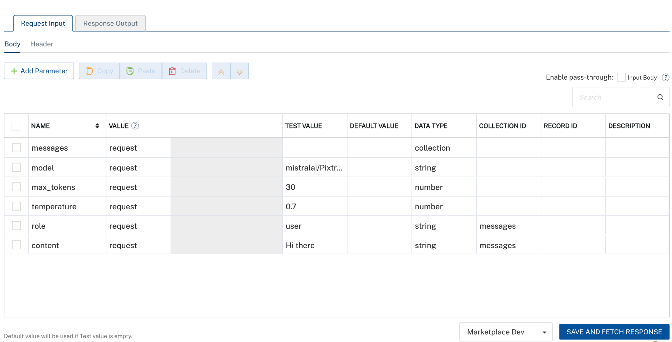
- Click SAVE AND FETCH RESPONSE. The Output Result dialog appears with the response. Otherwise, the Output Result shows an error.
. 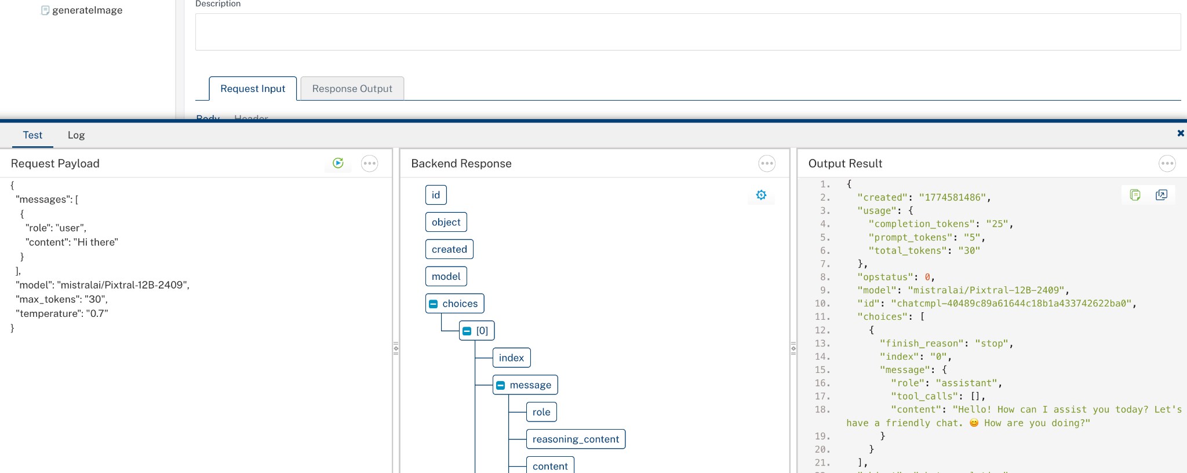

3. Publishing the App in VoltMX FOUNDRY:
After adding the Hyperbolic Data Adapter to your app and configuring the necessary configurations, you must publish the app to HCL Foundry. For more information, refer to Publish a foundry app.
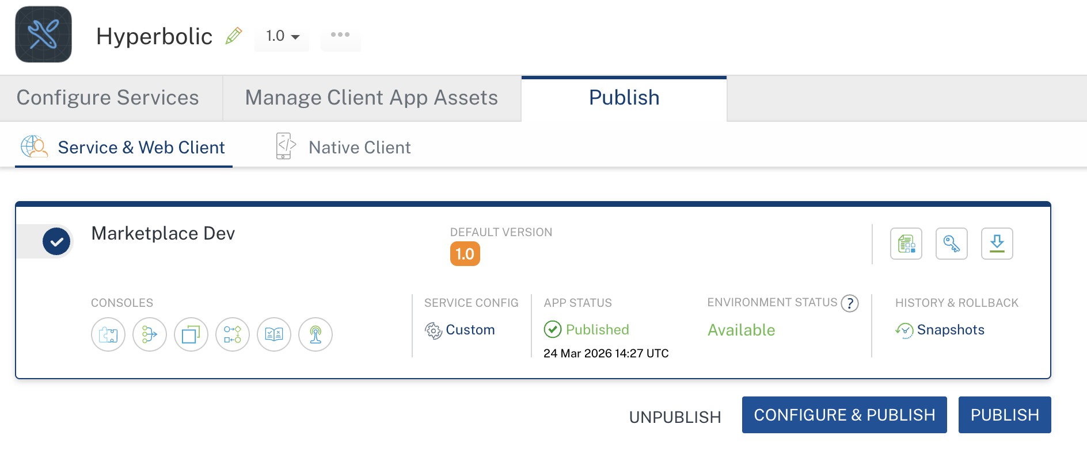

4. REFERENCES

Endpoint documentation
Hyperbolic

5. REVISION HISTORY
Adapter version 1.0.0:

Known Issues
None

Limitations
None

