Date : 27-Mar-25

HYPERBOLIC APPLICATION

VERSION: 1.0.0

OVERVIEW
The Hyperbolic AI application provides a unified interface to interact with multiple AI capabilities such as chat completion, text generation, image generation, vision-language processing, and audio generation through a single, intuitive UI.
It enables users to generate context-aware responses and multimodal outputs using simple inputs, while seamlessly integrating with Hyperbolic’s serverless inference APIs via backend services. The application eliminates the complexity of handling infrastructure by leveraging scalable GPU-powered inference through REST-based API calls.
The application supports flexible user inputs, dynamic model selection, and configurable parameters, allowing users to control output behavior for different AI tasks. It is designed with a chat-based interaction model, enabling multi-turn conversations and supporting various use cases within a single interface.
With support for text, image, and audio workflows, the Hyperbolic AI application demonstrates a scalable, low-latency, and user-friendly solution for building and testing AI-powered features, making it suitable for enterprise and demo purposes.

Use case:
- Conversational AI – Interact with chat-based AI for multi-turn, context-aware conversations.
- Content Generation – Generate text such as emails, documentation, and creative content.
- Image Generation – Create images from text prompts for design and visualization.
- Vision AI – Analyze images and perform visual Q&A using text + image inputs.
- Audio Generation – Convert text into speech for voice-based interactions.
- Multimodal Interaction – Use text, image, and audio capabilities within a single interface.

Features:
- Unified Interface – Access chat and image etc features from a single application UI.
- Dynamic Model Selection – Switch between models easily based on the selected use case.
- Context-Aware Chat – Supports multi-turn conversations with maintained history.
- Multimodal Support – Handles text and image interactions in one place.
- Configurable Parameters – Control output using parameters like temperature, max tokens, steps, etc.
- Structured Responses – Consistent response handling for seamless UI rendering.
- User-Friendly UI – Simple chat-based interface for easy interaction and testing.
- Seamless Integration – Connected with backend services via Foundry for secure and scalable API calls.

Percentage of re-use:
80%

GETTING STARTED

Prerequisites
Before you start using the Hyperbolic App, ensure you have the following:
- HCL Foundry
- Volt MX Iris
- https://app.hyperbolic.ai/settings/api-keys

Devices
- Mobile

Platforms
- Android
- IOS

Importing the App
To import the Hyperbolic App to Volt MX Iris, do the following:

To import the Hyperbolic App, do the following:
- Launch Volt MX Iris.
- Click project, and then select Import. The Import dialog box appears.
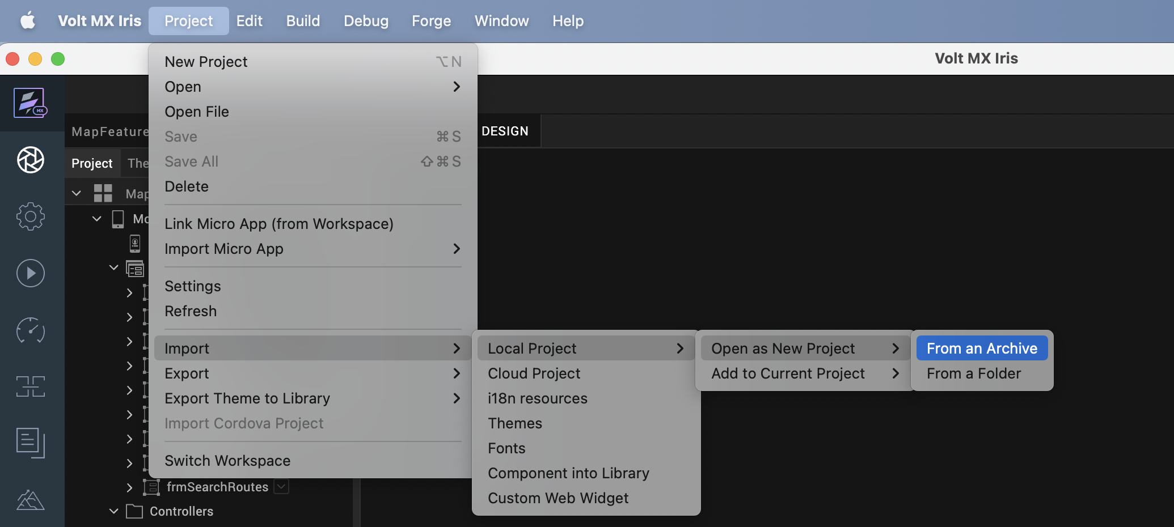

- Click From an Archive to navigate to the location of the project, select the files, and then click Import.
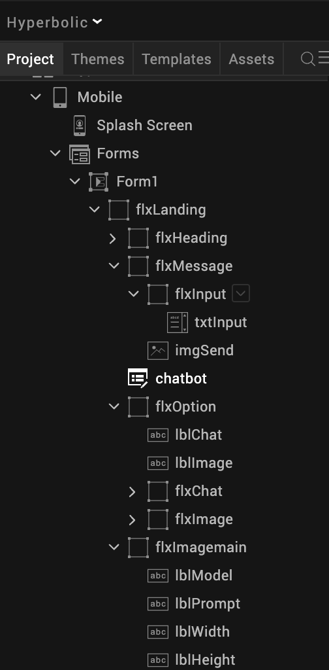
After you import the application, you can view the associated Foundry app connected at the in Data & Services section.
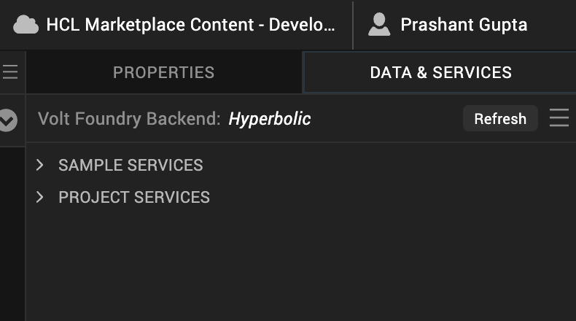

Hyperbolic Volt MX Foundry Services:
The Hyperbolic app contains an Integration Service:
Hyperbolic : Hyperbolic AI provides an OpenAI-compatible integration service for text generation, vision-language understanding, image synthesis, and audio processing. The service supports streaming, multi-turn conversations, and tool calling with 20+ models, optimized for low-latency, scalable deployments.
Operations

1. Chat Completions
Description:
This operation invokes Hyperbolic chat completion models to generate AI responses for conversational, reasoning, and text generation tasks with support for multi-turn context.
Endpoint:
POST /v1/chat/completions
Inputs include:
- messages – Conversation history with user and assistant roles
- model – Selected Hyperbolic-supported model
- temperature – Controls randomness of output
- top_p – Controls nucleus sampling
- max_tokens – Maximum tokens to generate
- stream (optional) – Enables streaming responses
Output:
- Generated assistant response in structured JSON format

2. Vision Completions
Description:
This operation processes text and image inputs together to perform vision-language tasks such as image understanding, captioning, and visual Q&A.
Endpoint:
POST /v1/chat/completions
Inputs include:
- messages – Contains text and base64-encoded image input
- model – Vision-capable model
- temperature – Controls response randomness
- max_tokens – Limits output size
Output:
- AI-generated response describing or analyzing the image
3. Image Generation
Description:
This operation generates high-quality images from text prompts using diffusion models.
Endpoint:
POST /v1/image/generation
Inputs include:
- model – Image generation model (e.g., FLUX)
- prompt – Text description for image generation
- height / width – Image dimensions
- steps – Controls generation quality
- cfg_scale – Controls adherence to prompt
Output:
- Base64 encoded generated image

4. Audio Generation
Description:
This operation converts text into speech audio output for voice-based applications.
Endpoint:
POST /v1/audio/generation
Inputs include:
- text – Input text for speech generation
- speed – Controls playback speed
Output:
- Base64 encoded audio (MP3 format)

F. Building the app
From the menu bar, go to Build and then select Build Native Local.
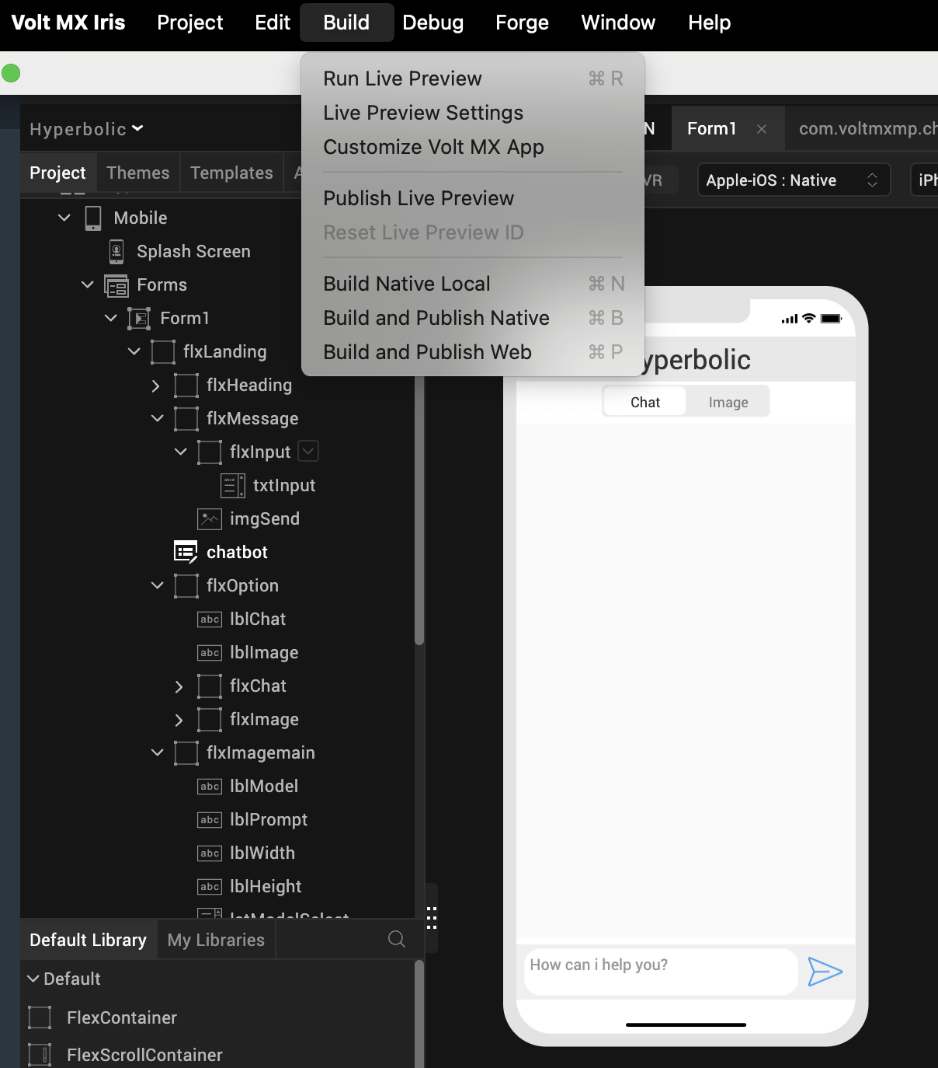

For Mobile, select Android and iOS. Click Build.
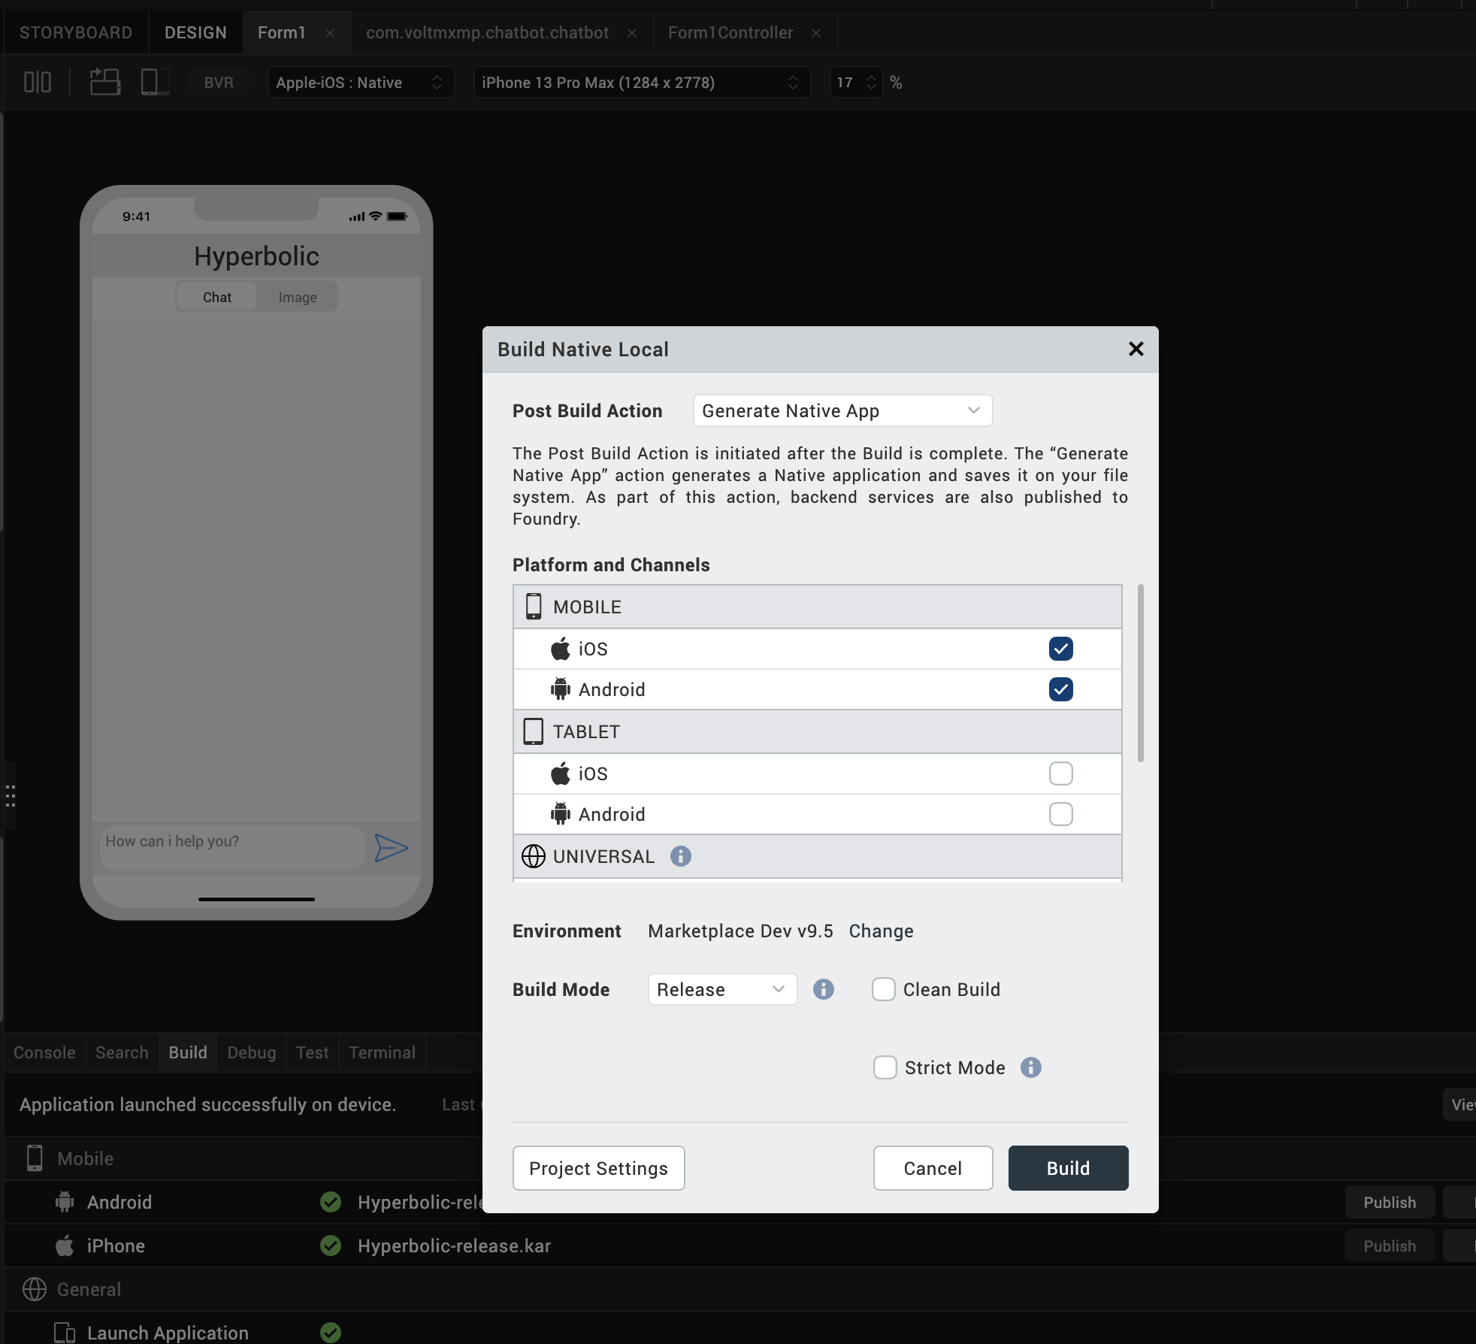

After the build is successful, run the app on your mobile device.

G. Application Flow
1. Landing Page of the application where we can switch between chat and image generation.
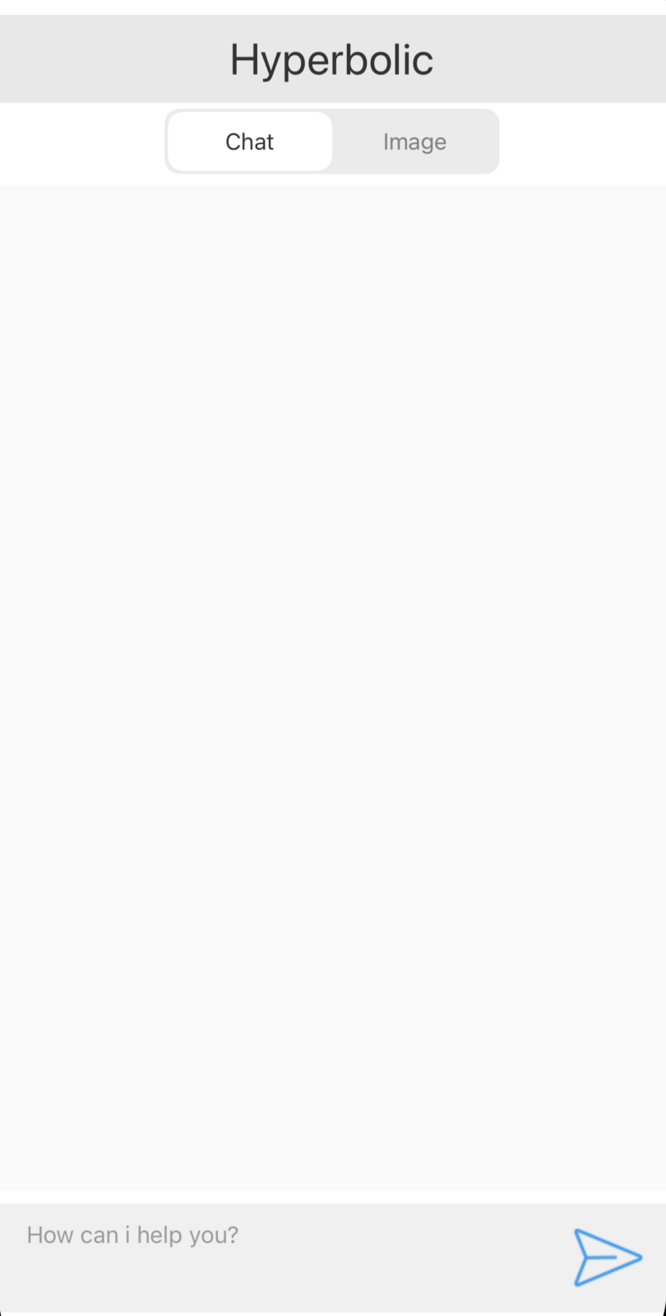

2. Chat using interactive UI with provided model system.

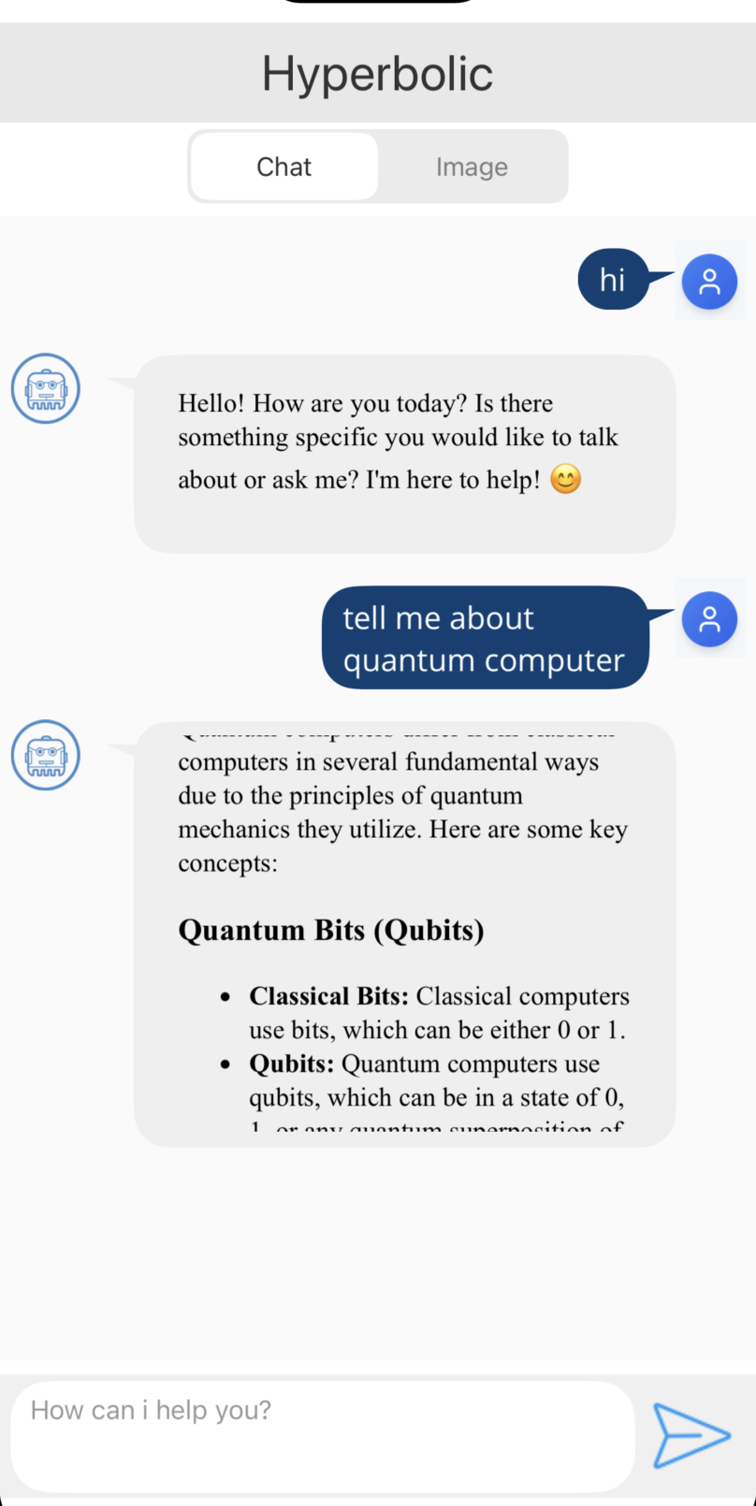

3. Switch to image tab and select required model, dimensions and prompt for image generation.
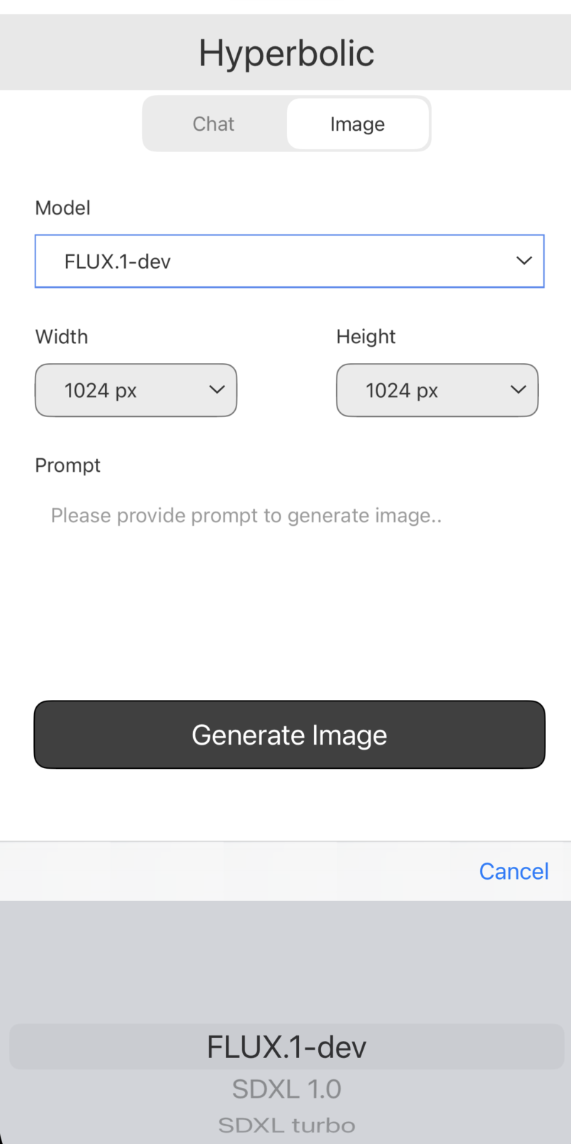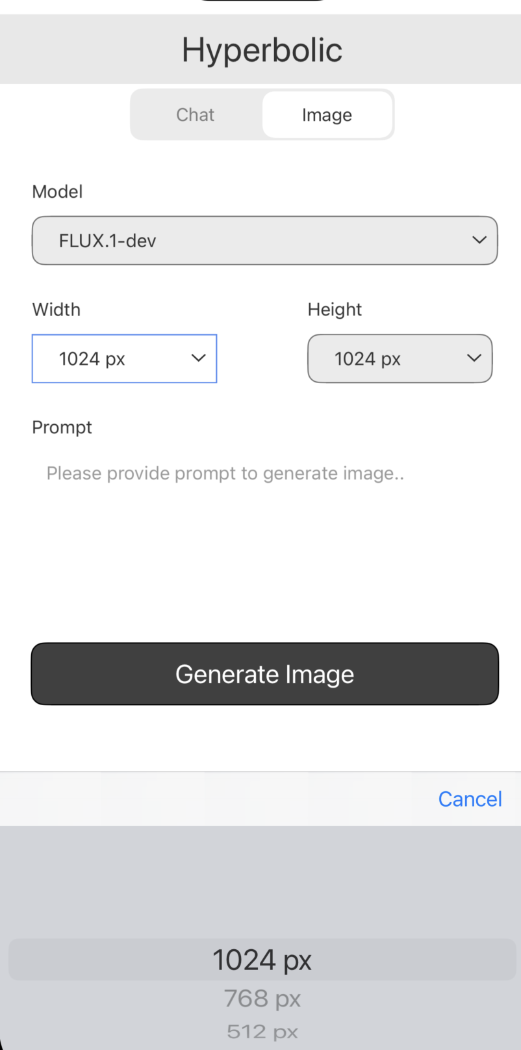

4. Provide prompt and click on generate image btn to make call and get success response.
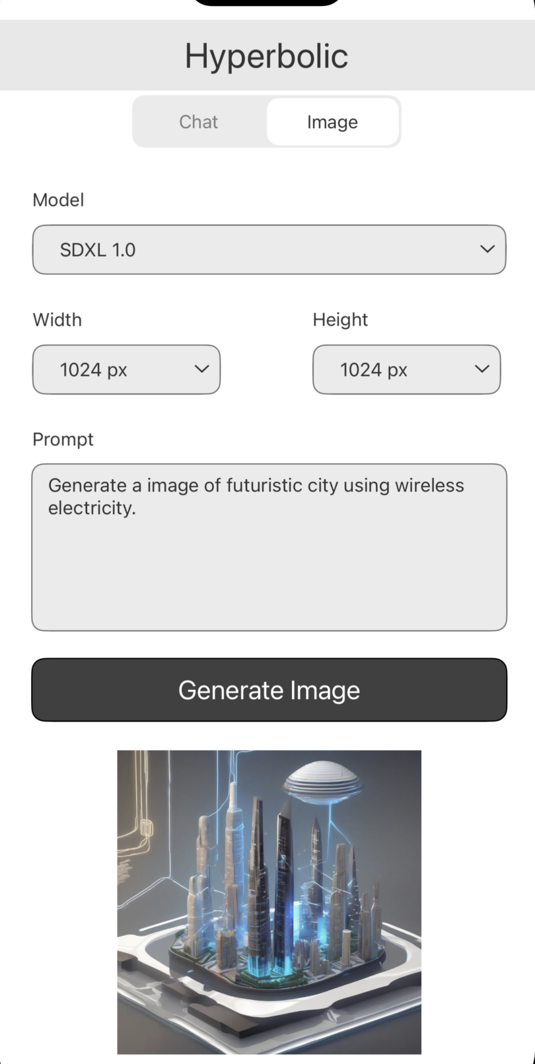

REVISION HISTORY
App version 1.0.0:

A. Limitations
1. Do not have support for Landscape mode.

B. Known Issue
- NA

