Date: 04-Aug-25

ID DOCUMENT EXTRACTION COMPONENT BACKEND SERVICE

VERSION: 1.0.0

OVERVIEW

The ID Document Extraction Component is a reusable module designed to analyze and extract key information from identity documents like Driver License, PAN Card etc.
We are using the ID document model from the prebuilt capabilities of Azure AI Document Intelligence to implement the required functionality.
Microsoft Azure AI Document Intelligence is a cloud-based service that uses advanced AI and OCR to extract structured data from documents like invoices, receipts, forms, and IDs. It automates data entry, improves accuracy, and enables faster decision-making across business processes. The service offers prebuilt and custom models for flexible data extraction.
Document Intelligence – ID Document Model:
Document Intelligence Identity document (ID) model combines Optical Character Recognition (OCR) with deep learning models to analyze and extract key information from identity documents. The API analyzes identity documents (including the following) and returns a structured JSON data representation.
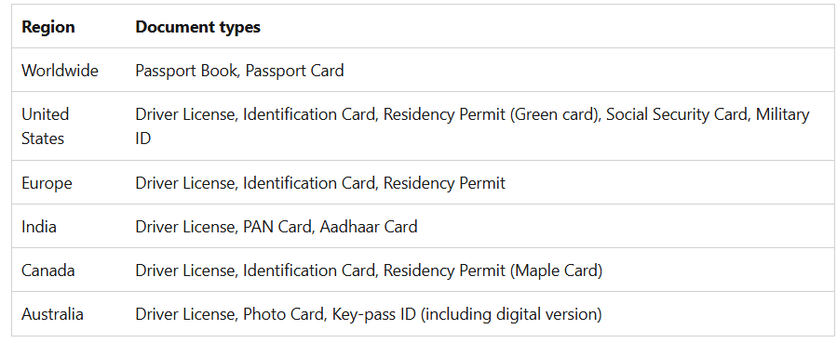

Features:

- Prebuilt Model(prebuilt-idDocument): We are using Document Intelligence Identity document (ID) model, and which combines Optical Character Recognition (OCR) with deep learning models to analyze and extract key information from identity documents. The API analyzes identity documents (including the following) and returns a structured JSON data representation.
- Document Models - Analyze Document: Analyzes documents using prebuilt or custom models. It extracts text content, detects key-value pairs, tables, figures, and barcodes. Returns results in JSON, plain text, markdown, or searchable PDF formats.
- Document Models - Get Analyze Result: Gets the result of a previously submitted document analysis using a prebuilt or custom model. It retrieves extracted data such as text, tables, and key-value pairs using the result ID.

Percentage of re-use:
80%

GETTING STARTED

Prerequisites
Before you start using the ID Document Extraction Component Back-end Service, ensure you have the following:

- HCL Foundry
- Volt MX Iris
- Microsoft account
- An Azure subscription - Create one for free
- A Document Intelligence (single-service) or Azure AI services (multi-service) resource. Once you have your Azure subscription, create a single-service or multi-service Document Intelligence resource, in the Azure portal. Here I created a single-service. After your resource deploys, select Go to resource.
  - You'll need the key and endpoint from the resource you create to connect your application to the Azure AI Document Intelligence service.
  - You can use the free pricing tier (F0) to try the service, and upgrade later to a paid tier for production.
Note: For Document Intelligence access only, create a Document Intelligence resource. You need a single-service resource if you intend to use Microsoft Entra authentication..
For more information, refer to the following links: https://learn.microsoft.com/en-us/azure/ai-services/document-intelligence/quickstarts/get-started-sdks-rest-api?view=doc-intel-4.0.0&pivots=programming-language-rest-api,

IMPORTING THE BACK-END SERVICE
- Download the ID Document Extraction Component service zip file from HCL Forge.
- Sign in to the HCL Foundry Console.
- On the Foundry Apps page, click IMPORT.
- On the Import App dialog box, drag and drop the zip file that you downloaded earlier. Alternatively, you can browse for the zip file on your system. After the zip file is uploaded, the console displays the default App Name and Version.
- Click IMPORT.

CONFIGURING THE IDENTITY SERVICE
1. Sign in to the HCL Foundry Console.
2. From the Foundry Apps page, select the app that you imported earlier.
3. Under Configure Services, on the Identity tab, select the MicrosoftAzureAIService identity
Service.

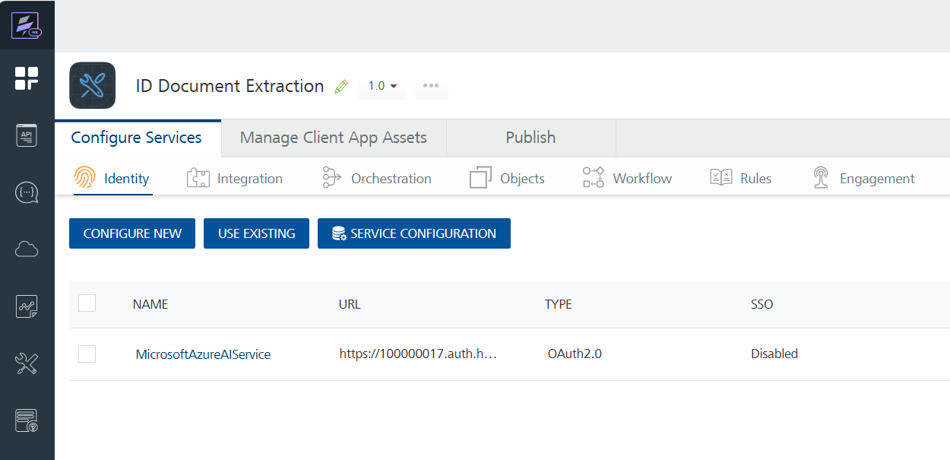

4. Under Client Details, type the Client ID and Client Secret that you obtained from Microsoft.
To obtain Client ID and Client Secret from Microsoft refer to the documentation below.
Links:
https://learn.microsoft.com/en-us/entra/identity-platform/quickstart-register-app?tabs=certificate,
https://learn.microsoft.com/en-us/entra/identity-platform/access-tokens,
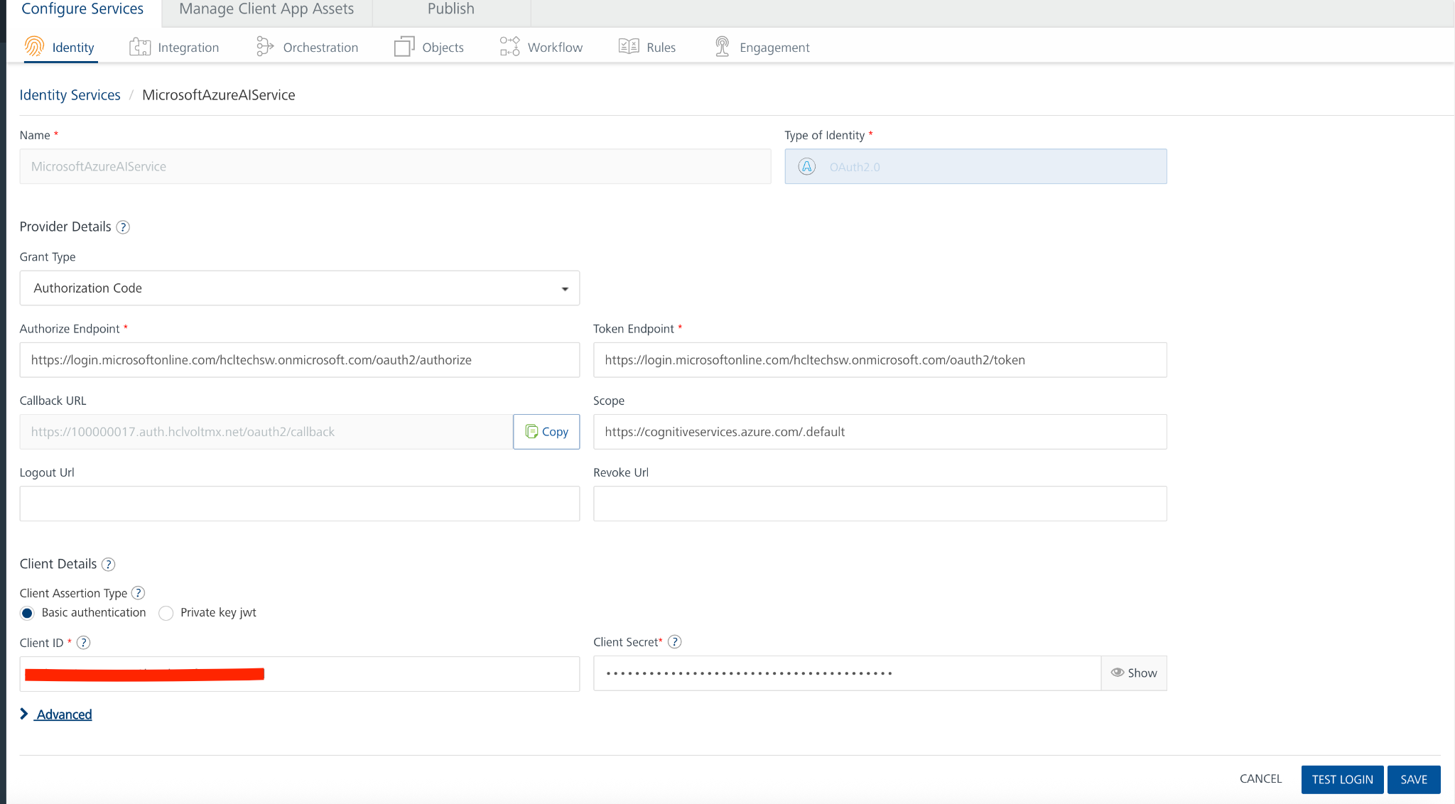
https://learn.microsoft.com/en-us/rest/api/aiservices/document-models/analyze-document?view=rest-aiservices-v4.0%20(2024-11-30)&tabs=HTTP#oauth2auth
Note: If you want to verify the details, click TEST LOGIN and sign in by using your Microsoft credentials.
5. Click Save.
USING INTEGRATION SERVICE

1. Sign in to the HCL Foundry Console.

2. From the Foundry Apps page, select the app that you imported earlier.

3. Under Configure Services, on the Integration tab, expand the IDDocumentService. Create an Integration Service using MicrosoftAzureAIService identity Service and Endpoint URL. To make any API call in the Foundry console, you must create an operation for the respective API and then execute the operation.
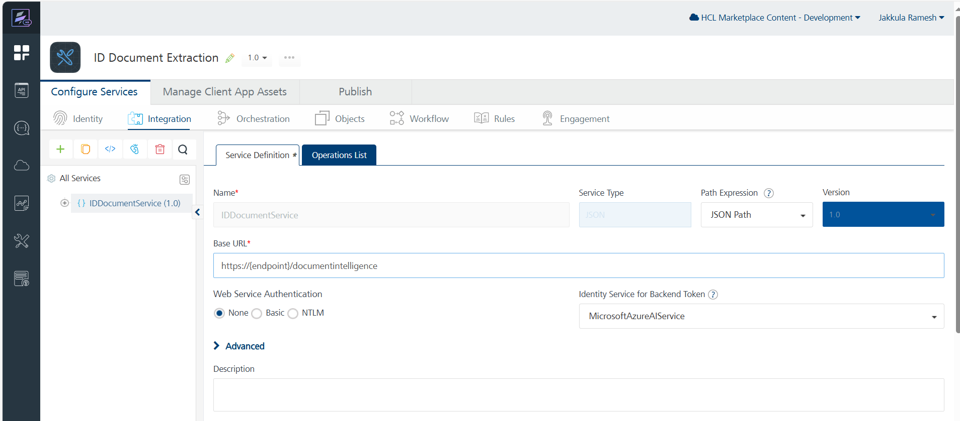

4. From the list of operations, select the operations to test. Executing an operation involves making the API call and displaying the response.

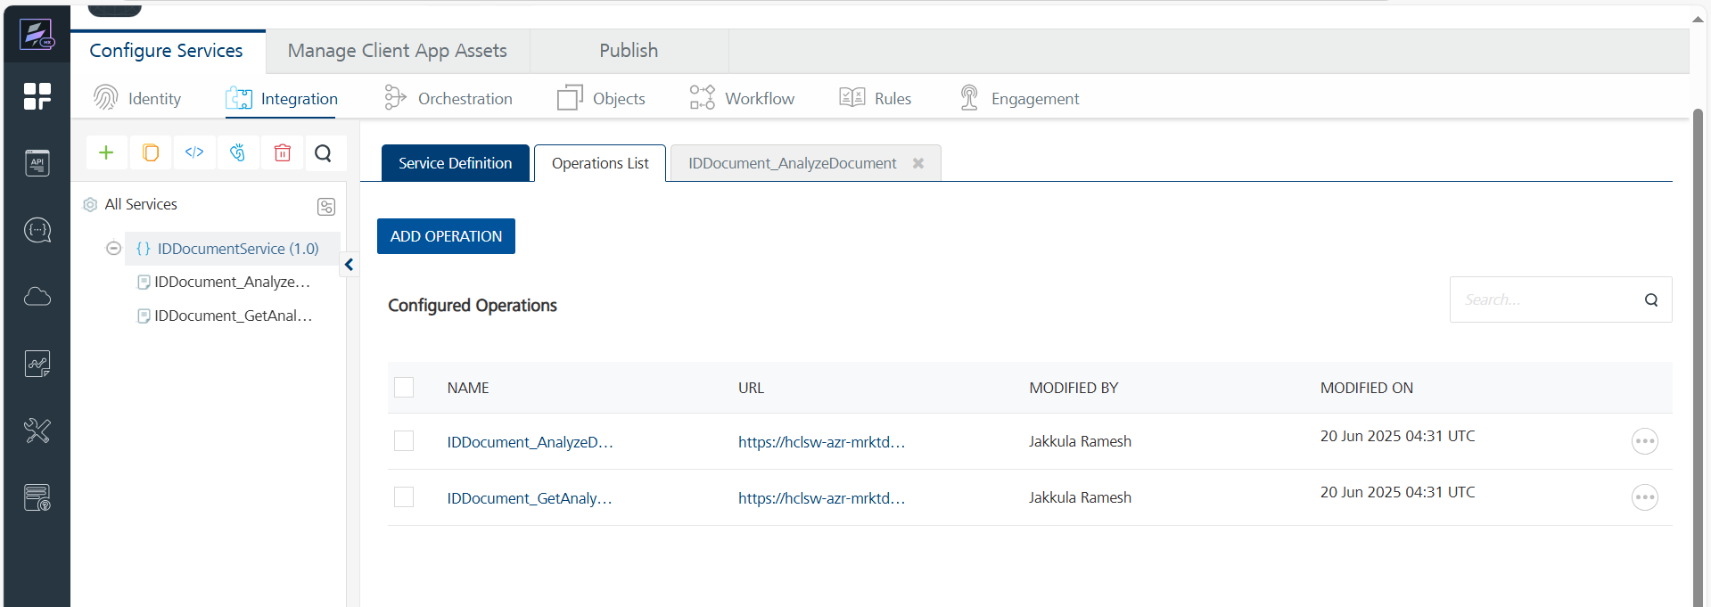

5. On the Request Input tab, enter a TEST VALUE or a DEFAULT VALUE for the parameters.
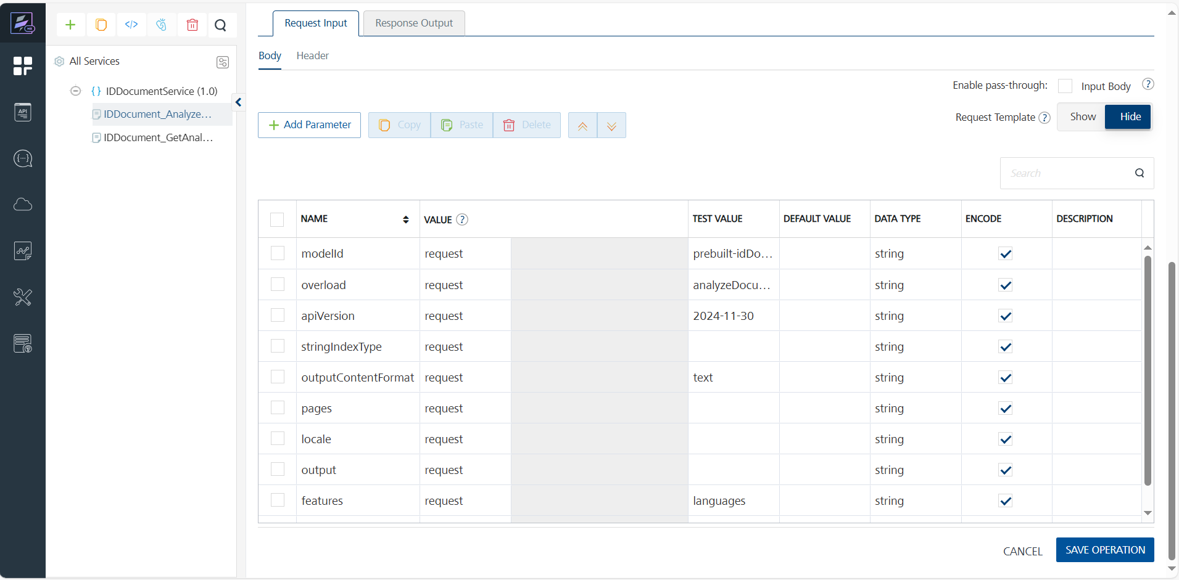

Provide the Ocp-Apim-Subscription-Key in the header. Log in to Azure at https://portal.azure.com, and open the resource created in the prerequisites section of Step-2. Then, navigate to the 'Keys and Endpoint' section to get the Ocp-Apim-Subscription-Key.
The authorization token will be used by default, as the Identity service is configured during the creation of the Integration service.

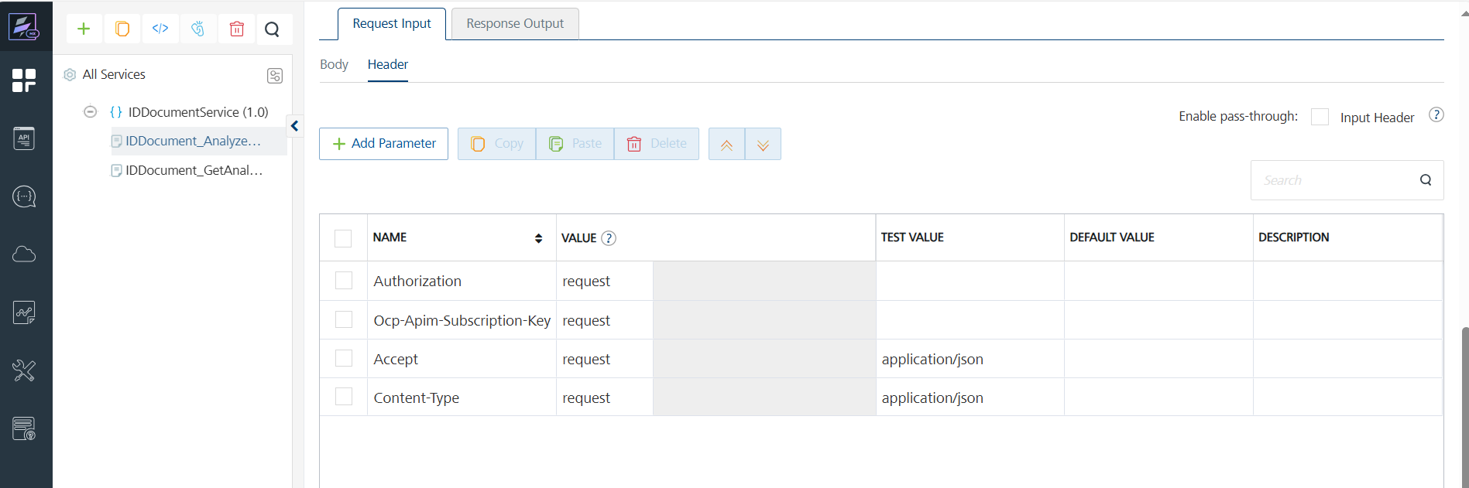
Note:
- To fetch the response on Volt MX Foundry, clear the Enable pass-through check box on the Response Output tab.
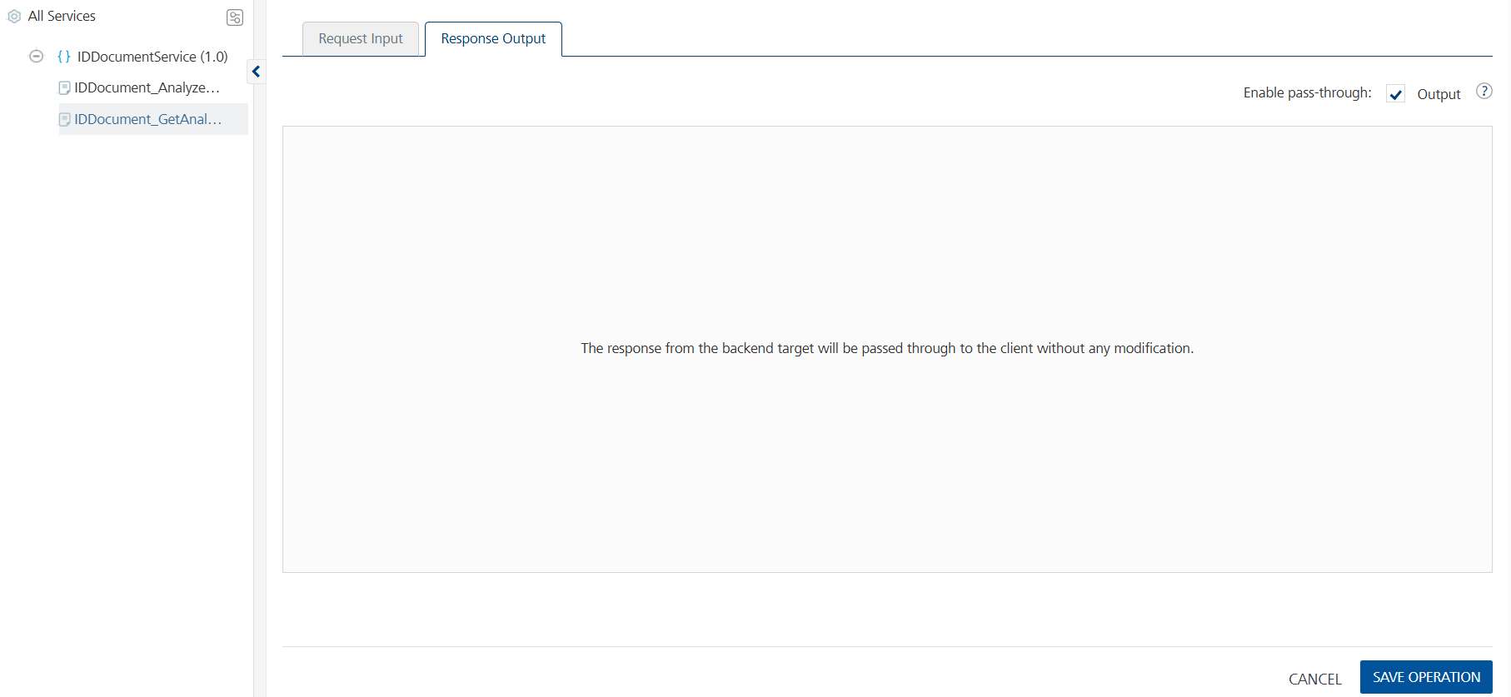
- Click SAVE OPERATION.

MISCELLANEOUS
- For APIs with POST calls, check the parameter names configured on Volt MX Foundry, as the parameters with the same names in a single request body will be renamed according to the context.

Publishing the App to Volt MX Foundry
After adding, configuring the necessary configurations, you must publish the app to Volt MX Foundry.
If you want to use the services in client applications, you need to publish an app to a run-time environment. You can create the service (as described above) in an application or import the service into an application and publish the application.
For more information, refer to Publish a Project to Volt MX Foundry.

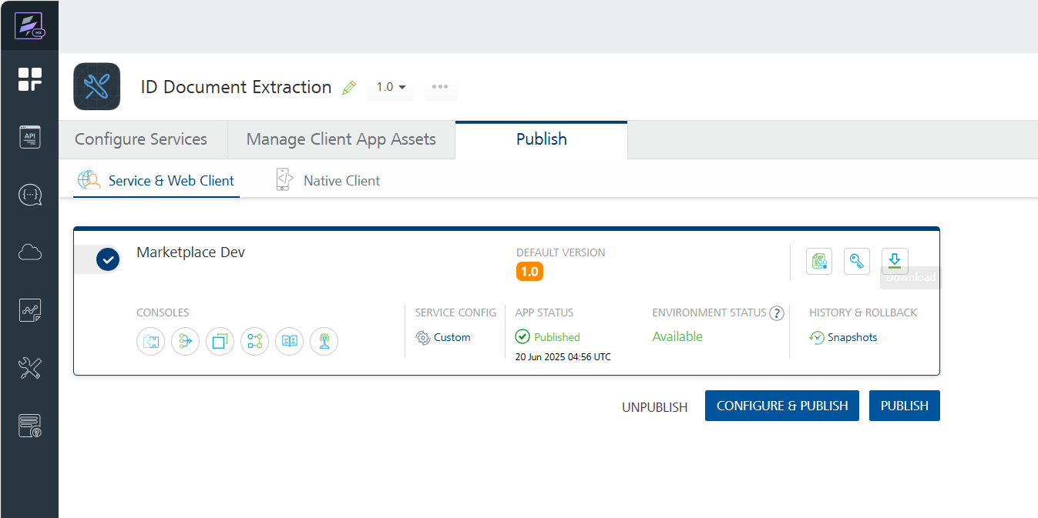
You can also link the Volt Foundry app to a client application.

- Reference API documentation:
Identity document (ID) processing – Document Intelligence - Azure AI services | Microsoft Learn
Document Classifiers - REST API (Azure Azure AI Services) | Microsoft Learn

REVISION HISTORY
App version 1.0.0:

Known Issues
None

Limitations
None

