Date :  27th Feb 2024

IP Geo Location

Version: 1.0.0

# **Overview**

API returns location data such as country, city, latitude, longitude, timezone, asn, currency, security data for IPv4 and IPv6 addresses in JSON or XML formats.

# **Getting Started**

## **Prerequisites:**

* Volt Foundry
* Subscribe to freemium for IP Geo Location from [RapidApi](https://rapidapi.com/hub)

## **Importing the adapter:**

**To import the Data Adapter to Volt Foundry, do the following:**

1. Sign in to the  [HCL Foundry](https://manage.hclvoltmx.com/).
2. From the left navigation menu, select **API Management**.
3. In **API Management**, select **Custom Data Adapters**.  
   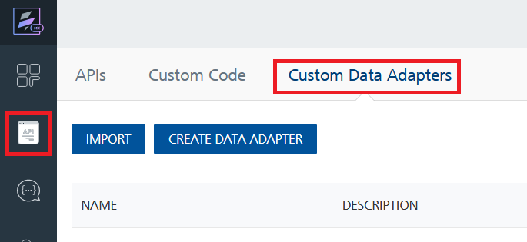
4. Click **IMPORT** to import a custom data adapter.  
   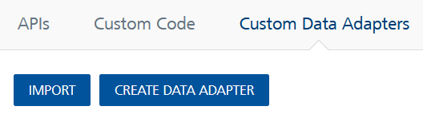
5. On the Import Data Adapter dialog box, click browser to import.  
   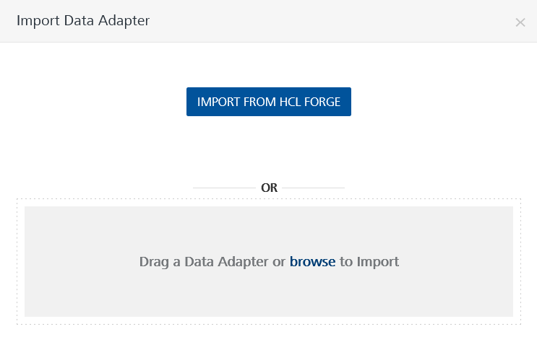
6. Select IP Geo Location zip file and click **IMPORT**.

After you import the data adapter, Volt Foundry opens a window that shows the metadata of the data adapter.

After you import the data adapter, you can view it on the Custom Data Adapters page and use it to create services on Volt Foundry.

**Following are the steps for generating API key :**

1. Go to [RapidApi.com](https://rapidapi.com/hub), create account.
2. Search IP Geo Location, Subscribe to its plan according to your requirement.

1. Api key and host will be mentioned in the code snippet.

1. Mention the same in headers in Foundry to get required responses.

## **[Creating an Integration service](javascript:void(0);):**

After you import the data adapter into Volt Foundry, you can use it to create an Integration Service.

Follow the given steps to create an Integration service using the IP Geo Location Adapter.

1. Sign in to the [HCL Foundry](https://manage.hclvoltmx.com/).
2. From the left navigation menu, select **API Management**.
3. In **API Management**, select **Integration**.  
   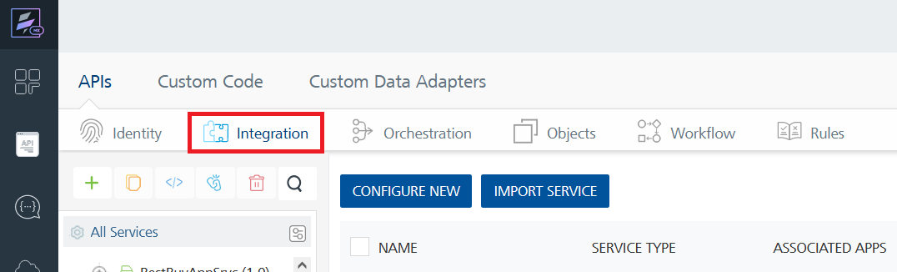
4. To create a new service, click the **+** button or the **CONFIGURE NEW** button.  
   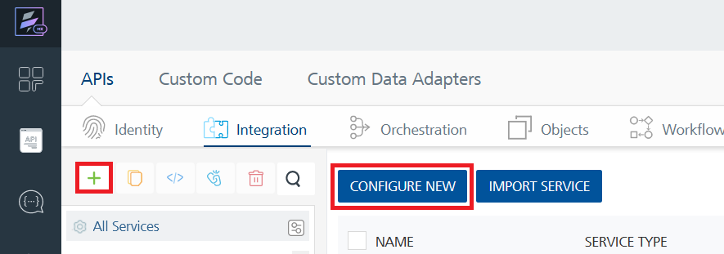
5. On the Service Definition tab, select the service type as IP Geo Location and click **SAVE**.  
   A screenshot of a computer

   Description automatically generated

Alternatively, you can also create a Foundry app and create an Integration service inside it.

## **[Creating and Executing operations](javascript:void(0);):**

After you create an integration service, you can create and execute operations using the service.

#### Creating an Operation

* In **API Management/Foundry app you created**, in the **Integration** section, select the service that you created.
* After you select the service, navigate to the **Operation List** tab.  
  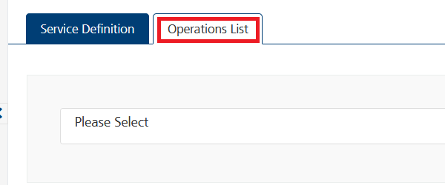
* From the drop down list, select an operation that you want to execute, and click **ADD OPERATION**.

#### Executing an Operation

* From the **Operations List** tab, in the **Configured Operations** section, select the operation you want to execute.

* On the Operation Page, in the Request Input tab, enter a TEST VALUE for all the fields.  
  A screenshot of a computer

  Description automatically generated
* Select a run-time environment and click **Save and Fetch Response** to get a response based on your inputs.

## [**Publishing your application**](javascript:void(0);)

If you want to use the services in client applications, you need to publish an app to a run-time environment. You can create the service (as described above) in an application or import the service into an application and publish the application.

# **References**

## Endpoint Documentation

|  |  |  |
| --- | --- | --- |
| Endpoints | Input params-Type | Description |
| /check | Format(string), filter(string), language(enum) | Returns the IP address of the client with all the location data |
| /{ip} | Format(string), filter(string), language(enum) | Provides geo information for the given IP |

* Refer [this link](https://rapidapi.com/natkapral/api/ip-geo-location) for more information about API endpoints.

# **Revision History**

Adapter version 1.0.0: