Date : 20-10-2023

IRCTC

version: 1.0.0

Overview
An API with various functionalities for Indian railways IRCTC API. We are not affiliated with Indian railways IRCTC in any form, and this is not an official API, but all the results are real-time and accurate. You can get in touch with us at https://t.me/rapidapisupport. For payment related inquiries, APIs and customised plans.

Getting Started

Prerequisites
- Volt Foundry
- Api key from https://rapidapi.com/IRCTCAPI/api/irctc1

Note:Provide this Api-Key in header part.

Importing the adapter
To import the Data Adapter to Volt Foundry, do the following:
- Sign in to the HCL Foundry.
- From the left navigation menu, select API Management.
- In API Management, select Custom Data Adapters.
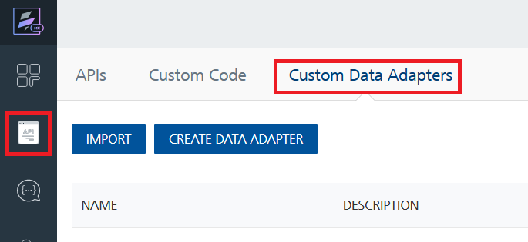
- Click IMPORT to import a custom data adapter.
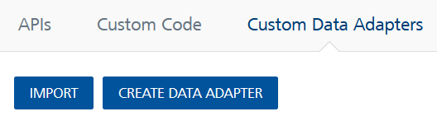
- On the Import Data Adapter dialog box, click browser to import.
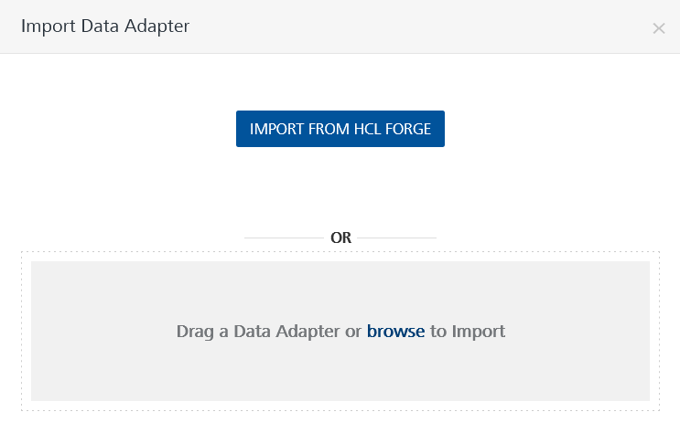
- Select IRCTC.zip file and click IMPORT.
After you import the data adapter, Volt Foundry opens a window that shows the metadata of the data adapter.
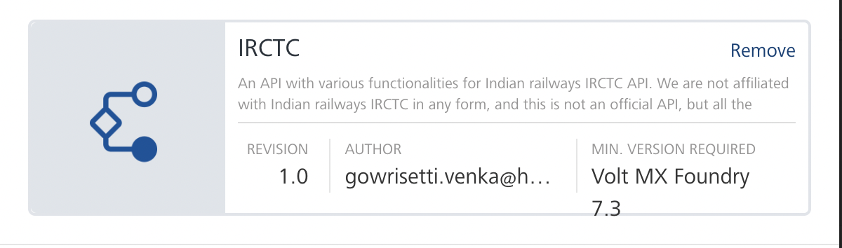
After you import the data adapter, you can view it on the Custom Data Adapters page and use it to create services on Volt Foundry.
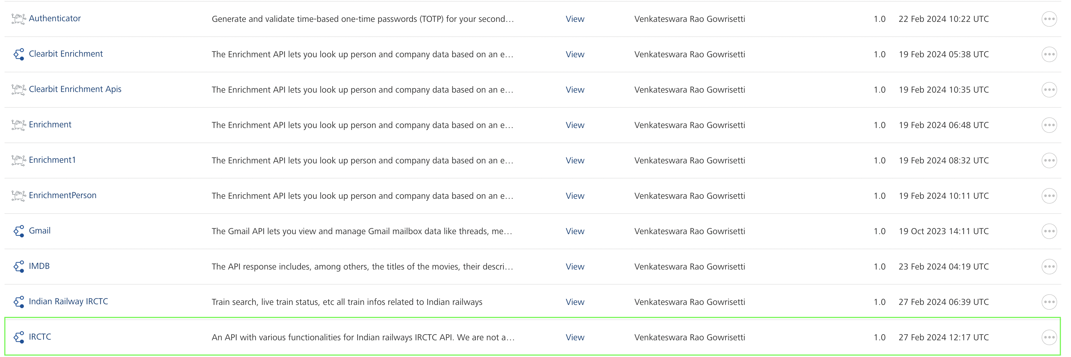

Creating an Integration service
After you import the data adapter into Volt Foundry, you can use it to create an Integration Service.
Follow the given steps to create an Integration service using the IRCTC Adapter.
- Sign in to the HCL Foundry.
- From the left navigation menu, select API Management.
- In API Management, select Integration.
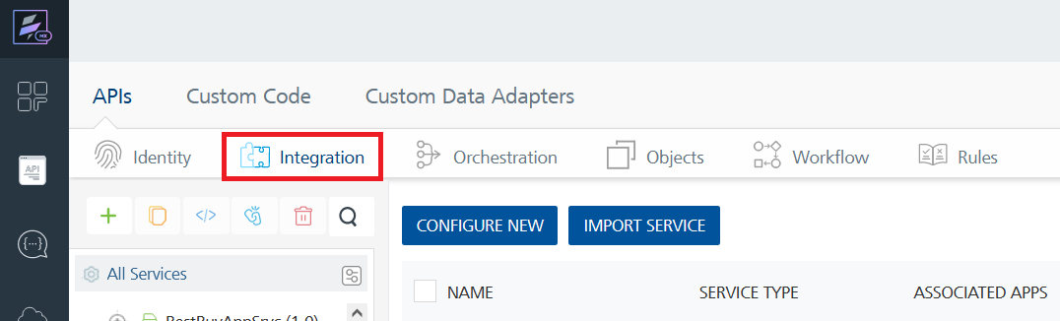
- To create a new service, click the + button or the CONFIGURE NEW button.
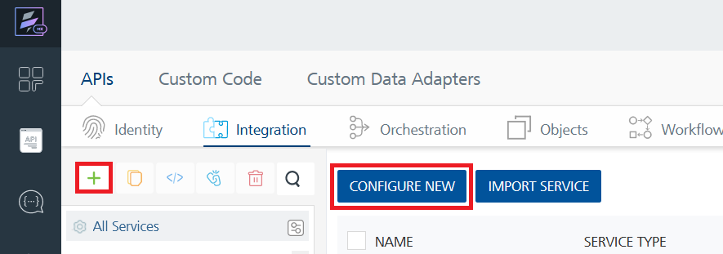
- On the Service Definition tab, select the service type as IRCTC and click SAVE.
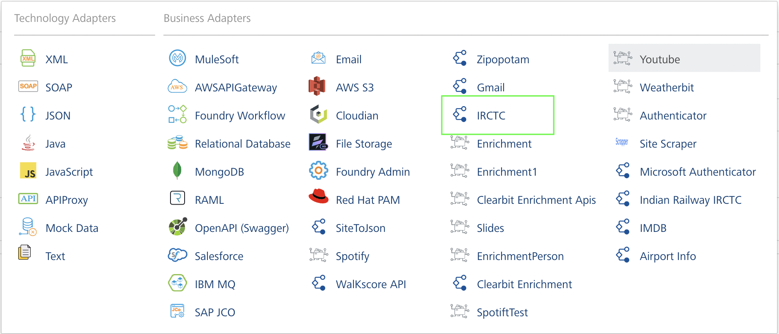
Alternatively, you can also create a Foundry app and create an Integration service inside it.
D. Creating and Executing operations
After you create an integration service, you can create and execute operations using the service.

Creating an Operation
- In API Management/Foundry app you created, in the Integration section, select the service that you created.
- After you select the service, navigate to the Operation List tab.
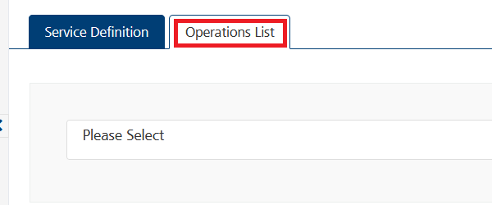
- From the drop down list, select an operation that you want to execute, and click ADD OPERATION.
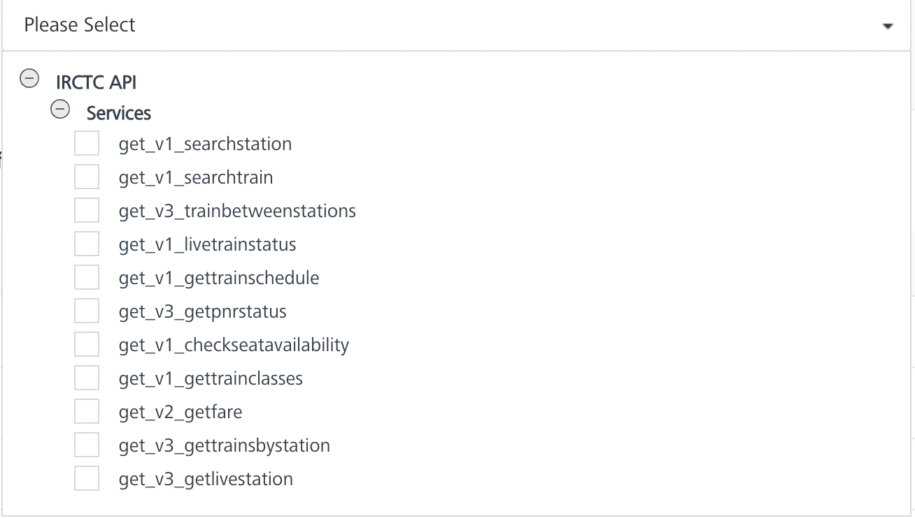

Executing an Operation

SearchStation
- From the Operations List tab, in the Configured Operations section, select the operation you want to execute.

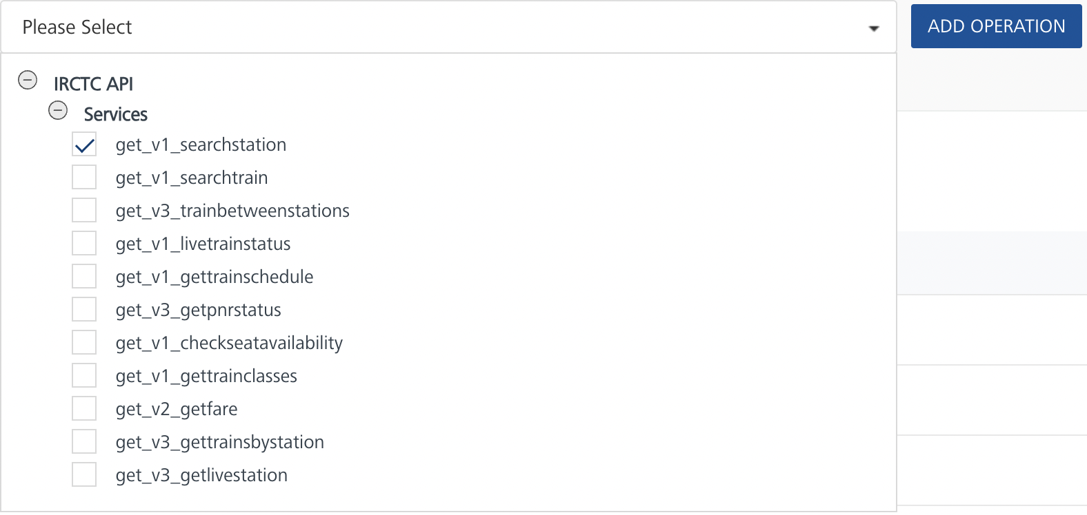
- On the Operation Page, in the Request Input tab, enter a TEST VALUE for all the fields.
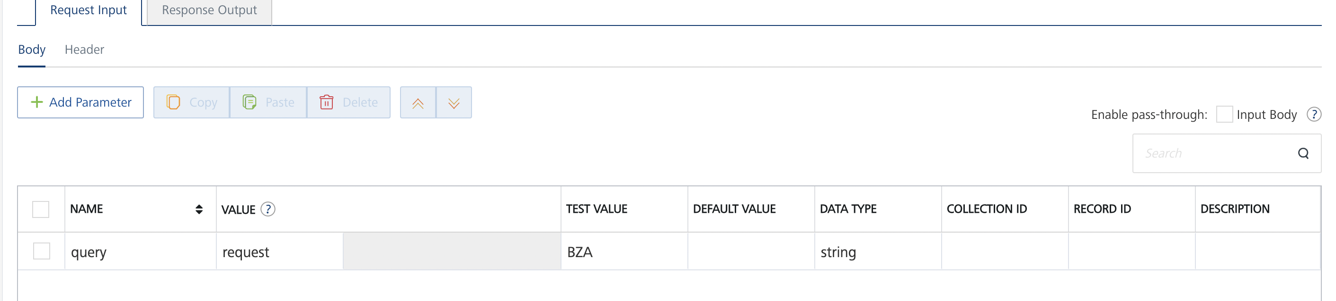
- Select a run-time environment and click Save and Fetch Response to get a response based on your inputs.
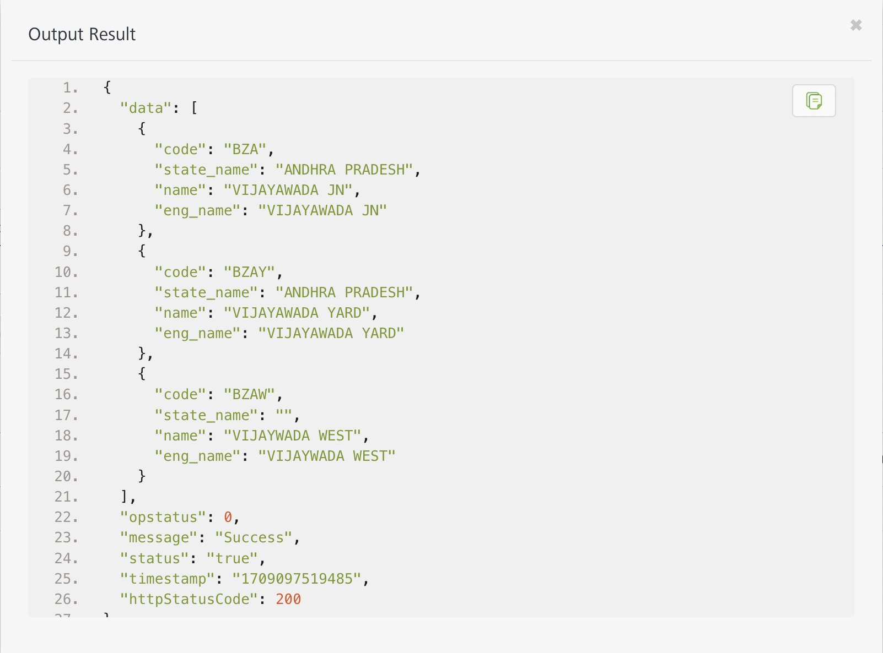

SearchTrain
- From the Operations List tab, in the Configured Operations section, select the operation you want to execute.
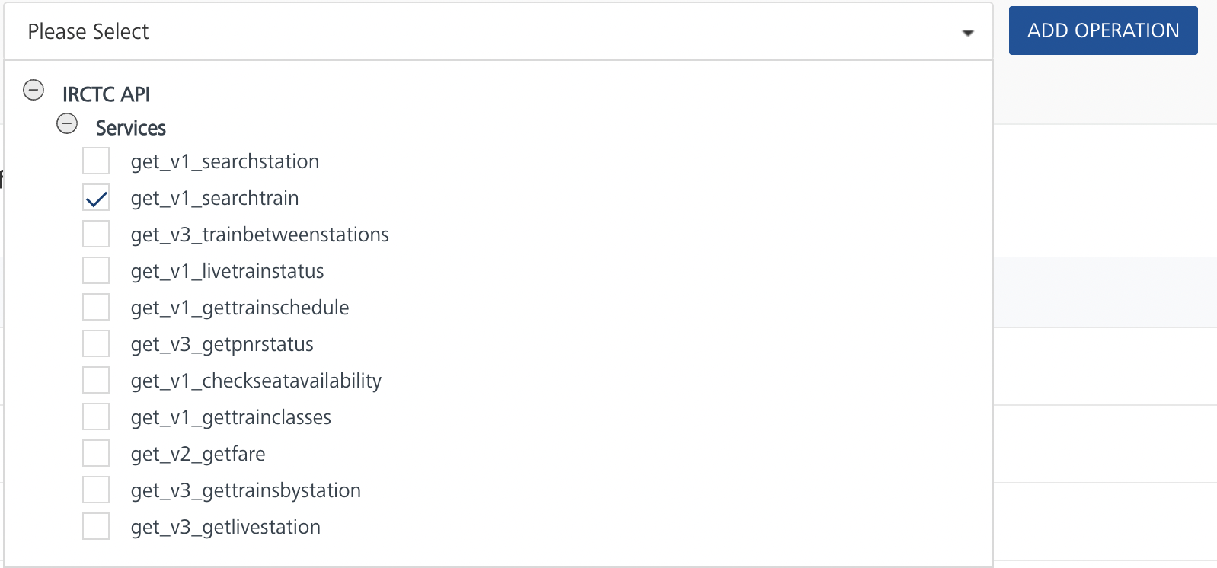

- On the Operation Page, in the Request Input tab, enter a TEST VALUE for all the fields.
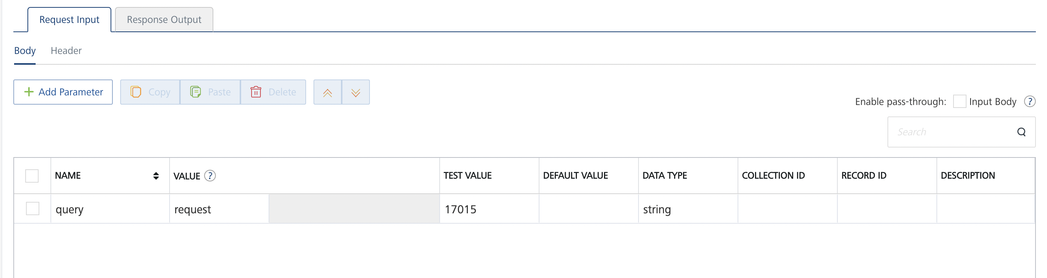
- Select a run-time environment and click Save and Fetch Response to get a response based on your inputs.
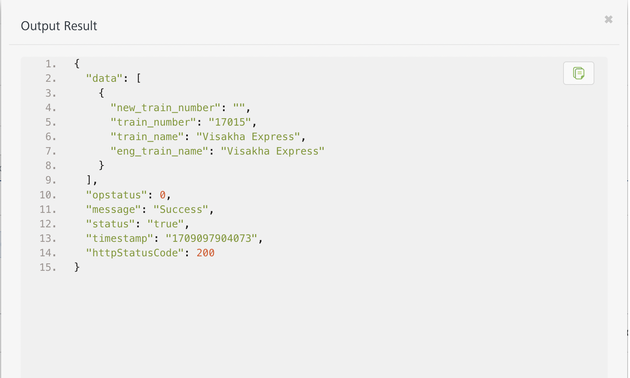

TrainsBetweenStations V3
- From the Operations List tab, in the Configured Operations section, select the operation you want to execute.

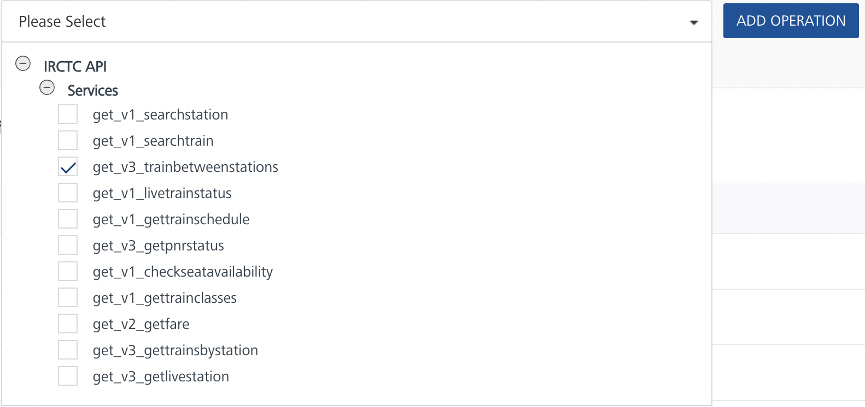
- On the Operation Page, in the Request Input tab, enter a TEST VALUE for all the fields.
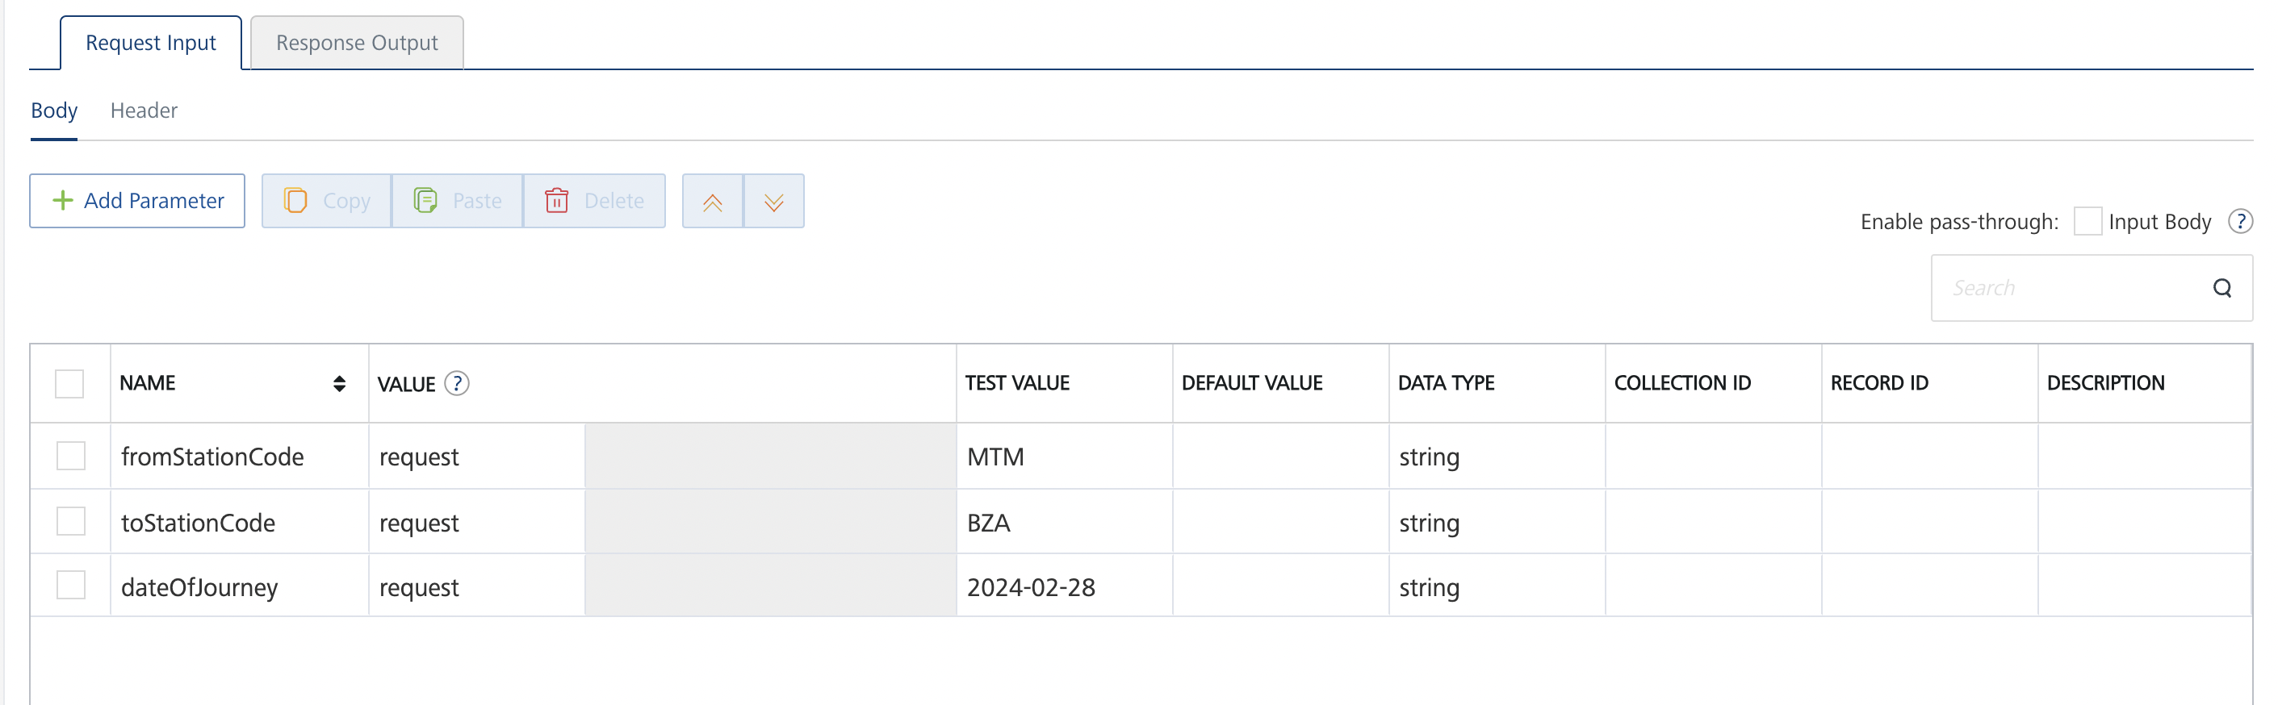
- Select a run-time environment and click Save and Fetch Response to get a response based on your inputs.
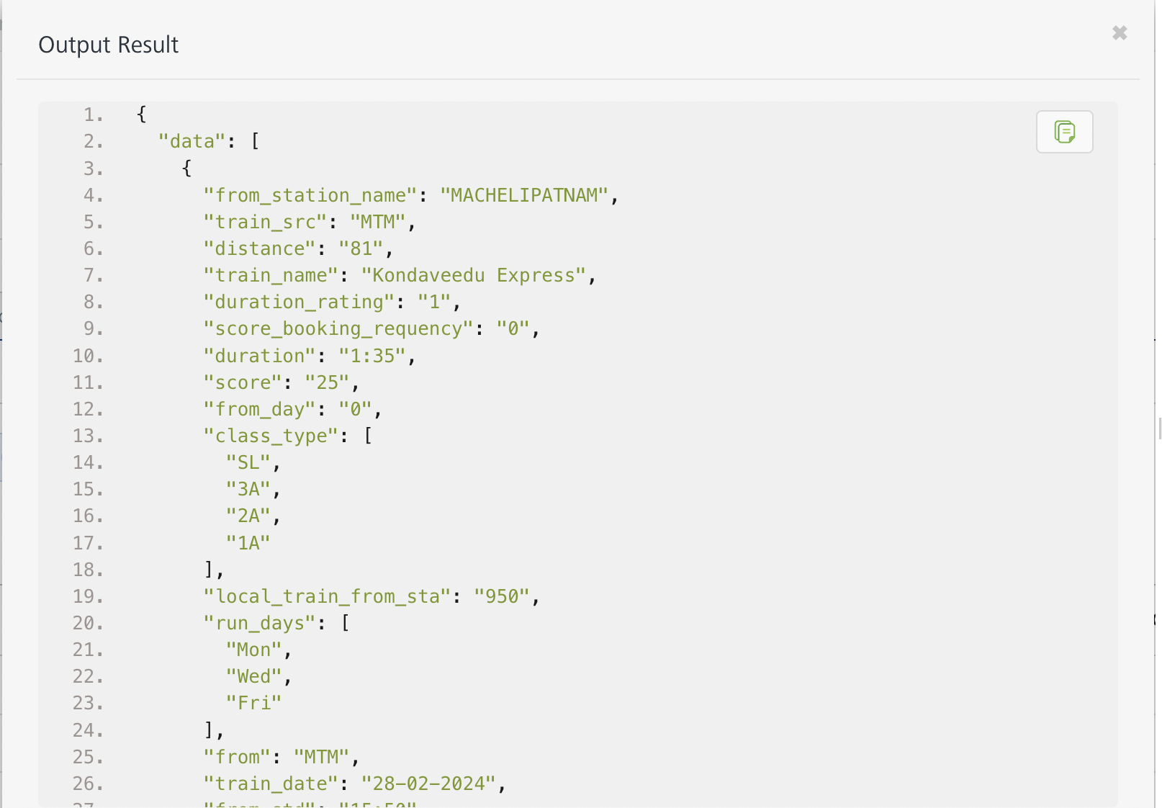

Get Train Live Status
- From the Operations List tab, in the Configured Operations section, select the operation you want to execute.

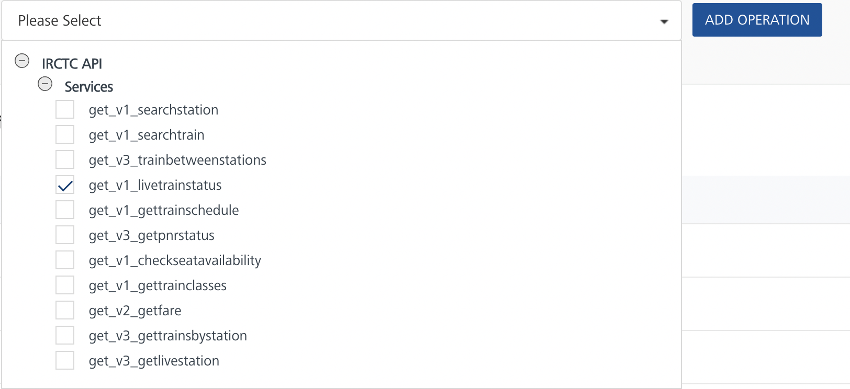
- On the Operation Page, in the Request Input tab, enter a TEST VALUE for all the fields.
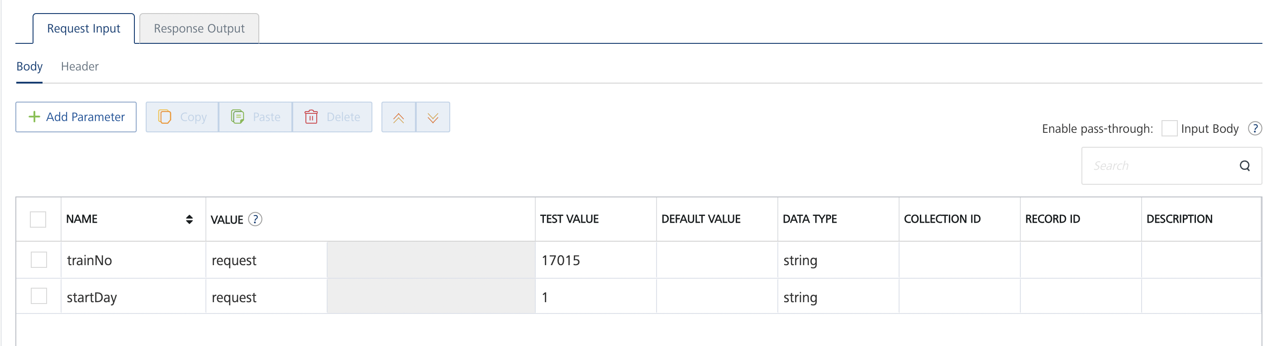
- Select a run-time environment and click Save and Fetch Response to get a response based on your inputs.
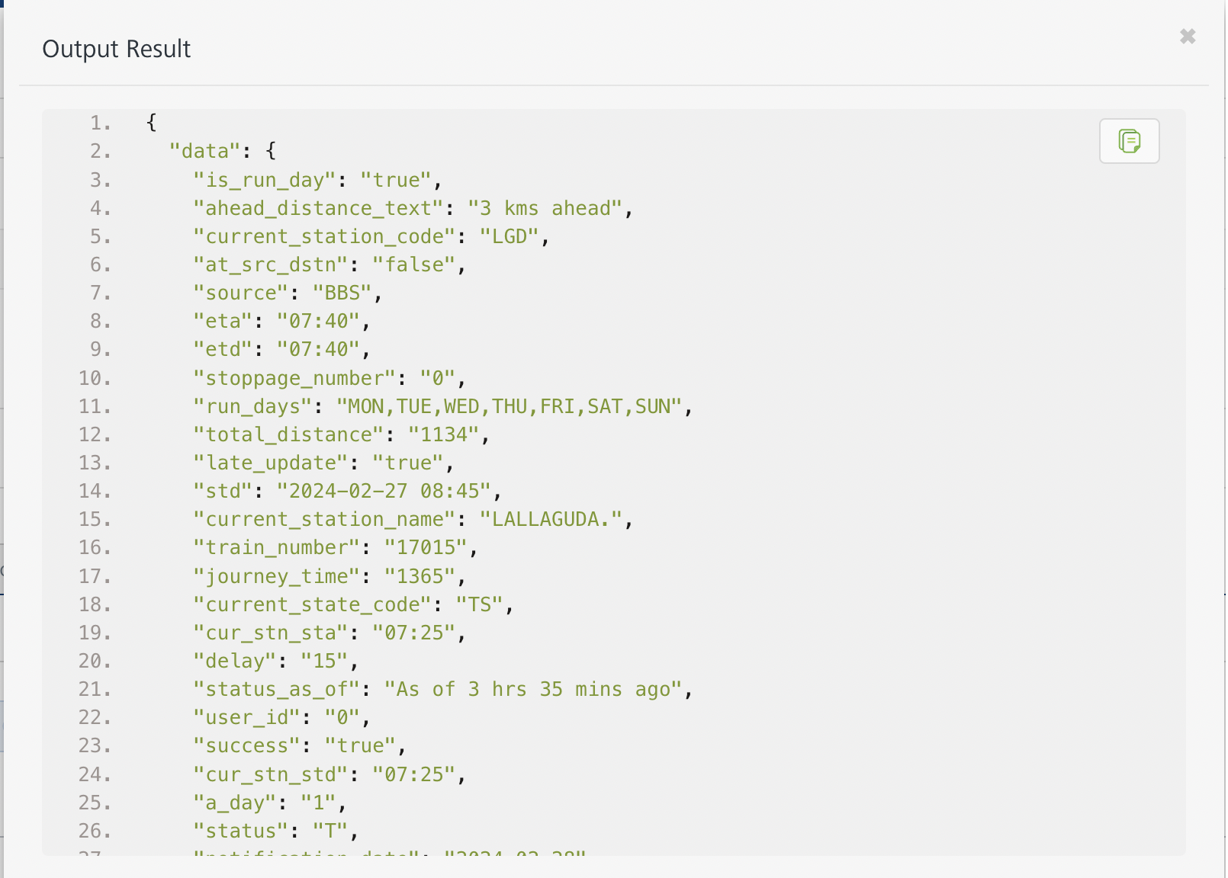

Get Train Schedule
- From the Operations List tab, in the Configured Operations section, select the operation you want to execute.

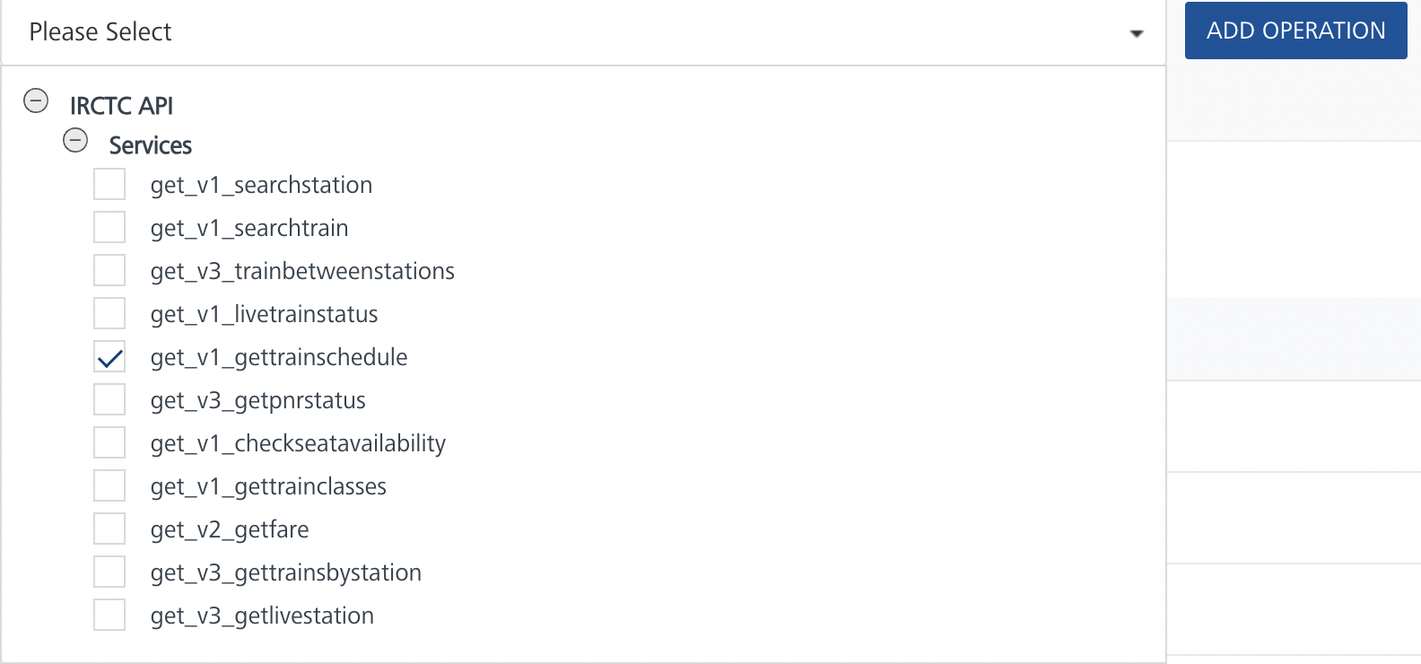
- On the Operation Page, in the Request Input tab, enter a TEST VALUE for all the fields.
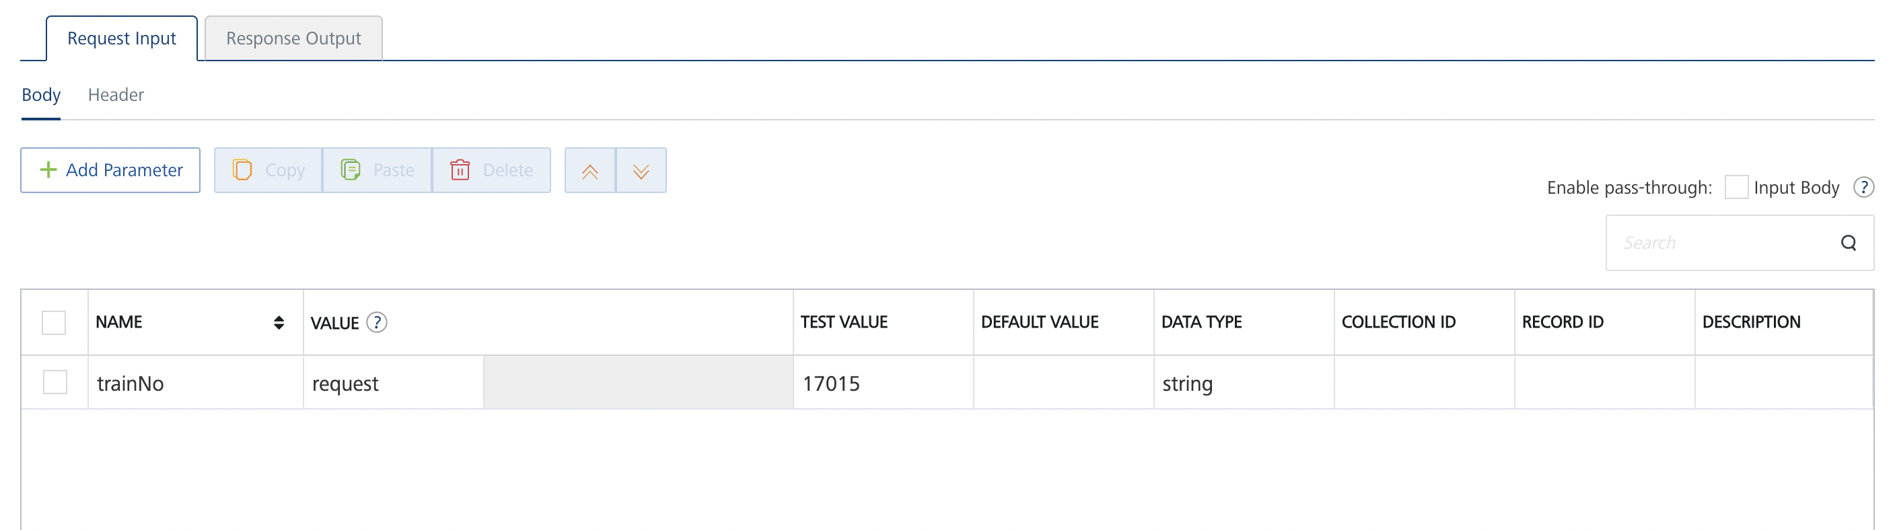
- Select a run-time environment and click Save and Fetch Response to get a response based on your inputs.
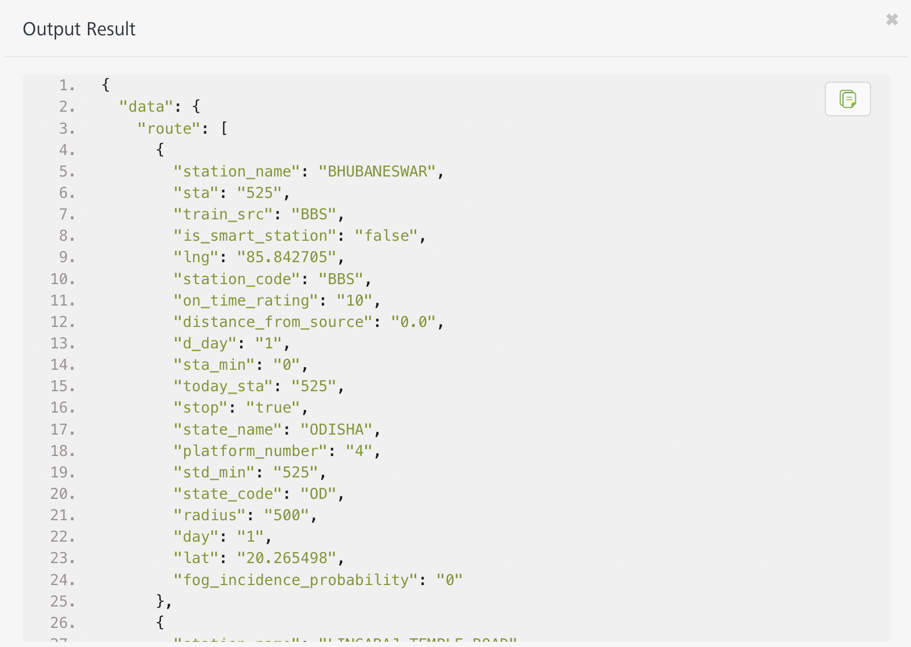

Get PNR Status V3
- From the Operations List tab, in the Configured Operations section, select the operation you want to execute.

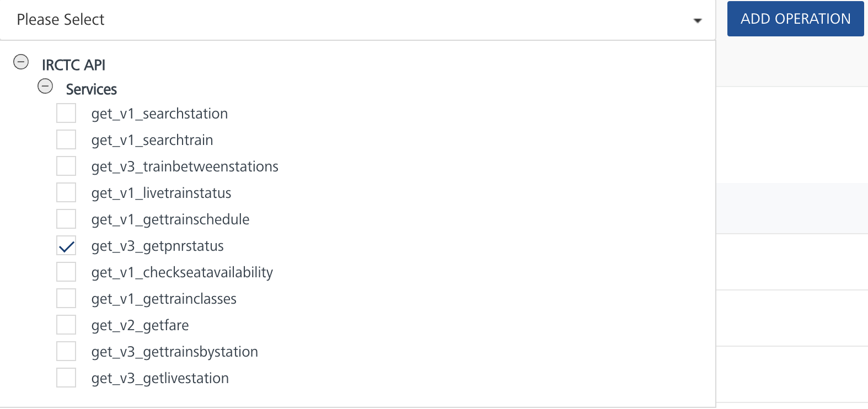
- On the Operation Page, in the Request Input tab, enter a TEST VALUE for all the fields.
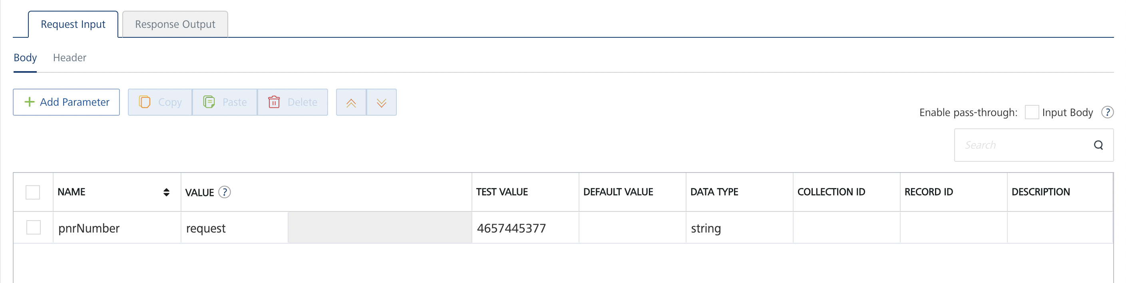
- Select a run-time environment and click Save and Fetch Response to get a response based on your inputs.
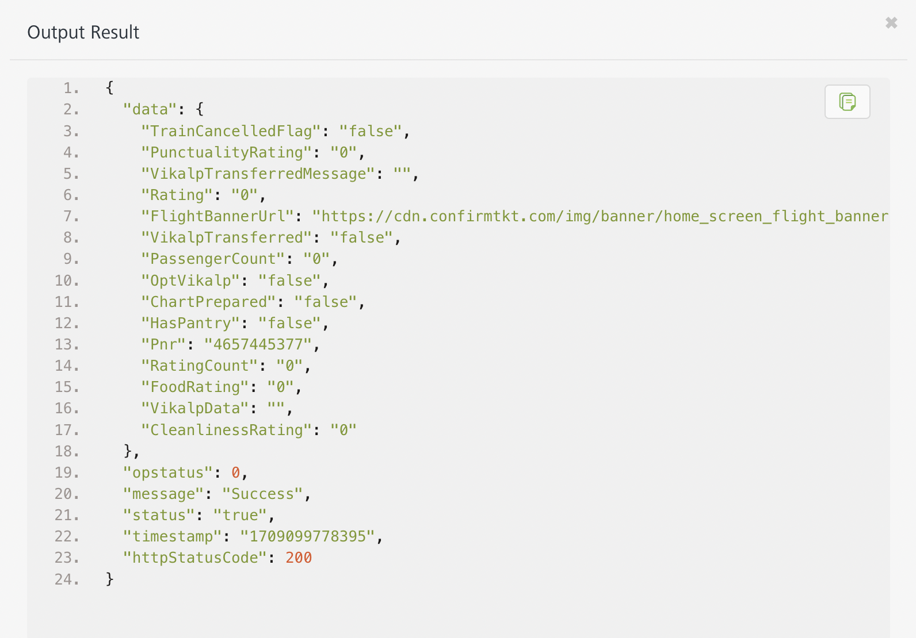

CheckSeatAvailability
- From the Operations List tab, in the Configured Operations section, select the operation you want to execute.

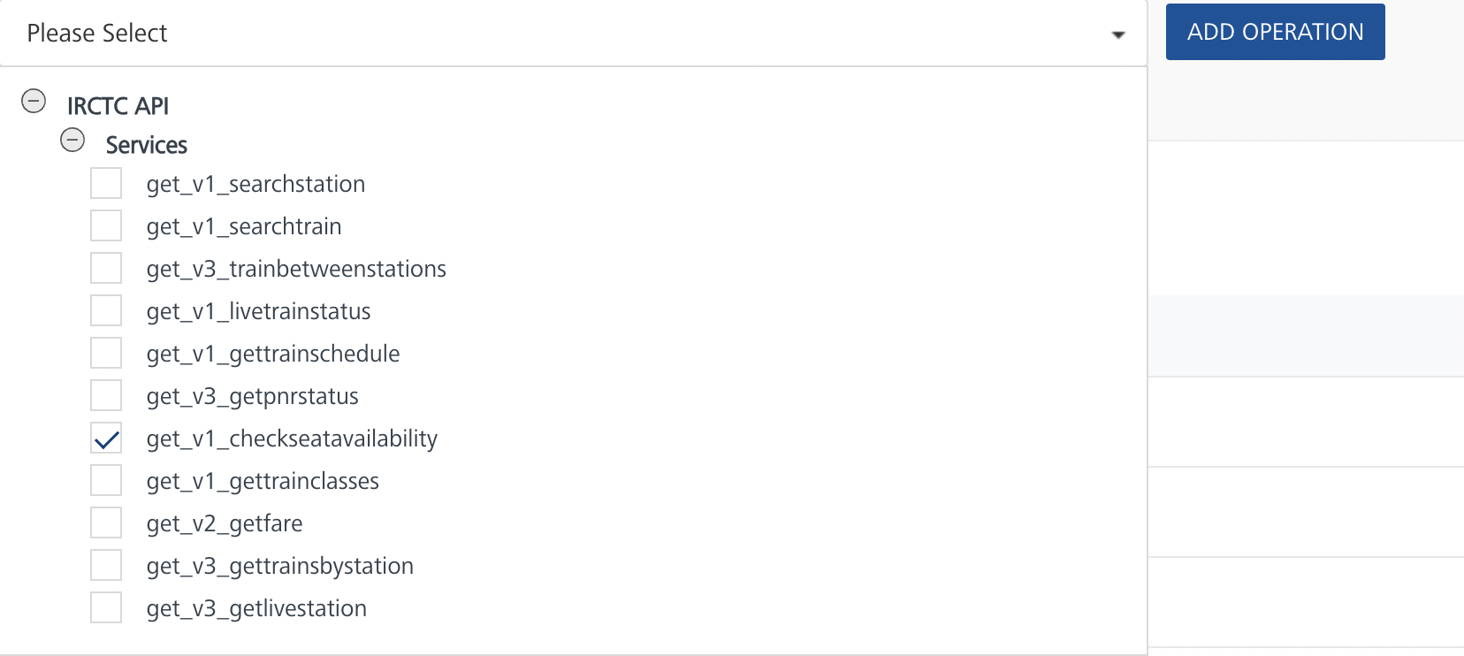
- On the Operation Page, in the Request Input tab, enter a TEST VALUE for all the fields.
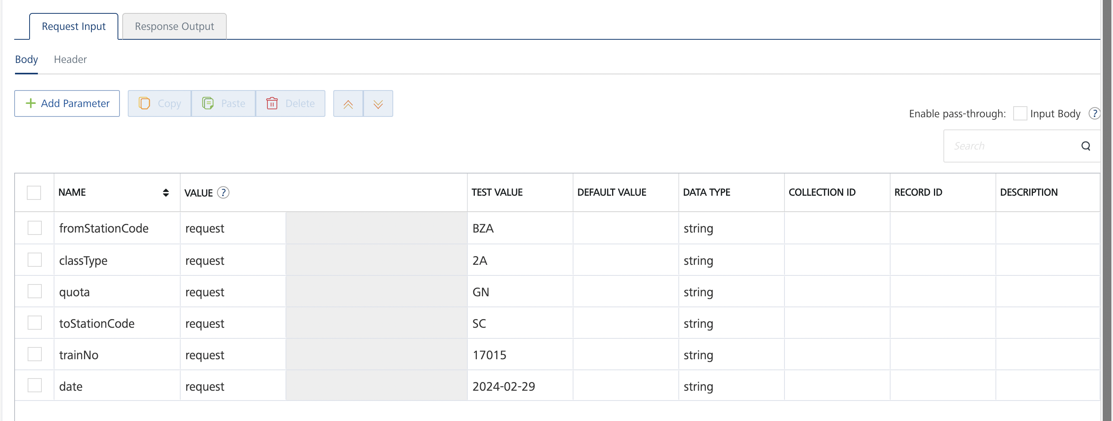
- Select a run-time environment and click Save and Fetch Response to get a response based on your inputs.
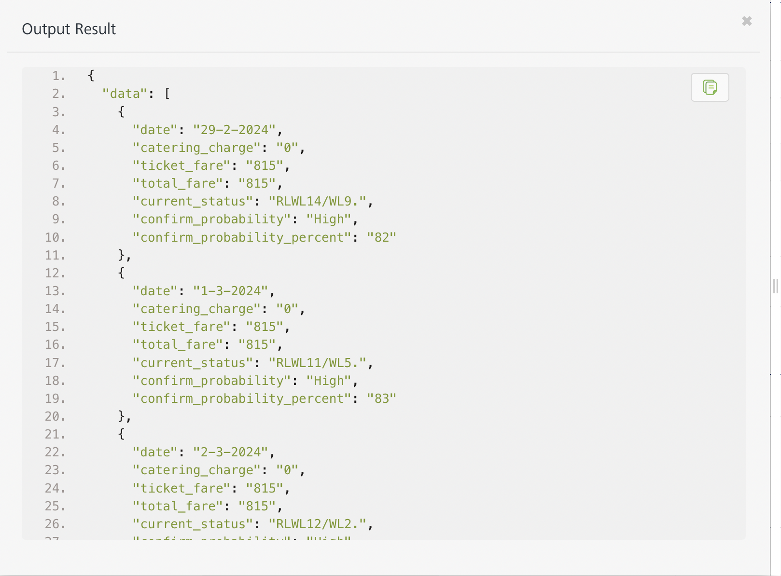

GetTrainClasses
- From the Operations List tab, in the Configured Operations section, select the operation you want to execute.

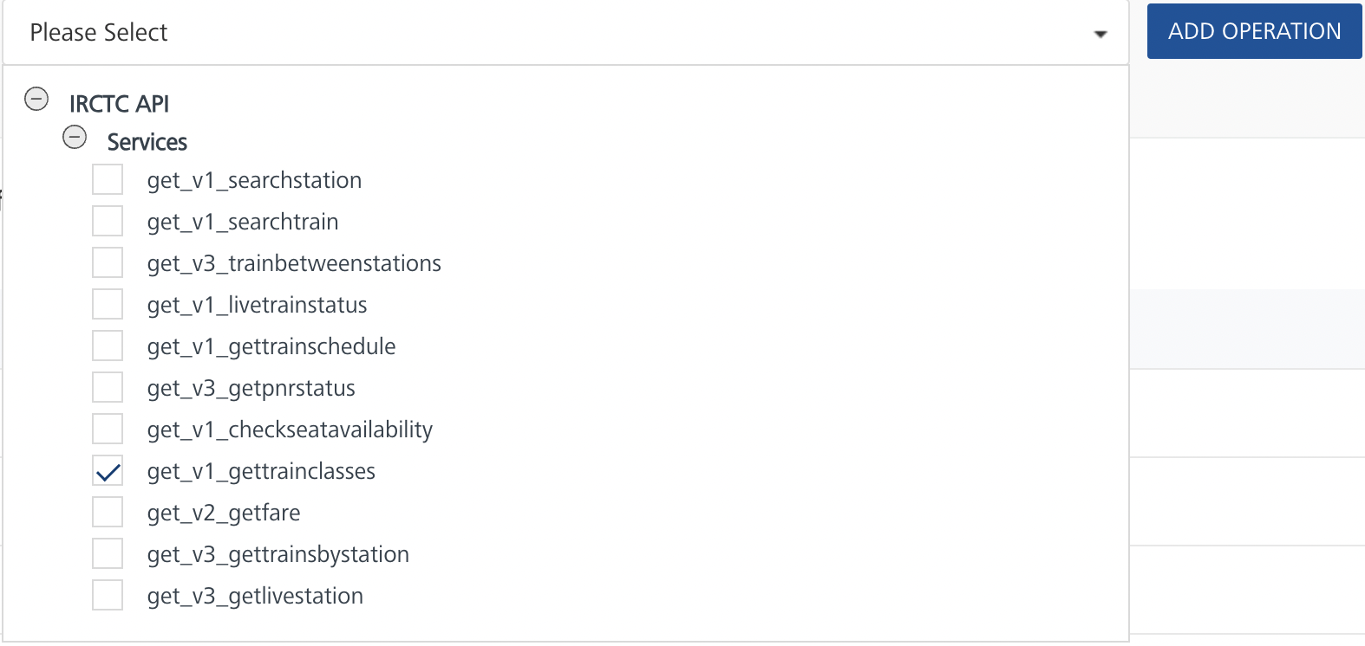
- On the Operation Page, in the Request Input tab, enter a TEST VALUE for all the fields.
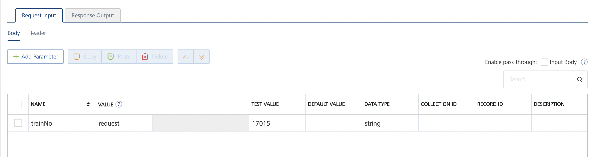
- Select a run-time environment and click Save and Fetch Response to get a response based on your inputs.
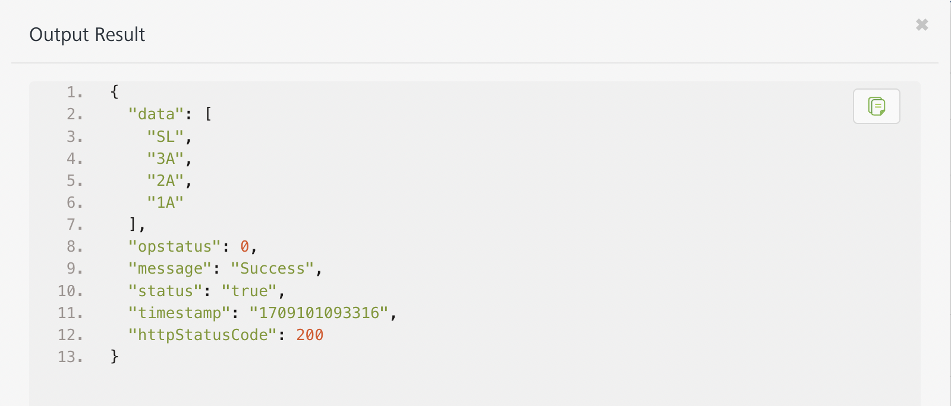

Get Fare
- From the Operations List tab, in the Configured Operations section, select the operation you want to execute.

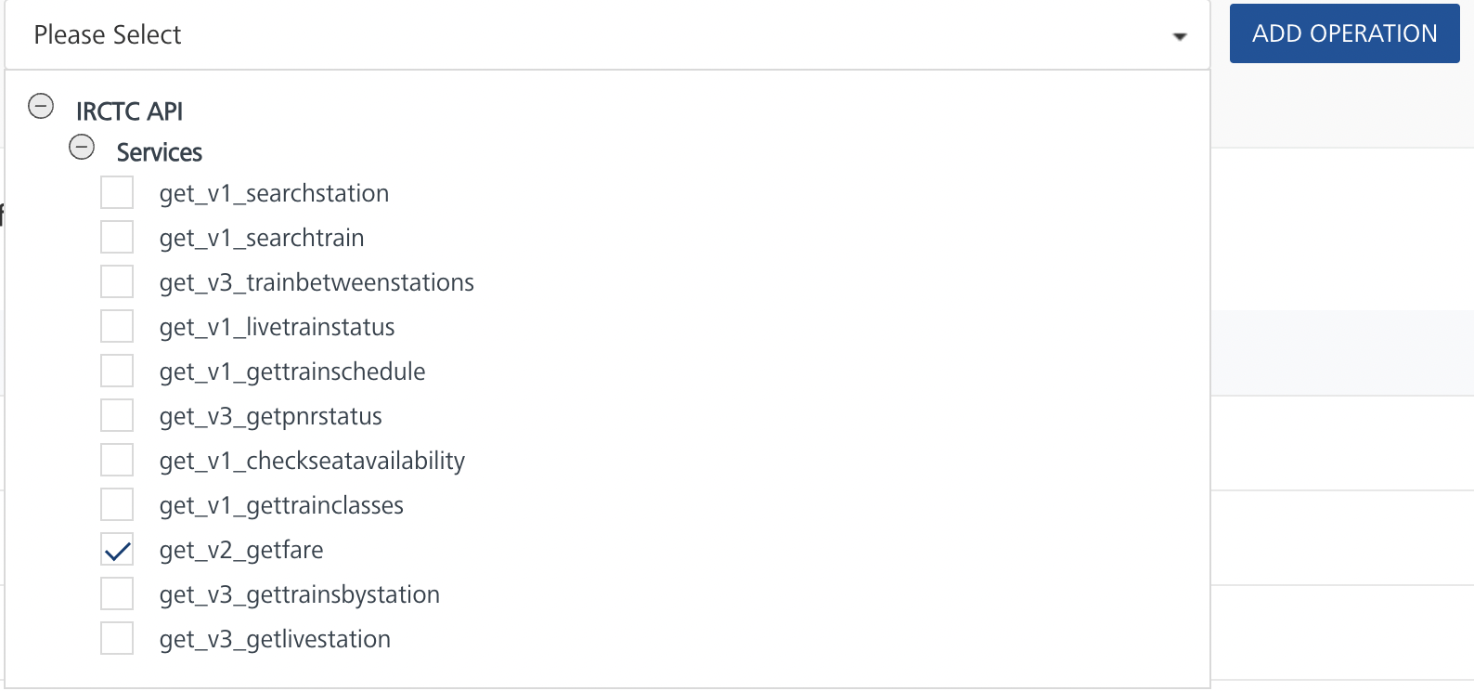
- On the Operation Page, in the Request Input tab, enter a TEST VALUE for all the fields.
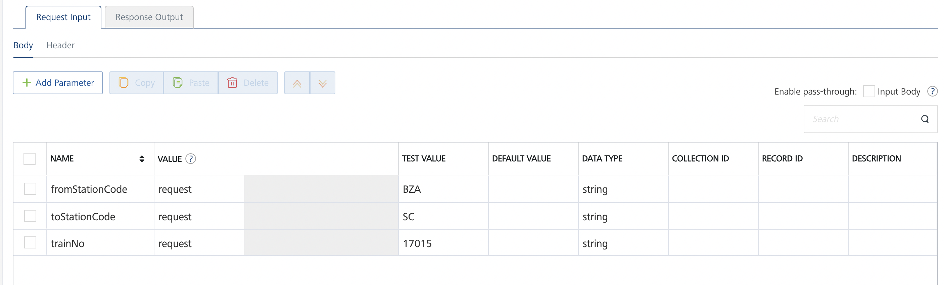
- Select a run-time environment and click Save and Fetch Response to get a response based on your inputs.
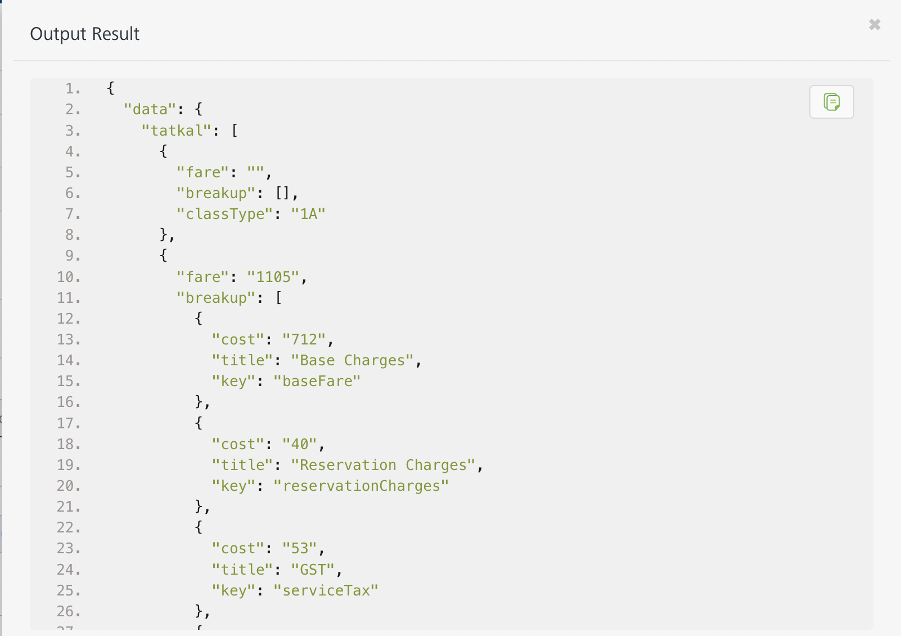

Get Trains By Station
- From the Operations List tab, in the Configured Operations section, select the operation you want to execute.
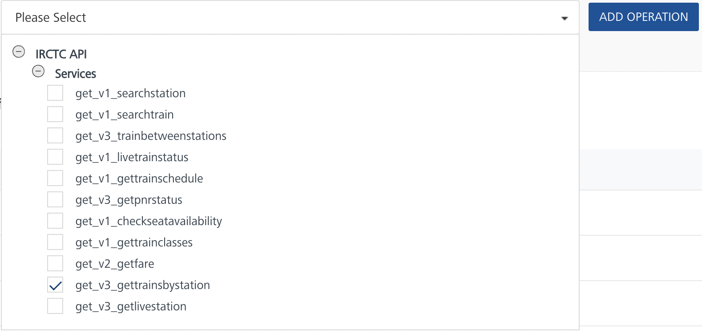

- On the Operation Page, in the Request Input tab, enter a TEST VALUE for all the fields.
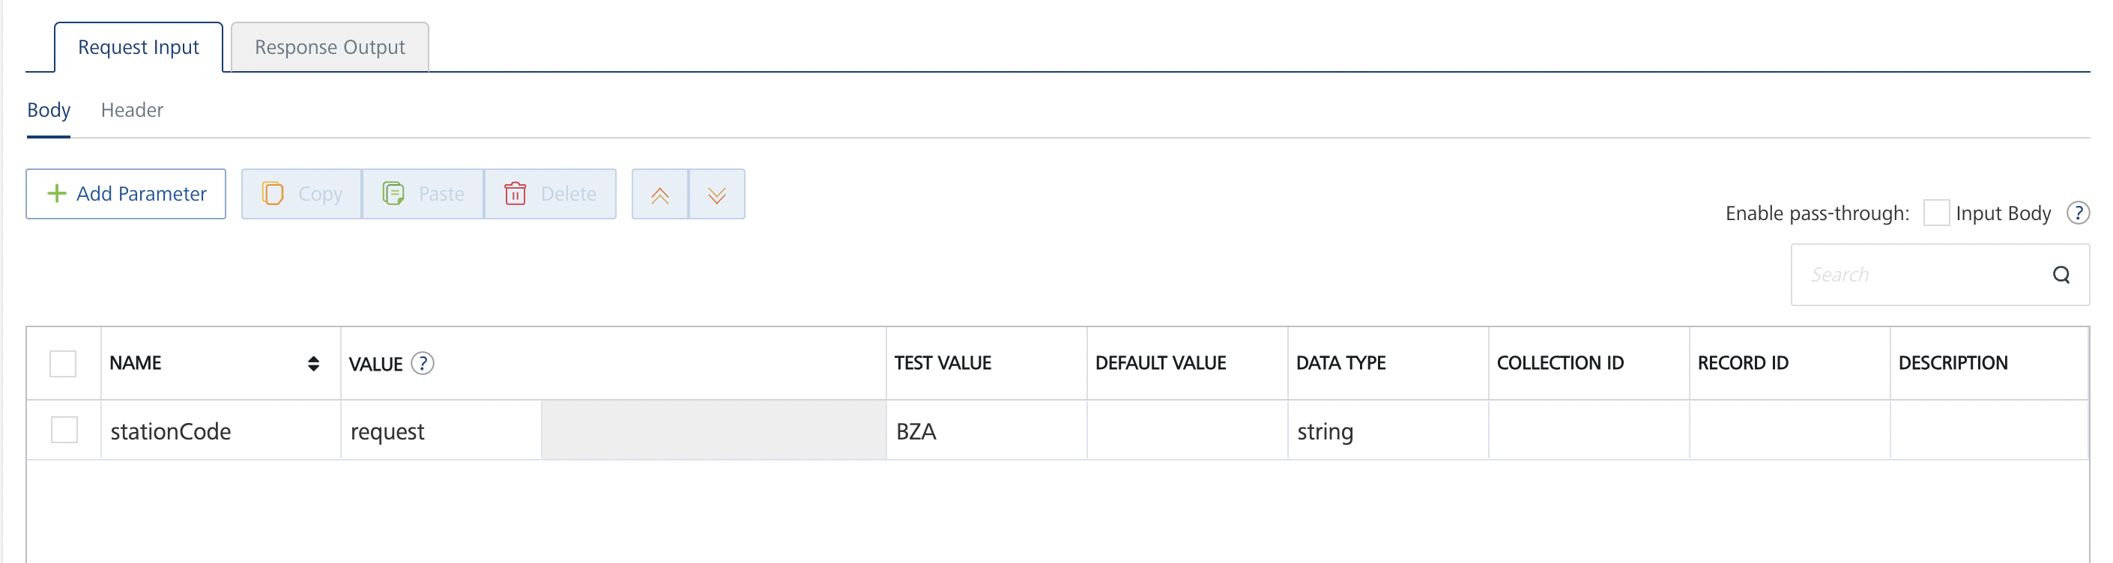
- Select a run-time environment and click Save and Fetch Response to get a response based on your inputs.
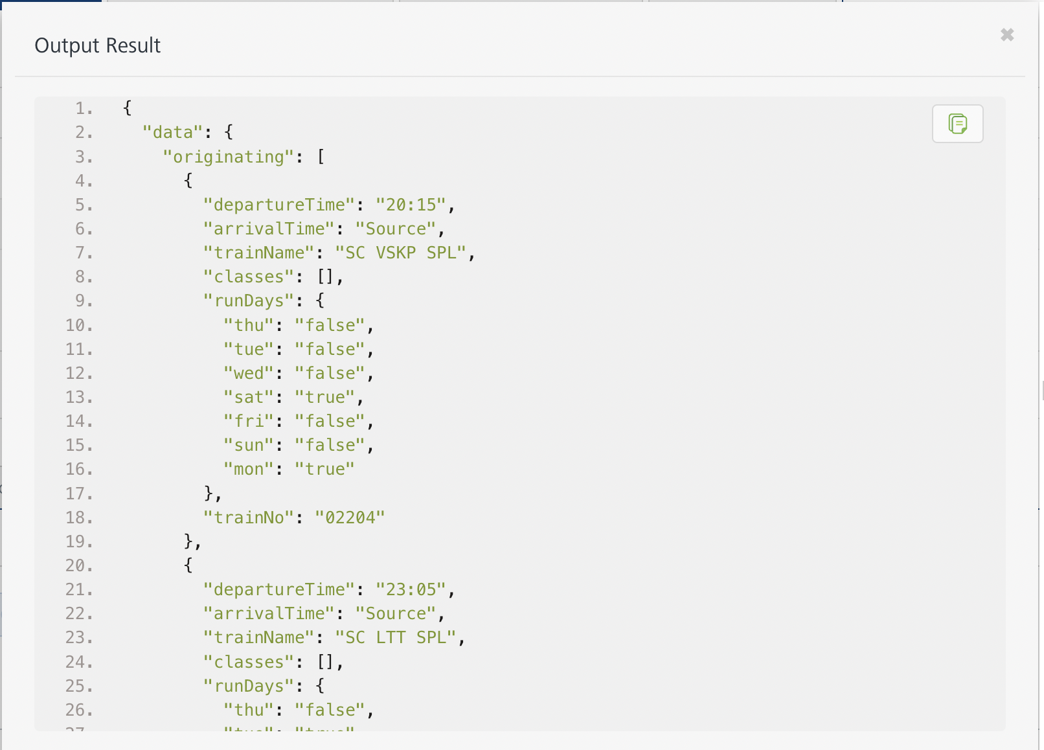

Get Live Station
- From the Operations List tab, in the Configured Operations section, select the operation you want to execute.

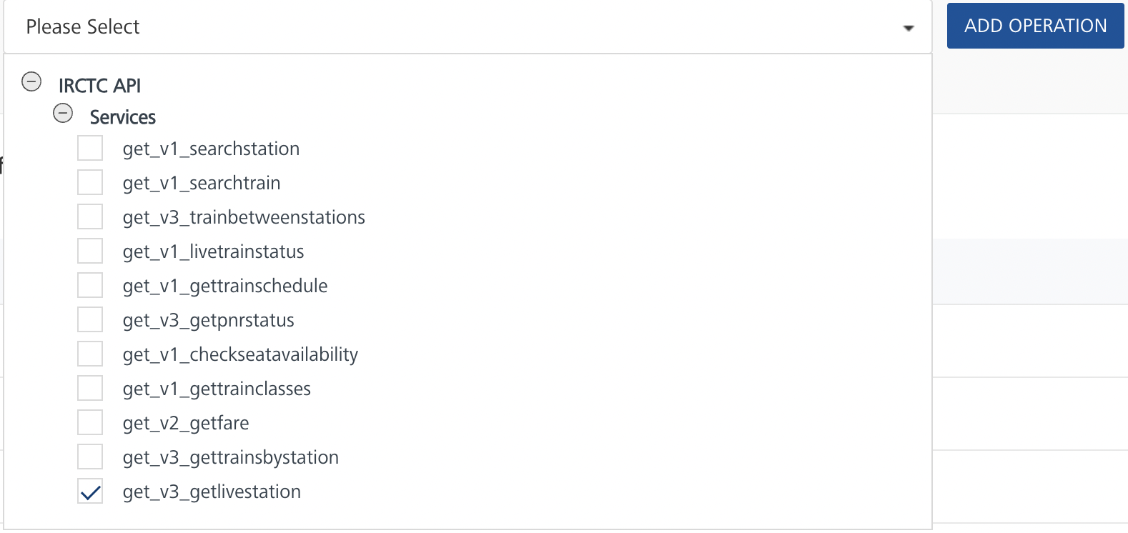
- On the Operation Page, in the Request Input tab, enter a TEST VALUE for all the fields.
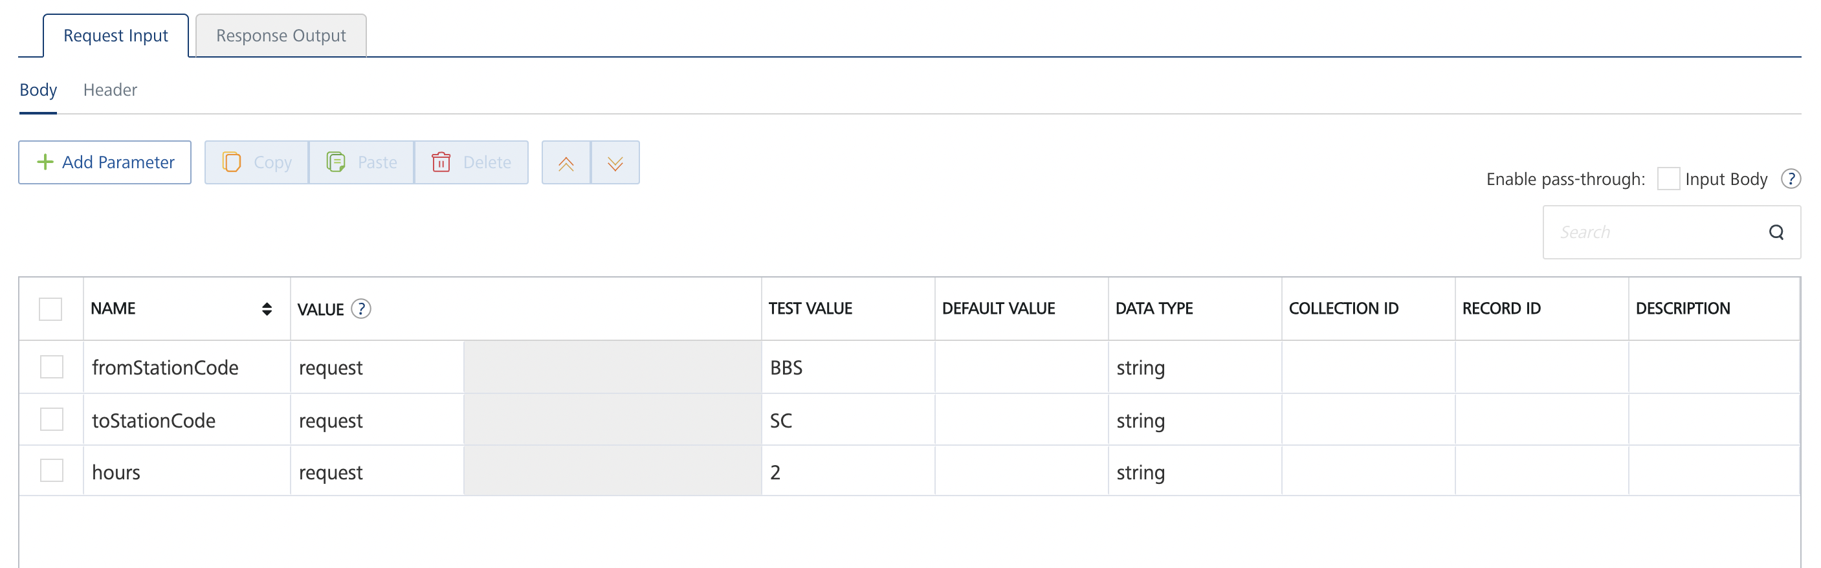
- Select a run-time environment and click Save and Fetch Response to get a response based on your inputs.
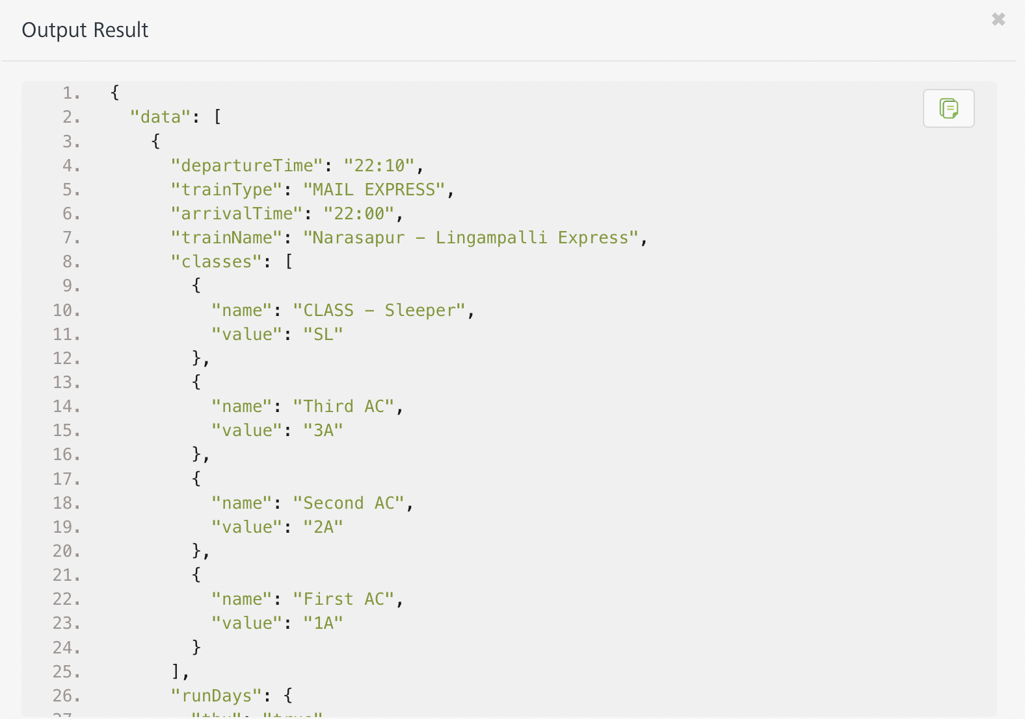

Publishing your application
If you want to use the services in client applications, you need to publish an app to a run-time environment. You can create the service (as described above) in an application or import the service into an application and publish the application.

References
https://rapidapi.com/IRCTCAPI/api/irctc1/

Revision History
Adapter version 1.0.0:

Known Issues
-

Limitations
-

