16 Nov 2021

JsGrid (2.0.1)

Overview
JSGrid is a JavaScript library that is based on jQuery. The JSGrid component integrates JSGrid with VoltMX Iris so that you can add data grids to your existing web apps.
You can use custom back-end data sources to display the data on the component. You can also modify the UI elements based on your preference. You can use this component in your web apps to display data from your back-end source as a data grid/ you can use static data.

Use case

JSGrid is a lightweight client-side data grid control based on jQuery. It supports basic grid operations like inserting, filtering, editing, deleting, paging, and sorting. JSGrid is flexible and allows to customize its appearance and components.

Percentage of re-use:
Approximately 80% reusable.

Features.
- Provides controls to customize the UI
- JSGrid is flexible and allows to customize its appearance and components.
- Allows user to perform basic grid operations like insert, edit, delete, search paging and sorting.

Getting Started

Prerequisites
Before you start using the JSGrid component, ensure the following:
• HCL Foundry
• Volt MX Iris

Platforms Supported

PWA & Responsive Web

Importing the app
You can import the Forge components only into the apps that are of the Reference Architecture type.
To import the JSGrid component, do the following:

Open your app project in Volt MX Iris..

In the Project Explorer, click the Templates tab.
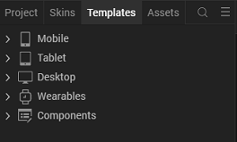

Right-click Components, and then select Import Component. The Import Component dialog box appears.
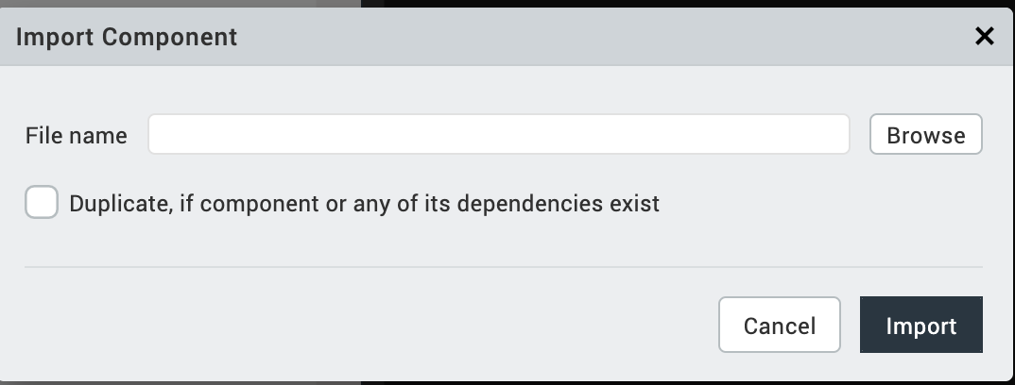

Click Browse to navigate to the location of the component, select the component, and then click Import. The component and its associated widgets and modules are added to your project.
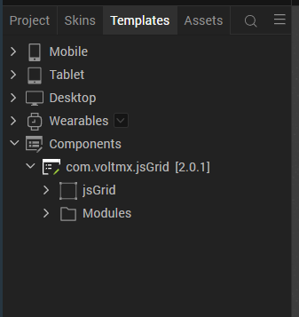
Once you have imported a component to your project, you can easily add the component to a form. For more information, refer Add a Component to a Form

Building and previewing the app
After performing all the above steps, you can build your app and run .For more information, you can refer to the Building and Viewing an Application section of the Volt MX User Guide.
You can then run your app to see the JsGrid work in real time

Modifying UI of the grid.
You can edit the CSS of the grid to modify the UI of the grid. To access the CSS file, follow the given steps.

In the Project explorer, navigate to Web → Localfiles → jsgrid-weblocal → css.

From the css folder, select either jsgrid.css or theme.css to open the file.
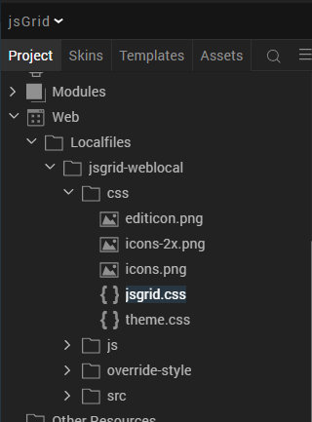

Use the text editor to edit the css based on your preference.
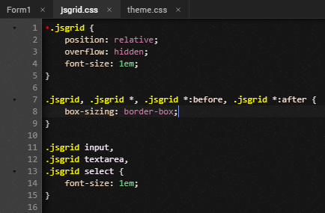

References

Dynamic Usage
If you want to use the JSGrid component dynamically, you will need to import the component into your project Templates. Follow the given steps to do so

Download the component from HCL VoltMX Marketplace as a zip file.

Go to the Templates tab in your project explorer.

Right click on Components and select Import Component.

Navigate to where you downloaded your zip file and import it into Iris.

After you import the component into your project templates, you can add it to your app dynamically. To do so, follow the given steps

Access the FormController of the form you want to add the component into.

Create a function called createComponent(); and write the code inside it to create and configure the component.

You can refer to the given sample code for more information.

/* Creating Action Sheet component instance */
createComponent:function(){
var jsGridInstance= new com.voltmx.jsGrid ({
"clipBounds": true,
"height": "100%",
"id": "jsGrid",
"isVisible": true,
"left": "0dp",
"top": "0dp",
"width": "100%",
"zIndex":"1"
}, {}, {
});
jsGridInstance.feildSorting=true;
jsGridInstance.sampleData=true;
jsGridInstance.heading=true;
jsGridInstance.filtering=true;
jsGridInstance.inserting=true;
jsGridInstance.deleting=true;
jsGridInstance.paging=true;
jsGridInstance.editing=true;
jsGridInstance.pageNextText="Next";
jsGridInstance.pagePrevText="Prev";
jsGridInstance.pageFirstText="First";
jsGridInstance.pageLastText="Last";
jsGridInstance.gridWidth="100%";
jsGridInstance.gridHeight="100%";
jsGridInstance.PageSize=10;
jsGridInstance.deleteConfirm="Are you sure ?";
jsGridInstance.invalidMessage="Invalid Data !";
jsGridInstance.loadMessage="Please, wait !";
jsGridInstance.noDataContent="There is not data to display";
this.view.add(jsGridInstance);
this.view.jsGrid.onItemDeletion = function(args)
{
alert("Item Deleted: "+JSON.stringify(args));
}.bind(this);

this.view.jsGrid.onItemInsertion = function(args)
{
alert("Item Added: "+JSON.stringify(args));
}.bind(this);
this.view.jsGrid.onItemUpdation = function(args)
{
alert("Item updated: "+JSON.stringify(args));
}.bind(this);
this.view.jsGrid.onErrorCallback = function(args)
{
alert("Error: "+JSON.stringify(args));
}.bind(this);
},

Properties
You can use a component's Properties to customize and configure the elements. These elements can be UI elements, service parameters, and so on. You can set the properties from the Visualizer's Properties panel on the right-hand side. You can also configure these properties using a JavaScript code.

General

Heading

Description : Toggles the visibility of the headers

Syntax : heading

Type : Boolean

Write/Read : write

Default Value : true

Example : this.view.jsGrid.heading=true;

Filtering

Description : Toggles the visibility of the filter entries option.

Syntax : filtering

Type : Boolean

Write/Read : write

Default Value : true

Example : this.view.jsGrid.filtering=true;

Insertion

Description : Toggles the visibility of add entries option

Syntax : inserting

Type : Boolean

Write/Read : write

Default Value : true

Example : this.view.jsGrid.inserting=true;

Editing

Description : Toggles the visibility of the edit entries option.

Syntax : editing

Type : Boolean

Write/Read : write

Default Value : true

Example : this.view.jsGrid.editing =true;

Sorting

Description : Toggles the visibility of the sort entries option

Syntax : feildSorting

Type : Boolean

Write/Read : write

Default Value : true

Example : this.view.jsGrid.feildSorting =true;

Deleting

Description : Toggles the visibility of the delete entries option

Syntax : deleting

Type : Boolean

Write/Read : write

Default Value : true

Example : this.view.jsGrid.deleting =true;

Paging

Description : Toggles the visibility of the headers Specifies whether you want to display the data in pages.

Syntax : paging

Type : Boolean

Write/Read : write

Default Value : true

Example : this.view.jsGrid.paging =true;

Page Size

Description : Specifies the number of entries that you want to display in one page.

Syntax : PageSize

Type : Integer

Write/Read : write

Default Value : 10

Example : this.view.jsGrid.PageSize =true;

Page Next Text

Description : Specifies the text that you want to display to open the next page of data.
Syntax : pageNextText

Type : String

Write/Read : write

Default Value : Next

Example : this.view.jsGrid.pageNextText ="Next";

Page Prev Text

Description : Specifies the text that you want to display to open the previous page

Syntax : pagePrevText

Type : String

Write/Read : write

Default Value : Prev

Example : this.view.jsGrid.pagePrevText ="Prev";

Page First Text

Description : Specifies the text that you want to display to open the first page of data.

Syntax : pageFirstText

Type : String

Write/Read : write

Default Value : First

Example : this.view.jsGrid.pageFirstText="First";

Page Last Text

Description : Specifies the text that you want to display to open the first page of data.

Syntax : pageLastText

Type : String

Write/Read : write

Default Value : Last

Example : this.view.jsGrid.pageLastText="Last";

Width

Description : Specifies the width that you want to set for the grid.

Syntax : gridWidth

Type : String

Write/Read : write

Default Value : 100%

Example : this.view.jsGrid.gridWidth= "100%";

Height

Description : Specifies the width that you want to set for the grid.

Syntax : gridHeight

Type : String

Write/Read : write

Default Value : 100%

Example : this.view.jsGrid. gridHeight = "100%";

Sample Data

Description : Specifies whether you want to display sample data on the grid.

Syntax : sampleData

Type : Boolean

Write/Read : write

Default Value : true

Example : this.view.jsGrid.sampleData =true;

Messages

Load Message

Description : Specifies the message that you want to display while the component loads the data.

Syntax : loadMessage

Type : string

Write/Read : write

Example : this.view.jsGrid.loadMessage="Please, wait !"

Delete confirm

Description : Specifies the message that you want to display to confirm a delete operation.

Syntax : deleteConfirm

Type : string

Write/Read : write

Example : this.view.jsGrid.deleteConfirm= "Are you sure ?";

Invalid Message

Description : Specifies the message that you want to display when the user enters invalid data.

Syntax : invalidMessage

Type : string

Write/Read : write

Example : this.view.jsGrid.invalidMessage= "Invalid Data !";

No Data Content

Description : Specifies the message that you want to display when the data array is empty.

Syntax : noDataContent

Type : string

Write/Read : write

Example : this.view.jsGrid.noDataContent= " There is not data to display”,

Events

onItemDeletion

Description : Invoked when the user deletes an item from the grid.

Syntax : onItemDeletion

Parameters : args [Array of JSON] : The item that the user deleted from the grid.

Example : this.view.jsGrid.onItemDeletion = function(args)
{
alert("Item Deleted: "+JSON.stringify(args));
}.bind(this);

onItemInsertion

Description : Invoked when the user insert an item in to the grid.

Syntax : onItemInsertion

Parameters : args [Array of JSON] : The item that the user added in the grid.

Example : this.view.jsGrid.onItemInsertion = function(args)
{
alert("Item Added: "+JSON.stringify(args));
}.bind(this);

onItemUpdation

Description : Invoked when the user updates an item in the grid.

Syntax : onItemUpdation

Parameters : args [Array of JSON] : The item that the user updated in the grid.

Example : this.view.jsGrid.onItemUpdation = function(args)
{
alert("Item updated: "+JSON.stringify(args));
}.bind(this);

onErrorCallback

Description : Invoked when error occurs.

Syntax : onErrorCallback

Parameters : args [Array of JSON] : Contains information about the error.

Example : this.view.jsGrid.onErrorCallback= function(args)
{
alert("Error: "+JSON.stringify(args));
}.bind(this);

API’s

setData

Description : Adds the given data to the grid.

Syntax : setData(header,data)

Parameters : header [Array of Strings] :A set of words that you want to display as the headers of the grid.
data [Array of JSON] :A set of JSON objects that contain the column name and the data that you want to enter into the grid.

Return Value : None

Example : var header =
[{
name: "Name",
type: "text",
validate: "required",
width: 100
}, {
name: "Salary",
type: "number",
validate: "required",
width: 50
}, {
name: "Age",
type: "number",
validate: "required",
width: 30
}, {
type: "control",
editButton: true,
deleteButton: true,
clearFilterButton: true,
inserting: true,
filtering: true,
editing: true,
sorting: true,
}, ];
var data =
[
{
"Name": "John",
"Salary": "54000",
"Age": "34"
},
{
"Name": "Kevin",
"Salary": "65909",
"Age": "34"
},
{
"Name": "Steven",
"Salary": "65909",
"Age": "34"
}
];
this.view.jsGrid.setData(header, data);

Revision History
App version 2.0.1:

Known Issues
NA

Limitations
NA

