24 Jul 2025

KEYWORD DETECTION

VERSION: 1.0.0

OVERVIEW
A reusable UI component that dynamically displays keywords
Use Cases
Content Tagging – Display tags or categories associated with an article, blog post, or product.
User Interests – Show a user’s selected interests or preferences in a profile or settings page.
Search Filters – Represent active filters or criteria in a search results interface using keyword chips.

Percentage of re-use:
Approximately 80% of reuse.

Getting Started

Prerequisites
Before you start using the KeyWord Detection Component, ensure you have the following:
- HCL Foundry
- Volt MX Iris

Platforms Supported

Mobile

iOS

Android

  - Importing the Component to your project

You can import the components only into the apps that are of the Reference Architecture type.

To import the KeyWord Detection Component, do the following:

- Open your app project in Volt MX Iris.

In the Project Explorer, click the Templates tab.

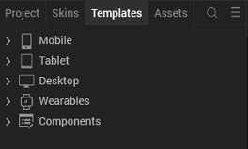

Right-click Components, and then select Import Component. The Import Component dialog box appears.
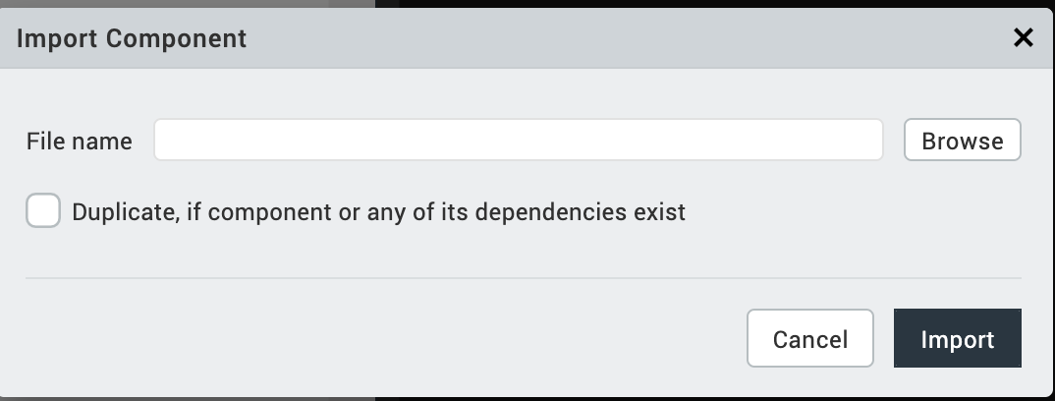

Click Browse to navigate to the location of the component, select the component and then click import. The component and its associated widgets and modules are added to your project.

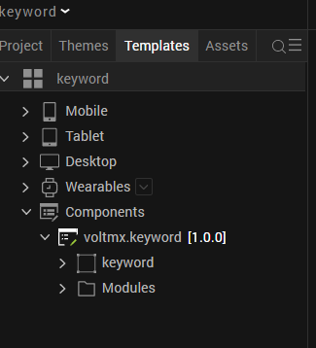
- Once you have imported a component to your project, you can easily add the component to a form. For more information, refer Add a Component to a Form

D. Building and previewing the app
After performing all the above steps, you can build your app and run it on your device. For more information, you can refer to the Building and Viewing an Application section of the Volt MX User Guide.
You can then run your app to see the KeyWord DetectionComponent work in real time.

3. References

Dynamic Usage
You can also add KeyWord DetectionComponent dynamically. To do so,
- In Project Explorer, on the Projects tab, click Controllers section to access the respective Form Controller. Create a method and implement the code snippet like the sample code mentioned below.

define({
// Type your controller code here
onNavigate: function() {
this.createComponent();
},
createComponent:function(){

var polly= new com.voltmx.Keyword({
"height": "100%",
"id": "polly",
"isVisible": true,
"left": "0dp",
"masterType": constants.MASTER_TYPE_USERWIDGET,
"skin": "CopyslFbox0b8ff21af8eb34d",
"top": "0dp",
"width": "12%",
"zIndex": 1,
}, {}, {});

polly.ServiceName = "Keyword";
this.view.add(Keyword);
}
});

In the code snippet, you can edit the properties of the component as per your requirement. For more information, see Setting Properties.
- Save the file

4. Properties:
The properties provided on the Component tab allow you to customize the UI elements in the KeyWord Detection component. You can set the properties directly on the Component tab or by writing a JavaScript.

1. ServiceName
Category: | Custom
Description: | Specifies the service name in the adapter.
Syntax:
  ServiceName
Type: | String
Read/Write: | Write
Example: | this.view.componentID.ServiceName = "Service Name";

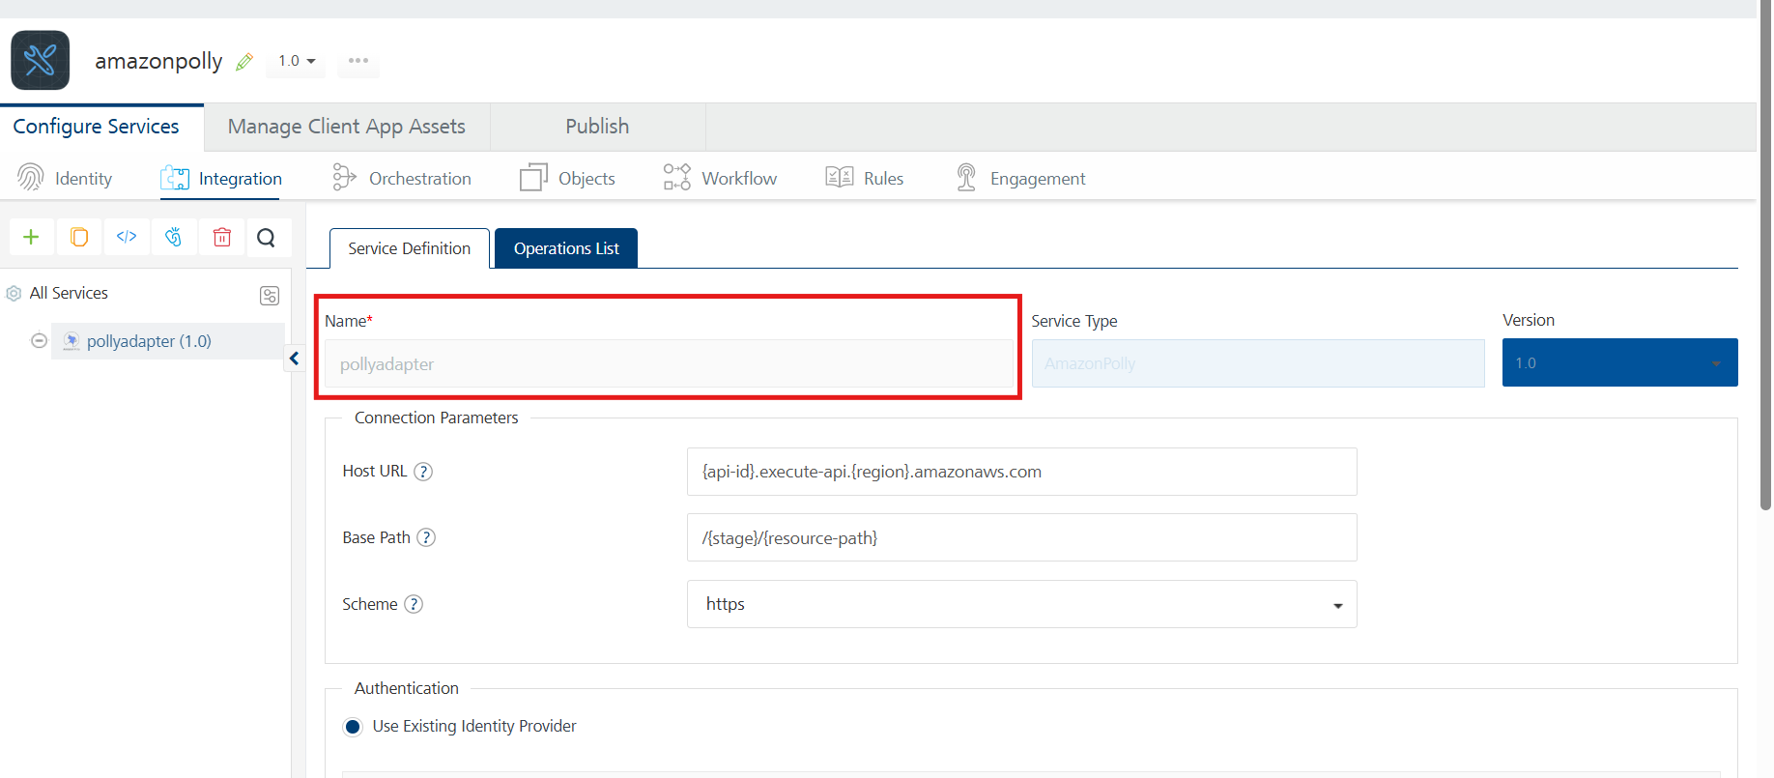
2. OperationName
Category: | Custom
Description: | Specifies the service name in the adapter.
Syntax:
  OperationName
Type: | String
Read/Write: | Write
Example: | this.view.componentID.OperationName = "Operation Name";

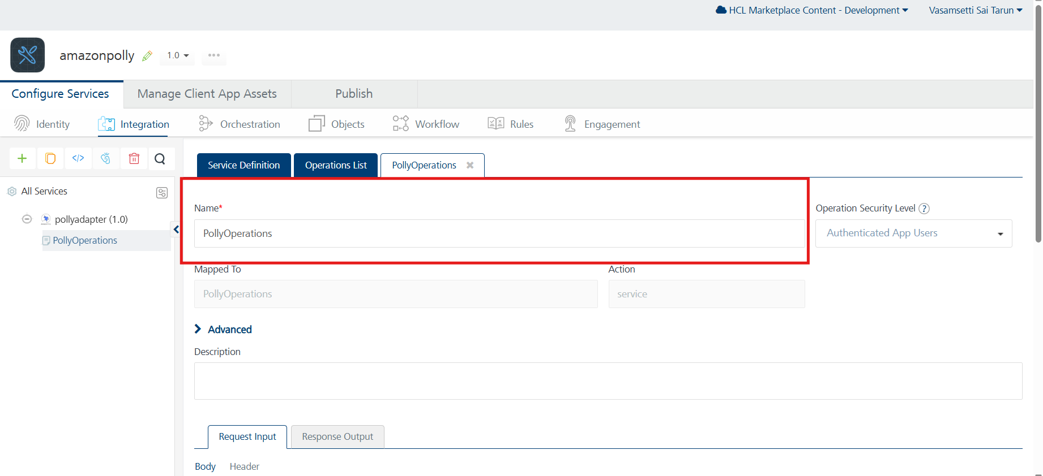

5. Revision History
App version 1.0.0:

Known Issues
- No Known Issues

Limitations

