Date : 9 Sept 2025

MICROSOFT AI CONTENT UNDERSTANDING APPLICATION

VERSION: 1.0.0

OVERVIEW

Microsoft AI Content Understanding is a new Generative AI based Azure AI Service, designed to process/ingest content of any types (documents, images and videos) into a user-defined output format.
Content Understanding offers a streamlined process to reason over large amounts of unstructured data, accelerating time-to-value by generating an output that can be integrated into automation and analytical workflows.
Microsoft AI Content Understanding Application enables users to upload images, videos, and PDF documents for intelligent content analysis. It leverages Microsoft’s AI-powered content understanding capabilities to automatically process the uploaded file and return insights based on its type:
Images → Extracts objects, text (OCR), and contextual meaning.
Videos → Analyzes scenes, detects objects/activities, and summarizes key events.
Documents (PDF only) → Reads, parses, and extracts relevant information for deeper understanding.
The features a simple and intuitive file upload interface and ensures seamless handling of supported content types. Once uploaded, the file is sent to the AI service, and the resulting analysis is returned in a structured format for further use.

Requirements:

- HCL Foundry
- Volt MX Iris
- To get started, you need an active Azure subscription. If you don't have an Azure account, create one for free.
- Once you have your Azure subscription, create an Azure AI Foundry resource in the Azure portal. Be sure to create it in a supported region.
  - This resource is listed under AI Foundry > AI Foundry in the portal.
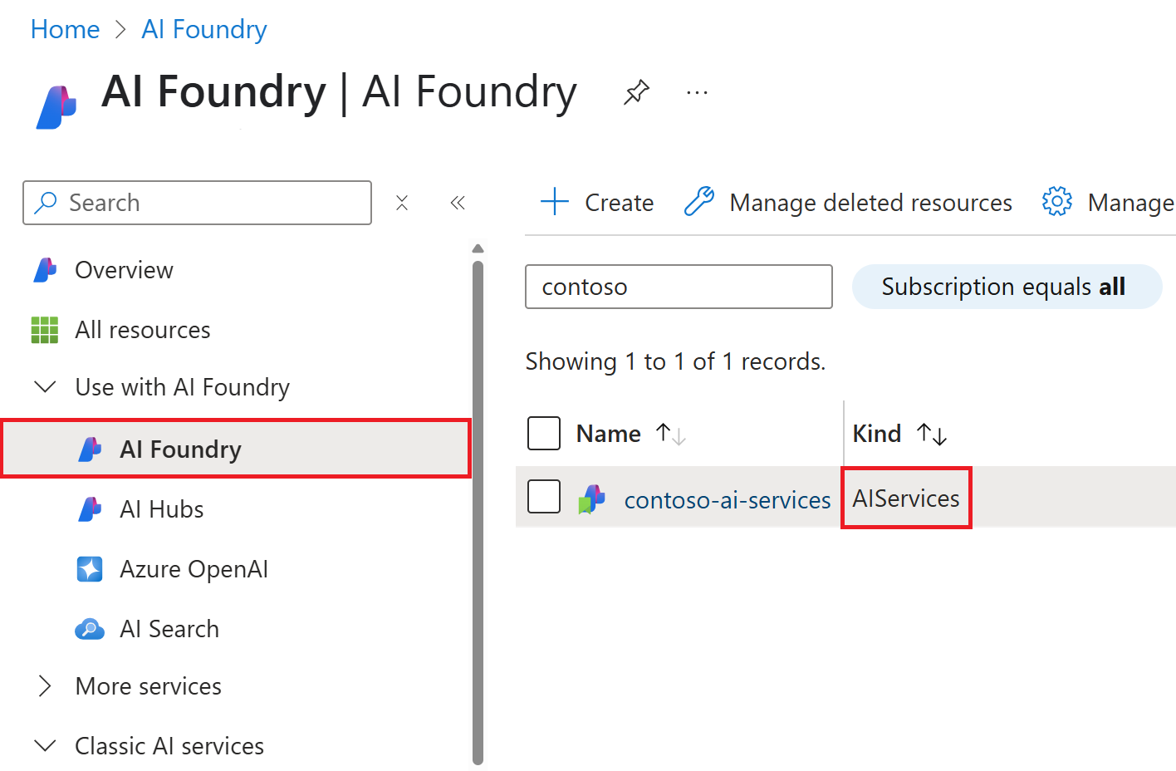
Need {endpoint} and {key} with the corresponding values from your Azure AI Foundry instance in the Azure portal.
Reference document: https://learn.microsoft.com/en-us/azure/ai-services/content-understanding/quickstart/use-rest-api?tabs=document

Devices:
- Mobile

Platforms:
- Android
- IOS

Features
- Multi-format Support – Allows uploading of images, videos, and PDF documents for AI-driven analysis.
- Intelligent Content Understanding – Extracts text, objects, and contextual insights tailored to each file type.
- Seamless Integration – Provides an easy-to-use upload interface with structured analysis results for downstream applications.

App Functionality
When you build and run the app, you can get structured data from multimodal content in document, image, and video files.
- Home Screen (frmHome)
  - The app allows the user to upload different types of content for analysis.
  - Three categories are available:
    - Document(only chooses pdf files)
    - Image
    - Video
  - The user can click the Upload file button to upload a file depending on the selected tab.
- Authentication
  - The app authenticates the user through MicrosoftAzureAIService from foundry before making Analysis requests.
- Result Retrieval & Display
- After uploading, the user navigates to the Output screen. There are two tabs:
  - Analysed Content – shows the uploaded file content (Document, Image or Video)
  - Results – shows the analysis or insights generated by the app in JSON format (e.g., text summary, sentiment, object detection, metadata).
- A small clipboard icon suggests copying the results data.
- Back Navigation
- Return to Home Screen to process a new request.

Importing the app
To import the Microsoft AI Content Understanding Application into your workspace, follow these steps:
- Open Volt MX Iris
- On the main menu select Forge → Browse.
- Search for the Microsoft AI Content Understanding Application, and then click Import to Workspace. The app is imported to your workspace. A dialog box appears, confirming that the app has been imported. Click OK.
- Switch to your project containing the Microsoft AI Content Understanding Application. To switch to your project, click File → Open → Reference Architecture → <project name>

Building the app
After performing all the above steps, you can build your app and run it on your device. For more information, you can refer to the Building and Viewing an Application section of the Volt MX User Guide.
You can then run your app to see the Microsoft AI Content Understanding Application work in real time.

Configure the UI and settings of the Microsoft AI Content Understanding Application

The Microsoft AI Content Understanding Application consists of the following key components:
- Microsoft AI Content Understanding Component – Used to get structured data from multimodal content in document, image, and video files.
UI Configuration
- Create the Home Screen
  - Take one form and add the component and you can add here a TabPane with tabs Document, Image and Video to choose the content type.
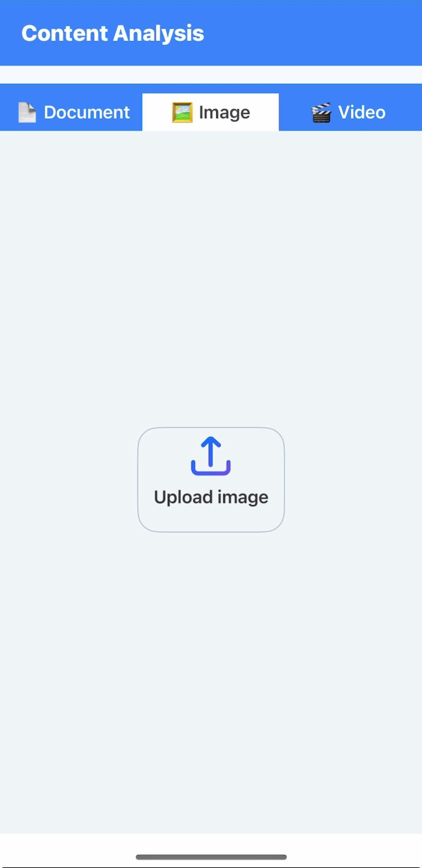

- Create the Result Screen
  - Add a TabPane with two tabs one is to display Analysed content and the other is for Results
  - Add a Label or RichText widget to display the analysed result in JSON format .
  - Add a Copy Button to allow users to copy the data.
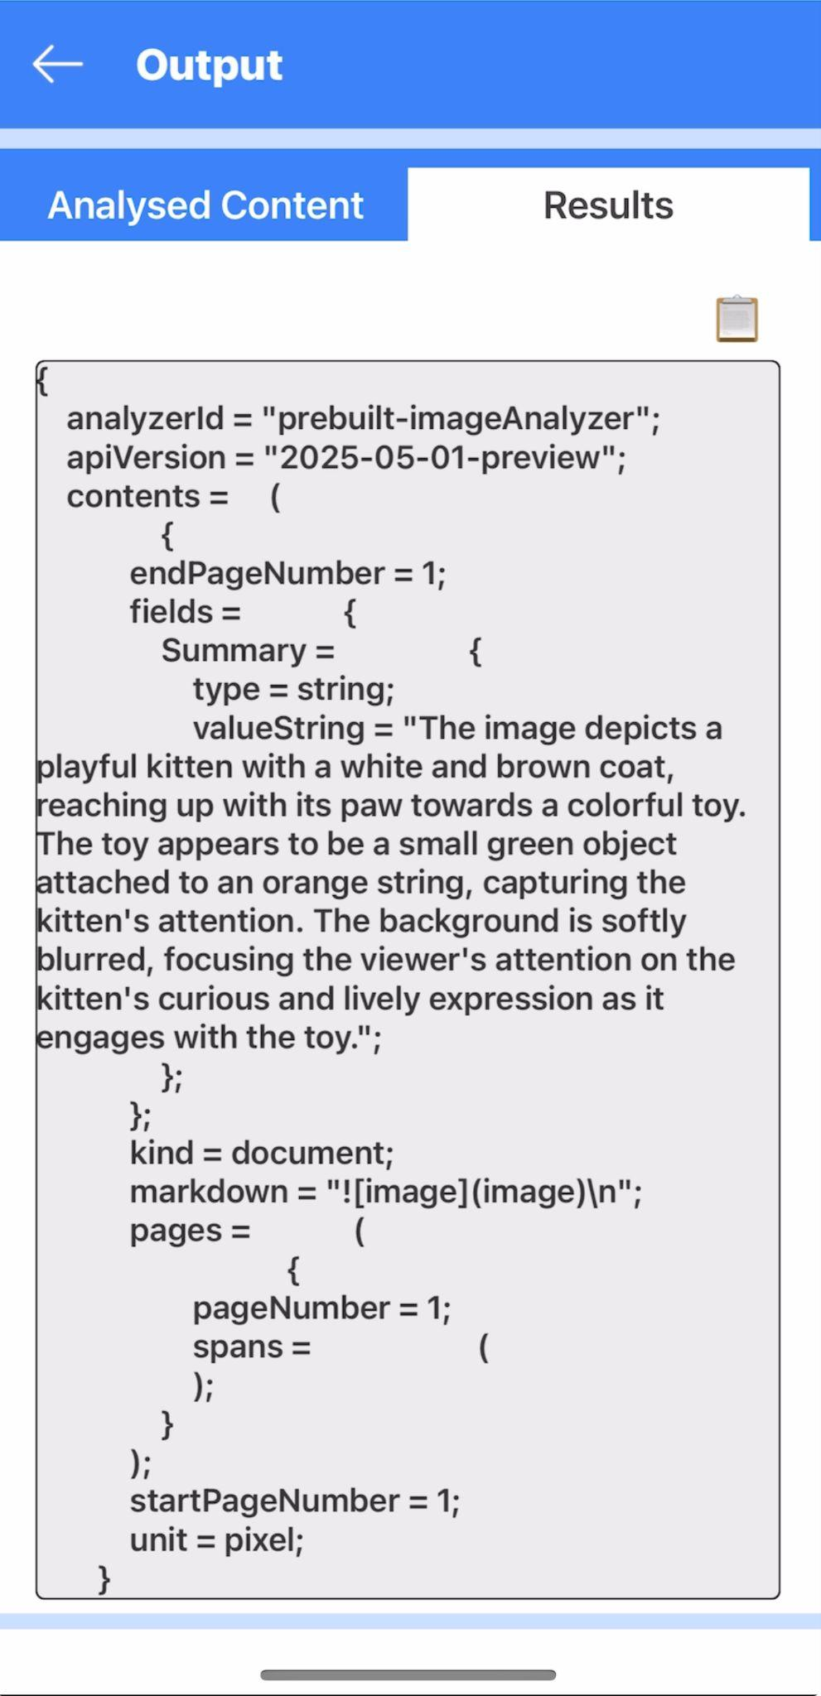

Configuring Native Settings (Android)
To configure the native settings for Android, follow these steps:
1. From the left navigation menu, click Project Settings.
2. In the Project Settings window, go to Native → Android Mobile/Tablet.
3. Set the required permissions to true.
To set a permission to true, select the permission from the left panel, and then click Add.

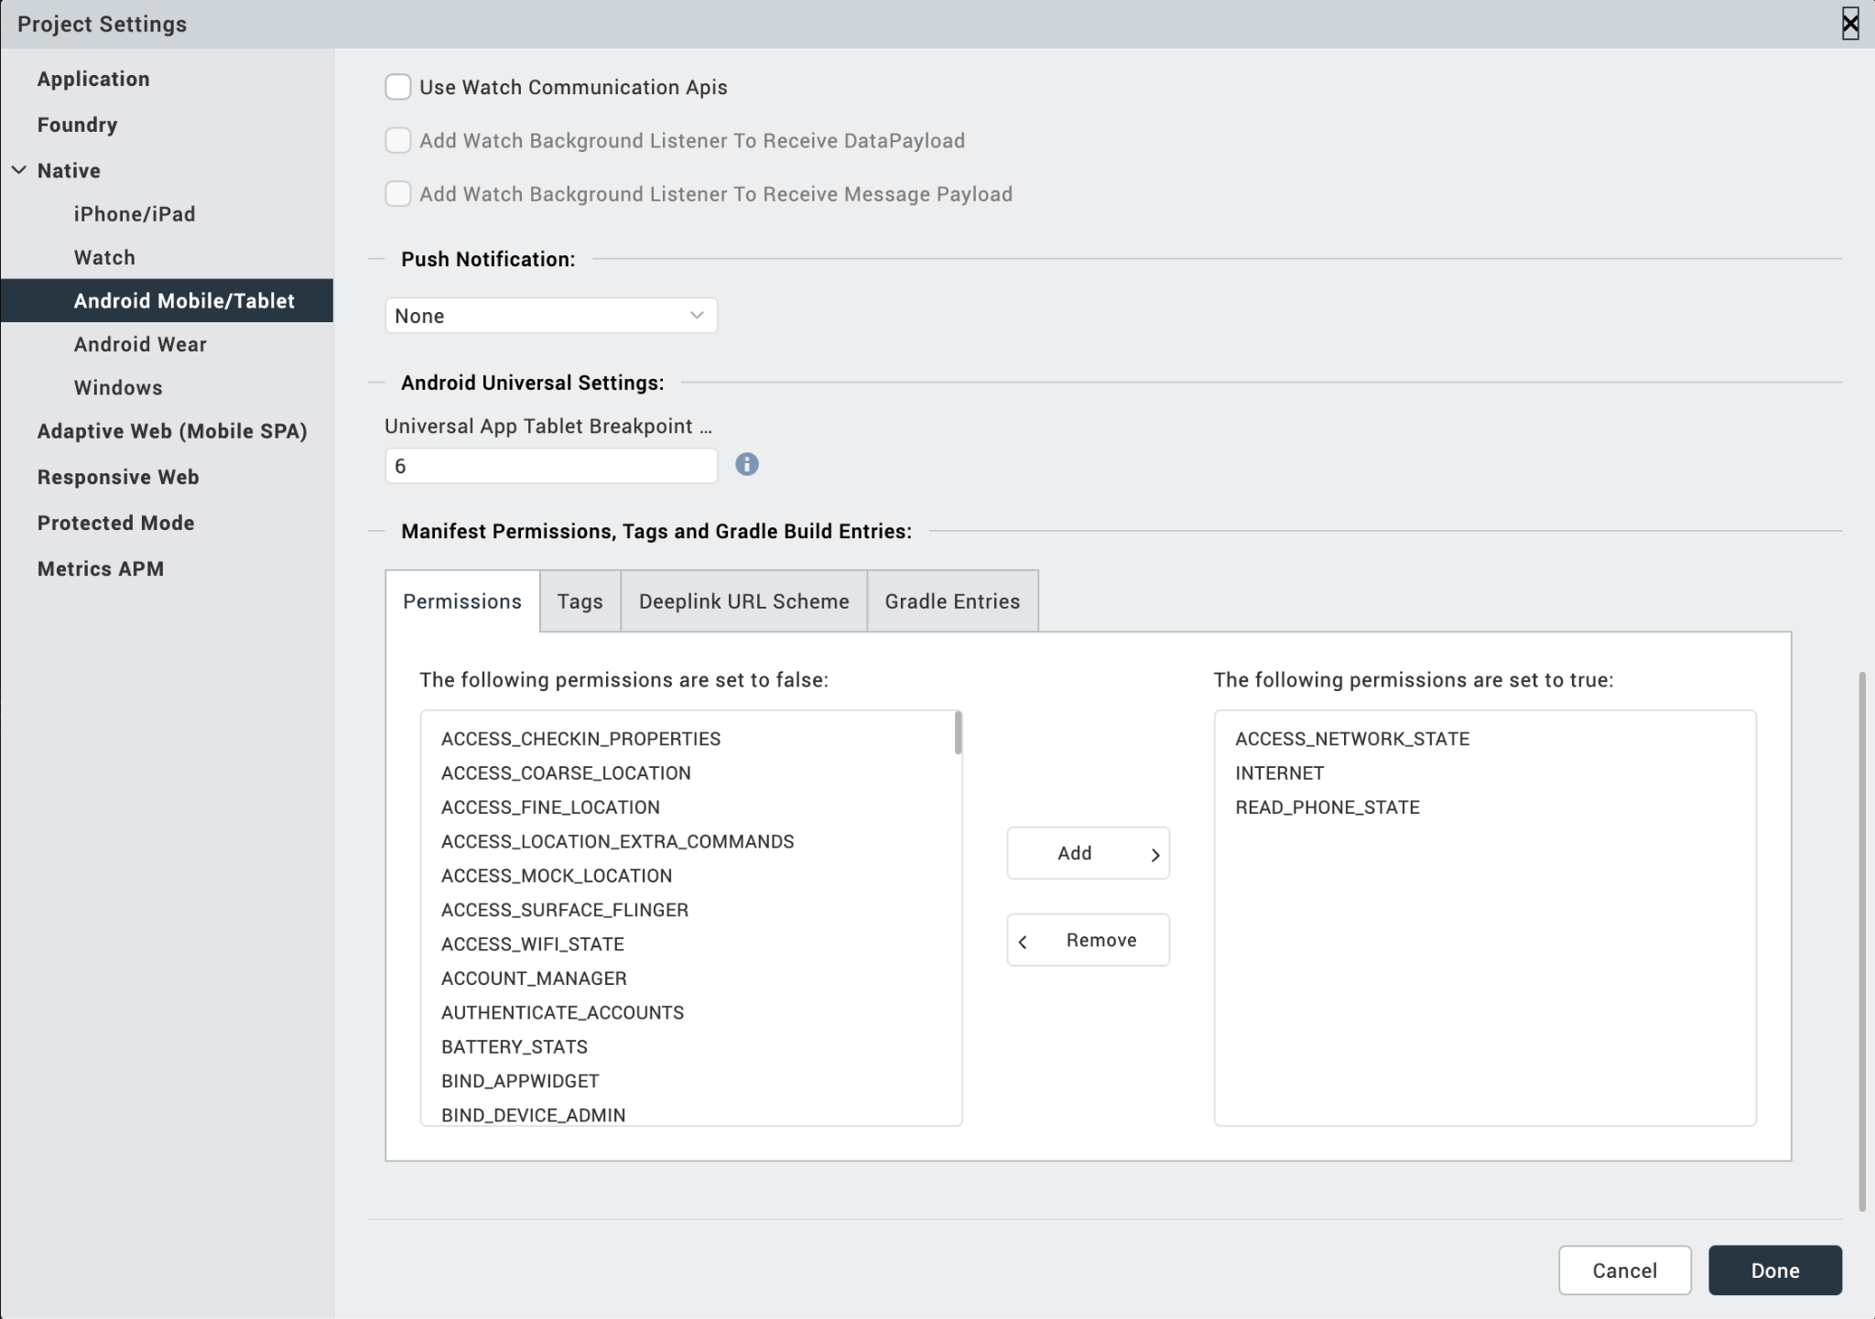
4. Switch to the Gradle Entries tab.
5. Add below Read_MEDIA_IMAGES permission flag at Project Settings/Android Mobile/Tablet/Manifest Permissions, Tags/Child tag entries under <manifest> tag/

<uses-permission android:name="android.permission.READ_MEDIA_IMAGES" />
<uses-permission android:name="android.permission.READ_MEDIA_VIDEO" />
<uses-permission android:name="android.permission.READ_EXTERNAL_STORAGE" />

NOTE:
- If you do not add the gradle entries to your project, the app crashes.
After you configure the native settings, you can Build and Run your app.

Foundry APP Setup
When you import the component to your Volt MX Iris project, the HCL Volt MX Foundry services of the Microsoft AI Content Understanding are added to the HCL Volt MX Foundry app, which is associated with the Volt MX Iris project. While importing the Microsoft AI Content Understanding Application to your Volt MX Iris project, if there is no HCL Volt MX Foundry app associated with the existing Volt MX Iris project, a new HCL Volt MX Foundry app is automatically added to your HCL Volt MX Foundry environment and is associated with your Volt MX Iris.
To set the Foundry app, follow these steps:
- Click the HCL Volt MX Foundry app associated with your Volt MX Iris project from the Project Explorer. Click DATA & SERVICES
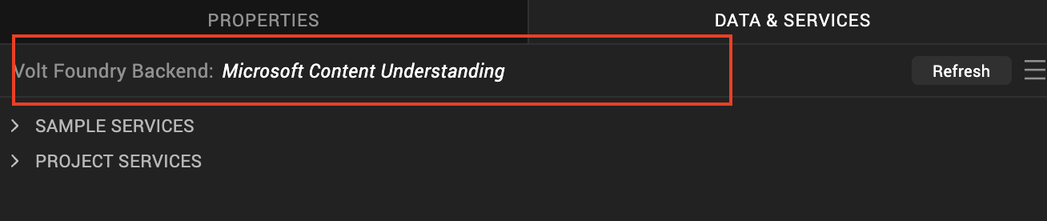
- Configure the Identity service
  - Under the Configure Services tab. Click the Identity tab and select the MicrosoftAzureAIService and click on it.
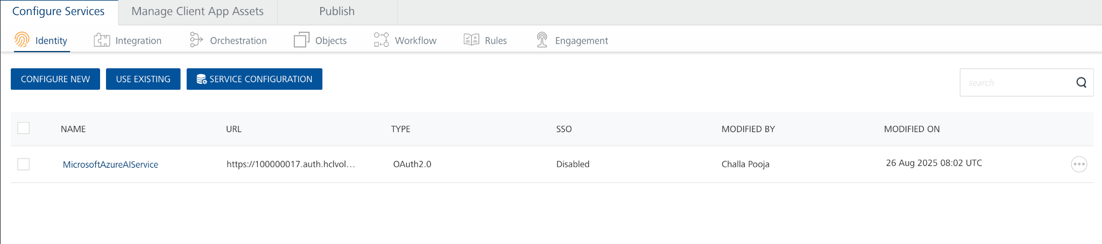
  - In the Client ID box, type the Client ID provided by Microsoft identity platform.
  - In the Client Secret box, type the secret key provided by Microsoft identity platform. These fields are mandatory.
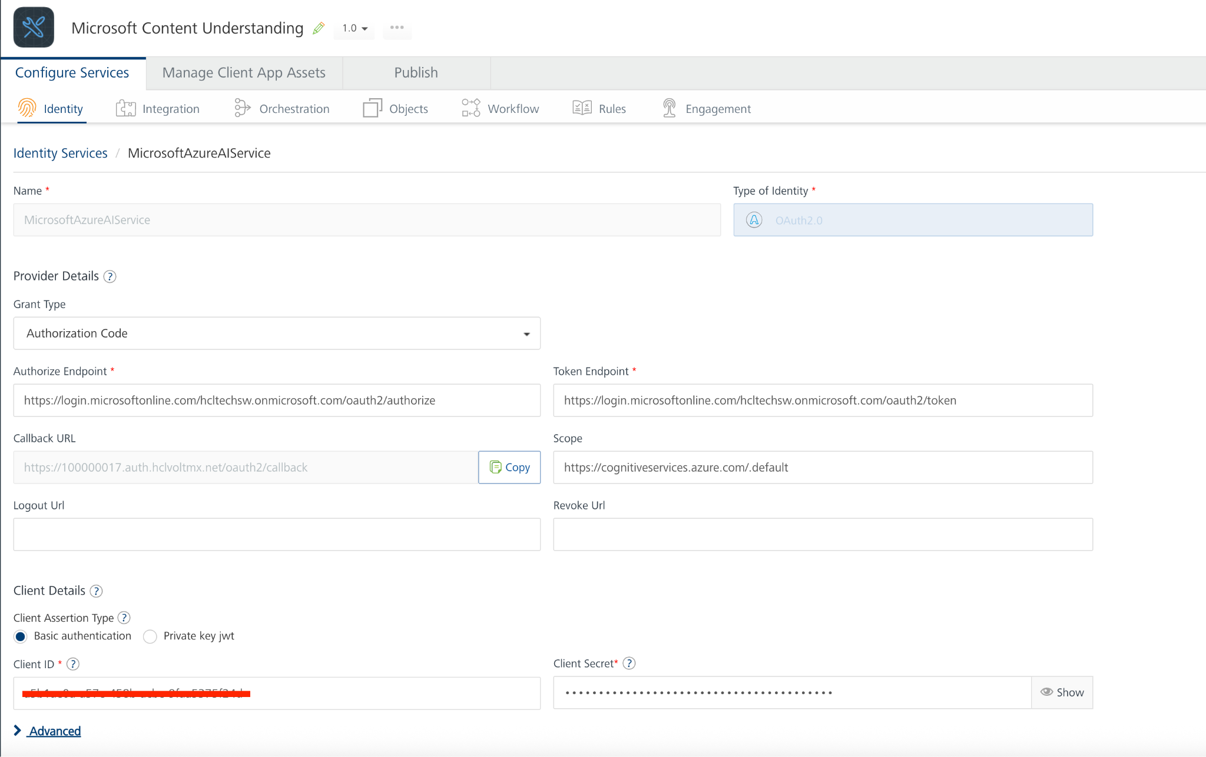

  - Under Client Details, type the Client ID and Client Secret that you received from Microsoft identity platform.
  - To obtain Client ID and Client Secret from Microsoft refer the below documentations
Links:
https://learn.microsoft.com/en-us/entra/identity-platform/quickstart-register-app?tabs=certificate
https://learn.microsoft.com/en-us/entra/identity-platform/access-tokens
https://learn.microsoft.com/en-us/rest/api/contentunderstanding/content-analyzers/analyze?view=rest-contentunderstanding-2025-05-01-preview&tabs=HTTP#oauth2auth

Note:
If you want to verify the details, click TEST LOGIN and sign in by using your Microsoft account credentials.
  - Click Save
- Under the Configure Services tab, click Integration and can see the MicrosoftContentUnderstanding Integration service. Click on that Integration service to add the keys.
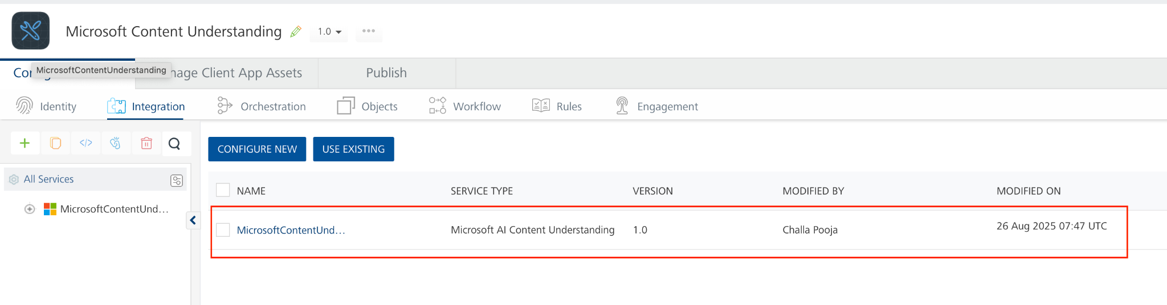
- Under Authentication select Use Existing Identity provider. From the drop-drown list select MicrosoftAzureAIService.
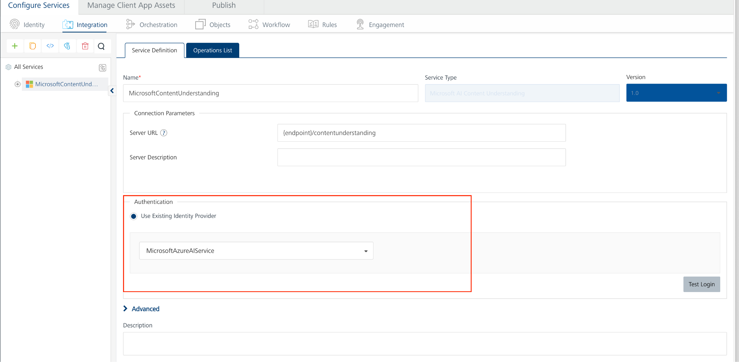
- In the Connection Parameters section, enter the service endpoint URL provided by Microsoft (see the Prerequisites section).
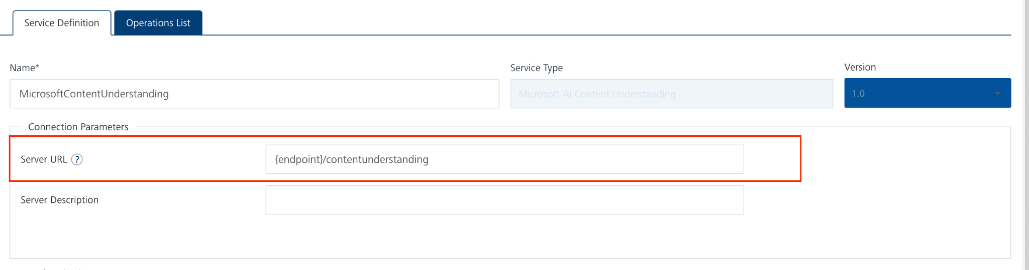
- Click Save.
If the details provided are valid, the Volt MX Foundry service connects to your Microsoft AI Content Understanding developer site and allows you to make the API calls.
Refer to Integration Services for more information on creating and using integration services.
- Click the Operations List tab. The Operations List tab opens with the list of operations available.
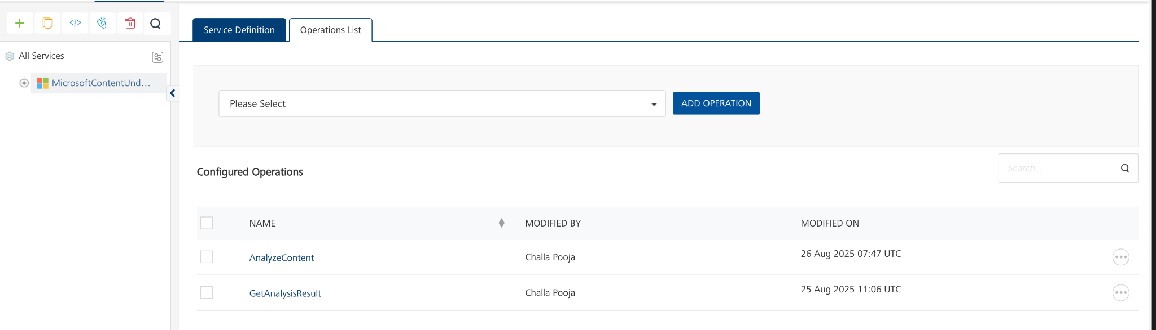
- Executing an Operation
Executing an operation involves making the API call by setting the necessary parameters and displaying the response. The procedure to execute any operation is the same, but the request parameters of the APIs vary. For more information on request parameters of API, refer Microsoft AI Content Understanding.
This section provides steps to execute the AnalyzeContent operation
- Under the Configured Operations section, click the AnalyzeContent operation. The AnalyzeContent tab opens with the Request Input sub-tab opened by default.
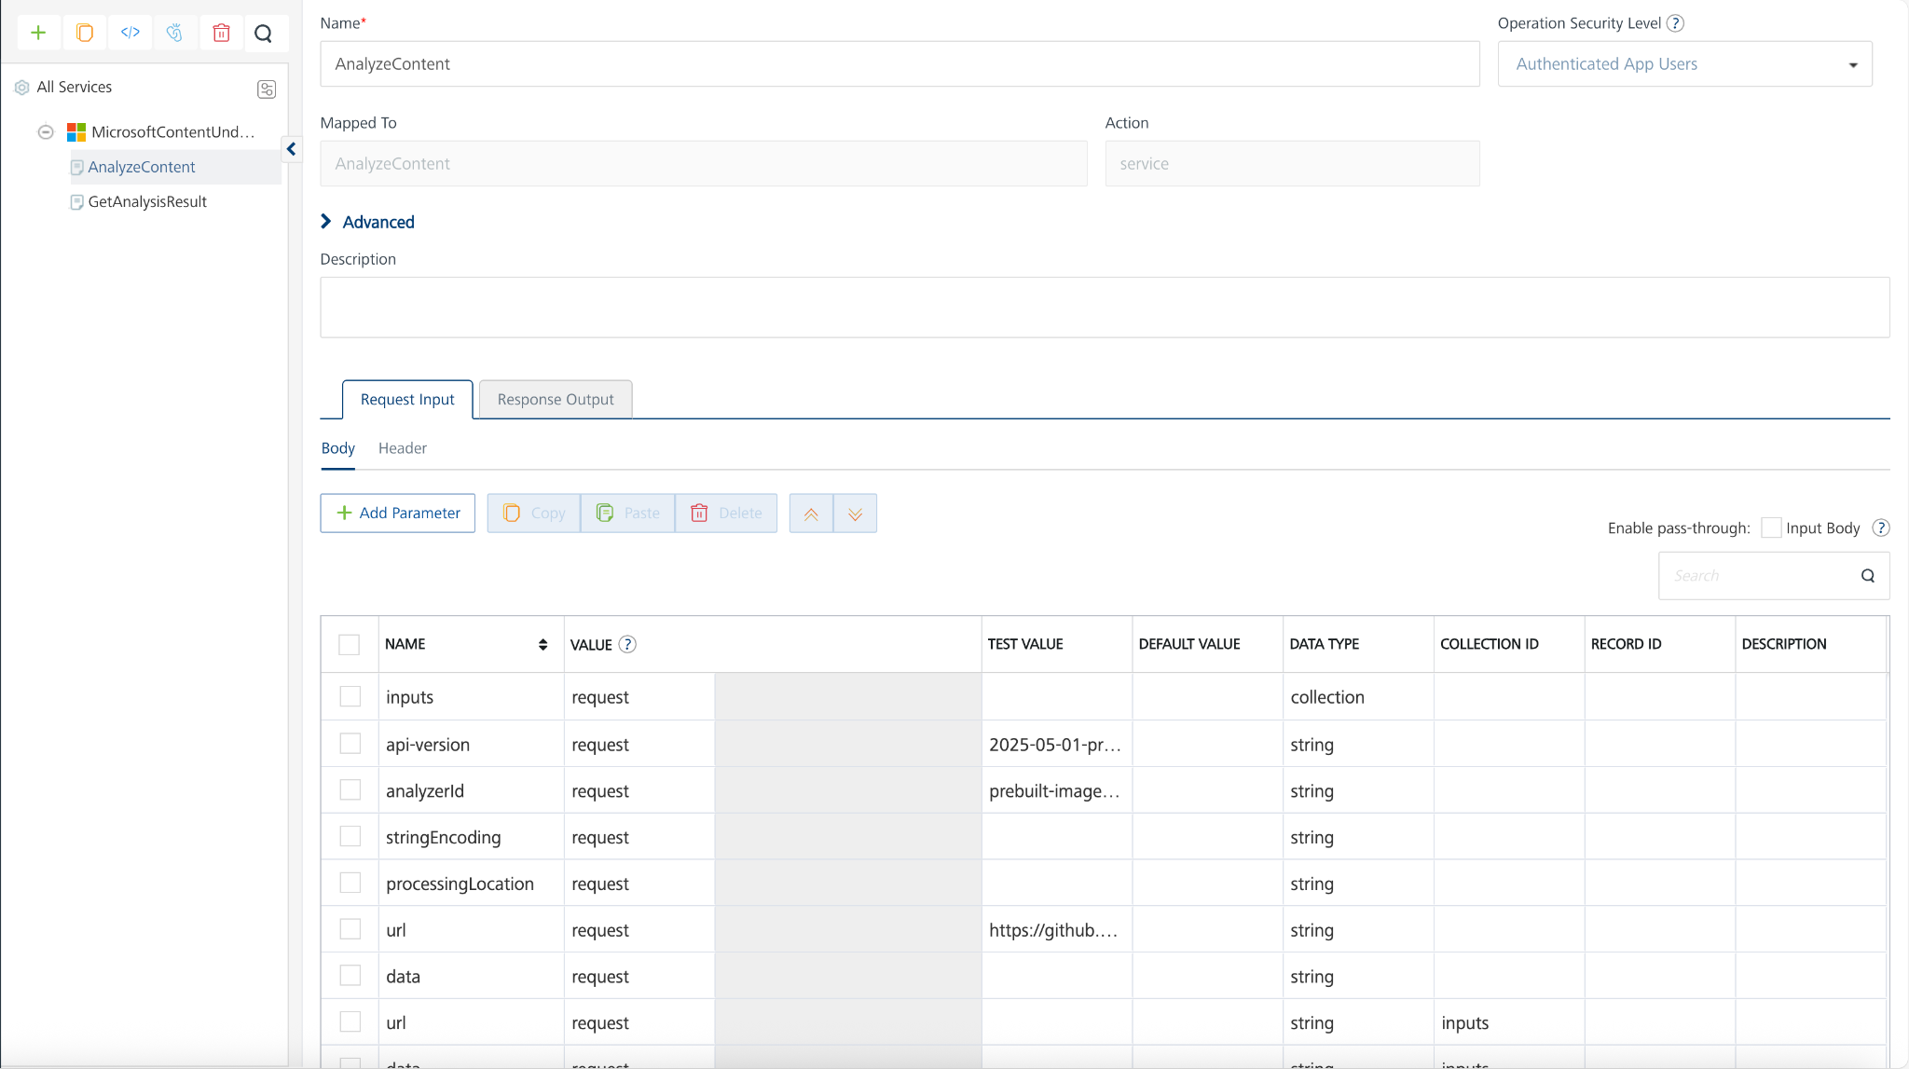
- In the Name box, the name of the operation is displayed by default. If you want, you can change the name.
- On the Request Input tab, in the Body section, for the following parameters, specify the values in the respective boxes under the Test Value column.
- Mandatory Parameters
- api-version: The API version to use for this operation.
- analyzerId: The unique identifier of the analyzer.
- data: Base64-encoded binary content of the primary input to analyze. Only one of url or data should be specified.
- url: The URL of the primary input to analyze. Only one of url or data should be specified.
For more information refer to this Microsoft AI Content Understanding and https://learn.microsoft.com/en-us/azure/ai-services/content-understanding/quickstart/use-rest-api?tabs=document#send-file-for-analysis
- Click Header sub-tab. The Header section opens.
- For Ocp-Apim-Subscription-Key, In the box under the TEST VALUE or DEFAULT VALUE column, type the API Key generated from Microsoft Azure.
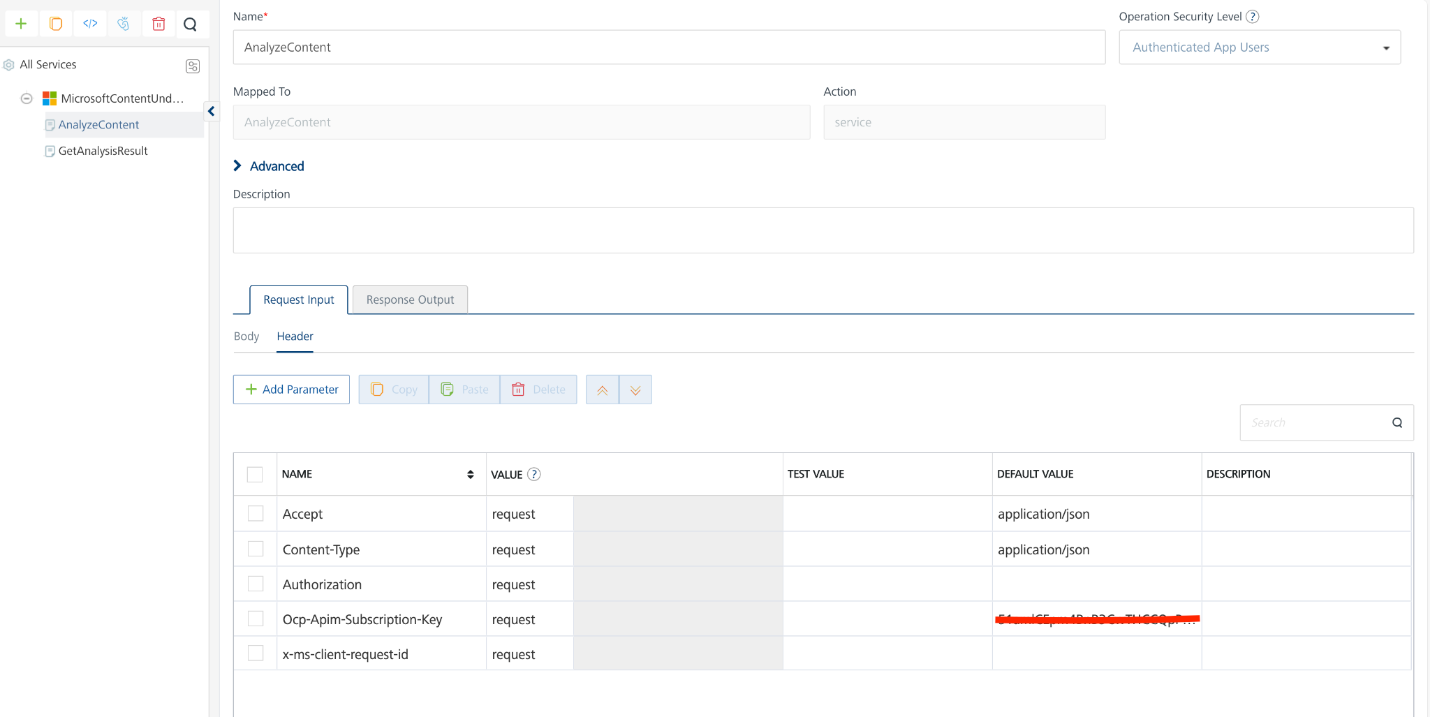
- Click SAVE OPERATION.
- Click SAVE AND FETCH RESPONSE. The Output Result dialog appears with the response. Otherwise, the Output Result shows an error.
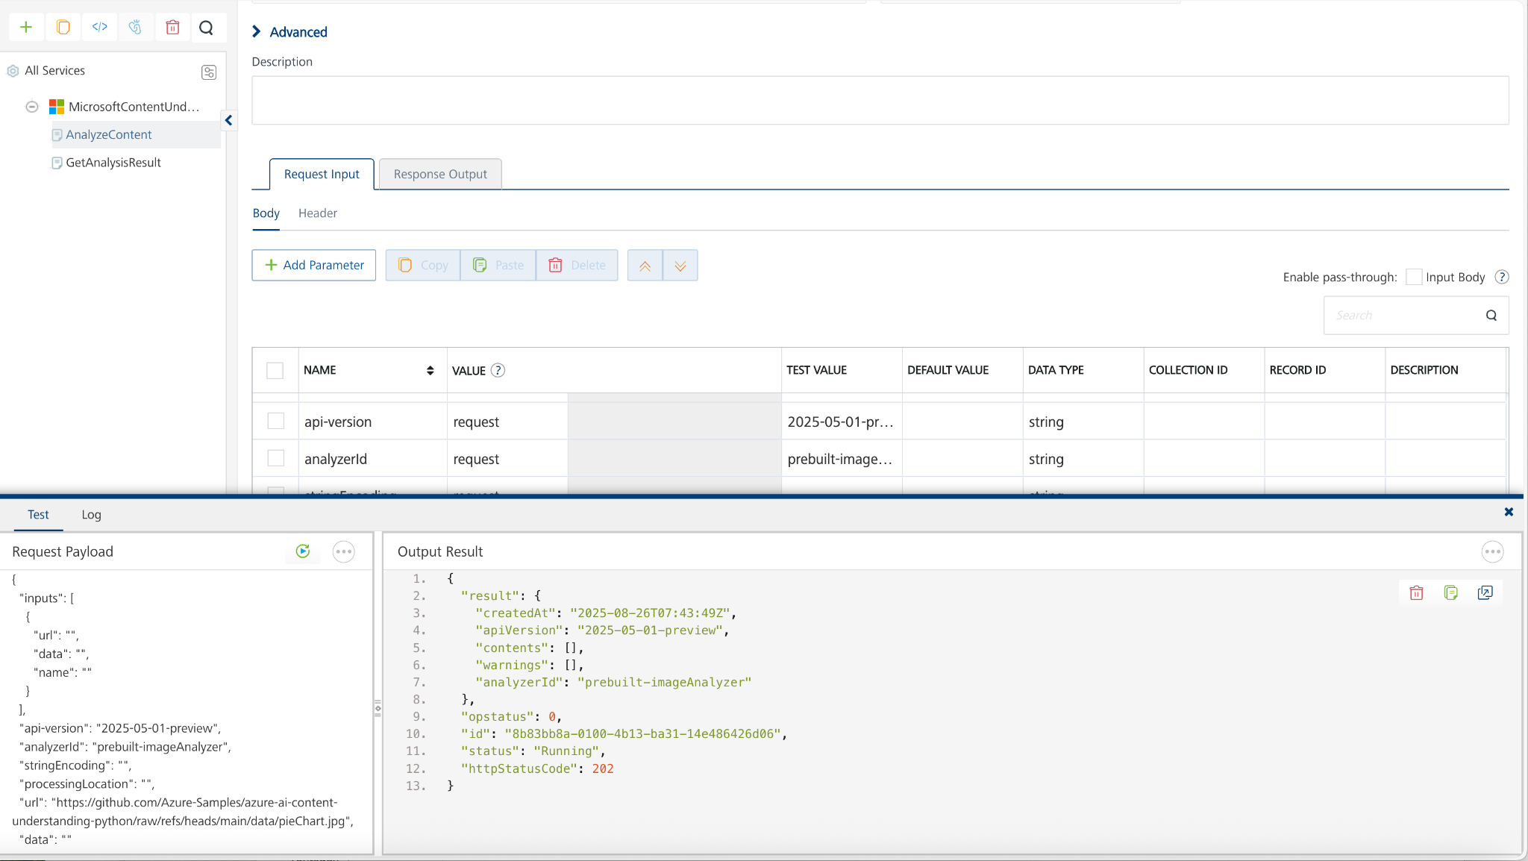

To get analyze result use GetAnalysisResult operation
- Use the request-id from the POST response and retrieve the result of the analysis.
  - Replace {endpoint} and {key} with the endpoint and key values from your Azure portal Azure AI Foundry instance.
  - Replace {request-id} with the request-id from the POST response, or use the complete URL from the Operation-Location response header.
- Click the icon to go back to Volt MX Iris.

Publish the HCL Volt MX Foundry App
After you set the Operation Security Level, you must publish the HCL Volt MX Foundry app. To publish the HCL Volt MX Foundry, follow these steps:
In Volt MX Iris, click DATA & SERVICES, and then click Publish Project Services to Publish to your foundry app.
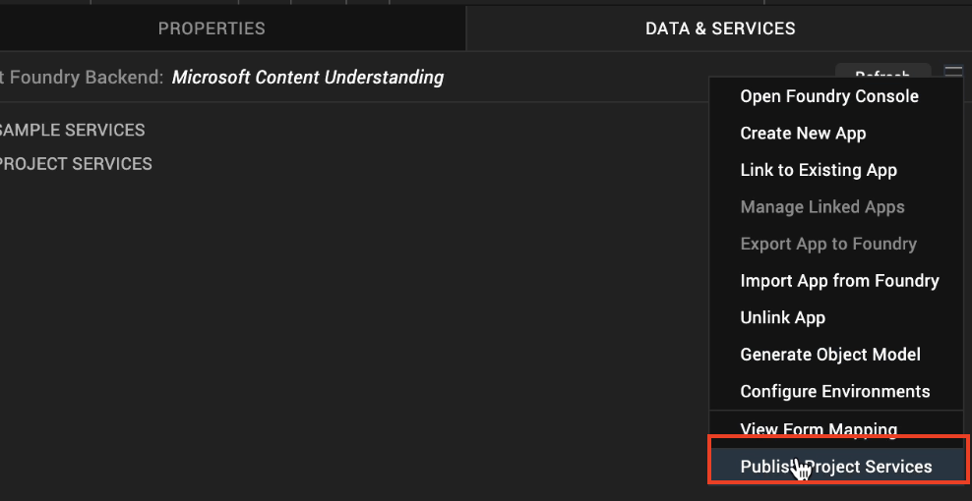
Select the environment to which you want to publish your app, and then click Publish.
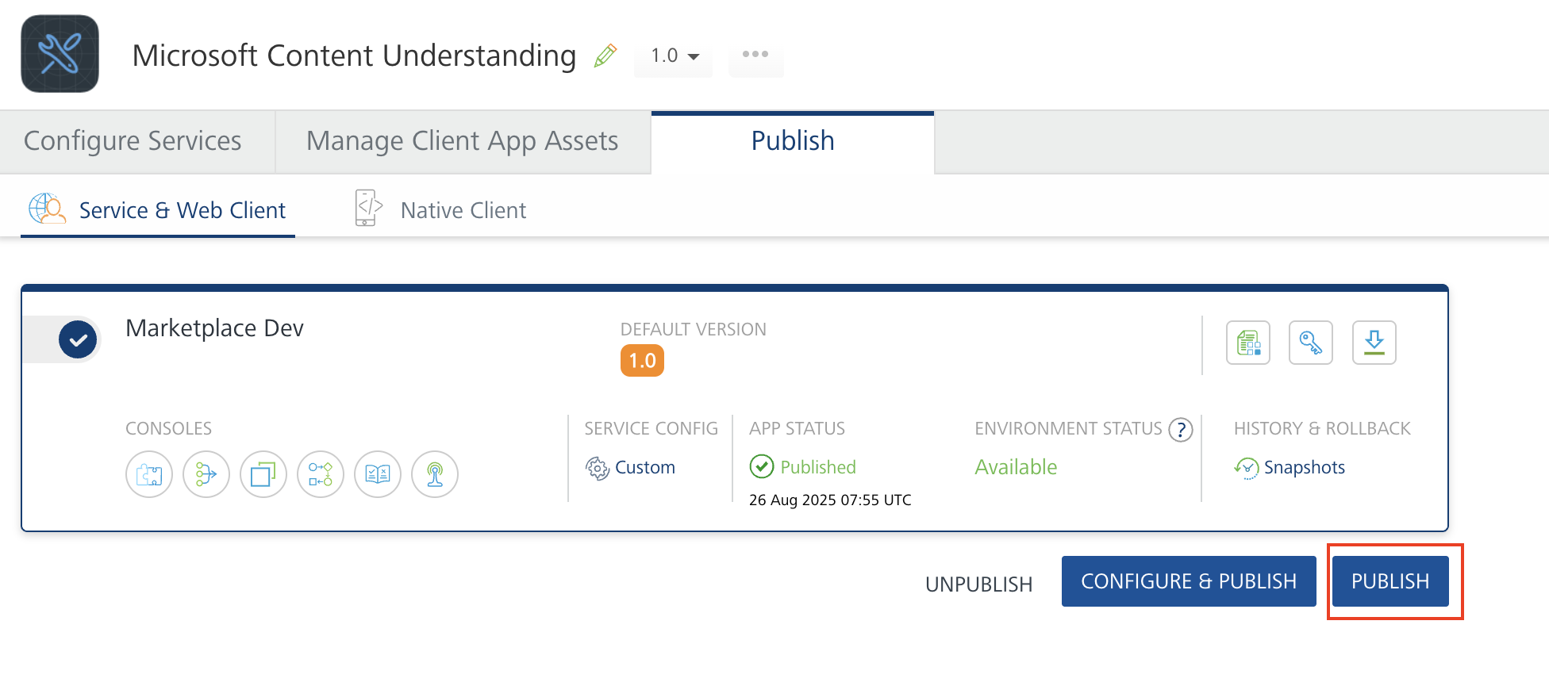
After the app is published to your environment, the following window appears confirming the publish.
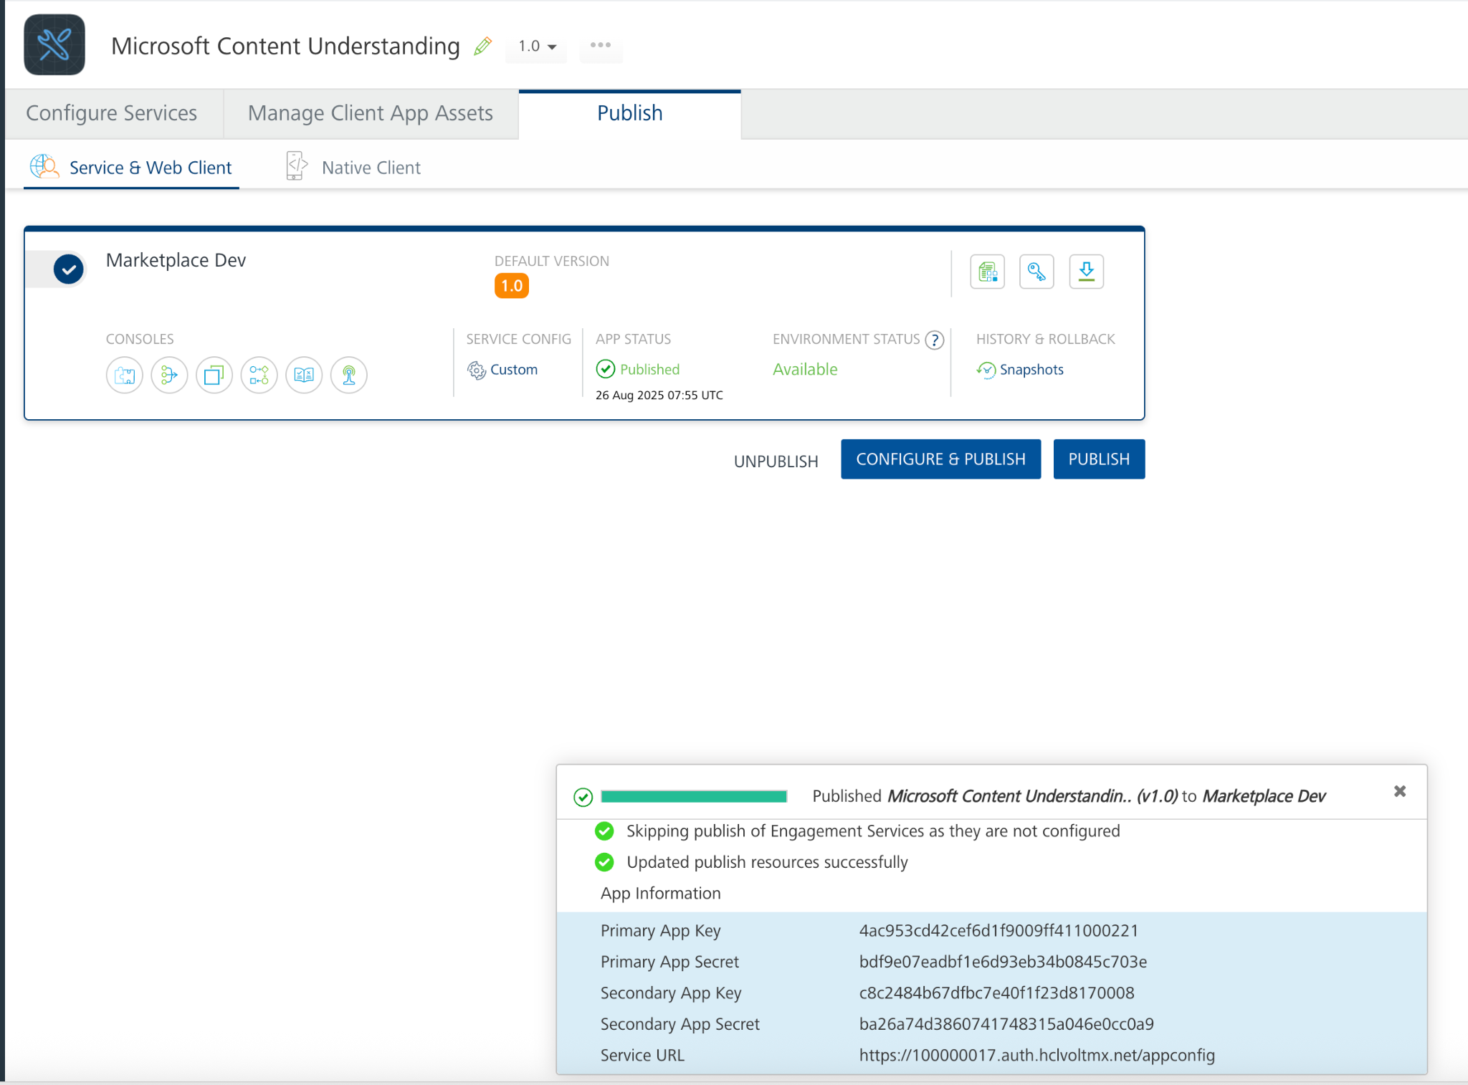

Building and previewing the app
After performing all the above steps, you can build your app and run it on your device. For more information, you can refer to the Building and Viewing an Application section of the Volt MX User Guide.
You can then run your app to see the Microsoft AI Content Understanding Component work in real time.

Reference Documents:
- https://learn.microsoft.com/en-us/azure/ai-services/content-understanding/quickstart/use-rest-api?tabs=document
- https://learn.microsoft.com/en-us/rest/api/contentunderstanding/content-analyzers/analyze?view=rest-contentunderstanding-2025-05-01-preview&tabs=HTTP

REVISION HISTORY
App version 1.0.0:

Known Issues
None

Limitations
- Use pdf less than 40MB
- Microsoft AI Content Understanding service quotas and limits https://learn.microsoft.com/en-us/azure/ai-services/content-understanding/service-limits

