Date :  12-May-25

**MICROSOFT AI DOCUMENT INTELLIGENCE BACKEND SERVICE**

**VERSION: 1.0.0**

# **OVERVIEW**

**Microsoft AI Document Intelligence** is a cloud-based service that uses advanced AI and OCR to extract structured data from documents like invoices, receipts, forms, and IDs. It automates data entry, improves accuracy, and enables faster decision-making across business processes. The service offers prebuilt and custom models for flexible data extraction.

## **Use case:**

Consider an organization that needs to process large numbers of receipts for expenses claims, project costs, and other accounting purposes. Suppose someone needs to manually enter the information into a database. The manual process is relatively slow and potentially error-prone.

Using document intelligence, the company can take a scanned image of a receipt, digitize the text with OCR, and pair the field items with their field names in a database. Document intelligence can identify specific data such as the merchant's name, merchant's address, total value, and tax value.

Azure AI Document Intelligence supports features that can analyze documents and forms with prebuilt and custom models. In this module, you explore how Azure AI services provide access to document intelligence capabilities.

## **Features:**

* **Prebuilt Models**: Out-of-the-box models for common document types, including invoices, receipts, identity documents, business cards, and tax form.
* **Optical Character Recognition (OCR)**: Extract printed and handwritten text from documents.
* **Custom Models**: Train tailored models to extract specific data from your unique document formats.
* **Layout Analysis**: Identify and extract tables, key-value pairs, and document structures.

## **Percentage of re-use:**

80%

# **GETTING STARTED**

## **Prerequisites**

Before you start using the **Microsoft AI Document Intelligence** Back-end Service, ensure you have the following:

* [HCL Foundry](https://manage.hclvoltmx.com/)
* Volt MX Iris
* [Microsoft account](https://portal.azure.com/)
* An Azure subscription - [Create one for free](https://azure.microsoft.com/free/cognitive-services/)
* A Document Intelligence (single-service) or Azure AI services (multi-service) resource. Once you have your Azure subscription, create a [single-service](https://portal.azure.com/#create/Microsoft.CognitiveServicesFormRecognizer) or [multi-service](https://portal.azure.com/#create/Microsoft.CognitiveServicesAIServices) Document Intelligence resource, in the Azure portal. Here I created a single-service. After your resource deploys, select Go to resource.
  + You'll need the key and endpoint from the resource you create to connect your application to the Azure AI Document Intelligence service.
  + You can use the free pricing tier (F0) to try the service, and upgrade later to a paid tier for production.

**Note:** For Document Intelligence access only, create a Document Intelligence resource. You need a single-service resource if you intend to use [Microsoft Entra authentication](https://learn.microsoft.com/en-us/azure/active-directory/authentication/overview-authentication).

* An Azure Blob Storage container**:** A standard performance [Azure Blob Storage account](https://portal.azure.com/#create/Microsoft.StorageAccount-ARM). You create containers to store and organize your training documents within your storage account. If you don't know how to create an Azure storage account with a container, following these quickstarts:
* [Create a storage account](https://learn.microsoft.com/en-us/azure/storage/common/storage-account-create). When creating your storage account, make sure to select Standard performance in the Instance details → Performance field.
* [Create a container](https://learn.microsoft.com/en-us/azure/storage/blobs/storage-quickstart-blobs-portal#create-a-container). When creating your container, set the Public access level field to Container (anonymous read access for containers and blobs) in the New Container window.

**For more information, refer to the following links:** <https://learn.microsoft.com/en-us/azure/ai-services/document-intelligence/quickstarts/get-started-sdks-rest-api?view=doc-intel-4.0.0&pivots=programming-language-rest-api>,

<https://learn.microsoft.com/en-us/azure/ai-services/document-intelligence/quickstarts/studio-custom-project?view=doc-intel-4.0.0>

## IMPORTING THE BACK-END SERVICE

1. Download the **Microsoft AI Document Intelligence back-end service** zip file from [HCL Forge](https://marketplace.hclvoltmx.com/).
2. Sign in to the [HCL Foundry Console](https://manage.hclvoltmx.com/).
3. On the **Foundry Apps** page, click **IMPORT**.
4. On the **Import** **App** dialog box, drag and drop the zip file that you downloaded earlier. Alternatively, you can **browse** for the zip file on your system. After the zip file is uploaded, the console displays the default **App Name** and **Version**.
5. Click **IMPORT**.

## **CONFIGURING THE IDENTITY SERVICE**

1. Sign in to the [HCL Foundry Console](https://manage.hclvoltmx.com/).

2. From the **Foundry Apps** page, select the app that you imported earlier.

3. Under **Configure Services**, on the **Identity** tab, select the **MicrosoftAzureAIService** identity service.   
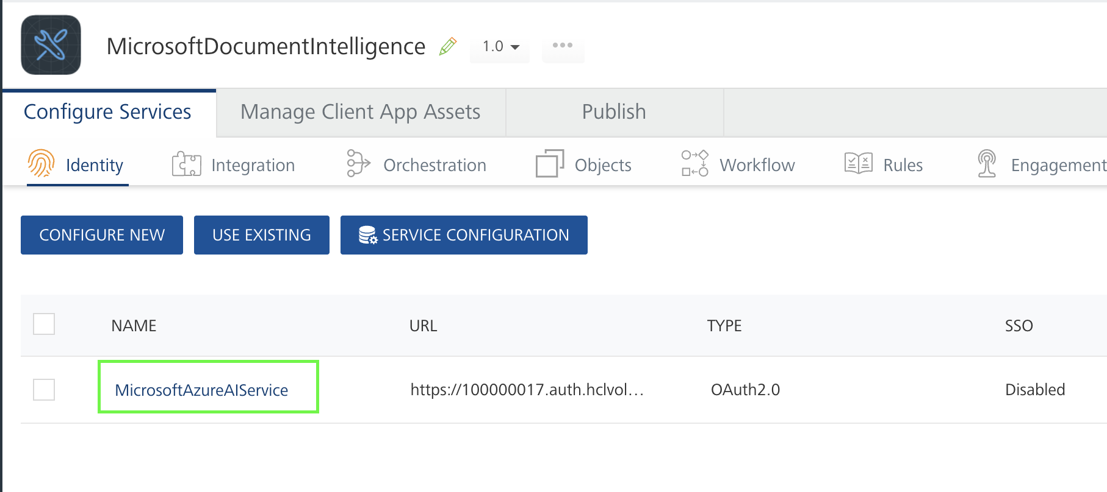

4. Under **Client Details**, type the **Client ID and Client Secret that you obtained from Microsoft.**

To obtain **Client ID** and **Client Secre**t from Microsoft refer the below documentations

**Links:** <https://learn.microsoft.com/en-us/entra/identity-platform/quickstart-register-app?tabs=certificate>,

<https://learn.microsoft.com/en-us/entra/identity-platform/access-tokens>,

<https://learn.microsoft.com/en-us/rest/api/aiservices/document-models/analyze-document?view=rest-aiservices-v4.0%20(2024-11-30)&tabs=HTTP#oauth2auth>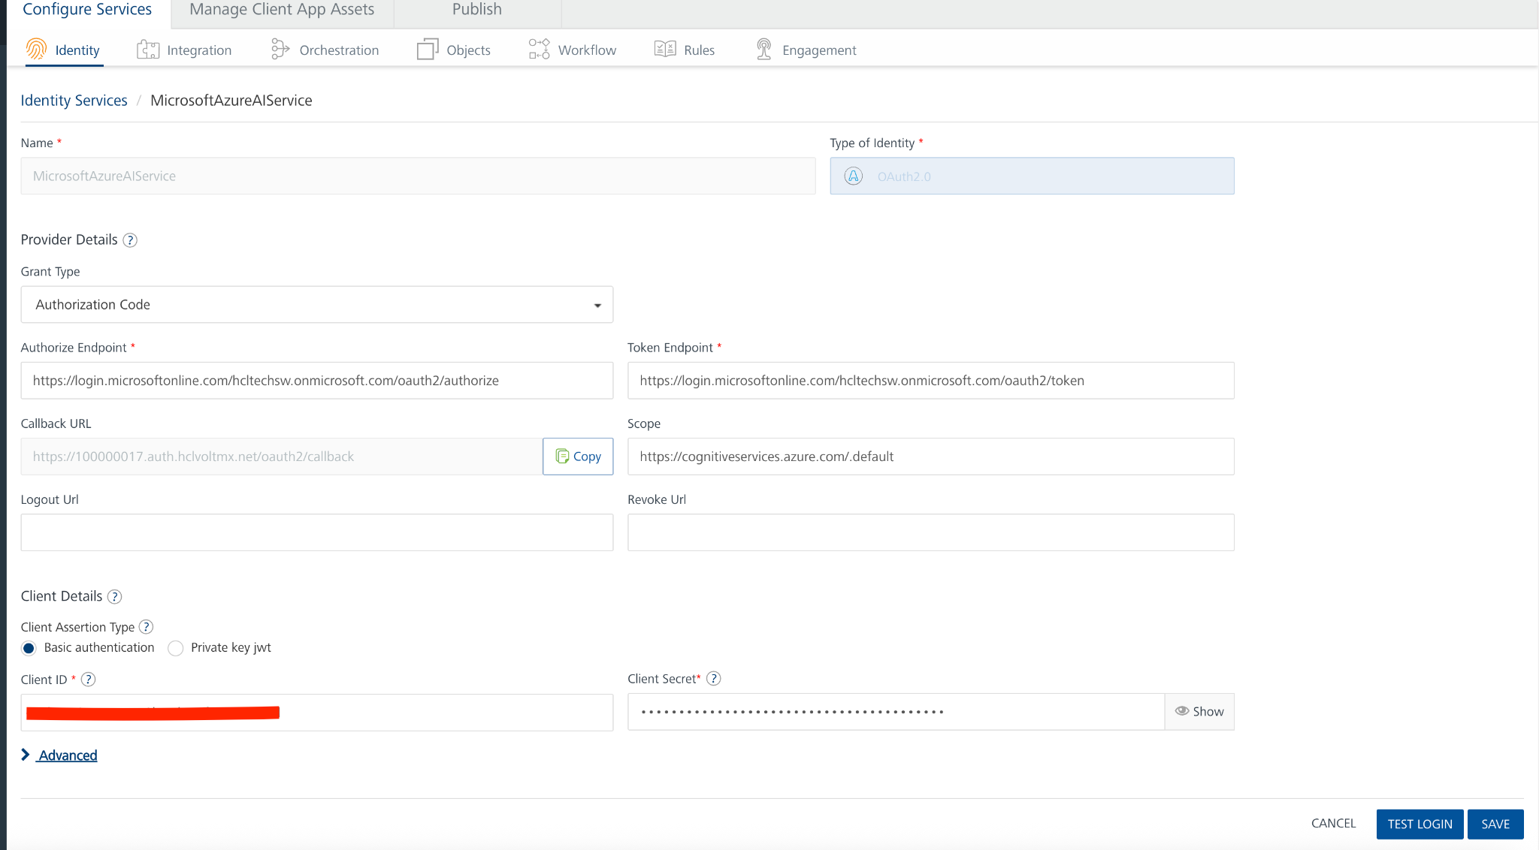

**Note:** If you want to verify the details, click **TEST LOGIN** and sign in by using your Microsoft credentials.

5. Click **Save**.

## **USING THE INTEGRATION SERVICE**

## 1. Sign in to the [HCL Foundry Console](https://manage.hclvoltmx.com/).

## 2. From the Foundry Apps page, select the app that you imported earlier.

## 3. Under Configure Services, on the Integration tab, expand the DocumentIntelligence service.

## 4. From the list of operations, select an operation that you want to test.

## 5. On the Request Input tab, enter a TEST VALUE or a DEFAULT VALUE for the parameters.

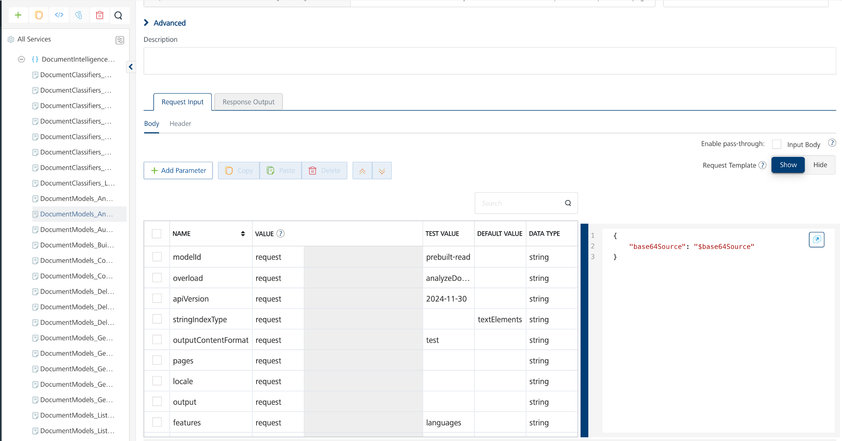

**Note:**

* To fetch the response on Volt MX Foundry, clear the **Enable pass-through** check box on the **Response Output** tab.

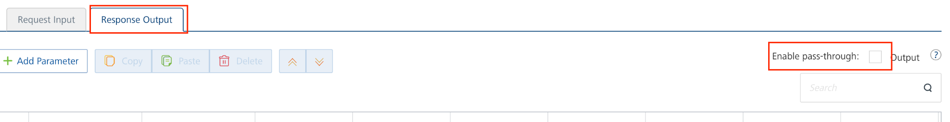

6. Click **SAVE**.

## MISCELLANEOUS

* For APIs with POST calls, check the parameter names configured on Volt MX Foundry, as the parameters with the same names in a single request body will be renamed according to the context.

## **Publishing the App to Volt MX Foundry**

After adding the **Microsoft AI Document Intelligence Service** to your app and configuring the necessary configurations, you must publish the app to Volt MX Foundry. For more information, refer to [Publish a Project to Volt MX Foundry.](https://opensource.hcltechsw.com/volt-mx-docs/docs/documentation/Iris/iris_user_guide/Content/PublishVoltMXFoundryServicesApp.html)  
  
If you want to use the services in client applications, you need to publish the app to a run-time environment.

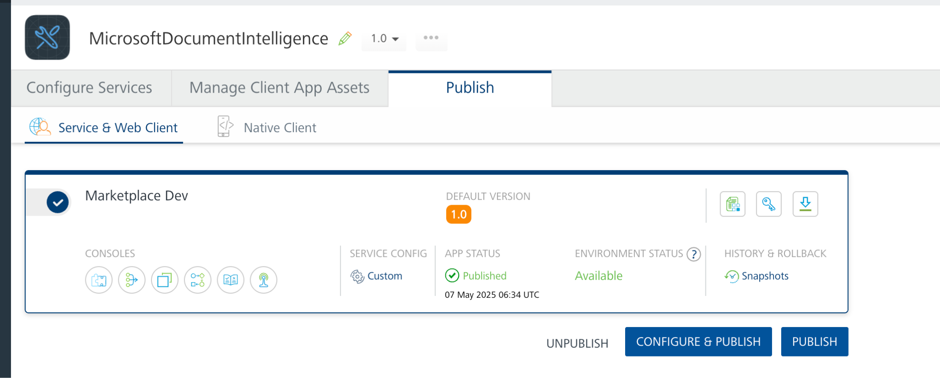

You can also link the Volt Foundry app to a client application.

**Reference API documentation:**

<https://learn.microsoft.com/en-us/rest/api/aiservices/operation-groups?view=rest-aiservices-v4.0%20(2024-11-30)>,

<https://learn.microsoft.com/en-us/azure/ai-services/document-intelligence/?view=doc-intel-4.0.0>

# **REVISION HISTORY**

App version 1.0.0:

## **Known Issues**

None

## **Limitations**

None