29 May 2025

MICROSOFT AI LANGUAGE

VERSION: 1.0.0

OVERVIEW
Microsoft AI Language (also known as Azure AI Language or formerly part of Cognitive Services) is a suite of natural language processing (NLP) services that enables applications to understand, interpret, and interact with human language in a sophisticated and meaningful way. It leverages large-scale machine learning models to extract insights from text.

- Use case:
It can be used to extract meaningful information such as entities, key phrases, and sentiment from customer feedback, social media posts, or support tickets, helping to improve customer experience and operational efficiency. It also supports detecting and redacting personally identifiable information (PII) to meet compliance requirements.

Percentage of re-use:
80% (Data can be customizable and customers need to implement UI by themselves).

Features
- EntityLinking
- EntityRecognition
- KeyPhraseExtraction
- LanguageDetection
- PiiEntityRecognition
- SentimentAnalysis

GETTING STARTED

Prerequisites
Before you start using the Microsoft AI Language Data Adapter, ensure you have the following:

- HCL Foundry
- Volt MX Iris
- Microsoft account
- A Microsoft Language or Azure AI service resource. Once you have your Azure subscription, create a Microsoft Language resource, in the Azure portal. Here I created a single-service. After your resource deploys, select Go to resource.
  - You'll need the key and endpoint from the resource you create to connect your application to the Azure AI language service.
  - You can use the free pricing tier (F0) to try the service, and upgrade later to a paid tier for production.
- Endpoint,and api-key to use the Microsoft’s AI Language API issued by Microsoft.
Reference document: https://learn.microsoft.com/en-us/azure/ai-services/language-service/overview
https://learn.microsoft.com/en-us/azure/ai-services/language-service/named-entity-recognition/quickstart?tabs=macos%2Cga-api&pivots=rest-api#prerequisites

Importing the data adapter

You can import Microsoft AI Language Data Adapter into HCL Foundry directly from the voltmx Forge website or by importing the data adapter zip file.

To import the data adapter zip file, do the following:
- Log on to your HCL Foundry. The Dashboard page appears by default.
- In the left pane, click the API Management menu. The APIs tab opens by default.
- Click the Custom Data Adapters tab. The Custom Data Adapter page appears.
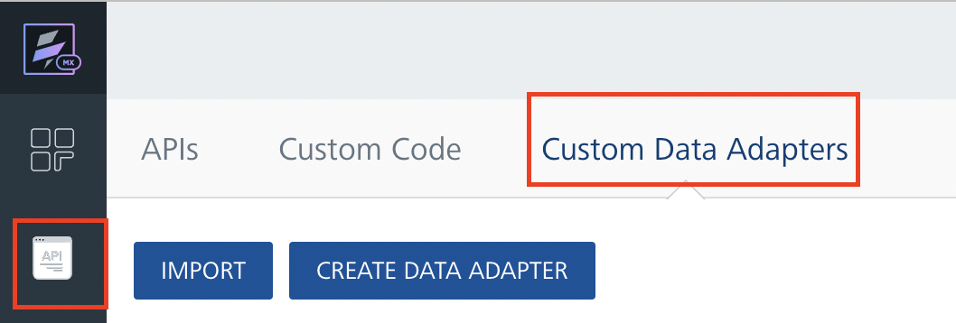
- Click Import. The Import Data Adapter dialog appears.

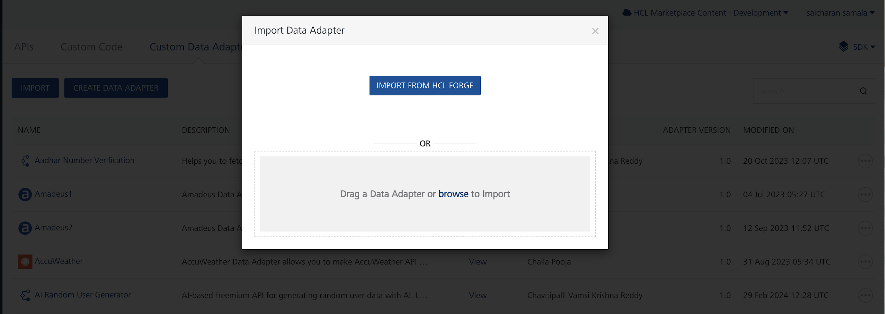

- Click IMPORT FROM HCL FORGE. The Import Data Adapter from HCL Forge dialog appears with a list of available data adapters.
- Click Import. Microsoft AI Language data adapter is listed on the Custom Data Adapters page.
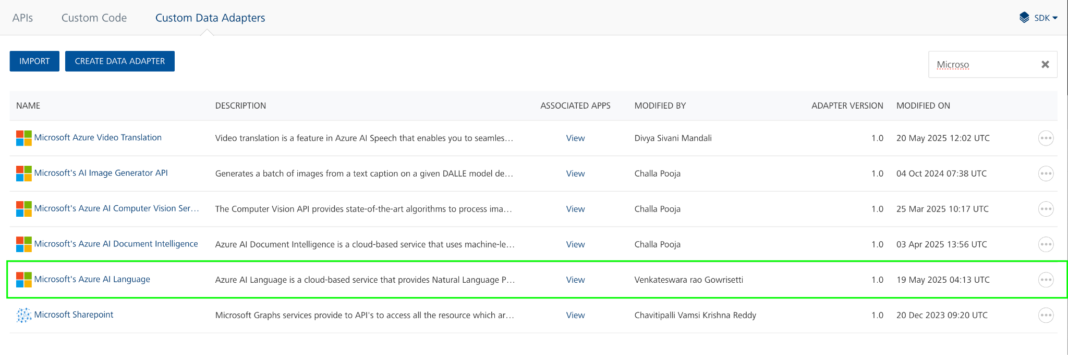

To import the data adapter zip file, do the following:
- Perform steps 1 to 4 in the above procedure
- Drag the data adapter zip file into the Drag a Data Adapter box.
Or
Click browse. The Open dialog appears.
Navigate to the location where you downloaded the data adapter (zip file) on your computer, select the data adapter, and click Open. The Import Data Adapter dialog shows the selected data adapter.

Creating an Identity Service
To create an identity service, follow these steps:
- Sign in to the HCL Foundry.
- From the left navigation menu, select API Management.
- Under APIs, on the Identity tab, click CONFIGURE NEW.
- From the Type of Identity list, select Oauth2..
- In the Client ID box, type the Client ID provided by Microsoft.
- In the Client Secret box, type the secret key provided by Microsoft. These fields are mandatory.

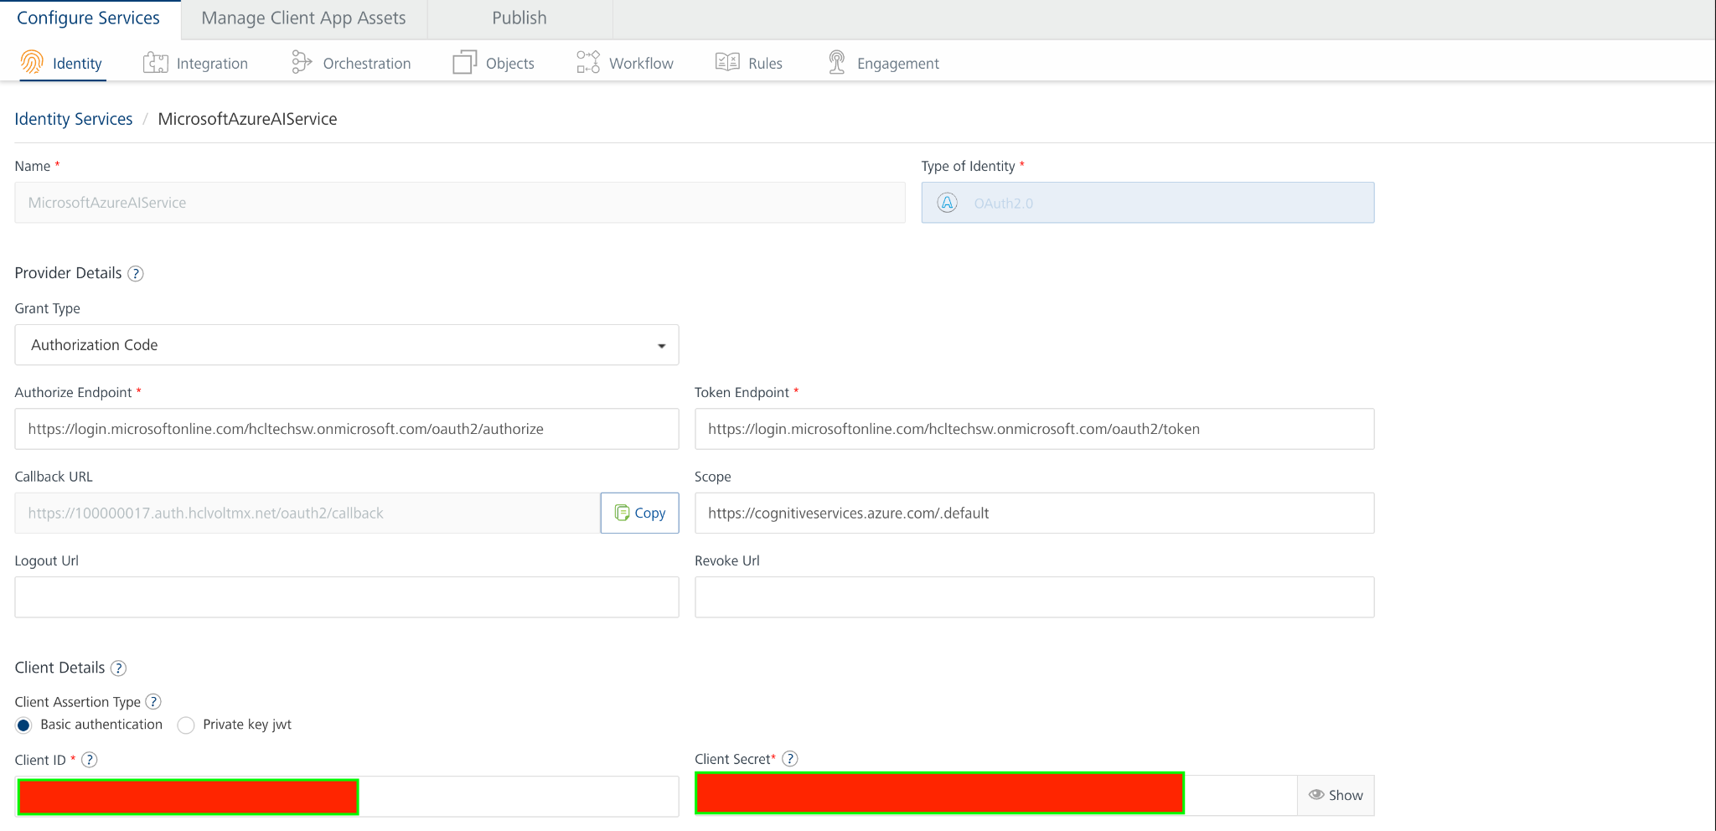
- Under Client Details, type the Client ID and Client Secret that you received from Microsoft

Note:
If you want to verify the details, click TEST LOGIN and sign in by using your Microsoft credentials.

- Click Save

Creating an Integration Service with Microsoft AI Language :
After you import Microsoft AI Language Data Adapter into Foundry, you must create an integration service with service type as Microsoft AI Language .
To create an integration service with Microsoft AI Language, do the following:
- Log on to your HCL Foundry. The Dashboard page appears by default.
- In the left pane, click the API Management menu. The APIs tab opens by default.
- Click the Integration tab. The Integration tab opens with a list of existing integration services.
- Click CONFIGURE NEW. The Service Definition tab opens.
- In the Name box, type a unique name for your service.
- From the Service Type list, select Microsoft AI Language.
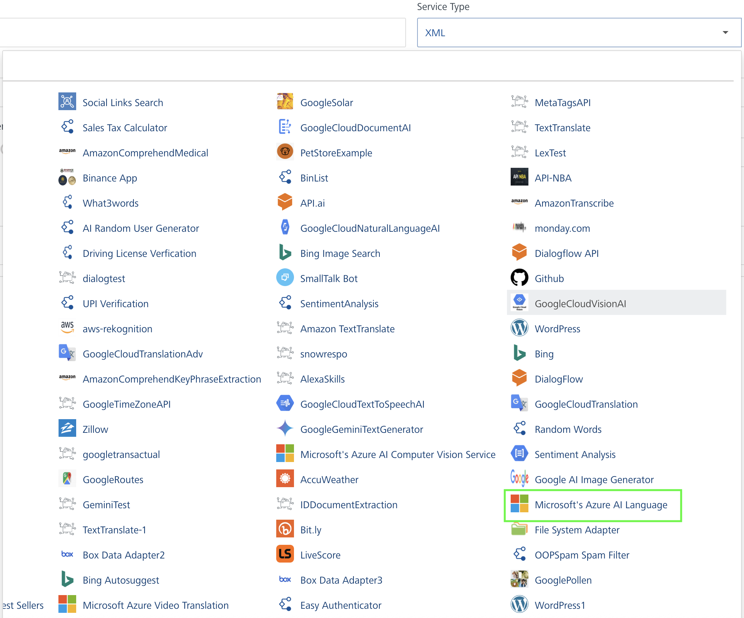
- Click Save

Creating an Operation
To make any API call in the HCL Foundry console, you must create an operation for the respective API and then execute the operation. Executing an operation involves making the API call and displaying the response.
This section provides steps to create an operation for the Microsoft AI Language API.
Steps to create an operation for the Microsoft AI Language API:
- Log on to your HCL Foundry. The Dashboard page appears by default.
- In the left pane, click the API Management menu. The APIs tab opens by default.
- Click the Integration tab. The Integration page appears with a list of existing integration services.
- From the list of integration services, select the integration service that you have created with service type as Microsoft AI Language. The Service Definition tab of the selected integration service opens by default.
- Click the Operations List tab. The Operations List tab opens.
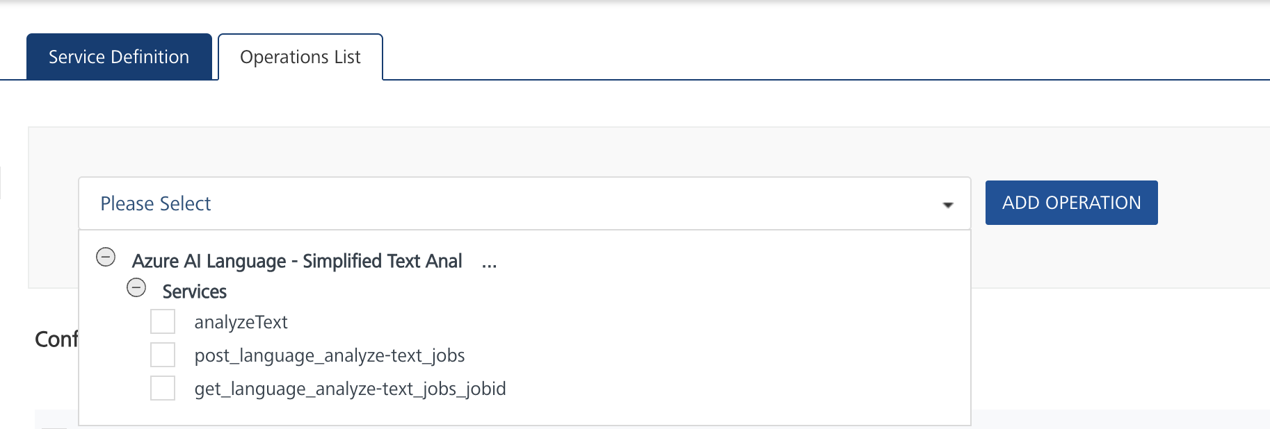
- Select analyzeText and Click Add Operation.

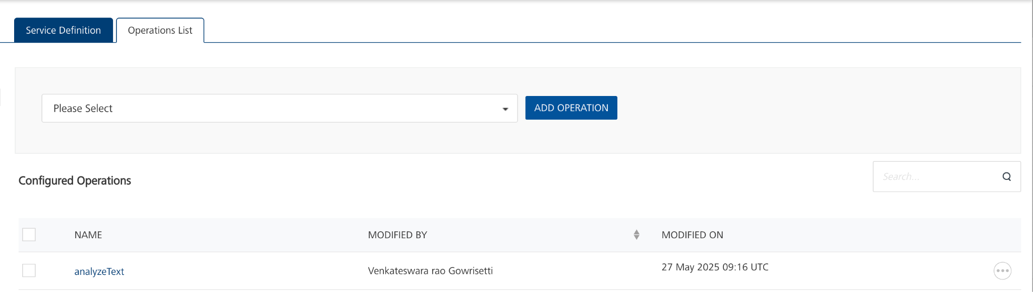

Executing Operation
Executing an operation involves making the API call by setting the necessary parameters and displaying the response. The procedure to execute any operation is same, but the request parameters of the APIs vary. This section provides steps to execute the Microsoft AI Language (explained in Creating an Operation).
Steps to execute the Microsoft AI Language operation:
- Log on to your Hcl Foundry. The Dashboard page appears by default.
- In the left pane, click the API Management menu. The APIs tab opens by default.
- Click the Integration tab. The Integration tab opens with a list of existing integration services.
- From the list of integration services, select the integration service that you have created with service type as Microsoft AI Language. The Service Definition tab of the selected integration service opens by default.
- Click the Operations List tab.
- In the Name box, the name of the operation is displayed by default. If you want, you can change the name.
- On the Request Input tab, in the Body section, for the following parameters, specify the values in the respective boxes under the Test Value column.
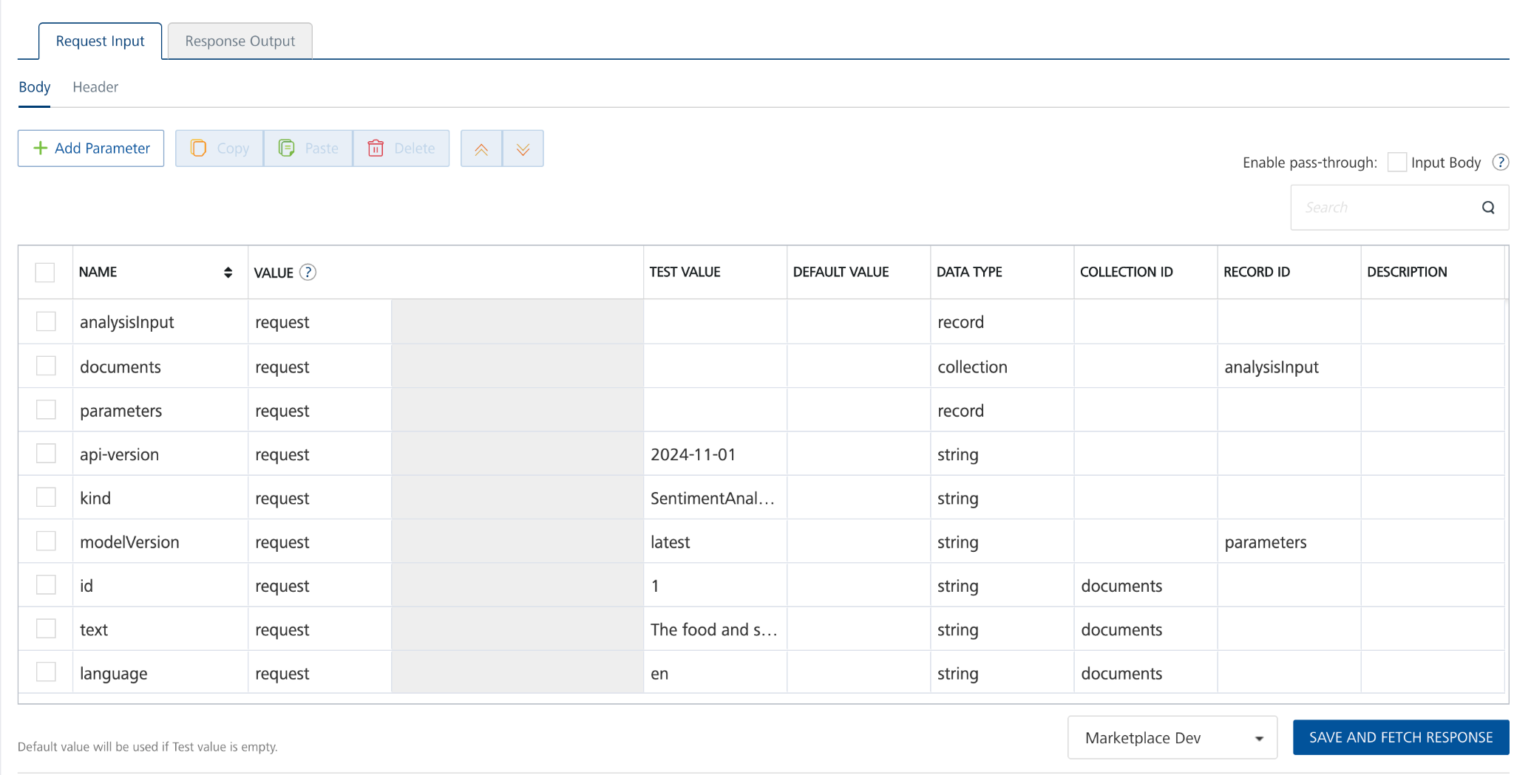

- Enter the value of Ocp-Apim-Subscription-Key in the header part as default value
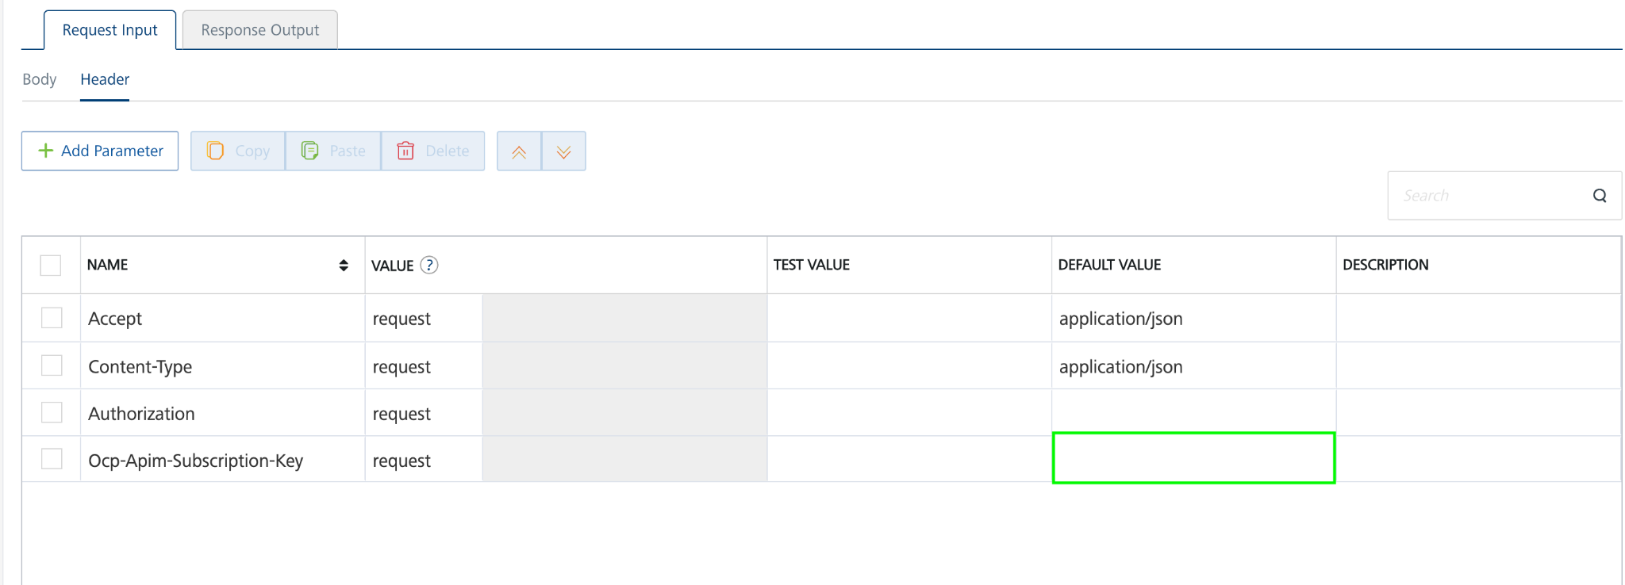
- Click SAVE AND FETCH RESPONSE. The Output Result dialog appears with the response. Otherwise, the Output Result shows an error.
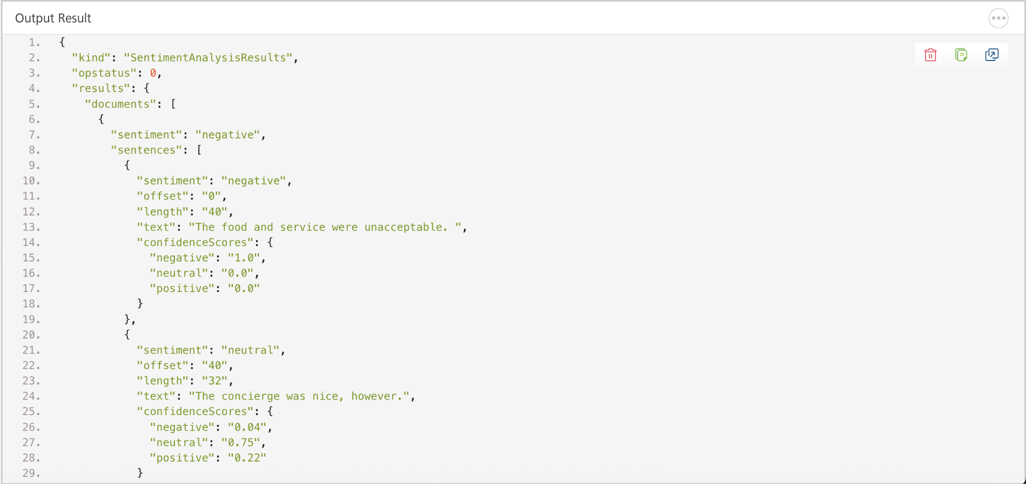
.

Publishing the App in VoltMX FOUNDRY:
After adding the Microsoft AI Language Data Adapter to your app and configuring the necessary configurations, you must publish the app to HCL Foundry. For more information, refer to Publish a foundry app.
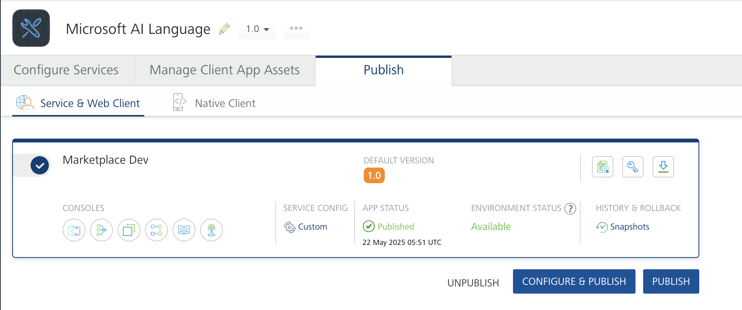

REFERENCES

Properties
- None of the properties are exposed.

Events
- None of the events are exposed.

API’s
- None of the APIs are exposed.

REVISION HISTORY
Adapter version 1.0.0:

Known Issues
None

Limitations
None

