Date : 10-Mar-26

MICROSOFT CUSTOM QUESTION AND ANSWERING APPLICATION

VERSION: 1.0.0

Overview
The Microsoft Custom Question Answering Application is an interactive chat-based application that allows users to ask questions in natural language and receive answers retrieved from a configured knowledge base. The application uses Microsoft Azure AI Language Service – Custom Question Answering to analyze user queries and return the most relevant answer from the published knowledge base.The application provides a simple chat interface where users can submit questions and instantly receive responses from the Microsoft Question Answering service. The application integrates with Azure through a REST API and uses configured parameters such as Project Name, Deployment Name, and API Version to access the appropriate knowledge base.
Purpose
This application enables users to:
- Ask natural language questions and retrieve answers from a configured knowledge base
- Interact with Microsoft Custom Question Answering service through a chat-based interface
- Query knowledge bases built in Azure Language Studio
- Configure project-specific parameters such as project name and deployment name
- Provide real-time responses to user questions using Azure AI Language Service
- Integrate intelligent knowledge retrieval into enterprise mobile applications
Microsoft Custom Question Answering is a cloud-based REST service that is part of Azure AI Language Services. The service allows developers to create intelligent question answering systems over structured or unstructured content.Developers can create a knowledge base by uploading FAQs, documents, or web content into Azure Language Studio, then publish the knowledge base as a project deployment. Applications can query this deployment through REST APIs to retrieve the most relevant answers for user questions.

Requirements:

- HCL Foundry
- Volt MX Iris
- Microsoft account - Create one for free
- Once you have your Azure subscription, create a Language resource with custom question answering feature enabled in the Azure portal to get your key and endpoint. Enter a unique name for your resource, select your subscription, and select a resource group, supported region (see Region availability), and supported pricing tier. Then select Create.
- The resource takes a few minutes to deploy. After it finishes, Select go to resource. In the left pane, under Resource Management, select Subscription Key and Endpoint. The endpoint and either of the keys are used to call APIs.
Create a project
- Sign in to the Language Studio portal with your Azure credentials.
- Open the question answering page.
- Select create new project.
- If you are creating the first project associated with your language resource, you have the option of creating future projects with multiple languages for the same resource. If you choose to explicitly set the language to a single language in your first project, you will not be able to modify this setting later and all subsequent projects for that resource will use the language selected during the creation of your first project.
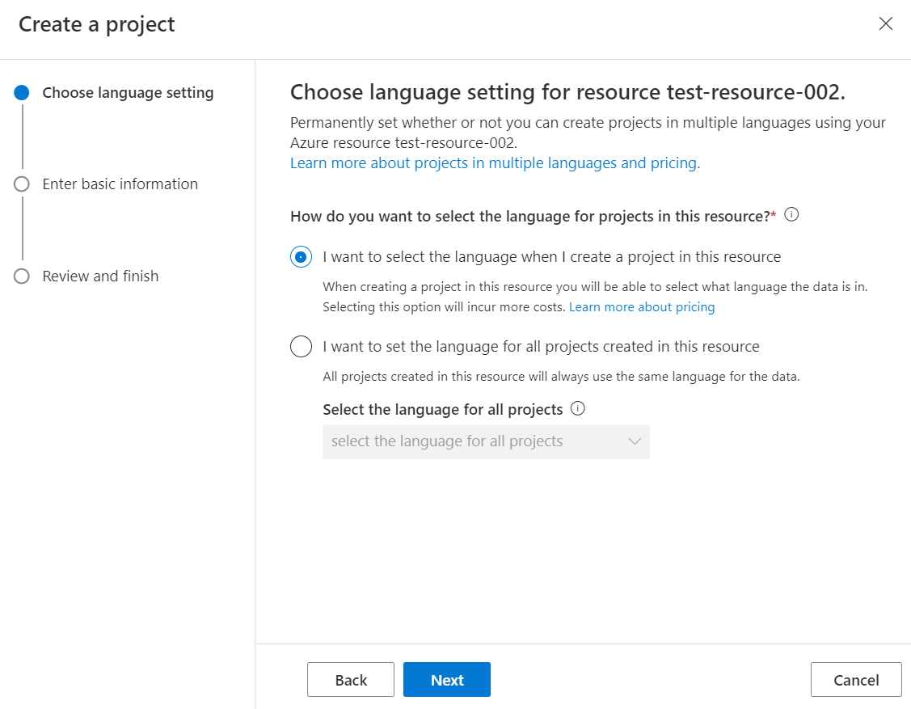
- Enter basic project settings like Name,Description,Source Language and Default Answer
- Select Manage sources in the left pane.
- There are three types of sources: URLS, Files, and Chitchat
- You can add new sources and FAQ content to your project by selecting Add source > and choosing URLs, Files, or Chitchat
- Get the project name and deployment id .
Reference document: https://learn.microsoft.com/en-us/azure/ai-services/language-service/question-answering/overview
https://learn.microsoft.com/en-us/azure/ai-services/language-service/question-answering/quickstart/sdk?tabs=macos&pivots=studio
https://learn.microsoft.com/en-us/azure/ai-services/language-service/question-answering/how-to/manage-knowledge-base

Devices:
- Mobile

Platforms:
- Android
- IOS

Features:
- Knowledge Base Question Answering
Retrieves answers from a curated knowledge base containing FAQs, documents, or other knowledge sources.
- Natural Language Query Support
Allows users to ask questions in natural language without needing exact keyword matches.
- Confidence-Based Answer Retrieval
Each response includes a confidence score indicating how relevant the answer is to the user’s query.
- Chat-Based User Interface
Provides a conversational interface where users can ask questions and receive answers in a chat format.
- Azure AI Integration
Uses Azure Language Service APIs to perform intelligent knowledge retrieval.
- Configurable Parameters
Supports configurable parameters such as Project Name, Deployment Name, and API Version to query different knowledge bases.

App Functionality:
Initial Launch Experience
When the application launches, users see a clean chat interface with a header displaying the application title. A configuration section is available where users can enter the Project Name and Deployment Name required for querying the Azure Question Answering service.
Below the properties section is the chat conversation area where user questions and system responses are displayed.
Properties Panel
The application provides input fields that allow users to configure the Azure Question Answering service parameters:
- Project Name
- Deployment Name
- API Version
These parameters determine which knowledge base deployment the application will query.
Question Input & Submission
Users can type their questions into the input field located at the bottom of the screen. Questions can be submitted either by pressing the Send button or by pressing the Enter key.
Once the question is submitted:
- The user’s question appears in the chat window as a message bubble.
- The system sends a request to the Azure Question Answering API through the Foundry integration service.
AI Response Handling
After a question is submitted, the application sends an HTTP POST request to the Microsoft Custom Question Answering endpoint using the configured parameters.
While the request is being processed, a loading indicator or typing indicator may appear in the chat interface.
Once the response is received:
- The bot’s answer is displayed in the chat window.
- The interface automatically scrolls to the latest message.
If no answer is found, the application displays a message such as:
Sorry, no answer found.
If an error occurs due to network issues or invalid configuration, an alert or error message is displayed to notify the user.
Continuous Chat Interaction
Users can continue asking questions in a conversational format. Each new question is sent to the Microsoft Question Answering API independently, allowing users to interact with the knowledge base multiple times during the same session.

Importing the app:
To import the Microsoft Question Answering Application into your workspace, follow these steps:
- Open Volt MX Iris
- On the main menu select Forge → Browse.
- Search for the Question and Answer Application, and then click Import to Workspace. The app is imported to your workspace. A dialog box appears, confirming that the app has been imported. Click OK.
- Switch to your project containing the Question and Answer Application.. To switch to your project, click File → Open → Reference Architecture → <project name>

Building the app:
After performing all the above steps, you can build your app and run it on your device. For more information, you can refer to the Building and Viewing an Application section of the Volt MX User Guide.
You can then run your app to see the Microsoft Question Answering Application work in real time.

Configure the UI and properties of the Microsoft Question Answering Application
The Microsoft Question Answering Application consists of the following component:
- The Microsoft Question Answering component is used to allow users to ask a question and interact with it using advanced Natural Language Processing (NLP) models to accurately extract or generate answers to user questions from text.
- Take one form and add the component. Add required widgets and code to create a chat like UI
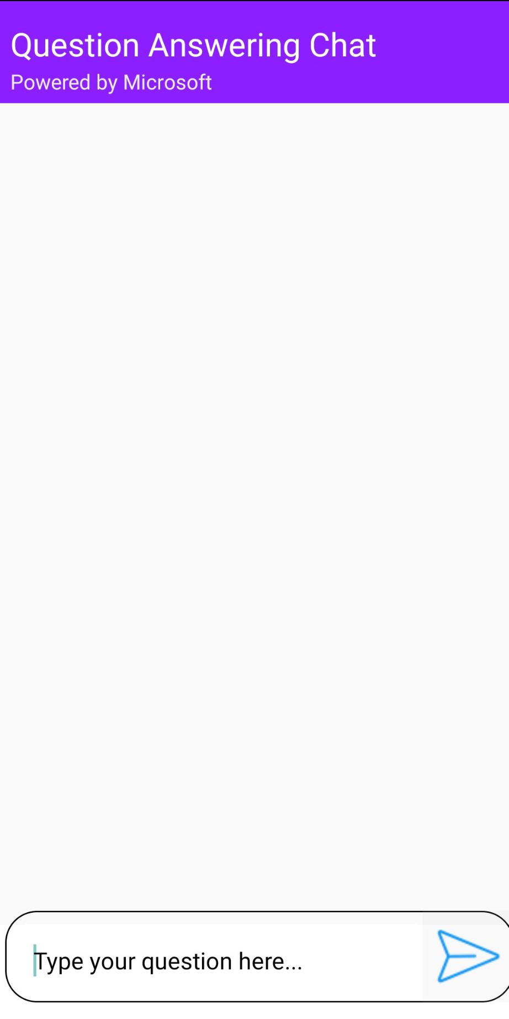
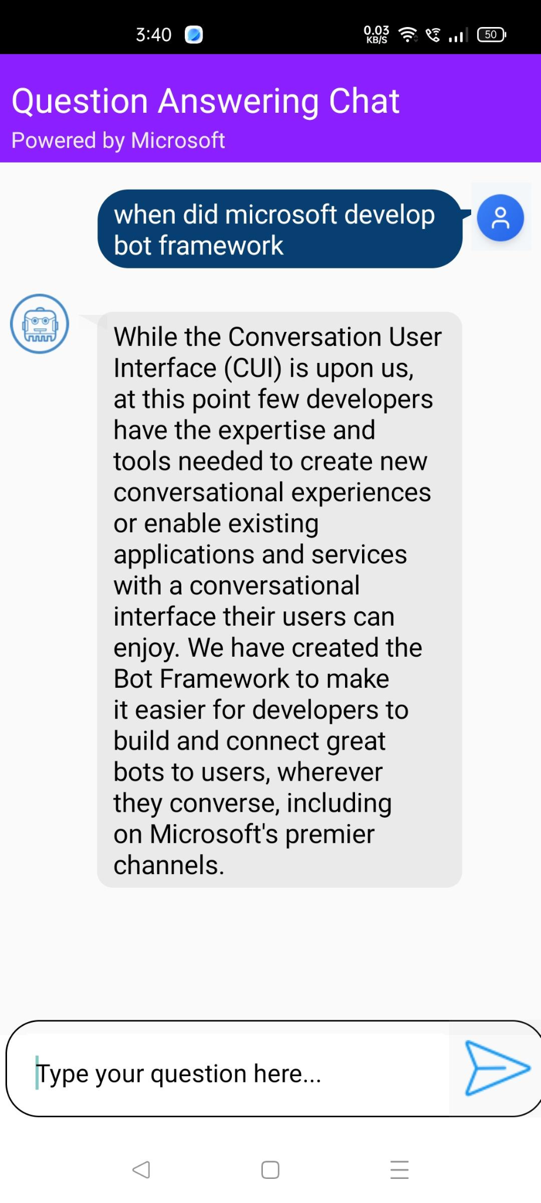

Foundry APP Setup
When you import the component to your Volt MX Iris project, the HCL Volt MX Foundry services of the Microsoft Question Answering are added to the HCL Volt MX Foundry app, which is associated with the Volt MX Iris project. While importing the Microsoft Question Answering Component to your Volt MX Iris project, if there is no HCL Volt MX Foundry app associated with the existing Volt MX Iris project, a new HCL Volt MX Foundry app is automatically added to your HCL Volt MX Foundry environment and is associated with your Volt MX Iris.
To set the Foundry app, follow these steps:
- Click the HCL Volt MX Foundry app associated with your Volt MX Iris project from the Project Explorer. Click DATA & SERVICES
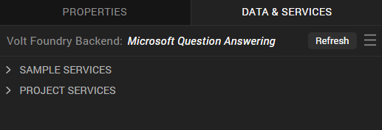
- Under the Configure Services tab, click Identity and In the Client ID box, type the Client ID provided by Microsoft.
- In the Client Secret box, type the secret key provided by Microsoft. These fields are mandatory.

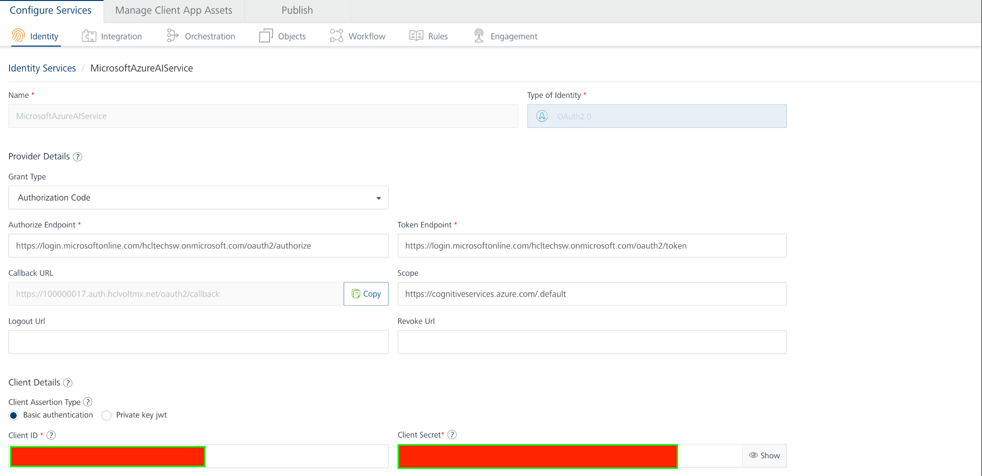
- Under Client Details, type the Client ID and Client Secret that you received from Microsoft

Note:
If you want to verify the details, click TEST LOGIN and sign in by using your Microsoft credentials.

- Click Save
- Under the Configure Services tab, click Integration and can see the generate answer service. Click on Integration service to add the server Url.The Service Definition tab of the selected integration service opens by default.
- Enter the value of Server Url as Endpoint value
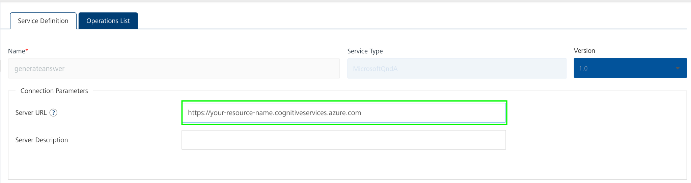

- Click the generateanswer Integration service. On the right pane, expand the generateanswer service and then select the queryKnowledgeBase operation.
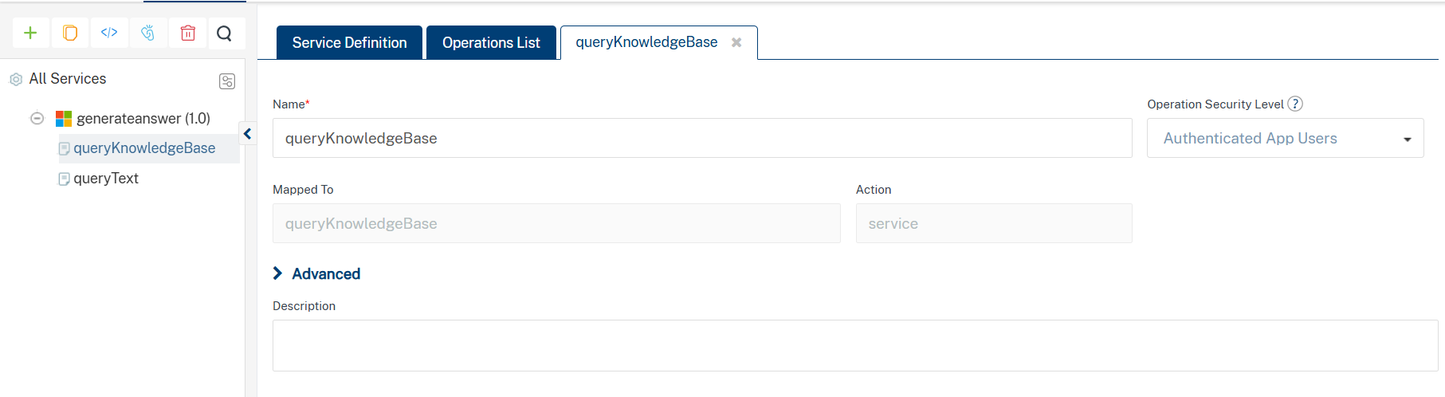
- The queryKnowledgebase tab opens with the Request Input sub-tab opened by default.
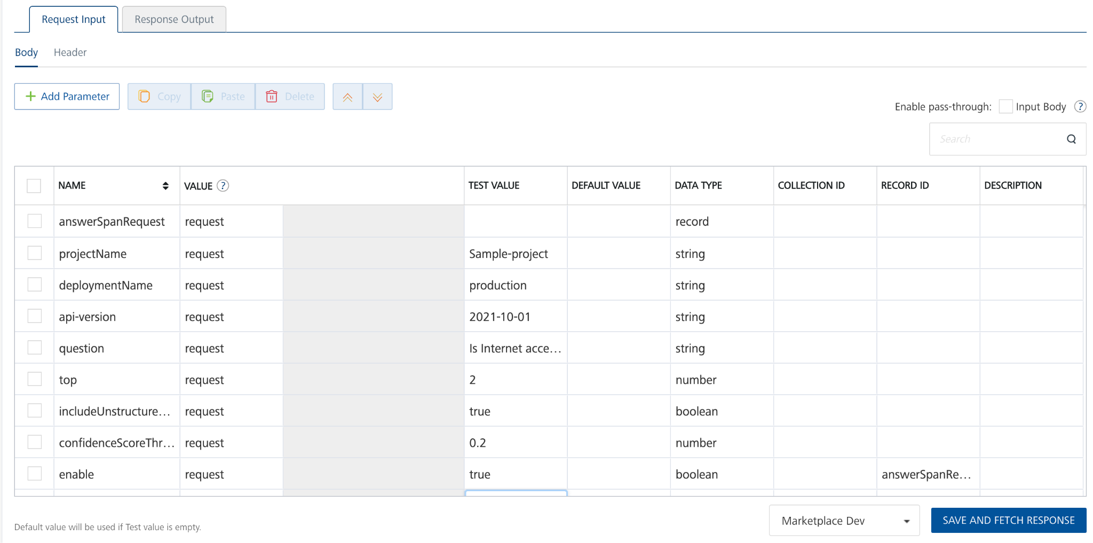
- Enter the value of Ocp-Apim-Subscription-Key in the header part as default value
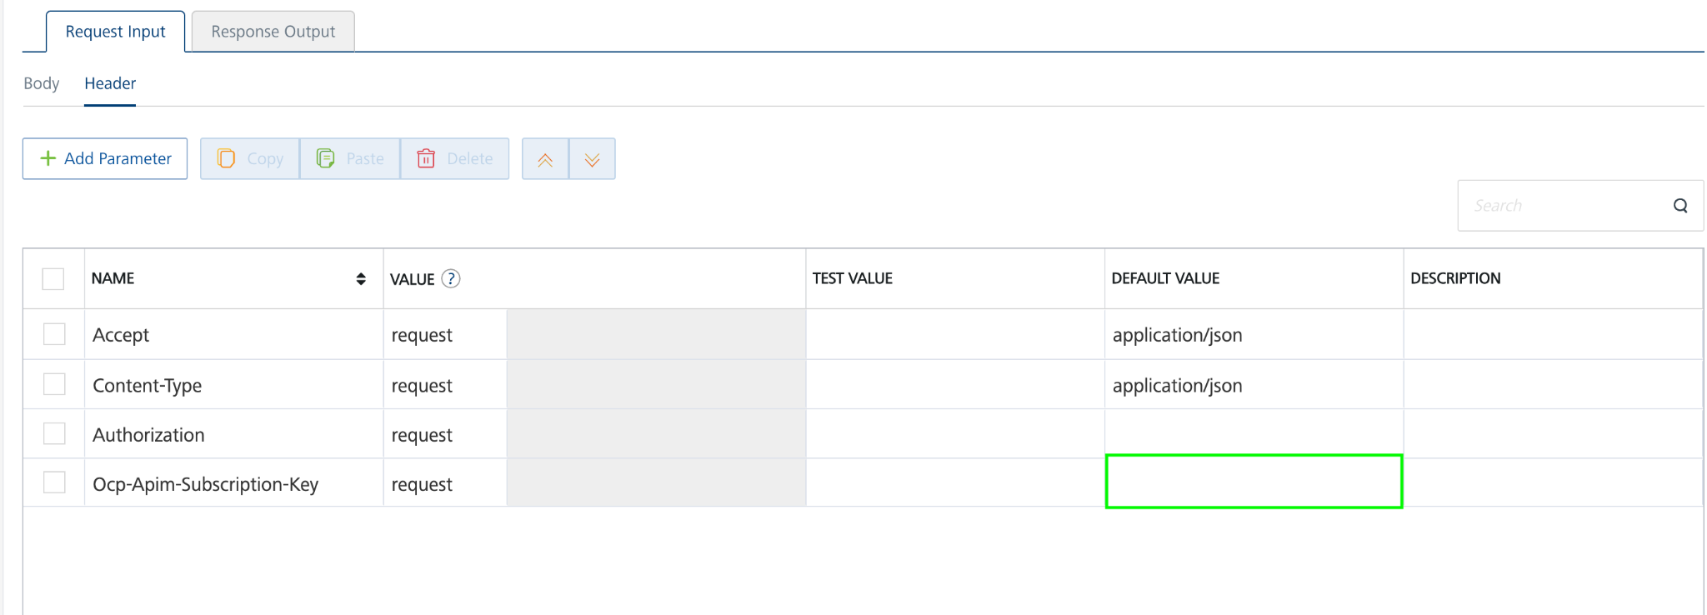
- Click SAVE AND FETCH RESPONSE. The Output Result dialog appears with the response. Otherwise, the Output Result shows an error.
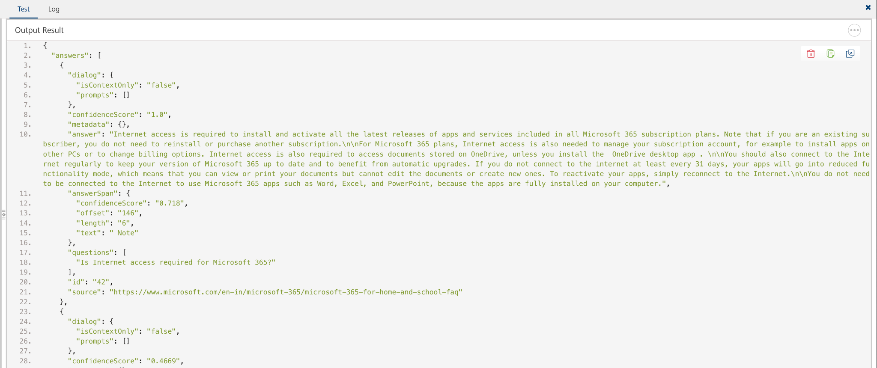

- Click the icon to go back to Volt MX Iris.

Publish the HCL Volt MX Foundry App
After you set the Operation Security Level, you must publish the HCL Volt MX Foundry app. To publish the HCL Volt MX Foundry, follow these steps:
In Volt MX Iris, click DATA & SERVICES, and then click Publish Project Services to Publish to your foundry app.
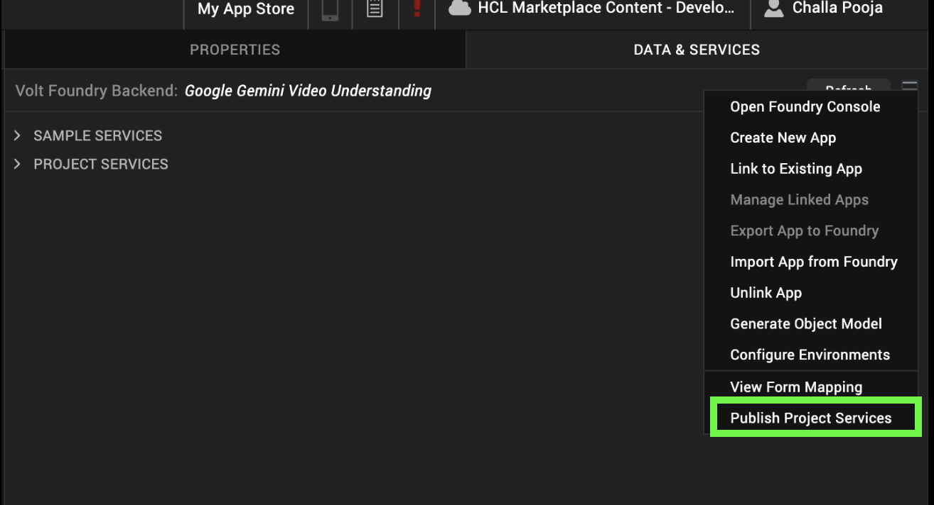
Select the environment to which you want to publish your app, and then click Publish.
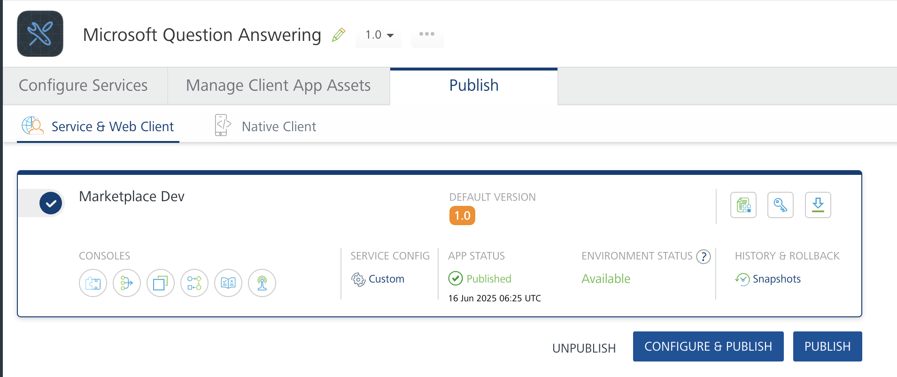
After the app is published to your environment, the following window appears confirming the publish.

Building and previewing the app
After performing all the above steps, you can build your app and run it on your device. For more information, you can refer to the Building and Viewing an Application section of the Volt MX User Guide.
You can then run your app to see the Microsoft Question Answering Component work in real time.

REFERENCES

Dynamic Usage
You can also add a Microsoft Question Answering Component component dynamically. To do so,
1. In the Project Explorer, on the Projects tab, click Controllers section to access the respective Form Controller. Create a method and implement the code snippet similar to the sample code mentioned below.

/* Creating Microsoft Question Answering Component Component instance */

createComponent: function()
{
/* Creating the component's object */
var MicrosoftQuestionAnswering = new com.voltmx.MicrosoftQuestionAnswering(
{
"clipBounds": true,
"height": "10%",
"id": "MicrosoftQuestionAnswering",
"isVisible": true,
"left": "1%",
"top": "88%",
"width": "100%",
"zIndex": 1
}, {}, {});
//General properties
MicrosoftQuestionAnswering.ApiVersion = "2021-10-01";
MicrosoftQuestionAnswering.ProjectName = "Sample-project";
MicrosoftQuestionAnswering.DeploymentName = "production";
this.view..add(MicrosoftQuestionAnswering);
In the code snippet, you can edit the properties of the component as per your requirement. For more information, see Setting Properties.
2. Save the file.

- Properties:

General Properties

- ProjectName

Description: | Specifies the Azure Custom Question Answering project name that contains the knowledge base
Syntax: | ProjectName
Type: | String
Read/Write: | Read + Write
Example: | this.view.MicrosoftQuestionAnswering.ProjectName = "sample-project";
- Question

Description: | Specifies the user question that will be sent to the Microsoft Custom Question Answering service.
Syntax: | Question
Type: | Integer
Read/Write: | Read + Write
Example: | this.view.MicrosoftQuestionAnswering.Question = "";
- ApiVersion

Description: | Specifies the API version of the Azure Language Service Question Answering endpoint used to process the request..
Syntax: | ApiVersion
Type: | String
Read/Write: | Read + Write
Example: | this.view.MicrosoftQuestionAnswering.ApiVersion = "2021-10-01";
- DeploymentName

Description: | Specifies the deployment name of the Custom Question Answering project..
Syntax: | DeploymentName
Type: | String
Read/Write: | Read + Write
Example: | this.view.MicrosoftQuestionAnswering.DeploymentName = "production";

APIs

No APIs

Events

getInput

Description: | Invoked after the input/Question is entered. This getInput should be invoked in the onNavigate function.
Syntax: | getInput
Parameters: | text: The given question or input text
Remarks: | Need to invoke this event to get the input text
Example: | onNavigate: function() {  this.view.MicrosoftQuestionAnswering.getInputText = function(text){  try{  if(text){  alert("Question= "+text);  }  else{  alert("Input is empty");  }  }.bind(this);  }

getGeneratedContent

Description: | Invoked after the component generates the content. This getGeneratedContent should be invoked in the onNavigate function.
Syntax: | getGeneratedContent
Parameters: | response[JSON] : The generated JSON object from the Microsoft Cloud Question Answering
Remarks: | Need to invoke this event to get the generated content result.
Example: | onNavigate: function() {  this.view.MicrosoftQuestionAnswering.getGeneratedContent = function(generatedContent){  try{  if(generatedContent){  alert("Generated content= "+JSON.stringify(generatedContent));  }  }  catch(err){  voltmx.ui.Alert({  message: "err in getGeneratedContent= "+err.message,  alertType: constants.ALERT_TYPE_INFO,  yesLabel: "OK"  }, {} );  }  }.bind(this);  }

onErrorCallback

Description : Invoked when error occurs.

Syntax : onErrorCallback

Parameters : args [Array of JSON] : Contains information about the error.

Example : this.view.MicrosoftAnswering.onErrorCallback= function(args)
{
alert("Error: "+JSON.stringify(args));
}.bind(this);

Reference API documentation:
https://learn.microsoft.com/en-us/azure/ai-services/language-service/question-answering/overview
https://learn.microsoft.com/en-us/azure/ai-services/language-service/question-answering/quickstart/sdk?tabs=macos&pivots=studio
https://learn.microsoft.com/en-us/azure/ai-services/language-service/question-answering/how-to/manage-knowledge-base

REVISION HISTORY
App version 1.0.0

Known Issues
None

Limitations
None

