Date :  07-Oct-24

**MICROSOFT’S AI IMAGE GENERATOR**

**VERSION: 1.0.0**

# **OVERVIEW**

Help users to create any image you can dream up with Microsoft's AI image generator. Describe your ideas and then watch them transform from text to images. Whether you want to create ai generated art for your next presentation or poster, or [generate the perfect photo](https://create.microsoft.com/en-us/learn/articles/things-you-can-do-with-designer-and-image-creator), Image Creator in Microsoft Designer can effortlessly handle any style or format.

Microsoft's AI Image Generator is a tool powered by artificial intelligence that can create images based on text descriptions provided by the user. It's designed to help users generate visual content quickly and easily without needing advanced design skills.It will get vivid, high-resolution images with stunning detail.

## **Use case:**

* Automates the generation of high-quality images for marketing, social media, and blog posts, saving time and effort.
* Helps artists and creative professionals brainstorm or enhance artwork by generating unique, AI-driven visuals.

## **Features:**

* Users can generate highly detailed images from text descriptions using AI-powered models like DALL-E.
* Allows users to adjust image parameters such as style, colors, and resolution to match their needs.
* Generates high-resolution, realistic images suited for both professional and casual use.

## **Percentage of re-use:**

80% (Data can be customizable and customers need to implement UI by themselves).

# **GETTING STARTED**

## **Prerequisites**

Before you start using the **Microsoft’s AI Image Generator** data adapter, ensure you have the following:

* [HCL Foundry](https://manage.hclvoltmx.com/)
* Volt MX Iris
* [Microsoft account](https://portal.azure.com/)
* Endpoint, deployment-id and api-key to use the **Microsoft’s AI Image Generator**  API issued by Microsoft.  
  **Reference document:** <https://learn.microsoft.com/en-us/azure/ai-services/openai/how-to/dall-e?tabs=dalle3>

## **Importing the adapter**

 To import the **Microsoft’s AI Image Generator** Adapter to Volt MX Foundry, do the following:

1. Sign in to the  [HCL Foundry](https://manage.hclvoltmx.com/)
2. In the left pane, click the **API Management** menu. The **APIs** tab opens by default.
3. In **API Management**, select **Custom Data Adapters**.

1. Click **IMPORT** to import a custom data adapter.

1. On the Import Data Adapter dialog box, click browser to import.

1. Drag the data adapter zip file into the **Drag a Data Adapter** box.

Or

Click **browse**. The **Open** dialog appears.

Navigate to the location where you downloaded the data adapter (zip file) on your computer, select the data adapter, and click **Open**. The **Import Data Adapter** dialog shows the selected data adapter.

**Note:**Click **Remove** if the selected data adapter is not the one that you want to import.

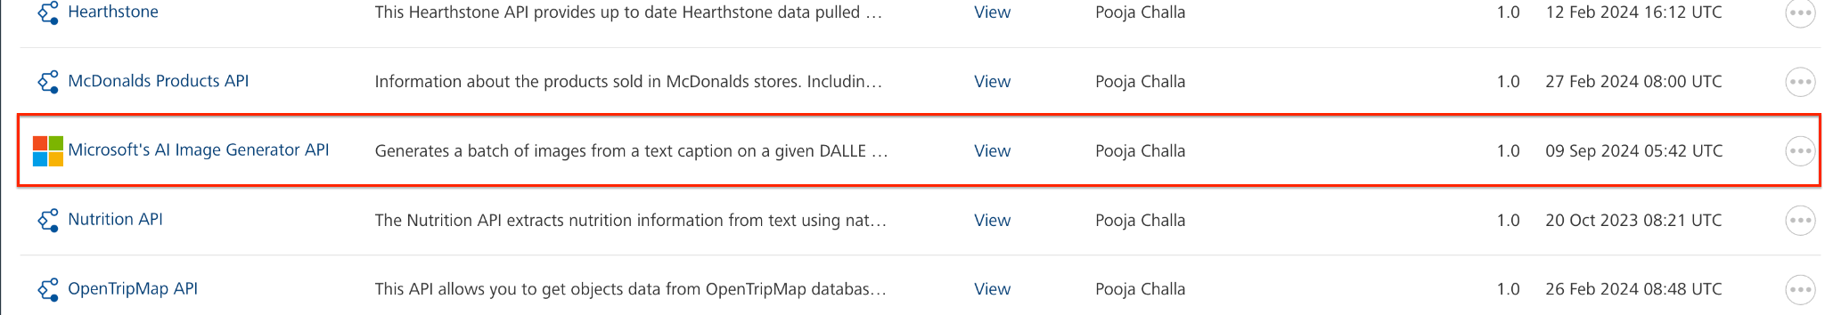

**OR**

**To import the data adapter zip file, do the following:**

1. Perform steps 1 through 4 in the above procedure
2. Click **IMPORT FROM HCL FORGE**. The **Import Data Adapter** from **HCL Forge** dialog appears with a list of available data adapters.
3. Click **Import**. The **Microsoft’s AI Image Generator**data adapter is listed on the **Custom Data Adapters** page.

After you import the data adapter, you can view it on the Custom Data Adapters page and use it to create services on Volt MX Foundry.

After you add the data adapter to your Volt Foundry app, you need to get your endpoint, deployment-id and api-key. You can refer to [Microsoft's AI Image Generator developer site](https://learn.microsoft.com/en-us/azure/ai-services/openai/reference#image-generation).

## **Creating an Integration Service with Microsoft’s AI Image Generator**

After you import **Microsoft’s AI Image Generator API** Data Adapter into Volt MX Foundry, you must create an integration service with service type as **Microsoft’s AI Image Generator**connecting with your [Microsoft's AI Image Generator website](https://create.microsoft.com/en-us/features/ai-image-generator).

**To create an integration service withMicrosoft’s AI Image Generator, do the following:**

1. Log on to your [HCL Foundry](https://manage.hclvoltmx.com/) The **Dashboard** page appears by default.
2. In the left pane, click the **API Management** menu. The **APIs** tab opens by default.
3. Click the **Integration** tab. The **Integration** tab opens with a list of existing integration services.
4. Click **CONFIGURE NEW**. The **Service Definition** tab opens.
5. In the **Name** box, type a unique name for your service.
6. From the **Service Type** list, select **Microsoft’s AI Image Generator API.**

**Note:**The **Microsoft’s AI Image Generator API**is listed only after you import the **Microsoft’s AI Image Generator** Data Adapter into Volt MX Foundry.

1. Under **Authentication** select **Use Existing Identity provider**. From the drop-down list select **Microsoft’s AI Image Generator API.**

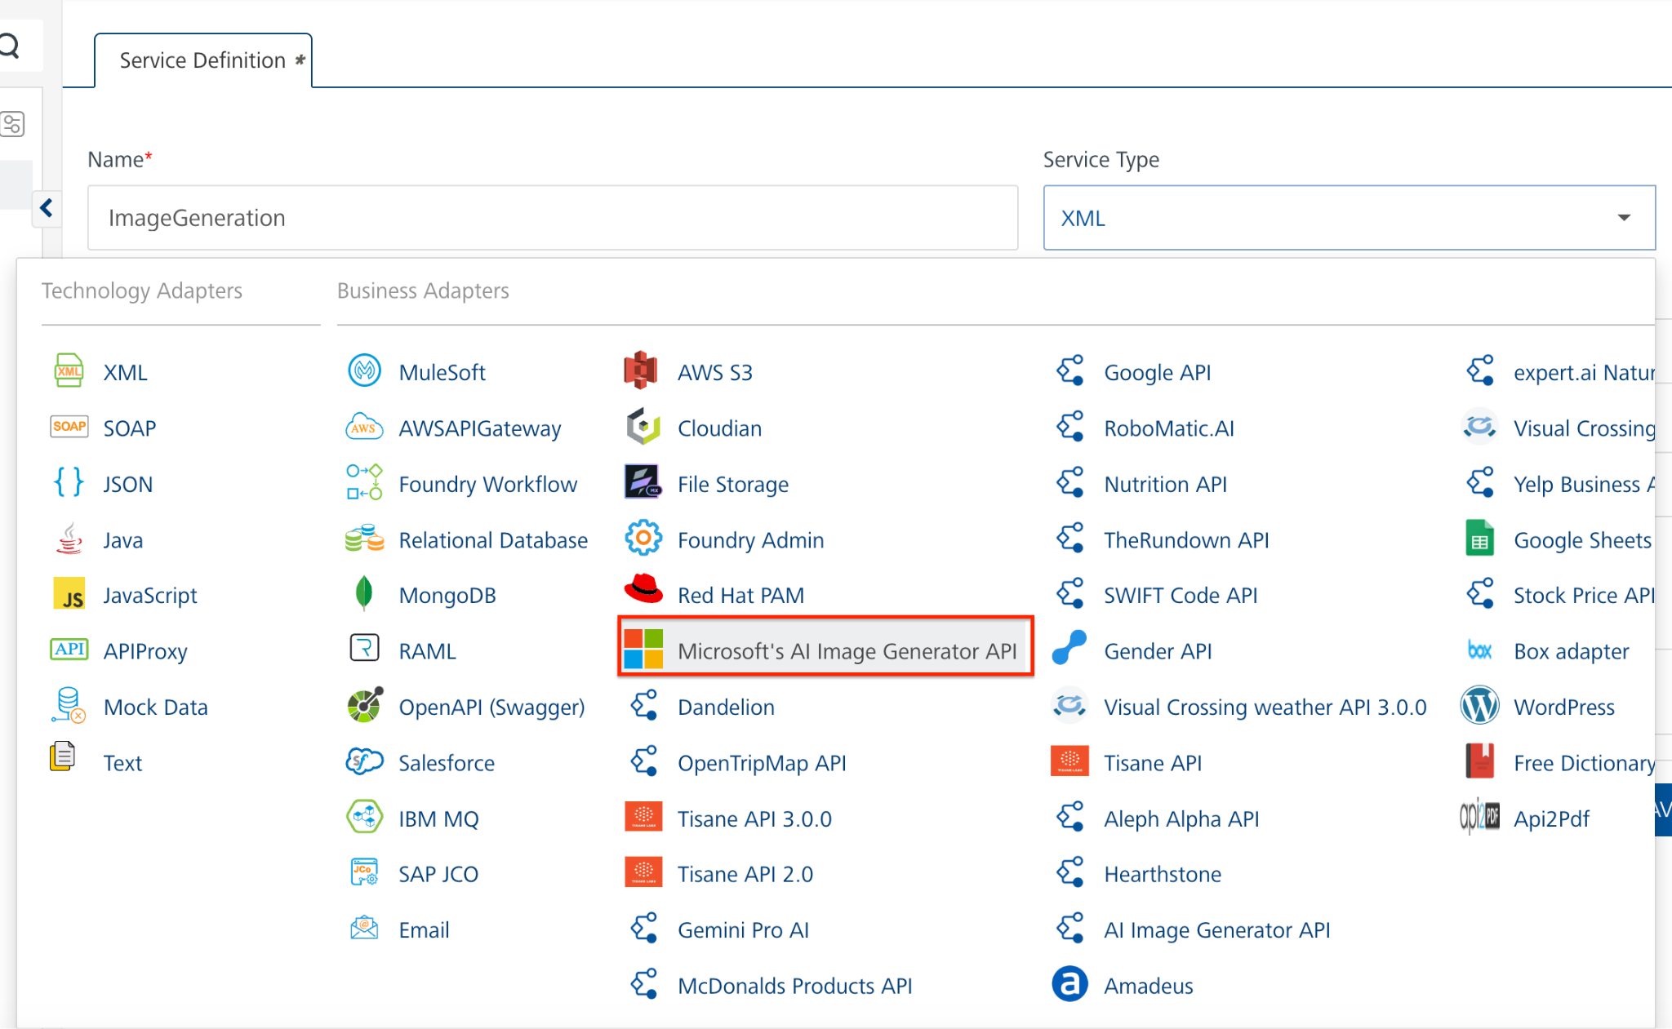

1. Click **Save**.

If the details provided are valid, the Volt MX Foundry service connects to your **Microsoft’s AI Image Generator API** developer site and allows you to make the API calls.

Refer to [Integration Services](https://opensource.hcltechsw.com/volt-mx-docs/docs/documentation/Foundry/vmf_integrationservice_admin_console_userguide/Content/Integration_Services.html) for more information on creating and using integration services.

## **Creating an Operation**

To make any API call in the Volt MX Foundry console, you must create an operation for the respective API and then execute the operation. Executing an operation involves making the API call and displaying the response. For more information, see Executing an Operation.

This section provides steps to create an operation for the **ImageGeneration** API.

**Steps to create an operation for the ImageGeneration API:**

1. Log on to your [HCL Foundry](https://manage.hclvoltmx.com/). The **Dashboard** page appears by default.
2. In the left pane, click the **API Management** menu. The **APIs** tab opens by default.
3. Click the **Integration** tab. The **Integration** page appears with a list of existing integration services.
4. From the list of integration services, select the integration service that you have created with service type as **ImageGeneration**. The **Service Definition** tab of the selected integration service opens by default.
5. Click the **Operations List** tab. The **Operations List** tab opens.
6. Click the context menu arrow to expand the **Please Select** list. The services is displayed.
7. Click the plus icon to expand thelist.
8. Click the plus icon to expand the **Services** list and select **generateImages**.  
   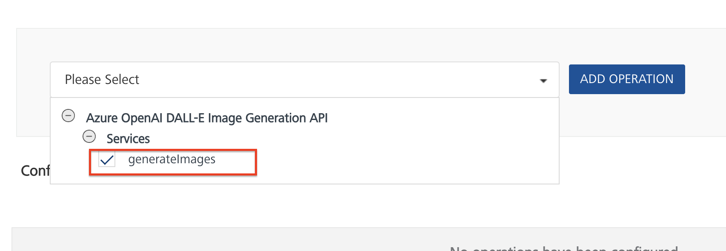
9. Click **ADD OPERATION**. The **generateImages** operation is listed in the **Configured Operations** section.  
     
   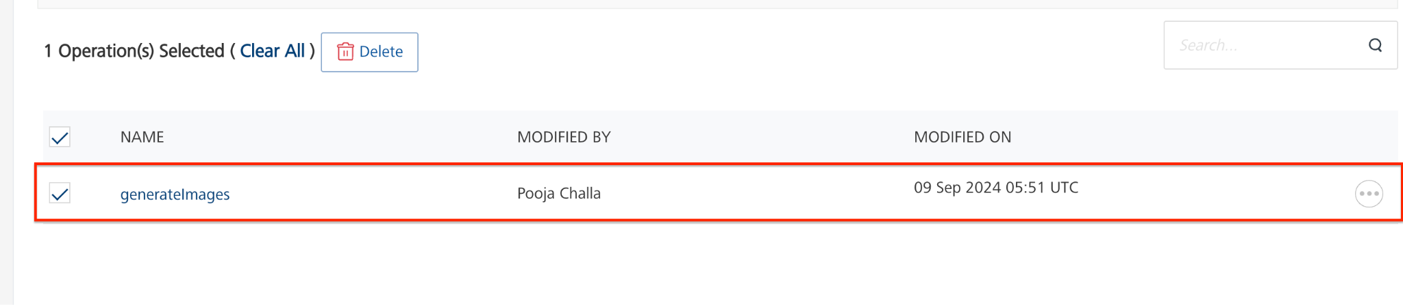

**Note:**You can follow the same steps to create operations for other methods, but ensure that you select the required API.

You can create multiple operations with required APIs and save them in the **Configured Operations** section. You can then execute the operations whenever required.

For the Server URL, the URI Parameters **endpoint** and **deployment-id** values should be replaced with the values obtained from [Microsoft Azure](https://portal.azure.com/#view/Microsoft_Azure_Marketplace/GalleryItemDetailsBladeNopdl/id/Microsoft.CognitiveServicesOpenAI/selectionMode~/false/resourceGroupId//resourceGroupLocation//dontDiscardJourney~/false/selectedMenuId/home/launchingContext~/%7B%22galleryItemId%22%3A%22Microsoft.CognitiveServicesOpenAI%22%2C%22source%22%3A%5B%22GalleryFeaturedMenuItemPart%22%2C%22VirtualizedTileDetails%22%5D%2C%22menuItemId%22%3A%22home%22%2C%22subMenuItemId%22%3A%22Search%20results%22%2C%22telemetryId%22%3A%22c2993307-64a2-442f-86f5-184e62a50a95%22%7D/searchTelemetryId/9cdde14e-a1c3-4113-8014-b682d287479a). Refer [Microsoft's AI Image Generator API](https://learn.microsoft.com/en-us/azure/ai-services/openai/reference#image-generation).

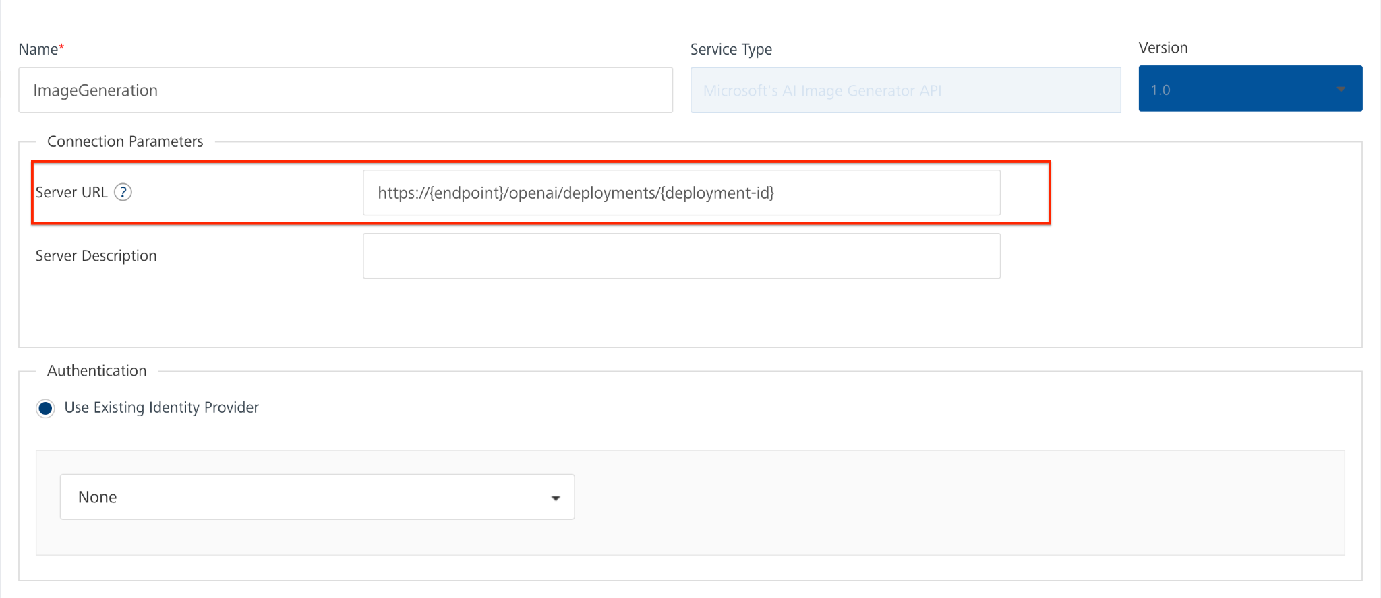

## **Executing an Operation**

Executing an operation involves making the API call by setting the necessary parameters and displaying the response. The procedure to execute any operation is the same, but the request parameters of the APIs vary. For more information on request parameters of API, refer [Microsoft's AI Image Generator API](https://learn.microsoft.com/en-us/azure/ai-services/openai/reference#image-generation).

This section provides steps to execute the **generateImages** operation (explained in Creating an Operation).

**Steps to execute the generateImages operation:**

1. Log on to your [HCL Foundry](https://manage.hclvoltmx.com/). The **Dashboard** page appears by default.
2. In the left pane, click the **API Management** menu. The **APIs** tab opens by default.
3. Click the **Integration** tab. The **Integration** tab opens with a list of existing integration services.
4. From the list of integration services, select the integration service that you have created with the service type as **generateImages**. The **Service Definition** tab of the selected integration service opens by default.
5. Click the **Operations List** tab.
6. Under the **Configured Operations** section, click the **generateImages** operation. The **generateImages** tab opens with the **Request Input** sub-tab opened by default.

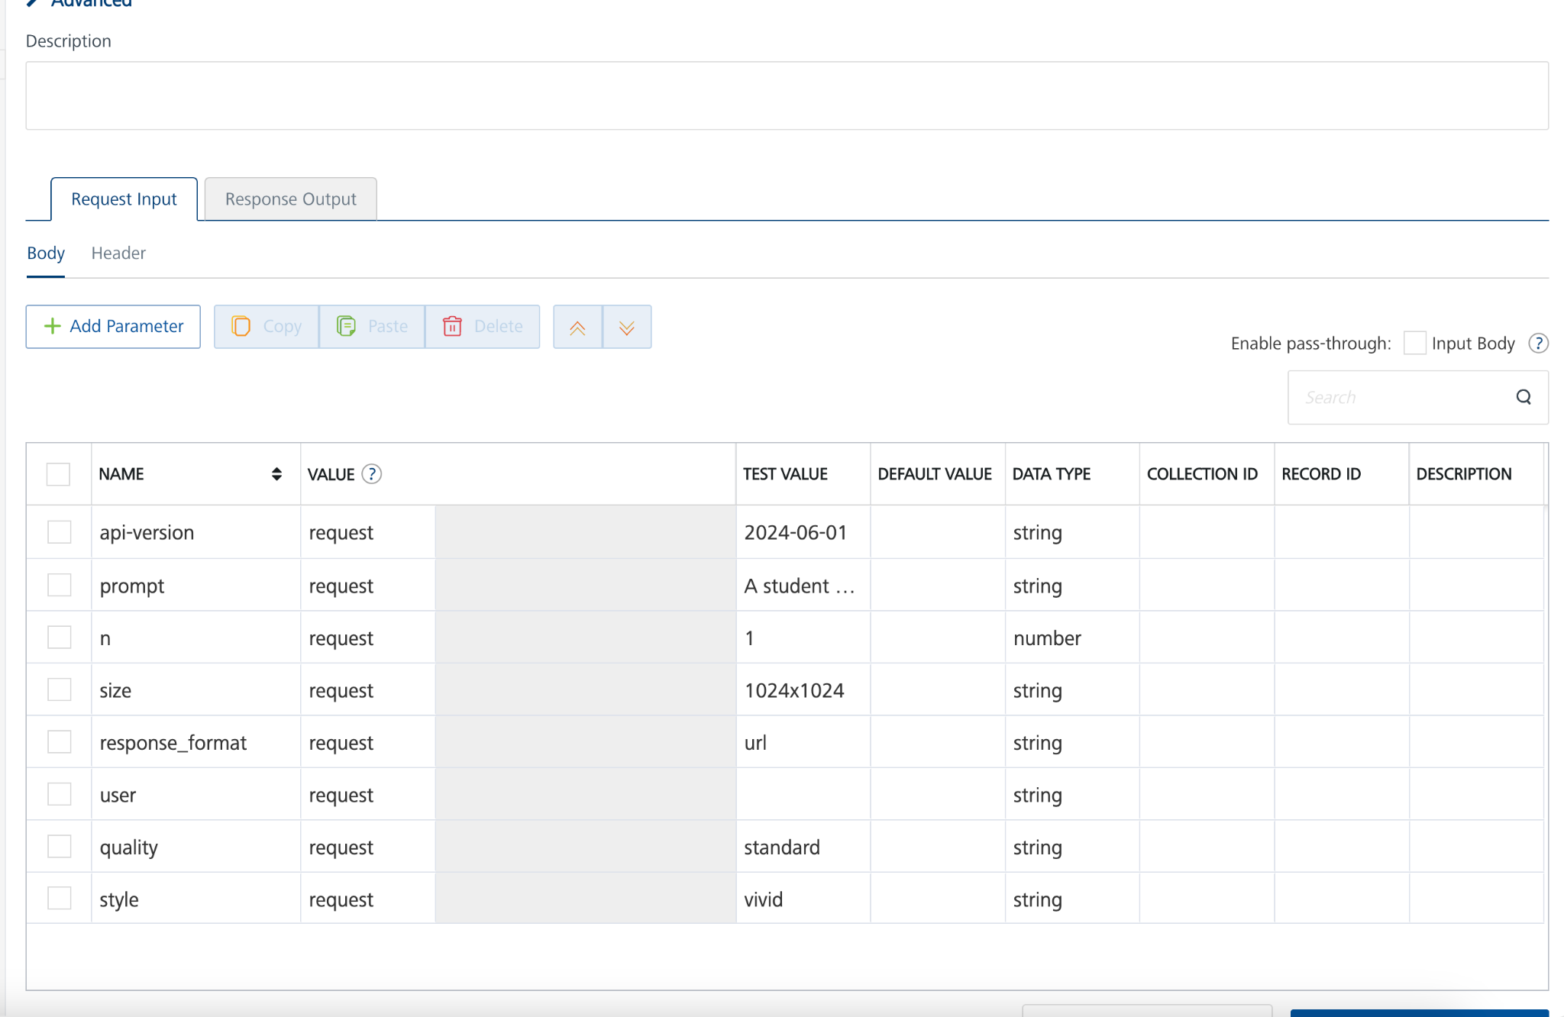

1. In the **Name** box, the name of the operation is displayed by default. If you want, you can change the name.
2. On the **Request Input** tab, in the **Body** section, for the following parameters, specify the values in the respective boxes under the **Test Value** column.

**Mandatory Parameters**

* + **prompt:** A text description of the desired image(s). The maximum length is 4000 character**s.**

1. Click **Header** sub-tab. The **Header** section opens.
2. For api-key, In the box under the **TEST VALUE** and **DEFAULT VALUE** columns, type the **API Key** generated from Microsoft Azure OpenAI.
3. Click **SAVE OPERATION**.
4. Click **SAVE AND FETCH RESPONSE**. The **Output Result** dialog appears with the response. Otherwise, the **Output Result** shows an error.

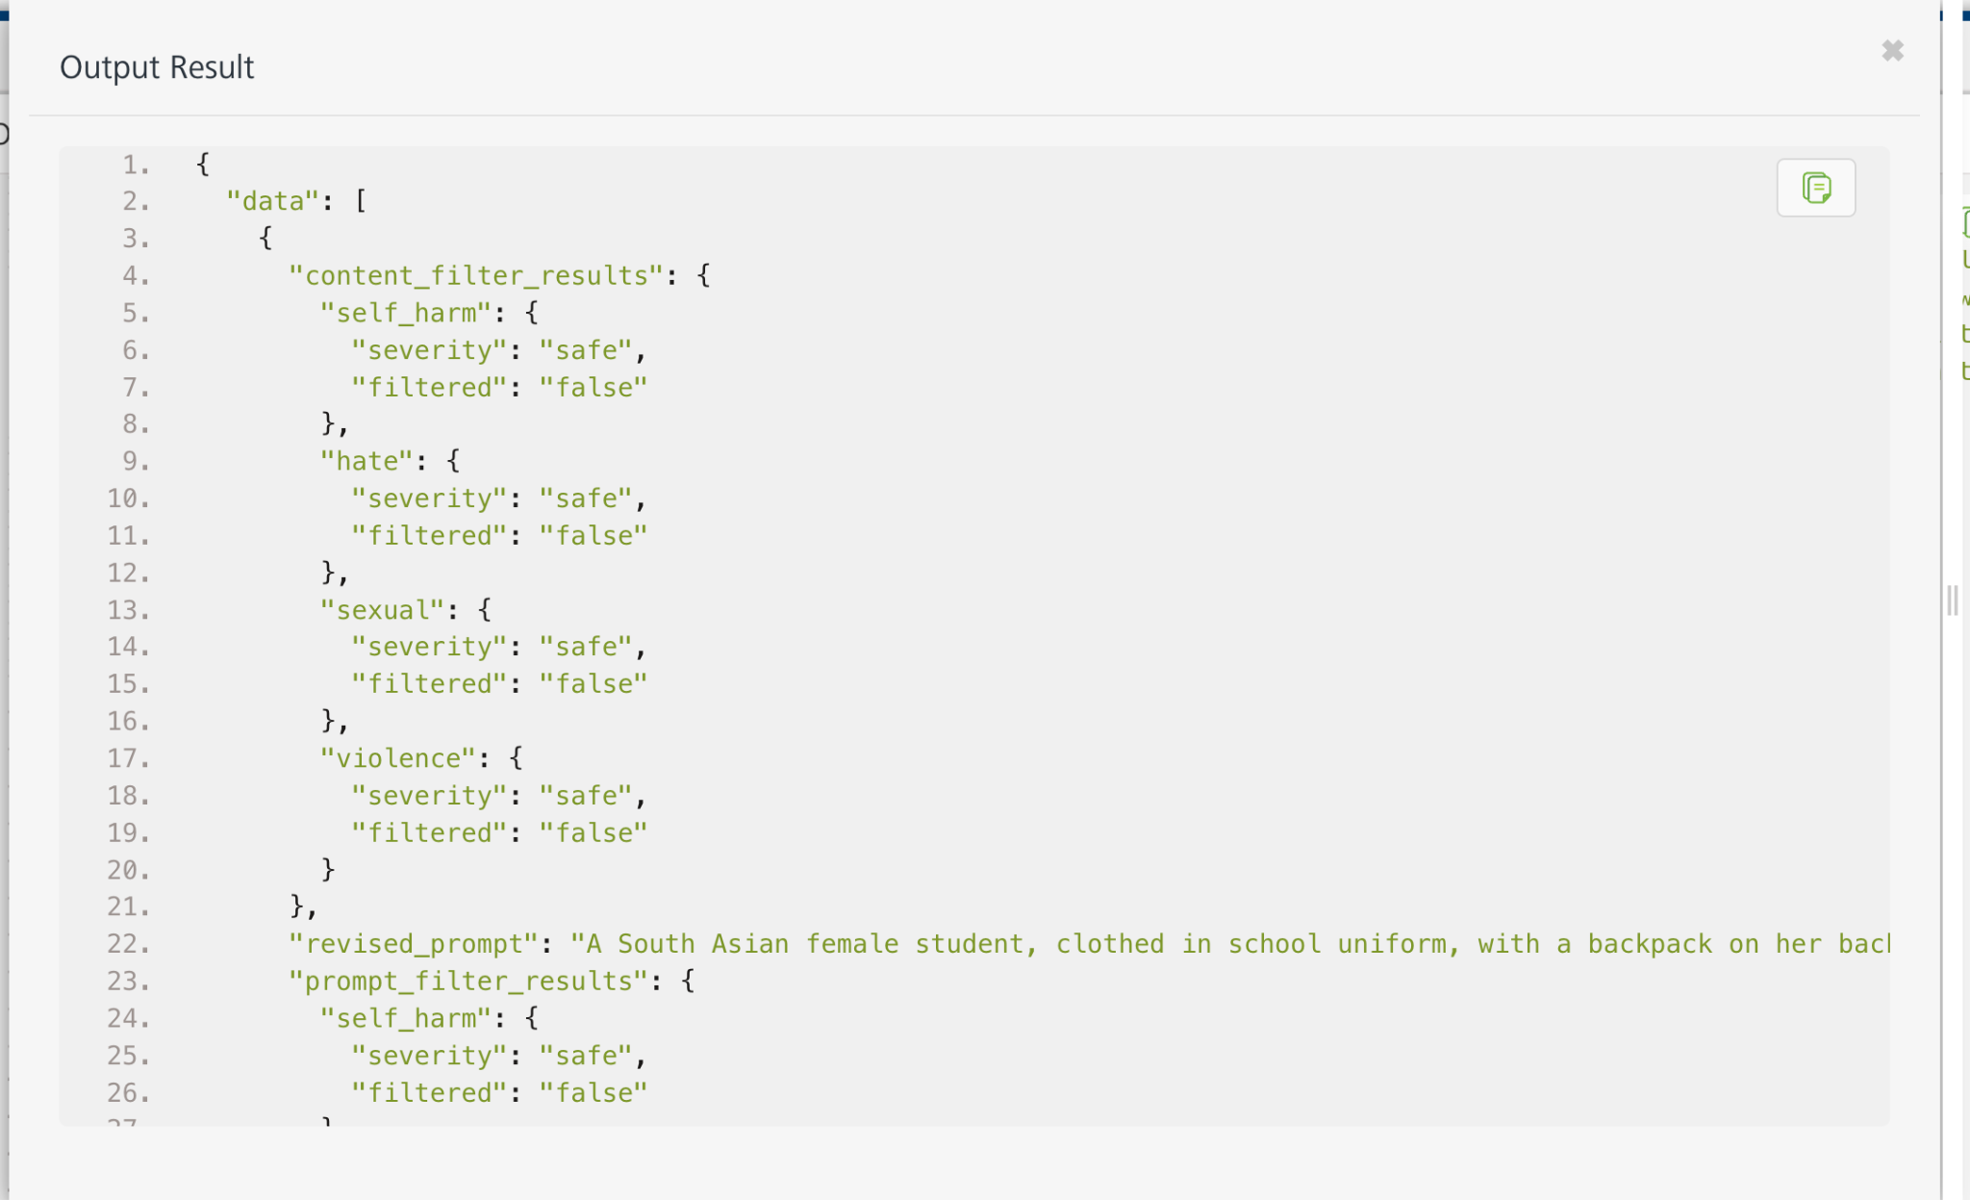

## **Publishing the App to Volt MX Foundry**

After adding the **Microsoft’s AI Image Generator** to your app and configuring the necessary configurations, you must publish the app to Volt MX Foundry. For more information, refer to [Publish a Project to Volt MX Foundry.](https://opensource.hcltechsw.com/volt-mx-docs/docs/documentation/Iris/iris_user_guide/Content/PublishVoltMXFoundryServicesApp.html)  
  
If you want to use the services in client applications, you need to publish the app to a run-time environment.

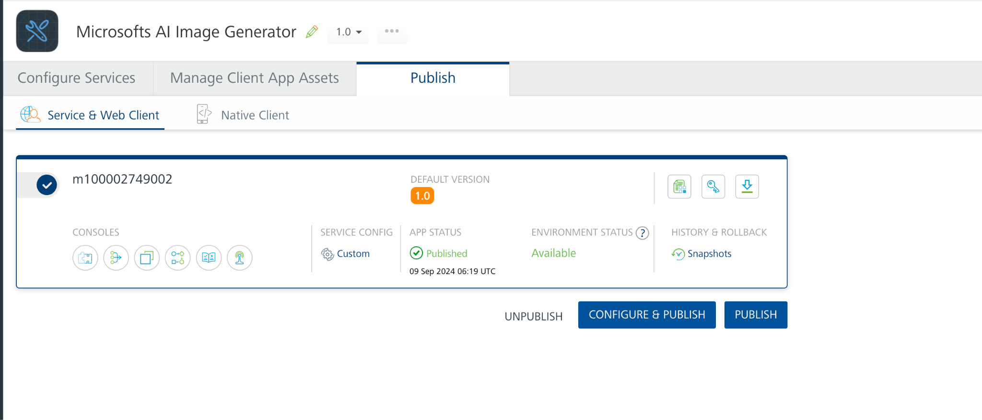

You can also link the Volt Foundry app to a client application.

# **REFERENCES**

## **Properties**

* None of the properties are exposed.

## **Events**

* None of the events are exposed.

## **API’s**

* None of the APIs are exposed.

# **REVISION HISTORY**

App version 1.0.0:

## **Known Issues**

None

## **Limitations**

None