06 -NOV-2025

MISTRAL AI

VERSION: 1.0.0

OVERVIEW
Mistral AI Platform provides a suite of large language models (LLMs) and multimodal AI services that enable developers and enterprises to build intelligent applications such as conversational AI, document understanding, vision analysis, and OCR-based workflows.

- Use case:
- Conversational AI / Chatbots
- Text generation and summarization
- Multi-turn chat applications
- Document OCR and text extraction
- Document Question & Answering
- Vision-based analysis (image understanding)

Percentage of re-use:
80% (Data can be customizable and customers need to implement UI by themselves).

Features
- Chat Models – Generate conversational and contextual responses using multi-turn messages.
- OCR Models – Extract structured text, markdown, and images from PDFs and documents.
- Vision Models – Analyze images with text prompts.

GETTING STARTED

Prerequisites
Before you start using the Mistral AI Data Adapter, ensure you have the following:

- HCL Foundry
- Volt MX Iris
- Mistral AI Account
  - Sign up athttps://console.mistral.ai to create your Mistral account.
- Mistral API Key
  - Once logged in, navigate to the API Keys section in the Mistral dashboard to generate an API key.
  - This key is required to authenticate your application when calling the Mistral APIs
- Model Access
  - Ensure your account has access to the required model families depending on your use case.
  - You can explore available models and capabilities under the Models documentation.
- Project Setup
  - You can start with the free tier for testing and experimentation, then upgrade to a paid plan for production usage if needed.
- Reference document:
Mistral Platform Overview
Mistral API Reference

Importing the data adapter
You can import Mistral AI Data Adapter into HCL Foundry directly from the voltmx Forge website or by importing the data adapter zip file.

To import the data adapter zip file, do the following:
- Log on to your HCL Foundry. The Dashboard page appears by default.
- In the left pane, click the API Management menu. The APIs tab opens by default.
- Click the Custom Data Adapters tab. The Custom Data Adapter page appears.
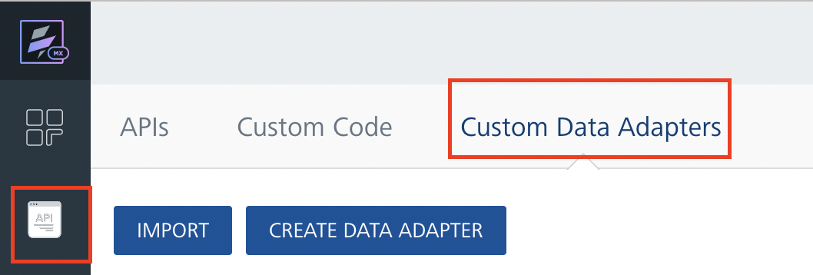
- Click Import. The Import Data Adapter dialog appears.

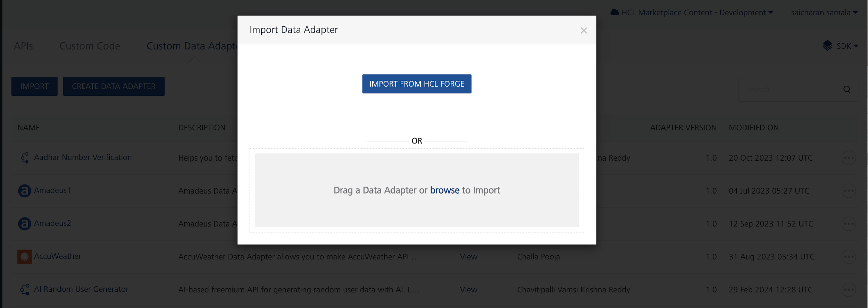

- Click IMPORT FROM HCL FORGE. The Import Data Adapter from HCL Forge dialog appears with a list of available data adapters.
- Click Import. MistralAI data adapter is listed on the Custom Data Adapters page.
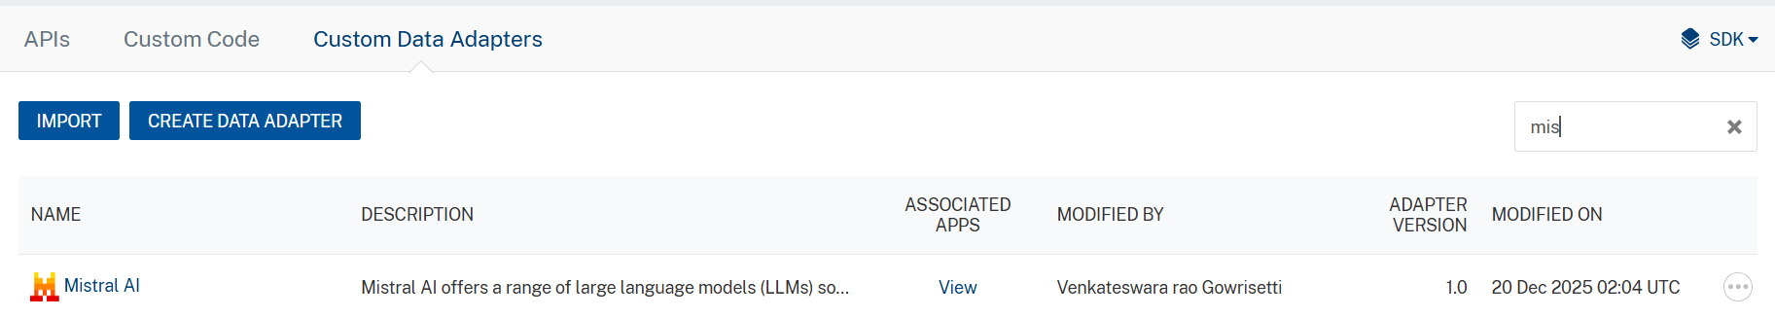

To import the data adapter zip file, do the following:
- Perform steps 1 to 4 in the above procedure
- Drag the data adapter zip file into the Drag a Data Adapter box.
Or
Click browse. The Open dialog appears.
Navigate to the location where you downloaded the data adapter (zip file) on your computer, select the data adapter, and click Open. The Import Data Adapter dialog shows the selected data adapter.

Creating an Integration Service with MistralAI :
After you import MistralAI Data Adapter into Foundry, you must create an integration service with service type as MistralAI .
To create an integration service with MistralAI, do the following:
- Log on to your HCL Foundry. The Dashboard page appears by default.
- In the left pane, click the API Management menu. The APIs tab opens by default.
- Click the Integration tab. The Integration tab opens with a list of existing integration services.
- Click CONFIGURE NEW. The Service Definition tab opens.
- In the Name box, type a unique name for your service.
- From the Service Type list, select MistralAI.
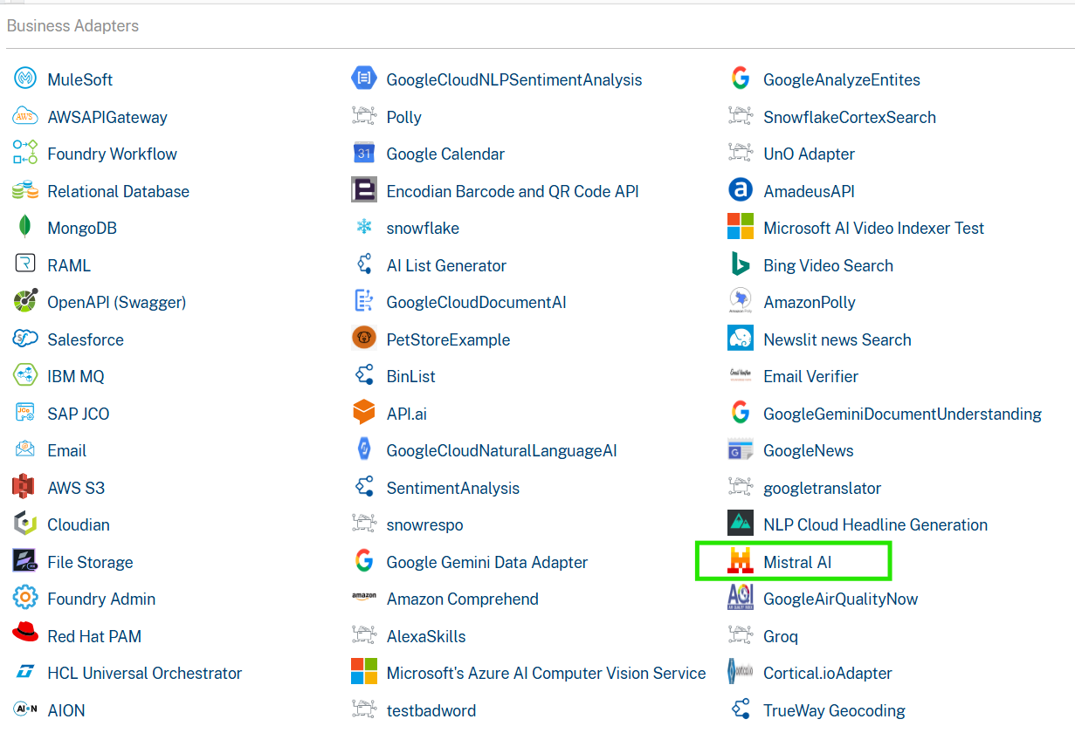
- Click Save

Creating an Operation
To make any API call in the HCL Foundry console, you must create an operation for the respective API and then execute the operation. Executing an operation involves making the API call and displaying the response.
This section provides steps to create an operation for the Mistral API.
Steps to create an operation for the Mistral API:
- Log on to your HCL Foundry. The Dashboard page appears by default.
- In the left pane, click the API Management menu. The APIs tab opens by default.
- Click the Integration tab. The Integration page appears with a list of existing integration services.
- From the list of integration services, select the integration service that you have created with service type as MistralAI. The Service Definition tab of the selected integration service opens by default.
- Click the Operations List tab. The Operations List tab opens.
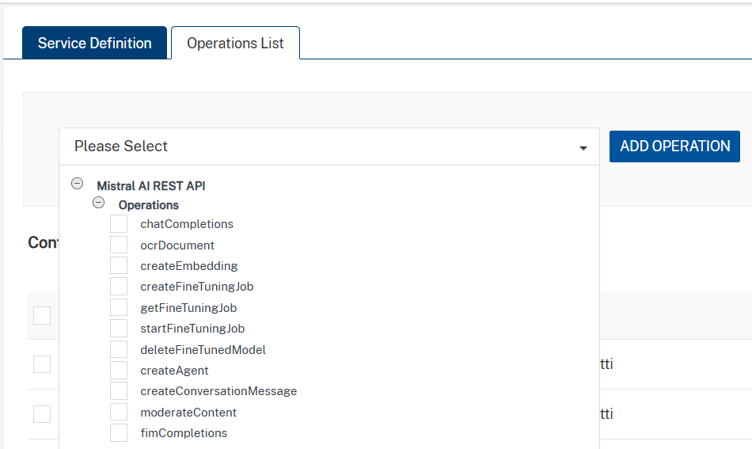
- Select chatCompletions and Click Add Operation.

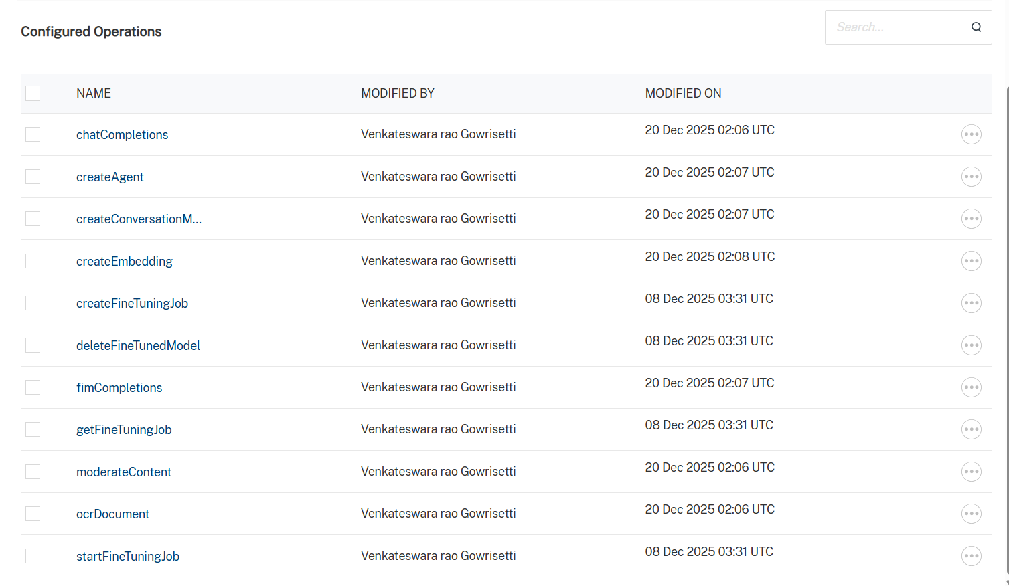

Executing Operation
Executing an operation involves making the API call by setting the necessary parameters and displaying the response. The procedure to execute any operation is same, but the request parameters of the APIs vary. This section provides steps to execute the MistralAI (explained in Creating an Operation).
Steps to execute the Mistral operation:
- Log on to your Hcl Foundry. The Dashboard page appears by default.
- In the left pane, click the API Management menu. The APIs tab opens by default.
- Click the Integration tab. The Integration tab opens with a list of existing integration services.
- From the list of integration services, select the integration service that you have created with service type as MistralAI. The Service Definition tab of the selected integration service opens by default.
- Click the Operations List tab.
- In the Name box, the name of the operation is displayed by default. If you want, you can change the name.
- On the Request Input tab, in the Body section, for the following parameters, specify the values in the respective boxes under the Test Value column.
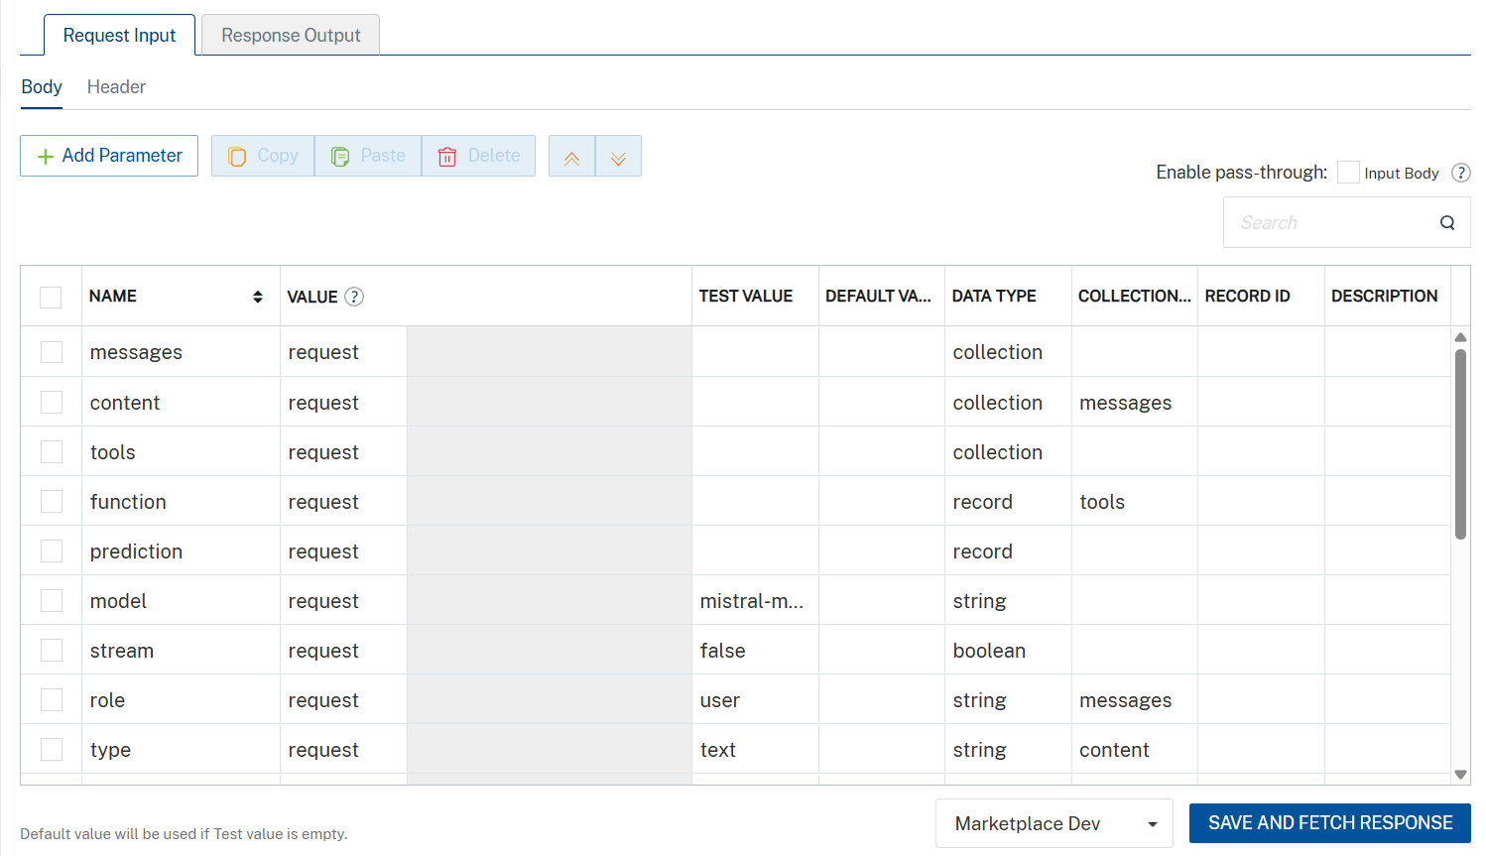

- Enter the value of Authorization in the header part as default value
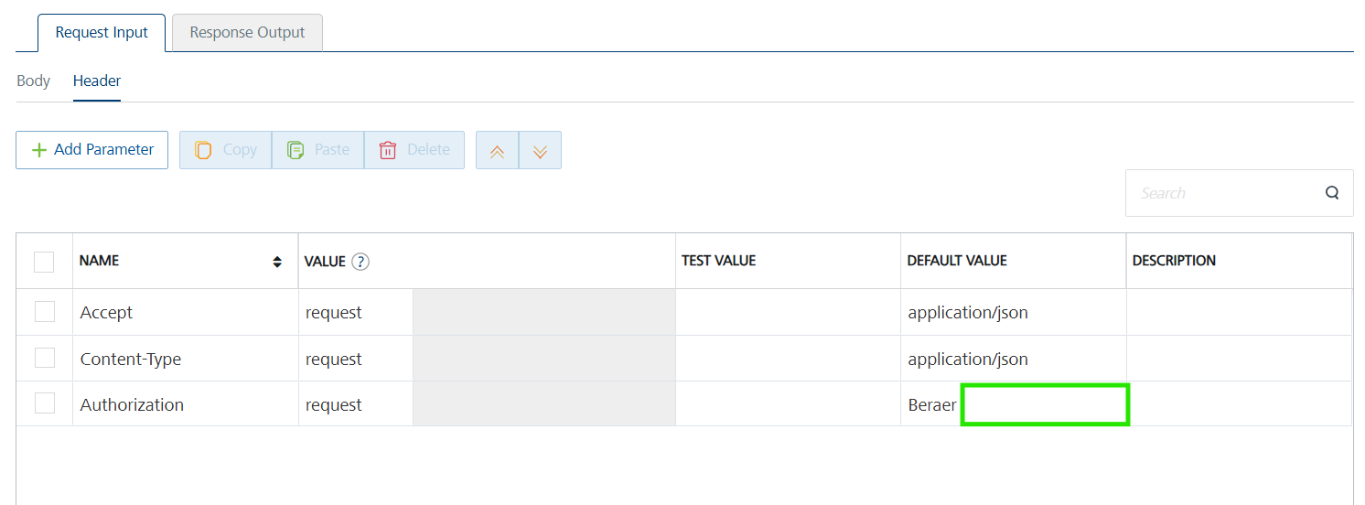
- Click SAVE AND FETCH RESPONSE. The Output Result dialog appears with the response. Otherwise, the Output Result shows an error.
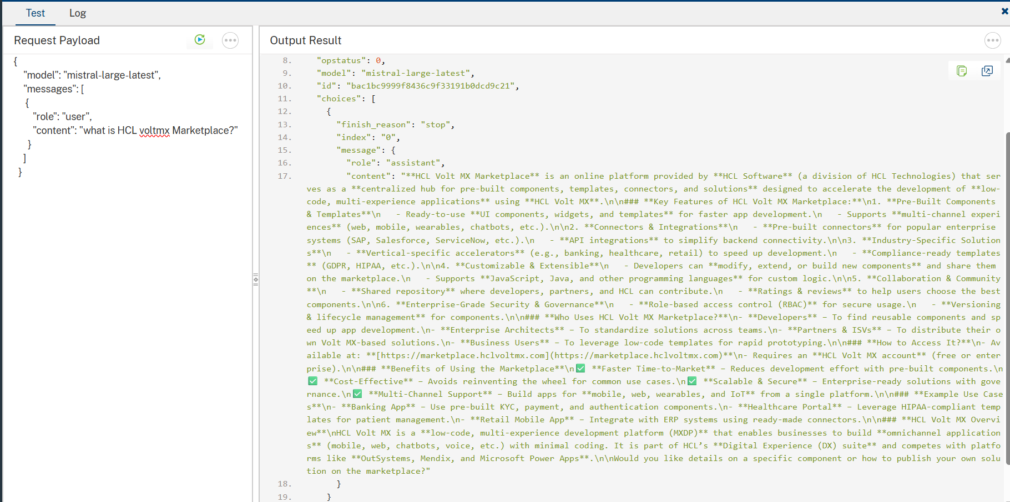
.

Publishing the App in VoltMX FOUNDRY:
After adding the MistralAI Data Adapter to your app and configuring the necessary configurations, you must publish the app to HCL Foundry. For more information, refer to Publish a foundry app.
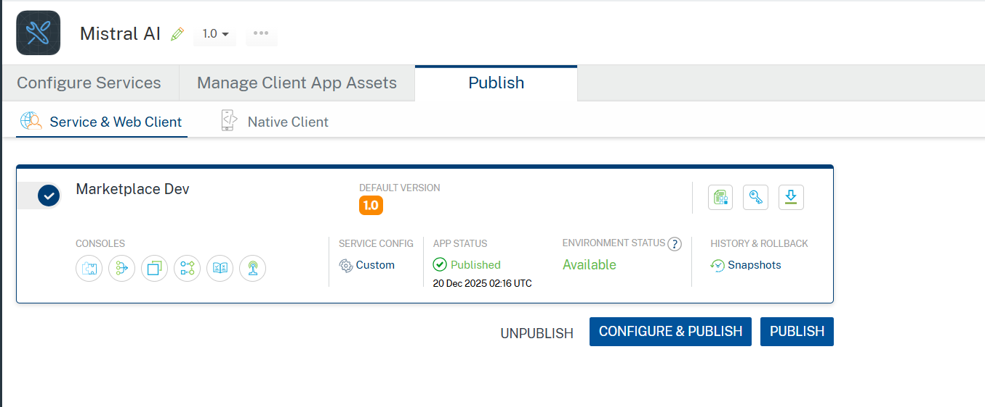

REFERENCES

Properties
- None of the properties are exposed.

Events
- None of the events are exposed.

API’s
- None of the APIs are exposed.

REVISION HISTORY
Adapter version 1.0.0:

Known Issues
None

Limitations
- Uploaded document files must not exceed 50 MB in size and should be no longer than 1,000 pages.
- Only PNG (.png),JPEG (.jpeg and .jpg),WEBP (.webp) and Non-animated GIF with only one frame (.gif) are supported.

