Date : 19-Dec-25

MISTRAL AI APPLICATION

VERSION: 1.0.0

Overview
The Mistral AI Sample Application is a multi-capability AI demonstration app that showcases text generation, vision-based image analysis, and document-based question answering using Mistral AI large language models.The application provides a simple, mobile-friendly interface allowing users to interact with Mistral AI through different AI-powered use cases. It demonstrates how Mistral AI APIs can be integrated with HCL Volt MX Iris and Foundry to build enterprise-ready AI applications.

Purpose
This application enables users to:
- Interact with Mistral AI Chat and Text Generation models
- Upload images and receive AI-powered visual analysis and extraction
- Ask natural-language questions against uploaded documents

Requirements:

- HCL Foundry
- Volt MX Iris
- Mistral AI API Key

Creating an Mistral AI Account and API Key:
- Go to https://mistral.ai
- Sign up for an account
- Navigate to the API / Dashboard section
- Generate a new API Key
- Copy and store the API key securely
(This key is required while configuring the Foundry integration service)

Devices:
- Mobile

Platforms:
- Android
- IOS

Features:
- Multi-Capability AI Interface – Chat, Vision, and Document Q&A in one app
- Context-Aware Responses – AI uses previous inputs where applicable
- Clean Mobile UI – Simple, card-based navigation
- Production-Ready APIs – Secure, scalable REST-based integration
- Enterprise-Friendly Architecture – Volt MX + Foundry based design

App Functionality:

Initial Launch Experience
- On app launch, users see a home screen listing:
  - Chat and Text Generation
  - Vision Analysis (Image Input)
  - Document Question and Answer
- Each capability is presented as a segment row.

Chat and Text Generation Flow
- User selects Chat and Text Generation
- A chat interface opens with a text input field
- User enters a prompt and taps Send
- App sends a POST request to the Mistral AI Foundry integration
- A loading indicator appears while processing
- AI response is displayed in the chat window
- Users can continue asking follow-up questions

Vision Analysis Flow
- User selects Vision Analysis (Image Input)
- User uploads or selects an image
- Image is sent to Mistral AI Vision model
- AI analyzes the image and returns extracted information
- The response is displayed on the results tab.

Document Question and Answer Flow
- User selects Document Question and Answer
- User uploads a document
- User enters a question related to the document
- App sends document content and question to Mistral AI
- AI returns a precise answer based on document context
- The answer is displayed to the user

Importing the app:
To import the Mistral AI Application into your workspace, follow these steps:
- Open Volt MX Iris
- On the main menu select Forge → Browse.
- Search for the Mistral AI Application, and then click Import to Workspace. The app is imported to your workspace. A dialog box appears, confirming that the app has been imported. Click OK.
- Switch to your project containing the Mistral AI Application.. To switch to your project, click File → Open → Reference Architecture → <project name>

Building the app:
After performing all the above steps, you can build your app and run it on your device. For more information, you can refer to the Building and Viewing an Application section of the Volt MX User Guide.
You can then run your app to see the Mistral AI Application work in real time.

Configure the UI and settings of the Mistral AI Application
The Mistral AI Application consists of the following components:
- The frmDashboard shows the capabililities of Mistral Data Adapter
- 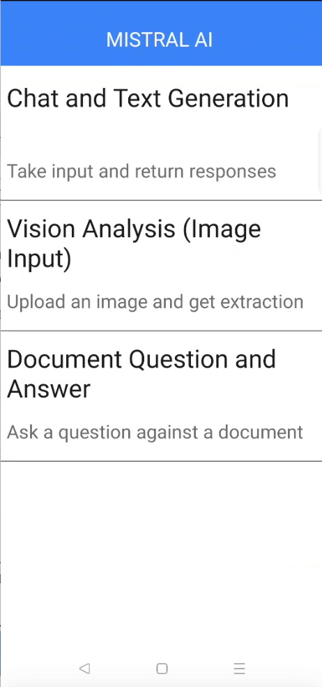
- The NLP Cloud Question Answering component is used to allow users to ask a question and interact with it using advanced Natural Language Processing (NLP) models to accurately extract or generate responses to user input from text.
- Take one form and add the component. Add required widgets and code to create a chat like UI
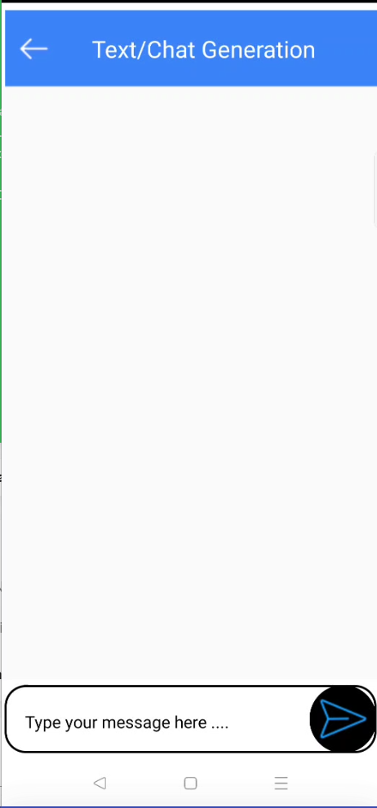
- 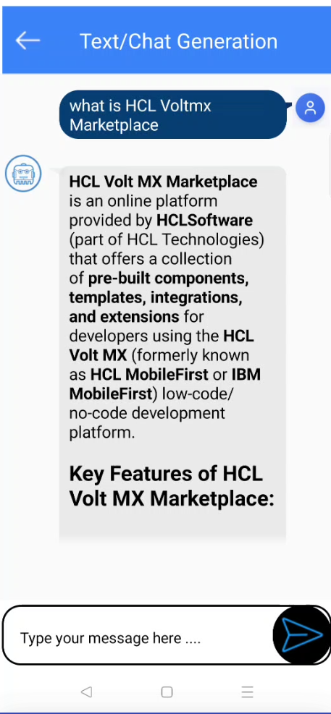
- The Gemini Document understanding component is used to allow users to ask a question and interact with it using advanced Natural Language Processing (NLP) models to accurately extract or generate responses to user input from uploaded document.
- Take one form and add the component. Add required widgets and code to create a UI like this
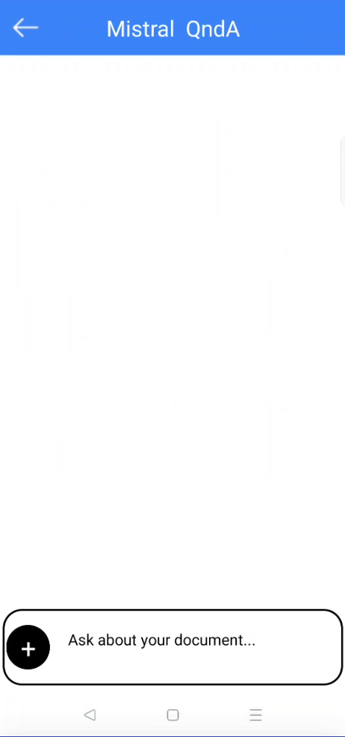
- 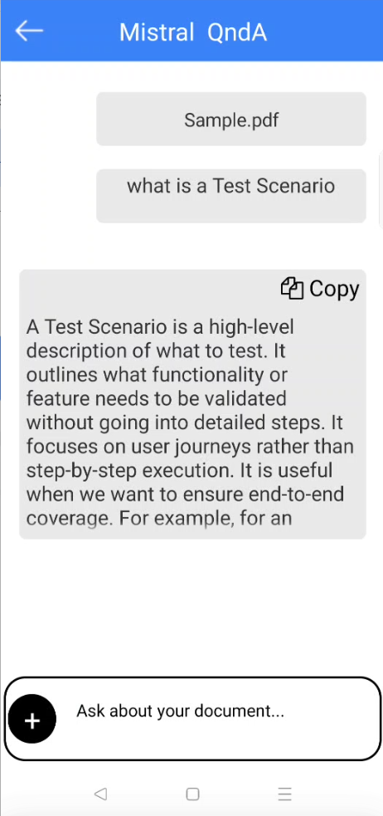
- The frmVision is used to allow users to interact with it using advanced Natural Language Processing (NLP) models to accurately extract or generate responses to user input from uploaded image.
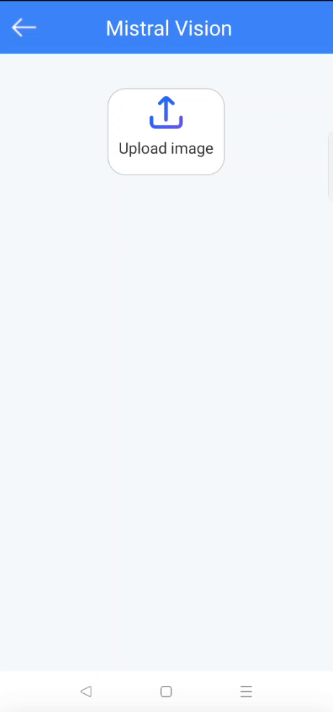
- 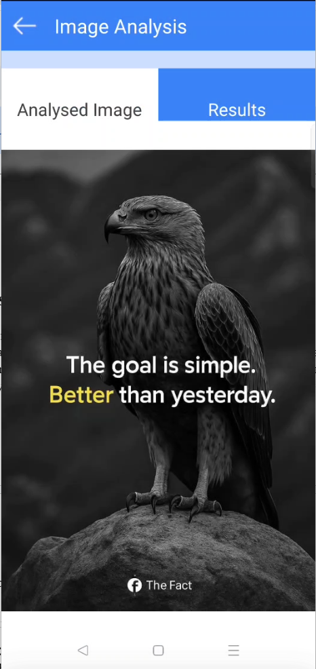
- 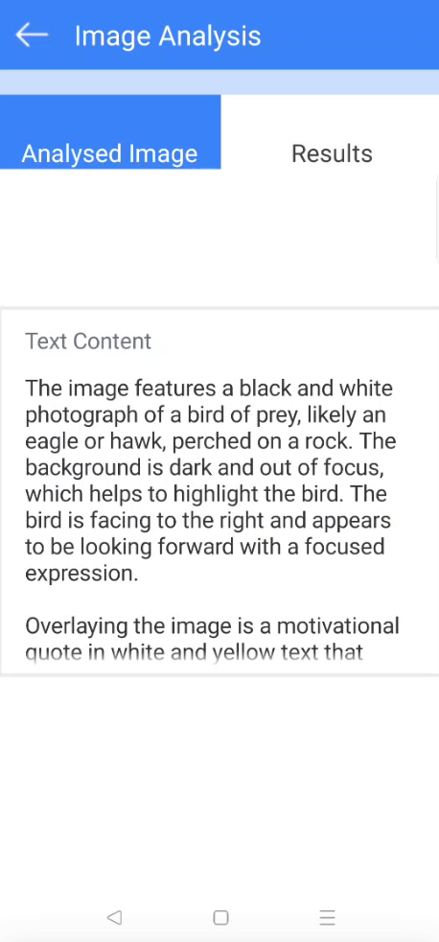

Foundry APP Setup
When you import the application into your Volt MX Iris, the HCL Volt MX Foundry services of the Mistral AI are added to the HCL Volt MX Foundry app, which is associated with the Volt MX Iris project. While importing the Mistral AI Application to your Volt MX Iris project, if there is no HCL Volt MX Foundry app associated with the existing Volt MX Iris project, a new HCL Volt MX Foundry app is automatically added to your HCL Volt MX Foundry environment and is associated with your Volt MX Iris.
To set the Foundry app, follow these steps:
- Click the HCL Volt MX Foundry app associated with your Volt MX Iris project from the Project Explorer. Click DATA & SERVICES
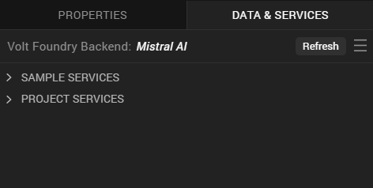
- Under the Configure Services tab, click Integration and can see the Mistral AI. Click on Integration service to add the keys.
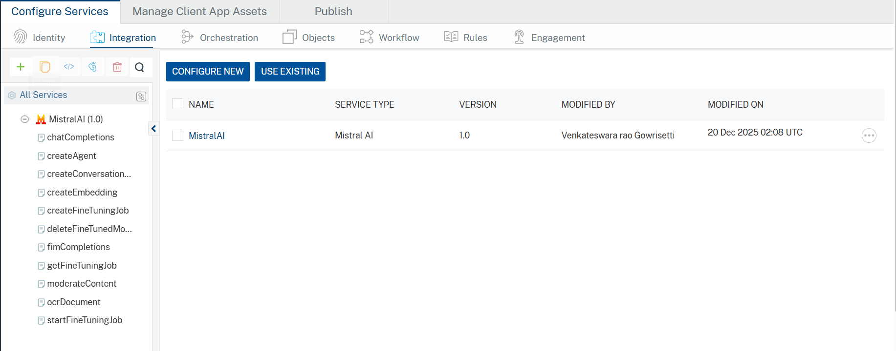
- Click the Mistral AI Integration service. On the right pane, expand the Mistral AI service and then select the chatCompletions operation.
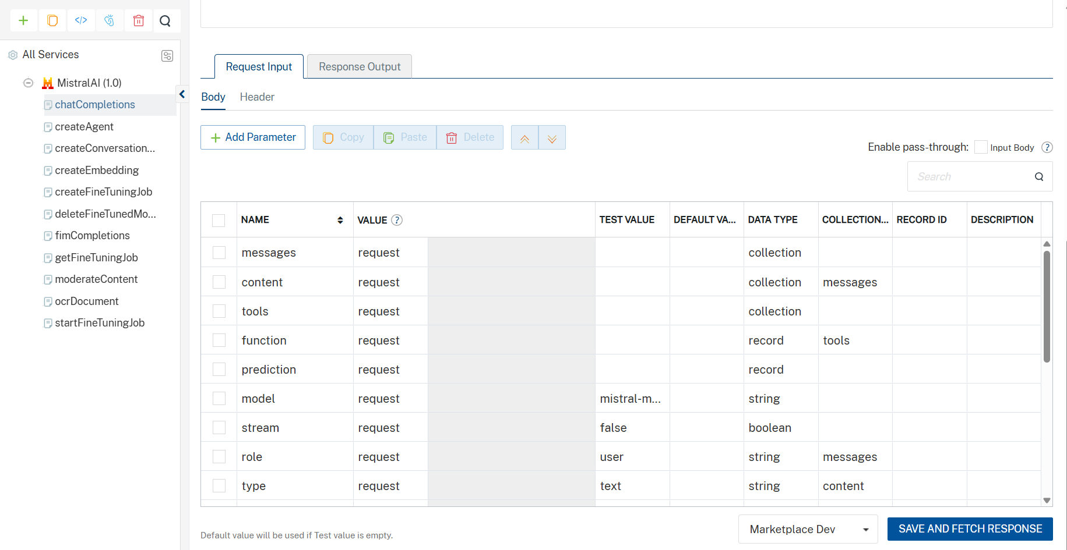
- The chatCompletions tab opens with the Request Input sub-tab opened by default.
- On the Request Input tab, in the Body section, for the following parameters, specify the values in the respective boxes under the Test Value column.
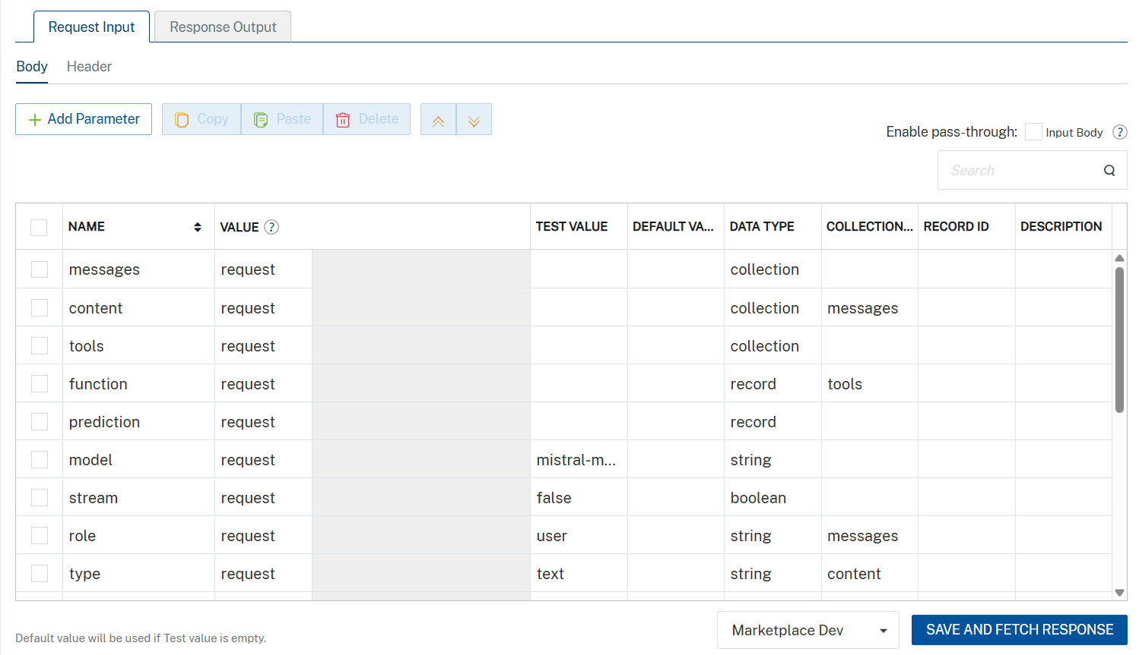
- Click Header sub-tab. The Header section opens.
- For Authorization, In the box under the DEFAULT VALUE column, type the API Key generated from https://admin.mistral.ai/organization/api-keys.
Syntax: Bearer Your_API_KEY
- 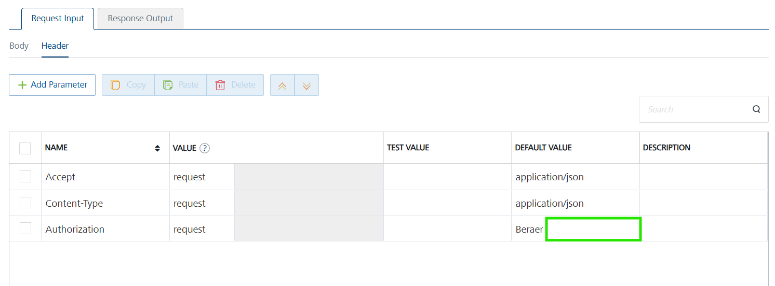
- Click SAVE AND FETCH RESPONSE. The Output Result dialog appears with the response. Otherwise, the Output Result shows an error. 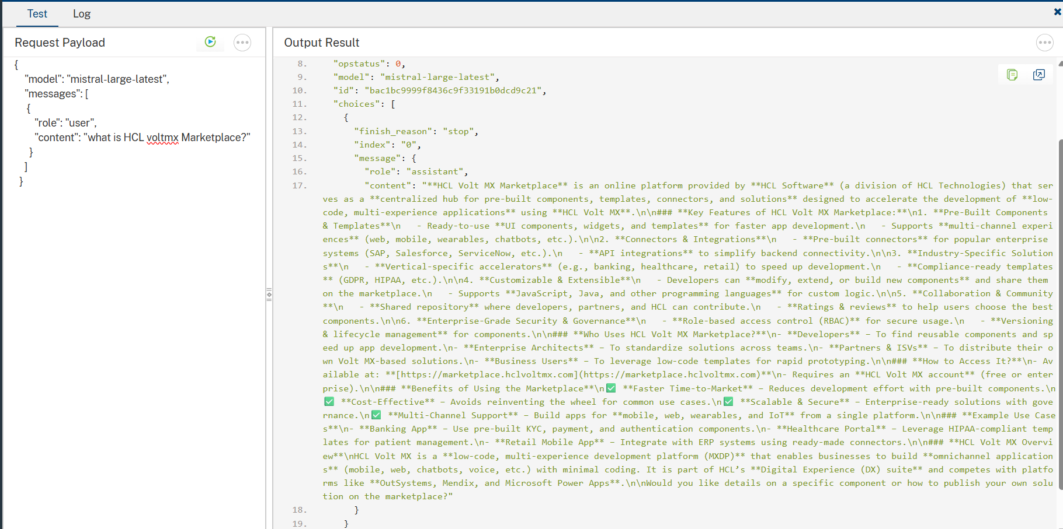
- Click the icon to go back to Volt MX Iris.

Publish the HCL Volt MX Foundry App
After you set the Operation Security Level, you must publish the HCL Volt MX Foundry app. To publish the HCL Volt MX Foundry, follow these steps:
In Volt MX Iris, click DATA & SERVICES, and then click Publish Project Services to Publish to your foundry app.
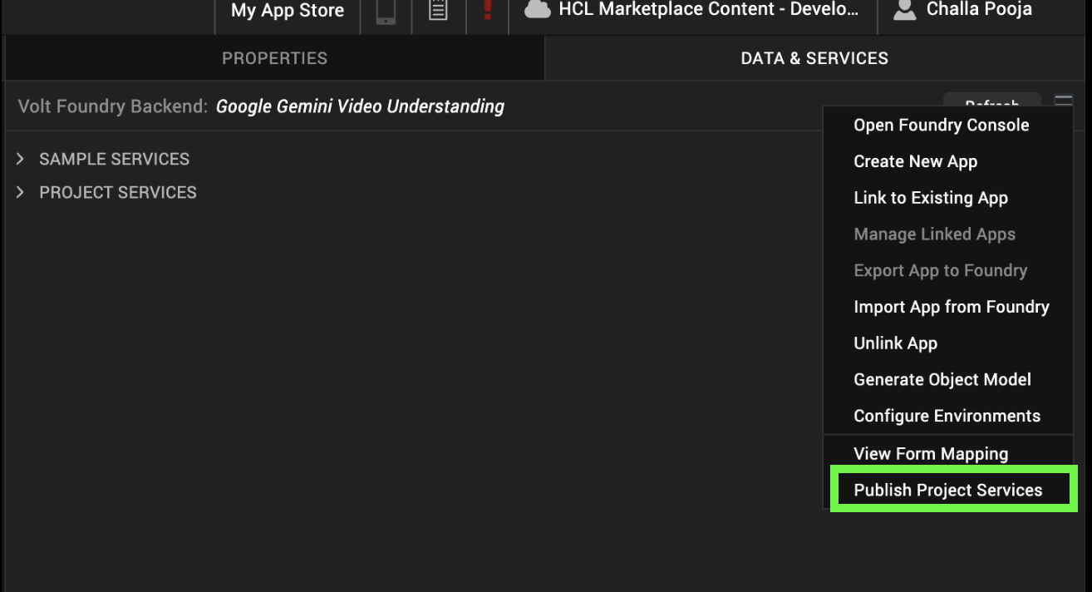
Select the environment to which you want to publish your app, and then click Publish.
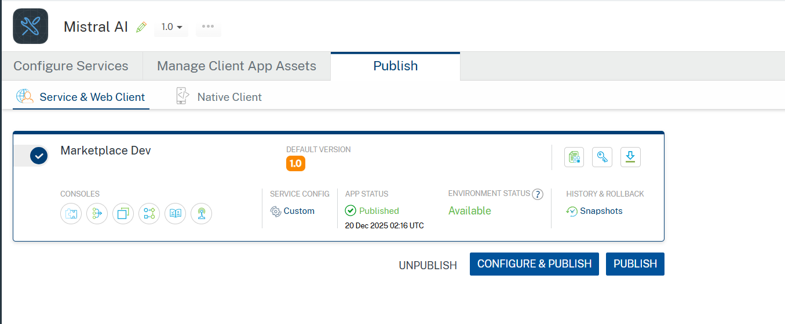
After the app is published to your environment, the following window appears confirming the publish.
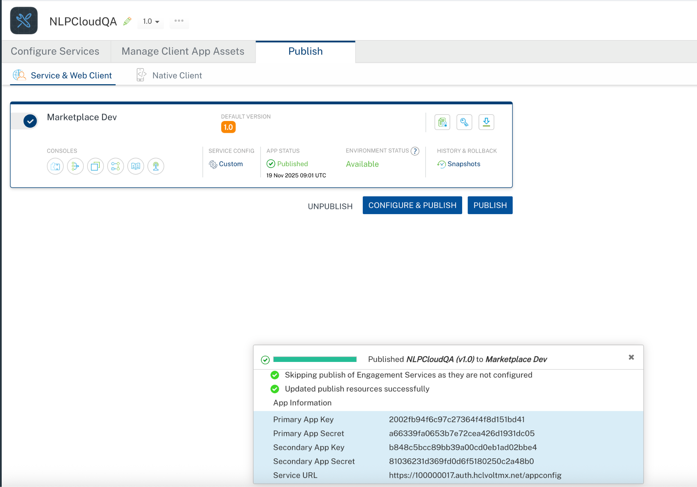

Building and previewing the app
After performing all the above steps, you can build your app and run it on your device. For more information, you can refer to the Building and Viewing an Application section of the Volt MX User Guide.
You can then run your app to see the Mistral AI Application work in real time.

APIs

No APIs

Events

getInput

Description: | Invoked after the input is entered. This getInput should be invoked in the onNavigate function.
Syntax: | getInput
Parameters: | text: The given input text
Remarks: | Need to invoke this event to get the input text
Example: | onNavigate: function() {  this.view.NLPCloudQuestionAnswering.getInputText = function(text){  try{  if(text){  alert("Question= "+text);  }  else{  alert("Input is empty");  }  }.bind(this);  }

getGeneratedContent

Description: | Invoked after the component generates the content. This getGeneratedContent should be invoked in the onNavigate function.
Syntax: | getGeneratedContent
Parameters: | response[JSON] : The generated JSON object from the Mistral AI
Remarks: | Need to invoke this event to get the generated content result.
Example: | onNavigate: function() {  this.view.NLPCloudQuestionAnswering.getGeneratedContent = function(generatedContent){  try{  if(generatedContent){  alert("Generated content= "+JSON.stringify(generatedContent));  }  }  catch(err){  voltmx.ui.Alert({  message: "err in getGeneratedContent= "+err.message,  alertType: constants.ALERT_TYPE_INFO,  yesLabel: "OK"  }, {} );  }  }.bind(this);  }

onErrorCallback

Description : Invoked when error occurs.

Syntax : onErrorCallback

Parameters : args [Array of JSON] : Contains information about the error.

Example : this.view.NLPCloudQuestionAnswering.onErrorCallback= function(args)
{
alert("Error: "+JSON.stringify(args));
}.bind(this);

getRawbytesFromPDF

Description: | Receives the Base64-encoded content of the uploaded PDF file. This can be used to display or process the PDF within the app.
Syntax: | getRawbytesFromPDF
Parameters: | rawbytesFromPDF  The Base64 representation of the PDF file.
Example: | this.view.componentID.getRawbytesFromPDF = function(rawbytesFromPDF){  alert("Received PDF in Base64 format: " + rawbytesFromPDF.substring(0, 50) + "...");  }.bind(this);

getInputText

Description: | Receives the input text prompt provided by the user along with the PDF. This allows you to display or log the user’s query.
Syntax: | getInputText
Parameters: | InputText  The input text prompt entered by the user.
Example: | this.view.componentID.getInputText = function(text){  alert("User entered text prompt: " + text);  }.bind(this);

getGeneratedContent

Description: | Receives the AI-generated content/response based on the PDF and input text. This is the processed output from Mistral.
Syntax: | getGeneratedContent
Parameters: | generatedContent  The AI-generated text result.
Example: | this.view.componentID.getGeneratedContent = function(generatedContent){  alert("AI Response: " + generatedContent);  }.bind(this);

onContentGenerationFailure

Description: | Triggered when the content generation process fails due to errors (e.g., invalid input, service error, network issues).
Syntax: | onContentGenerationFailure
Parameters: | error  Error details describing the failure.
Example: | this.view.componentID.onContentGenerationFailure = function(error){  alert("Content generation failed: " + JSON.stringify(error));  }.bind(this);

Reference API documentation: https://docs.mistral.ai/

REVISION HISTORY
Adapter version 1.0.0:

Known Issues
None

Limitations
- Uploaded document files must not exceed 50 MB in size and should be no longer than 1,000 pages.
- Only PNG (.png),JPEG (.jpeg and .jpg),WEBP (.webp) and Non-animated GIF with only one frame (.gif) are supported.

