Date: 02 Jan 2025

MLKIT BARCODE/QR SCANNER

VERSION: 2.0.2

Overview
The MLKit Barcode/QR Code Scanner component can scan and decode barcodes. Under the hood, the component contains NFIs that use the Google MLKit Barcode API. The component also supports continuous scanning.

Use case:
1. An event organizer app, where a user needs to continuously scan barcodes on passes and allow entry to the attendees.
2. A calendar app that adds events to a user's calendar using the QR Code of the event

Percentage of re-use:

95%

Features
- The component utilizes Google MLKit Barcode SDK for decoding barcodes and QR codes.
- It supports the following Barcode types:
Android:(https://developers.google.com/android/reference/com/google/mlkit/vision/barcode/Barcode)
iOS:( https://developers.google.com/ml-kit/reference/ios/mlkitbarcodescanning/api/reference/Enums/MLKBarcodeFormat )

Getting Started

A. Prerequisites
Before you start using the MLKit Barcode /QR code Scanner component, ensure the following:
• HCL Foundry
• Volt MX Iris

Platforms Supported

Mobile

iOS

Android

Tablets

Importing the app

You can import the Forge components only into the apps that are of the Reference Architecture type.

To import the Google MLKit Barcode/QR code Scanner component, do the following:

Open your app project in Volt MX Iris.
  - In the Project Explorer, click the Templates tab.
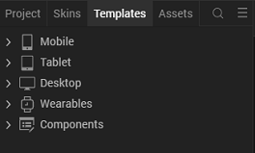

  - Right-click Components, and then select Import Component. The Import Component dialog box appears.
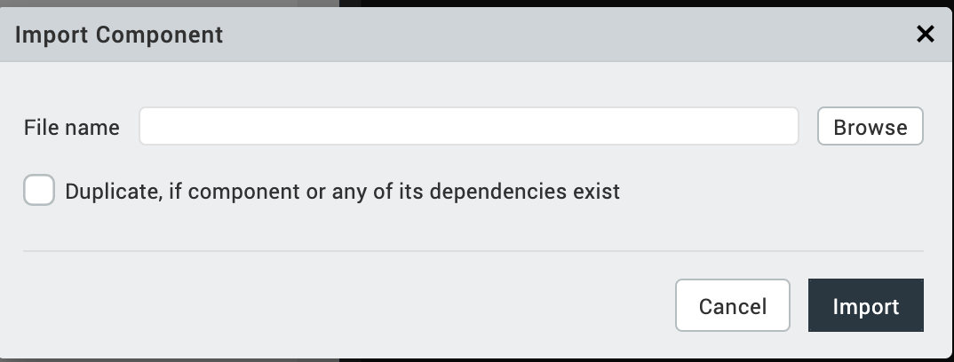
  - Click Browse to navigate to the location of the component, select the component, and then click Import. The component and its associated widgets and modules are added to your project.

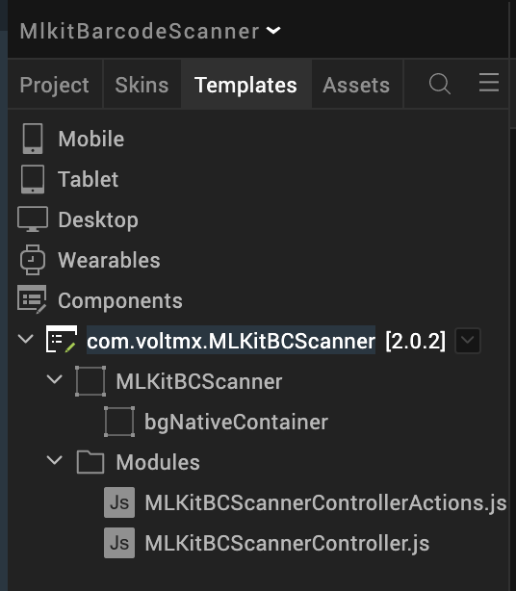

Once you have imported a component to your project, you can easily add the component to a form. For more information, refer Add a Component to a Form

Building and previewing the app
After performing all the above steps, you can build your app and run it on your device. For more information, you can refer to the Building and Viewing an Application section of the Volt MX User Guide.
You can then run your app to see the Barcode/QR code Scanner work in real time.

References

Dynamic Usage
You can also add an MLKit Barcode/QR code Scanner component dynamically. To do so,

1. In the Project Explorer, on the Projects tab, click Controllers section to access the respective Form Controller. Create a method and implement the code snippet similar to the sample code mentioned below.

/* Creating Google MLKit Barcode/QR code Scanner component instance */

var MLKitBCScanner = new com.voltmx.MLKitBCScanner ({
"height": "100%",
"id": "MLKitBCScanner",
"isVisible": true,
"left": "0dp",
"masterType": constants.MASTER_TYPE_USERWIDGET,
"isModalContainer": false,
"skin": "slFbox",
"top": "0dp",
"width": "100%",
"zIndex": 1,
"overrides": {
"MLKitBCScanner": {
"right": "viz.val_cleared",
"bottom": "viz.val_cleared",
"minWidth": "viz.val_cleared",
"minHeight": "viz.val_cleared",
"maxWidth": "viz.val_cleared",
"maxHeight": "viz.val_cleared",
"centerX": "viz.val_cleared",
"centerY": "viz.val_cleared"
}
}
}, {
"overrides": {}
}, {
"overrides": {}
});

//property to set the enableContinuousScan
MLKitBCScanner.enableContinuousScan = false;

/*Adding the Google MLKit Barcode/QR code Scanner component to a Form*/

this.view.add(MLKitBCScanner);
if(this._isiOS) {
this.view.MLKitBCScanner.codeFormats = [this.MLKBarcodeFormatAll, this.MLKBarcodeFormatQRCode];
}
else if(this._isAndroid) {
this.view.MLKitBCScanner.codeFormats = [this.FORMAT_ALL_FORMATS, this.FORMAT_QR_CODE];
}
this.view.MLKitBCScanner.addResultCallback(this.callback);
},
callback: function(data) {
if(data.error.length !== 0) {
voltmx.print("Error while scanning the codes");
alert("Error while scanning the codes");
return;
}else{
var result = delete data.error;
alert(JSON.stringify(data));
}
this.view.MLKitBCScanner.stopSession();
},
In the code snippet, you can edit the properties of the component as per your requirement. For more information, see Setting Properties.
2. Save the file.

Configuring Native Settings (iOS)
To configure the native settings for iOS, follow these steps:
- From the Project explorer, go to Assets and expand Media.
- Right-click Common, and then select Resource Location. Volt MX Iris opens the common resources folder in a file explorer.
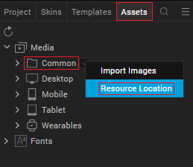
- Open the infoplist_configuration.json file with a text or code editor.
- At the end of the file, type the following code. You can change the description based on your preference.
"NSCameraUsageDescription”: "Your Description"

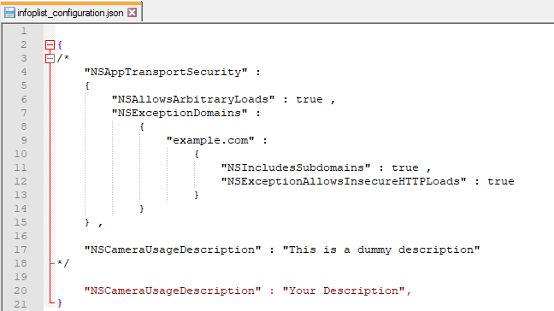
- Save the file.
Configuring Deployment Target
- From the left navigation menu, click Project Settings.
- In the Project Settings window, go to Native → iPhone/iPad.
- Under Target Versions, from the iOS Version list, select 11.0 or higher.
- Set the application launch mode to Both and select both Portrait and Landscape for supported orientations.

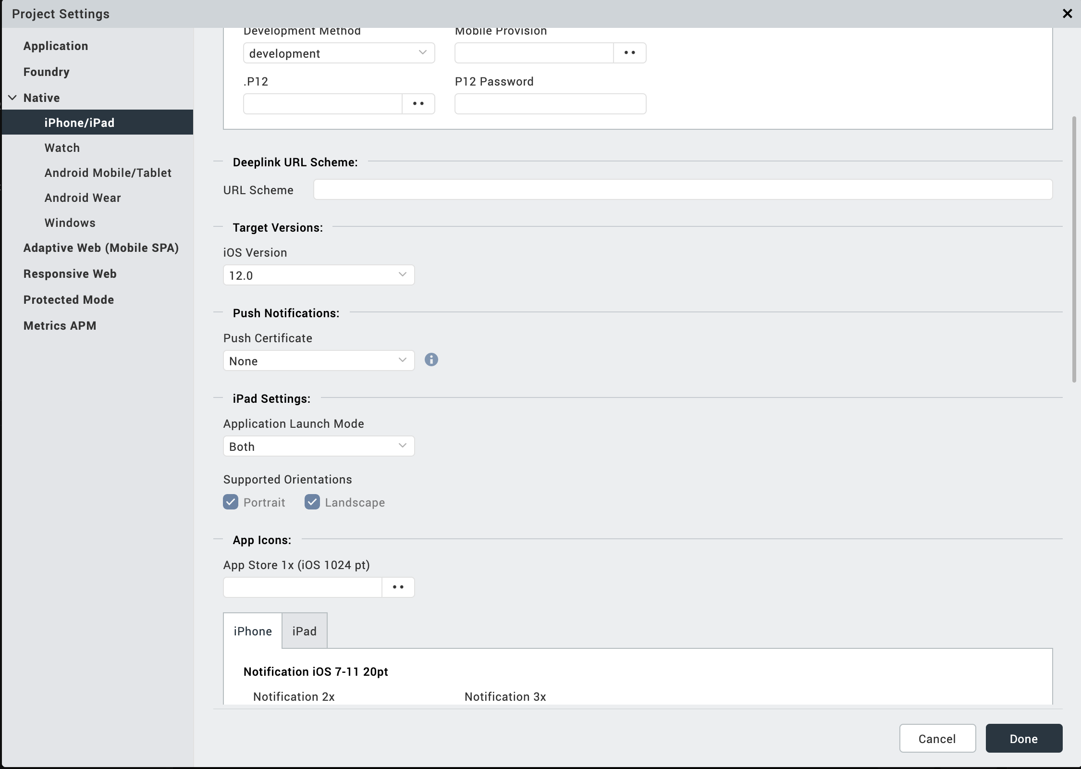
After you configure the native settings, you can Build and Run your app to see the Google MLKit Barcode/QR Code Scanner component work in real time.

Configuring Native Settings (Android)

To configure the native settings for Android, follow these steps:
- From the left navigation menu, click Project Settings.
- In the Project Settings window, go to Native → Android Mobile/Tablet.
- Set the CAMERA permission to true.
To set a permission to true, select the permission from the left panel, and then click Add.
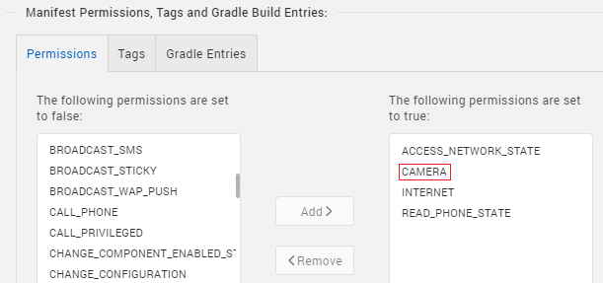
4. Switch to the Gradle Entries tab.
- Add below Camera permission flag at Project Settings/Android Mobile/Tablet/Manifest Permissions, Tags and Gradle Build Entries/Tags/Child tag entries under <manifest> tag/
<uses-feature android:name="android.hardware.camera.any" />

- In the build.gradle entries to Suffix box, type the given code based on the version of the component.
dependencies {
// CameraX
implementation "androidx.camera:camera-camera2:1.0.0-beta11"
implementation "androidx.camera:camera-lifecycle:1.0.0-beta11"
implementation "androidx.camera:camera-view:1.0.0-alpha18"

// MLKit
implementation 'com.google.mlkit:barcode-scanning:16.0.3'
implementation 'org.jetbrains:annotations:15.0'

// used for 32 bit support
android { defaultConfig { renderscriptSupportModeEnabled false}}}
NOTE:
- If you do not add the gradle entries to your project, the app crashes.
- You can update the Play Services version in the later builds of your app.

After you configure the native settings, you can Build and Run your app to see the Barcode/QR Code Scanner component work in real time.

General Properties

1. Code Formats (codeFormats)

Description: | Specifies the code formats to allow.
Syntax: | codeFormats
Type: | Array of Constants
Read/Write: | Read + Write
Example: | if(this._isiOS) {  this.view.MLKitBCScanner.codeFormats=[this.MLKBarcodeFormatAll, this.MLKBarcodeFormatQRCode];  }  else if(this._isAndroid) {  this.view.MLKitBCScanner.codeFormats=[this.FORMAT_ALL_FORMATS, this.FORMAT_QR_CODE];  }
Remarks: | - On Iris, you can set this property from a drop-down list.  - The default value for the property is NA.
Values: | Android:(https://developers.google.com/android/reference/com/google/mlkit/vision/barcode/Barcode)  iOS:( https://developers.google.com/ml-kit/reference/ios/mlkitbarcodescanning/api/reference/Enums/MLKBarcodeFormat )
- Enable Continuous Scanning (enableContinuousScan)
Description: | Specifies whether the camera should remain open after scanning a code.
Syntax: | enableContinuousScan
Type: | Boolean
Read/Write: | Read + Write
Example: | this.view.MLKitBCScanner.enableContinuousScan = true;
Remarks: | If you want the camera to scan codes continuously, set the Enable Continuous Scan property to true. If the Enable Continuous Scanning property is false, then the component closes the camera after scanning a code.  - The default value for the property is “true”.  - For dynamic component import, its mandatory to set this property.

APIs

stopSession

Description: | Stops the scanning.
Syntax: | stopSession ()
Parameters: | None
Return Value: | None
Remarks: | Call this API after successful scan to avoid the continues scan.  And call this API when app moves to background.
Example: | this.view.MLKitBCScanner.stopSession();

restartSession

Description: | Restarts the stopped scanning.
Syntax: | restartSession ()
Parameters: | None
Return Value: | None
Remarks: | Call this API restart the scan after the stopSession() invocation.  And In case session stopped on the background. call this API when app moves to foreground to resume the scanning.
Example: | this.view.MLKitBCScanner.restartSession();

enableFlash

Description: Turns on/off the device flashlight
Syntax: enableFlash()
Parameters: None
Return Value: None
Remarks: Call this API to turn on the flashlight
Example: this.view. MLKitBCScanner.enableFlash();

zoomIn

Description: | Increase zoom by 1 step.
Syntax: | zoomIn()
Parameters: | None
Return Value: | None
Remarks: | Call this API to Zoom In
Example: | this.view.MLKitBCScanner.zoomIn();

zoomOut

Description: | decrease zoom by 1 step.
Syntax: | zoomOut()
Parameters: | None
Return Value: | None
Remarks: | Call this API to Zoom Out
Example: | this.view.MLKitBCScanner.zoomOut();

isFlashSupports

Description: | Returns status about the Flashlight support in the device.
Syntax: | isFlashSupports()
Parameters: | None
Return Value: | Boolean: True/False
Remarks: | Call this API to get the Flashlight support status
Example: | this.view.MLKitBCScanner.isFlashSuuports();

isCameraPermissionAllowed

Description: | Returns status about the Camera permissions allowed or not.
Syntax: | isCameraPermissionAllowed ()
Parameters: | None
Return Value: | Boolean: True/False
Remarks: | Call this API to get the Camera Permissions status
Example: | this.view.MLKitBCScanner.isCameraPermissionAllowed();

setupCustomRectOfInterest

Description: | Adds the Rectangle/Square image on top of the Camera Screen.
Syntax: | setupCustomRectOfInterest (frame, image)
Parameters: | frame; is array of integers with the defined index  [centerx, centery, width, height]  Image; Parameter is for rectangle/Square image which should place in resources/mobile/native/iphone/mainbundle for iOS, resources/mobile/native/android/Drawable folders for Android passing  empty parameter will take the default image.
Return Value: | None
Remarks: | Call this API to add Rectangle/Square image on top of the Camera. And it should be  Called every time when session restarts. And this function must be invoked after  The component initialization completion callback; addInitCompleteCallback.
Example: | this.view.MLKitBCScanner.setupCustomRectOfInterest([0, 0, 250, 250], "");

removeRectofInterest

Description: | Removes the added Rectangle/Square image from the Camera Screen.
Syntax: | removeRectofInterest ()
Parameters: | None
Return Value: | None
Remarks: | Call this API to remove added Rectangle/Square image from the Camera.  And it should be called every time in the result Callback to remove from the screen  After successful scan.
Example: | this.view.MLKitBCScanner.removeRectofInterest();

startSession

Description: | Starts the scanning.
Syntax: | startSession ()
Parameters: | None
Return Value: | None
Remarks: | Call this API to do scan.  And call this API when app moves to background.
Example: | this.view.MLKitBCScanner.startSession();

xi. setupRectOfInterest

Description: | Adds the Rectangle image from the Camera Screen.
Syntax: | setupRectOfInterest ()
Parameters: | None
Return Value: | None
Example: | this.view.MLKitBCScanner.setupRectOfInterest();

xii. setupSquareOfInterest

Description: | Adds the Square image from the Camera Screen.
Syntax: | setupSquareOfInterest ()
Parameters: | None
Return Value: | None
Example: | this.view.MLKitBCScanner.setupSquareOfInterest();

Events

1. addResultCallback

Description: | Invoked after the component scans and decodes a barcode or a QR code.
Syntax: | addResultCallback
Parameters: | data[JSON] : The data that is decoded from the barcode or QR code.
Remarks: | If you want the camera to scan codes continuously, do not call the stopSession() in addResultCallback.
Example: | onNavigate: function(context) {  this.view.MLKitBCScanner.addResultCallback(this.callback);  },  callback: function(data) {  if(data.error.length !== 0) {  voltmx.print("Error while scanning the codes");  alert("Error while scanning the codes");  return;  } else{  var result = delete data.error;  alert(JSON.stringify(data));  }  this.view.MLKitBCScanner.stopSession();  },

2. addInitCompleteCallback

Description: | Invoked after the component completes the initialization. This addInitCompleteCallback should be invoked in onNavigate function.
Syntax: | addInitCompleteCallback
Parameters: | function(): a call back function
Remarks: | setupCustomRectOfInterest invocation must be in this callback only.
Example: | onNavigate: function(context) {  this.view.MLKitBCScanner.addInitCompleteCallback(this.initComplete);  },  initComplete: function() {  // first time adding the square of intrest after scan initialization completes.  // First Parameter is for the rectangle frame: array indexes are respected following: 0-center x, 1-center y, 2-width, 3-height  // Second Parameter is for rectangle image which should place in resources/mobile/native/iphone/mainbundle for iOS, resources/mobile/native/android/Drawable folders for Android passing empty parameter will take default image from the NFI.  this.view.MLKitBCScanner.setupCustomRectOfInterest([0, 0, 250, 250], "");  // Hide/Unhide flash button based on the flash light support  this.view.btnFlash.setVisibility(this.view.MLKitBCScanner.isFlashSupports() && this.view.MLKitBCScanner.isCameraPermissionAllowed());  },

REVISION HISTORY
Asset version 2.0.2:

Limitations

1. This component supports only 64-bit devices

B. Known Issue

-N.A.-

